**SUPPLEMENTARY FIGURES**

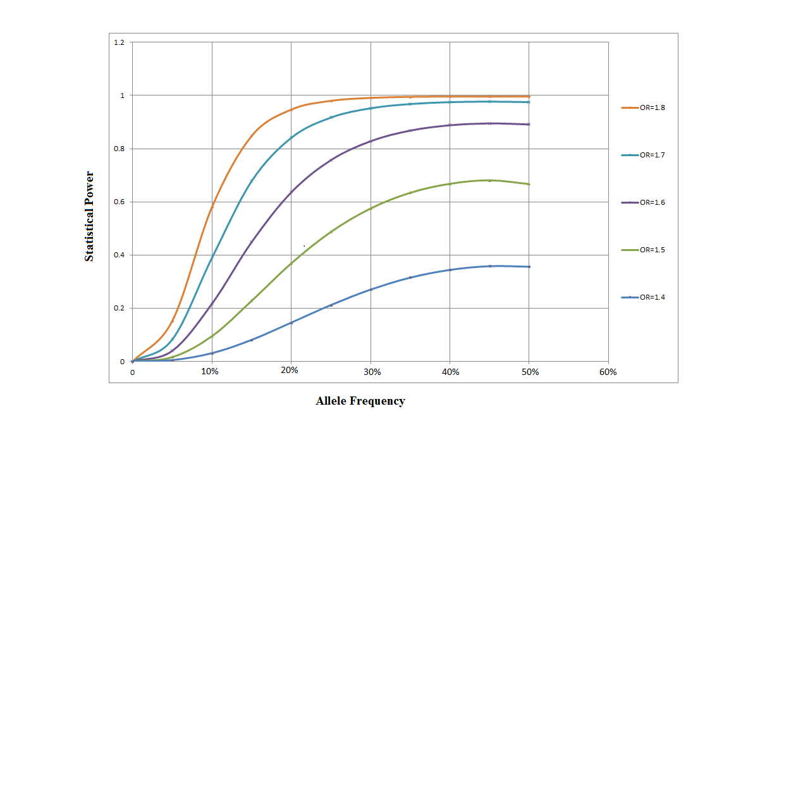**Supplementary Figure 1.** Statistical power under different MAFs (in proportion) and ORs at α=1x10-5.

**Supplementary Figure 2.** QQ plot for the imputed dataset in our study.

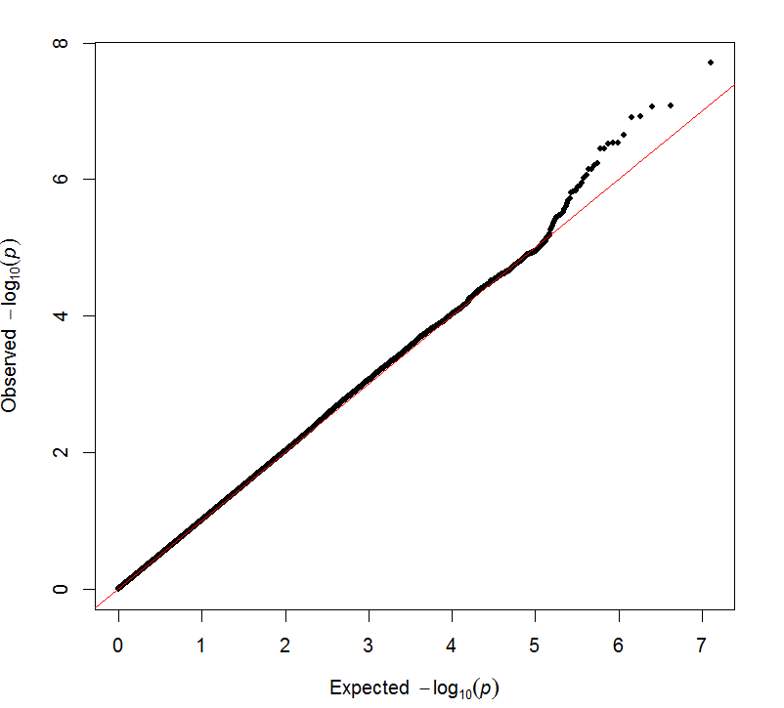

**Supplementary Figure 3.** Principal components analysis of the samples (before and after clean up) as well as together with Near Eastern data.

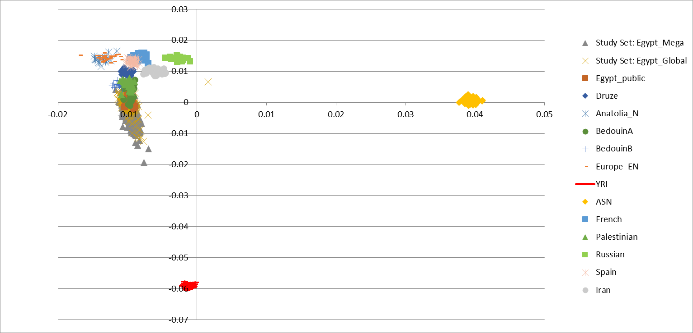

**PC1 VS PC2**

**PC1 VS PC3**

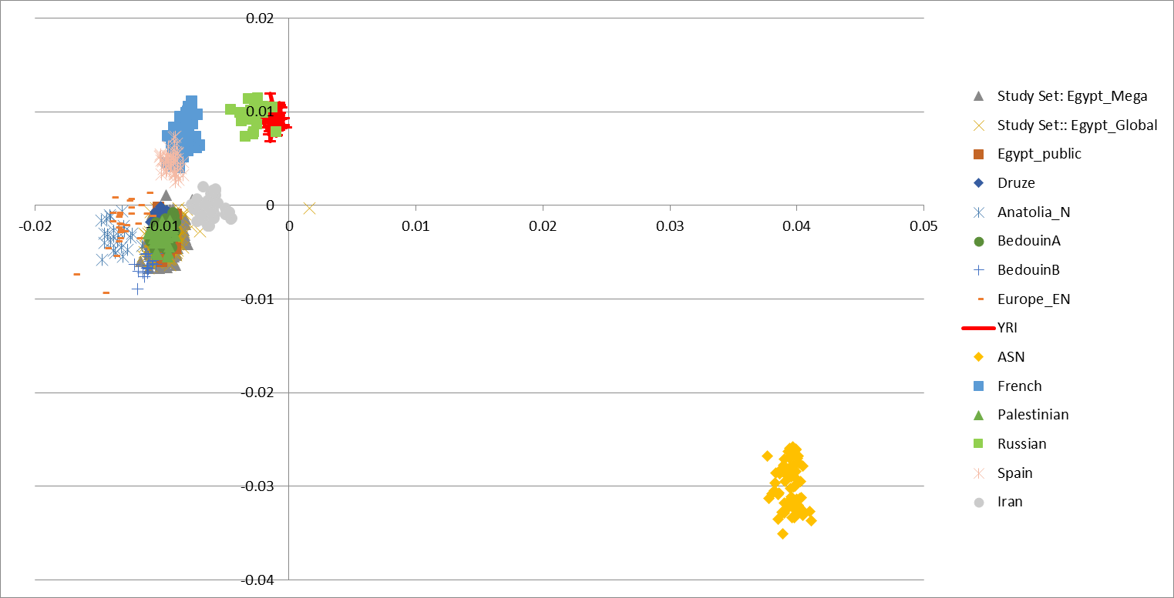

**PC2 VS PC3**

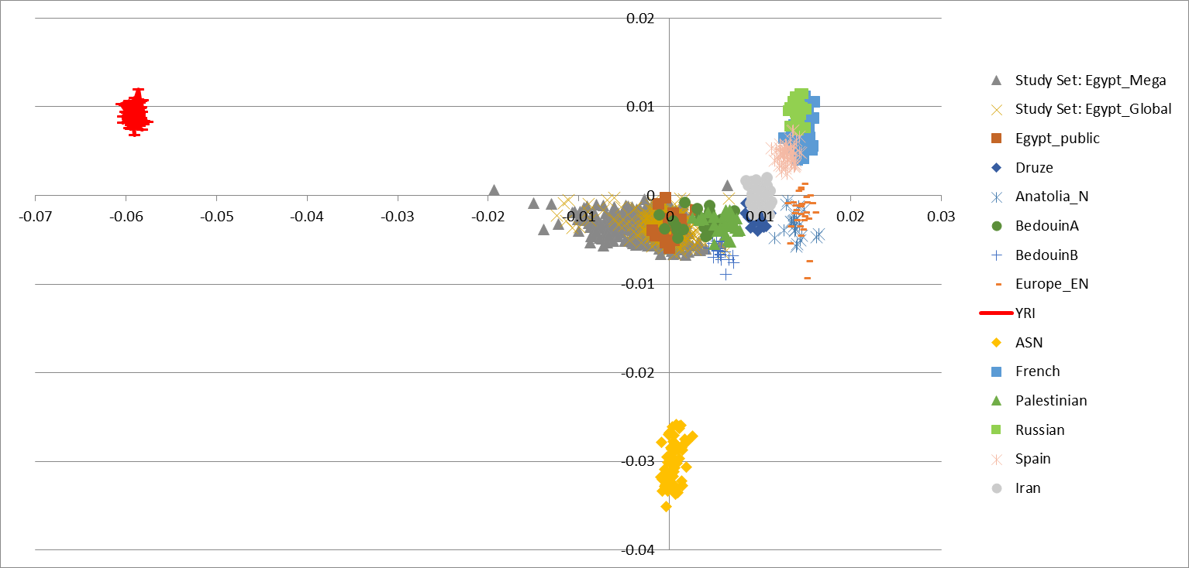





**Supplementary Figure 4.** Admixture cross-validation plot for *K*=1-18 with samples from Near East samples.

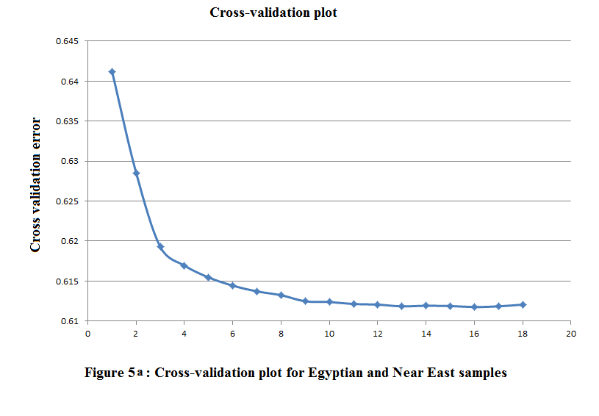

**Number of population (K)**