Supplementary Material

# Impedance of the Cascaded Metasurface

**Supplementary Figure 1** showsImpedance of the cascaded metasurface obtained from the equivalent circuit model. Here,  and  denote the impedance of the resistive layer and the bandpass layer, respectively.  and  denote the impedances of the series LC circuit and the parallel LC circuits.

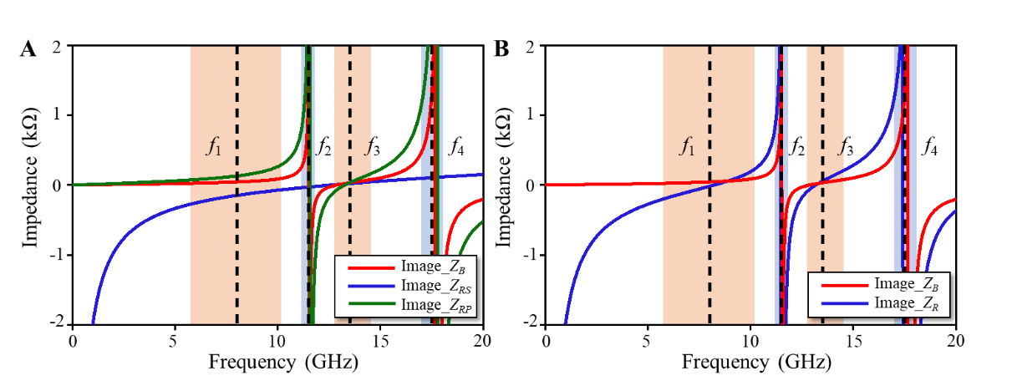

**Supplementary Figure 1.** Impedance of the cascaded metasurface obtained from the equivalent circuit model. (A) Imaginary parts of ,  and . (B) Imaginary parts of  and .The Circuit parameters are as follows:, , , , , , , , , .

# The oblique-angle dependence of cascaded metasurface

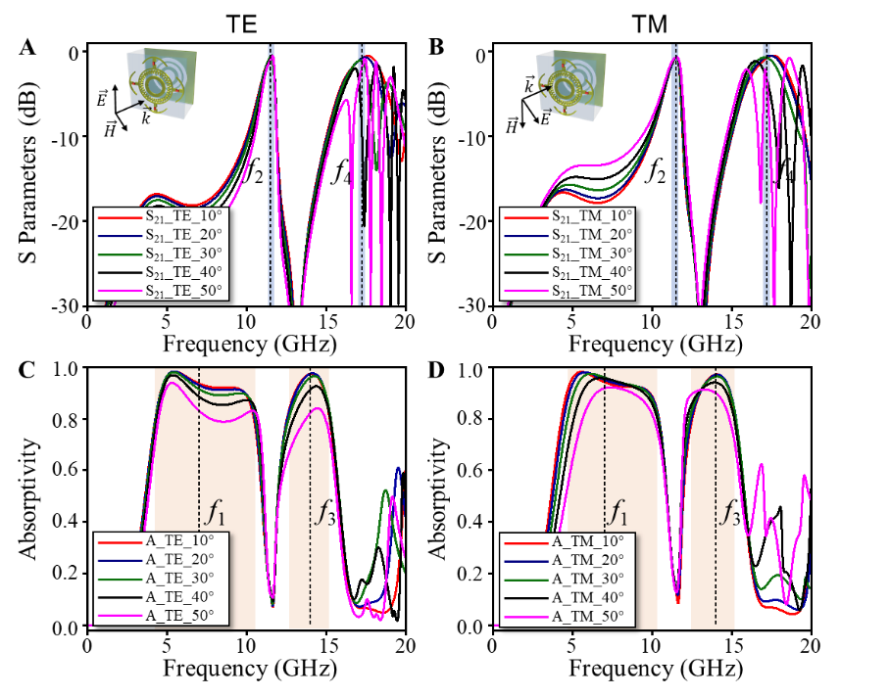

**Supplementary Figure 2.** Oblique-angle dependence of cascaded metasurface. Transmission coefficients and absorptivity under **(A, C)** TE polarization, **(B, D)** TM polarization.

# Structure Parameter Sweeping for Cascaded Metasurface

We preform structure parameter sweeping for the bandpass layer and the resistive layer, respectively, as shown in **Supplementary Figures 3,4.**

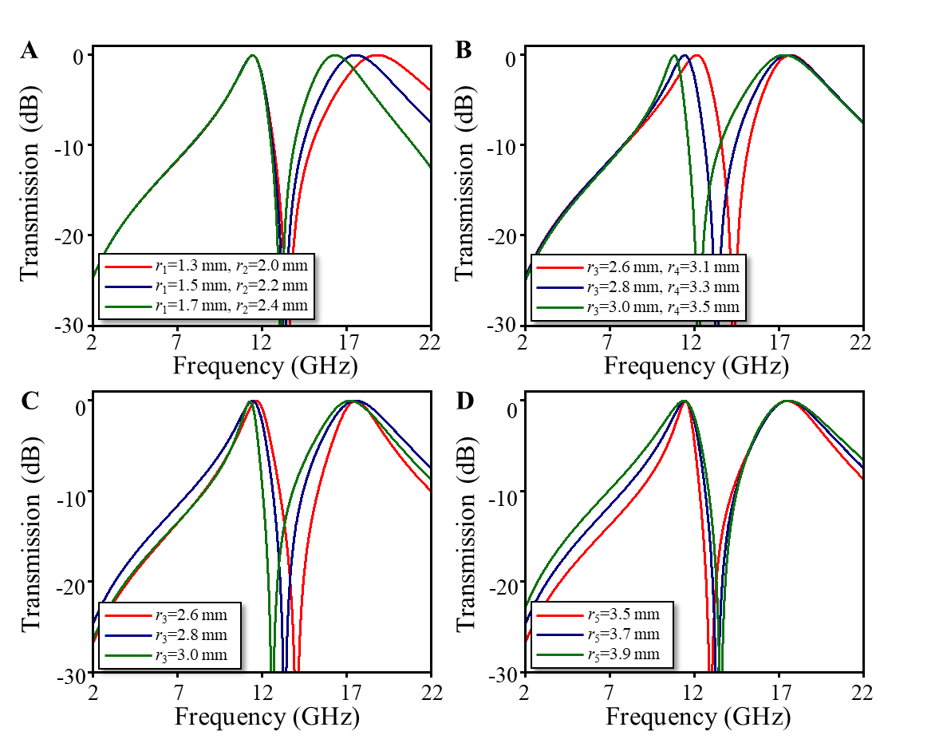

**Supplementary Figure 3.** The transmission of the bandpass layer with **(A)** different *r*1 and *r*2, **(B)** different *r*3 and *r*4, **(C)** different *r*3, and **(D)** different *r*5.

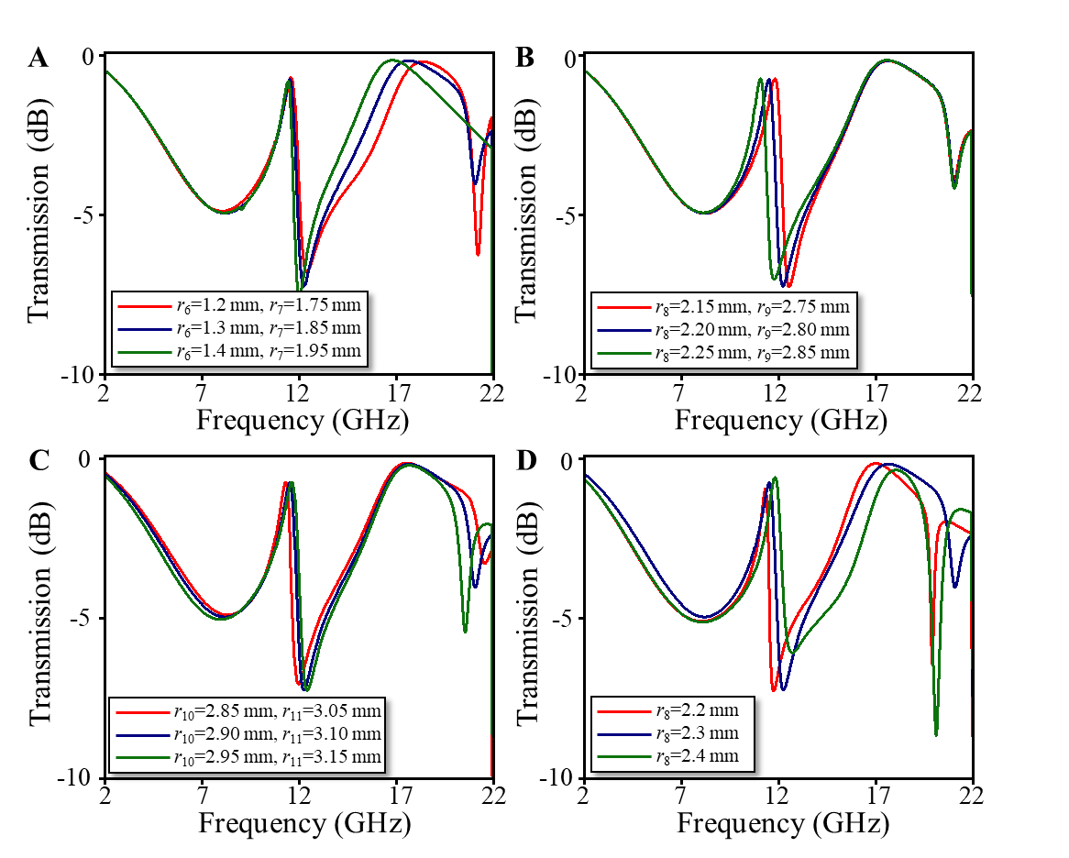

**Supplementary Figure 4.** The transmission of the resistive layer with **(A)** different *r*6 and *r*7, **(B)** different *r*8 and *r*9, **(C)** different *r*10 and *r*11, and **(D)** different *r*8.

# The Physical Parameters of Cascaded Metasurface

Details about the resistive layer are shown in the **Supplementary Figure 5**. All physical parameters of the structure are shown in **Supplementary Table 1**.

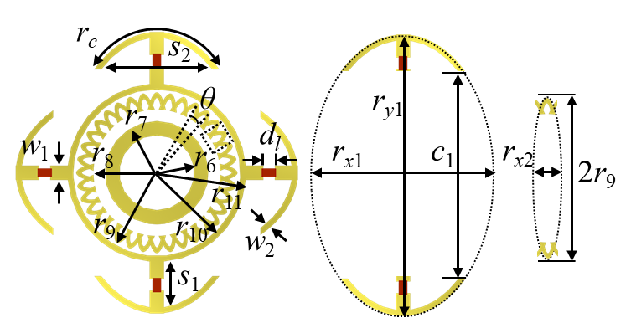

**Supplementary Figure 5.** The top view of the resistive layer with detailed parameters.

**Supplementary Table 1.** The physical parameters of cascaded metasurface

|  |  |  |  |  |  |  |  |
| --- | --- | --- | --- | --- | --- | --- | --- |
| *p* | $$r_{1}$$ | $$r_{2}$$ | $$r_{3}$$ | $$r_{4}$$ | $$r_{5}$$ | $$r_{6}$$ | $$r_{7}$$ |
| 10 mm | 1.3 mm | 2.1 mm | 2.6 mm | 3.2 mm | 3.5 mm | 1.3mm | 1.9 mm |
| $$r_{8}$$ | $$r_{9}$$ | $$r_{10}$$ | $$r_{11}$$ | $$r_{c}$$ | $$s_{1}$$ | $$s_{2}$$ | $$w_{1}$$ |
| 2.6 mm | 2.9 mm | 3.1 mm | 3.6 mm | 5.3 mm | 1.6 mm | 3.8 mm | 0.5 mm |
| $$w_{2}$$ | $$d_{l}$$ | $$θ$$ | *g* | *h* | *t* | $$r_{x1}$$ | $$r_{y1}$$ |
| 0.2 mm | 0.4 mm | $${10}^{°}$$ | 0.13 mm | 5 mm | 0.508 mm | 6.4 mm | 9.8 mm |
| $$c_{1}$$ | $$r_{x2}$$ |  |  |  |  |  |  |
| 7.2 mm | 1 mm |  |  |  |  |  |  |

# The Circuit Parameters of Cascaded Metasurface

**Supplementary Figure 6** illustrates the S-parameters of the cascaded metasurface calculated by full-wave simulation (solid curves) and equivalent circuit model (dashed curves), where the circuit parameters are as follows: , , , , , , , , , , . The full-wave results are in good agreement with equivalent circuit analysis in **Supplementary Figure 6.**

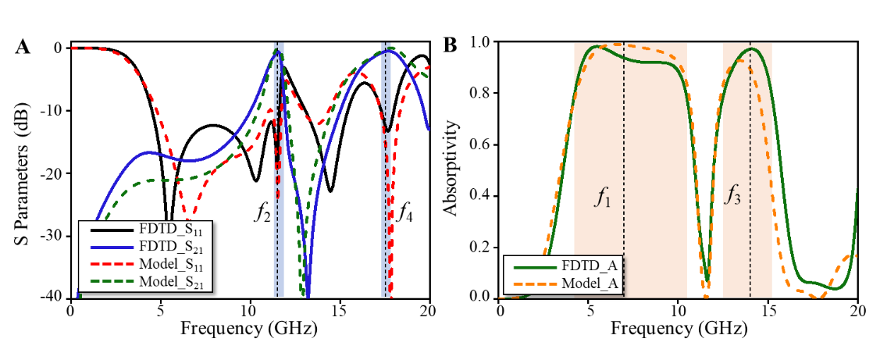

**Supplementary Figure 6.** Full-wave simulation (solid curves) and equivalent circuit model (dashed curves), spectra of the cascaded metasurface with **(A)** transmission/ reflection, and **(B)** absorptivity.

# The New Design of Cascaded Metasurface

Based on the cascaded metasurface, we have newly designed two different meta-devices, where the transmission band of Design I is located at 11.5GHz/20GHz, and the transmission band of Design II is located at 13.5GHz/18GHz, as shown in **Supplementary Figure 7**.

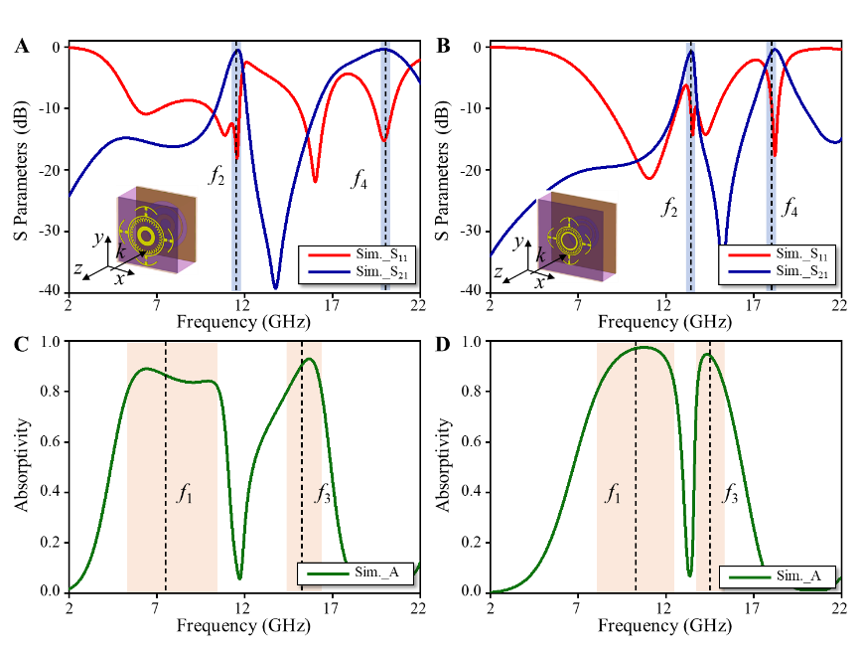

**Supplementary Figure 7.** Simulation results of the cascaded metasurface. Transmission/ reflection coefficients and absorptivity of **(A, C)** Design I, **(B, D)** Design II.