Supplementary Material

Table S1 The relative ratio of freshweight of Mesembryanthemum cordifolium L. f.
 | Aerial (%)
 | May | June
ck | 100 | 100
S1 | 128.69 | 138.95
S2 | 159.24 | 174.75
S3 | 229.96 | 238.12

Table S2 The relative ratio of water hold capacity of Mesembryanthemum cordifolium L. f.
 | Maximum moisture capacity (%) | Capillary capacity (%) | Field capacity (%)
ck | 100 | 100 | 100
S1 | 111.57 | 119.6 | 128.91
S2 | 123.96 | 149.35 | 155.21
S3 | 148.13 | 187.05 | 174.86

Table S3 The relative ratio of physico-chemical properties of soil
 | ck | S1 | S2 | S3
VW (%) | 100 | 86.20 | 80.55 | 70.97
pH (%) | 100 | 98.47 | 97.99 | 99.83
EC (%) | 100 | 75.30 | 65.43 | 57.77
AP (%) | 100 | 256.07 | 412.98 | 255.24
AN (%) | 100 | 178.63 | 193.42 | 116.78
N (%) | 100 | 166.45 | 179.72 | 393.83
P (%) | 100 | 126.19 | 124.98 | 130.07
OC (%) | 100 | 239.90 | 325.02 | 438.55
OM (%) | 100 | 239.91 | 325.02 | 438.55
K (%) | 100 | 212.5 | 111.76 | 91.83

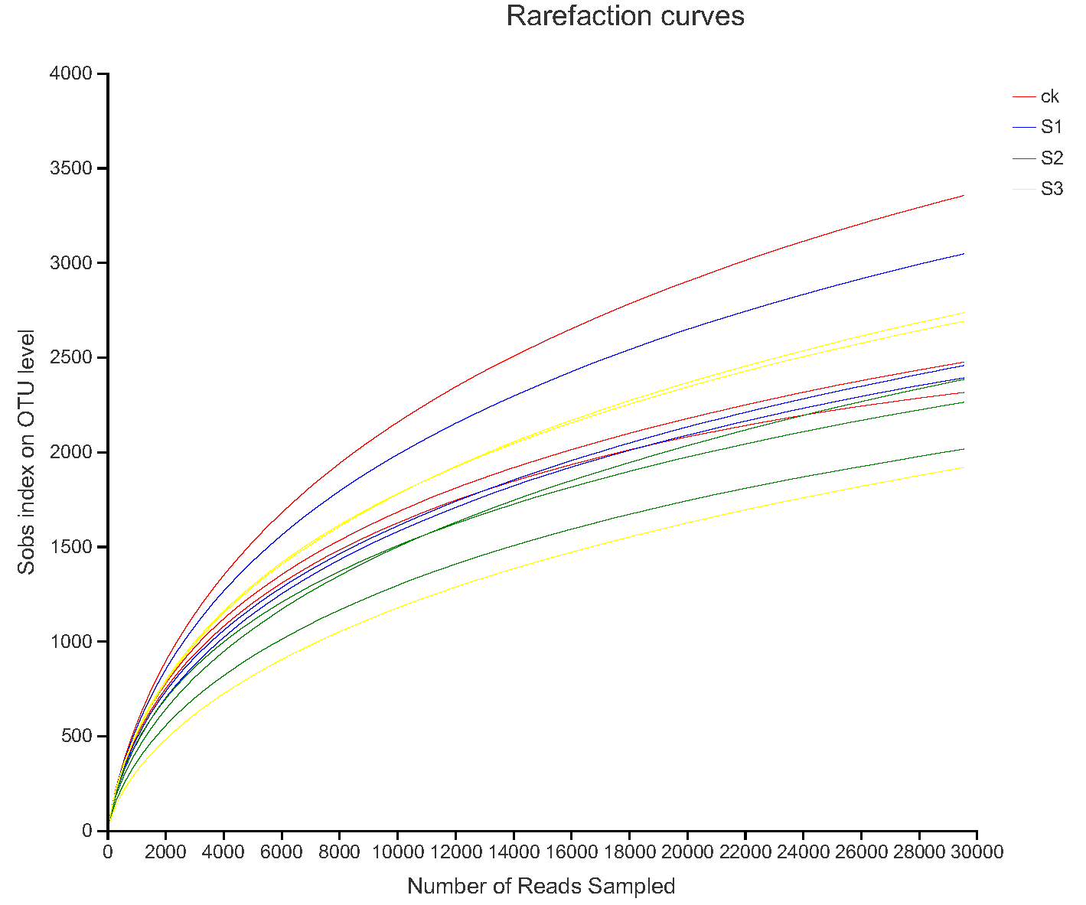
Fig S1 Rarefaction curves depicting the number of OTUs with 97% similarity identified from different samples

Table S4 Operational taxonomic unit (OTU; 97% similarity cut-off) richness and diversity indices of different samples
Sample\Estimators | sobs | shannon | simpson | ace | chao | coverage
ck | 2712 | 6.58 | 0 | 3543.21 | 3487.33 | 0.97
S1 | 2629 | 6.4 | 0.01 | 3612.04 | 3578.92 | 0.97
S2 | 2218 | 5.91 | 0.01 | 3393.14 | 3213.61 | 0.97
S3 | 2446 | 6.01 | 0.02 | 3681.49 | 3461.84 | 0.97

Fig S2 Relative abundance of several differential genera
Table S5 The relative ratio of several differential genera
Genera | ck | S1 | S2 | S3
Micromonospora | 100 | 163.82 | 1099.39 | 234.15
Bacillus | 100 | 144.70 | 275.44 | 145.68
norank_o__Gaiellales | 100 | 33.76 | 14.19 | 35.52
Rhodococcus | 100 | 1877.78 | 1714.81 | 7714.81
Ilumatobacter | 100 | 308.94 | 367.60 | 290.50

Table S6 Spearman rank correlation of top 30 abundant genera and environmental parameters
Genus | VW | pH | EC | FC | AP | AN | N | P | K | OC | OM
norank_f__Geminicoccaceae | 0.203 | -.074 | 0.224 | -0.322 | -0.287 | -0.063 | -0.336 | -0.028 | -0.420 | -0.308 | -0.371
norank_c_Subgroup_6 | 0.105 | 0.567 | 0.259 | -0.280 | -0.608* | -0.455 | -0.231 | 0.014 | -0.545 | -0.273 | -0.301
Micromonospora | -0.112 | -0.669* | -0.301 | 0.287 | 0.706* | 0.573 | 0.231 | 0.112 | 0.650* | 0.203 | 0.287
Bacillus | -0.490 | -0.687* | -0.497 | 0.559 | 0.713** | 0.804** | 0.420 | 0.469 | 0.699* | 0.434 | 0.469
norank_f_A4b | -0.301 | -0.357 | -0.287 | 0.133 | 0.301 | 0.154 | 0.301 | 0.406 | 0.210 | 0.154 | 0.217
norank_o_SBR1031 | -0.308 | 0.130 | -0.280 | 0.182 | 0.056 | -0.140 | 0.455 | 0.350 | 0.189 | 0.224 | 0.273
Actinomadura | -0.224 | -0.425 | -0.361 | 0.273 | 0.564 | 0.550 | 0.280 | 0.133 | 0.539 | 0.256 | 0.235
Arthrobacter | -0.007 | 0.504 | 0.154 | -0.210 | -0.385 | -0.469 | -0.042 | -0.154 | -0.329 | -0.042 | -0.077
Marinobacter | -0.431 | -0.611* | -0.532 | 0.361 | 0.623* | 0.403 | 0.483 | 0.476 | 0.473 | 0.427 | 0.455
norank_f_67-14 | 0.161 | 0.371 | 0.469 | -0.028 | -0.503 | -0.259 | -0.238 | -0.147 | -0.406 | -0.182 | -0.168
norank_c_Gitt-GS-136 | -0.294 | 0.189 | -0.056 | 0.168 | -0.168 | -0.042 | 0.189 | 0.469 | -0.035 | 0.056 | 0.133
unclassified_f_Myxococcaceae | -0.338 | 0.489 | -0.277 | 0.306 | 0.062 | -0.138 | 0.437 | 0.229 | 0.076 | 0.244 | 0.215
norank_o_Gaiellales | 0.503 | 0.578* | 0.490 | -0.664* | -0.846** | -0.776** | -0.622* | -0.420 | -0.909** | -0.476 | -0.580*
Blastococcus | 0.417 | 0.242 | 0.480 | -0.231 | -0.116 | -0.095 | -0.249 | -0.543 | -0.004 | -0.382 | -0.305
Pelagibius | -0.455 | -0.476 | -0.329 | 0.524 | 0.636* | 0.587* | 0.559 | 0.217 | 0.664* | 0.476 | 0.503
unclassified_c_AlphaProteobacteria | -0.531 | -0.620* | -0.629* | 0.524 | 0.748** | 0.531 | 0.531 | 0.378 | 0.650* | 0.552 | 0.545
Rhodococcus | -0.594* | -0.399 | -0.566 | 0.503 | 0.413 | 0.580* | 0.503 | 0.545 | 0.399 | 0.643* | 0.538
norank_f_D05-2 | -0.615* | -0.371 | -0.566 | 0.559 | 0.559 | 0.678* | 0.601* | 0.608* | 0.643* | 0.531 | 0.538
norank_f_Gemmatimonadaceae | 0.462 | 0.228 | 0.552 | -0.580* | -0.643* | -0.385 | -0.629* | -0.497 | -0.727** | -0.392 | -0.510
unclassified_f_Geodermatophilaceae | -0.245 | -0.151 | -0.140 | 0.476 | 0.441 | 0.455 | 0.427 | 0.182 | 0.573 | 0.196 | 0.294
*Correlation is significant at the 0.05 level (2-tailed). **Correlation is significant at the 0.01 level (2-tailed).Correlation coefficient (rho) is ranged from-1 to 1, absolute value of rho represents: 0.20-0.39 “weak;” 0.40-0.59 “moderate;” 0.60-0.79 “strong;” 0.80-1.0 “very strong.”.

