Supplementary Material

Supplementary Table 1. Composition of freshwater media used in this study and prepared by modifying BG-11 medium from Sigma Aldrich’s C3061.
Nutrient Name | Concentration,  mg/L (Exp #1, BG-11) | Concentration,  mg/L (Exp #2, 3 & 4)
Nitrogen | 45,  (as sodium nitrate) | 45  (as AN wastewater)
Magnesium sulfate.7H₂O | 75 | 75
Potassium phosphate dibasic | 40 | 40
Calcium Chloride dihydrate | 36 | 36
Sodium carbonate | 20 | 20
Citric acid | 6 | 6
Ferric ammonium citrate | 6 | 6
Boric acid | 2.86 | 2.86
Manganese chloride. 4H₂O | 1.81 | 1.81
EDTA disodium magnesium | 1 | 1
Sodium molybdate. 2H₂O | 0.39 | 0.39
Zinc sulfate. 7 H₂O | 0.222 | 0.222
Cupric sulfate. 5H₂O | 0.079 | 0.079
Cobalt nitrate. 6H₂O | 0.0494 | 0.0494
Dissolved in | Filtered water | Plant influent wastewater

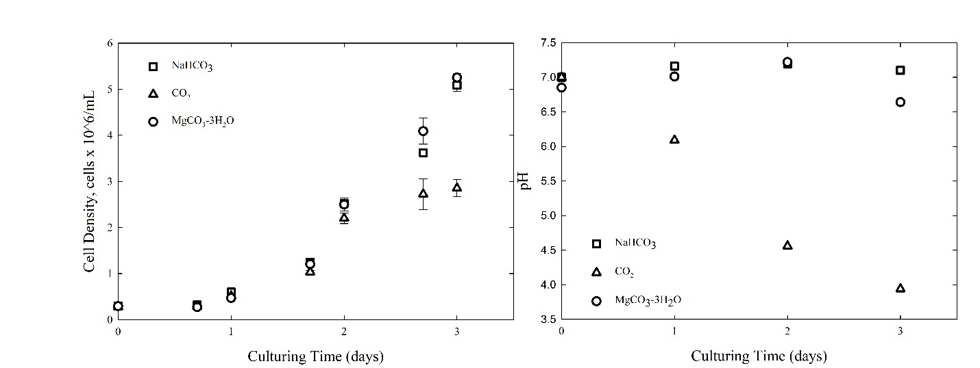
Supplementary Figure 1. Biomass growth and pH observed for freshwater microalga, S. obliquus, when growing on ammonium modified BG-11 medium using different C sources such as a) CO₂ alone ( ), b) CO₂ + NaHCO₃ ( ), c) CO₂ + MgCO₃-3H₂O (o).

