Supplementary Information

**Title:** Characterization of PM2.5-bound trace elements, source apportionment, and assessment of associated human health risks during summer and winter in Greater Noida, National Capital Region of India

**Authors:** *Vishnu Kumar1, Mudit Yadav1, and Sailesh N. Behera1,2\**

**Affiliations of Authors:** 1Air Quality Laboratory, Department of Civil Engineering, Shiv Nadar University, Delhi-NCR, Greater Noida, Uttar Pradesh, India 201314.

2Centre for Environmental Sciences and Engineering, Shiv Nadar University, Delhi-NCR, Greater Noida, Uttar Pradesh, India 201314.

____________________________________________________________________________________

**\*Corresponding Author:** Sailesh N. Behera, Ph.D.; Associate Professor, Department of Civil Engineering, Shiv Nadar University, Delhi-NCR, Greater Noida, Uttar Pradesh, India 201314; Tel: +91-120-2663801 (Ext: 745); Fax: +91-120-3001580.

Email Address: [sailesh.behera@snu.edu.in](mailto:sailesh.behera@snu.edu.in).

Revision Submitted to

**Frontiers in Environmental Science (Atmosphere and Climate Section)**

**Research Topic: Sources and Optical Properties of Aerosol Particles over Asia**

August 2022

**2.1. Description of study domain and sampling site**

The sampling site was located in an Institutional area within the University’s campus of around 300 acres. The responsible particulate emission sources near the sampling site were vehicle movement on roads, road/soil dust, domestic cooking, construction activities, diesel generator set running during the power-cut period and dust from gardening work inside the campus. The National Highway-91 (NH91) road passes close to the campus boundary. The Eastern Peripheral Expressways road is near the University's campus. Many small-scale industries and brick manufacturing kilns are located within a radius of 5 km around this campus area. A large-scale industry of power plant, known as the National Thermal Power Plant (NTPC) is situated near the campus at about 4 km. The NTPC has an operating power capacity of 1820 MW, 817 MW and 5 MW, respectively, running with coal, gas and solar sources. The sampling site is close to agricultural fields and agricultural residue burning after crop harvesting is common throughout the year in the nearby areas of the campus.

The hourly temperature in the study domain can vary from 20 to 47°C during summer and 4 to 26°C during winter. Similarly, relative humidity (RH) can range from 10 to 45% and 30 to 99%, respectively, during summer and winter. The monsoon precipitation commences around mid-June and lasts until the end of September. The average annual rainfall in this study domain is about 800 mm. Due to the rise in air pollution activities locally and long-range transport (LRT) air masses from higher emission areas in the city and biomass burning sites, this particular study domain faces many episodic air pollution events with recurrence of more hazy days during summer and winter.

**2.2. Particulate sample collection and measurement**

Considering the rise in pollution and drop in temperature like winter, we have considered November as winter to represent episodic events that start from November until the following January. The sampling time was considered from morning 08:00 AM of a particular day to 08:00 AM of the next morning to capture PM sample representing 24 h complete duration of a day. The sampling was conducted to cover three days per week, consisting of at least two weekdays (working days) and one weekend day. The total number of collected PM2.5 filter samples was 79 with 39 during summer and 40 during winter. Three-time readings were taken to maintain reliability and consistency in weighing measurement and the average of three observations was considered as the final weight of a particular sample specimen. After taking the final weight, individual post-sampled filters were kept in closed Petri dishes and a bundle of 5 individual samples in closed Petri dishes was wrapped with aluminum foil. These bundles of samples were kept in the refrigerator for further chemical analysis. The filter samples were handled using a Teflon-coated tweezer to avoid chances of any contamination in the laboratory and sampling site. We used Micro-Orifice Uniform Deposit Impactor (MOUDI) (110R, MSP Corp, USA) to collect filter samples of PM at 10 different sizes having aerodynamic diameter ranging from 0.056 to 18 µm, specifically 0.056-0.1, 0.1-0.18, 0.18-0.32, 0.32–0.56, 0.56–1.0, 1.0–1.8, 1.8–3.2, 3.2–5.6, 5.6-10, and 10-18 μm. The gravimetric mass of the particulate sample was calculated by subtracting the initial weight of an unexposed filter from its respective final weight after being exposed to sampling.

**2.3. Analysis of trace elements**

The instrumentation of XRF spectroscopy is a powerful technique for quantifying the intensity of a produced X-ray in terms of energy or wavelength. The ED-XRF can provide qualitative assessment and quantitative data for the atoms of elements present in a solid sample of PM. The ED-XRF spectrometer was capable of scanning and quantifying elements in the solid-state in a wide range that can cover elements listed in the periodic table. The XRF standard BRPC3 was used in pre-calibration to conduct a semi-quantitative analysis that provides advantages to users in comparing spectral data from PM samples that resulted in assessing the relative concentration of elements between PM samples (*Xu et al, 2016; Banger et al., 2021*). The instrumental setup was configured to conduct QA-QC procedures during elemental analysis using standard reference material (NIST SRM 2783) (*Hazarika et al., 2015*). The uncertainty in quantifying elemental concentration on ED-XRF was determined in the range of 5 to 10%, which seemed to be within the permissible limit. The standards were run regularly to monitor and manage the instrument's operation by checking the uncertainty of the analytical procedures. In addition to this quality assurance check on uncertainty, we used an exact amount of 10 mg SRM 1648a for obtaining the recovery of related elements. The analytical recovery of target elements was estimated by comparing the results of elements from ED-XRF analysis with certified values of SRM 1648a, using Eq(1):



The recovery of individual elements was found in the range of 89–108%, which was within the acceptable range recommended by the Association of Analytical Communities. The reproducibility of SRM materials with the same analytical procedure tests had acceptable results within ±10% for all elements analyzed in ED-XRF analysis in this study. The concentration of each trace element was determined in ng/m3 from the results of ED-XRF considering the volume of sampled air and weight of PM2.5 mass obtained on a specific filter sample. The method detection limit (MDL) of an individual element was estimated as three times the standard deviation of the results obtained from the analysis of seven replicates of the blank filter. Table S1 presents values of MDL of all individual elements measured in this study. During analytical work in the quantification of elements, it was observed that the concentrations of elements in PM2.5 samples were higher than their respective MDL values in this study. The levels of elements in blank filters were evaluated and the concentration of each element was adjusted by subtracting the corresponding elemental levels in blank filters.

**2.4. Backward trajectory analysis of air masses**

As levels of PM2.5 concentration measured at the sampling site of this study domain depends on both local source activities and long-range transport of polluted air masses from higher pollution areas to the sampling site, we conducted a backward trajectory analysis of air masses reaching this particular site. The backward trajectory analysis represents the path of air mass traveled, a function of time in a three-dimensional configuration consisting of latitude, longitude and altitude. To provide a complete picture of wind profiles in boundary layer heights and to reduce effects from existing local land cover and topographic undulations, 3 path heights (500, 1000 and 1500 m) were considered during the simulation process (*Behera et al., 2015b; Sharma and Mandal, 2017; Shivani et al., 2019*). To get the flow of air masses within the atmospheric boundary layer and just above the boundary layer throughout a day, we considered three altitudes (500, 1000 and 1500 m) for running the HYSPLIT model for creating profiles of backward trajectories of air masses to the sampling site (*Tiwari et al., 2012; Amnuaylojaroen et al., 2020*). *Nakoudi et al. (2019)* examined diurnal variations of boundary layer height at Delhi and reported that this value reached its maximum (1028 ± 292 m) at 11:00 UTC and the transition of trends started from 14:00 (UTC). In another study conducted by *Zhang et al. (2014)* on diurnal variations of the boundary layer height at Yichang, China reported that the evening transition in values of boundary layer height occurred at 1900 LT (local time) during summer and winter. From these studies, it can be seen that the transition in trends of atmospheric boundary layer height occurs during the evening 7:00-8.00 PM local time. Therefore, some previous studies conducted in the past had considered 14:00 (UTC) as the beginning time and end time during the generation of backward trajectory profiles through the HYSPLIT model (*Tiwari et al., 2012; Liu et al., 2018; Behera et al., 2015b*).

The fire count data was retrieved from the MODIS (Moderate Resolution Imaging Spectroradiometer) database, superimposed with a true color image to provide the location of geographical regions that played a crucial role in increasing particulate concentrations at the sampling site of this study domain (URL: https://earthdata.nasa.gov/active-fire-data).

**2.5. Source identification of trace elements**

This is also a fact that under the ideal scenario, EF is 1 for PM2.5-bound elements, which are emitted from a purely natural (crustal) source of origin. However, under ambient conditions, crustal composition keeps varying and produces uncertainties in fractionations due to weathering, aerosol suspension, transport, and attrition processes taking place in the atmosphere. Hence, the chances for deviation of EF from the ideal value 1 of any natural (crustal) element are higher, as a result, this value falls in the range from 1 to 10 for ambient particulate samples. When the value of EF varies in the range of 1 to 10, it indicates that the related elements are non-enriched with a substantial proportion originating from natural (crustal) sources of origin. When the result of EF of any element is greater than 10, it indicates that the specific element is enriched with non-crustal (anthropogenic) sources of origin.

**2.6. Source apportionment of PM2.5 concentrations**

The PCA approach is a statistical tool, which is used for reducing the variance of an extensive dataset containing inter-correlated variables by transforming it into a small number dataset of independent variables, referred to as principal components (PCs) (*Henry and Hidy 1979; Thurston and Spengler 1985; Mondal and Singh, 2021*). To get better results in modeling exercises through the PCA-APCS model, the number of samples must be greater than the number of selected species (elements) (*Guo et al., 2004;* *Wu et al., 2019*). In this study, all individual samples were used for summer and winter for twenty-four elements and the apportionment exercise followed the guidelines for running the PCA-APCS model.

During the selection of the results of factors, the outcomes with an Eigenvalue greater than 1 at 95% significance were considered for further interpretation through Kaiser’s criteria. The value of Kaiser-Meyer-Olkin (KMO) greater than 0.6 is normally acceptable with respect to the suitability of data subjected to factor analysis (*Li et al., 2004; Jain et al., 2021*). From the results of the PCA-APCS model for all chemical species, we considered data with factor loading greater than 0.5 for further interpretation on source contribution analysis.

**2.7. Deposition of PM2.5 and elements in the human respiratory system**

This computational health risk model (MPPD) has the capability to predict deposition efficiencies of particulate species in different regions of the human respiratory tract using several mechanisms such as diffusion, sedimentation, and impaction. The model predicts the deposition fraction of particulate species during one breathing cycle that includes inspiration, pause and expiration. Particulate species ranging from 0.001 µm (1 nm) to a coarser size of 100 µm can be selected for the simulation process in performing health impact analysis (*Lyu et al., 2018; Zwozdziak et al., 2017*). The details of model description, the principle of software development and procedures of various methodologies in running simulations of different perspectives of health assessment can be found elsewhere (*Asgharian and Anjilvel, 1998; Asgharian and Price, 2007*). To get more formation of the human airway in the respiratory tract, multiple diameters in the range of 10 nm to 10 µm were considered (*Lyu et al. 2018*). From the results of elemental compositions in PM2.5, it was observed that crustal matter had more mass contribution to PM2.5 mass concentration during summer than episodic winter period (*Khlystov et al., 2004*). In other words, the density of PM2.5 during summer would be higher than in winter. With the support from previous studies, the mass density of PM2.5 particles was assumed as 1.78 and 1.66 g/cm3 during summer and winter, respectively (*Li et al., 2016; Long et al., 2021*). The health impact assessment was performed with assumptions to consider standard input parameters, as adjusted in a model configuration having Yeh-Schum Single path, as follows: human adult as an object having the tidal volume of 625 ml, functional reserve capacity as 3300 ml, upper respiratory tract as 50 ml, nasal breathing frequency as 12 breaths/min and inspiratory fraction as 0.5. The health impact assessment was performed with assumptions to consider standard input parameters.

**2.8. Cancer and non-cancer human health risk assessments**

The risk assessment due to exposure to toxic elements in PM2.5 was conducted to predict cancer and non-cancer risks of humans during summer and winter episodic periods. We used recommended approach of USEPA, which has been widely practiced by several research groups in the assessment of associated human health risks for an adult through exposure to toxic particulate constituents (*Zhang et al., 2018; Wu et al., 2019; Yadav et al, 2020; Long et al., 2021*). In brief, this particular methodology involved several procedural steps such as hazard identification, exposure assessment, dose-response assessment, and risk characterization (<http://www.epa.gov/iris>). Based on guidelines of the International Agency for Research on Cancer (IARC) and USEPA Integrated Risk Information System (IRIS), we considered elements such as Cd, Co, Cr, Ni and Pb for the assessment of cancer risks and Al, Cd, Cr, Mn and Pb for the assessment of non-cancer risks. For cancer risk assessment, excessive lifetime cancer risk (ELCR) and for non-cancer risk assessment, hazard quotient (HQ) were estimated for individual elements and then summed up to find the cumulative risks during summer and winter episodic periods.

The assumptions were made to distinguish between two scenarios of air pollution in the study domain and to find concentration of PM2.5 constituents throughout the year. As the present study was conducted for two seasons (summer and winter), we considered such a literature-supported approach in arriving at the average concentrations of PM2.5 constituents throughout the year (*Betha et al., 2014; Behera et al., 2015c)*. The elements used in risk assessment analysis were Al, Cd, Co, Cr, Mn, Ni and Pb. The overall assumptions of risk assessment analysis were: (i) concentration ratio (monsoon/summer) of these individual elements was 0.5, and (ii) concentration ratio (post-monsoon/monsoon) of these individual elements was 2.0. From the literature review with Indian studies, it was difficult to get all these elements in one place. However, on an average basis, it could be assessed that the assumptions in this study were matching with the results of the previous studies on the values of seasonal concentration ratios of PM mass and its constituents (*Karar and Gupta, 2006; Shukla and Sharma, 2008; Gawhane et al., 2017; Jain et al., 2021; Bangar et al., 2021; Kaushik et al., 2021).* On qualitative assessment in finding errors in the assumptions in this study, we found a negligible error or deviation of the results from the previous studies. Quantitatively, it was observed that some elements (Cr, Mn and Pb) in this study provided 0% error or deviation with respect to the results of studies reported by *Shukla and Sharma (2008) and Jain et al. (2021).* For other elements, the percentage of error was estimated within ±28%. With such sensitivity analysis and the support of the method reported in the literature, the assumptions made in finding the average concentrations during two distinct scenarios to predict the associated human health risks (cancer and non-cancer) were quite rational.

# References

Amnuaylojaroen, T., Inkom, J., Janta, R., and Surapipith, V. (2020). Long range transport of southeast asian PM2.5 pollution to northern Thailand during high biomass burning episodes. *Sustainability*, 12(23), 10049. https://doi.org/10.3390/su122310049

Asgharian, B., and Anjilvel, S. (1998). A multiple-path model of fiber deposition in the rat lung. *Toxicol. Sci.* 44(1), 80-86. https://doi.org/10.1093/toxsci/44.1.80

Asgharian, B., and Price, O.T. (2007). Deposition of ultrafine (nano) particles in the human lung. *Inhal. Toxicol.* 19(13), 1045-1054. https://doi.org/10.1080/08958370701626501

Bangar, V., Mishra, A.K., Jangid, M., and Rajput, P. (2021). Elemental Characteristics and Source-Apportionment of PM2.5 during the Post-Monsoon Season in Delhi, India. *Front. Sustainable Cities*, 18. https://doi.org/10.3389/frsc.2021.648551

Behera, S.N., Betha, R., Huang, X., and Balasubramanian, R. (2015b). Characterization and estimation of human airway deposition of size-resolved particulate-bound trace elements during a recent haze episode in Southeast Asia. *Environ. Sci. Pollut. Res.* 22(6), 4265-4280. https://doi.org/10.1007/s11356-014-3645-6

Behera, S.N., Cheng, J., Huang, X., Zhu, Q., Liu, P., and Balasubramanian, R. (2015c). Chemical composition and acidity of size-fractionated inorganic aerosols of 2013-14 winter haze in Shanghai and associated health risk of toxic elements. *Atmos. Environ.* 122, 259-271. https://doi.org/10.1016/j.atmosenv.2015.09.053

Betha, R., Behera, S.N., and Balasubramanian, R., (2014). 2013 Southeast Asian smoke haze: fractionation of particulate-bound elements and associated health risk. *Environ. Sci. Technol.* 48(8), 4327-4335. https://doi.org/10.1021/es405533d

Gawhane, R. D., Rao, P. S. P., Budhavant, K. B., Waghmare, V., Meshram, D. C., and Safai, P. D. (2017). Seasonal variation of chemical composition and source apportionment of PM2.5 in Pune, India. *Environ. Sci. Pollut. Res.* *24*(26), 21065-21072. https://doi.org/10.1007/s11356-017-9761-3

Guo, H., Wang, T., Simpson, I.J., Blake, D.R., Yu, X.M., Kwok, Y.H., and Li, Y.S. (2004). Source contributions to ambient VOCs and CO at a rural site in eastern China. *Atmos. Environ.* 38(27), 4551-4560. https://doi.org/10.1016/j.atmosenv.2004.05.004

Hazarika, N., Jain, V.K., and Srivastava, A. (2015). Source identification and metallic profiles of size-segregated particulate matters at various sites in Delhi. *Environ. Monit. Assess.* 187(9), 1-22. https://doi.org/10.1007/s10661-015-4809-7

Henry, R.C. and Hidy, G.M. (1979). Multivariate analysis of particulate sulfate and other air quality variables by principal components-Part I: Annual data from Los Angeles and New York. *Atmos. Environ.* 13(11), 1581-1596. https://doi.org/10.1016/0004-6981(79)90068-4

Jain, S., Sharma, S.K., Vijayan, N., and Mandal, T.K. (2021). Investigating the seasonal variability in source contribution to PM2.5 and PM10 using different receptor models during 2013–2016 in Delhi, India. *Environ. Sci. Pollut. Res.* 28(4), 4660-4675. https://doi.org/10.1007/s11356-020-10645-y

Karar, K., and Gupta, A. K. (2006). Seasonal variations and chemical characterization of ambient PM10 at residential and industrial sites of an urban region of Kolkata (Calcutta), India. *Atmos. Res.* 81(1), 36-53. https://doi.org/10.1016/j.atmosres.2005.11.003

Kaushik, A., Kumar, A., Aswini, M.A., Panda, P.P., Shukla, G., and Gupta, N.C. (2021). Seasonal variation in chemical composition of size-segregated aerosols over the Northeastern Arabian Sea. *Front. Environ. Sci.* 8, 296. https://doi.org/10.3389/fenvs.2020.619174

Khlystov, A., Stanier, C., and Pandis, S.N. (2004). An algorithm for combining electrical mobility and aerodynamic size distributions data when measuring ambient aerosol special issue of aerosol science and technology on findings from the fine particulate matter supersites program. *Aerosol Sci. Technol.* 38(S1), 229-238. https://doi.org/10.1080/02786820390229543

Li, Z., Hopke, P.K., Husain, L., Qureshi, S., Dutkiewicz, V.A., Schwab, J.J., Drewnick F., and Demerjian, K.L. (2004). Sources of fine particle composition in New York city. *Atmos. Environ.* 38(38), 6521-6529. https://doi.org/10.1016/j.atmosenv.2004.08.040

Li, X., Yan, C., Patterson, R.F., Zhu, Y., Yao, X., Zhu, Y., Ma, S., Qiu, X., Zhu, T., and Zheng, M., (2016). Modeled deposition of fine particles in human airway in Beijing, China. *Atmos. Environ.* 124, 387-395. https://doi.org/10.1016/j.atmosenv.2015.06.045

Liu, T., Marlier, M. E., DeFries, R. S., Westervelt, D. M., Xia, K. R., Fiore, A. M., et al. (2018). Seasonal impact of regional outdoor biomass burning on air pollution in three Indian cities: Delhi, Bengaluru, and Pune. *Atmos. Environ.* 172, 83-92. https://doi.org/10.1016/j.atmosenv.2017.10.024

Long, L., He, J., and Yang, X. (2021). Characteristics, emission sources and health risk assessment of trace elements in size-segregated aerosols during haze and non-haze periods at Ningbo, China. *Environ. Geochem. Health*. 43(8), 2945-2963. https://doi.org/10.1007/s10653-020-00757-2

Lyu, Y., Guo, H., Cheng, T., and Li, X. (2018). Particle size distributions of oxidative potential of lung-deposited particles: Assessing contributions from quinones and water-soluble metals. *Environ. Sci. Technol.* 52(11), 6592-6600. https://doi.org/10.1021/acs.est.7b06686

Mondal, S., and Singh, G. (2021). PM2.5-bound trace elements in a critically polluted industrial coal belt of India: seasonal patterns, source identification, and human health risk assessment. *Environ. Sci. Pollut. Res.* 28(25), 32634-32647. https://doi.org/10.1007/s11356-021-12876-z

Nakoudi, K., Giannakaki, E., Dandou, A., Tombrou, M., and Komppula, M. (2019). Planetary boundary layer height by means of lidar and numerical simulations over New Delhi, India. *Atmos. Meas. Tech.*, 12(5), 2595-2610. https://doi.org/10.5194/amt-12-2595-2019

Sharma, S.K., and Mandal, T.K. (2017). Chemical composition of fine mode particulate matter (PM2.5) in an urban area of Delhi, India and its source apportionment. *Urban Clim.* 21, 106-122. https://doi.org/10.1016/j.uclim.2017.05.009

Shivani., Gadi, R., Saxena, M., Sharma, S.K., and Mandal, T.K. (2019). Short-term degradation of air quality during major firework events in Delhi, India. *Meteorol. Atmos. Phys.* 131(4), 753-764. https://doi.org/10.1007/s00703-018-0602-9

Shukla, S. P., and Sharma, M. (2008). Source apportionment of atmospheric PM10 in Kanpur, India. *Environ. Eng. Sci.*, *25*(6), 849-862. https://doi.org/10.1089/ees.2006.0275

Thurston, G.D., and Spengler, J.D. (1985). A quantitative assessment of source contributions to inhalable particulate matter pollution in metropolitan Boston. *Atmos. Environ.* 19(1), 9-25. https://doi.org/10.1016/0004-6981(85)90132-5

Tiwari, S., Chate, D. M., Pragya, P., Ali, K., and Bisht, D. S. (2012). Variations in mass of the PM10, PM2.5 and PM1 during the monsoon and the winter at New Delhi. *Aerosol Air Qual. Res.*12(1), 20-29. https://doi.org/10.4209/aaqr.2011.06.0075

Wu, Y., Lu, B., Zhu, X., Wang, A., Yang, M., Gu, S., Wang, X., Leng, P., Zierold, K.M., Li, X., Tang, K.K., Fang, L., Huang, R., Xu, G., and Chen, L. (2019). Seasonal variations, source apportionment, and health risk assessment of heavy metals in PM2.5 in Ningbo, China. *Aerosol Air Qual. Res.* 19(9), 2083-2092. https://doi.org/10.4209/aaqr.2018.12.0452

Xu, H., Cao, J., Chow, J.C., Huang, R.J., Shen, Z., Chen, L.A., Ho, K.F., and Watson, J.G. (2016). Inter-annual variability of wintertime PM2.5 chemical composition in Xi'an, China: evidences of changing source emissions. *Sci. Total Environ.* 545, 546-555. https://doi.org/10.1016/j.scitotenv.2015.12.070

Yadav, A., Behera, S.N., Nagar, P.K., and Sharma, M. (2020). Spatio-seasonal concentrations, source apportionment and assessment of associated human health risks of PM2.5-bound polycyclic aromatic hydrocarbons in Delhi, India. *Aerosol Air Qual. Res.* 20(12), 2805-2825. https://doi.org/10.4209/aaqr.2020.04.0182

Zhang, J., Wu, L., Fang, X., Li, F., Yang, Z., Wang, T., et al. (2018). Elemental composition and health risk assessment of PM10 and PM2.5 in the roadside microenvironment in Tianjin, China. *Aerosol Air Qual. Res.* 18(7), 1817-1827. https://doi.org/10.4209/aaqr.2017.10.0383

Zhang, Y., Zhang, S., Huang, C., Huang, K., Gong, Y., and Gan, Q. (2014). Diurnal variations of the planetary boundary layer height estimated from intensive radiosonde observations over Yichang, China. Science China Technological Sciences, 57(11), 2172-2176. https://doi.org/10.1007/s11431-014-5639-5

Zwozdziak, A., Gini, M. I., Samek, L., Rogula-Kozlowska, W., Sowka, I., and Eleftheriadis, K. (2017). Implications of the aerosol size distribution modal structure of trace and major elements on human exposure, inhaled dose and relevance to the PM2.5 and PM10 metrics in a European pollution hotspot urban area. *J. Aerosol Sci.* 103, 38-52. https://doi.org/10.1016/j.jaerosci.2016.10.004

**Table S1.** Method detection limits (MDLs) of PM2.5-bound elements

|  |  |  |  |
| --- | --- | --- | --- |
| Elements | MDL (ppm) | MDL (µg/m3) | MDL (ng/m3) |
| Al | 2.426 | 0.101 | 100.9 |
| Ba | 1.059 | 0.044 | 44.0 |
| Bi | 0.021 | 0.001 | 0.9 |
| Ca | 1.858 | 0.077 | 77.3 |
| Cd | 0.019 | 0.001 | 0.8 |
| Co | 0.044 | 0.002 | 1.8 |
| Cr | 0.086 | 0.004 | 3.6 |
| Cu | 0.118 | 0.005 | 4.9 |
| Fe | 1.783 | 0.074 | 74.1 |
| Ga | 0.027 | 0.001 | 1.1 |
| K | 3.548 | 0.148 | 147.5 |
| Li | 0.092 | 0.004 | 3.8 |
| Mg | 1.764 | 0.073 | 73.3 |
| Mn | 0.157 | 0.007 | 6.5 |
| Na | 2.329 | 0.097 | 96.8 |
| Ni | 0.076 | 0.003 | 3.2 |
| Pb | 0.163 | 0.007 | 6.8 |
| S | 2.441 | 0.101 | 101.5 |
| Se | 0.096 | 0.004 | 4.0 |
| Si | 3.548 | 0.148 | 147.5 |
| Te | 0.026 | 0.001 | 1.1 |
| Tl | 0.031 | 0.001 | 1.3 |
| Zn | 1.048 | 0.044 | 43.6 |
| Zr | 0.034 | 0.001 | 1.4 |

MDL in the unit of µg/m3 was calculated after considering

the volume of air sampled during measurement.

**Table S2. Pearson correlation coefficient matrix between elements of PM2.5 during summer**

|  |  |  |  |  |  |  |  |  |  |  |  |  |  |  |  |  |  |  |  |  |  |  |  |  |
| --- | --- | --- | --- | --- | --- | --- | --- | --- | --- | --- | --- | --- | --- | --- | --- | --- | --- | --- | --- | --- | --- | --- | --- | --- |
|  | **Al** | **Ba** | **Bi** | **Ca** | **Cd** | **Co** | **Cr** | **Cu** | **Fe** | **Ga** | **K** | **Li** | **Mg** | **Mn** | **Na** | **Ni** | **Pb** | **S** | **Se** | **Si** | **Te** | **Tl** | **Zn** | **Zr** |
| **Al** | 1.00 |  |  |  |  |  |  |  |  |  |  |  |  |  |  |  |  |  |  |  |  |  |  |  |
| **Ba** | **0.84** | 1.00 |  |  |  |  |  |  |  |  |  |  |  |  |  |  |  |  |  |  |  |  |  |  |
| **Bi** | 0.26 | 0.18 | 1.00 |  |  |  |  |  |  |  |  |  |  |  |  |  |  |  |  |  |  |  |  |  |
| **Ca** | **0.78** | **0.74** | 0.16 | 1.00 |  |  |  |  |  |  |  |  |  |  |  |  |  |  |  |  |  |  |  |  |
| **Cd** | 0.16 | 0.17 | 0.28 | 0.21 | 1.00 |  |  |  |  |  |  |  |  |  |  |  |  |  |  |  |  |  |  |  |
| **Co** | 0.14 | 0.19 | **0.68** | 0.23 | 0.29 | 1.00 |  |  |  |  |  |  |  |  |  |  |  |  |  |  |  |  |  |  |
| **Cr** | 0.16 | 0.14 | **0.74** | 0.18 | 0.23 | **0.68** | 1.00 |  |  |  |  |  |  |  |  |  |  |  |  |  |  |  |  |  |
| **Cu** | 0.19 | 0.29 | 0.34 | 0.14 | 0.16 | 0.29 | 0.28 | 1.00 |  |  |  |  |  |  |  |  |  |  |  |  |  |  |  |  |
| **Fe** | **0.79** | **0.89** | 0.24 | **0.81** | 0.24 | 0.16 | 0.24 | 0.27 | 1.00 |  |  |  |  |  |  |  |  |  |  |  |  |  |  |  |
| **Ga** | 0.29 | 0.27 | 0.32 | 0.26 | 0.26 | 0.28 | 0.26 | **0.69** | 0.18 | 1.00 |  |  |  |  |  |  |  |  |  |  |  |  |  |  |
| **K** | **0.64** | **0.67** | 0.24 | **0.83** | 0.18 | 0.21 | 0.19 | 0.18 | **0.76** | 0.26 | 1.00 |  |  |  |  |  |  |  |  |  |  |  |  |  |
| **Li** | 0.21 | 0.28 | **0.59** | 0.26 | 0.21 | **0.66** | **0.58** | 0.28 | 0.16 | 0.16 | 0.21 | 1.00 |  |  |  |  |  |  |  |  |  |  |  |  |
| **Mg** | **0.76** | **0.68** | 0.18 | **0.86** | 0.15 | 0.28 | 0.24 | 0.16 | **0.74** | 0.18 | **0.64** | 0.18 | 1.00 |  |  |  |  |  |  |  |  |  |  |  |
| **Mn** | 0.23 | 0.24 | 0.28 | 0.29 | **0.56** | 0.26 | 0.28 | **0.68** | 0.25 | **0.69** | 0.22 | 0.24 | 0.26 | 1.00 |  |  |  |  |  |  |  |  |  |  |
| **Na** | **0.79** | **0.86** | 0.16 | **0.84** | 0.28 | 0.24 | 0.16 | 0.21 | **0.76** | 0.18 | **0.76** | 0.16 | **0.74** | 0.23 | 1.00 |  |  |  |  |  |  |  |  |  |
| **Ni** | 0.14 | 0.18 | 0.27 | 0.26 | **0.78** | 0.26 | 0.28 | 0.14 | 0.18 | 0.28 | 0.14 | 0.23 | 0.18 | **0.57** | 0.16 | 1.00 |  |  |  |  |  |  |  |  |
| **Pb** | 0.24 | 0.21 | 0.29 | 0.23 | **0.59** | 0.28 | 0.28 | **0.72** | 0.27 | **0.74** | 0.24 | 0.27 | 0.23 | **0.68** | 0.21 | **0.58** | 1.00 |  |  |  |  |  |  |  |
| **S** | 0.19 | 0.24 | 0.26 | 0.21 | 0.29 | 0.24 | 0.29 | **0.76** | 0.17 | **0.79** | **0.58** | 0.19 | 0.18 | **0.72** | 0.18 | 0.26 | **0.74** | 1.00 |  |  |  |  |  |  |
| **Se** | 0.16 | 0.18 | 0.24 | 0.18 | 0.24 | 0.29 | 0.24 | **0.82** | 0.22 | **0.82** | 0.18 | 0.14 | 0.21 | **0.69** | 0.24 | 0.18 | **0.71** | **0.68** | 1.00 |  |  |  |  |  |
| **Si** | **0.81** | **0.73** | 0.19 | **0.74** | 0.28 | 0.18 | 0.19 | 0.18 | **0.76** | 0.19 | **0.72** | 0.25 | **0.76** | 0.26 | **0.75** | 0.16 | 0.24 | 0.21 | 0.18 | 1.00 |  |  |  |  |
| **Te** | 0.24 | 0.28 | **0.68** | 0.14 | 0.24 | **0.72** | **0.68** | 0.28 | 0.19 | 0.26 | 0.16 | **0.58** | 0.25 | 0.28 | 0.22 | 0.21 | 0.28 | 0.28 | 0.29 | 0.16 | 1.00 |  |  |  |
| **Tl** | 0.16 | 0.17 | 0.27 | 0.26 | 0.16 | 0.26 | 0.25 | **0.78** | 0.14 | **0.81** | 0.17 | 0.28 | 0.23 | **0.74** | 0.26 | 0.19 | **0.68** | **0.72** | **0.71** | 0.18 | 0.26 | 1.00 |  |  |
| **Zn** | 0.23 | 0.27 | 0.23 | 0.22 | **0.76** | 0.28 | 0.17 | 0.21 | 0.16 | 0.28 | 0.14 | 0.21 | 0.22 | **0.54** | 0.19 | **0.74** | **0.56** | 0.24 | 0.25 | 0.24 | 0.16 | 0.28 | 1.00 |  |
| **Zr** | 0.21 | 0.29 | **0.74** | 0.28 | 0.28 | **0.58** | **0.64** | 0.26 | 0.21 | 0.24 | 0.21 | **0.62** | 0.16 | 0.29 | 0.25 | 0.23 | 0.29 | 0.26 | 0.28 | 0.21 | **0.72** | 0.24 | 0.17 | 1.00 |

The values in bold are statistically significant at *P < 0.05.*

**Table S3. Pearson correlation coefficient matrix between elements of PM2.5 during winter**

|  |  |  |  |  |  |  |  |  |  |  |  |  |  |  |  |  |  |  |  |  |  |  |  |  |
| --- | --- | --- | --- | --- | --- | --- | --- | --- | --- | --- | --- | --- | --- | --- | --- | --- | --- | --- | --- | --- | --- | --- | --- | --- |
|  | **Al** | **Ba** | **Bi** | **Ca** | **Cd** | **Co** | **Cr** | **Cu** | **Fe** | **Ga** | **K** | **Li** | **Mg** | **Mn** | **Na** | **Ni** | **Pb** | **S** | **Se** | **Si** | **Te** | **Tl** | **Zn** | **Zr** |
| **Al** | 1.00 |  |  |  |  |  |  |  |  |  |  |  |  |  |  |  |  |  |  |  |  |  |  |  |
| **Ba** | **0.78** | 1.00 |  |  |  |  |  |  |  |  |  |  |  |  |  |  |  |  |  |  |  |  |  |  |
| **Bi** | 0.22 | 0.21 | 1.00 |  |  |  |  |  |  |  |  |  |  |  |  |  |  |  |  |  |  |  |  |  |
| **Ca** | **0.76** | **0.71** | 0.18 | 1.00 |  |  |  |  |  |  |  |  |  |  |  |  |  |  |  |  |  |  |  |  |
| **Cd** | 0.17 | 0.23 | 0.26 | 0.18 | 1.00 |  |  |  |  |  |  |  |  |  |  |  |  |  |  |  |  |  |  |  |
| **Co** | 0.16 | 0.18 | **0.74** | 0.17 | 0.27 | 1.00 |  |  |  |  |  |  |  |  |  |  |  |  |  |  |  |  |  |  |
| **Cr** | 0.18 | 0.16 | **0.78** | 0.19 | 0.26 | **0.74** | 1.00 |  |  |  |  |  |  |  |  |  |  |  |  |  |  |  |  |  |
| **Cu** | 0.21 | 0.27 | 0.28 | 0.16 | 0.24 | 0.26 | 0.25 | 1.00 |  |  |  |  |  |  |  |  |  |  |  |  |  |  |  |  |
| **Fe** | **0.76** | **0.84** | 0.18 | **0.78** | 0.16 | 0.14 | 0.18 | 0.17 | 1.00 |  |  |  |  |  |  |  |  |  |  |  |  |  |  |  |
| **Ga** | 0.25 | 0.24 | 0.28 | 0.28 | 0.22 | 0.24 | 0.29 | **0.74** | 0.16 | 1.00 |  |  |  |  |  |  |  |  |  |  |  |  |  |  |
| **K** | **0.58** | **0.59** | 0.18 | **0.67** | 0.21 | 0.26 | 0.21 | 0.23 | **0.58** | 0.24 | 1.00 |  |  |  |  |  |  |  |  |  |  |  |  |  |
| **Li** | 0.24 | 0.26 | **0.64** | 0.22 | 0.23 | **0.71** | **0.64** | 0.26 | 0.15 | 0.24 | 0.24 | 1.00 |  |  |  |  |  |  |  |  |  |  |  |  |
| **Mg** | **0.74** | **0.64** | 0.16 | **0.81** | 0.15 | 0.22 | 0.19 | 0.14 | **0.72** | 0.16 | **0.58** | 0.16 | 1.00 |  |  |  |  |  |  |  |  |  |  |  |
| **Mn** | 0.25 | 0.27 | 0.24 | 0.23 | **0.59** | 0.28 | 0.26 | **0.78** | 0.18 | **0.74** | 0.26 | 0.26 | 0.22 | 1.00 |  |  |  |  |  |  |  |  |  |  |
| **Na** | **0.76** | **0.82** | 0.14 | **0.78** | 0.21 | 0.16 | 0.17 | 0.18 | **0.72** | 0.16 | **0.65** | 0.14 | **0.71** | 0.19 | 1.00 |  |  |  |  |  |  |  |  |  |
| **Ni** | 0.15 | 0.21 | 0.28 | 0.18 | **0.84** | 0.29 | 0.27 | 0.21 | 0.16 | 0.29 | 0.18 | 0.28 | 0.16 | **0.64** | 0.14 | 1.00 |  |  |  |  |  |  |  |  |
| **Pb** | 0.22 | 0.18 | 0.25 | 0.17 | **0.66** | 0.23 | 0.24 | **0.82** | 0.21 | **0.82** | 0.27 | 0.24 | 0.21 | **0.72** | **0.68** | **0.56** | 1.00 |  |  |  |  |  |  |  |
| **S** | 0.17 | 0.19 | 0.29 | 0.16 | 0.28 | 0.28 | 0.29 | **0.81** | 0.15 | **0.84** | **0.74** | 0.21 | 0.19 | **0.78** | 0.17 | 0.28 | **0.81** | 1.00 |  |  |  |  |  |  |
| **Se** | 0.18 | 0.22 | 0.27 | 0.14 | 0.22 | 0.22 | 0.24 | **0.86** | 0.19 | **0.86** | 0.21 | 0.18 | 0.18 | **0.81** | 0.22 | 0.21 | **0.86** | **0.79** | 1.00 |  |  |  |  |  |
| **Si** | **0.78** | **0.68** | 0.21 | **0.66** | 0.17 | 0.16 | 0.15 | 0.16 | **0.74** | 0.17 | **0.61** | 0.23 | **0.74** | 0.21 | **0.71** | 0.15 | 0.18 | 0.18 | 0.14 | 1.00 |  |  |  |  |
| **Te** | 0.22 | 0.22 | **0.74** | 0.15 | 0.29 | **0.78** | **0.74** | 0.22 | 0.21 | 0.28 | 0.18 | **0.68** | 0.23 | 0.26 | 0.19 | 0.21 | 0.24 | 0.28 | 0.28 | 0.14 | 1.00 |  |  |  |
| **Tl** | 0.21 | 0.19 | 0.24 | 0.25 | 0.21 | 0.28 | 0.28 | **0.82** | 0.18 | **0.85** | 0.24 | 0.25 | 0.21 | **0.84** | 0.18 | 0.22 | **0.74** | **0.82** | **0.82** | 0.16 | 0.29 | 1.00 |  |  |
| **Zn** | 0.18 | 0.19 | 0.18 | 0.19 | **0.88** | 0.26 | 0.21 | 0.24 | 0.22 | 0.26 | 0.18 | 0.19 | 0.18 | **0.66** | 0.16 | **0.82** | 0.28 | 0.28 | 0.27 | 0.18 | 0.21 | 0.26 | 1.00 |  |
| **Zr** | 0.17 | 0.26 | **0.81** | 0.24 | 0.29 | **0.64** | **0.72** | 0.28 | 0.16 | 0.27 | 0.25 | **0.74** | 0.14 | 0.25 | 0.22 | 0.27 | 0.26 | 0.29 | 0.24 | 0.19 | **0.83** | 0.28 | 0.24 | 1.00 |

The values in bold are statistically significant at *P < 0.05.*

**Table S4. Summary of PCA factor loading results with varimax rotation for all PM-bound elements during summer and winter.**

|  |  |  |  |  |  |  |  |  |  |  |  |  |
| --- | --- | --- | --- | --- | --- | --- | --- | --- | --- | --- | --- | --- |
| **Summer** | | | | | |  | **Winter** | | | | | |
| Elements | PCA factor loading | | | | |  | Elements | PCA factor loading | | | | |
| F1 | F2 | F3 | F4 | F5 |  | F1 | F2 | F3 | F4 | F5 |
| Al | **0.814** | 0.176 | 0.141 | -0.089 | 0.113 |  | Al | **0.714** | -0.123 | 0.130 | 0.116 | 0.213 |
| Ba | **0.786** | 0.114 | -0.108 | 0.116 | 0.132 |  | Ba | **0.726** | 0.128 | -0.213 | 0.096 | 0.236 |
| Bi | -0.137 | 0.268 | 0.239 | 0.168 | **0.567** |  | Bi | 0.205 | -0.203 | 0.185 | 0.136 | **0.603** |
| Ca | **0.882** | 0.096 | 0.149 | 0.086 | 0.084 |  | Ca | **0.801** | 0.193 | 0.132 | 0.138 | 0.108 |
| Cd | -0.142 | **0.829** | 0.123 | 0.076 | 0.148 |  | Cd | -0.103 | **0.862** | 0.225 | 0.043 | 0.136 |
| Co | 0.183 | -0.164 | 0.261 | 0.168 | **0.562** |  | Co | 0.086 | 0.229 | 0.152 | 0.208 | **0.653** |
| Cr | 0.125 | 0.216 | 0.185 | 0.169 | **0.536** |  | Cr | -0.132 | 0.187 | 0.203 | 0.203 | **0.594** |
| Cu | 0.273 | 0.162 | **0.749** | 0.123 | 0.161 |  | Cu | 0.183 | 0.159 | **0.843** | 0.138 | 0.106 |
| Fe | **0.878** | 0.154 | 0.078 | 0.139 | -0.112 |  | Fe | **0.778** | 0.137 | 0.087 | 0.148 | -0.116 |
| Ga | 0.238 | 0.162 | **0.668** | 0.086 | 0.267 |  | Ga | 0.164 | 0.236 | **0.737** | 0.108 | 0.136 |
| K | **0.626** | -0.086 | 0.075 | **0.689** | 0.113 |  | K | **0.586** | -0.108 | 0.088 | **0.743** | 0.107 |
| Li | -0.118 | 0.137 | 0.294 | 0.142 | **0.552** |  | Li | -0.228 | 0.178 | 0.183 | 0.116 | **0.618** |
| Mg | **0.756** | 0.152 | 0.157 | -0.117 | 0.139 |  | Mg | **0.716** | 0.164 | 0.236 | -0.123 | -0.186 |
| Mn | -0.269 | **0.594** | **0.764** | 0.087 | 0.122 |  | Mn | -0.213 | **0.616** | **0.784** | -0.136 | 0.128 |
| Na | **0.851** | 0.112 | 0.148 | 0.126 | -0.128 |  | Na | **0.796** | 0.145 | 0.167 | 0.148 | -0.138 |
| Ni | 0.131 | **0.816** | 0.188 | 0.129 | 0.138 |  | Ni | 0.237 | **0.863** | 0.112 | 0.105 | 0.178 |
| Pb | -0.148 | **0.659** | **0.759** | -0.136 | 0.104 |  | Pb | -0.138 | **0.628** | **0.804** | -0.149 | 0.117 |
| S | 0.104 | 0.123 | **0.614** | **0.648** | 0.086 |  | S | 0.101 | 0.082 | **0.702** | **0.626** | 0.046 |
| Se | -0.184 | 0.147 | **0.781** | 0.136 | 0.175 |  | Se | -0.107 | 0.183 | **0.824** | 0.162 | 0.218 |
| Si | **0.853** | 0.187 | 0.129 | 0.074 | 0.197 |  | Si | **0.726** | 0.194 | 0.153 | 0.128 | 0.214 |
| Te | 0.172 | -0.182 | 0.219 | 0.142 | **0.527** |  | Te | 0.107 | -0.116 | 0.267 | 0.127 | **0.628** |
| Tl | -0.167 | 0.098 | **0.813** | 0.105 | 0.246 |  | Tl | -0.138 | 0.108 | **0.846** | 0.108 | 0.128 |
| Zn | 0.291 | **0.832** | 0.116 | -0.089 | 0.121 |  | Zn | 0.216 | **0.882** | 0.129 | -0.106 | 0.178 |
| Zr | 0.245 | 0.159 | 0.246 | 0.174 | **0.582** |  | Zr | 0.206 | 0.186 | 0.224 | 0.148 | **0.586** |
| Variance (%) | 28.3 | 17.4 | 16.6 | 8.2 | 8.3 |  | Variance (%) | 21.4 | 19.6 | 18.3 | 16.2 | 12.1 |
| Cumulative (%) | 28.3 | 45.7 | 62.3 | 70.5 | 78.8 |  | Cumulative (%) | 21.4 | 41 | 59.3 | 75.5 | 87.6 |
| Main sources | Soil/road dust | Vehicles | Coal Combustion | Biomass burning | Other Industry |  | Main sources | Soil/road dust | Vehicles | Coal Combustion | Biomass burning | Other Industry |

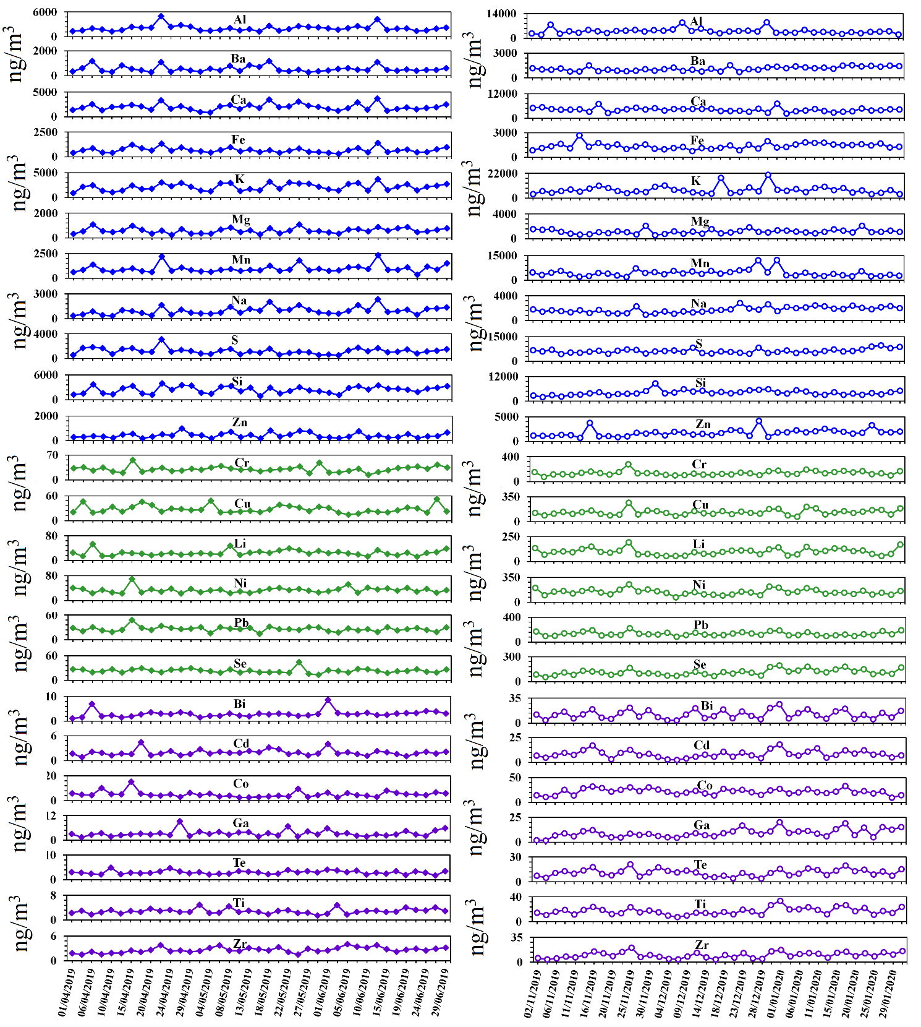

**Fig. S1. Temporal variations of PM2.5-bound elements during summer and winter (Y-axis contains concentration of respective element in ng/m3).**

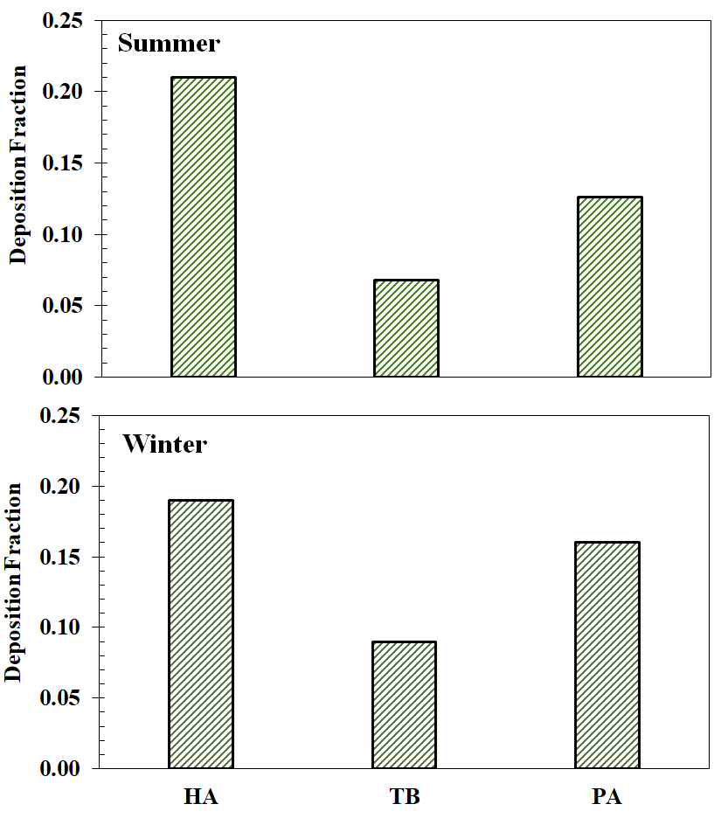

**Fig. S2. Deposition fraction of PM2.5 mass in various regions of the human respiratory tract (HA: head airway, TB: trachea and bronchiolar, PA: pulmonary and alveolar) during summer and winter.**

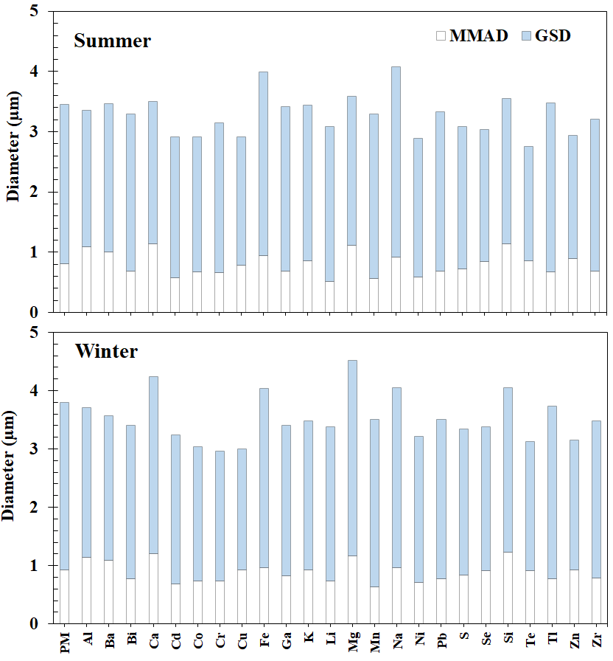

**Fig. S3. The mass median aerodynamic diameter (MMAD) and geometric standard deviation (GSD) of PM mass and elements of particles during summer and winter.**