Testing the functional and phylogenetic assembly of plant communities in Gobi deserts of northern Qinghai-Tibet Plateau
Jianming Wang^{1,3*}, Yin Wang¹, Mengjun Qu¹, Yiming Feng², Bo Wu², Qi Lu², Nianpeng He³, Jingwen Li^{1*}
- School of Ecology Nature Conservation, Beijing Forestry University, Beijing, China.
2. Institute of Desertification Studies, Chinese Academy of Forestry, Beijing, China.
3. Key Laboratory of Ecosystem Network Observation and Modeling, Institute of Geographic Sciences and Natural Resources Research, Chinese Academy of Science, Beijing 100101，China
Table S1 Plant lists occurring in 61 Gobi survey sites
 | Species | Family | Genera
1 | Sarcozygium xanthoxylum | Zygophyllaceae | Sarcozygium
2 | Salsola tragus | Amaranthaceae | Salsola
3 | Stipa tianschanica var. gobica | Poaceae | Stipa
4 | Ajania fruticulosa | Asteraceae | Ajania
5 | Sympegma regelii | Amaranthaceae | Sympegma
6 | Gymnocarpos przewalskii | Caryophyllaceae | Gymnocarpos
7 | Ephedra przewalskii | Ephedraceae | Ephedra
8 | Krascheninnikovia ceratoides | Amaranthaceae | Krascheninnikovia
9 | Bassia dasyphylla | Amaranthaceae | Bassia
10 | Halogeton glomeratus | Amaranthaceae | Halogeton
11 | Nitraria tangutorum | Nitrariaceae | Nitraria
12 | Reaumuria soongarica | Tamaricaceae | Reaumuria
13 | Asterothamnus centraliasiaticus | Asteraceae | Asterothamnus
14 | Nitraria sphaerocarpa | Nitrariaceae | Nitraria
15 | Haloxylon ammodendron | Amaranthaceae | Haloxylon
16 | Calligonum mongolicum | Polygonaceae | Calligonum
17 | Achnatherum splendens | Poaceae | Achnatherum
18 | Kalidium foliatum | Amaranthaceae | Kalidium
19 | Phragmites australis | Poaceae | Phragmites
20 | Caryopteris mongholica | Lamiaceae | Caryopteris
21 | Salsola arbuscula | Amaranthaceae | Salsola
22 | Artemisia desertorum | Asteraceae | Artemisia
23 | Tamarix chinensis | Tamaricaceae | Tamarix
24 | Tamarix ramosissima | Tamaricaceae | Tamarix
25 | Corethrodendron multijugum | Fabaceae | Corethrodendron
26 | Salsola laricifolia | Amaranthaceae | Salsola
27 | Artemisia annua | Asteraceae | Artemisia
28 | Askellia flexuosa | Asteraceae | Askellia
29 | Sphaerophysa salsula | Fabaceae | Sphaerophysa
30 | Scorzonera divaricata | Asteraceae | Scorzonera
31 | Apocynum pictum | Apocynaceae | Apocynum
32 | Lycium ruthenicum | Solanaceae | Lycium
33 | Halostachys caspica | Amaranthaceae | Halostachys
34 | Reaumuria kaschgarica | Tamaricaceae | Reaumuria
35 | Myricaria bracteata | Tamaricaceae | Myricaria
36 | Agropyron cristatum | Poaceae | Agropyron
37 | Nitraria roborowskii | Nitrariaceae | Nitraria
38 | Limonium aureum | Plumbaginaceae | Limonium
39 | Calligonum caput-medusae | Polygonaceae | Calligonum
40 | Tamarix hispida | Tamaricaceae | Tamarix
41 | Astragalus mongholicus | Fabaceae | Astragalus
42 | Echinops gmelinii | Asteraceae | Echinops
43 | Salix cheilophila | Salicaceae | Salix
44 | Halocnemum strobilaceum | Amaranthaceae | Halocnemum

Table S2 Best predictor for the functional and phylogenetic assembly of plant communities in Gobi deserts of northern Qinghai-Tibet Plateau.
Soil total nitrogen content, TSN; Soil organic carbon content, TOC; Soil moisture, SM; precipitation seasonality, PS; mean annual precipitation, MAP; temperature seasonality, TS; mean annual temperature, MAT. Phylogeny, phylogenetic assembly; All traits, combine of all functional traits; Leaf nitrogen concentration, LNC; Leaf phosphorus concentration, LPC; Specific leaf area, SLA; Leaf area, LA; Root nitrogen concentration, RNC; Root phosphorus concentration, RPC; Specific root length, SRL; Root length, RL.
 | Local factors |  |  |  |  | Climatic factors |  |  |  | Model R² | Model P
 | SM | TSN | TOC | pH | GC | MAT | TS | MAP | PS | Model R² | Model P
Phylogeny |  |  |  |  | 0.55 |  |  |  | -0.43 | 0.140 | <0.001
All traits | 0.32 |  |  |  | -0.26 |  | -0.17 |  | 0.17 | 0.403 | <0.001
LNC |  |  |  | -0.28 |  | -0.15 |  |  |  | 0.077 | <0.001
LPC |  |  |  | -0.37 |  | -0.41 |  |  | 0.20 | 0.326 | <0.001
SLA |  | 0.19 |  | 0.18 | -0.25 | 0.15 |  |  |  | 0.188 | <0.001
LA |  |  |  | 0.23 | -0.18 |  |  | 0.10 |  | 0.363 | <0.001
RNC |  |  | 0.14 |  |  |  |  |  | -0.21 | 0.088 | <0.001
RPC |  |  |  |  |  | 0.62 |  |  |  | 0.299 | <0.001
SRL | 0.29 |  |  |  | -0.26 |  |  | 0.16 | 0.13 | 0.378 | <0.001
RL |  |  |  | 0.26 | -0.19 |  |  |  | -0.24 | 0.191 | <0.001

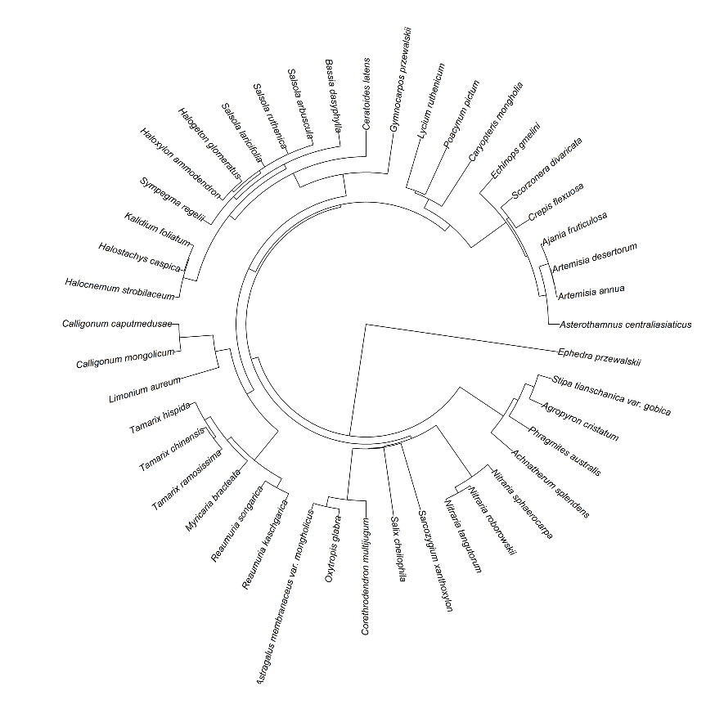
Figure S1 Phylogenetic tree of 44 species in this study

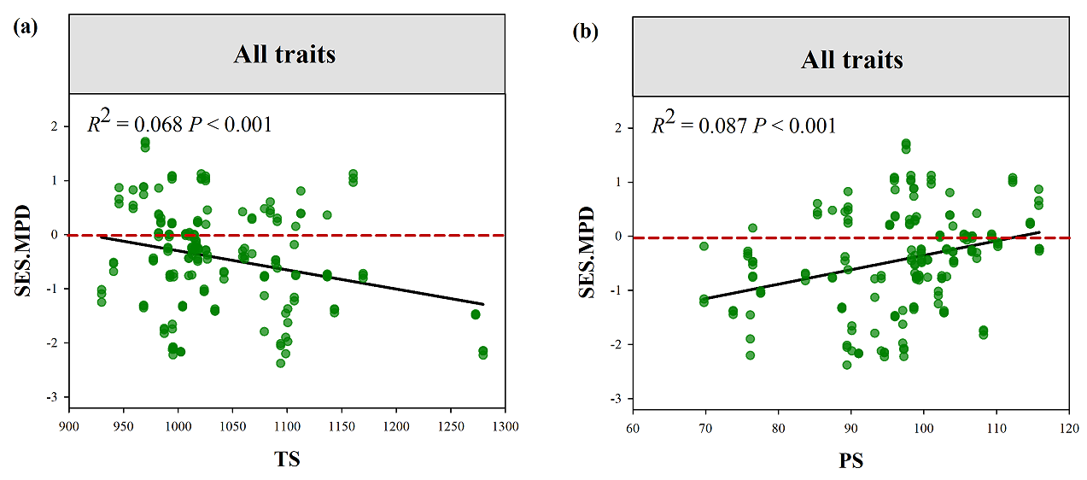
Figure S2 Variation in standard effect size of MPD for all traits along the gradients of TS and PS
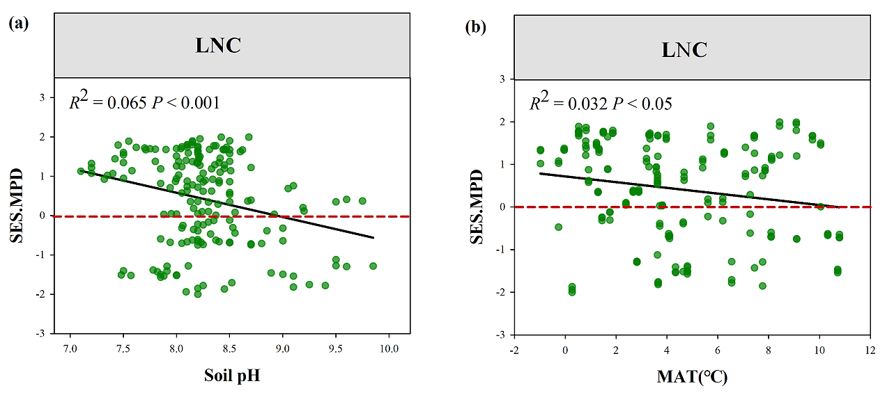
Figure S3 Variation in standard effect size of MPD for LNC along the gradients of soil pH and MAT

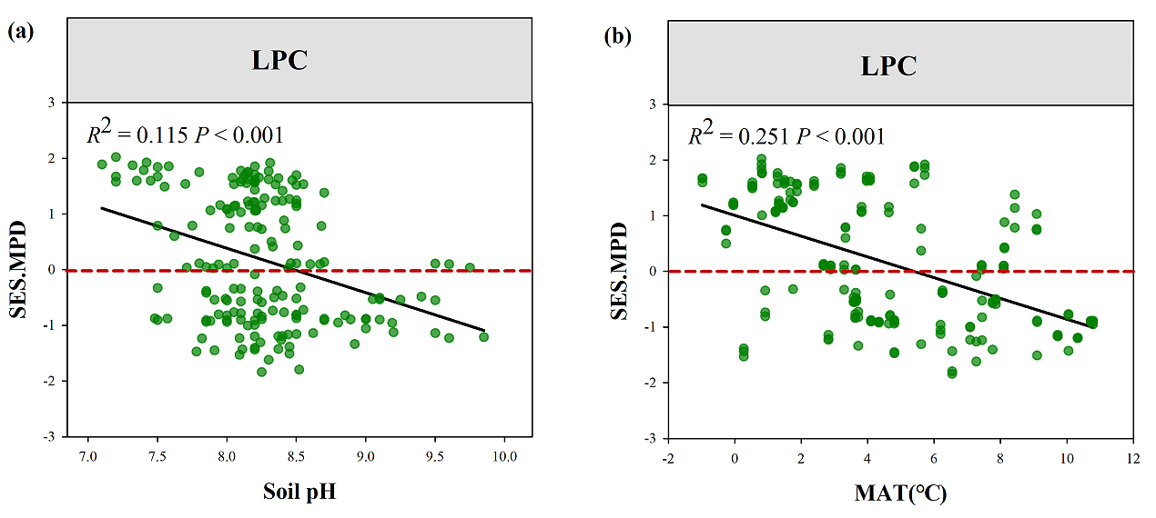
Figure S4 Variation in standard effect size of MPD for LPC along the gradients of soil pH and MAT

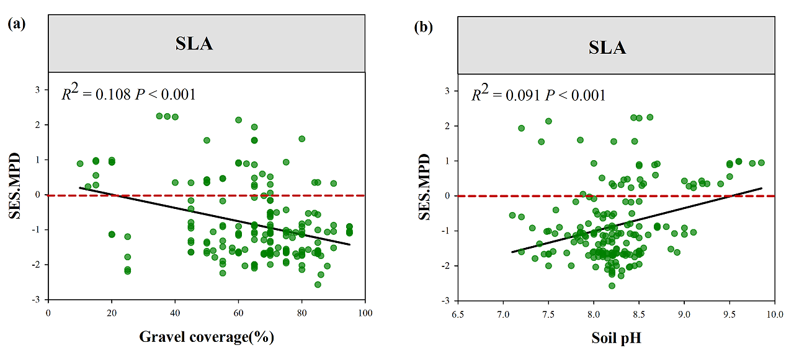
Figure S5 Variation in standard effect size of MPD for SLA along the gradients of Gravel and soil pH

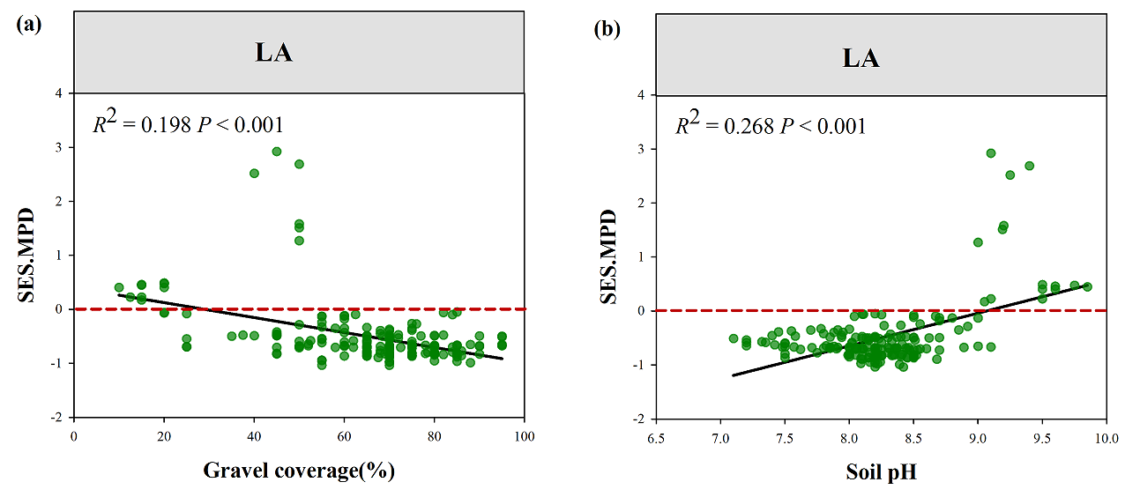
Figure S6 Variation in standard effect size of MPD for LA along the gradients of Gravel and soil pH

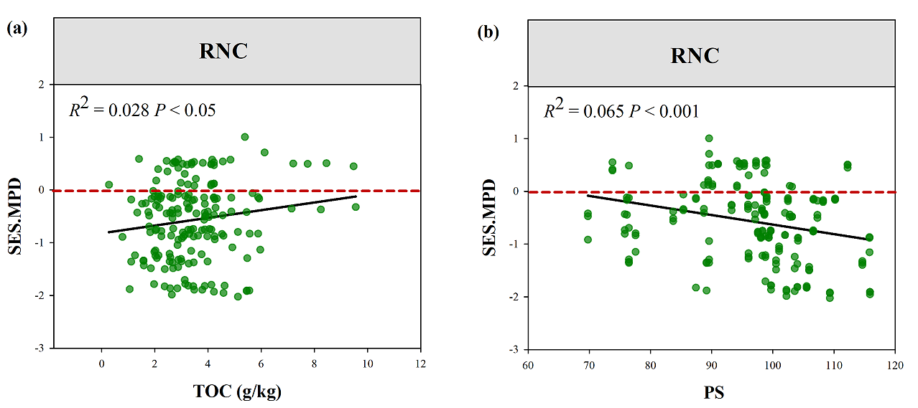
Figure S7 Variation in standard effect size of MPD for RNC along the gradients of TOC and PS

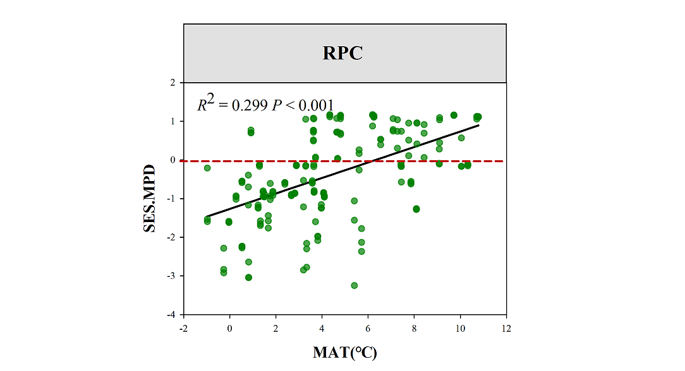
Figure S8 Variation in standard effect size of MPD for RPC along the gradient of MAT

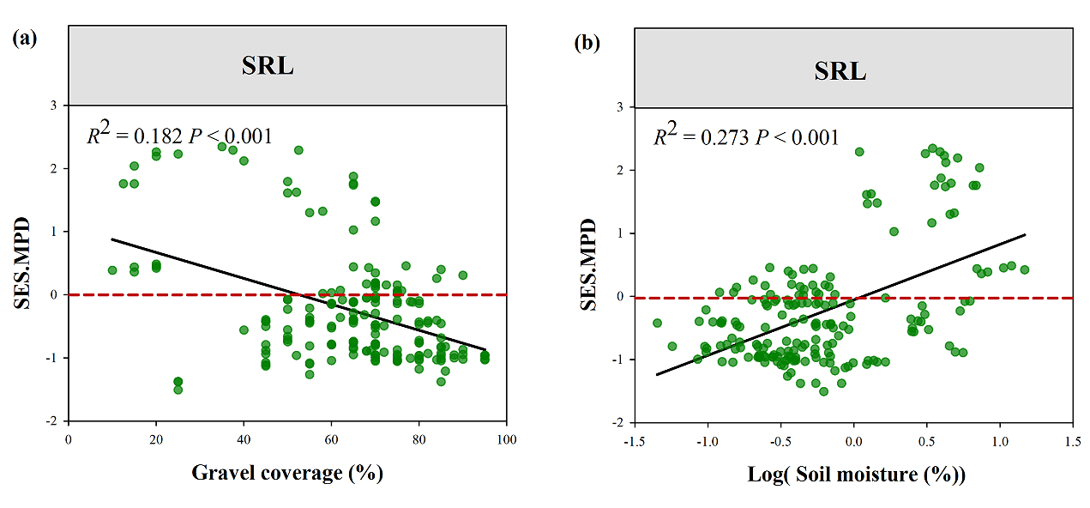
Figure S9 Variation in standard effect size of MPD for SRL along the gradients of Gravel and SM

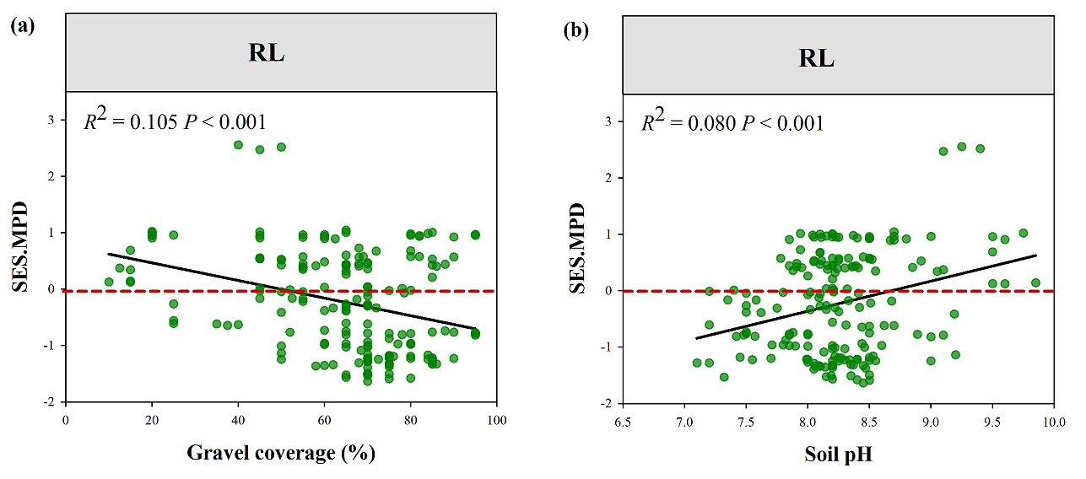
Figure S10 Variation in standard effect size of MPD for RL along the gradients of Gravel and soil pH

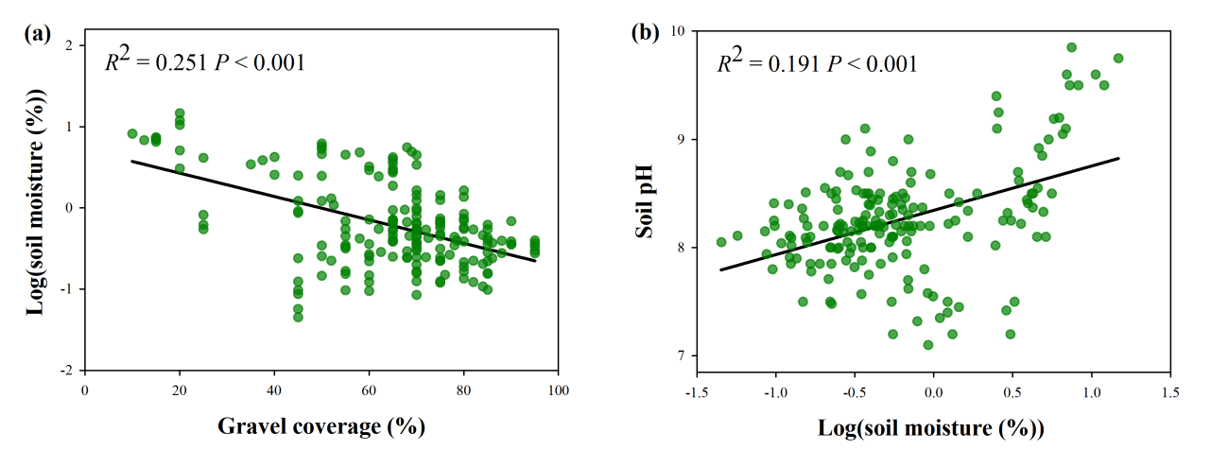
Figure S11 Relationships between soil moisture and gravel coverage, soil pH in Gobi deserts.

