**Coastal carbonate system variability along an active lava-seawater interface.**

David González-Santana, J.Magdalena Santana-Casiano, Aridane G. González and Melchor González-Dávila*

Instituto de Oceanografía y Cambio Global (IOCAG), Universidad de Las Palmas de Gran Canaria (ULPGC), 35017, Las Palmas de Gran Canaria, Spain.

[David.gonzalez@fpct.ulpgc.es](mailto:David.gonzalez@fpct.ulpgc.es)

[Magdalena.santana@ulpgc.es](mailto:Magdalena.santana@ulpgc.es)

[Aridane.gonzalez@ulpgc.es](mailto:Aridane.gonzalez@ulpgc.es)

[Melchor.gonzalez@ulpgc.es](mailto:Melchor.gonzalez@ulpgc.es)

Table S1. Discrete samples data for the carbonate system variables (AT and CT) and sensor data (Salinity, Temperature and pHT,is) at Tazacorte coastal waters affected by the lava, from September 22nd 2021 to January 11th 2022. Table includes date (dd-mm-yyyy), station (St), Latitude N (Lat), Longitude W (Long), depth in m (D), salinity (Sal), temperature in ºC (Temp), total alkalinity in µmol kg-1 (AT), total dissolved inorganic carbon in µmol kg-1 (CT), and pH in total scale at in-situ conditions (pHT,is). Initial conditions at the north (N), central (C), south (S) and reference (R) stations before the lava arrived to the coastal waters of Tazacorte, La Palma, The Canary Islands, are also included.

|  |  |  |  |  |  |  |  |  |  |
| --- | --- | --- | --- | --- | --- | --- | --- | --- | --- |
| Date | St | Lat | Long | D | Sal | Temp | AT | CT | pHT,is |
| 22-9-2021 | N | 28.6225 | -17.9352 | 1 | 37.010 | 25.132 | 2406.6 | 2119.1 | 7.981 |
| 22-9-2021 | C | 28.6119 | -17.9290 | 1 | 37.171 | 25.152 | 2414.6 | 2120.1 | 7.991 |
| 22-9-2021 | S | 28.6037 | -17.9278 | 1 | 37.170 | 25.144 | 2414.1 | 2119.1 | 7.992 |
| 23-9-2021 | R | 28.6197 | -17.9395 | 1 | 36.871 | 24.561 | 2391.6 | 2117.6 | 7.965 |
| 30-9-2021 | 1 | 28.6067 | -17.925 | 5 | 37.026 | 24.963 | 2361.6 | 2101.4 | 7.940 |
| 30-9-2021 | 2 | 28.608 | -17.928 | 29 | 37.050 | 24.375 | 2400.2 | 2126.6 | 7.969 |
| 30-9-2021 | 2 | 28.608 | -17.928 | 2 | 37.450 | 36.997 | 2206.0 | 2047.4 | 7.581 |
| 30-9-2021 | 3 | 28.612 | -17.93 | 0.5 | 37.184 | 28.338 | 2326.6 | 2100.5 | 7.831 |
| 30-9-2021 | 4 | 28.613 | -17.94 | 1 | 37.050 | 25.209 | 2389.2 | 2121.6 | 7.944 |
| 30-9-2021 | 4 | 28.613 | -17.94 | 25 | 36.918 | 24.199 | 2392.2 | 2122.3 | 7.966 |
| 30-9-2021 | 5 | 28.608 | -17.935 | 1 | 37.074 | 25.593 | 2387.2 | 2125.6 | 7.929 |
| 30-9-2021 | 5 | 28.608 | -17.935 | 25 | 36.915 | 24.175 | 2395.1 | 2125.8 | 7.966 |
| 30-9-2021 | 6 | 28.61 | -17.93 | 20 | 37.016 | 24.323 | 2390.4 | 2121.4 | 7.965 |
| 30-9-2021 | 7 | 28.615 | -17.928 | 1 | 37.174 | 25.414 | 2351.8 | 2119.4 | 7.880 |
| 1-10-2021 | 1 | 28.6067 | -17.9267 | 0.5 | 37.086 | 29.864 | 2332.7 | 2110.3 | 7.801 |
| 1-10-2021 | 1 | 28.6067 | -17.926 | 5 | 36.955 | 24.406 | 2365.7 | 2113.6 | 7.935 |
| 1-10-2021 | 2 | 28.6075 | -17.9275 | 0.5 | 37.150 | 30.805 | 2321.3 | 2094.9 | 7.794 |
| 1-10-2021 | 3 | 28.6083 | -17.9283 | 0.5 | 36.987 | 28.162 | 2333.4 | 2096.3 | 7.858 |
| 1-10-2021 | 3 | 28.6083 | -17.9283 | 5 | 37.482 | 24.281 | 2381.1 | 2120.7 | 7.941 |
| 1-10-2021 | 4 | 28.6092 | -17.9286 | 0.5 | 37.030 | 30.339 | 2323.7 | 2101.4 | 7.795 |
| 1-10-2021 | 5 | 28.61 | -17.93 | 0.5 | 37.071 | 29.170 | 2330.5 | 2101.3 | 7.825 |
| 1-10-2021 | 5 | 28.61 | -17.93 | 5 | 36.892 | 24.721 | 2356.9 | 2119.0 | 7.904 |
| 1-10-2021 | 7 | 28.6127 | -17.9288 | 0.5 | 36.964 | 27.544 | 2331.1 | 2103.1 | 7.847 |
| 1-10-2021 | 7 | 28.6127 | -17.9288 | 5 | 36.911 | 24.590 | 2350.6 | 2111.2 | 7.913 |
| 1-10-2021 | 8 | 28.615 | -17.9283 | 0.5 | 37.020 | 28.301 | 2329.4 | 2102.7 | 7.838 |
| 1-10-2021 | 9 | 28.605 | -17.9266 | 0.5 | 36.973 | 28.564 | 2348.9 | 2113.9 | 7.842 |
| 1-10-2021 | 9 | 28.605 | -17.9266 | 5 | 36.912 | 24.436 | 2370.1 | 2118.7 | 7.931 |
| 1-10-2021 | 1 | 28.6117 | -17.935 | 5 | 36.938 | 24.455 | 2374.7 | 2113.7 | 7.947 |
| 1-10-2021 | 1 | 28.6117 | -17.935 | 0.5 | 36.947 | 24.450 | 2371.9 | 2112.9 | 7.946 |
| 1-10-2021 | 12 | 28.61 | -17.9433 | 5 | 36.938 | 24.132 | 2376.3 | 2111.4 | 7.959 |
| 1-10-2021 | 12 | 28.61 | -17.9433 | 0.5 | 37.017 | 24.870 | 2380.4 | 2117.6 | 7.942 |
| 2-10-2021 | 1 | 28.6017 | -17.9283 | 0.5 | 36.910 | 24.369 | 2370.5 | 2115.3 | 7.941 |
| 2-10-2021 | 1 | 28.6017 | -17.9283 | 21 | 36.863 | 23.784 | 2380.2 | 2117.9 | 7.959 |
| 2-10-2021 | 3 | 28.6067 | -17.935 | 0.5 | 36.900 | 24.460 | 2381.4 | 2117.3 | 7.952 |
| 2-10-2021 | 5 | 28.6083 | -17.9283 | 0.5 | 36.897 | 24.248 | 2380.2 | 2117.7 | 7.952 |
| 2-10-2021 | 6 | 28.615 | -17.9266 | 0.5 | 36.870 | 24.906 | 2375.4 | 2115.9 | 7.938 |
| 8-10-2021 | 1 | 28.6012 | -17.9306 | 0.5 | 36.881 | 24.914 | 2380.6 | 2116.0 | 7.948 |
| 8-10-2021 | 1 | 28.6012 | -17.9306 | 5 | 36.880 | 24.163 | 2391.4 | 2110.4 | 7.989 |
| 8-10-2021 | 3 | 28.6067 | -17.9339 | 0.5 | 36.878 | 24.106 | 2368.4 | 2119.9 | 7.932 |
| 8-10-2021 | 5 | 28.6159 | -17.9346 | 0.5 | 36.892 | 24.402 | 2365.1 | 2118.2 | 7.928 |
| 8-10-2021 | 8 | 28.6062 | -17.9290 | 0.5 | 36.930 | 24.360 | 2365.2 | 2123.7 | 7.914 |
| 8-10-2021 | 10 | 28.6095 | -17.9330 | 0.5 | 36.895 | 26.908 | 2370.1 | 2115.2 | 7.900 |
| 8-10-2021 | 11 | 28.6118 | -17.9335 | 0.5 | 36.856 | 25.085 | 2389.4 | 2140.3 | 7.917 |
| 8-10-2021 | 12 | 28.6140 | -17.9324 | 0.5 | 36.866 | 24.893 | 2387.4 | 2135.7 | 7.927 |
| 23-10-2021 | 1 | 28.6156 | -17.9286 | 0.5 | 37.094 | 23.856 | 2385.6 | 2120.5 | 7.960 |
| 23-10-2021 | 2 | 28.6122 | -17.9296 | 0.5 | 37.103 | 23.756 | 2384.7 | 2119.5 | 7.962 |
| 23-10-2021 | 3 | 28.6089 | -17.9283 | 0.5 | 37.078 | 23.775 | 2384.5 | 2118.5 | 7.962 |
| 23-10-2021 | 4 | 28.6075 | -17.9269 | 0.5 | 37.077 | 23.981 | 2383.1 | 2120.5 | 7.954 |
| 23-10-2021 | 6 | 28.6089 | -17.9366 | 0.5 | 37.071 | 23.771 | 2386.6 | 2126.7 | 7.952 |
| 8-11-2021 | 1 | 28.6073 | -17.9252 | 0.5 | 36.949 | 23.323 | 2393.6 | 2122.8 | 7.980 |
| 8-11-2021 | 3 | 28.6082 | -17.9269 | 0.5 | 36.923 | 23.297 | 2395.4 | 2120.4 | 7.988 |
| 8-11-2021 | 5 | 28.6095 | -17.9291 | 0.5 | 36.981 | 23.603 | 2396.4 | 2119.8 | 7.985 |
| 8-11-2021 | 7 | 28.6113 | -17.9299 | 0.5 | 36.951 | 23.259 | 2395.2 | 2122.3 | 7.986 |
| 8-11-2021 | 9 | 28.6144 | -17.9288 | 0.5 | 36.938 | 23.211 | 2394.1 | 2119.3 | 7.987 |
| 8-11-2021 | 11 | 28.6099 | -17.9316 | 0.5 | 36.912 | 23.267 | 2394.7 | 2121.8 | 7.985 |
| 12-11-2021 | 2 | 28.6039 | -17.9256 | 0.2 | 37.380 | 34.269 | 2296.8 | 2100.0 | 7.695 |
| 12-11-2021 | 3 | 28.6045 | -17.9256 | 0.2 | 37.204 | 35.724 | 2251.5 | 2078.5 | 7.633 |
| 12-11-2021 | 4 | 28.6050 | -17.9256 | 0.2 | 37.535 | 38.437 | 2153.6 | 2011.6 | 7.524 |
| 12-11-2021 | 5 | 28.6048 | -17.9260 | 0.2 | 37.457 | 46.326 | 1860.3 | 1874.6 | 7.016 |
| 12-11-2021 | 6 | 28.6052 | -17.9263 | 0.1 | 37.555 | 44.637 | 1930.5 | 1890.3 | 7.192 |
| 12-11-2021 | 7 | 28.6055 | -17.9267 | 0.2 | 37.687 | 41.339 | 2024.2 | 1940.9 | 7.347 |
| 12-11-2021 | 8 | 28.6063 | -17.927 | 0.2 | 37.612 | 38.535 | 2157.4 | 2003.9 | 7.551 |
| 12-11-2021 | 12 | 28.6013 | -17.9334 | 0.2 | 37.029 | 30.991 | 2304.6 | 2086.5 | 7.783 |
| 14-11-2021 | 1 | 28.6162 | -17.9282 | 0.2 | 36.842 | 23.502 | 2415.3 | 2135.4 | 7.992 |
| 14-11-2021 | 12 | 28.6065 | -17.9275 | 0.2 | 37.050 | 25.634 | 2375.5 | 2100.9 | 7.954 |
| 14-11-2021 | 13 | 28.6060 | -17.9264 | 0.2 | 37.069 | 28.282 | 2378.2 | 2091.2 | 7.940 |
| 14-11-2021 | 14 | 28.6055 | -17.9260 | 0.2 | 37.092 | 28.999 | 2367.5 | 2089.5 | 7.911 |
| 14-11-2021 | 15 | 28.6049 | -17.9260 | 0.5 | 37.060 | 30.022 | 2372.4 | 2087.5 | 7.913 |
| 14-11-2021 | 30 | 28.6044 | -17.9367 | 0.5 | 36.996 | 24.847 | 2394.8 | 2105.5 | 7.990 |
| 20-11-2021 | 1 | 28.6037 | -17.9254 | 0.5 | 36.811 | 23.752 | 2426.7 | 2298.4 | 7.682 |
| 20-11-2021 | 3 | 28.6053 | -17.9260 | 0.5 | 36.939 | 29.082 | 2342.6 | 2096.7 | 7.864 |
| 20-11-2021 | 5 | 28.6067 | -17.9279 | 0.5 | 36.910 | 24.478 | 2360.4 | 2103.6 | 7.943 |
| 20-11-2021 | 6 | 28.6098 | -17.9295 | 0.5 | 36.889 | 23.906 | 2362.7 | 2106.3 | 7.950 |
| 20-11-2021 | 10 | 28.6149 | -17.9276 | 0.5 | 36.838 | 22.918 | 2363.9 | 2109.4 | 7.960 |
| 20-11-2021 | 11 | 28.6131 | -17.9342 | 0.5 | 36.879 | 22.828 | 2419.6 | 2169.7 | 7.948 |
| 8-12-2021 | 2 | 28.6044 | -17.9256 | 0.5 | 36.880 | 22.391 | 2393.9 | 2116.7 | 8.004 |
| 8-12-2021 | 4 | 28.6064 | -17.9273 | 0.5 | 36.904 | 21.879 | 2388.9 | 2115.4 | 8.005 |
| 8-12-2021 | 5 | 28.6081 | -17.9276 | 0.5 | 36.995 | 22.388 | 2394.5 | 2116.4 | 8.010 |
| 8-12-2021 | 10 | 28.6147 | -17.9281 | 0.5 | 36.873 | 21.733 | 2415.8 | 2177.5 | 7.946 |
| 8-12-2021 | 11 | 28.6171 | -17.9392 | 0.5 | 36.874 | 21.675 | 2409.7 | 2144.8 | 7.995 |
| 8-12-2021 | 13 | 28.6251 | -17.9349 | 0.5 | 36.900 | 21.846 | 2366.7 | 2119.6 | 7.961 |
| 11-1-2022 | 1 | 28.6047 | -17.9262 | 0.5 | 37.042 | 21.070 | 2406.6 | 2139.2 | 8.006 |
| 11-1-2022 | 3 | 28.6072 | -17.9273 | 0.5 | 37.112 | 21.481 | 2411.6 | 2141.4 | 8.009 |
| 11-1-2022 | 5 | 28.6094 | -17.9285 | 0.5 | 37.047 | 21.104 | 2406.6 | 2134.6 | 8.017 |
| 11-1-2022 | 7 | 28.6132 | -17.9289 | 0.5 | 37.056 | 21.140 | 2408.4 | 2138.7 | 8.011 |
| 11-1-2022 | 10 | 28.6245 | -17.9347 | 0.5 | 37.001 | 20.921 | 2416.6 | 2164.7 | 7.979 |
| 11-1-2022 | 12 | 28.6266 | -17.9386 | 0.5 | 37.040 | 21.062 | 2421.3 | 2143.4 | 8.025 |

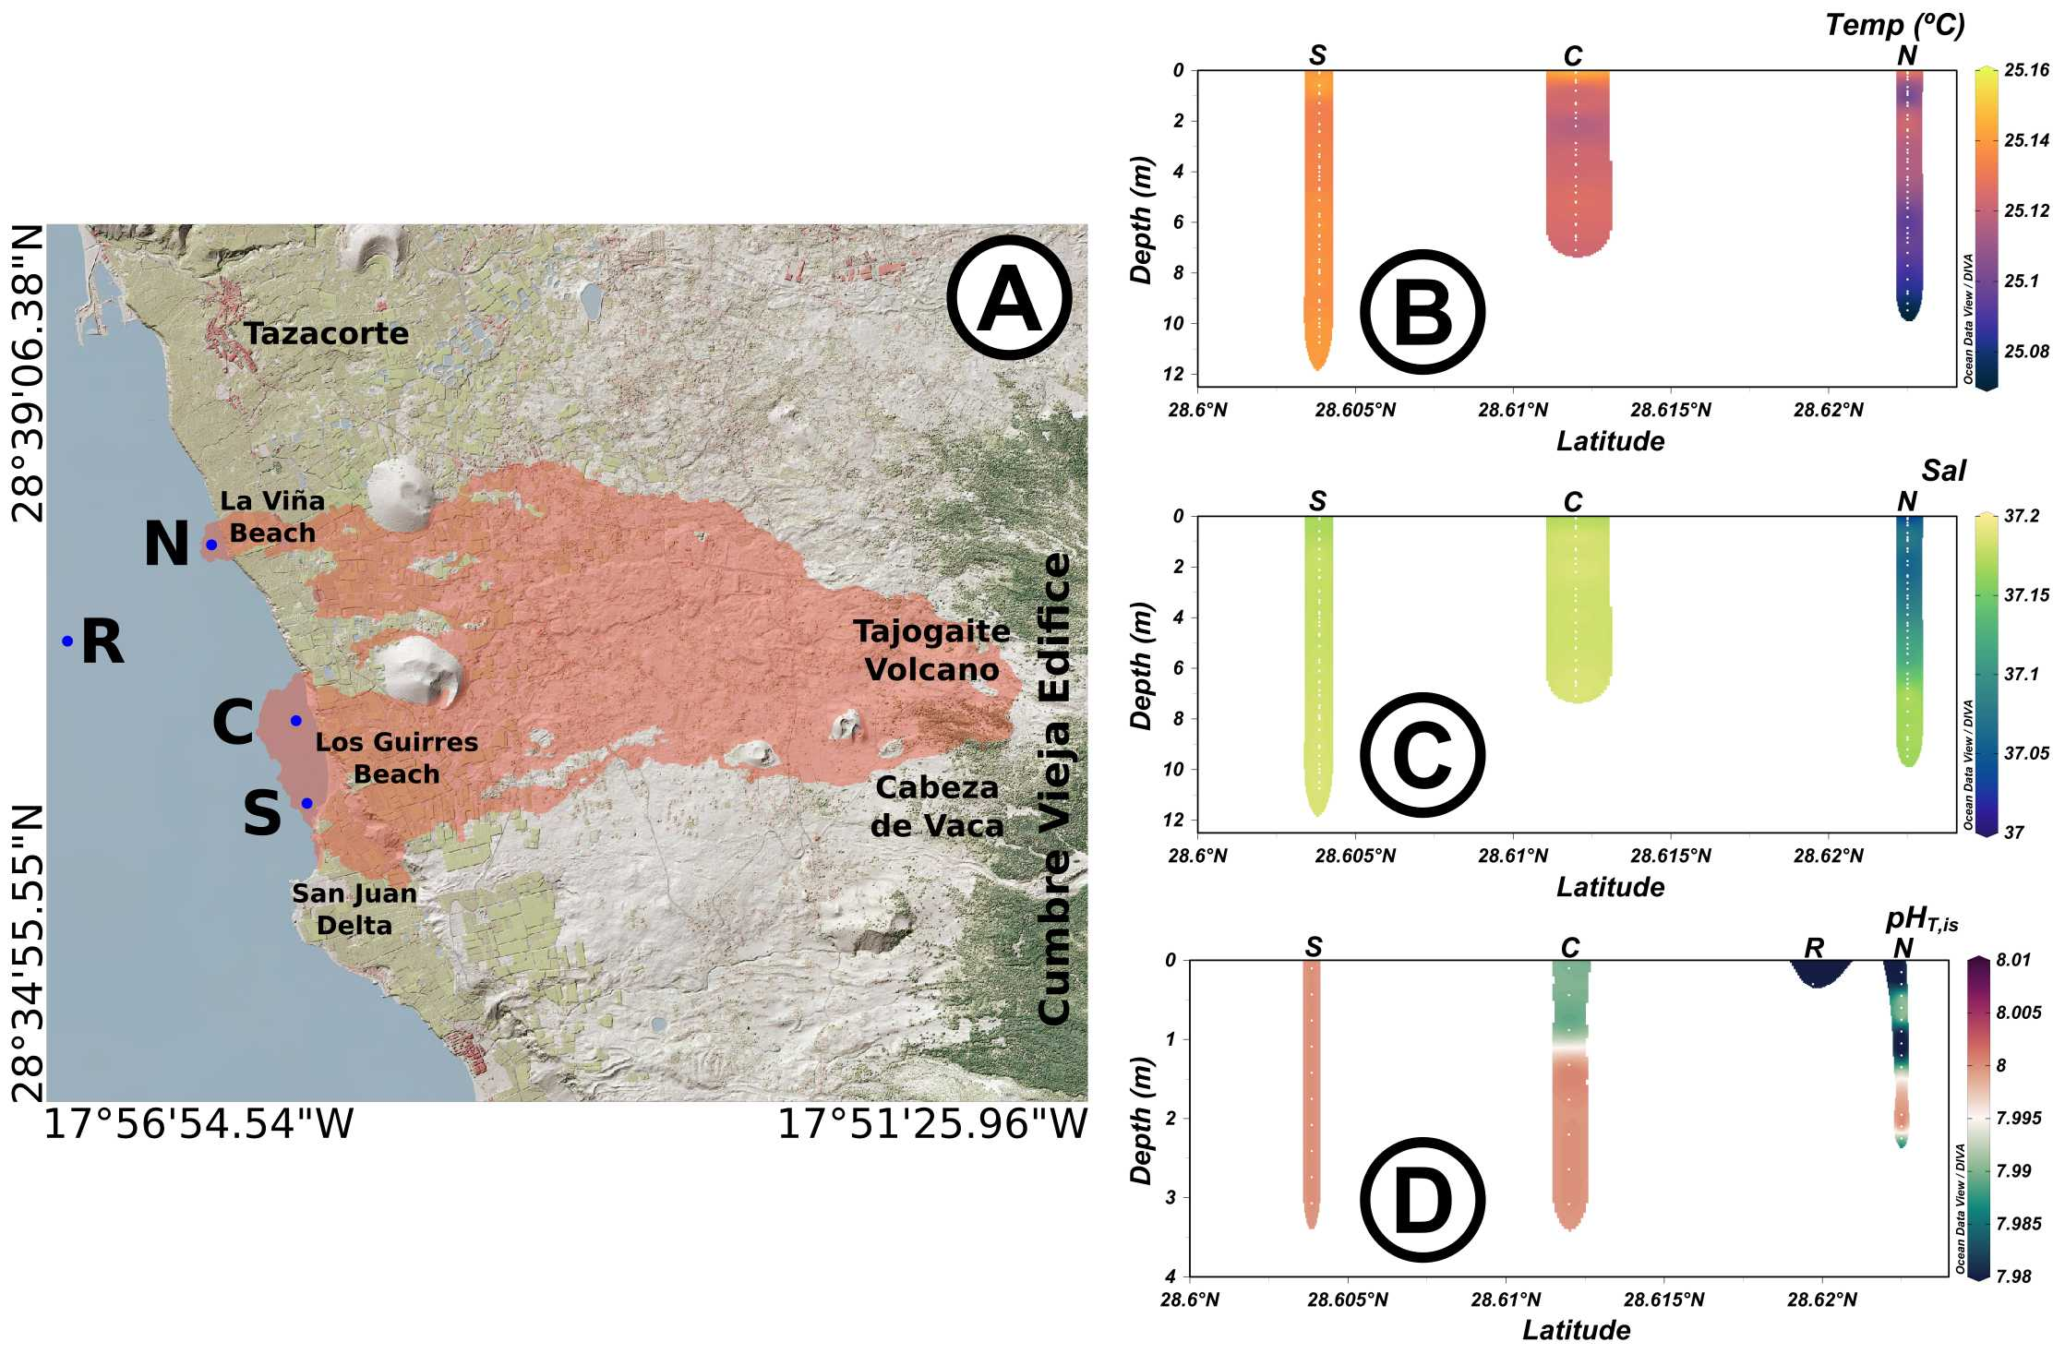

Figure S1. (A) Map of the coast of Tazacorte with the new gained deltas. Blue dots correspond with the sampling station. North, N, centre, C, south, S, and reference, R, correspond with the locations of the pre-lava arrival stations. Vertical profiles measured on September 22nd of B) temperature (Temp ºC), C) salinity (Sal) and D) pH in total scale at in situ conditions (notice 3 m was the recorded data for the pHT,is) at the three selected positions The surface pH value at the reference R site (D) on September 22nd is also indicated. Site C site was located where the lava first reached the ocean on September 28th, site S was covered by the lava on November 10th and site N was covered on November 22th.

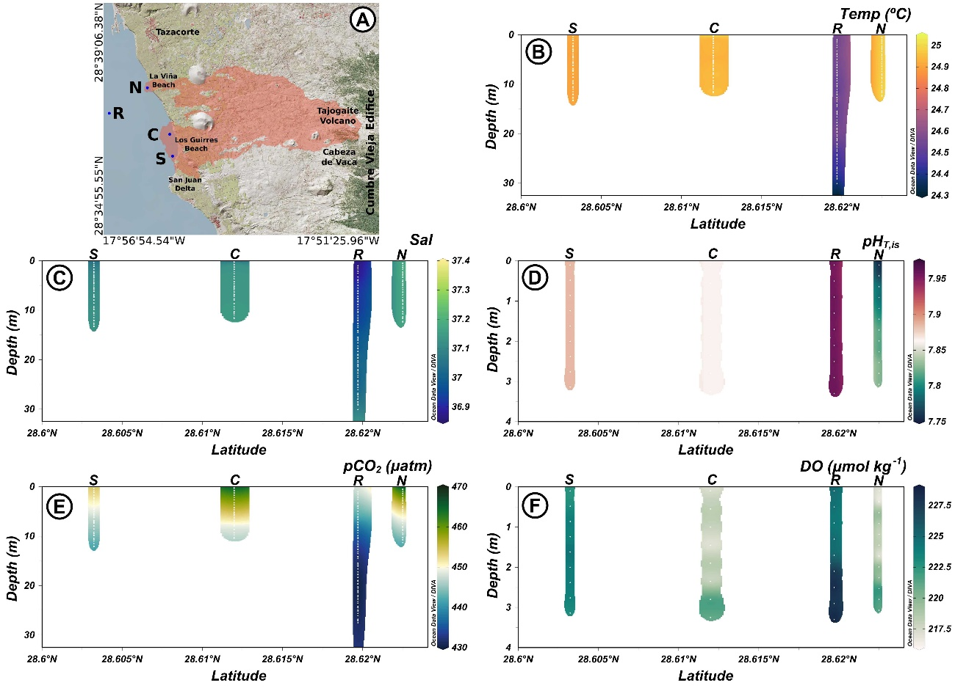

Figure S2. (A) Map of the coast of Tazacorte with the new formed deltas. Blue dots correspond with the sampling station. North, N, centre, C, south, S, and reference, R, correspond with the locations of the pre-lava arrival stations. Vertical profiles measured on September 23rd of B) temperature (Temp, ºC), C) salinity (Sal), D) pH in total scale at in situ conditions (pHT,is), E) partial pressure of CO2 (pCO2, µatm) and F) dissolved oxygen (DO, µmol kg-1) at the three selected positions north N, central C and south S and at the reference R. Notice, pH and DO were recorded in the top 3 m.

**Balance of the total acid added to the seawater by the molten lava.**

To compute the different components of Eq. 5 in the main text,

$\sum{H_{Tot}^{+}}=H_{sol}^{+}+H_{Alk}^{+}+H_{unb}^{+}$ (1)

the pH values should be converted into proton concentration ($\left[H^{+}\right]= {10}^{-pH} (mol kg^{-1}))$. For the region prior to lava arriving to the sea, the average pH in the top 6-10 m of the water column was 7.995 ± 0.008 at 25 ºC. To compute the acid needed to produce the observed decrease in pH ($H_{sol}^{+}$) in the water column, the difference between the proton concentration at each station and that for the reference water at the *in situ* conditions should be computed. The excel CO2SYSv2.5 program (Pierrot et al., 2006) was used to compute pH in other experimental conditions. The pH of the reference seawater but at the temperature measured in November 12th was computed using the pair pHT, NAT (7.995, 2404.4 µmol kg-1, respectively) to account for variation in pH due to temperature alone. The reference proton concentrations at the new temperatures were then subtracted from those corresponding to the measured pH at the same *in situ* conditions.

The resulting protons at each depth and station were integrated along the water column until the depth where [H+] was lower than that of the reference station (first 5-7 m). This [H+] value in mol m-2 units per station is therefore $\sum_{1}^{n}{(H_{n+1}-H_{n)}*(d_{n+1}-d_{n})}$, where *d* is the depth in m. Four transects were selected due to the observed plume and position of the stations (Fig. 5 A, main text). The frontal zone was located at about 30 m away from the delta and was 620 m long. The second transect was 706 m long and was located at about 535 m away from the delta, while the third was 630 m long and was located 835 m away from the delta. A final 200 m long transect at a distance of 1090 m from the delta and the farthest point located at 1300m were also included. For each transect, [H+] in mol m-2 were integrated between the closest stations and the sum along the full transect was determined providing the [H+] in mol m-1. The values were then plotted against the distance to the delta (Fig. S3) and the polynomial fitting equation was integrated between the delta and the 1300 m to compute the corresponding $H_{sol}^{+}$ in units of mol.

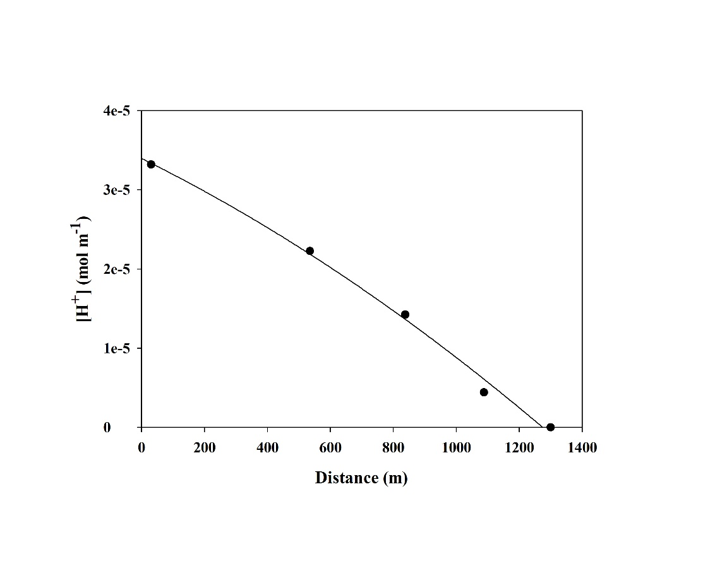

Figure S3. Integrated proton concentration in mol m-1 for the stations located in each transect at different distances to the delta needed to produce the observed decrease in pH in the affected area with respect to the pH in the reference station ($H_{sol}^{+}$).

To compute the added protons to titrate the alkalinity of the seawater ($H_{Alk}^{*}$) by the magmatic acidity, the experimental temperature (t in ºC) to NAT relationship in Fig. 5 was applied to each profile data measured on November 12th,

(2)

The pH was then computed, both at the *in situ* temperature for the reference station with fixed NAT and NCT (2404.4 µmol kg-1 and 2112.8 µmol kg-1, respectively) and at the fixed NCT and the computed profile alkalinity. The differences in proton concentration for each computed pH condition were then integrated as indicated above for the H+sol, and the plotted values for each transect were integrated for the affected area (Figure S4).

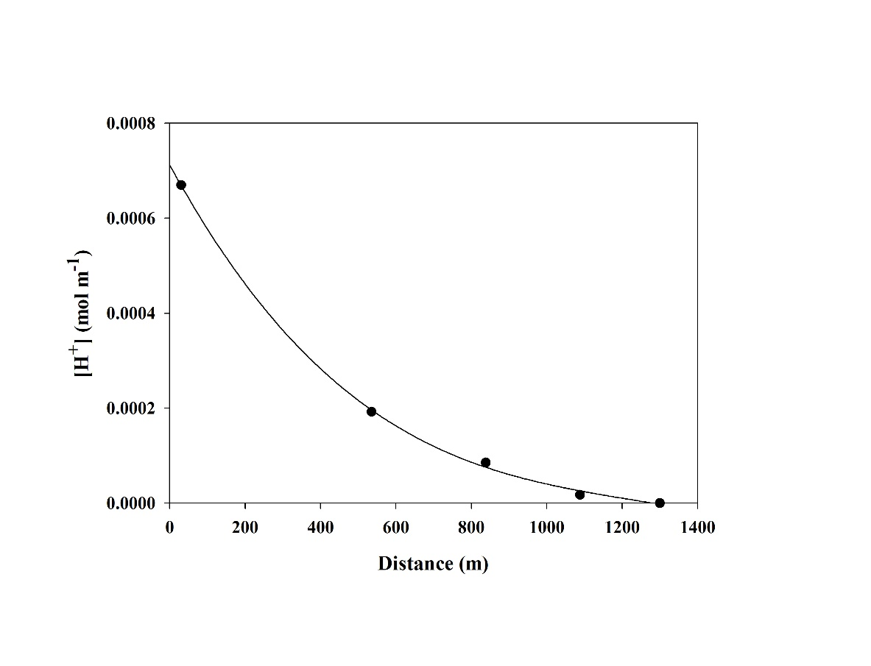Figure S4. Integrated proton concentration in mol m-1 for the stations located in each transect at different distances to the delta needed to produce the observed change in alkalinity with respect to the reference station but at the in situ temperature conditions ($H_{Alk}^{+}$).

For the $H_{unb}^{+}$ used to react with the basaltic rocks liberating cations, the distribution of iron in the volcano Tagoro at El Hierro (Santana-Casiano et al. 2013) was used, considering that the iron excesses with respect to a reference station at different distances from the volcano were applicable here. According to the observed values, the corresponding Fe concentrations in mol m-2 for each station were integrated (mol m-1) for each transect (Table S2) and were integrated for the affected area (Figure S5). The result was considered applicable for both Fe+3 and Al+3, with three used protons for each metal in solution.

Table S2. Average station excess of Fe (mol m-2) and Fe excess (mol m-1) along the transects considered in this study.

|  |  |  |  |  |  |
| --- | --- | --- | --- | --- | --- |
|  | Transect1 | Transect 2 | Transect 3 | Transect 4 | Reference |
| Average station excess  of Fe, mol m-2 | 1.83e-8 | 3.50e-9 | 1.50e-9 | 3e-10 | 0 |
| Transect Excess of  Fe, mol m-1 | 1.125e-5 | 2.47e-6 | 9.53e-7 | 6.0e-8 | 0 |

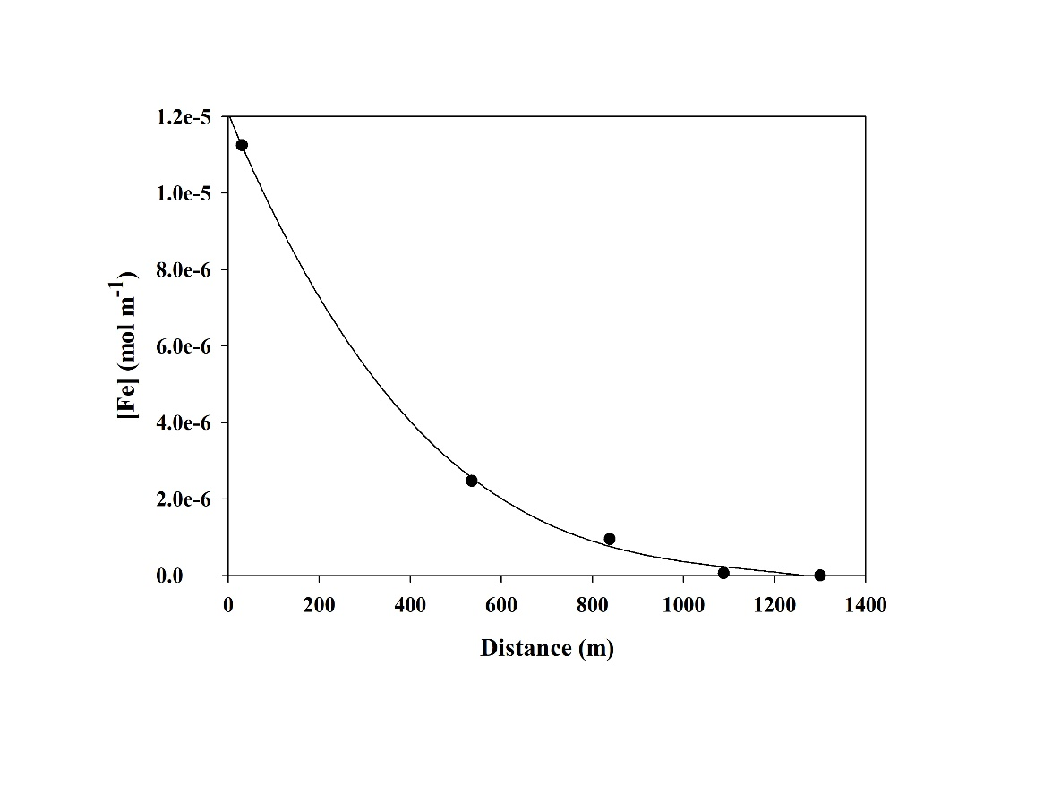

Figure S5. Integrated Fe concentration in mol m-1 as indicated in Table S1 for the stations located in each transect at different distances to the delta. ($H_{sol}^{+}$).

Reference

Pierrot D. E., Lewis E. and Wallace D. W. R. (2006). MS Excel program developed for CO2 system calculations. Carbon Dioxide Information Analysis Center, Oak Ridge National Laboratory, US Department of Energy. ORNL-CDIAC-IOS.

Santana-Casiano, J. M., González-Dávila, M., Fraile-Nuez, E., de Armas, D., González, A. G., Domínguez-Yanes, J. F., et al. (2013). The natural ocean acidification and fertilization event caused by the submarine eruption of El Hierro. *Sci. Rep.* 3, 1140. Available at: http:--dx.doi.org-10.1038-srep01140.