Supplementary Material

# Pressure sensor calibration

All the pore pressure sensors were thoroughly calibrated before the start of the experiment. A reference water column and the columns, later to be filled with dredged sediment, were filled with water up to 88 cm prior to the start of the calibration procedure (Figure 1). At this point, the relative pressure difference between each “sediment” column and the reference water column is zero and the output of all pore pressure sensors was set to 0.000 mV. Then, the water level in the reference column was increased/decreased with increments of 2 cm, while the water level in both sediment columns stayed at 88 cm. The output in mV was recorded at five relative water levels: -2 cm, 2 cm, 4 cm, 6 cm, and 8 cm (Figure 1). Calibration curves were determined for each pore pressure sensor. Figure 2 and Figure 3 show the calibration curves for the control column and the vegetated column respectively.

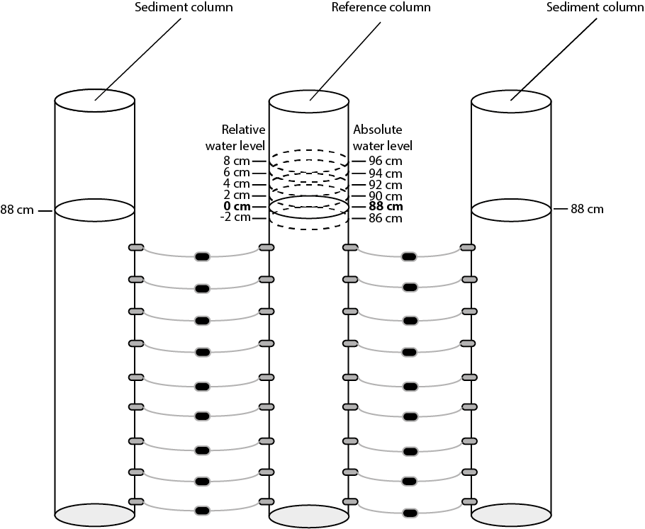

Figure Schematic of the calibration procedure. All pore pressure sensors are calibrated using six different water levels in reference water column connected to the sediment columns to measure relative pressures. Relative pressure differences are measured for the following differences in water level : -2, 0, 2, 4, 6, and 8 cm.

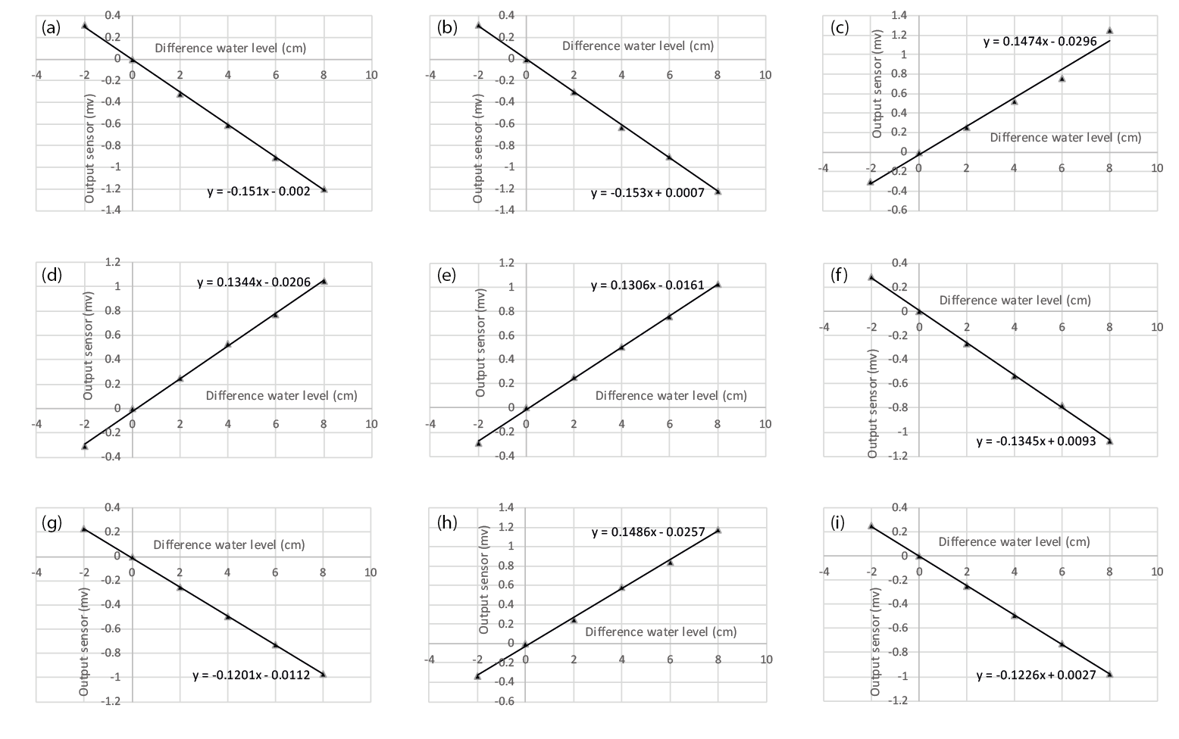

Figure Calibration lines of all pore pressure sensors attached between the reference column and the control column: 4 cm depth (a), 14 cm depth (b), 24 cm depth (c), 34 cm depth (d), 44 cm depth (e), 54 cm depth (f ), 64 cm depth (g), 74 cm depth (h), and 84 cm depth (i).

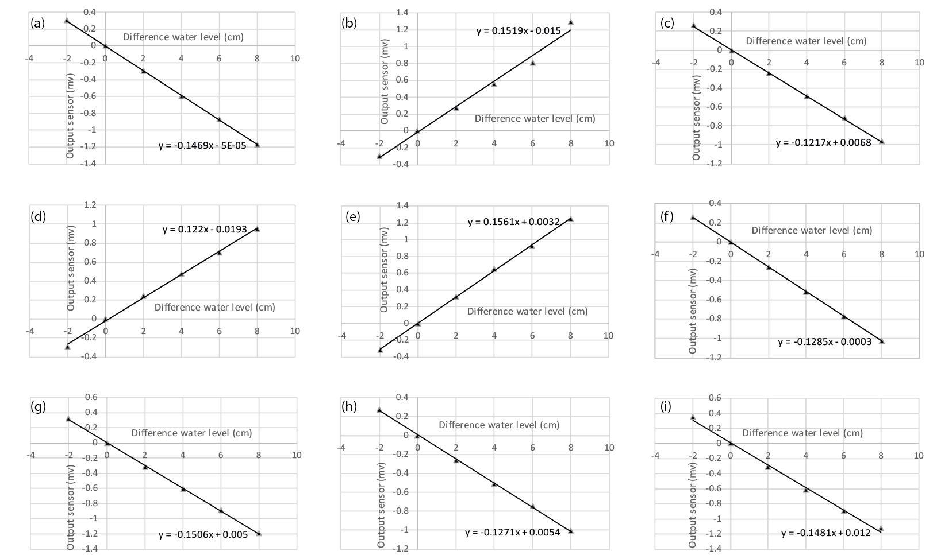

Figure Calibration lines of all pore pressure sensors attached between the reference column and the vegetated column: 4 cm depth (a), 14 cm depth (b), 24 cm depth (c), 34 cm depth (d), 44 cm depth (e), 54 cm depth (f ), 64 cm depth (g), 74 cm depth (h), and 84 cm depth (i).

A water density of 998.774 kg/m3, corresponding to the constant lab temperature of 17.4 ±C, was used to convert the output of the pore pressure sensors in mV to kPa. A gravity acceleration of 9.8125m/s2 corresponds to the latitude of the laboratory (i.e., 52° N). This means that 0.01 m of water results in a pressure increase of 0.01mx 998.774 kg/m3 x 9.8125m/s2 = 0.098004 kPa.

The relative difference in pressure between the reference column and the sediment column was calculated with the equations of the calibration lines in Figure 2 and Figure 3. For each pore pressure sensor: pressure (kPa) = 0.098004 (amV + b – 87 cm). This is because the water level in the reference column was fixed at 87 cm during the experiment, changes in kPa are directly related to changes in pore pressure in the sediment columns.

# Experimental setup zoom in

Figure 4 shows a closer look or zoom on theexperimental set-up.

Figure Experimental set-up of the columns, drainage pipes, Mariotte bottles, and location of the sensors (at 0.4, 10.4, 20.4, 30.4, 40.4, 50.4, 60.4, 70.4, and 80.4 cm from the base of the column). The 88 cm sediment is the value at the end of the experiment. The 88 cm sediment level is the value at the end of the experiment

# Pore pressure measurements over time

Figure 5 shows the evolution over time of the measured relative pore pressure at different heights in the control and vegetated columns.

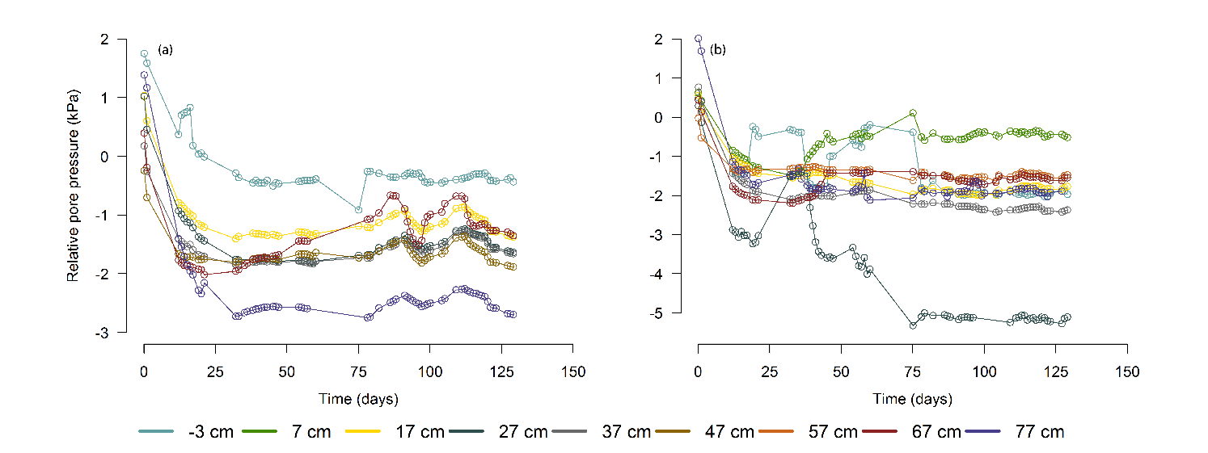

Figure Relative pore pressure (kPa) relative to the reference water column at all depths of the control column (a) and the vegetated column (b) for the duration of the experiment. Each pore pressure sensor is connected at the same height at the sediment column and at the reference water column. This reference column has a constant height of water of 87 cm

The majority of the pore water sensors installed in the column with no drainage were defective and stopped working immediately. This happened with all the sensors of the same (defective) batch. Consequently, from this column there are the pore water pressure data available at two column heights. Figure 6 shows the absolute pore water pressure measured by these two sensors and the sensors at the same height of the control and vegetated column. This figure shows that, 17 cm below the water table (i.e., at *z* = 60 cm from the bottom), the absolute pore water pressure decreased faster at the beginning of the experiment for the control column and vegetated column. This implies that excess pore water pressures are dissipated more rapidly and, therefore, the consolidation rate is larger. Furthermore, it shows that the uppermost sensor (*z* = -3 cm) recorded negative pressures (suctions) for the column with no drainage and the vegetated column. This is a different situation than in the control column, where a positive pressure of 0.49 kPa was measured.

Figure 6. Absolute pore water sensor measurements 3 cm above (labelled as -3 cm) and 17 cm below the water level of 77 cm. They correspond to an absolute height of 80 and 60 cm from the bottom of the column.

# Conductivity profiles

The measured water fluxes (Figure 3) were used for calculating the hydraulic conductivity using Equ. (1). Figure 7 shows the calculated hydraulic conductivity profiles (*k*(*z*) from Equ. (1)) of the vegetated column and the control column, calculated under the assumption that the flow *Q* is uniform over depth. It is questionable if this assumption is valid, as more permeable parts may attract more flow and less permeable parts less flow. So conclusions drawn from this figure are, to a certain extent, uncertain.

Figure 7 shows that in the first two days of the experiment (phase 1), the hydraulic conductivity started relatively high on average (8.8 x 10-9 m s-1 for the vegetated column and 5.3 x 10-9 m s-1 for the control column). The hydraulic conductivity rapidly decreased due to self-weight consolidation in phase 2 to 1.3 x 10-11 m s-1 on average in the control column and to 1.1 x 10-10 m s-1 on average in the vegetated column. This agrees with settling curves, which show that the sediment height in both columns lowered rapidly in the first 15 days. The difference in the initial hydraulic conductivities between the control column and the vegetated column might be caused by small disturbances induced when transplanting the reed seedlings at t = 0 days. The hydraulic conductivities in both columns stabilized on average to 3.2 x 10-10 m s-1 in the control column and 1.3 x 10-9m s-1 in the vegetated column. In phase 3, the hydraulic conductivity in the vegetated column averaged at 1.9 x 10-10 m s-1, while the hydraulic conductivity in the control column averaged at 1.3 x 10-10 m s-1. Thus, the hydraulic conductivity increased with a factor 1.4 compared to the control column due to enhanced drainage via transpiration in the phase when plants became active. Note that at t = 0, the hydraulic conductivity computed in the vegetated and non-vegetated columns differ considerably. These differences can be explained by Equ. (1): *P*(*z*) is measured but *Q*(*z*) not, therefore depth-averaged *Q* value was used. However, a larger or smaller *P*(*z*) would affect *Q* locally. Together with the inherent inhomogeneities in the soil, this leads to errors in *k*(*z*). These errors reduce over time, as flow rates, and thus their absolute errors, decrease over time.

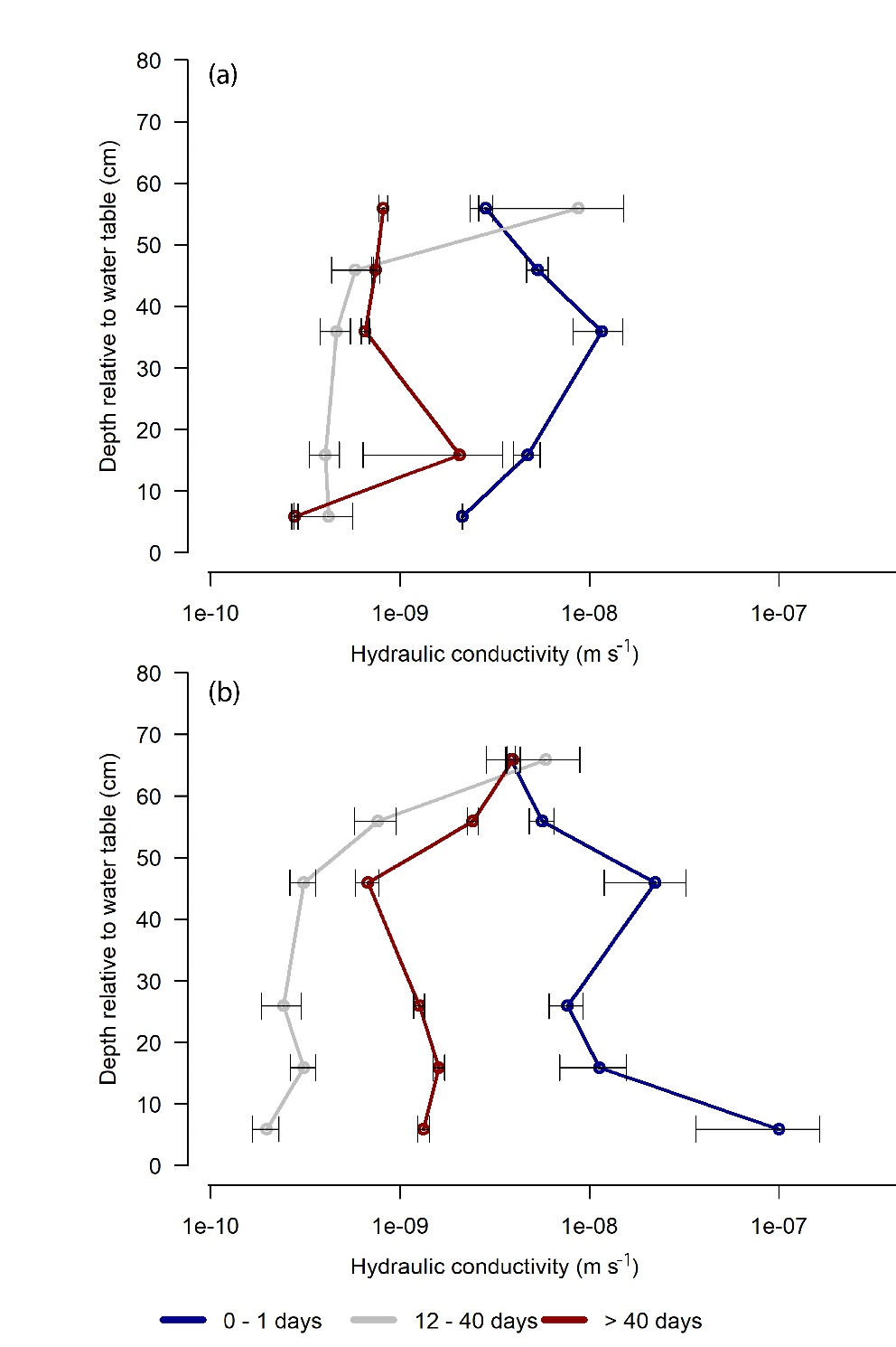

Figure Conductivity profiles (m s-1) for the control column (a) and the vegetated column (b) with standard errors. Profiles are averaged for three different time phases: 1) fast consolidation phase (0-1 days), 2) stable phase (12-40 days), and 3) plant transpiration phase (> 40 days).

Although Figure 7 is not conclusive, it is to be expected that deeper into the soil, where soil density increases, hydraulic conductivity decreases. While roots grow and penetrate the soil, they open drainage channels, facilitating pore water flow along their wall (Orozco-López et al. 2018). Thus, it can be assumed that below 60 cm this effective conductivity exceeds the soils own hydraulic conductivity. Water uptake at a depth greater than 60 cm would then mostly originate from above, via the roots. Total pore pressures are measured at the wall of the column, and the local, vegetation-induced under-pressures may not be noticed by the pressure sensors, as being compensated by vertical pore water flow.

# Additional plant development data

Figure 8 shows the root surface for unit leaf area. 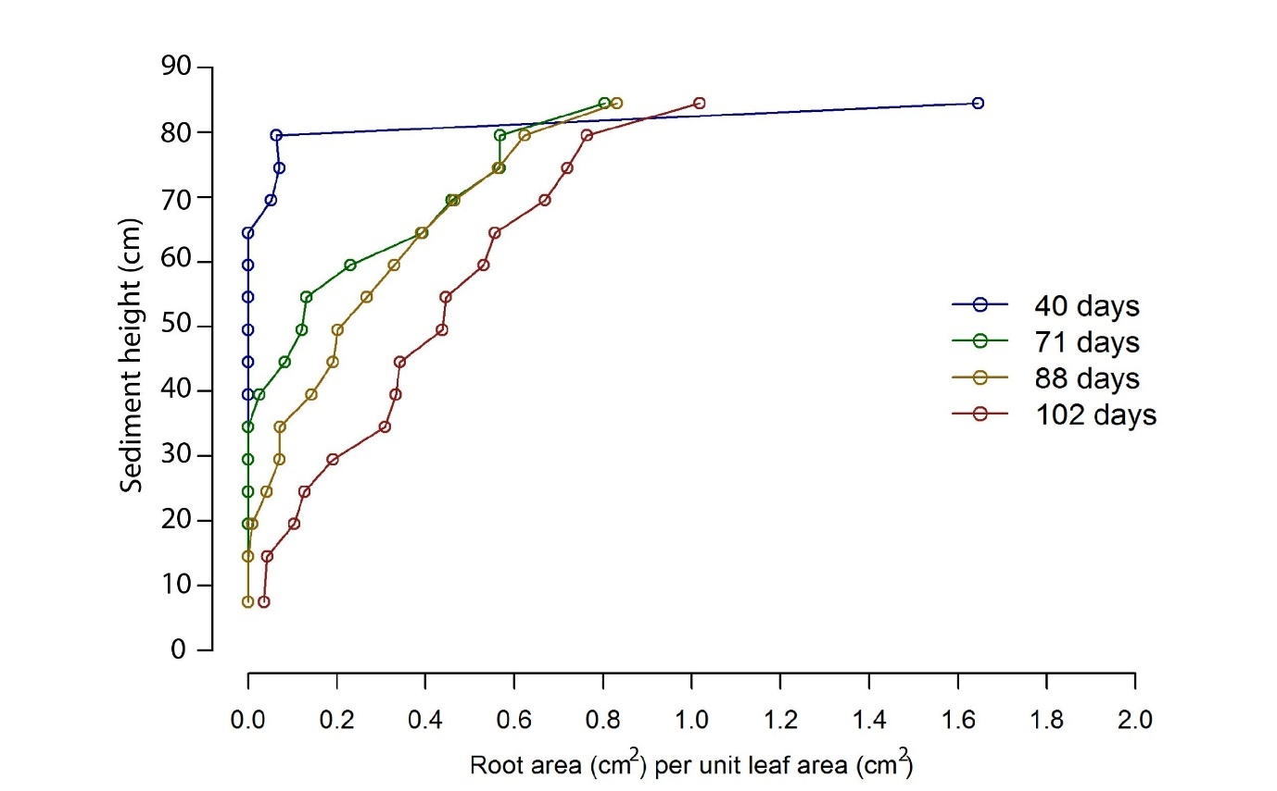

Figure Root surface area per unit leaf area (cm2) across sediment height at four different time steps.

Table 1 shows the plant characteristics and Table 2 the photosynthetic parameters. The results in Table 2 show that the photosynthesis rates are realistic (i.e. plants behaved like expected in field conditions, e.g. Ho, 1979), with a maximum rate of the Rubisco carboxylase activity (Vcmax) varying between 115 and 39.8 µmol m-2 s-1 and a maximum rate of the photosynthetic electron transport (Jmax) varying between 161 and 72.9 µmol m-2 s-1. Both variables decreased in time, which indicates a decrease in leaf effectiveness when the leaves of P. australis mature (i.e., photosynthesis and transpiration decrease per unit leaf area).

Table Extended table of plant characteristics at 40, 71, 88 and 102 days as measured from harvested columns. Root length, root area, root biomass, and root volume are expressed per cm-3 column volume.

|  |  |  |  |  |  |
| --- | --- | --- | --- | --- | --- |
|  |  | **40 days** | **71 days** | **88 days** | **102 days** |
| **Leaf area** | **cm2** | 48.8 | 189 | 406 | 263 |
| **Leaf biomass** | **gr** | 0.17 | 0.67 | 1.48 | 1.00 |
| **Leaf mass per area (LMA)** | **g m2** | 342 | 354 | 365 | 382 |
| **Stem biomass** | **gr** | 0.43 | 1.46 | 2.13 | 2.42 |
| **Max. rooting depth** | **cm** | 18 | 48 | 68 | 80 |
| **Root length** | **cm cm-3** | 0.26 | 0.36 | 0.60 | 0.59 |
| **Root area** | **cm2 cm-3** | 0.07 | 0.18 | 0.33 | 0.29 |
| **Root biomass** | **mg cm-3** | 0.90 | 0.80 | 1.30 | 1.07 |
| **Root volume** | **mm3 cm-3** | 0.42 | 5.5 | 16 | 15 |
| **Shoot:Root ratio** |  | 0.49 | 0.74 | 0.54 | 0.53 |
| **Root volume** | **cm3** | 2.55 | 33.66 | 96.30 | 88.50 |
| **Sediment volume** | **cm3** | 6469 | 6432 | 6424 | 6414 |

Table Photosynthetic parameters of P. australis at 61, 81 and 97 days. The maximum rate of Rubisco carboxylase activity (Vcmax), the maximum rate of photosynthetic electron transport (Jmax) and the respiration rate (Rd) are presented (±S.E.) as well as the light compensation point (Γ*). All values are in µmol m-2 s-1.

|  |  |  |  |  |  |  |
| --- | --- | --- | --- | --- | --- | --- |
|  | **Day 61** | | **Day 81** | | **Day 97** | |
| **Vcmax** | 115 | *±8.72* | 59.21 | *±3.50* | 39.8 | ­±1.20 |
| **J**max | 161 | *±6.17* | 108 | *±4.84* | 72.9 | ±1.89 |
| **Rd** | 1.67 | *±0.68* | 3.99 | *±0.55* | 0.46 | ±0.18 |
| **Γ\*** | 28.79 | *-* | 28.84 | *-* | 28.63 | - |

More detailed information on photosynthetic parameters is presented in Figure 9, which shows net CO2 assimilation rates versus light intensity.

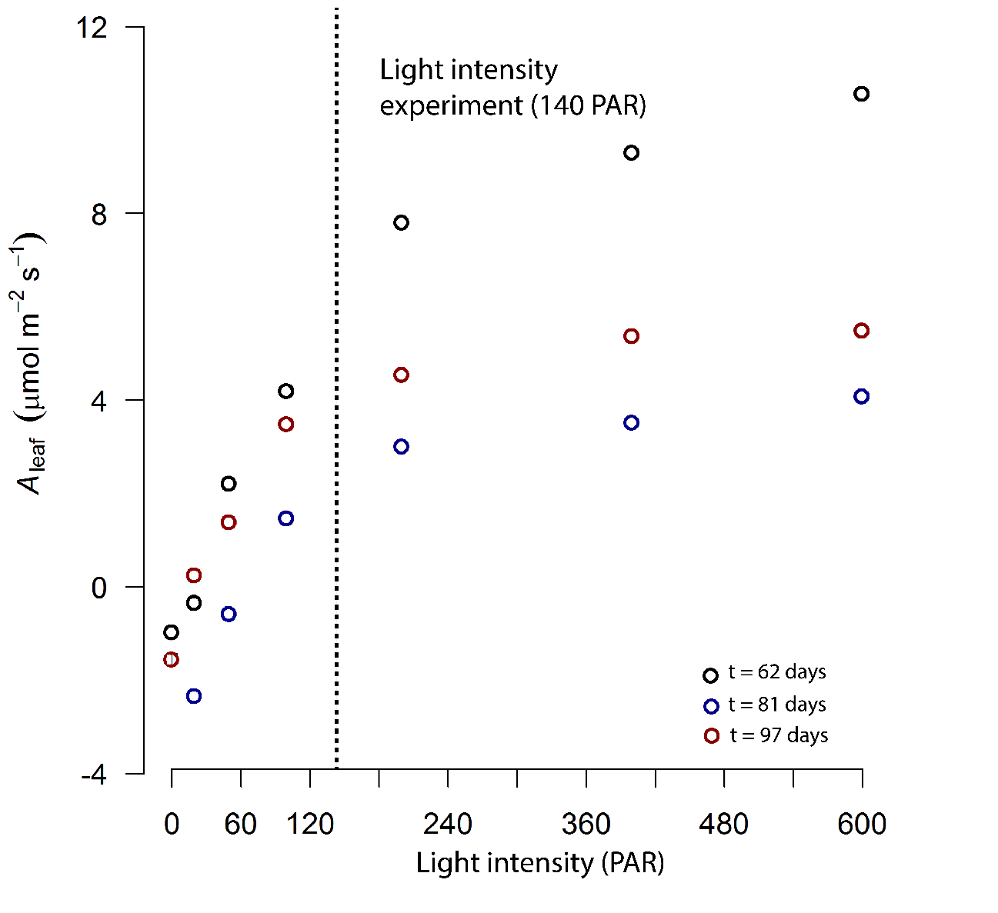

Figure . Net CO2 assimilation rates (µmol m-2 s-1) versus light intensity (PAR) at 61, 81 and 97 days after the start of the experiment. The vertical grey dotted line represents the light condition during the experiment (140 PAR).

# Additional references

Ho, Y.B. Shoot development and production studies of phragmites Australis (Cav.) Trin. Ex Steudel in Scottish Lochs. *Hydrobiologia* **64**, 215–222 (1979).