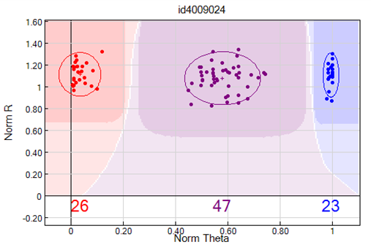
Fig S 1. Clusters of alleles based on the ratio of the cy3/cy5 signal (BeadXpress)

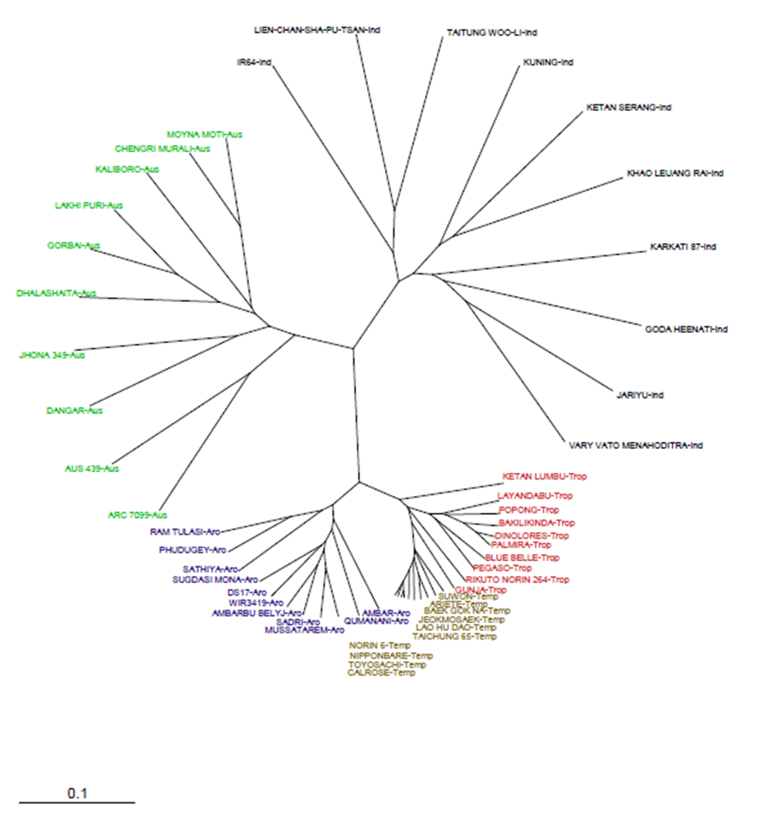
Aromatic
Indica
Fig S 2. Diversity analysis of 50 rice accessions (Thomson et al. 2012)

