Supplementary Material

# Supplementary material S1

## Forage physicochemical characteristics associated with microbial communities

Among the 60 microbial features selected by the sPLS approach within H community assemblies, Proteobacteria including an unclassified *Rhizobiaceae*, a species of the group *Allorhizobium-Neorhizobium-Pararhizobium-Rhizobium* (*Allorhizobium-NPR* sp.), and *Pantoea agglomerans*, Actinobacteria including unclassified *Microbacteriaceae*, and *Bacteroidetes* represented by *Spirosoma* sp*.* exhibited the highest loading weights in sPLS component 2 (Supplementary Figure 5B), showing their high contribution in the separation of clusters in component 2 (Supplementary Figure S5B,C). The MaAsLin2 approach selected 55 microbial features significantly associated with magnesium, moisture, and NDF contents, as well as the storage form of hay. MaAsLin2 is a complementary approach to sPLS in that it can integrate categorical variables in the analysis model. Actinobacteria including *Nocardioides* sp*.* and Proteobacteria including *Serratia* sp*.*, *Pseudomonas* sp*.*, and *Yersinia* sp*.* that were found significantly associated with moisture content (Supplementary Figure S5D) are expected to be part of cluster 1. The canonical relationships between taxa found to be significantly associated with quantitative and categorical variables identified after sPLS and MaAsLin2 analyses were modelled using CCpnA. This analysis revealed that within the variable describing hay storage forms detected by MaAsLin2 analysis, loose hay, not wrapped square/round bales, correlated with community variation. CCpnA also confirmed the impact of sampling periods on taxa occurrence and abundance within H microbiota.

For the GL samples, Firmicutes represented by *Lactobacillus* spp., Proteobacteria including *Methylobacterium* sp*.* and *Sphingomonas* sp*.*, and Actinobacteria represented by *Curtobacterium* sp*.* contributed the much to the separation between clusters in component 1 (Supplementary Figure 7B). On the other hand, Firmicutes including *Weissella* spp., *Lactobacillus* spp., and *Pediococcus* sp*.*, Actinobacteria comprising *Aeriscardovia* spp. and *Corynebacterium* sp*.*, and finally Proteobacteria represented by *Serratia* sp*.* exhibited the highest contribution to cluster separation in component 2 (Supplementary Figure 7B). Of the 77 ASVs distributed among the three clusters, Firmicutes almost essentially composed cluster 1, indicating distinctively higher correlations between putative taxa and moisture, FA and VFA (Supplementary Figure S7C). Proteobacteria, mostly positively correlated with pH, mainly composed cluster 2. Other Firmicutes showing stronger associations with CP_NH3 mainly composed cluster 3. Complementarily, MaAsLin2 analysis identified 27 ASVs significantly associated with pH values, LA, moisture, crude fat (CF), and ammonia (NH3). For instance, while some Firmicutes including *Lactobacillus* spp., *Lentilactobacillus buchneri*, *Pediococcus* *parvulus*, and *Carnobacterium* sp*.* were found negatively correlated with pH, hence indicating their high contribution to silage low pH, others such as *Weissella paramesenteroides*, *Lactococcus* sp*.*, *Pediococcus* sp*.*, and *P. pentosaceus* were positively associated with pH, thus under certain circumstances involved in silage high pH outcomes. Consequently, the latter ASVs would drop into cluster 2, and the remaining into cluster 1. The analysis of these canonical relationships also revealed that in addition to pH, ASVs composing cluster 2 were correlated with silage storage forms including wrapped square/round bales and oxygen-limiting silos (Figure 7B, Supplementary Figure S7D). On the other hand, all ASVs composing cluster 1 and most ASVs composing cluster 3, principally those identified by the sPLS approach and generally highly correlated with moisture, LA, FA, CP, and VFA, were also correlated with concrete-stave and stack silos (Figure 7B). It appears that cluster 1, specifically composed of ASVs that were correlated with LA and moisture, are largely dominated by Firmicutes, although *Erwinia* sp*.*, and another unclassified *Enterobacteriaceae* were present. Almost all ASVs in this cluster largely occur in concrete-stave silos, pressed silos, and oxygen-limiting silos. ASVs composing cluster 2 broadly exhibited greatest prevalence levels, particularly within wrapped square/round bale, and pressed silo groups, in which they generally occurred at low relative abundance, except *P. pentosaceus*, *W. paramesenteroides*, and *Pediococcus* sp*.* that exhibited highest relative abundance (Supplementary Figure S8). ASVs that fell into cluster 3 were generally the least prevalent and abundant, occurring almost essentially in concrete-stave and oxygen-limiting silos.

In the case of GLI samples, sPLS regression selected 79 ASVs of which Proteobacteria represented by *Methylobacterium* sp. and Firmicutes including *Pediococcus* sp*.* and *Lactobacillus* sp*.* exhibited high contributions for the separation of clusters in component 1, while Firmicutes including *Lactobacillus* spp. and an unclassified *Clostridiaceae* contributed the most to cluster separation in component 2 (Supplementary Figure S9B). The MaAsLin2 analysis resulted in the selection of 67 ASVs that variably correlated with the type of inoculant used during ensiling, the form of storage applied, or ESC, LA, AA, calcium, and phosphorus content (Supplementary Figure S9C). Some Firmicutes including *Lactobacillus* spp. and *Weissella* sp*.* showed positive correlations with both AA and LA content, indicating the influence of the ensiling environment on species development. ASVs composing cluster 1 were mostly associated with silage storage forms including oxygen-limiting and concrete-stave silos, as well as inoculant types including 11G22 and Biotal Supersile, while ASVs in cluster 2 mostly associated with the inoculant Biotal Buchneri 500. However, cluster 1 grouped ASVs with the highest prevalence levels and broader distribution patterns among concrete-stave and oxygen-limiting silos (Supplementary Figure S10). Except for *Corynebacterium* sp*.* and *Yersinia* sp*.* that belong to the phyla Actinobacteria and Proteobacteria, respectively, all ASVs in this cluster were Firmicutes of the genera *Lactobacillus*, *Ligilactobacillus*, *Limosilactobacillus*, *Lentilactobacillus*, *Weissella*, *Pseudogracilibacillus*, *Pediococcus*, and *Staphylococcus*. Within cluster 2, all ASVs, practically absent from oxygen-limiting silos, were mostly Proteobacteria, while in cluster 3, ASVs mostly included Firmicutes with few occurrences in oxygen-limiting silos.

Within the selected microbiota of uninoculated silage, Firmicutes represented by *Lactobacillus* spp. contributed the most to the separation of clusters on component 1, while other *Lactobacillus* spp. contributed the most to cluster separation on component 2 (Supplementary Figure S11B). The 40 ASVs composing the sPLS derived clusters belonged to the phyla Firmicutes and Proteobacteria (Supplementary Figure S11 C). The MaAsLin2 modelling revealed 113 ASVs significantly associated with CP_ADF, LA, and the silage storage forms. Compared with the sPLS approach, additional phyla including Actinobacteria and Bacteroidetes were selected. Most of these taxa were positively correlated to silage storage forms, while only six including *Lactobacillus* spp., *Acetobacter* spp., an unclassified Lactobacillales*,* and *Enterobacteriaceae* positively correlated with LA content. On the other hand, among ASVs negatively associated with LA were Firmicutes and mostly Proteobacteria. Firmicutes included *Pedicoccus* sp*.*, *Lentilactobacillus diolivorans*, *L. buchneri*, and other lactobacilli. Proteobacteria were represented by *Ameyamaea* spp., *Achromobacter* sp*.*, *Comamonas* sp*.*, *Providencia stuartii*, *Providencia* spp., and *Morganella morganii*. Taxa grouped in cluster 1 appeared to mostly associate with pressed and stack silos, while those in cluster 2 correlated with concrete-stave silos. As illustrated in Supplementary Figure S12, taxa that significantly correlated with C metadata were not uniformly distributed among silage storage forms. Broadly, lower prevalence levels were observed within members of cluster 1 compared with those in cluster 2, and taxa with the highest relative abundance were not necessarily the more prevalent. The latter included as members of cluster 1 *Lactobacillus* sp*.* occurring in concrete-stave, stack, and pressed silos, *Acetobacter* sp*.* occurring in stack silos, *Pseudomonas* sp*.* occurring in a pressed silo, and *Lactobacillus* spp. occurring in a stack silo. Among ASVs composing cluster 2, those with highest relative abundance included *Serratia* sp*.* occurring mostly in concrete-stave and stack silos, and *Lactobacillus* sp*.* occurring mostly in concrete-stave and pressed silos.

Of the 50 ASVs identified by the sPLS approach (Supplementary Figure S13C) within the CI microbial community, Proteobacteria including *Lelliottia* sp*.*, *Enterobacter* spp., *Raoultella terrigena*, and an unclassified *Enterobacteriaceae*, and Firmicutes represented by *Lactobacillus* spp. and *Vagococcus fluvialis* highly contributed to the separation of clusters on the sPLS component 1, while a Proteobacteria identified as *Serratia* sp*.* exhibited a strong contribution to cluster separation on component 2 (Supplementary Figure S13B). Modelling the relationships between the selected variables and microbial communities using MaAsLin2, we identified 20 ASVs significantly associated with CP, AA, and ESC, as well as the silage storage form and the type of inoculant used for ensiling. Proteobacteria represented by *Methylobacterium adhaesivum*, and Firmicutes including *Lactobacillus* sp*.* and *Leuconostoc* sp*.* were negatively correlated with AA, indicating their probable susceptibility to increasing amounts of some AA. Moreover, ASVs composing cluster 1 mostly associated with the inoculant 11CFT, while those found in cluster 2 mostly associated with the inoculant 11C33 and with bunker silo. As depicted in Supplementary Figure S14, of all the taxa selected, Proteobacteria and Firmicutes were the most represented. However, Firmicutes which mostly composed cluster 1 were the more prevalent, being largely distributed across concrete-stave and bunker silos. The most abundant taxa included *Lactobacillus* sp*.* occurring in concrete-stave silos, *Acetobacter* sp*.* occurring in concrete-stave silos and a bunker silo, and *Lactobacillus* sp*.* and *Latilactobacillus sakei* both occurring in concrete-stave silos.

## Molecular ecological network analyses

Within the GL network, we found that the node corresponding to *L. buchneri* positively interacted with *Lactobacillus* spp. and showed negative relationships with other *Lactobacillus* spp. as well as *Pediococcus* spp., *Weissella* sp., *Bacillus* sp., and *Sphingomonas* sp. *Lactiplantibacillus plantarum*, represented by a single phylotype, exhibited only negative relationships with four ASVs including *Pediococcus* sp., *Lactobacillus* sp., *Bacillus* sp., and *Sphingomonas* sp. In addition to *Sphingonomas* sp., other Proteobacteria phylotypes including *M. adhaesivum*, *Allorhizobium* group., *Pantoea* spp., and *Stenotrophomonas* positively interacted with Firmicutes comprising *Pediococcus* spp., *Enterococcus* sp., *Loigolactobacillus coryniformis*, and *L. sakei* (Supplementary Figure S15).

On the other hand, the GLI network (Supplementary Figure S16) was composed of 47 nodes of which more than 87% were Firmicutes and the remaining Proteobacteria. *L. buchneri* only co-occurred with *Lactobacillus* sp., while sharing negative relationships with more than 87% of nodes, including Proteobacteria (*Pseudomonas* sp., *Serratia* spp., *Allorhizobium* group) and Firmicutes (*Bacillus* spp., *Lactobacillus* spp., *Lactobacillus* *acidipiscis*, *Limosilactobacillus panis*, *L.* *coryniformis*, *Pediococcus* spp., *P. pentosaceus*, *Weissella* spp., *W.* *paramesenteroides*, *Oceanobacillus caeni*, and *Kroppenstedtia sanguinis*). Like *L. buchneri*, *L. plantarum* exhibited the same pattern of interactions with other nodes in the network, sharing a unique positive relationship with a phylotype of *Lactobacillus* sp. and negative relationships with the same taxa as *L. buchneri*, except *L.* *coryniformis*. Of the 47 keystones phylotypes identified in the GL pMEN, the two network hubs included a Firmicutes classified as *Weissella* sp. and a Proteobacteria classified as *Sphingomonas* sp. (Supplementary Table S4). Connectors were composed of Actinobacteria including *Rhodococcus* sp., Firmicutes represented by a phylotype of *Bacillus* sp., *L. buchneri*, *L. plantarum*, *L. coryniformis*, *Lactococcus* sp., nine phylotypes of *Lactobacillus* spp., eight phylotypes of *Weissella* spp., and two phylotypes of unclassified *Lactobacillaceae*, and Proteobacteria including a phylotype of *Aeromonas* sp., *Allorhizobium* group, *Methylobacterium* sp., *Serratia* sp., two phylotypes of *M. adhaesivum*, *Pantoea* spp., *Pseudomonas* spp., *Stenotrophomonas* spp., and three phylotypes of unclassified *Enterobacteriaceae* (Supplementary Table S4).

The C network was composed of 80% Firmicutes including 17 phylotypes of *Lactobacillus* spp., two phylotypes of *L. coryniformis*, and one phylotype of *P. parvulus*, and 20% Proteobacteria represented by one phylotype of *Pseudomonas* sp., three phylotypes of *Serratia* spp., and one phylotype of unclassified *Enterobacteriaceae*. All the five phylotypes of Proteobacteria positively interacted with each other, and with Firmicutes including principally *Lactobacillus* spp. and *L. coryniformis*, indicating that these lactobacilli covaried with Proteobacteria. However, the other phylotypes of lactobacilli and that of *P. parvulus* negatively interacted with Proteobacteria (Supplementary Figure S17A). On the other hand, 55 nodes composing the CI network were subdivided into two modules (Supplementary Figure S17B), involving mostly Firmicutes (80%) and Proteobacteria (18%), the phylum Actinobacteria being represented by a single phylotype. Among the Firmicutes contained in the CI network were one phylotype of *L. buchneri*, two phylotypes of *L. plantarum*, two phylotypes of *L. coryniformis*, one phylotype of *Paucilactobacillus hokkaidonensis*, 34 phylotypes of *Lactobacillus* spp., one phylotype of *P. parvulus*, *P. pentosaceus*, *Weissella* sp., and *Leuconostoc* sp. Proteobacteria of this network included three phylotypes of *Acetobacter* spp. and *Serratia* spp., one phylotype of *Klepsiella* sp., *Pseudomonas* sp., *Yersinia* sp., and an unclassified *Enterobacteriaceae*. *Oerskovia* sp. was the sole Actinobacteria of the CI network. *L. buchneri* positively interacted with Firmicutes only, including *P. parvulus*, *Lactobacillus* sp., and *L. plantarum*, while exhibiting negative relationships with almost all Proteobacteria and Actinobacteria, as well as most of other Firmicutes including *L. plantarum*, *P. hokkaidonensis*, *L. coryniformis*, and *P. pentosaceus*. *L. plantarum* shared positive relationships with *P. parvulus* and eight other lactobacilli, and negative relationships with all Proteobacteria, Actinobacteria, and most of the other Firmicutes. The two phylotypes of *L. plantarum* had different node degrees, probably indicating different ecological roles in the silage fermentation process. Concerning *P. pentosaceus*, another species constitutive of some inoculants, positive relationships were shared with only few Firmicutes comprising *L. coryniformis*, while negative relationships were shared with most Proteobacteria and other Firmicutes.

# Supplementary Figures and Tables

## Supplementary Figures

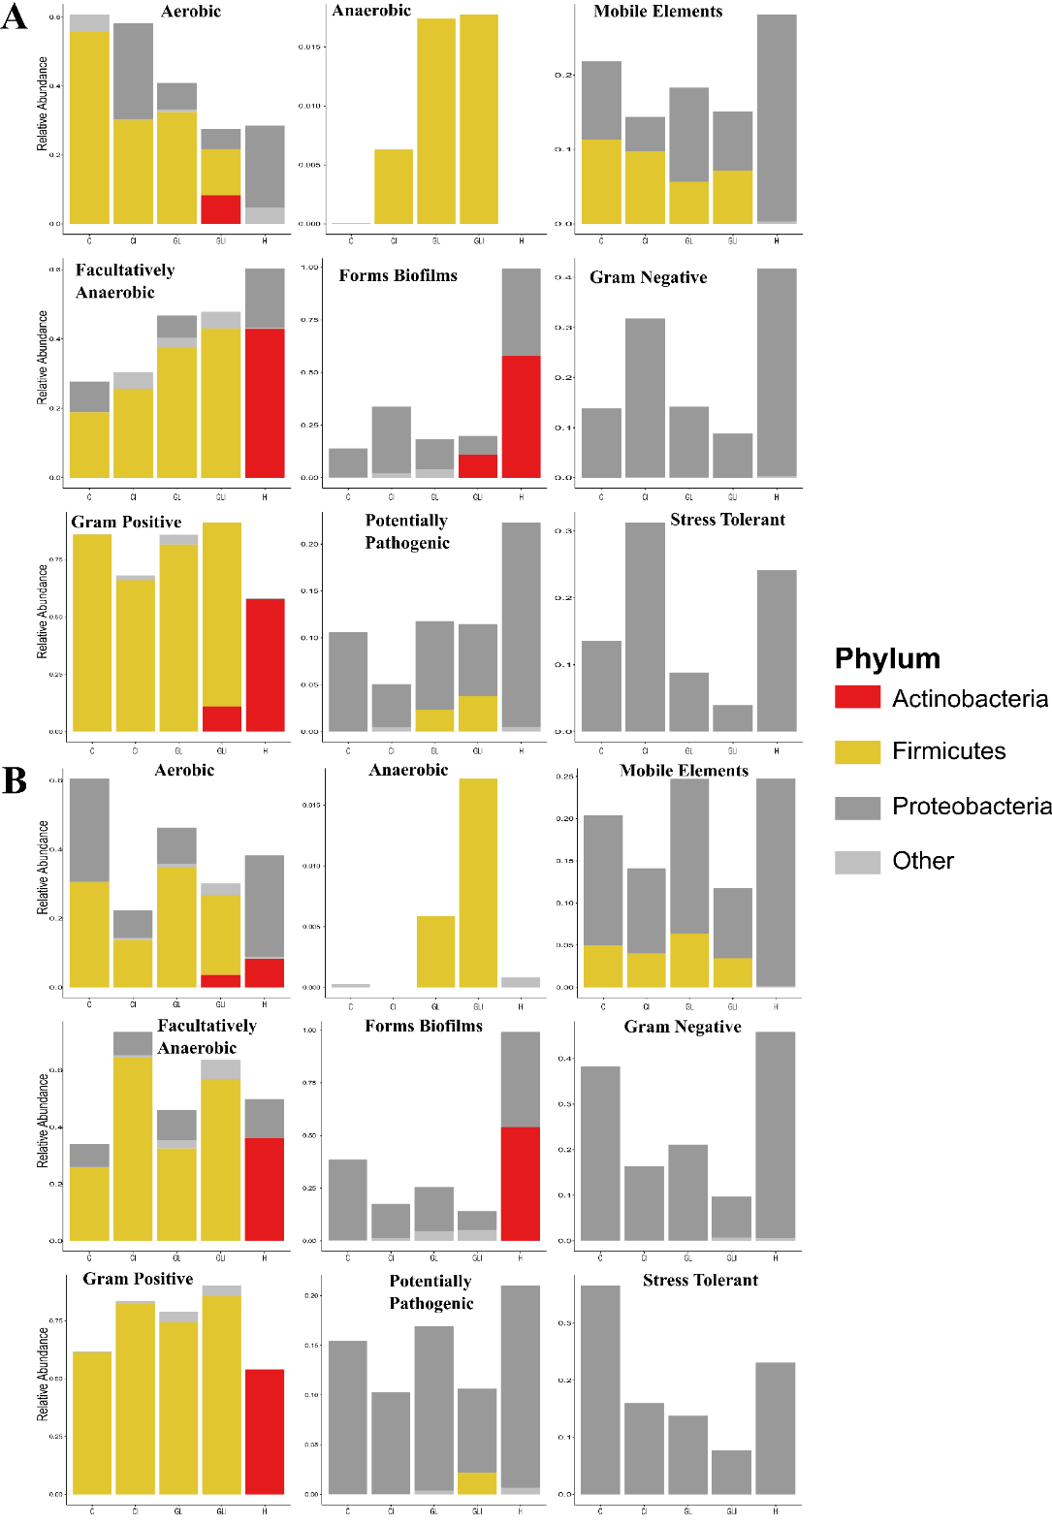

**Supplementary Figure S1.** Predicted contribution to the phenotypic traits inferred by BugBase. Relative abundance of the phyla that contributed to microbial phenotypic traits in preserved forage in the fall 2015 (A) and spring 2016 (B).

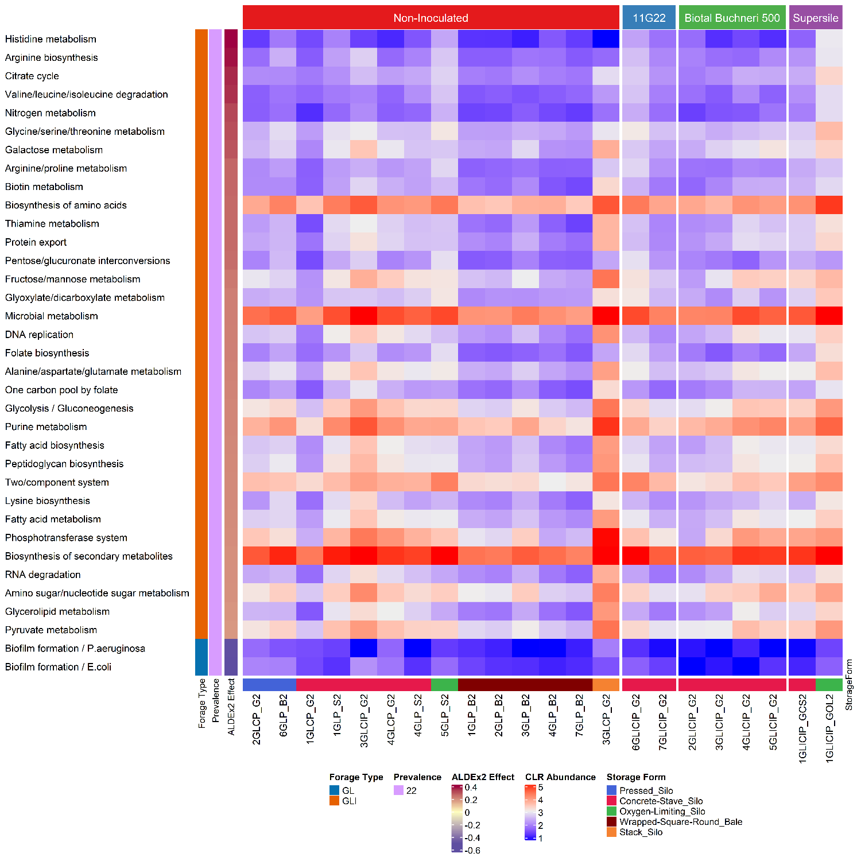

**Supplementary Figure S2.** Distribution of differentially abundant function pathways predicted using Piphillin in inoculated and uninoculated grass/legume silage in the fall 2015.

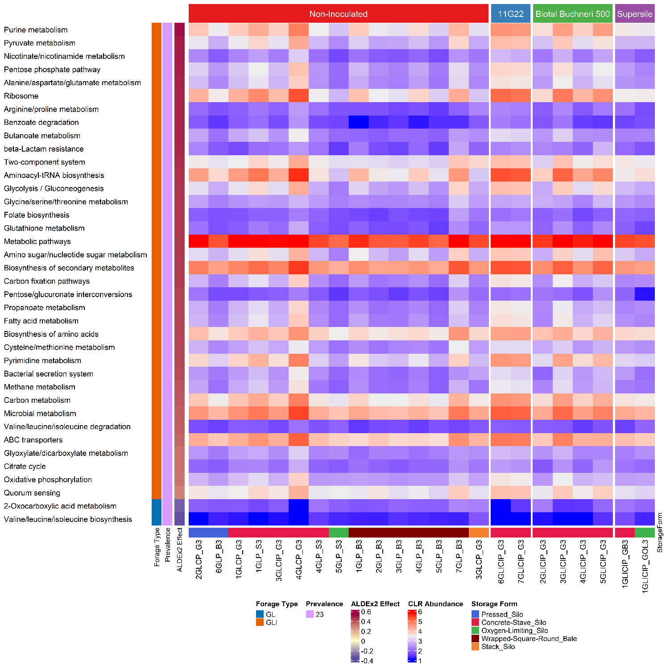

**Supplementary Figure S3.** Distribution of differentially abundant function pathways predicted using Piphillin in inoculated and uninoculated grass/legume silage in the spring 2016.

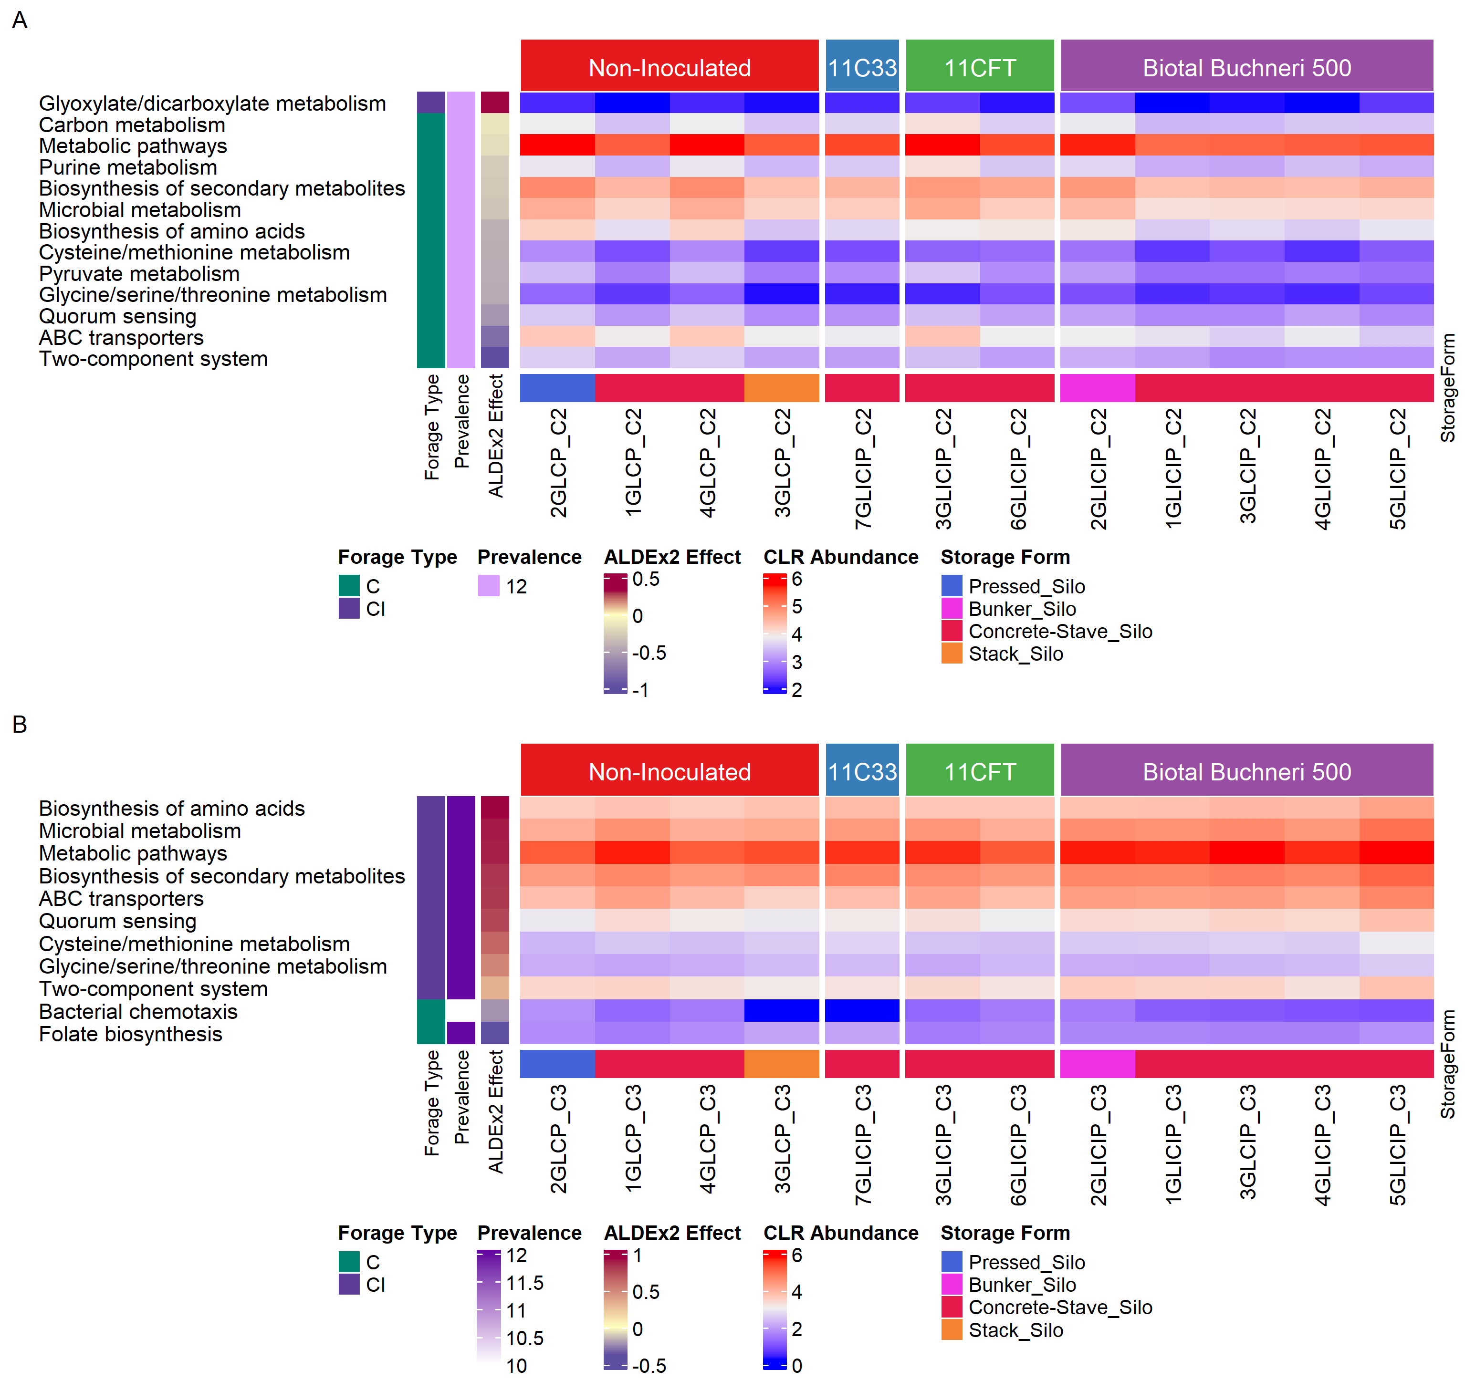

**Supplementary Figure S4.** Distribution of differentially abundant function pathways predicted using Piphillin. Inoculated and uninoculated corn silage in the fall 2015 (A) or spring 2016 (B).

**Supplementary Figure S5.** Sparse partial least square regression of hay physicochemical parameters and bacterial ASV. (A) Correlation circle plot based on the first two dimensions. (B) Loading plot of ASV showing their contributions to the first (left) and the second (right) components. (C) Clustered image map showing correlations between physicochemical parameters and ASV. Mg, magnesium; NDF_D_30, neutral detergent fiber digestibility at 30 hours; NDF_D_30DM, neutral detergent fiber digestibility at 30 hours as percent dry matter; Mstr, moisture.

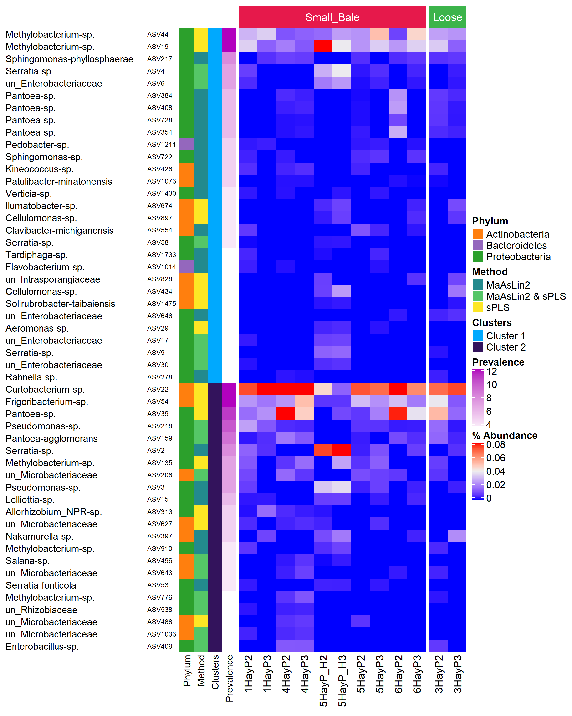

**Supplementary Figure S6.** Prevalence, abundance, and distribution across clusters of ASV significantly correlated with hay physicochemical parameters.

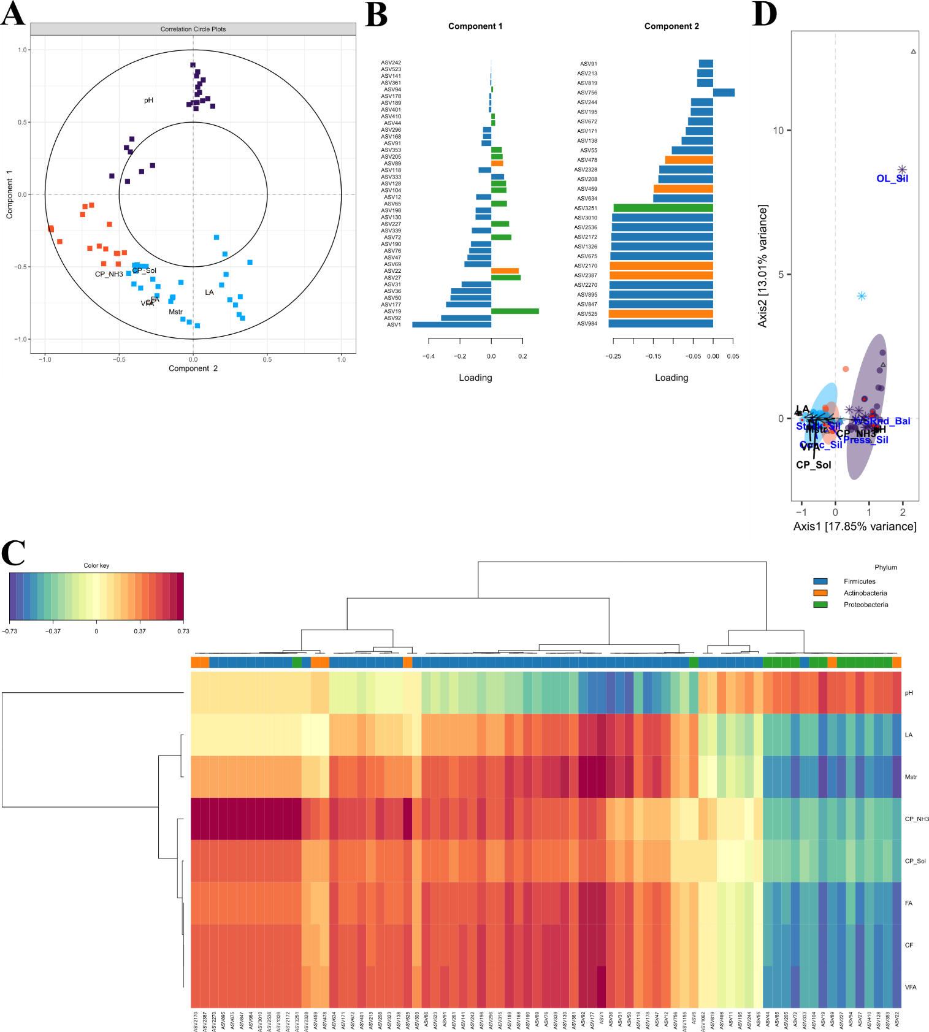

**Supplementary Figure S7.** Sparse partial least square regression analysis of physicochemical parameters and bacterial ASV for uninoculated grass/legume silage. (A) Correlation circle plot based on the first two dimensions. (B) Loading plots of ASV showing their contributions to the first (left) and second (right) components. (C) Clustered image map showing correlations between physicochemical parameters and ASV. (D) Illustration of the complete CCpnA plot showing canonical relationships associated with the sub-variable Oxygen limiting silo (OL_Silo). Abbreviations on the triplot are the same as those provided in Figure 7. pH, potential of hydrogen; LA, lactic acid; Mstr, moisture; CP_NH3, ammonia as percent crude protein; CP_Sol, soluble crude protein; FA, fatty acid; CF, crude fat; VFA, volatile fatty acid.

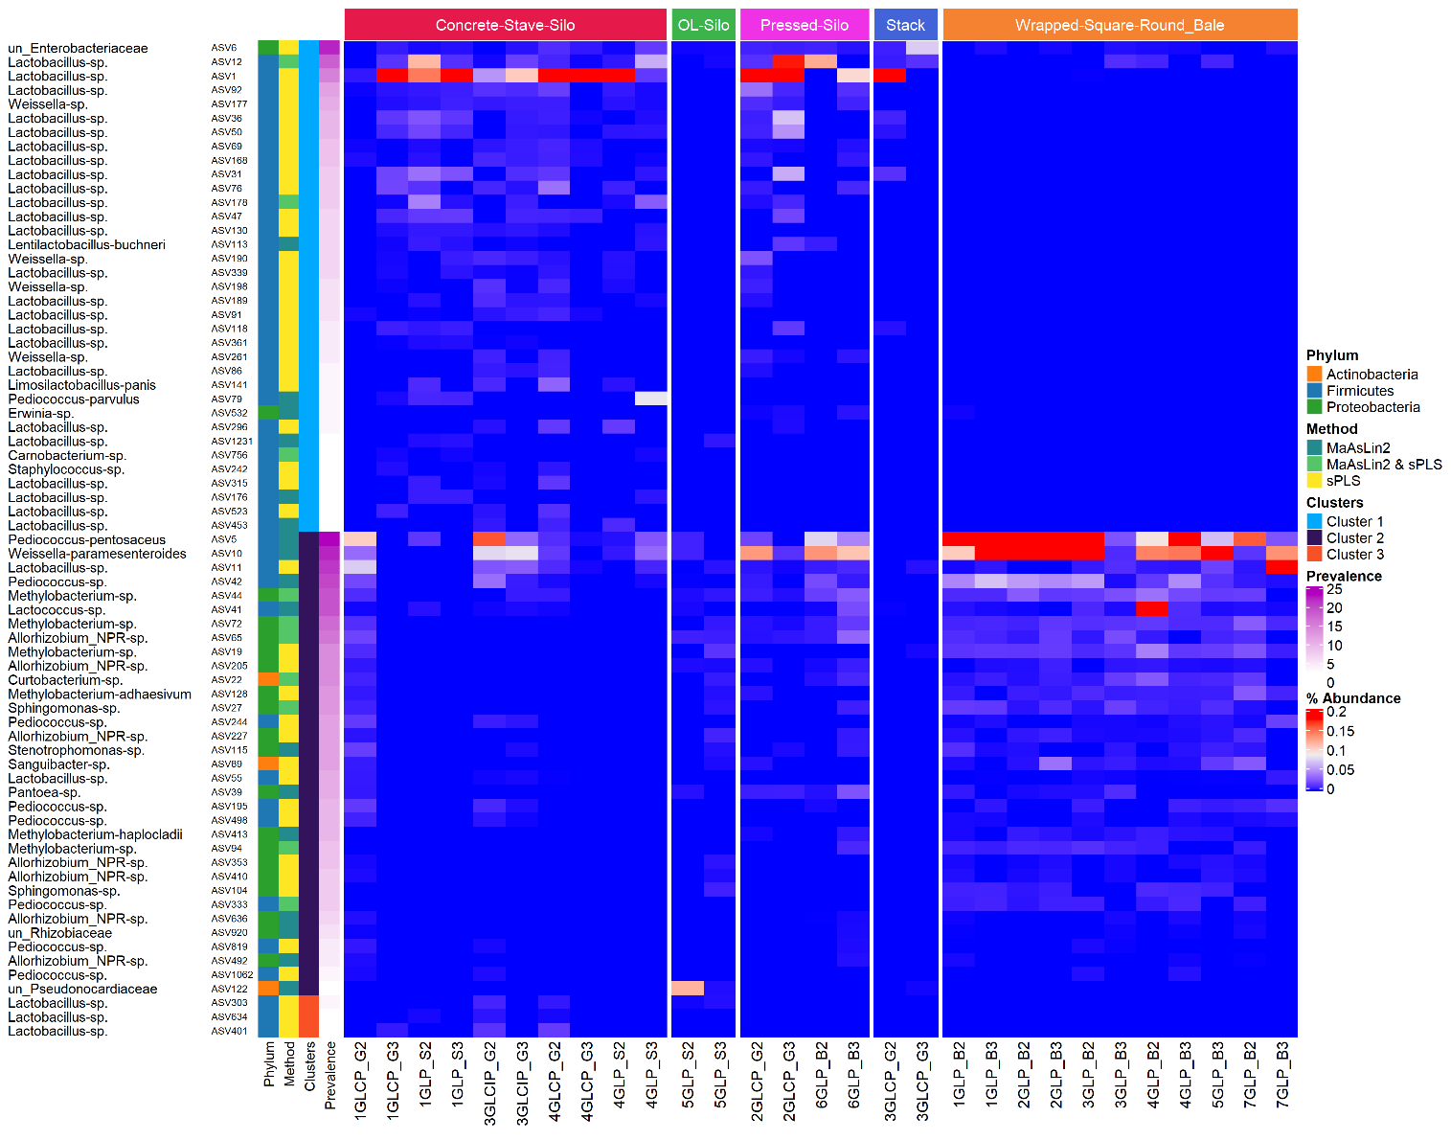

**Supplementary Figure S8.** Prevalence, abundance, and distribution across clusters of ASV significantly correlated with physicochemical parameters for uninoculated grass/legume silage.

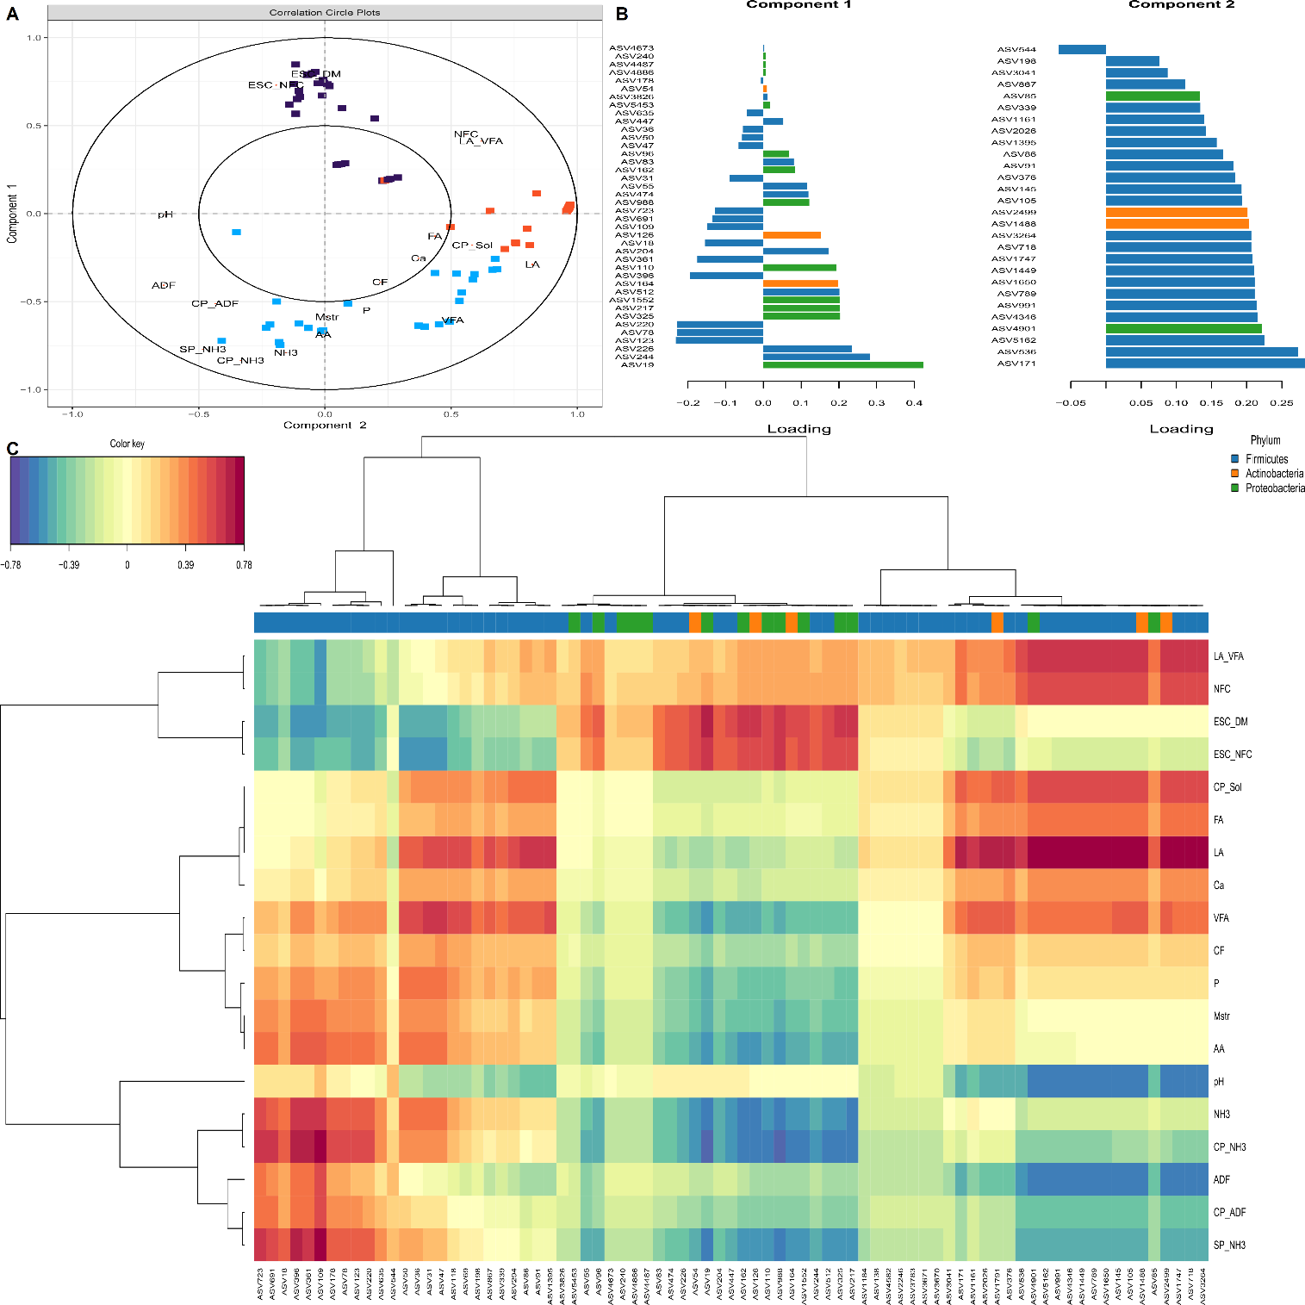

**Supplementary Figure S9.** Sparse partial least square regression analysis of physicochemical parameters and bacterial ASV for inoculated grass/legume silage. (A) Correlation circle plot based on the first two dimensions. (B) Loading plots of ASV showing their contributions to the first (left) and second (right) components. (C) Clustered image map showing correlations between physicochemical parameters and ASV. LA_VFA, lactic acid expressed as percent volatile fatty acids; NFC, non-fiber carbohydrates; ESC_DM, ethanol-soluble carbohydrates as percent dry matter; ESC_NFC, ethanol-soluble carbohydrates as percent non-fiber carbohydrates; CP_Sol, soluble crude protein; FA, fatty acid; LA, lactic acid; Ca, calcium; VFA, volatile fatty acid; CF, crude fat; P, potassium; Mstr, moisture; AA, amino acid; pH, potential of hydrogen; NH3, ammonia; CP_NH3, ammonia expressed as percent crude protein; ADF, acid detergent fiber; CP_ADF, acid detergent fiber as percent crude protein; SP_NH3, ammonia as percent soluble protein.

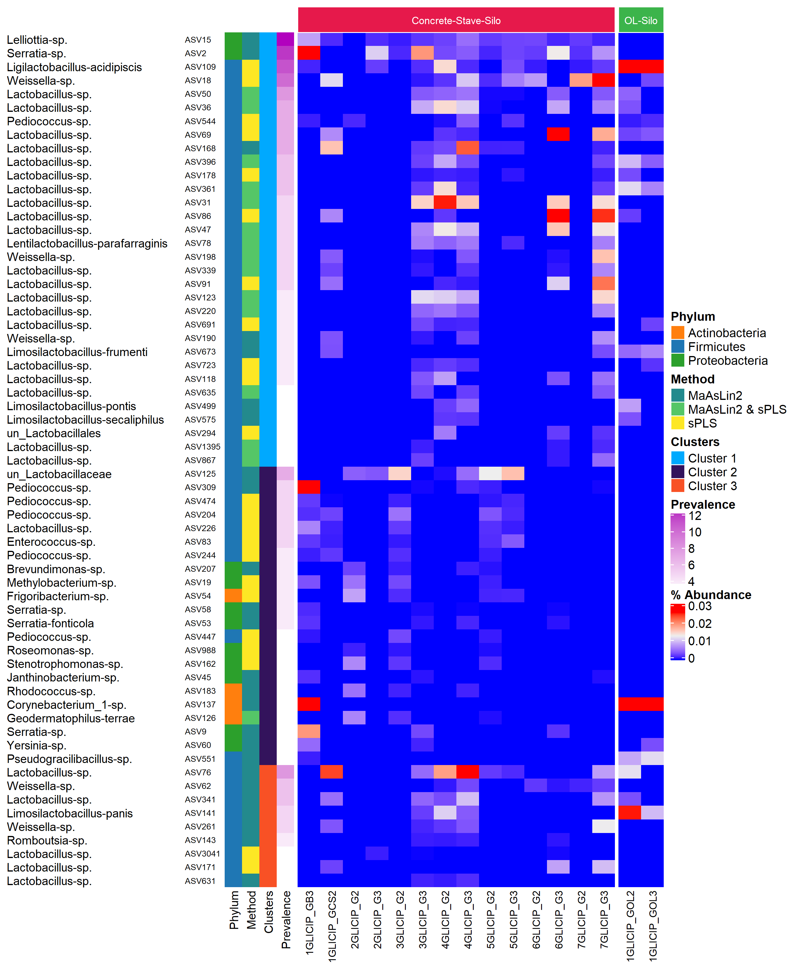

**Supplementary Figure S10.** Prevalence, abundance, and distribution across clusters of ASV significantly correlated with physicochemical parameters for inoculated grass/legume silage.

**Supplementary Figure S11.** Sparse partial least square regression analysis of physicochemical parameters and bacterial ASV for uninoculated corn silage. (A) Correlation circle plot based on the first two dimensions. (B) Loading plots of ASV showing their contributions to the first (left) and second (right) components. (C) Clustered image map showing correlations between physicochemical parameters and ASV. CP_ADF, acid detergent fiber as percent crude protein; LA, lactic acid.

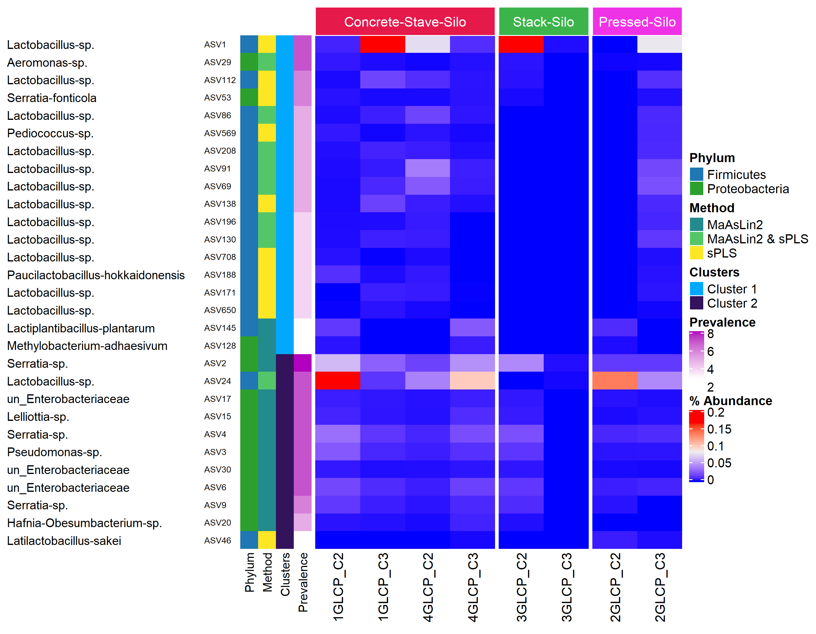

**Supplementary Figure S12.** Prevalence, abundance, and distribution across clusters of ASV significantly correlated with physicochemical parameters for uninoculated corn silage.

**Supplementary Figure S13.** Sparse partial least square regression analysis of physicochemical parameters and bacterial ASV for inoculated corn silage. (A) Correlation circle plot based on the first two dimensions. (B) Loading plots of ASV showing their contributions to the first (left) and second (right) components. (C) Clustered image map showing correlations between physicochemical parameters and ASV. FA, fatty acid; AA, amino acid; CP_DM, crude protein as percent dry matter; LA_VFA, lactic acid as percent volatile fatty acid; CHO_NFC, carbohydrate as percent non-fiber carbohydrate; CHO_DM, carbohydrate as percent dry matter.

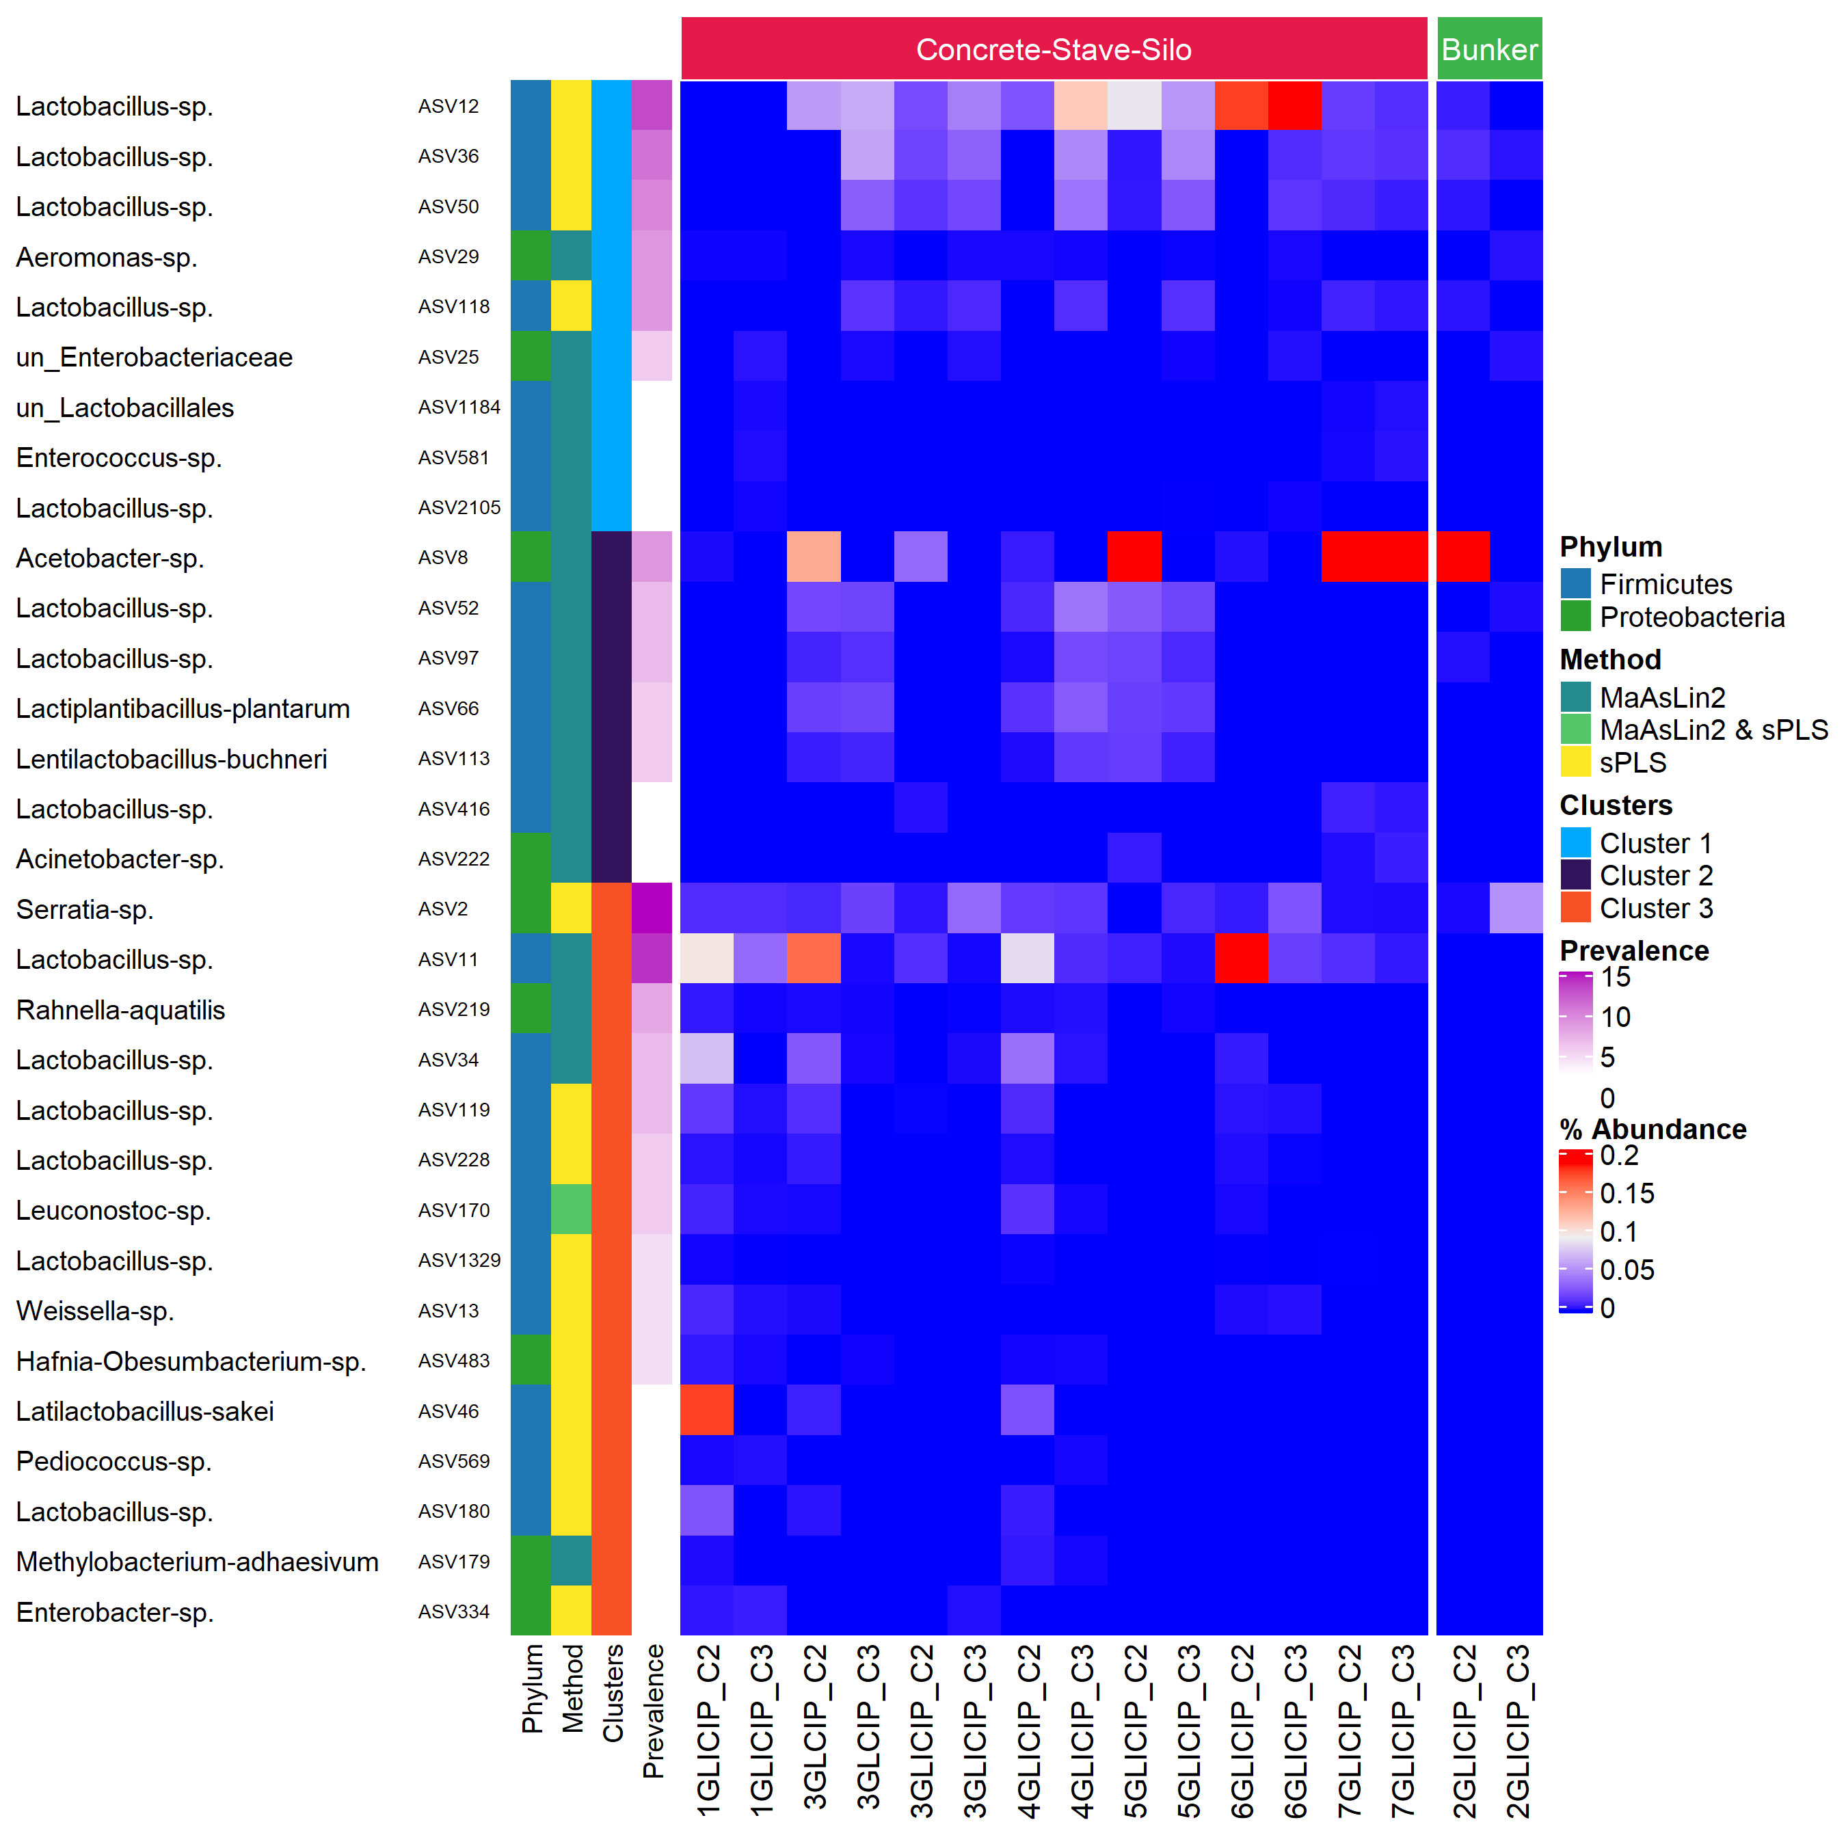

**Supplementary Figure S14.** Prevalence, abundance, and distribution across clusters of ASV significantly correlated with physicochemical parameters for inoculated corn silage.

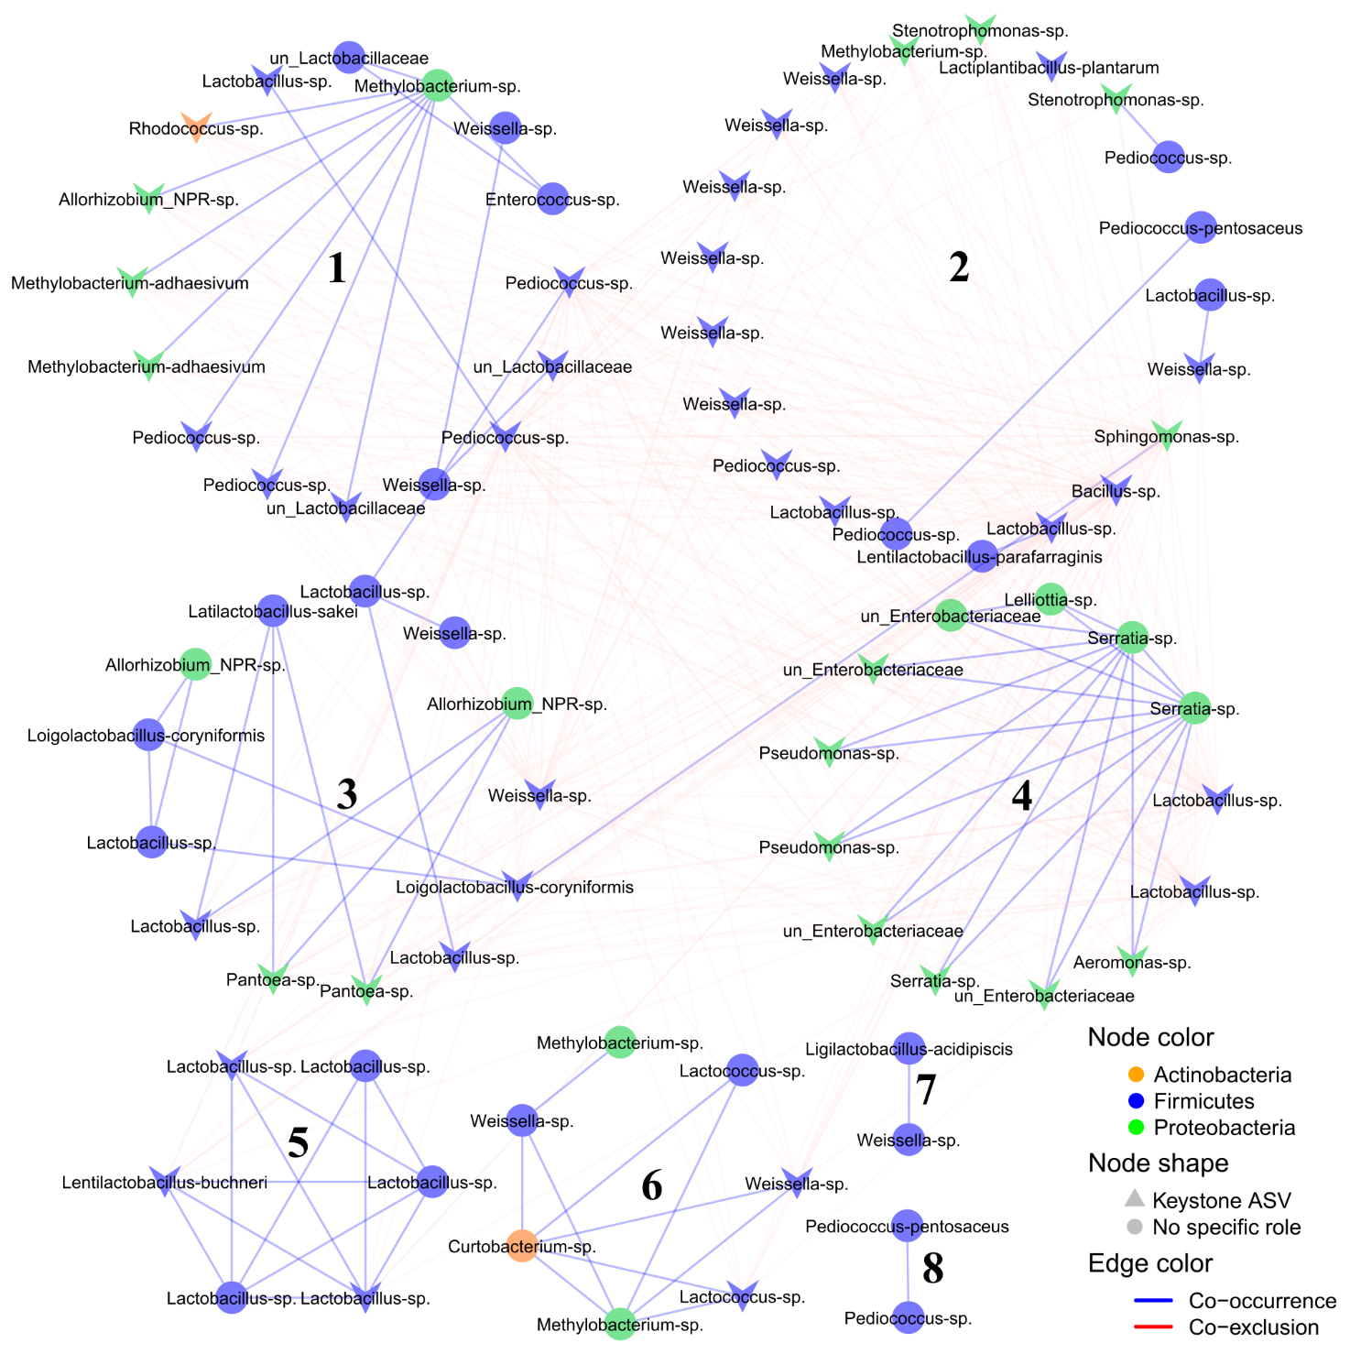

**Supplementary Figure S15.** Network analysis of co-occurring and co-excluding ASV in uninoculated grass/legume silage.

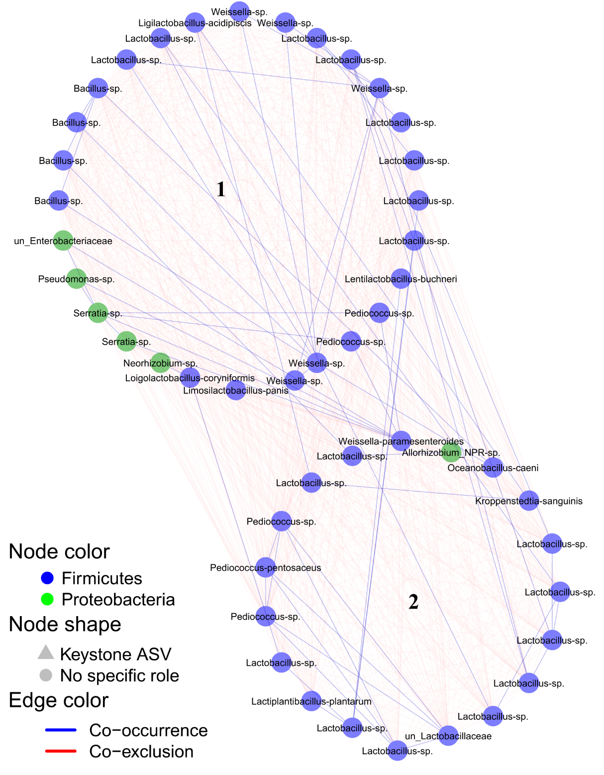

**Supplementary Figure S16.** Network analysis of co-occurring and co-excluding ASV in inoculated grass/legume silage.

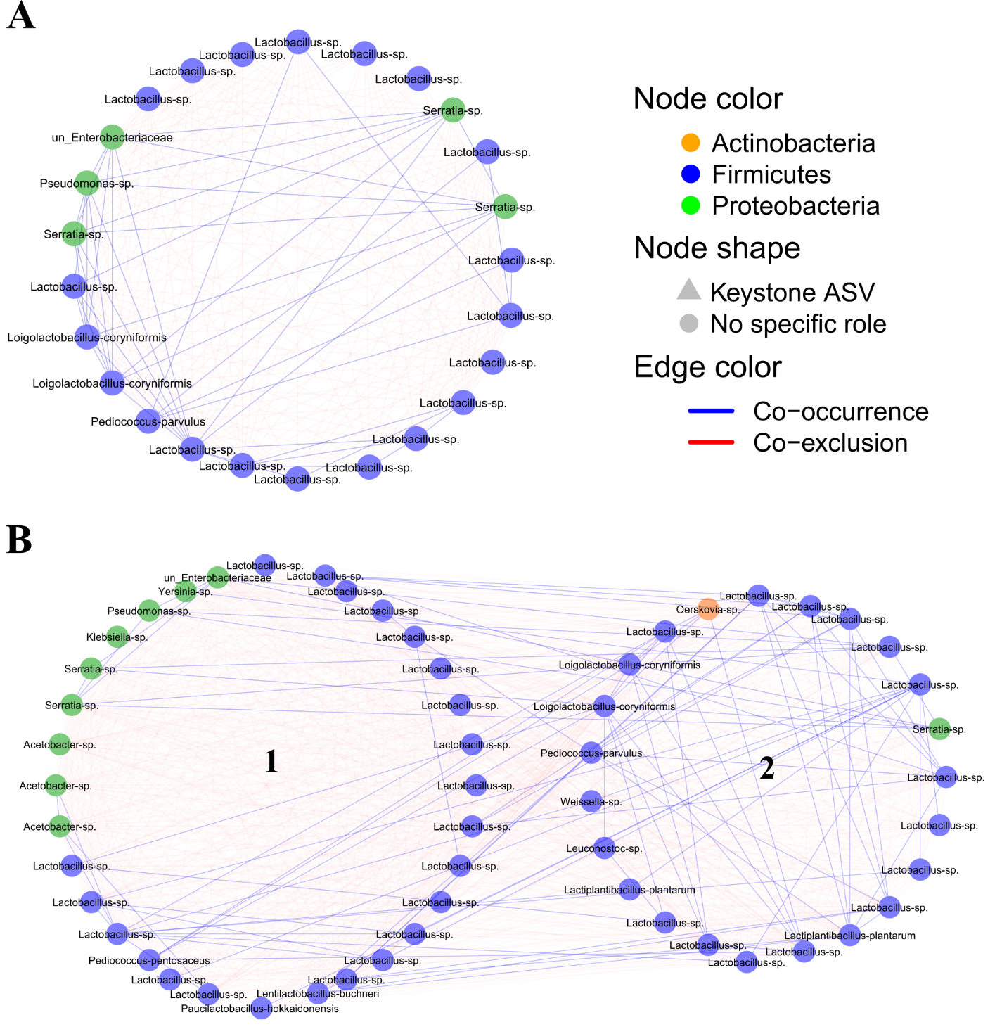

**Supplementary Figure S17.** Network analysis of co-occurring and co-excluding ASV in uninoculated (A) and inoculated (B) corn silage.

## Supplementary tables

Supplementary Table S1: Chemical composition of hay in the Fall 2015 and Spring 2016.

|  |  |  |  |
| --- | --- | --- | --- |
| **Parameters1** | **Fall 2015 (n=6)** | **Spring 2016 (n=6)** | **p value** |
| Moisture (% of total weight) | 13.4 ± 3.2 | 12.7 ± 3.1 | 0.75 |
| Proteins |  |  |  |
| Crude (% of DM) | 11.0 ± 1.6 | 12.7 ± 2.1 | 0.15 |
| Soluble (% of CP) | 8.6 ± 13.6 | 3.6 ± 0.2 | 0.15 |
| Carbohydrates |  |  |  |
| ESC (% of DM) | 8.2 ± 1.5 | 8.3 ± 2.0 | 0.42 |
| Fibers |  |  |  |
| ADF (% of DM) | 38.3 ± 2.4 | 37.2 ± 3.2 | 0.42 |
| aNDF (% of DM) | 63.0 ± 1.6 | 57.2 ± 5.2 | 0.04 |
| Minerals |  |  |  |
| Calcium (% of DM) | 0.5 ± 0.1 | 0.7 ± 0.1 | 0.11 |
| Phosphorus (% of DM) | 0.2 ± 0.0 | 0.3 ± 0.0 | 0.17 |
| Magnesium (% of DM) | 0.2 ± 0.0 | 0.2 ± 0.0 | 0.52 |
| Potassium (% of DM) | 1.6 ± 0.3 | 2.2 ± 0.3 | 0.04 |
| Energy |  |  |  |
| TDN (% of DM) | 60.6 ± 1.8 | 60.1 ± 1.9 | 0.57 |
| NFC (% of DM) | 23.2 ± 2.3 | 25.6 ± 3.1 | 0.13 |

Within a row, each mean is given with the corresponding standard deviation. p values were obtained after performing a Wilcoxon Rank Sum Test across sampling periods. 1 ESC, ethanol soluble carbohydrates; NFC, non-fibre carbohydrates; ADF, acid detergent fiber; aNDF, amylase derived neutral detergent fiber; TDN, total digestible nutrient;% of DM, percent of dry matter;% of CP, percent of crude protein.

Supplementary Table S2: Chemical and fermentation characteristics of GL and GLI silage in the Fall 2015 and Spring 2016

|  |  |  |  |  |  |  |
| --- | --- | --- | --- | --- | --- | --- |
| **Parameters1** | **Fall 2015** | | **p value3** | **Spring 2016** | | **p value3** |
| **GL (n=14)2** | **GLI (n=8)2** | **GL (n=15)** | **GLI (n=8)** |
| Moisture (%) | 55.1 ± 10.6 | 59.1 ± 5.1 | 0.41 | 51.5 ± 10.3 | 58.1 ± 8.0 | 0.14 |
| Proteins |  |  |  |  |  |  |
| Crude (% of DM) | 18.1 ± 2.3 | 18.5 ± 2.3 | 0.76 | 17.3 ± 3.3 | 19.3 ± 2.7 | 0.23 |
| ADF (% of CP) | 10.5 ± 2.3 | 9.7 ± 2.8 | 0.94 | 10.9 ± 4.3 | 9.5 ± 3.2 | 0.36 |
| Soluble (% of CP) | 55.4 ± 8.5 | 56.3 ± 4.3 | 0.91 | 51.7 ± 8.1 | 59.5 ± 8.0 | <0.05 |
| Ammonia |  |  |  |  |  |  |
| % of DM | 1.4 ± 0.6 | 1.5 ± 0.5 | 0.54 | 1.2 ± 0.6 | 1.8 ± 0.5 | <0.05 |
| % of CP | 7.6 ± 3.2 | 8.0 ± 2.1 | 0.35 | 6.6 ± 2.5 | 9.3 ± 2.4 | <0.05 |
| % of SP | 13.6 ± 4.1 | 14.3 ± 4.1 | 0.68 | 12.7 ± 3.9 | 16.2 ± 5.2 | 0.10 |
| Fibers |  |  |  |  |  |  |
| ADF (% of DM) | 34.2 ± 2.6 | 34.2 ± 4.4 | 0.71 | 34.6 ± 3.5 | 34.6 ± 4.3 | 0.87 |
| aNDF (% of DM) | 47.3 ± 5.3 | 46.8 ± 5.1 | 0.73 | 50.2 ± 7.6 | 47.2 ± 8.1 | 0.60 |
| Carbohydrates |  |  |  |  |  |  |
| ESC (% of NFC) | 15.8 ± 6.4 | 12.4 ± 5.9 | 0.21 | 18.4 ± 8.0 | 10.1 ± 5.7 | <0.05 |
| Energy |  |  |  |  |  |  |
| NFC (% of DM) | 24.9 ± 4.3 | 24.4 ± 4.7 | 0.83 | 23.9 ± 3.8 | 22.7 ± 4.7 | 0.38 |
| Others |  |  |  |  |  |  |
| Crude Fat (% of DM) | 3.5 ± 0.6 | 3.6 ± 0.2 | 0.68 | 3.4 ± 0.4 | 3.7 ± 0.7 | 0.30 |
| Fatty Acid (% of DM) | 2.1 ± 0.5 | 2.1 ± 0.3 | 0.83 | 2.1 ± 0.3 | 2.1 ± 0.4 | 0.72 |
| Volatile Fatty Acid  (% of DM) | 7.1 ± 3.5 | 9.3 ± 1.2 | 0.39 | 7.0 ± 3.5 | 10.9 ± 3.2 | <0.05 |
| pH | 4.5 ± 0.4 | 4.3 ± 0.2 | 0.18 | 4.5 ± 0.4 | 4.4 ± 0.2 | 0.44 |
| Lactic Acid |  |  |  |  |  |  |
| % of DM | 4.4 ± 2.1 | 5.3 ± 0.9 | 0.17 | 4.4 ± 2.3 | 6.1 ± 2.2 | 0.15 |
| % of VFA | 55.9 ± 15.8 | 57.4 ± 8.0 | 0.83 | 63.1 ± 20.0 | 55.6 ± 9.3 | 0.22 |
| Acetic Acid  (% of DM) | 3.1 ± 2.2 | 3.5 ± 1.2 | 0.29 | 2.3 ± 1.7 | 4.4 ± 1.7 | <0.05 |
| Butyric Acid  (% of DM) | 0.3 ± 0.4 | 0.4 ± 0.3 | 0.72 | 0.1 ± 0.2 | 0.3 ± 0.3 | 0.24 |

1 ADF, acid detergent fiber; aNDF, amylase derived neutral detergent fibre; ADF-CP, acid detergent fiber-protein; Soluble Protein CP, soluble crude protein fraction; Ammonia CP, crude protein associated ammonia; Ammonia SP, soluble protein associated ammonia; NFC carbohydrates, ethanol-soluble carbohydrates as percentage of non-fiber carbohydrates; VFA Lactic Acid, lactic acid as percentage of total volatile fatty acid. 2 No significant difference was obtained across sampling periods for GL and GLI, respectively. 3 p values were obtained after performing a Wilcoxon Rank Sum Test.% of DM, percent of dry matter;% of CP, percent of crude protein;% of SP, percent of soluble protein;% of non-fiber carbohydrates;% of VFA, percent of total volatile fatty acid.

Supplementary Table S3: Chemical and fermentation characteristics of C and CI silage in the Fall 2015 and Spring 2016

|  |  |  |  |  |  |  |
| --- | --- | --- | --- | --- | --- | --- |
| **Parameters1** | **Fall 2015** | | **p value3** | **Spring 2016** | | **p value3** |
| **C (n=4)2** | **CI (n=8)2** | **C (n=4)** | **CI (n=8)** |
| Moisture (%) | 68 ± 7.8 | 62.2 ± 3.6 | 0.20 | 64.5 ± 6.1 | 61.1 ± 2.1 | 0.20 |
| Proteins |  |  |  |  |  |  |
| Crude (% of DM) | 7. 5 ± 1.6 | 7.6 ± 0.7** | 0.30 | 7.4 ± 1.0 | 6.8 ± 0.7 | 0.10 |
| ADF (% of CP) | 12.2 ± 1.0 | 10.2 ± 3.9 | 0.50 | 12.3 ± 0.5 | 12.3 ± 1.3 | 0.73 |
| Soluble (% of CP) | 46.2 ± 2.9 | 51.6 ± 5.6 | 0.05 | 49.3 ± 5.9 | 59.9 ± 7.3 | <0.05 |
| Ammonia |  |  |  |  |  |  |
| % of DM | 0.7 ± 0.3 | 1.0 ± 0.3 | 0.20 | 0.8 ± 0.1 | 1.1 ± 0.3 | <0.01 |
| % of CP | 9.0 ± 1.6 | 12.6 ± 3.1* | <0.05 | 10.3 ± 1.5 | 16.3 ± 2.7 | <0.05 |
| % of SP | 19.5 ± 3.1 | 24.1 ± 4.6 | <0.05 | 21.1 ± 2.6 | 27.3 ± 4.1 | <0.05 |
| Carbohydrates |  |  |  |  |  |  |
| ESC (% of NFC) | 3.8 ± 4.4 | 1.7 ± 0.8 | 0.27 | 2.6 ± 0.9 | 1.5 ± 1.3 | 0.06 |
| Fibers |  |  |  |  |  |  |
| ADF (% of DM) | 26.3 ± 8 | 22.5 ± 2.1 | 0.30 | 24.9 ± 3.8 | 24.3 ± 6.6 | 0.61 |
| aNDF (% of DM) | 44.9 ± 11.1 | 39.1 ± 2.3 | 0.20 | 43 ± 5.8 | 35.3 ± 11.7 | 0.17 |
| Energy |  |  |  |  |  |  |
| NFC (% of DM) | 43.4 ± 12.7 | 48.4 ± 2.5 | 0.61 | 45.2 ± 6.4 | 49.4 ± 4.2 | 0.31 |
| Others |  |  |  |  |  |  |
| Crude Fat (% of DM) | 2.5 ± 0.1 | 2.8 ± 0.2 | <0.05 | 2.5 ± 0.1 | 2.8 ± 0.3 | 0.31 |
| Fatty Acid (% of DM) | 2.1 ± 0.5 | 2.6 ± 0.1 | 0.06 | 2.4 ± 0.1 | 2.7 ± 0.3 | 0.11 |
| Volatile Fatty Acid  (% of DM) | 6.4 ± 2.5 | 4.9 ± 1.4 | 0.40 | 5.1 ± 0.6 | 6.1 ± 2.7 | 0.31 |
| pH | 3.8 ± 0.2 | 3.7 ± 1.1 | 0.10 | 3.9 ± 0.0 | 3.9 ± 0.2 | 0.61 |
| Lactic Acid |  |  |  |  |  |  |
| % of DM | 4.9 ± 1.7 | 2.6 ± 1.5 | 0.10 | 3.4 ± 0.5 | 4.1 ± 1.9 | 0.61 |
| % of VFA | 77.5 ± 5.2* | 52.8 ± 24.1 | <0.05 | 66.0 ± 7.7 | 59.2 ± 15.6 | 0.31 |
| Acetic Acid  (% of DM) | 1.3 ± 1.2 | 2.3 ± 1.3 | 0.30 | 1.8 ± 0.5 | 2.6 ± 0.8 | 0.09 |
| Butyric Acid  (% of DM) | ND | ND | - | ND | ND | - |
| Propanediol  (% of DM) | 0.9 ± 1.3 | 1.8 ± 0.9 | 0.20 | 1.6 ± 0.4 | 2 .0± 0.9 | 0.2 |

1 ADF, acid detergent fiber; aNDF, amylase derived neutral detergent fibre; ADF-CP, acid detergent fiber-protein; Soluble Protein CP, soluble crude protein fraction; Ammonia CP, crude protein associated ammonia; Ammonia SP, soluble protein associated ammonia; NFC carbohydrates, ethanol-soluble carbohydrates as percentage of non-fiber carbohydrates; VFA Lactic Acid, lactic acid as percentage of total volatile fatty acid. 2 Within a row, the superscript following a mean and corresponding standard deviation indicates the significance of the difference with the same category during the next sampling period. 3 p values were obtained after performing a Wilcoxon Rank Sum Test.% of DM, percent of dry matter;% of CP, percent of crude protein;% of SP, percent of soluble protein;% of non-fiber carbohydrates;% of VFA, percent of total volatile fatty acid.

Supplementary Table S4: Keystone phylotypes of the GL pMEN

|  |  |  |  |  |
| --- | --- | --- | --- | --- |
| **Keystones** | **Phylum** | **Family / Species** | **Phylotypes1** | **Module** |
| Network hubs | *Firmicutes* | *Weissella* sp. | ASV248 | 3 |
| *Proteobacteria* | *Sphingomonas* sp. | ASV27 | 2 |
| Connectors | *Actinobacteria* | *Rhodococcus* sp. | ASV183 | 1 |
| *Firmicutes* | *Bacillus* sp. | ASV21 | 2 |
| *Lentilactobacillus buchneri* | ASV113 | 5 |
| *Loigolactobacillus coryniformis* | ASV101 | 3 |
| *Lactiplantibacillus plantarum* | ASV66 | 2 |
| *Lactobacillus* spp. | ASV163 | 1 |
| ASV178 | 2 |
| ASV93, ASV637 | 3 |
| ASV97, ASV24, ASV226 | 4 |
| ASV47, ASV118 | 5 |
| *Lactococcus* sp. | ASV440 | 6 |
| *Pediococcus* spp. | ASV152, ASV474, SV221, ASV244 | 1 |
| ASV204 | 2 |
| *Lactobacillaceae* | ASV125, ASV324 | 1 |
| *Weissella* spp. | ASV275, ASV262, ASV290, ASV67, ASV186, ASV190, ASV198 | 2 |
| ASV600 | 6 |
| *Proteobacteria* | *Aeromonas* sp. | ASV29 | 4 |
| *Allorhizobium* group | ASV111 | 1 |
| *Methylobacterium adhaesivum* | ASV179, ASV128 | 1 |
| *Methylobacterium* sp. | ASV94 | 2 |
| *Pantoea* spp. | ASV56, ASV39 | 3 |
| *Pseudomonas* spp. | ASV14, ASV3 | 4 |
| *Serratia* sp. | ASV9 | 4 |
| *Stenotrophomonas* spp. | ASV162, ASV115 | 2 |
| *Enterobacteriaceae* | ASV17, ASV25, ASV30 | 4 |

1 Phylotypes highlighted in red are GL connectors that changed their topological role to peripherals in the GLI network.