**Supplementary Figure 1**

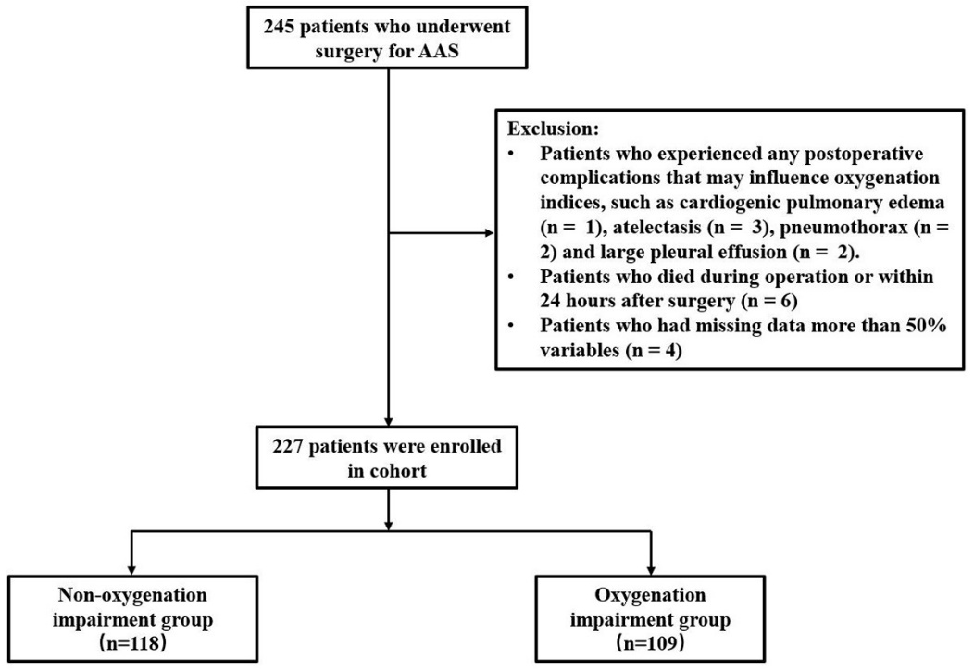

**Supplementary Figure 1.** Study flow chart in the retrospective study. AAS: acute aortic syndrome.

**Supplementary Figure 2**

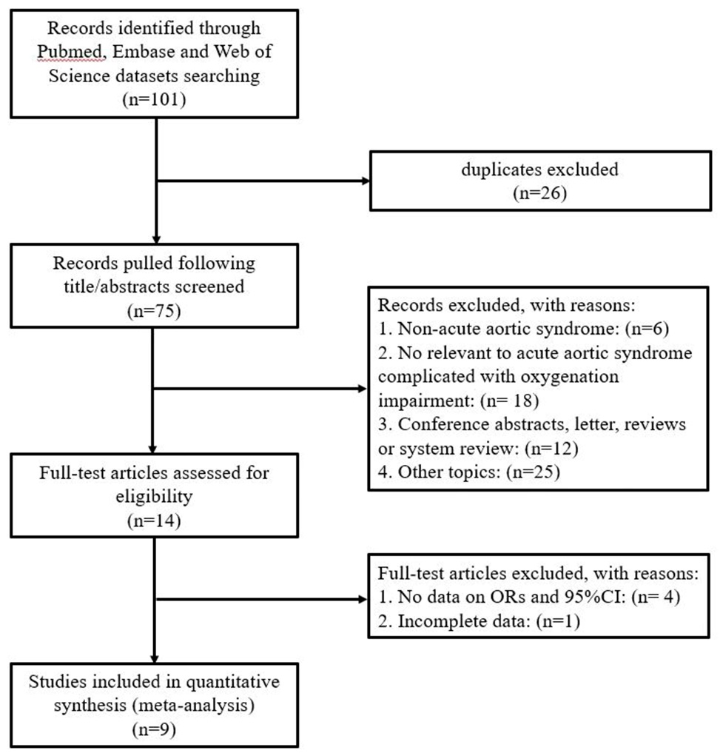

**Supplementary Figure 2.** Flow diagram of literatures screen with criteria.

**Supplementary Figure 3**

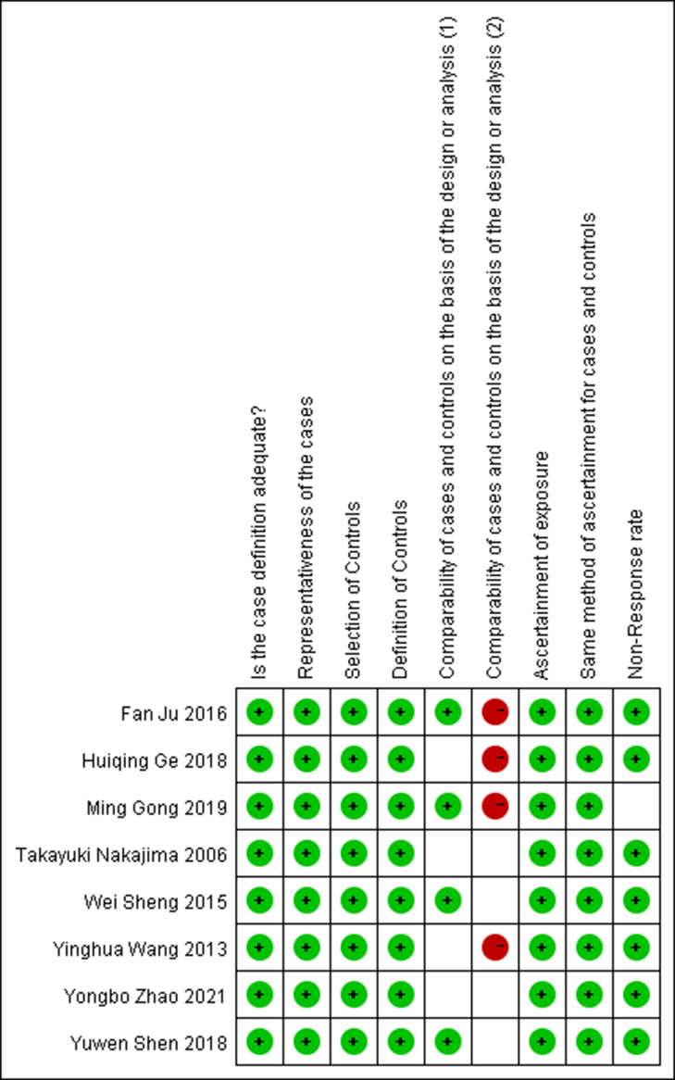

**Supplementary Figure 3.** Literature quality evaluation based on NOS assessment. NOS: Newcastle-Ottawa Scale.

**Supplementary Figure 4**

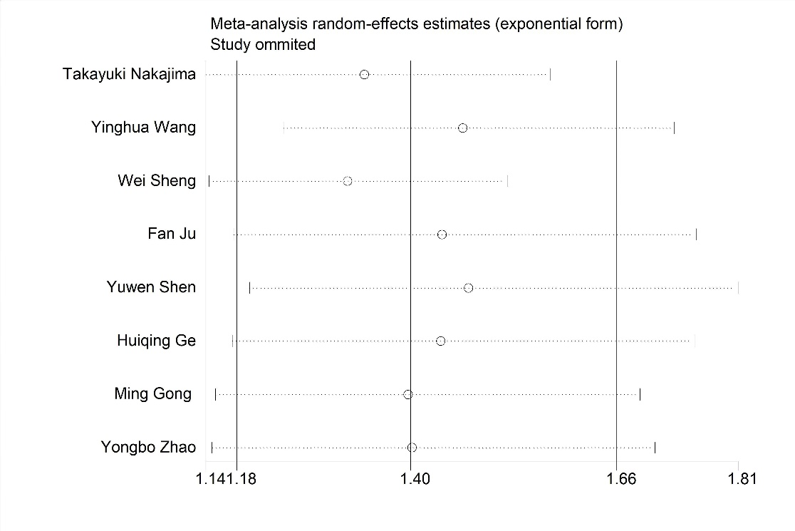

**Supplementary Figure 4.** The sensitivity analysis from the studies included.

**Supplementary Figure 5**



**Supplementary Figure 5.** Funnel plot of publication bias from the studies included.