**Supplement figures**

**Surgery for Bilateral Vocal Fold Paralysis: Systematic Review and Meta-Analysis**

Kai Titulaer1, Peter Schlattmann, MD PhD2 Orlando Guntinas-Lichius, MD1*

1Department of Otorhinolaryngology, Jena University Hospital, Jena, Germany

2Department of Medical Statistics, Computer Sciences and Data Sciences, Jena University Hospital, Jena, Germany

**Supplement Figure 1**

**837 titles retrieved**

**645** articles eliminated  
(not matching inclusion criteria)

**192** abstracts reviewed

**78** articles eliminated (study type, animal studies, same dataset, etc.)

**114** articles reviewed

**12** articles eliminated (subgroup size n < 3)

**102** articles selected, **2802** patients

**Supplement Figure 2**

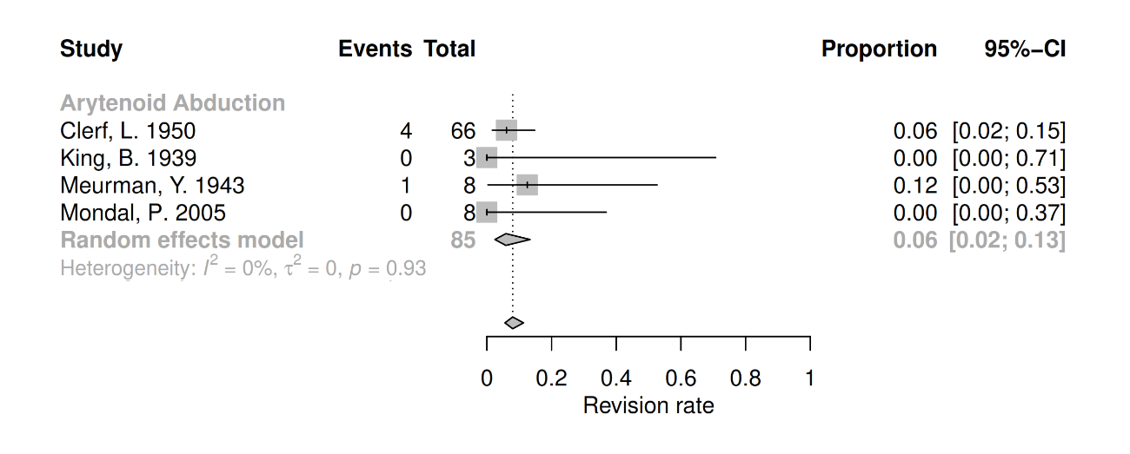

**Supplement Figure 3**

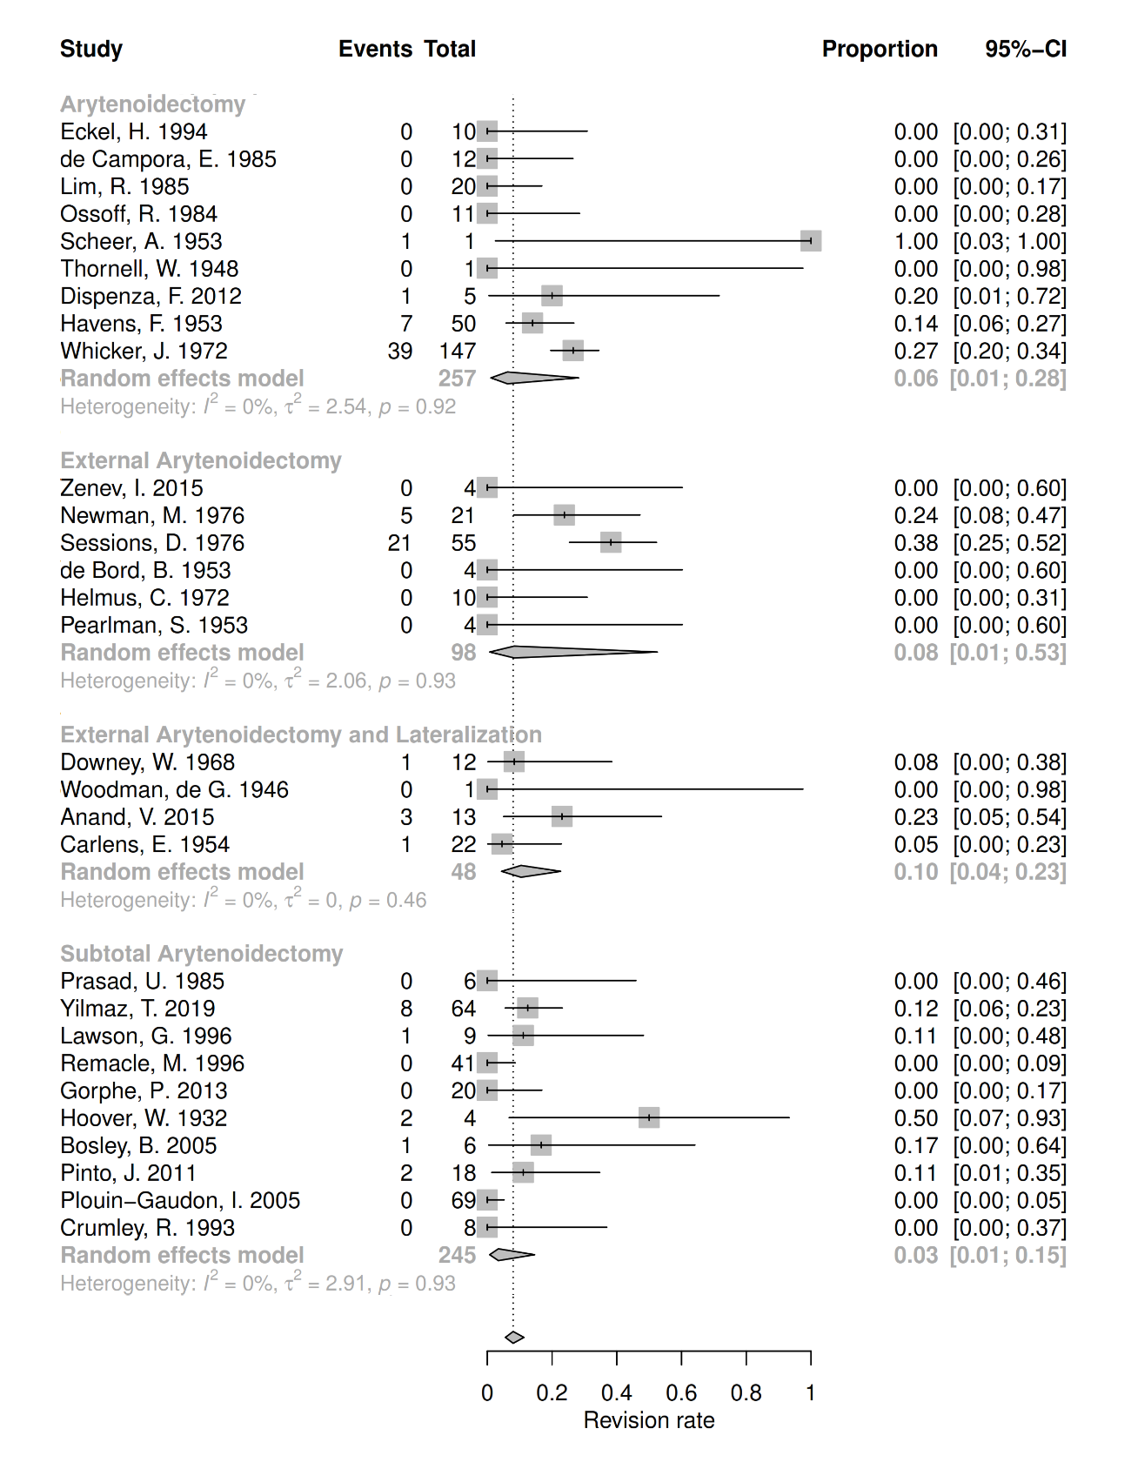

**Supplement Figure 4**

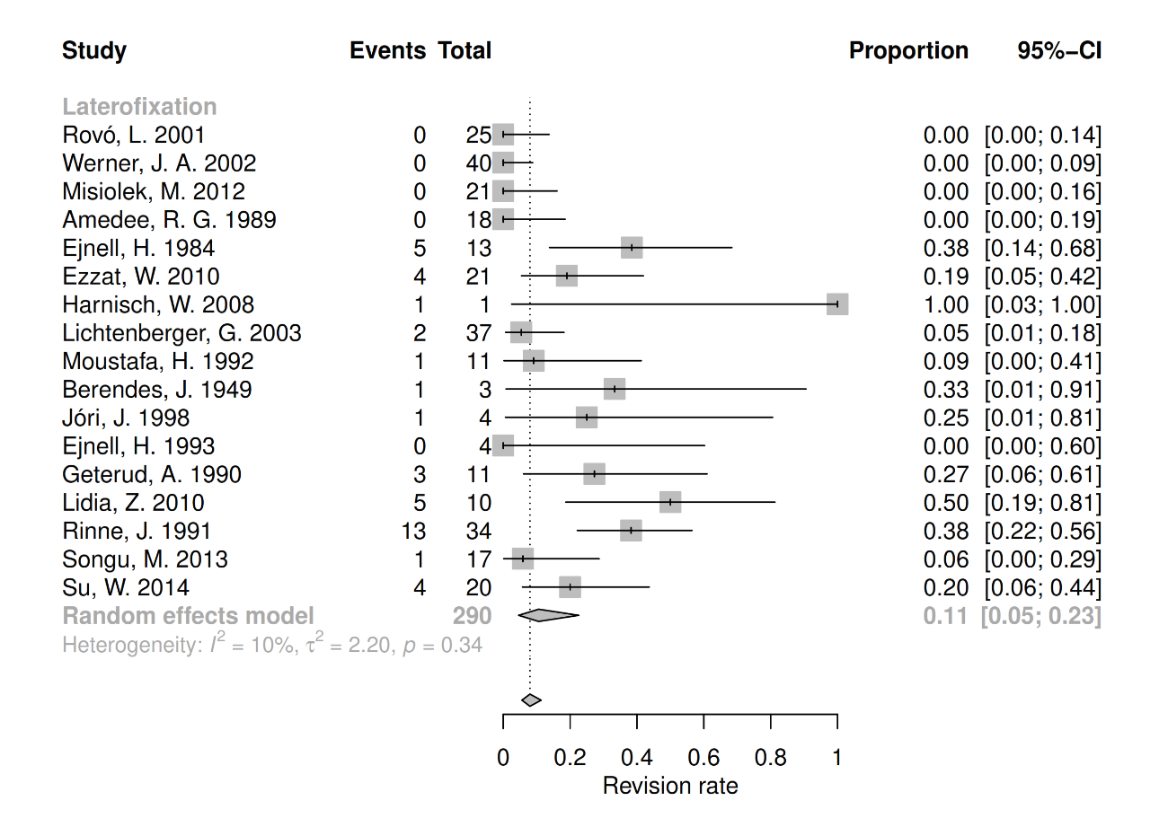

**Supplement Figure 5**

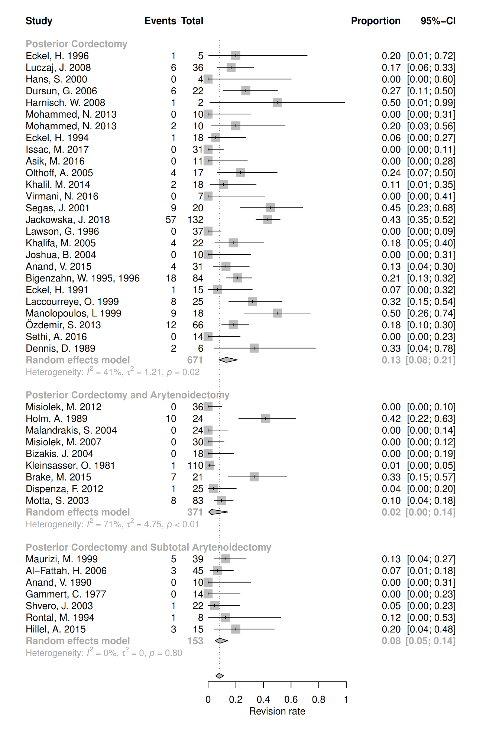

**Supplement Figure 6**

