Supplementary Material

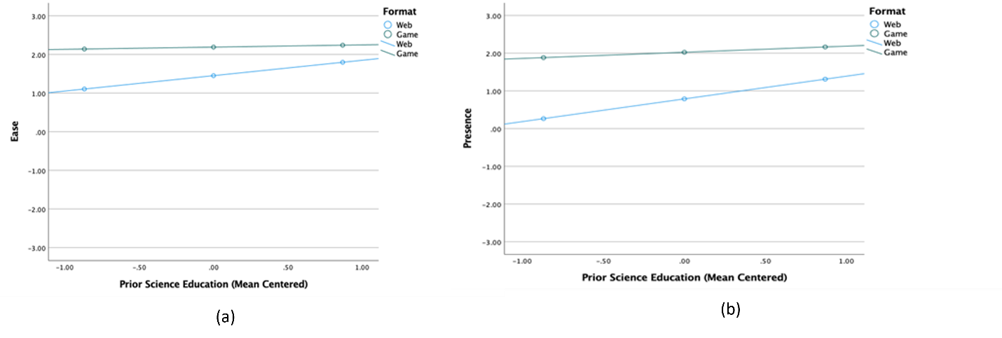
Supplementary Figure 1. Effect of format of science material and extent of past science education experiences on ease and enjoyment of the program (a), and feeling a sense of presence in the experience (b)

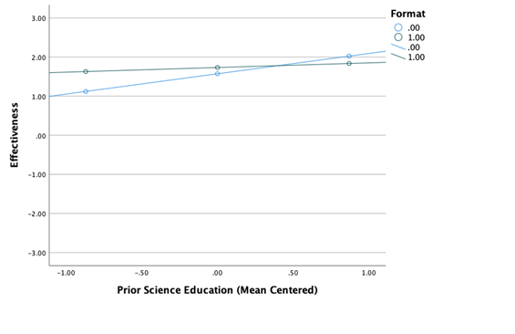
Supplementary Figure 2. Effect of format of science material and extent of past science education experiences on perceived effectiveness of the experience

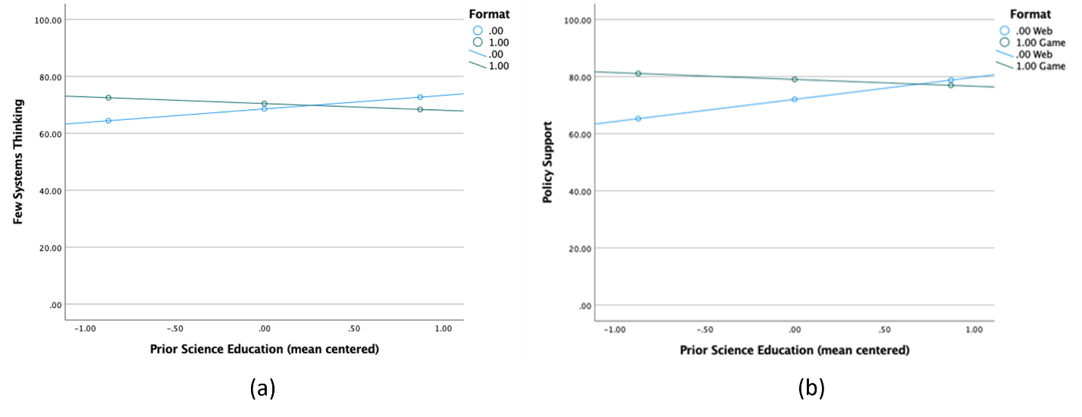
Supplementary Figure 3. Effect of format of science material and extent of past science educational experiences on systems thinking (a), and support for policies that influence systems thinking (b), from individual behaviors to food, energy, and water consequences

