Electronic Supplement for
Microwear textures associated with experimental near-natural diets suggest that seeds and hard insect body parts cause high enamel surface complexity in small mammals
Winkler^{1,2,3}, D.E., Clauss⁴, M., Kubo², M.O., Schulz-Kornas^{3,5}, E., Kaiser³, T.M., Tschudin⁶, A., De Cuyper⁷, A., Kubo⁸, T., Tütken¹, T.
¹Applied and Analytical Palaeontology, Institute of Geosciences, Johannes Gutenberg University, J.-J.-Becher-Weg 21, 55128 Mainz, Germany, tuetken@uni-mainz.de
https://orcid.org/0000-0002-2590-8600
²Department of Natural Environmental Studies, Graduate School of Frontier Sciences, The University of Tokyo, 5-1-5 Kashiwanoha, Kashiwa, Chiba 277-8563, Japan, daniela.eileen.winkler@k.u-tokyo.ac.jp
https://orcid.org/0000-0001-7501-2506
mugino@k.u-tokyo.ac.jp
https://orcid.org/0000-0002-7748-7377
³Leibniz Institute for the Analysis of Biodiversity Change, Zoological Museum, Martin-Luther-King-Platz 3, 20146 Hamburg, Germany, t.kaiser@leibniz-lib.de
https://orcid.org/0000-0002-8154-1751
⁴Clinic for Zoo Animals, Exotic Pets and Wildlife, Vetsuisse Faculty, University of Zurich, Winterthurerstr. 260, 8057 Zurich, Switzerland, mclauss@vetclinics.uzh.ch
https://orcid.org/0000-0003-3841-6207
⁵Department of Cariology, Endodontology and Periodontology, University of Leipzig, Leipzig, Germany, ellen.schulz-kornas@medizin.uni-leipzig.de
https://orcid.org/0000-0003-1657-8256
⁶Granovit Zoofeed, Granovit AG, Rinaustr. 380, 4303 Kaiseraugst, Switzerland, Anja_Tschudin@granovit.ch,
https://orcid.org/ 0000-0002-0495-3197
⁷Department of Veterinary and Biosciences, Faculty of Veterinary Medicine, Ghent University, Merelbeke, Belgium, Annelies.DeCuyper@UGent.be
https://orcid.org/0000-0003-2057-8283
⁸The University Museum, The University of Tokyo, Hongo 7-3-1, Bunkyo-ku, Tokyo 113-0033, Japan, taikubo@um.u-tokyo.ac.jp

This supplement contains:
Supplementary text (results)
Figures S1-S2
Tables S1-S11 are provided in a separate excel sheet

Results (continued)
Area parameters
All area-related parameters fell within the same range, and no significant differences between diet groups were found (Table S10). Animals on fruit mix showed the largest variability in area parameter range. Parameter values increased from M1 to M2 in all diet groups for hill area (Sha), dale area (Sda) and mean area (mea). Significant differences were found for the seed group (Sda: p=0.03106), and the cricket group (mea: p=0.0453). For hill area (Sha), a distinct but non-significant increase was only observed for seed- and cricket-feeding animals. However, after correcting for multiple comparisons, these significant differences were not confirmed (Tab. S10).
Complexity parameters
Seed-feeding and cricket-feeding animals showed the highest parameter values for the parameters area-scale complexity (Asfc) and developed interfacial area ratio (Sdr). This holds true for both the comparison within M1 and within M2. Seed-feeder showed the highest variability for both tooth positions, while cricket-feeder showed more variability in M2 values. Cricket-feeder had significantly higher Asfc than vegetable- and daychick-feeder (M1), and significantly higher Asfc and Sdr values as compared to BSFL-feeders (M2). After correcting for multiple comparisons, the significant differences in Asfc were not confirmed, however multiple significant pairs for Sdr were detected (Tab. S10). Heterogeneity of complexity (HAsfc 3x3) was largest in the daychick group for M1 and M2, and lowest in the seeds group for M1. Only the seeds group displayed a strong increase in HAsfc 3x3 from M1 to M2, while the vegetable, cricket and daychick groups had a small increase in mean parameter values, but still M2 fell within the range of M1.
A distinct increase in parameter values from M1 to M2 was found in the vegetable (Asfc: p=0.0367, Sdr: p=0.022), seed, cricket and daychick (both: p=0.045) group for Asfc and Sdr. In the BSFL group, values slightly increased from M1 to M2, while they slightly decreased in the fruit group.
Density parameters
Autocorrelation length (Sal) was very similar between all feeding groups and both tooth positions. For the M1, density of peaks (Spd) was highest in cricket and BSFL-feeding individuals, while for M2, all feeding groups fell within a similar parameter range. Mean density of furrows (medf) was highest in M1 in vegetable-feeders (Table S10). Raw p-values indicated several significances, which were not confirmed after correcting for multiple comparisons.
Sal, Spd and metf increased from M1 to M2 in all groups except fruit-feeders, in which it decreased. Except for fruit-feeders, (Table S10).
Direction parameters
Isotropy of the texture (IsT) was similar between all diet groups for M1, and significantly lower as daychicks and crickets in fruit-feeders for M2 Table S10). Both anisotropy parameters (new epLsar and Sfrax epLsar) showed largest anisotropy values in the vegetable group for the M1, and in the fruit group for the M2.
Texture direction (Std) was highly variable in all diet groups, but very similar between M1 and M2. For the M1, BSFL-feeders had higher parameter values than vegetable-, fruit-, and cricket-feeders.
For the M1, vegetable- and fruit-feeders have lower texture aspect ratio (Str) than the other diet groups. For the M2, all diet groups fall within the same parameter range, except for BSFL, which was lower than fruit and crickets (Table S10).
The first, second, and third texture direction (Tr1R, Tr2R, and Tr3R) were not found to be indicative of diet in previous studies, and are therefore not further discussed here.
Height parameters
In 13 out of 15 surface height-related parameters, the fruit-, seed-, and cricket-feeders had higher values as compared to vegetable-, BSFL-, and daychick-feeders for the M1. Daychick feeders had significantly lower values than several other groups for S5p, S5v, Sa, Sq, Sdc, Sk, matf, and metf (Figs. 3, S2, Table S10).
Between M1 and M2, fruit and BSFL groups showed no or only slight increase in parameter values. Contrarily, all other groups showed pronounced increase in height parameter values from M1 to M2, with significant differences found for vegetable feeders in 10 out of 15 (S10z, S5p, S5v, Sa, Sp, Sq, Sz, matf, metf, meh), for seed-feeders in 5 out of 15 (matf, S5v, Sa, Sq, Sk), for cricket-feeders in 10 out of 15 (S10z, S5p, S5v, Sa, Sp, Sq, Sdc, matf, metf, meh), and in daychick feeders in 10 out of 15 (S10z, S5p, S5v, Sa, Sp, Sq, Sdc, Sk, matf, metf) (Table S10).
Peak sharpness
Peak sharpness (Spc) was similar between all diet groups for M1 but increased significantly to M2 in vegetable- (p=0.012), seed- (p=0.045), cricket- (p=0.045), and daychick-feeders (p=0.031). Thus, within M2, several significant differences between diet groups were found (Table S10, Fig. S2).
Plateau size parameters
Smc was largest in fruit-feeders, and lowest in BSFL- and daychick-feeders for M1. For M2, parameter values increased in all groups except fruit feeders, and the highest parameter values were observed in vegetable-feeders. The increase was significant for the vegetable (p=0.0216), seed (p=0.0131), and cricket (p=0.0453) groups, with additional significances being detected after correcting for multiple comparisons. Smr was lowest for fruit feeders and similar in all other groups for the M1. From M1 to M2 Smr decreased in all groups.
Slope
For M1, seed- and cricket-feeders displayed the largest slope values (Sdq). A pronounced increase in Sdq was seen for the M2 in vegetable (p=0.022), seed, cricket (p=0.020) and daychick (p=0.020) groups, with both the seed and cricket group still showing the highest values.
Volume parameters
For M1, fruit and daychick groups were best distinguished by volume parameters, while the other diet groups showed similar parameter values. Dale volume (Svd) was largest for fruit-, seed-, cricket-, and insect-feeders. Material volume (Vm) was larger in fruit-feeders than in seed-, cricket-, BSFL- and daychick-feeders . Daychick-feeder showed lowest core material volume (Vmc), void volume (Vv), and void volume of the core (Vvc) significantly lower than fruit- (p=0.008), seed- (p=0.013), and cricket-feeders (p=0.045), with Vvc being additionally significantly lower than in vegetable- feeders (p=0.023) (Table S10).
Svd decreased in all diet groups from M1 to M2. For the other volume parameters, an increase in parameter values was observed from M1 to M2. The strongest increase was found in vegetable, seed, and cricket groups, followed by daychick-feeders.

Figures

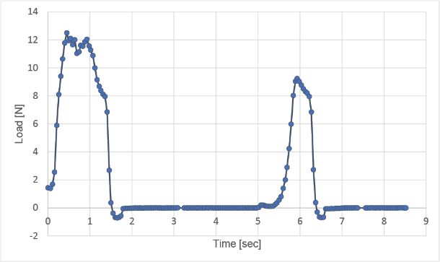
Figure S1. Calculation of TPA hardness. Exemplary time/force curve from stalk celery. The maximum recorded force during the first indentation was 12.4 N, this is divided by tester are (7.069 mm²) to obtain TPA hardness.

Area
Sda  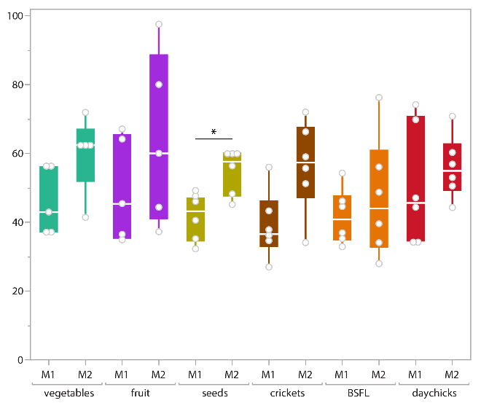 | Sha  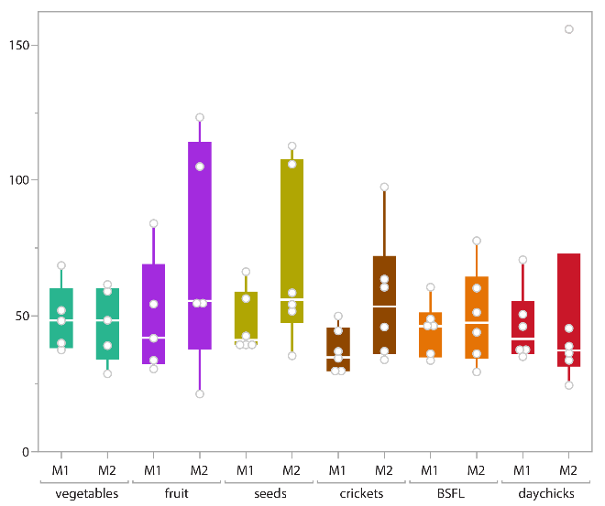 | mea  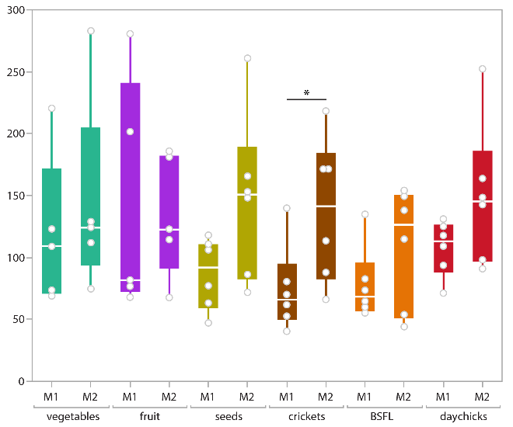

Complexity
Sdr  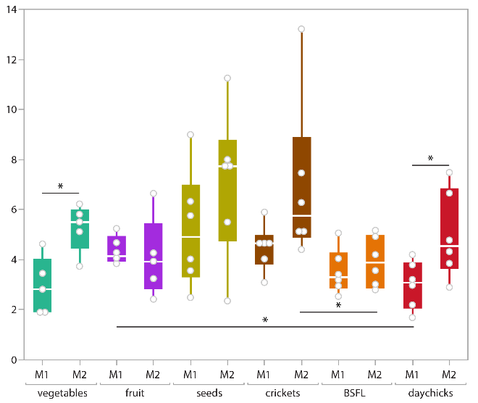 | Asfc  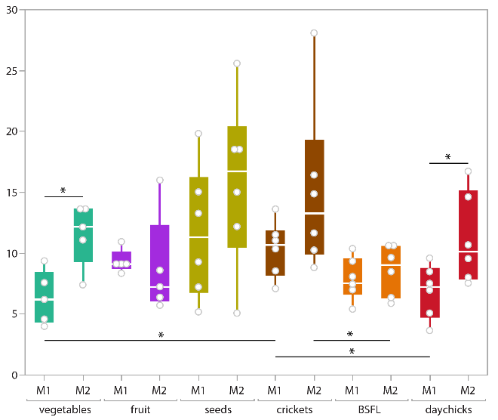 | HAsfc 3x3  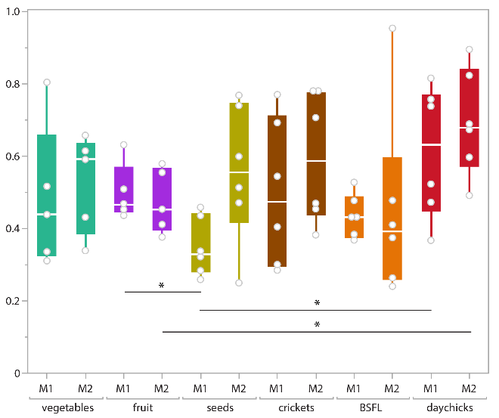

Density
Sal  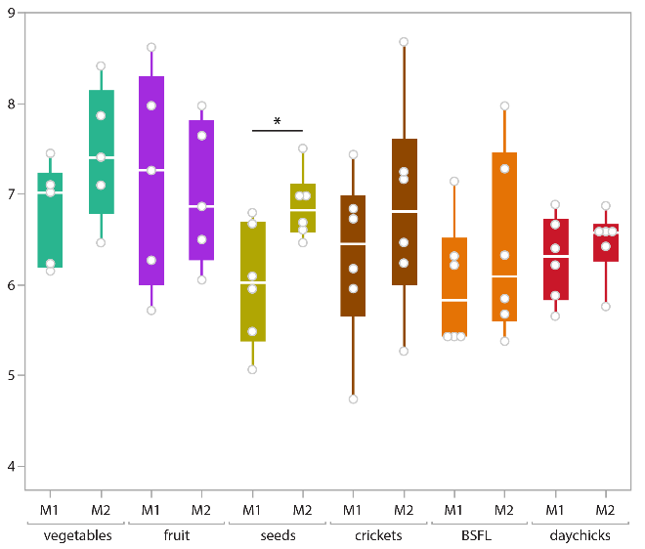 | Spd  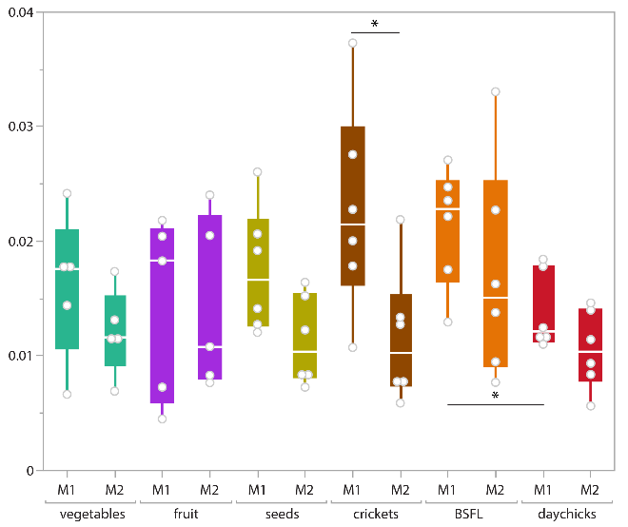 | medf  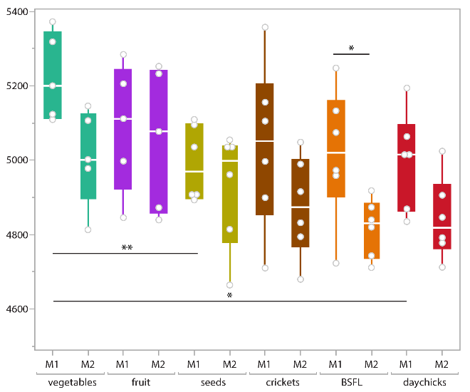
Direction
Std  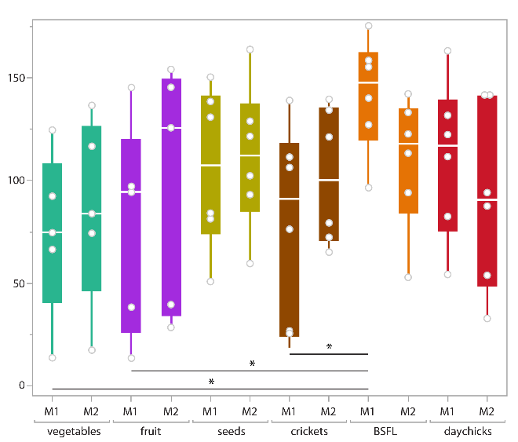 | Str  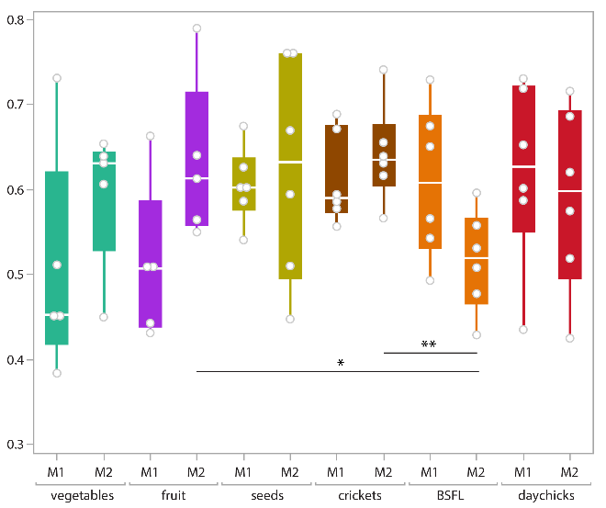

Direction (cont.)
Tr1R  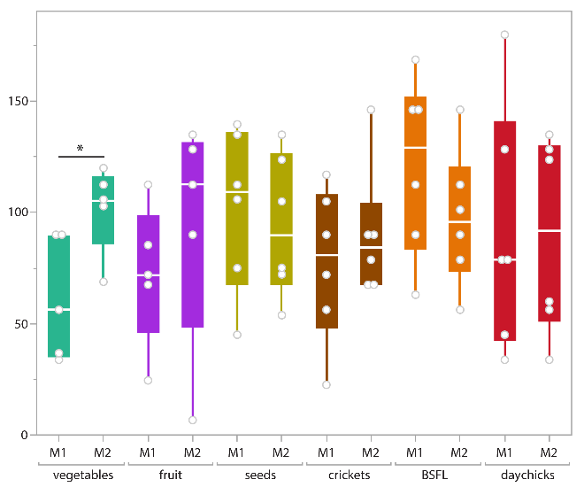 | Tr2R  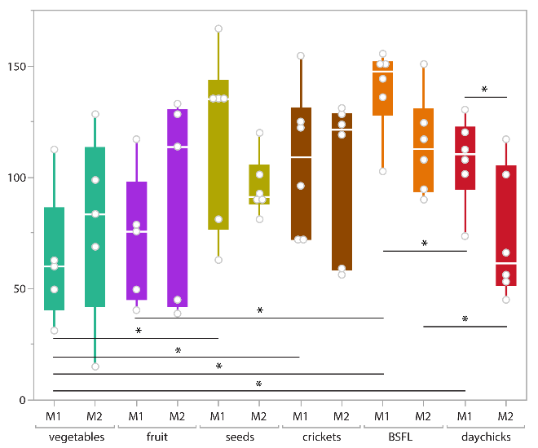 | Tr3R  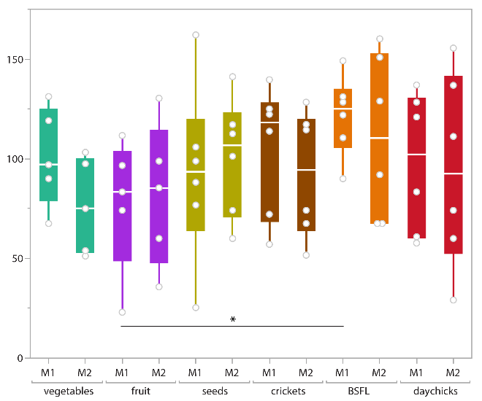
IsT  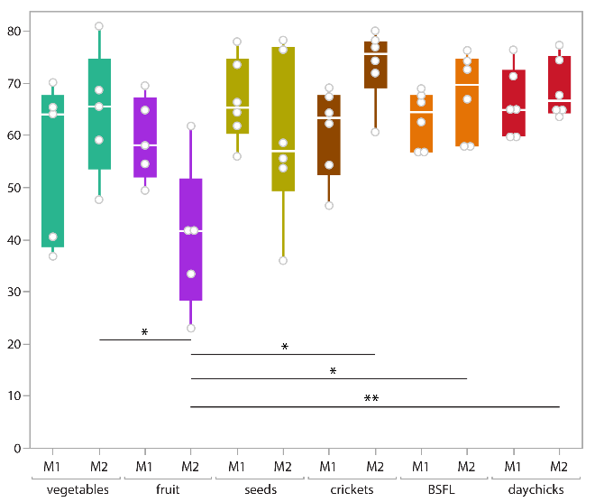 | “new epLsar”  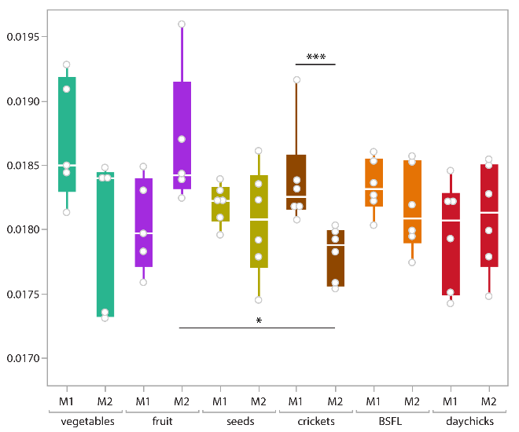 | “Sfrax epLsar”  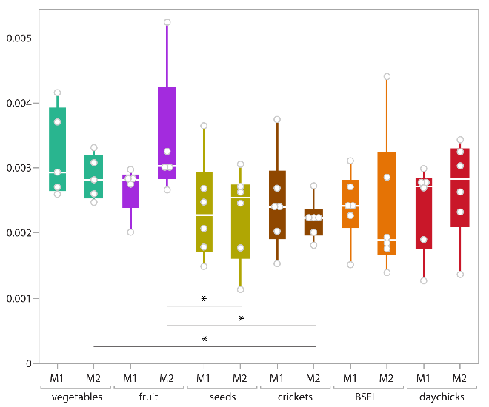

Height
S10z  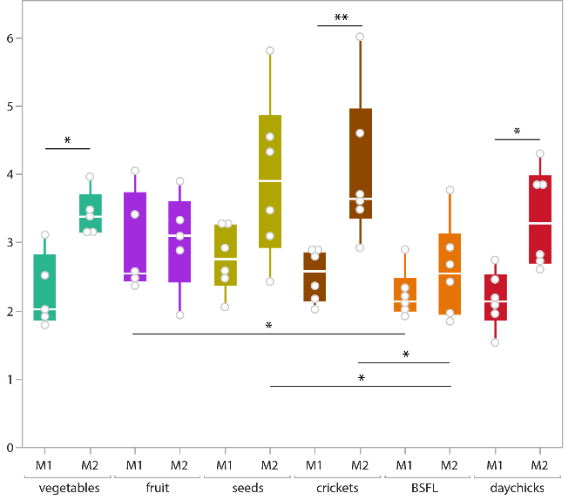 | S5p  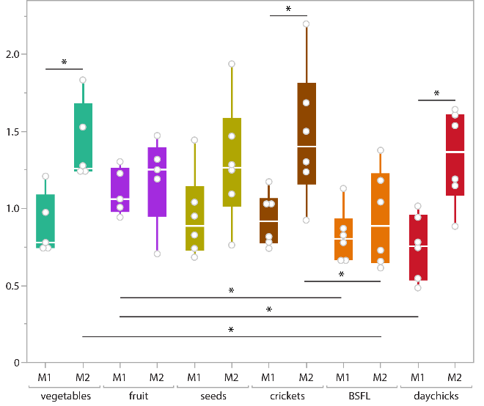 | S5v  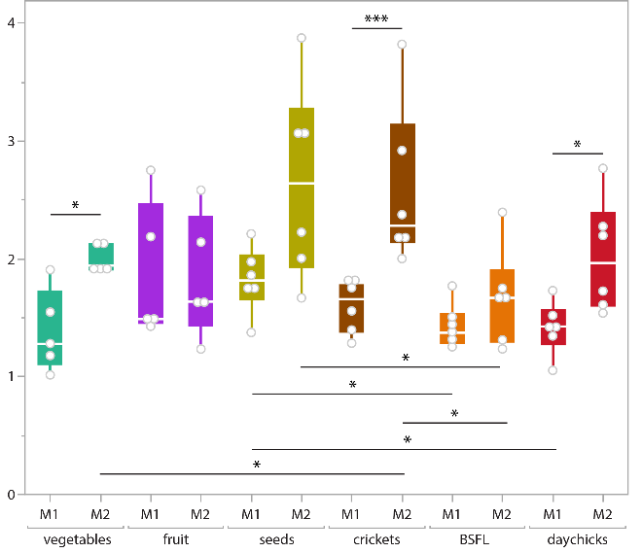
Sa  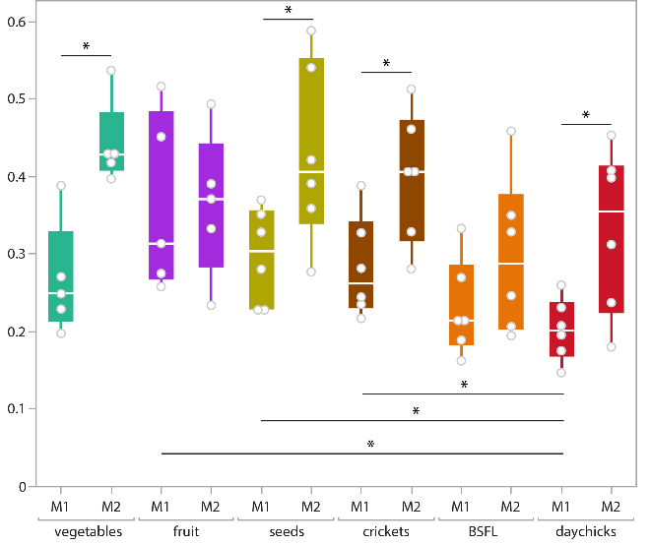 | Sku  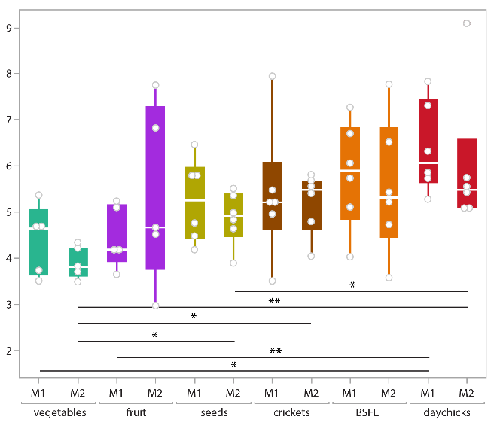 | Sp  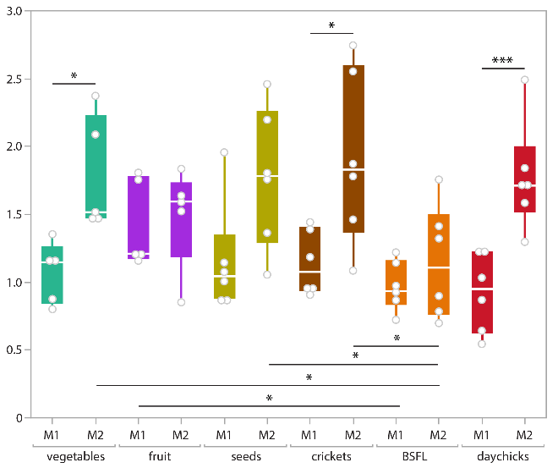

Height (cont.)
Sq  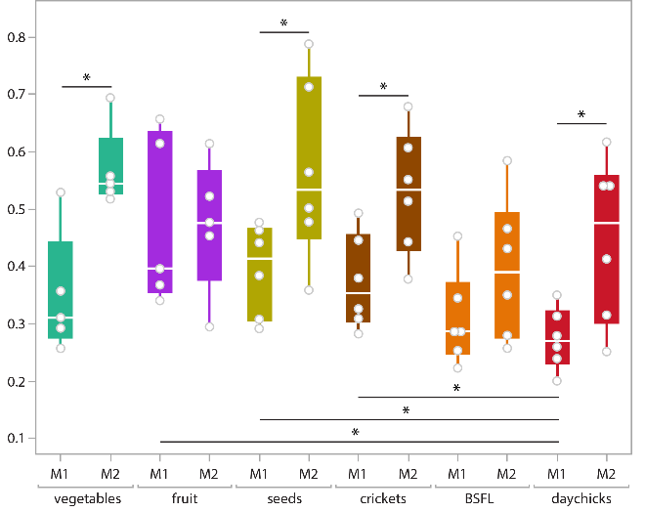 | Ssk  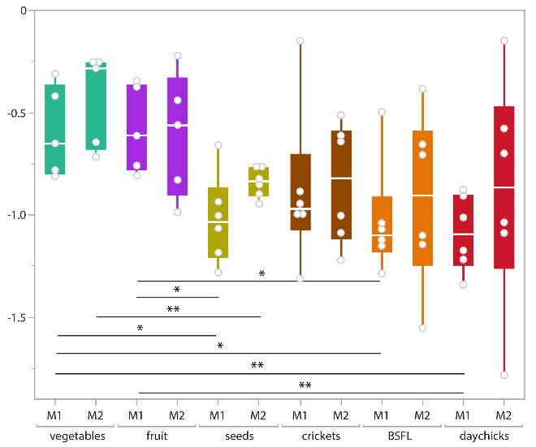 | Sv  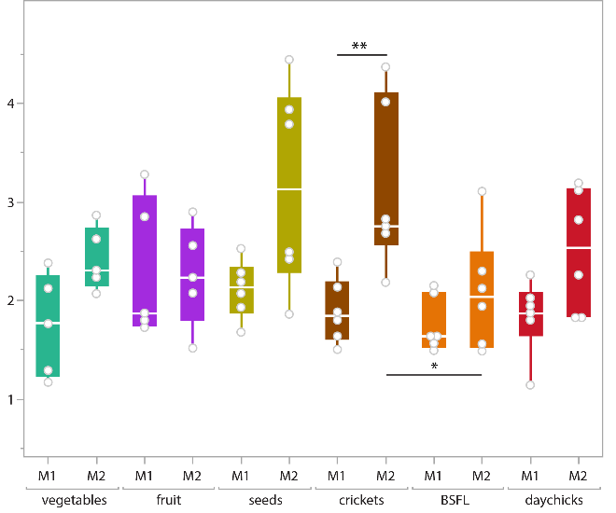
Sdc (former Sxp)  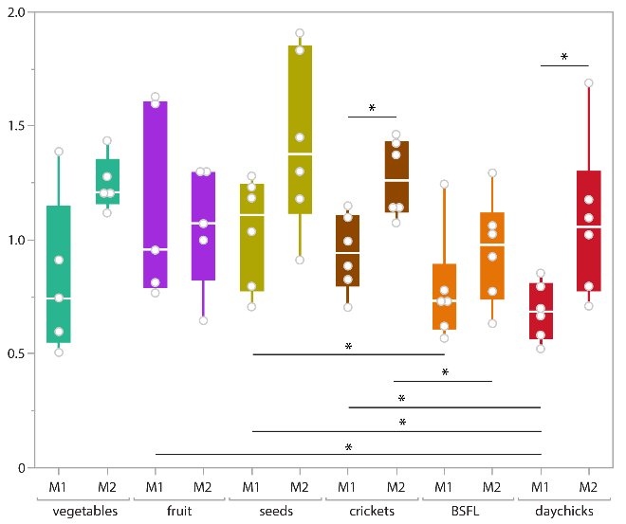 | Sz  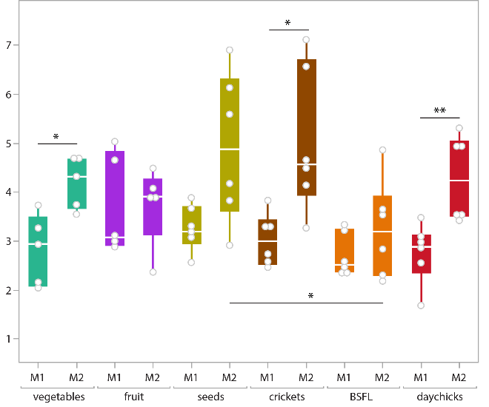 | Sk  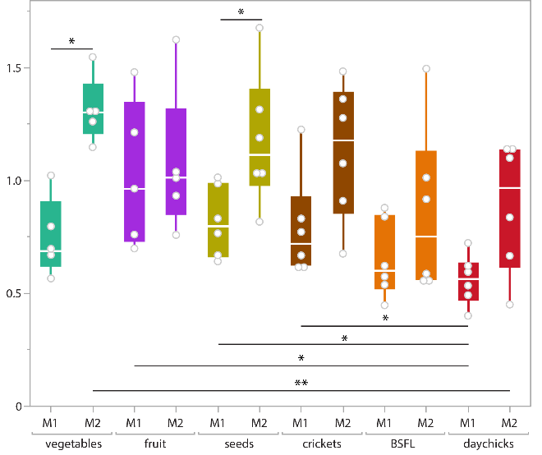

Height (cont.)
madf  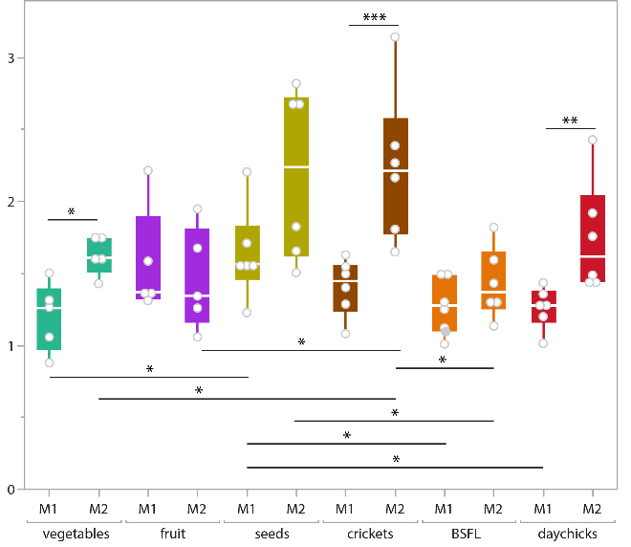 | metf  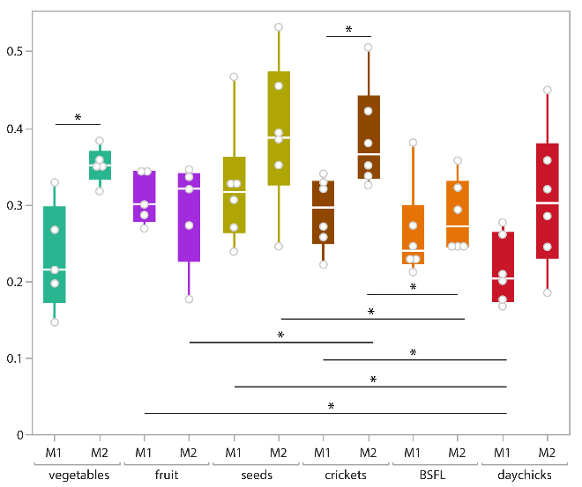 | meh  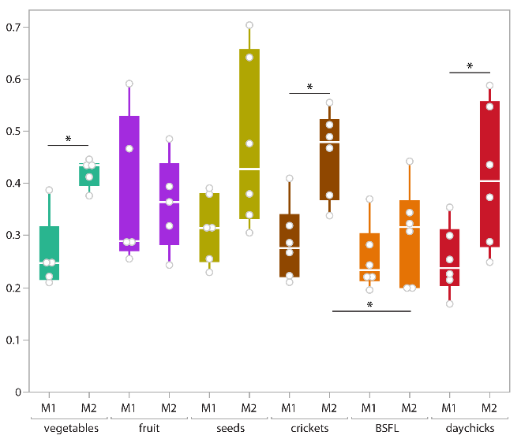
Peak sharpness | Plateau size
Spc  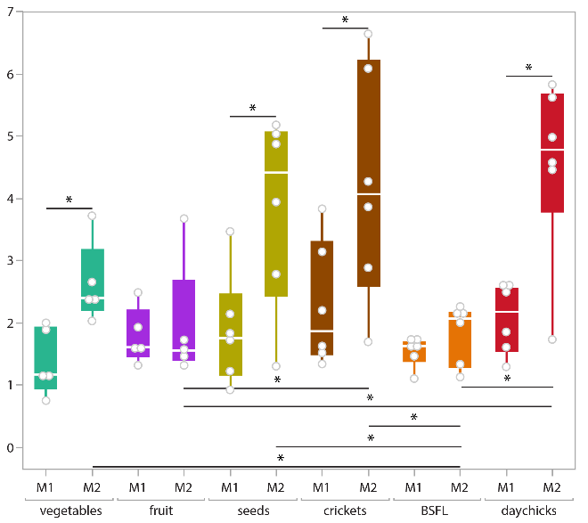 | Smc  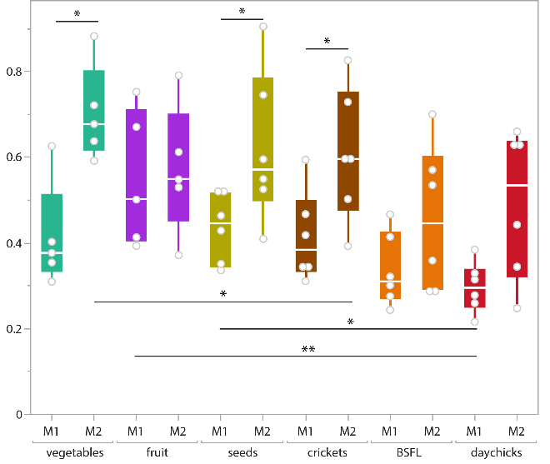 | Smr  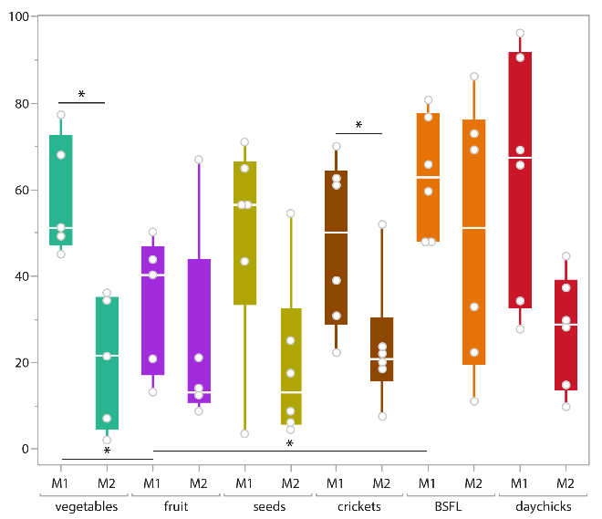

Slope
Sdq
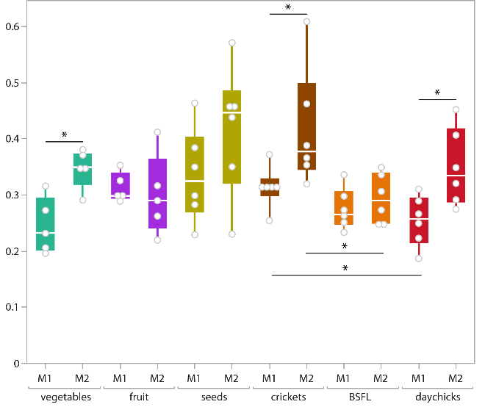
Volume
Sdv  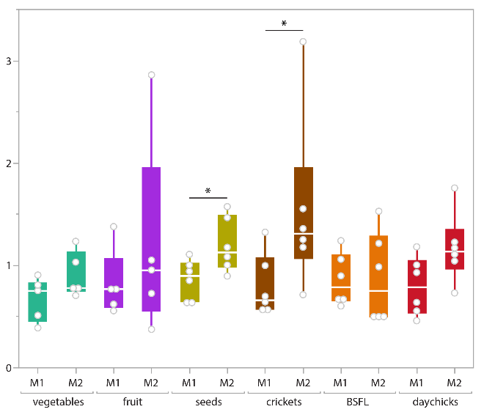 | Shv  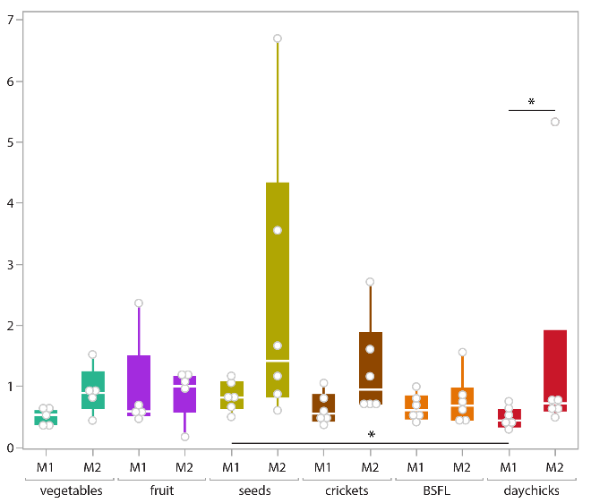 |  | Svd  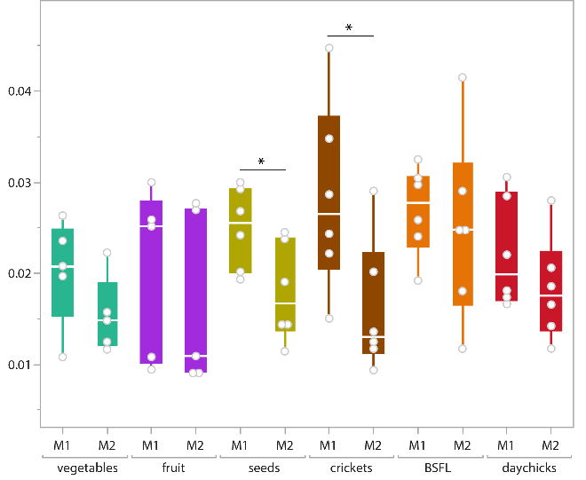

Volume (cont.)
Vm  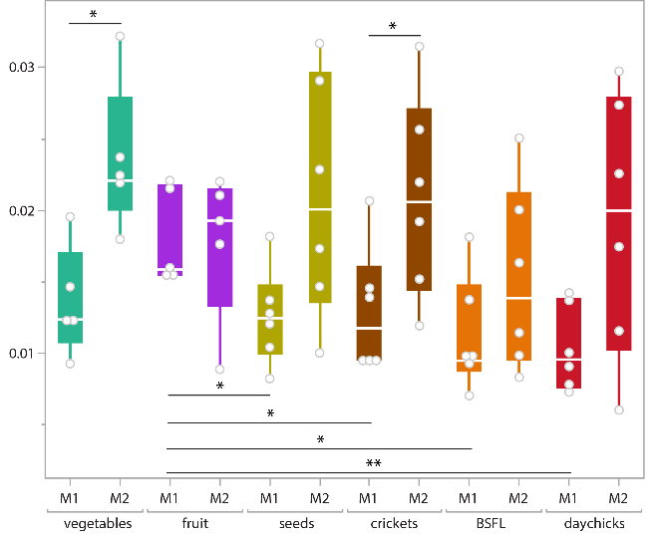 | Vmc  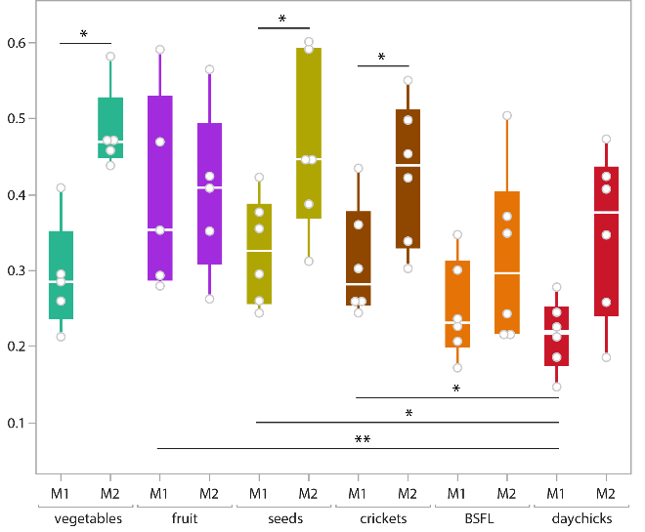 | Vv  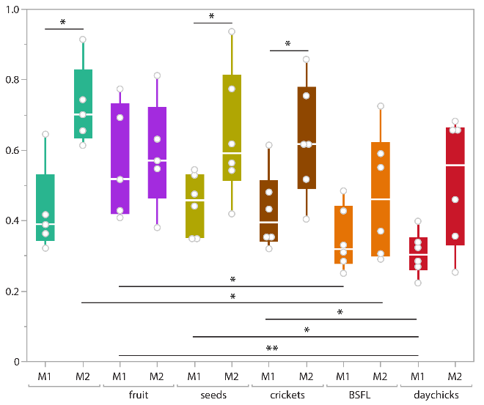
Vvc  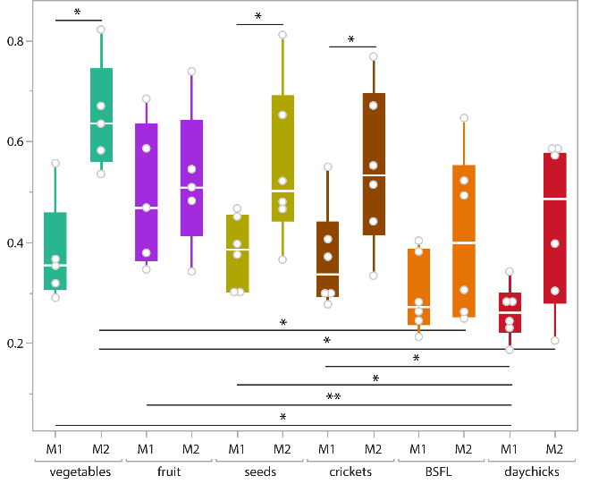 | Vvv  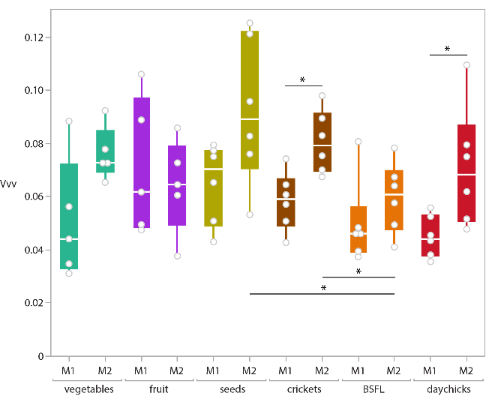
Figure S2. Boxplots for all 44 analysed dental microwear texture parameters for the upper M1 and M2. The thick horizontal bar represents the median; the box encloses the first (25%) and third (75%) quartiles; the whiskers extend to the full interquartile range. Statistics are computed between diet groups for the same tooth position (significances below boxplots), and between tooth positions within the same diet group (significances above boxplots). Significance levels from raw p-values: ***=0.005, **=0.01, *=0.05. For parameter descriptions, see Table S1.

