# Supplement Information - Probabilistic risk assessment of pesticides under future agricultural and climate scenarios using a Bayesian network

Authors: Sophie Mentzel, Merete Grung, Roger Holten, Knut Erik Tollefsen, Marianne Stenrød, and S. Jannicke Moe

1. **Study area**

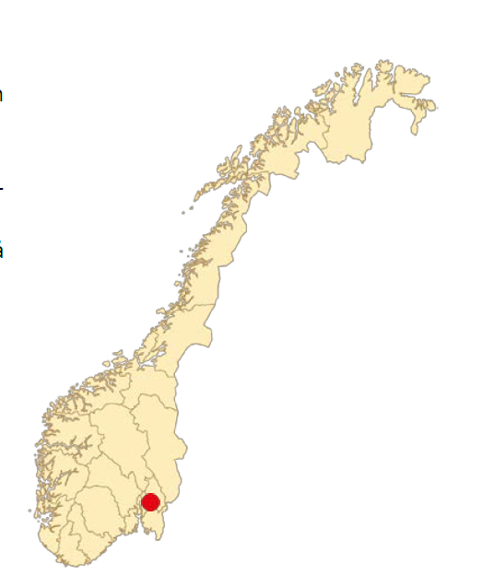

Figure S. 1 Map of Norway detailing the Syverud location (red dot).

1. **Pesticide properties**

Table S. 1 Summary of pesticide properties considered in the WISPE platform (Lewis et al., 2016)

|  |  |  |  |  |  |  |  |  |  |  |  |
| --- | --- | --- | --- | --- | --- | --- | --- | --- | --- | --- | --- |
|  | Mol. Weight | Solubility, mg/L | Plant Uptake Factor | Koc | DT50soil, lab, days | Vapour pressure, mPa | Freundlich exp. 1/n | EXAMS Aerobic metabolism, days (DT50water) | Q10, 20 °C | EXAMS Anaerobic met. days (DT50 sediment) | Direct Photolysis, days |
| Clopyralid | 192 | 7850 | 0.5 | 5 | 23.2 | 1.36E-09 | na * | 148 | 2.58 | 1000 | 271 |
| Fluroxypyr-meptyl | 367.24 | 0.136 | 0 | 19550 | 1 | 0.01 | na * | 34.7 | 2.58 | 1000 | 63 |
| Mcpa | 200.62 | 29390 | 0.5 | 74 | 24 | 0.4 | 0.68 | 13.5 | 2.58 | 1000 | 0.05 |
| Prothioconazole | 344.26 | 22.5 | 0.5 | 2556 | 0.44 | 7.40E-06 | 0.88 | 0.0 | 2.58 | 1000 | 2.1 |
| Trifloxystrobin | 408.37 | 0.61 | 0 | 2287 | 0.34 | 3.40E-03 | 0.96 | 1.1 | 2.58 | 1000 | 2.7 |

1. **Comparison Climate variables Climate model 1 & 2: Mann-Kendall -trend analysis**

Table S. 2 Mann-Kendall trend analysis for Climate variables of Climate model 1 (C1) and Climate model 2 (C2) for mean day since application (mean over 3 previous days) and 21 days (mean of 10 previous days) climate conditions for application in May and October.

|  |  |  |  |  |  |  |  |
| --- | --- | --- | --- | --- | --- | --- | --- |
|  |  | May |  |  | October |  |  |
| Days since application | output | MK.tau | MK.p | conclusion | MK.tau | MK.p | conclusion |
| 1 | MeanTemp1 | 0.167 | 0.252 | zero | **0.273** | **0.059** | pos |
| 1 | MeanPrecip1 | -0.011 | 0.962 | zero | **0.361** | **0.012** | pos |
| 1 | MeanEpot1 | **0.244** | **0.093** | pos | **0.25** | **0.084** | pos |
| 1 | MeanWind1 | 0.196 | 0.191 | zero | 0.131 | 0.374 | zero |
| 1 | MeanRadiat1 | -0.067 | 0.657 | zero | 0 | 1 | zero |
| 1 | MeanTemp2 | 0.16 | 0.272 | zero | 0.053 | 0.726 | zero |
| 1 | MeanPrecip2 | 0.135 | 0.369 | zero | **-0.32** | **0.029** | neg |
| 1 | MeanEpot2 | 0.05 | 0.744 | zero | -0.127 | 0.387 | zero |
| 1 | MeanWind2 | -0.168 | 0.264 | zero | 0.172 | 0.242 | zero |
| 1 | MeanRadiat2 | **-0.36** | **0.012** | neg | -0.067 | 0.657 | zero |
| 21 | MeanTemp1 | **0.249** | **0** | pos | **0.301** | **0** | pos |
| 21 | MeanPrecip1 | -0.029 | 0.676 | zero | 0.015 | 0.83 | zero |
| 21 | MeanEpot1 | **0.279** | **0** | pos | **0.318** | **0** | pos |
| 21 | MeanWind1 | 0.018 | 0.79 | zero | -0.037 | 0.588 | zero |
| 21 | MeanRadiat1 | -0.063 | 0.358 | zero | **-0.123** | **0.072** | neg |
| 21 | MeanTemp2 | **0.267** | **0** | pos | **0.451** | **0** | pos |
| 21 | MeanPrecip2 | **-0.124** | **0.069** | neg | 0.088 | 0.201 | zero |
| 21 | MeanEpot2 | **0.196** | **0.004** | pos | **0.412** | **0** | pos |
| 21 | MeanWind2 | 0.072 | 0.29 | zero | 0.07 | 0.308 | zero |
| 21 | MeanRadiat2 | -0.005 | 0.942 | zero | **-0.195** | **0.004** | neg |

1. **Visualized Result output for all selected pesticides for direct and indirect climate effect- Risk quotient distribution for climate model 1 and application scenarios**

Figure S. 2 Risk estimation of a selected herbicides, clopyralid (a), fluroxypyr-meptyl (b), MCPA (c) and fungicides, prothiocanazole (d) and trifloxystrobin €, for a time since application of 1 day, for the climate model C1 and for EC50 based effects distribution, for all time period and application scenarios.

## **References**

Lewis, K. A., Tzilivakis, J., Warner, D. J., & Green, A. (2016). An international database for pesticide risk assessments and management. *Human and Ecological Risk Assessment: An International Journal*, *22*(4), 1050-1064. <https://doi.org/10.1080/10807039.2015.1133242>