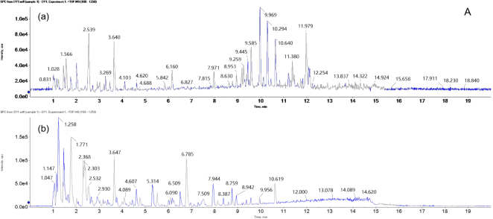

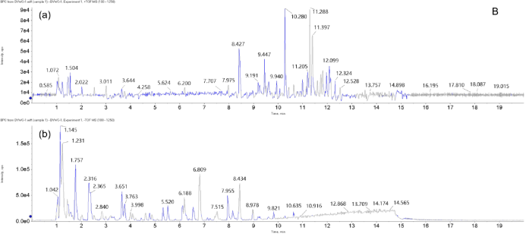

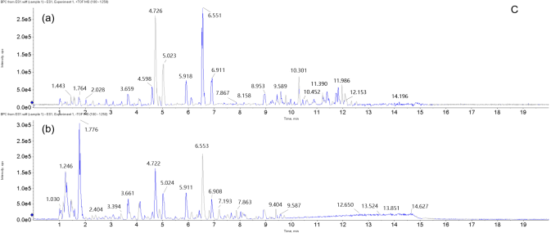

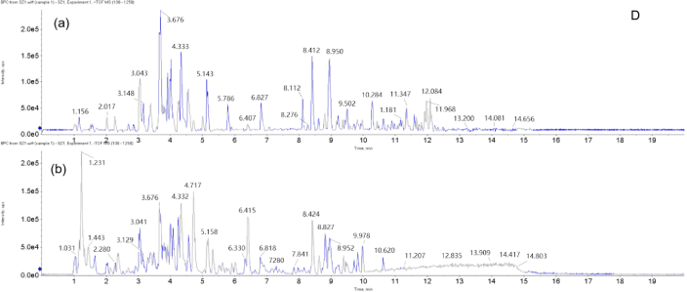

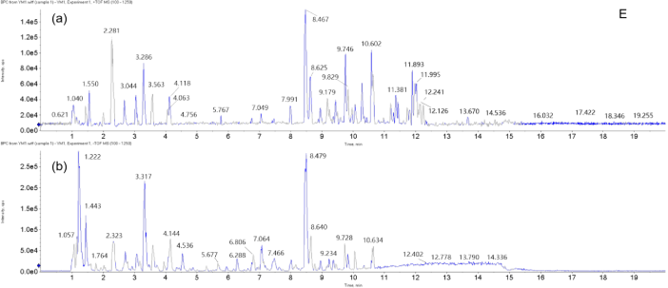

**FIGURE S1** UHPLC–Q-TOF–MS ion mode (a.positive mode ; b. negative mode ) in base peak ion chromatogram (BPI) diagram of ***Oxytropis*** sample (A. DW; B. DYWC; C. ES; D. SZ; E. YM)



**FIGURE S2** SVM model of *Oxytropis*

**

**FIGURE S3** SVM model of *O. myriophylla* from the two different geographical origins