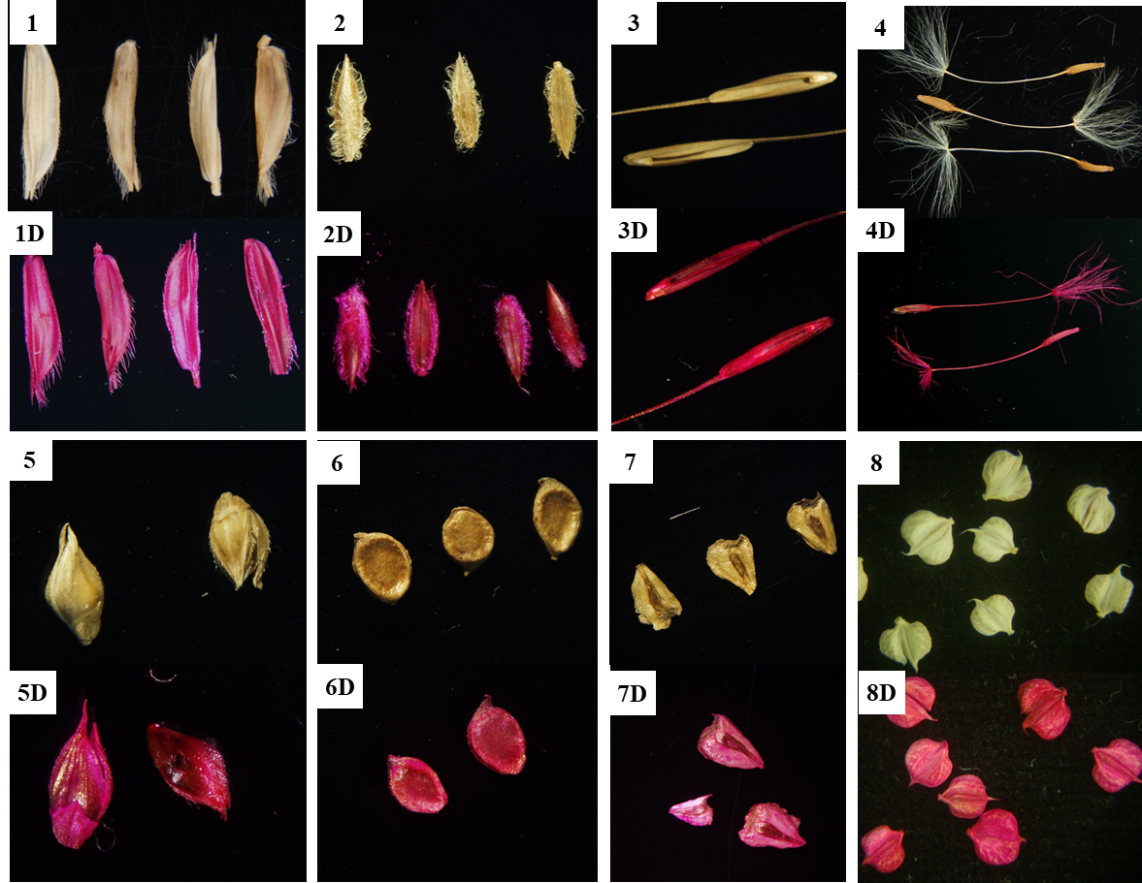
Figure 1 Some diaspores of farmland weeds for which distinguishing between post-stained and pre-stained fruits or seeds is easy; Upper diaspores showing their natural color; bottom diaspores after staining with safranine; Species: (1)Leersia japonica; (2)Digitaria ciliaris; (3)Roegneria kamoji; (4)Taraxacum mongolicum; (5)Echinochloa crusgalli (L.) Beauv.; (6)Ranunculus chinensis; (7)Sagittaria trifolia; and (8)Beckmannia syzigachne.
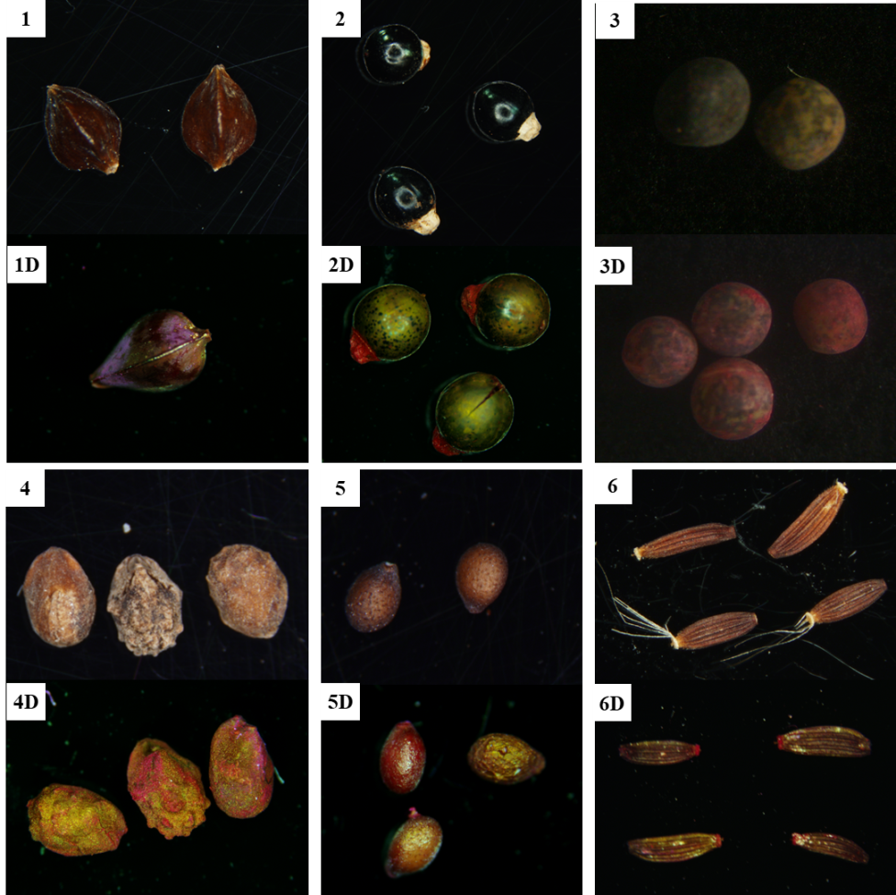
Figure 2 Some diaspores of farmland seeds/fruits for which distinguishing between post-stained and pre-stained fruits and seed is a little difficult; Upper diaspores showing their natural color; bottom diaspores after staining with safranine; Species: (1) Rumex crispus; (2)Polygonum perfoliatum ; and (3)Vicia vicia; (4)Elsholtzia densa;(5) Salvia plebeia; (6)Youngia Japonica

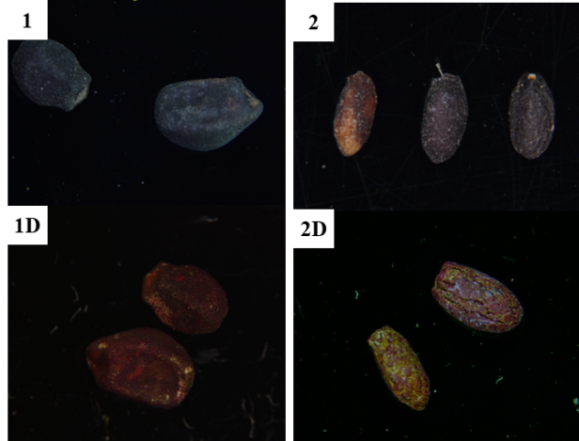
Figure 3 Diaspores of farmland weeds for which distinguishing between post-stained and pre-stained fruits and seed is difficult; Upper diaspores showing their natural color; bottom diaspores after staining with safranine; Species: (1)Calystegia hederacea; and (2)Glechoma longituba

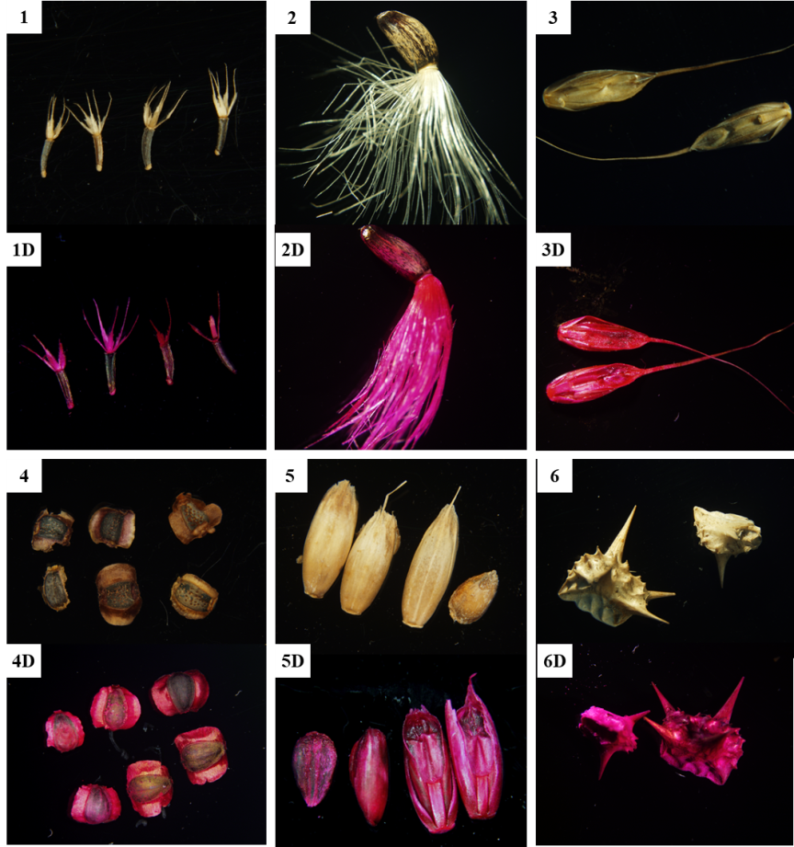
Figure 4 Some diaspores of invasive alien plants which distinguishing between post-stained and pre-stained fruits and seed is easy; Upper diaspores showing their natural color; bottom diaspores after staining with safranine; Species: (1)Ageratum conyzoides; (2)Silybum marianum; (3)Lolium temulentum L. var. longiaristatum Parnell ; (4)Coreopsis lanceolata; (5)Lolium temulentum var. arvense Bab.; and (6)Tribulus terrester.

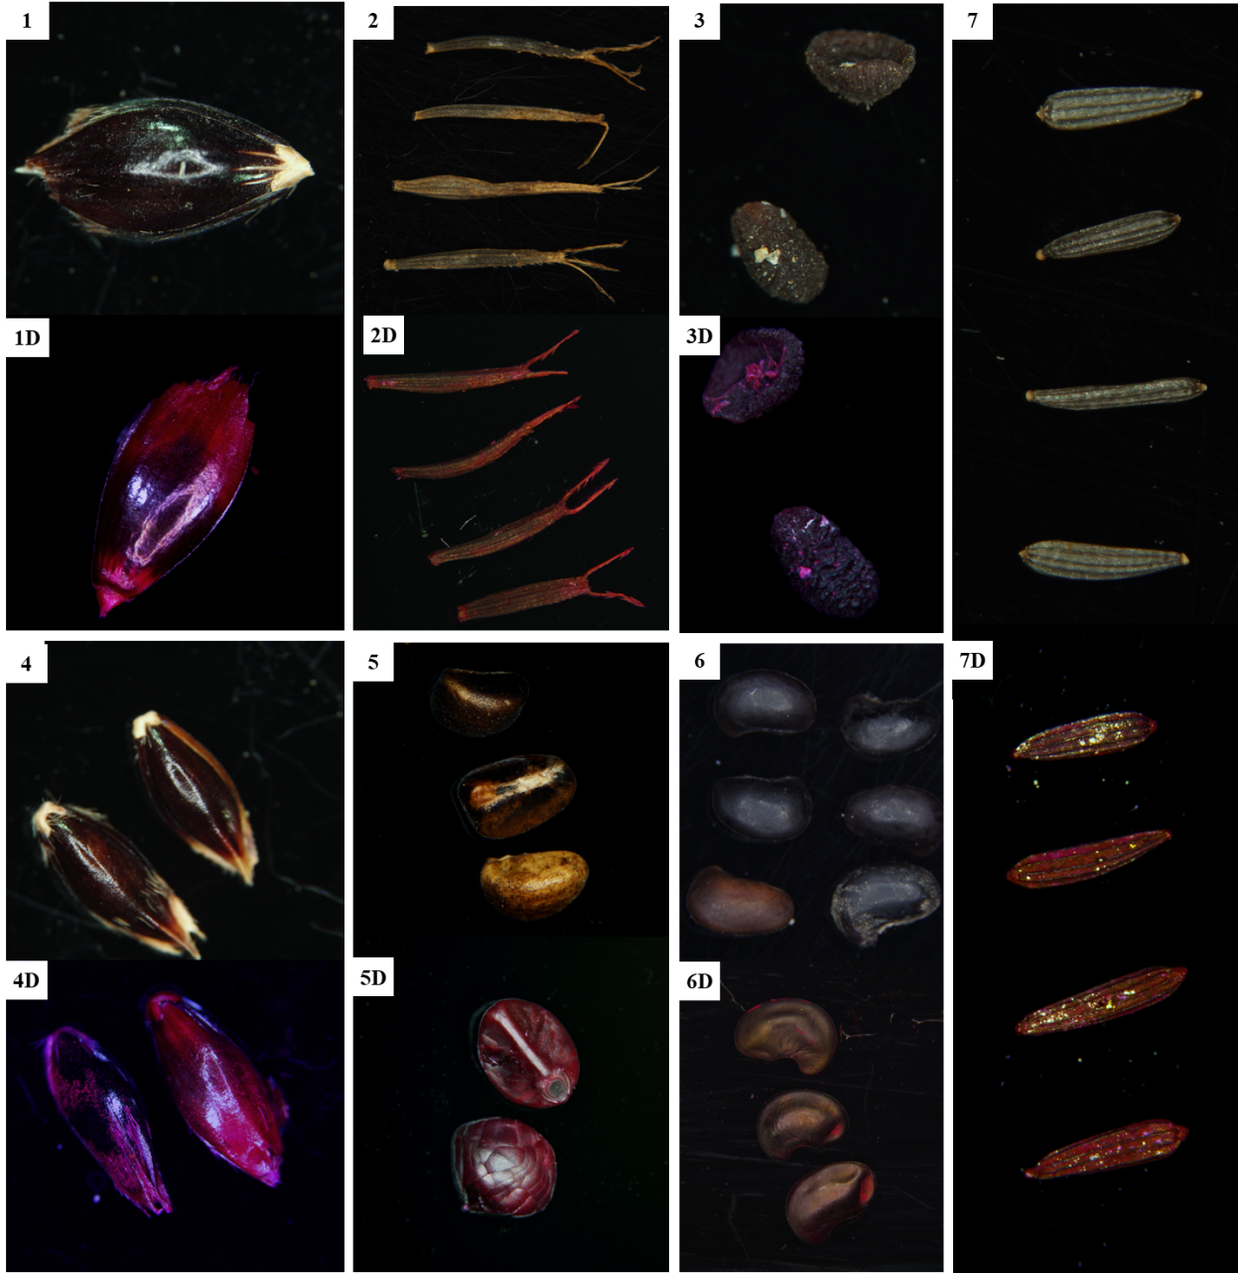
Figure 5 Diaspores of invasive alien plants for which distinguishing between post-stained and pre-stained fruits and seed is a little difficult. Upper diaspores showing their natural color; bottom diaspores after staining with safranine. Species: (1)Sorghum sudanense, (2)Bidens pilosa; (3)Veronica hederaefolia; (4)Sorghum halepense; (5)Ipomoea triloba; (6)Aeschynomene indica, and (7)Flaveria bidentis.

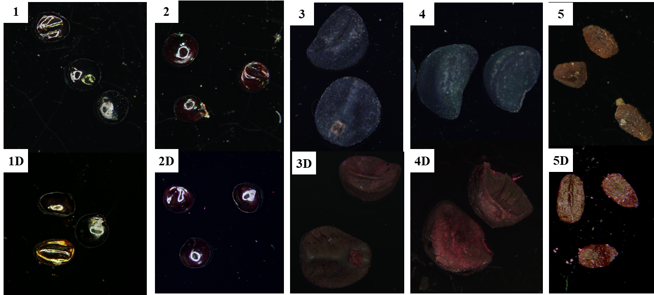
Figure 6 Diaspores of invasive alien plants for which distinguishing between post-stained and pre-stained fruits and seed is difficult; Upper diaspores showing their natural color; bottom diaspores after staining with safranine; Species: (1)Celosia argentea; (2)Amaranthus spinosus; (3)Pharbitis purpurea; (4)Pharbitis nil and (5)Veronica peregrina

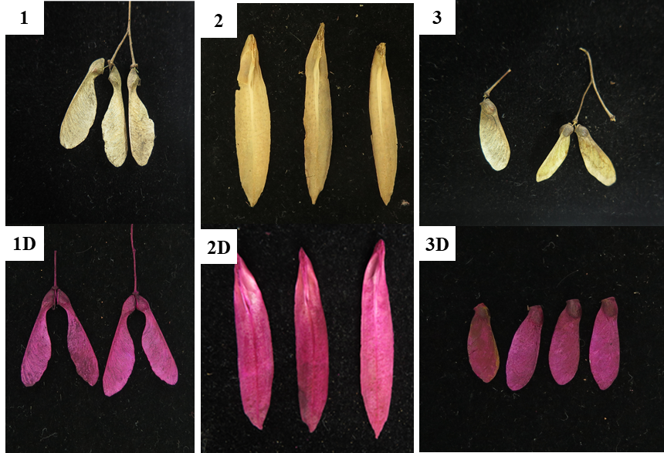
Figure 7 Diaspores of woody plants for which distinguishing between post-stained and pre-stained fruits and seed is easy; Upper diaspores showing their natural color; bottom diaspores after staining with safranine; Species: (1)Acer buergerianum; (2)Liriodendron chinense; and (3)Acer palmatum.

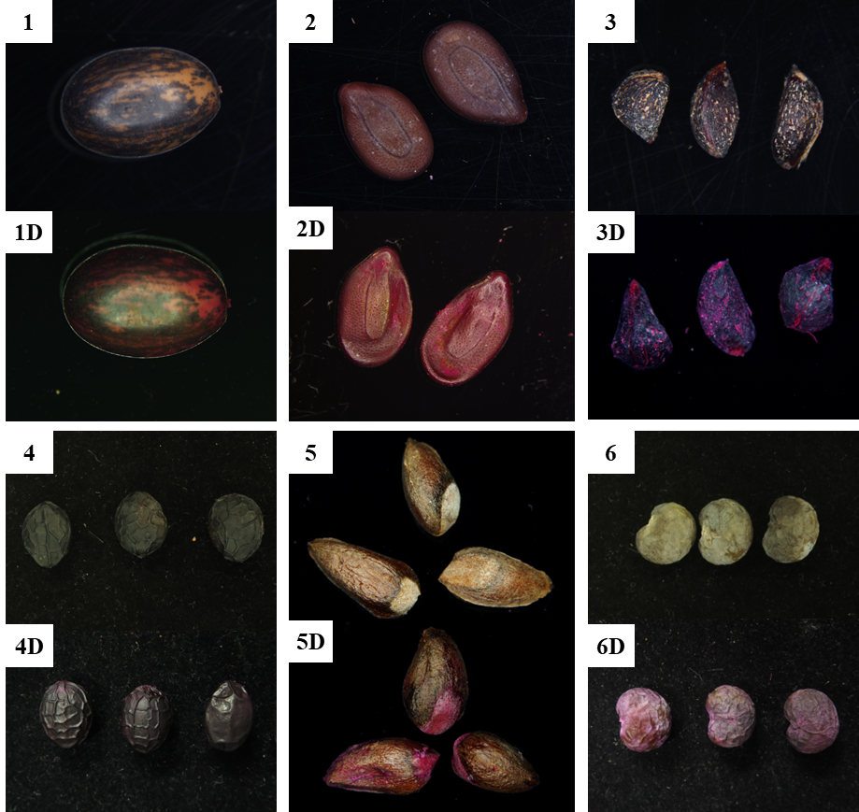
Figure 8 Diaspores of woody plants for which distinguishing between post-stained and pre-stained fruits and seed is difficult; Upper diaspores showing their natural color; bottom diaspores after staining with safranine; Species: (1)Caesalpinia decapetala; (2)Leucaena leucocephala; (3)Rosa multiflora; (4)Phoebe sheareri; (5)Platycladus orientalis; and (6)Trachycarpus fortune.

