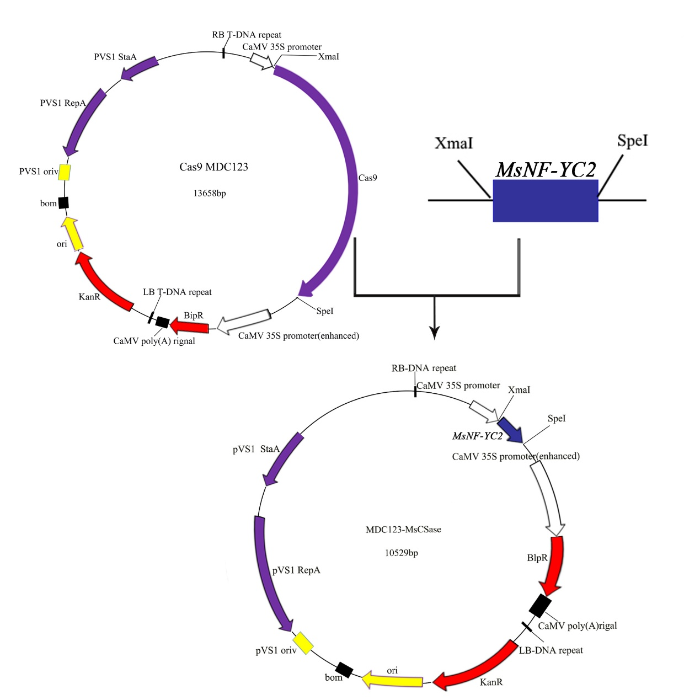

**Supplementary Figure 1. Schematic diagram of the construction of the alfalfa overexpression vector. The blue rectangle represents the *MsNY-YC2* target gene for this assay.**