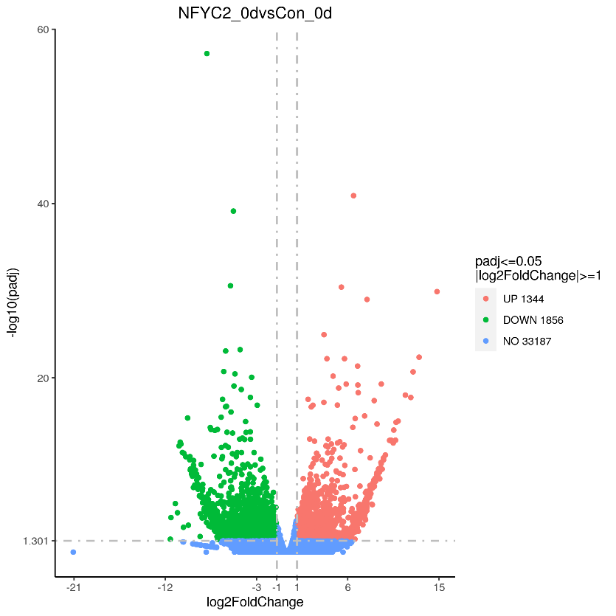

**Supplementary Figure 3. Volcano plot showed the numbers of DEGs identified in comparisons between pairs of libraries.**