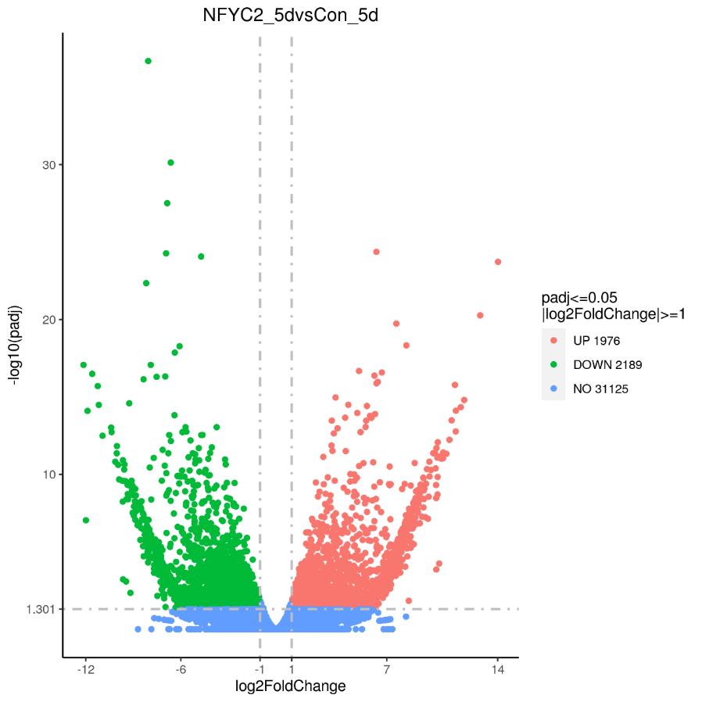

**Supplementary Figure 4. Volcano plot showed the numbers of DEGs identified in comparisons between pairs of libraries.**