Supplementary Material

# Comparison of frequentist growth parameters

Regarding the comparison of two populations, such as aquarium versus wild and females versus males, growth parameter estimates can be obtained separately for both populations; however, a formal comparison requires the formulation of a statistical test. The vB equation characterizing growth depends on ${DW}_{∞}$ and $k$, but not on $σ^{2}$ as the latter only pertains to random errors. Therefore we tested whether both ${DW}_{∞}$ and $k$, taken jointly, were the same across the two populations, while allowing for distinct variance parameters. This yields the null hypothesis $H_{0}:({{DW}_{∞}}^{\left(1\right)},k^{\left(1\right)}={{DW}_{∞}}^{\left(2\right)},k^{\left(2\right)})$ against the (two-tailed) alternative $H_{1}:({{DW}_{∞}}^{\left(1\right)},k^{\left(1\right)}≠{{DW}_{∞}}^{\left(2\right)},k^{\left(2\right)})$, where the $(1)$ and $(2)$ superscripts identify the populations. We constructed a likelihood ratio test (LRT) by assuming a Gaussian distribution for all errors, with log-likelihood denoted by $l(θ)$ where $θ$ is a vector collecting all model parameters (for both populations, including the two distinct error variances). We then defined two MLEs: $\hat{θ}$ is the unconstrained MLE where ${DW}_{∞}$ and $k$ are allowed to be different across the two populations, while ${\hat{θ}}_{0}$ is the MLE constrained under $H_{0}$, i.e., forcing ${DW}_{∞}$ and $k$ to be the same for all individuals, wild and aquarium alike. The LRT statistic is then $2(l(\hat{θ})-$ $l({\hat{θ}}_{0})$) where the log-likelihood difference $l(\hat{θ})-l({\hat{θ}}_{0})≥0$ represents the gain in goodness of fit by letting the pair (${DW}_{∞}, k$) be freely estimated on the two populations rather than forced to be the same. Thus a large LRT statistic value is evidence against $H_{0}$ and a $p$-value can be computed as the probability under $H_{0}$ to observe an LRT statistic larger than the value obtained on the data at hand. With large sample sizes such a probability can be computed under a ${χ }^{2}$ distribution with two degrees of freedom but our experience with small to moderate $n$ points shows that the ${χ }^{2}$ asymptotic approximation leads to overinflated $p$-values. We therefore computed the LRT $p$-value by means of a parametric bootstrap scheme: given the parameter estimates ${\hat{θ}}_{0}$ computed on the original data, we simulated $B$ =10,000 independent bootstrap samples according to the Fabens model under the null hypothesis using the original data lengths at capture and times at liberty (thus the same $n$). On each bootstrap sample we computed the LRT statistic, so we ended up with $B$ independent values. The parametric bootstrap $p$-value is then the proportion among these $B$ values that exceed the LRT statistic computed on the original data.

# Defining the prior distribution of von Bertalanffy growth parameter ${DW}_{∞}$ for wild and aquarium-housed *A. narinari*

Following Dureuil et al. (2022), we constructed a lognormal prior for ${DW}_{∞}$ based on published studies for the wild *Aetobatus narinari* population. The maximum size reported for each sex was examined across the entire species range (Supplementary Table 2.1). The lognormal median of the prior was defined as 99% of ${DW}_{max},$ the size of the largest individual reported, assuming potentially larger individuals exist but have not been captured and measured. The variance is found numerically such that the 99th lognormal percentile matches 1.2 times the median. The 1.2 coefficient ensures a reasonably wide distribution and excludes small reported maximum sizes which are thought to result from inadequate techniques to capture large rays (Supplementary Figure 2.1).

**Supplementary Table 2.1** Literature summary of the maximum sizes reported for *Aetobatus narinari* throughout its range (western Atlantic Ocean). ${DW}_{max}$ values for each sex are in bold.

|  |  |  |  |
| --- | --- | --- | --- |
| **Reference** | **Geographical area** | **Maximum size recorded**  (disc width in cm) | |
| **Male** | **Female** |
| Araújo et al. (2022) | northeastern Brazil | 141 | 169.8 |
| DeGroot et al. (2021) | east coast of Florida | 153 | 203.8 |
| Briones Bell-lloch (2016) | southern Cuba | 159 | 160 |
| Utrera-López (2015) | southern Gulf of Mexico | 142 | 186 |
| Tagliafico et al. (2012) | northeastern Venezuela | **190** | **226** |
| Ajemian et al. (2012) | Bermuda | 142 | 170 |
| Cuevas-Zimbrón et al. (2011) | southern Gulf of Mexico | 150 | 202 |
| Dubick (2000) | southwestern Puerto Rico | 136.2 | 165.4 |
| Silliman & Gruber (1999) | Bimini, Bahamas | 140 | 195.2 |

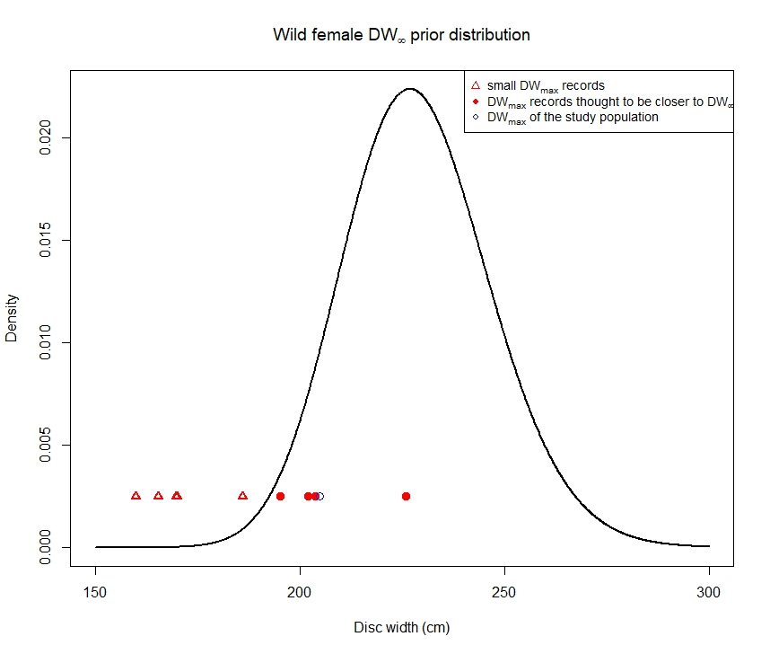

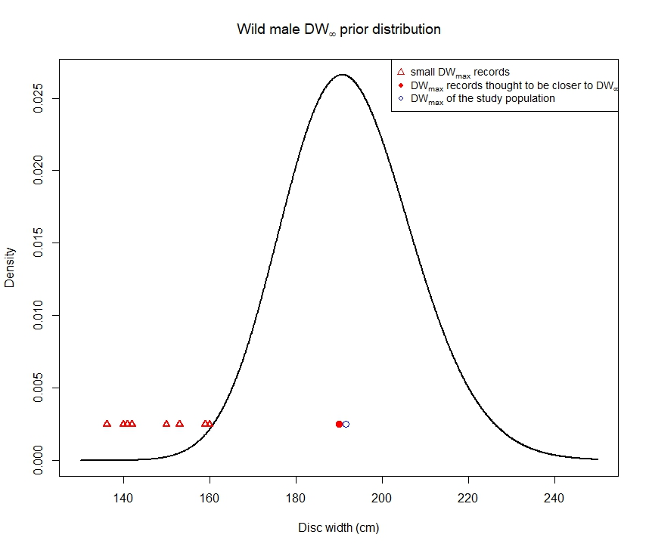

**Supplementary Figure 2.1** Prior distribution of ${DW}_{∞}$ for wild *A. narinari*

The same methodology was adopted to define the lognormal prior distribution for ${DW}_{∞}$ for our aquarium population, using the maximum sizes reported by surveyed AZA aquariums. Resulting prior distributions are plotted in Supplementary Figure 2.2.

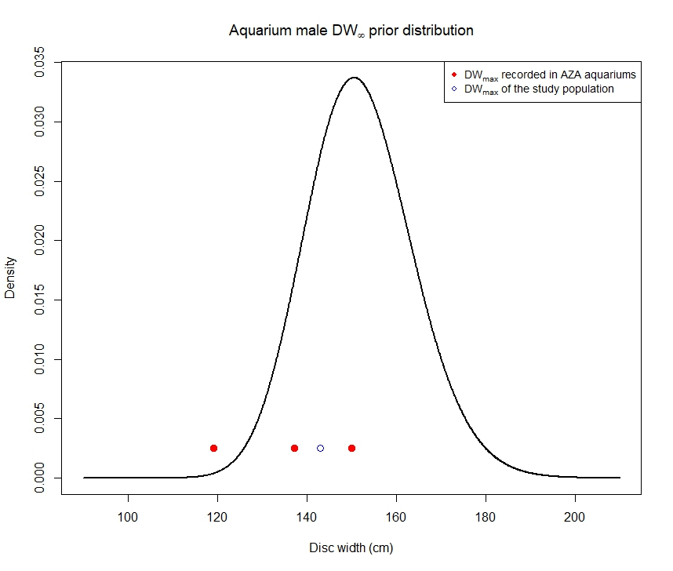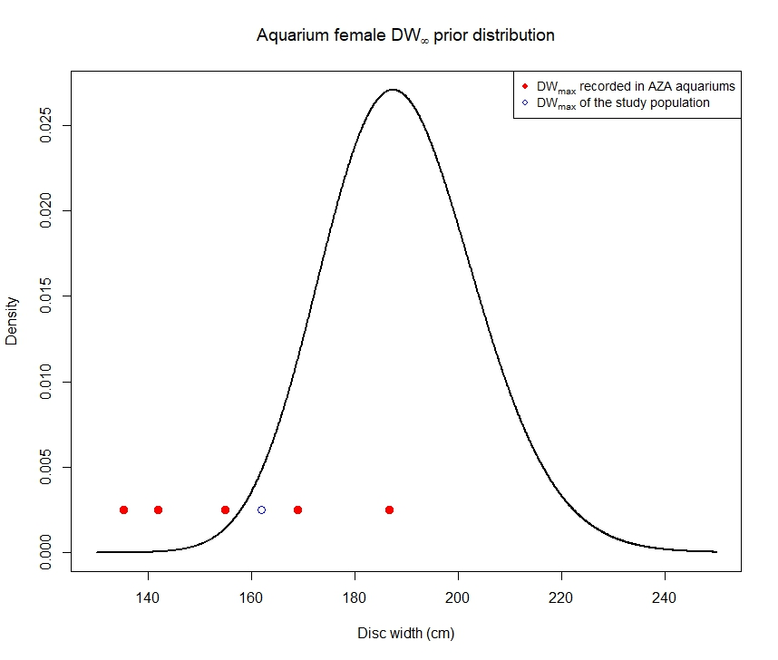

**Supplementary Figure 2.2** Prior distribution of ${DW}_{∞}$ for aquarium-housed *A. narinari*

${DW}_{max}$ and lognormal parameter values for each population and each sex are available in the Supplementary Table 2.2.

**Supplementary Table 2.2 ${DW}_{max}$**  and hyperparameters used for the prior distribution of ${DW}_{∞}$

|  |  |  |  |
| --- | --- | --- | --- |
| **Population** | $${DW}_{max}$$ | **Lognormal mean** | **Lognormal standard deviation** |
| Wild females | 226.0 | 5.43058534 | 0.07835089 |
| Wild males | 190.0 | 5.25707441 | 0.07835089 |
| Aquarium females | 186.7 | 5.23955339 | 0.07835089 |
| Aquarium males | 150.0 | 5.02068563 | 0.07835089 |

# Posterior histograms of von Bertalanffy growth parameters obtained from NUTS algorithm draws

For each *A. narinari* population, posterior distributions of growth parameters ${DW}_{∞}$ and $k$ and the error standard deviation σ were computed from 50,000 No-U-Turn Sampling (NUTS; Hoffman and Gelman, 2014) draws.

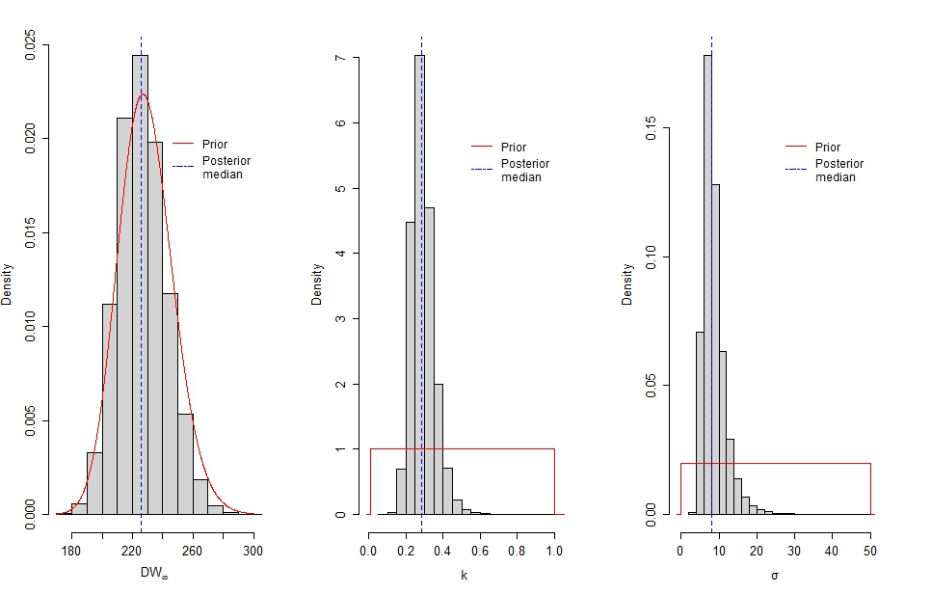

**Supplementary Figure 3.1** Posterior distribution of each estimated parameter for wild females

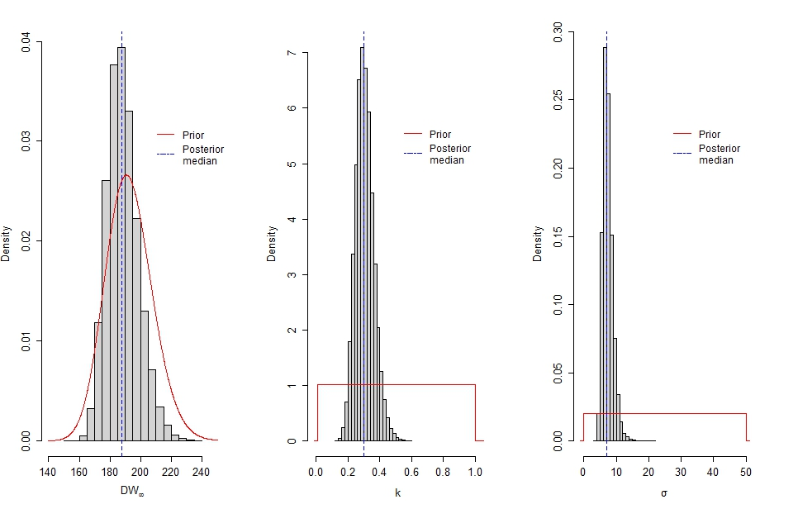

**Supplementary Figure 3.2** Posterior distribution of each estimated parameter for wild males

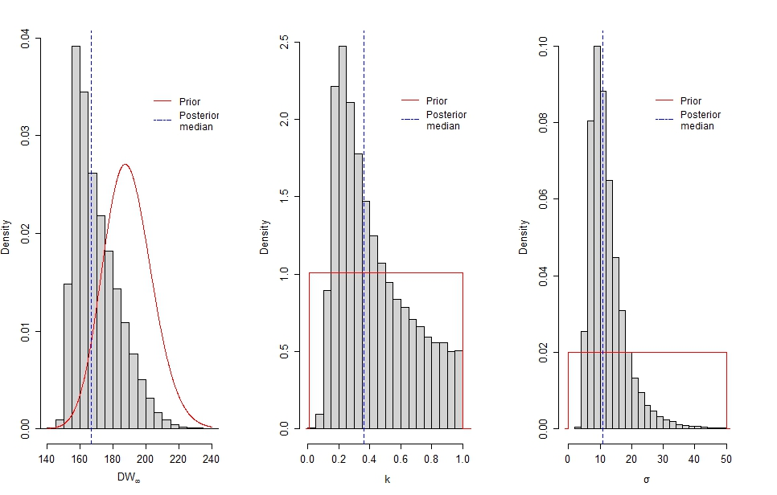

**Supplementary Figure 3.3** Posterior distribution of each estimated parameter for aquarium-housed females

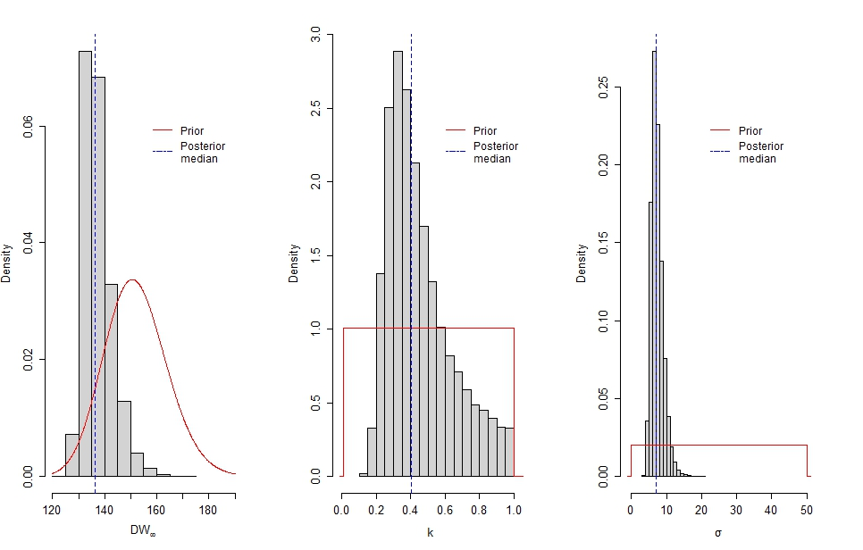

**Supplementary Figure 3.4** Posterior distribution of each estimated parameter for aquarium-housed males

# Comparison of Bayesian growth parameters

In our Bayesian approach, the formal comparison of wild versus aquarium populations, and similarly for females versus males, was carried out by computing Bayes factors (BFs; Kass & Raftery, 1995). A BF is used to compare two candidate models, denoted $M_{0}$ and $M_{1}$, and is defined as the ratio of the probability of the data given $M_{1}$ divided by the probability of the data given $M_{0}$. Thus large BF values are evidence in favor of $M_{1}$ as having generated the data. Here, $M_{0}$ is the Fabens model with ${DW}_{∞}$ and $k$ set constant across the two populations we compare (in effect equivalent to $H_{0}$ in the frequentist approach described above), while $M_{1}$ is the more flexible model where ${DW}_{∞}$ and $k$ are allowed to be different (equivalent to $H_{1}$). The probabilities defining the BF are marginal densities here whose evaluation requires integrating all parameters out; we relied on the Laplace approximation for such integrals. We also required a prior distribution for the common ${DW}_{∞}$ in $M_{0}$. We used a lognormal distribution with mean and variance parameters set so that it sufficiently covered the two distinct lognormal priors in $M_{1}$: the $M_{0}$ median is the average of the two prior medians in $M_{1}$, and given the mean the $M_{0}$ variance parameter is numerically found so that the 99th percentile of the common prior in $M_{0}$ matches that of the prior distribution in $M_{1}$ which puts more mass towards larger values (e.g., matching the 99th percentile of the prior distribution for females in case of a females versus males comparison).

# Comparing the length-weight relationship between wild and aquarium-housed A. narinari

## Methods

The length-weight relationship was compared between wild-caught individuals and animals housed at the Georgia Aquarium using a linear mixed-effects model. This model was chosen to account for repeated measurements on individuals across time which violates the assumption of independence for traditional generalized linear regression analyses. Individual ray IDs were set as Gaussian random intercepts in the model and disc width (DW, cm) was a fixed effect. Sex and location (wild or Georgia Aquarium) were also tested as possible fixed effects. Backward stepwise selection and Akaike’s Information Criterion (AIC) were used to aid in model selection. Following initial model assessment, which included data from both wild and Georgia Aquarium (GAI) in the same model with location (wild or GAI) as a fixed effect, it was determined that the model was overparameterized, possibly due to the wild data having too few repeated measurements per individual and higher spread in the random intercepts. Therefore, a separate model was created for each location. The relationship between disc width and weight was nonlinear; thus, a natural log transformation was applied to variables disc width and weight before fitting the model. The length-weight equation below was used to predict weight (W, kg) at disc width:

$$\log\left(W_{ij}\right)=a+b*\log\left({DW}_{ij}\right)+{ID}_{i}+ε_{ij}$$

Where $i$ identifies an individual ray and j is a measurement for a given ray. The error term is assumed to come from an independent Gaussian distribution with a mean of zero and constant variance $σ_{ε}^{2}$. ID is also assumed to come from an independent Gaussian distribution with a mean of zero and a variance of $σ_{ID}^{2}$. Studentized residuals were examined for outliers and significant outliers were removed. A 95% confidence envelope capturing both between individual and within individual variability was calculated using a parametric bootstrap procedure in which both random intercepts and response error terms were simulated according to independent Gaussian distributions with mean zero and variance parameters estimates plugged-in (Wild: $\hat{σ_{ID}}=0.129, \hat{σ_{ε}}=0.078$; Georgia Aquarium: $\hat{σ_{ID}}=0.036, \hat{σ_{ε}}=0.107$). To calculate the predicted 95% confidence envelope for the population average, 1000 independent samples were simulated (setting all random intercepts to zero) and the population average predicted curve was calculated for every sample. The same was done to create the predicted 95% confidence envelope for the individual-specific curves with individual-specific predicted curves being calculated for every bootstrap sample. The confidence envelopes were constructed by ranking the 1000 generated curves in terms of band depth and then retaining the outer curves which encompass 95% of them, following the construction of functional boxplots (Sun and Genton, 2011). Analyses were conducted following methods outlined by Zurr et al. 2009 using the ‘nlme’ package (v. 3.1-153, Pinheiro et al. 2021) and ‘lmer’ package (v. 1.1-23, Bates et al. 2015) in R (v. 4.1.2, R Core Team 2021).

## Results

Three wild ray measurements (SER393 (M) DW 98.4 cm, Weight 70 kg; SER 098 (F) DW 86.0 cm, Weight 39 kg; SER 608 (F) DW 98.7 cm, weight 40.8 kg) and one Georgia Aquarium ray measurement (Accession #74 (M) DW 62 cm, Weight 1.2 kg) were identified as outliers and were removed from the length-weight relationship analysis. Sex was not a significant variable for the wild ray model or the Georgia Aquarium model, thus was dropped as an explanatory variable following AIC assessment. Disc width was the only fixed effect in the final model for both locations. There was a significant positive correlation between disc width and weight for both wild whitespotted eagle rays (p <0.001, Supplementary Table 5.1) and the animals housed at Georgia Aquarium (p <0.001, Supplementary Table 5.2). The marginal R² (representing the variance explained by the fixed effects) was 0.985 for the wild ray model and 0.983 for the Georgia Aquarium model. The conditional R² (variance explained by the entire model with fixed and random effects) was also high for both models, 0.996 and 0.985 for the wild model and Georgia Aquarium model, respectively. The tight relationship between length and weight can be observed in the Supplementary Figures 5.1 and 5.2. The confidence envelope was rather narrow for the population average length-weight relationships (fixed effects only, Supplementary Figure 5.1), but was wider when individual variability was also incorporated into the confidence envelope (fixed and random effects, Supplementary Figure 5.2). Measurements from the same individual were more correlated for the wild rays (ICC = 0.73) than for the Georgia Aquarium rays (ICC = 0.14). This could be due to the fact that most of the wild recaptures occurred within the same year whereas the Georgia Aquarium measurements occurred across multiple consecutive years.

## Figures and Tables



**Supplementary Figure 5.1** Observed measurements (black dots) with the predicted population average represented by the red line. The pink shading around the line represents the 95% confidence envelope. This envelope appears rather narrow because a population average curve (i.e., neglecting individual variability) was calculated on each bootstrapped sample.



**Supplementary Figure 5.2** Observed measurements (black dots) with the predicted 95% confidence envelope (pink shading) encompassing the predicted individual-specific curves (not displayed). The red line represents the predicted population average curve.

**Supplementary Table 5.1** Length-weight relationship linear mixed effect model results for wild whitespotted eagle rays.

|  |  |  |  |  |  |  |  |
| --- | --- | --- | --- | --- | --- | --- | --- |
| *Predictors* |  | *Estimates* | *Std Error* | *DF* | *t-value* | *CI* | *p* |
| (Intercept) |  | -11.37 | 0.08 | 513 | -149.86 | -11.52 - -11.22 | <0.001 |
| Disc Width (log) |  | 3.05 | 0.02 | 25 | 190.43 | 3.02 - 3.08 | <0.001 |
|  |  |  |  |  |  |  |  |
| **Random Effects** |  |  |  |  |  |  |  |
| $$σ$$ | 0.078 |  |  |  |  |  |  |
| $$τ_{00 ID}$$ | 0.02 |  |  |  |  |  |  |
| ICC | 0.73 |  |  |  |  |  |  |
| $$N_{ID}$$ | 514 |  |  |  |  |  |  |
| Observations | 540 |  |  |  |  |  |  |
| Marginal R²/Conditional R² | 0.985/0.996 |  |  |  |  |  |  |

**Supplementary Table 5.2** Length-weight relationship linear mixed effect model results for Georgia Aquarium whitespotted eagle rays.

|  |  |  |  |  |  |  |  |
| --- | --- | --- | --- | --- | --- | --- | --- |
| *Predictors* |  | *Estimates* | *Std Error* | *DF* | *t-value* | *CI* | *p* |
| (Intercept) |  | -11.83 | 0.18 | 102 | -65.95 | -12.19 - -11.48 | <0.001 |
| Disc Width (log) |  | 3.16 | 0.04 | 102 | 82.72 | 3.09 - 3.24 | <0.001 |
|  |  |  |  |  |  |  |  |
| **Random Effects** |  |  |  |  |  |  |  |
| $$σ$$ | 0.107 |  |  |  |  |  |  |
| $$τ_{00 ID}$$ | 0.00 |  |  |  |  |  |  |
| ICC | 0.14 |  |  |  |  |  |  |
| $$N_{ID}$$ | 18 |  |  |  |  |  |  |
| Observations | 117 |  |  |  |  |  |  |
| Marginal R²/Conditional R² | 0.983/0.985 |  |  |  |  |  |  |

# Morphometrics of aquarium-housed rays (n=19)

|  |  |  |  |  |  |  |  |
| --- | --- | --- | --- | --- | --- | --- | --- |
| Studbook Accession Number | Sex | Date of capture | First DW measurement (cm) | Last DW measurement (cm) | Date of last DW measurement | Time since capture (years) | DW growth in aquarium (cm) |
| 31 | M | 1-Mar-2009 | 94 | 133 | 14-Feb-2020 | 10.96 | 39 |
| 32 | F | 1-Mar-2009 | 108 | 148 | 11-Feb-2017 | 7.96 | 40 |
| 33 | F | 1-Mar-2009 | 97 | 144 | 13-Apr-2015 | 6.12 | 47 |
| 35 | M | 11-Oct-2012 | 68.6 | 138 | 22-Feb-2020 | 7.37 | 69.4 |
| 36 | M | 15-Oct-2012 | 91.4 | 128 | 11-Jul-2018 | 5.74 | 36.6 |
| 38 | M | 15-Oct-2012 | 55.9 | 130 | 22-Feb-2020 | 7.36 | 74.1 |
| 39 | M | 11-Oct-2012 | 60.1 | 143 | 5-Mar-2019 | 6.40 | 82.9 |
| 40 | M | 10-Oct-2012 | 54 | 125 | 22-Feb-2020 | 7.37 | 71 |
| 41 | M | 16-Oct-2012 | 48.3 | 130 | 22-Feb-2020 | 7.36 | 81.7 |
| 69 | M | 11-Oct-2013 | 114 | 133 | 1-Mar-2018 | 4.39 | 19 |
| 70 | M | 18-Oct-2013 | 120 | 132 | 15-Feb-2020 | 6.33 | 12 |
| 71 | M | 9-Oct-2013 | 100 | 118 | 16-Jan-2017 | 3.27 | 18 |
| 72 | F | 11-Oct-2013 | 105 | 161 | 13-Feb-2020 | 6.35 | 56 |
| 73 | F | 11-Oct-2013 | 64 | 162 | 15-Feb-2020 | 6.35 | 98 |
| 74 | M | 6-Nov-2013 | 62 | 126 | 22-Feb-2020 | 6.30 | 64 |
| 75 | M | 11-Nov-2013 | 69 | 122 | 22-Feb-2020 | 6.28 | 53 |
| 99 | M | 25-Sept-2015 | 91 | 140 | 22-Feb-2020 | 4.41 | 49 |
| 100 | F | 25-Sept-2015 | 100.6 | 156.5 | 15-Feb-2020 | 4.39 | 55.9 |
| 101 | F | 28-Sept-2015 | 97.8 | 151.5 | 14-Feb-2020 | 4.38 | 53.7 |

# Wild ray recaptures used in the growth analysis (n=22)

|  |  |  |  |  |  |  |  |
| --- | --- | --- | --- | --- | --- | --- | --- |
| Mote ID | Sex | Capture date | DW (cm) | Recapture date | DW (cm) | Time at liberty (years) | Mean growth rate (cm/year) |
| 9 | M | 22-Jul-09 | 107 | 27-May-10 | 122 | 0.85 | 17.7 |
| 25 | M | 28-Aug-09 | 104 | 29-Jul-10 | 130 | 0.92 | 28.3 |
| 35 | M | 09-Sep-09 | 109 | 22-Apr-10 | 114 | 0.62 | 8.1 |
| 37 | M | 11-Sep-09 | 93 | 18-May-10 | 102 | 0.68 | 13.2 |
| 42 | M | 18-Sep-09 | 108 | 12-Oct-10 | 125.2 | 1.07 | 16.1 |
| 49 | M | 02-Oct-09 | 116 | 17-Apr-13 | 159.5 | 3.54 | 12.3 |
| 52 | M | 02-Oct-09 | 127 | 12-Jun-12 | 169.5 | 2.69 | 15.8 |
| 54 | M | 07-Oct-09 | 90.6 | 20-Aug-13 | 158 | 3.87 | 17.4 |
| 106 | F | 23-Apr-10 | 129 | 31-May-11 | 162 | 1.1 | 29.9 |
| 143 | M | 01-Jun-10 | 130 | 21-Jun-11 | 149.4 | 1.05 | 18.4 |
| 170 | M | 08-Jul-10 | 159 | 03-Apr-12 | 162 | 1.74 | 1.7 |
| 217 | F | 20-Oct-10 | 121.6 | 18-Apr-12 | 159.5 | 1.49 | 25.4 |
| 326 | F | 17-Apr-12 | 155 | 27-May-14 | 185.2 | 2.11 | 14.3 |
| 338 | F | 10-Jul-12 | 90.2 | 08-Aug-13 | 134 | 1.08 | 40.6 |
| 376 | F | 23-Apr-13 | 100 | 20-Aug-14 | 149.5 | 1.33 | 37.4 |
| 382 | M | 16-May-13 | 106.2 | 27-Sep-13 | 122.5 | 0.37 | 44.4 |
| 405 | F | 09-Oct-13 | 60 | 30-Jun-16 | 139.6 | 2.72 | 29.2 |
| 418 | M | 21-Oct-13 | 70 | 04-Sep-14 | 92 | 0.87 | 25.3 |
| 439 | M | 06-May-14 | 75 | 21-Oct-14 | 100 | 0.46 | 54.3 |
| 453 | M | 05-Jun-14 | 80.2 | 23-Apr-15 | 113.4 | 0.88 | 37.6 |
| 465 | M | 04-Sep-14 | 51 | 26-Aug-15 | 84 | 0.97 | 33.9 |
| 505 | F | 22-Jun-15 | 114 | 16-May-17 | 156.2 | 1.9 | 22.2 |

# References

Ajemian M.J., Powers S.P., Murdoch T.J.T. (2012). Estimating the Potential Impacts of Large Mesopredators on Benthic Resources: Integrative Assessment of Spotted Eagle Ray Foraging Ecology in Bermuda. *PLOS ONE* 7(7): e40227. <https://doi.org/10.1371/journal.pone.0040227>

Araújo, P. R. V., Oddone, M. C., Evêncio-Neto, J., & Lessa, R. (2022). Reproductive biology of the whitespotted eagle ray *Aetobatus narinari* (Myliobatiformes) captured in the coast of Paraíba and Pernambuco, Brazil. *Journal of Fish Biology*, 1–14. doi: 10.1111/jfb.15026.

Bates, D., M. Maechler, B. Bolker, and S. Walker. 2015. Fitting linear mixed-effects models using lme4. Journal of Statistical Software, 67: 1-48. doi: 10.18637/jss.v067.i01.

Briones Bell-lloch, A. (2016). Captura incidental de tiburones y rayas (Elasmobranchii) en los muestreos biológico-pesqueros del camarón rosado en Cuba. Master’s tesis, Havana, Cuba: Centro de Investigaciones Marinas, Universidad de La Habana.

Cuevas-Zimbrón, E., Sosa-Nishizaki, O., Pérez-Jiménez, J. C. *et al.* (2012). An analysis of the feasibility of using caudal vertebrae for ageing the spinetail devilray, *Mobula japanica* (Müller and Henle, 1841). *Environmental Biology of Fishes,* 96,907–914.

DeGroot, B.C., Bassos-Hull, K., Wilkinson, K.A. *et al.* (2021). Variable migration patterns of whitespotted eagle rays *Aetobatus narinari* along Florida’s coastlines. *Mar Biol* 168,18. <https://doi.org/10.1007/s00227-021-03821-2>

Dubick, J. D. (2000). Age and growth of the spotted eagle ray, *Aetobatus narinari* (Euphrasen, 1790), from southwest Puerto Rico with notes on its biology and life history. Master's thesis, Mayaguez: University of Puerto Rico.

Dureuil, M., Aeberhard, W. H., Dowd, M., Froese, R., Pardo, S. A., Whoriskey, F. G., & Worm, B. (2022). Reliable growth estimation from mark–recapture tagging data in elasmobranchs. Under review for Fisheries Research.

Foundation for Statistical Computing, Vienna, Austria. [http://www.R-project.org/](http://www.r-project.org/).

Hoffman M. D. & Gelman A. (2014). The No-U-turn sampler: adaptively setting path lengths in Hamiltonian Monte Carlo. *J. Mach. Learn. Res*. 15(1), 1593–1623.

Kass, R. E. & Raftery, A. E. (1995). Bayes Factors. *Journal of the American Statistical Association*, 90(430), p. 773‑795, doi:[10.2307/2291091](https://doi.org/10.2307/2291091).

Pinheiro, J., D. Bates, S. DebRoy, D. Sarkar, and R Core Team. 2021. nlme: Linear and nonlinear mixed effects models. R package version 3.1-153. [https://CRAN.R-project.org/package=nlme](https://cran.r-project.org/package=nlme).

R Core Team. 2021. R: A language and environment for statistical computing. R

Silliman, W. R., & Gruber, S. H. (1999). Behavioral biology of the spotted eagle ray, *Aetobatus narinari*. *Bahamas Journal of Science*, 7, 13–20.

Sun, Y. and M. G. Genton. 2011. Functional Boxplots. Journal of Computational and Graphical Statistics, 20: 316-334. doi:10.1198/jcgs.2011.09224

Tagliafico, A., Rago, N., Rangel, S., & Mendoza, J. (2012). Exploitation and reproduction of the spotted eagle ray (*Aetobatus narinari*) in the Los frailes archipelago, Venezuela. *Fishery Bulletin*, 110, 307–316.

Utrera-López, N. (2015). Estimación de la edad y crecimiento de la raya águila *Aetobatus narinari* (Euphrasen, 1790) en el sur del Golfo de México. Master's thesis, La Paz, Mexico: Universidad autónoma de Baja California Sur.

Zurr, A.F., E.N. Ieno, N.J. Walker, A.A. Saveliev, and G.M. Smith. 2009. Mixed effects models and extensions in ecology with R. Springer, New York, New York.