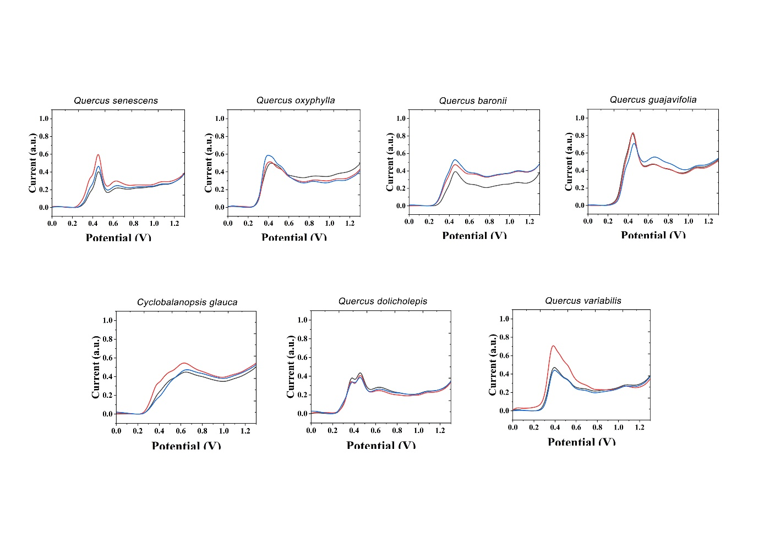
Figure S1. Electrochemical fingerprint of Q. senescens, Q. oxyphylla, Q. baronii, Q. guajavifolia, Cyclobalanopsis glauca, Q. dolicholepis and Q. variabilis after water extraction and recorded under PBS condition.

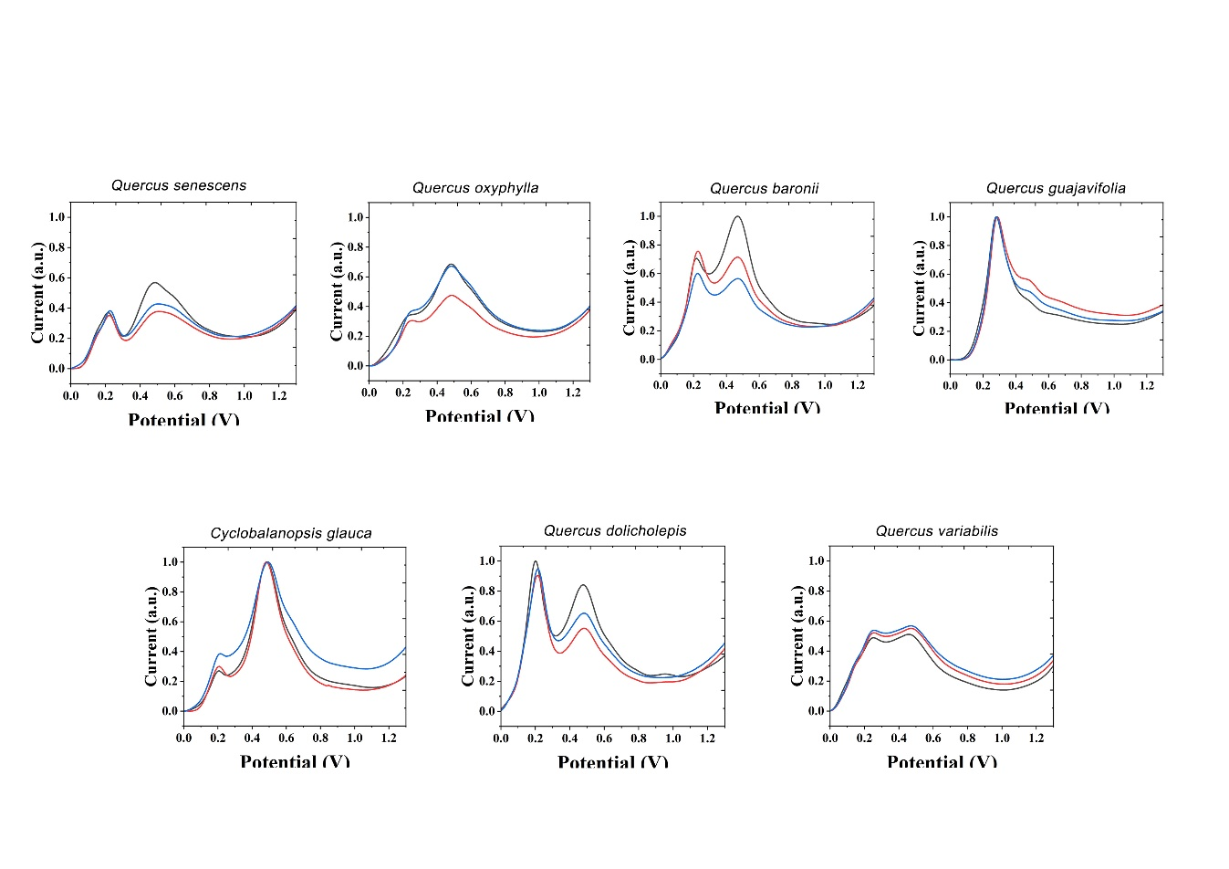
Figure S2. Electrochemical fingerprint of Q. senescens, Q. oxyphylla, Q. baronii, Q. guajavifolia, Cyclobalanopsis glauca, Q. dolicholepis and Q. variabilis after ethanol extraction and recorded under ABS condition.

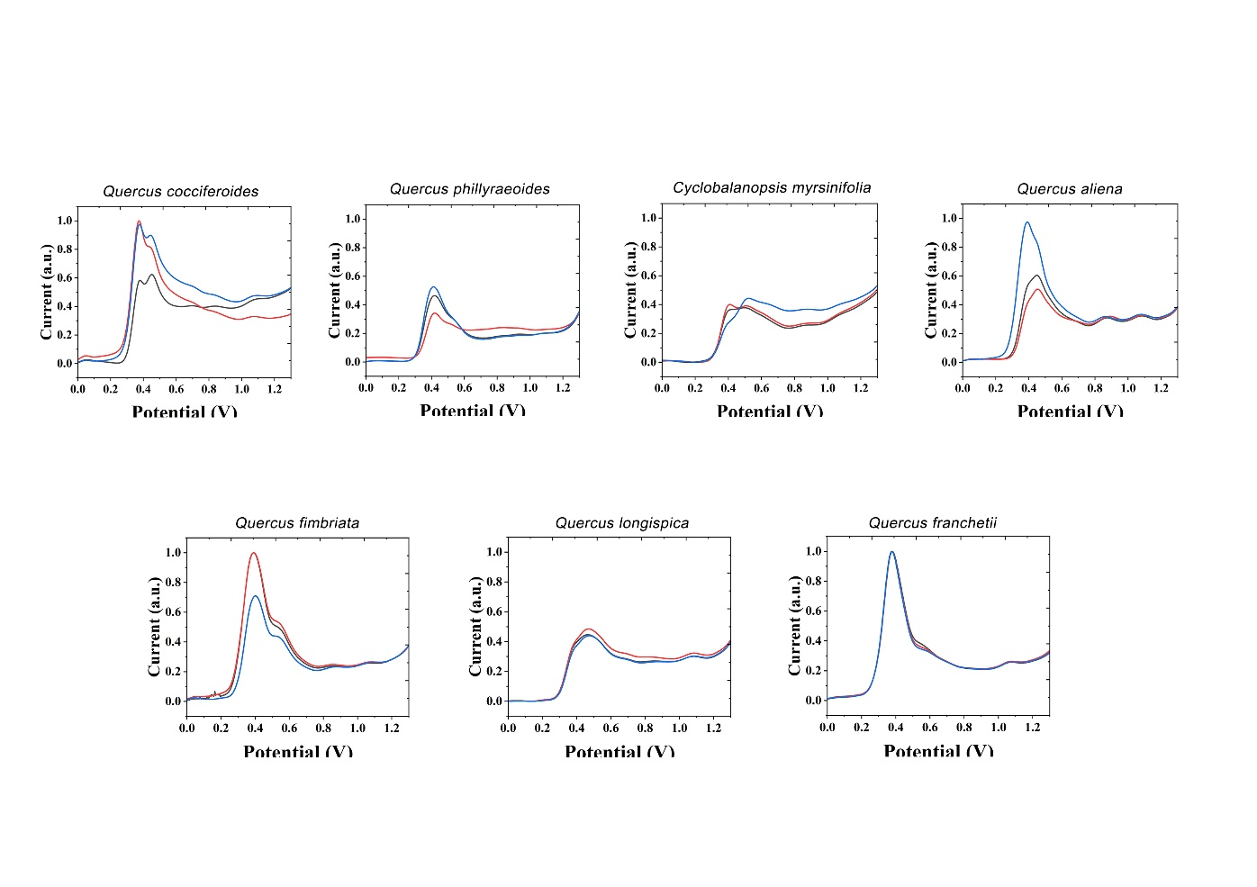
Figure S3. Electrochemical fingerprint of Q.cocciferodies, Q. phillyraeoides, Cyclobalanopsis myrsinifolia, Q. aliena, Q. fimbriata, Q. longispica, Q. franchetli after water extraction and recorded under PBS condition.
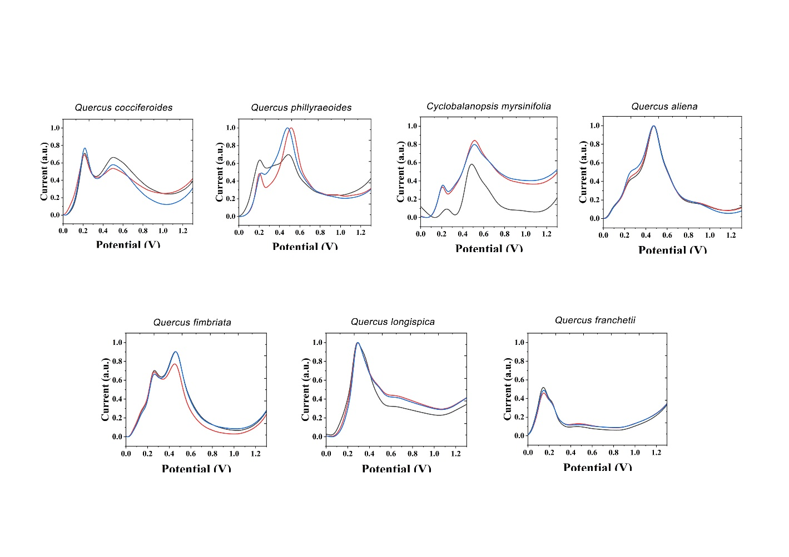
Figure S4. Electrochemical fingerprint of Q.cocciferodies, Q. phillyraeoides, Cyclobalanopsis myrsinifolia, Q. aliena, Q. fimbriata, Q. longispica, Q. franchetli after ethanol extraction and recorded under ABS condition.

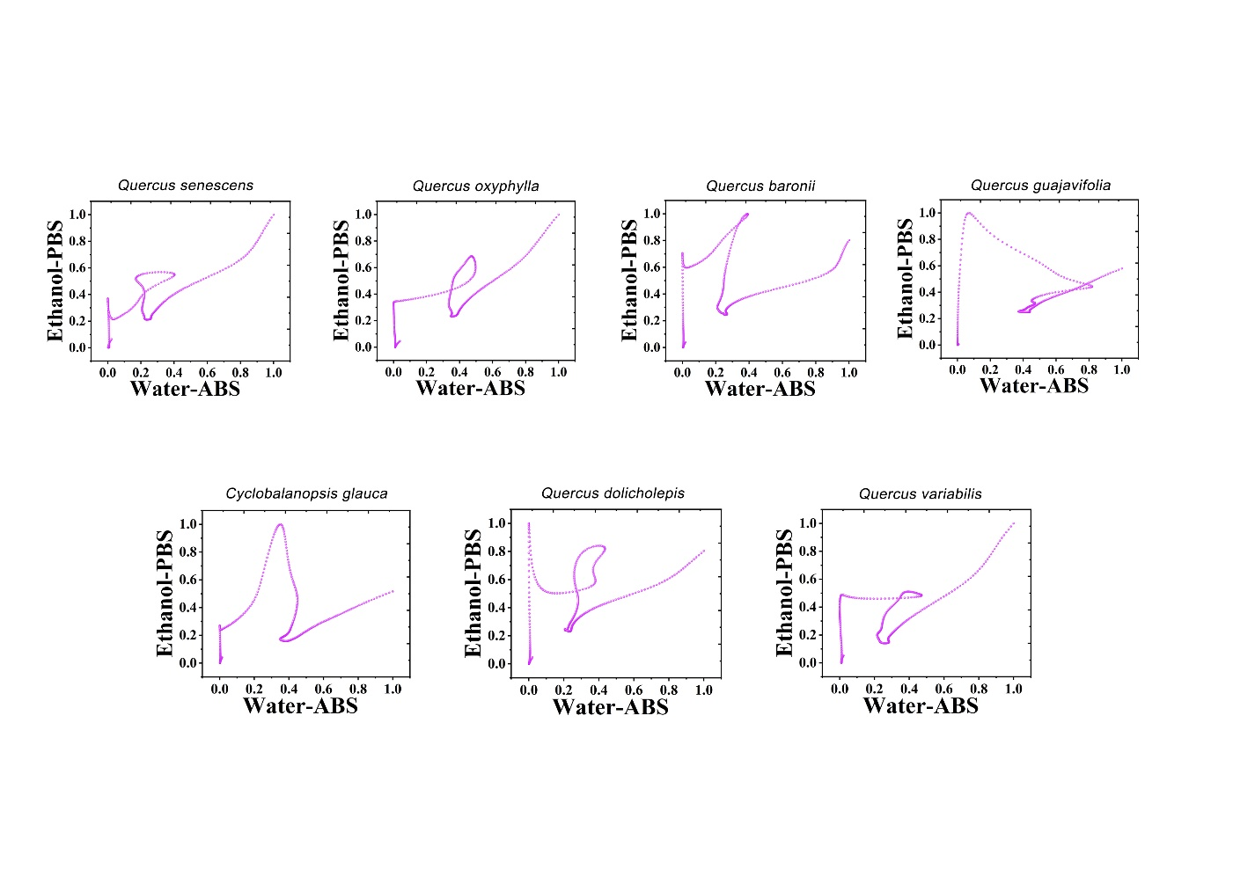
Figure S5. Scatter plots of Q. senescens, Q. oxyphylla, Q. baronii, Q. guajavifolia, Cyclobalanopsis glauca, Q. dolicholepis and Q. variabilis combining the signals collected under ABS for the water extracts and under PBS for the ethanol extracts.

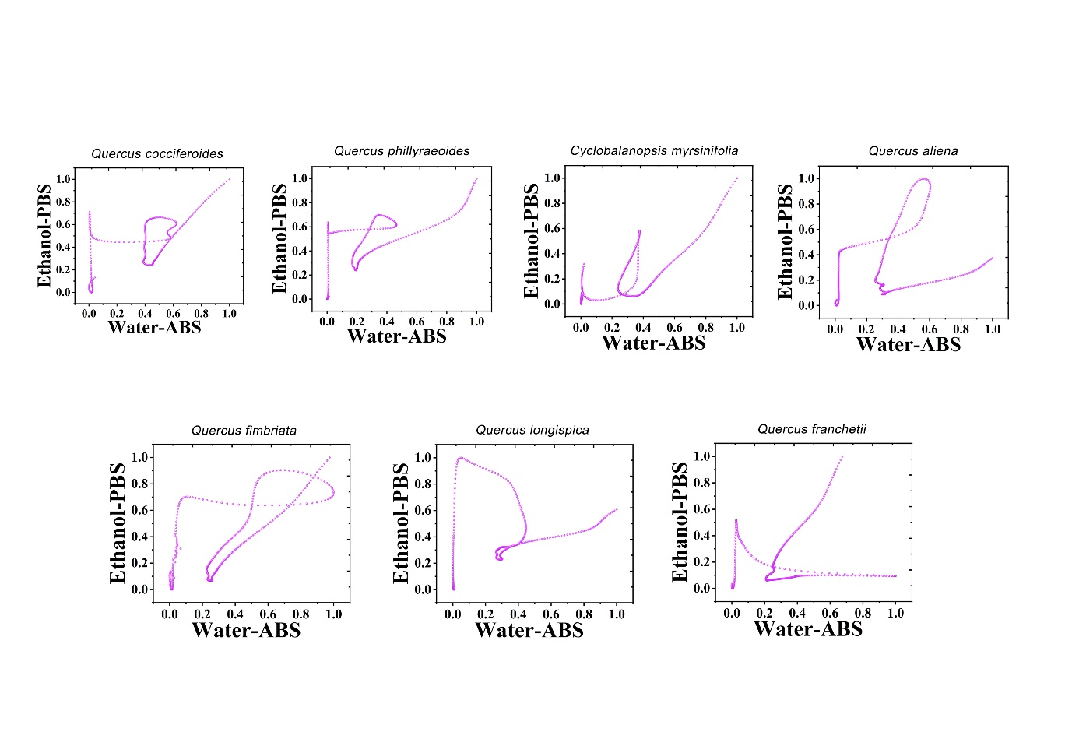
Figure S6. Scatter plots of Q.cocciferodies, Q. phillyraeoides, Cyclobalanopsis myrsinifolia, Q. aliena, Q. fimbriata, Q. longispica, Q. franchetli combining the signals collected under ABS for the water extracts and under PBS for the ethanol extracts.

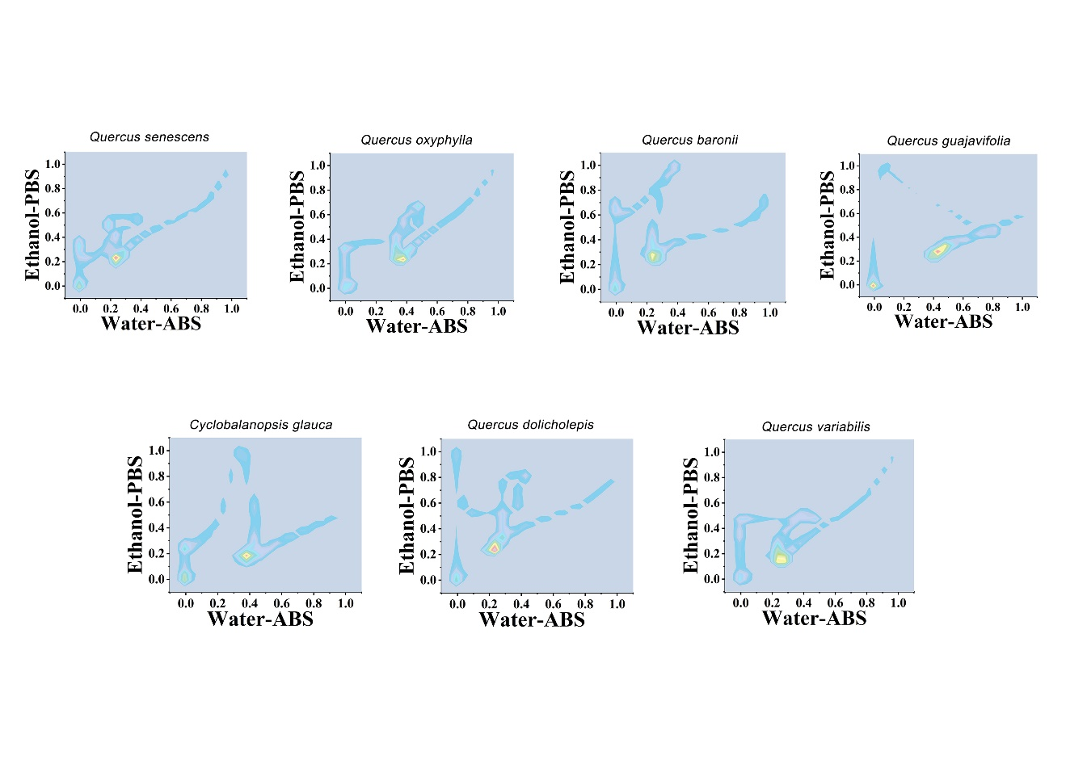
Figure S7. Two-dimensional density map of Q. senescens, Q. oxyphylla, Q. baronii, Q. guajavifolia, Cyclobalanopsis glauca, Q. dolicholepis and Q. variabilis combining the signals collected under ABS for the water extracts and under PBS for the ethanol extracts.

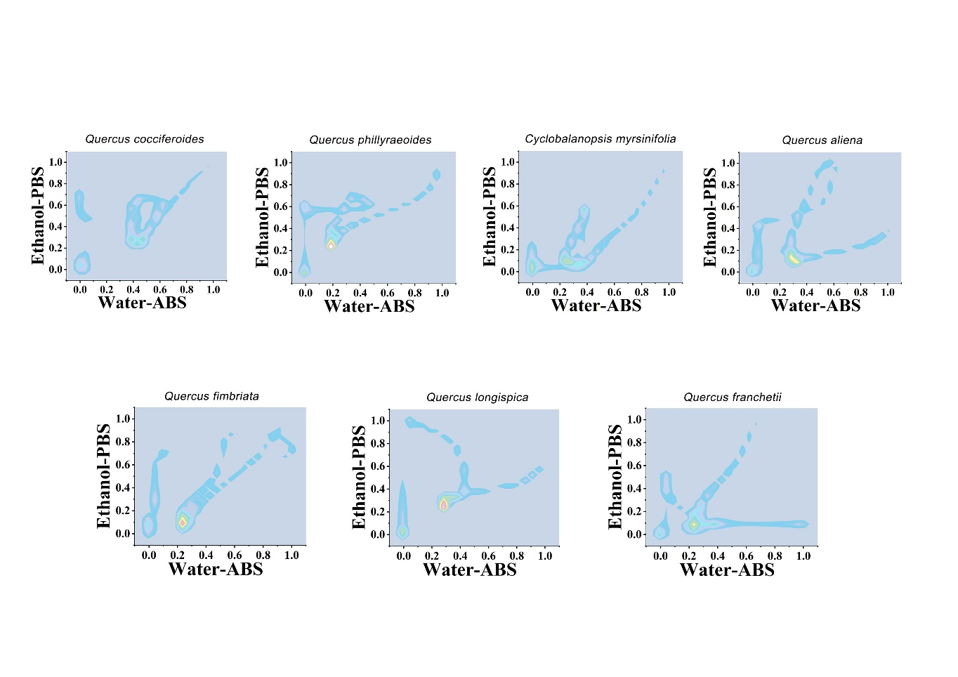
Figure S8. Two-dimensional density map of Q.cocciferodies, Q. phillyraeoides, Cyclobalanopsis myrsinifolia, Q. aliena, Q. fimbriata, Q. longispica, Q. franchetli combining the signals collected under ABS for the water extracts and under PBS for the ethanol extracts.

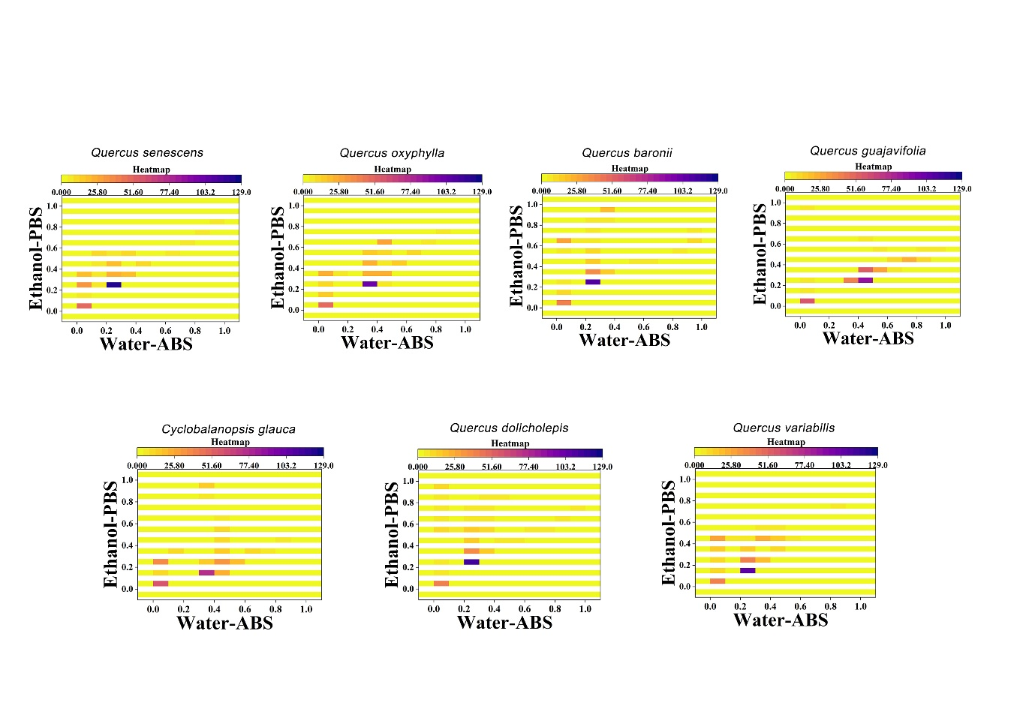
Figure S9. Heatmap of Q. senescens, Q. oxyphylla, Q. baronii, Q. guajavifolia, Cyclobalanopsis glauca, Q. dolicholepis and Q. variabilis combining the signals collected under ABS for the water extracts and under PBS for the ethanol extracts.

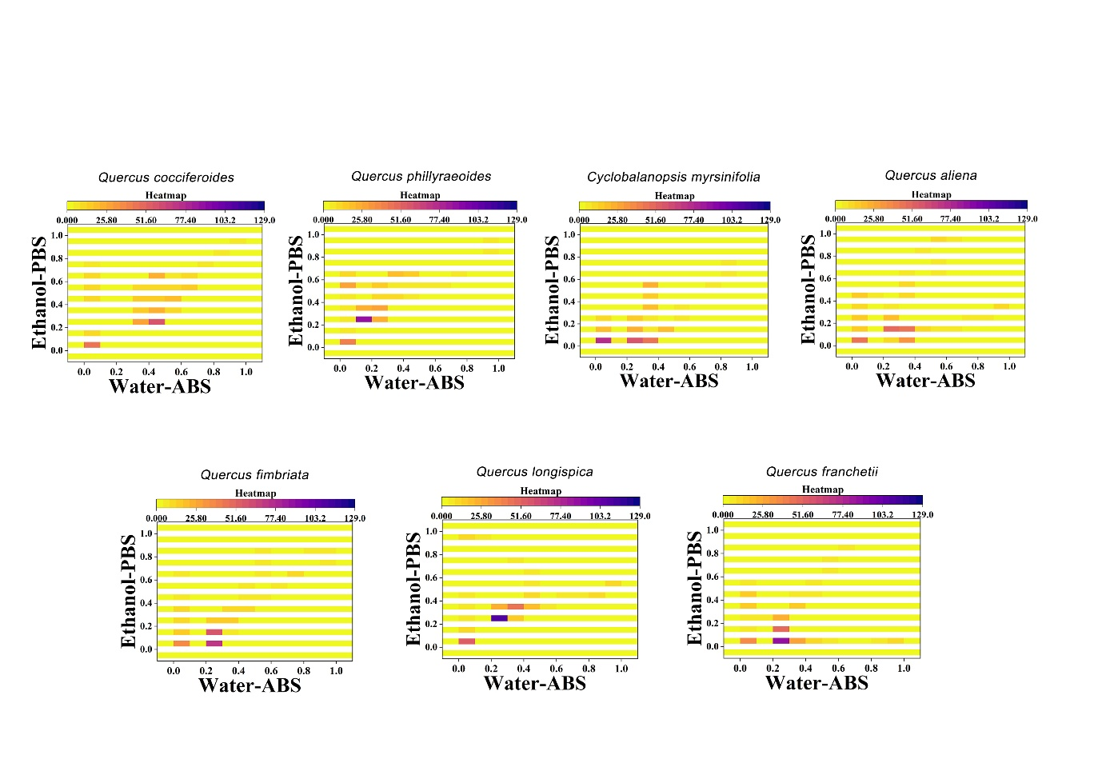
Figure S10. Heatmap of Q.cocciferodies, Q. phillyraeoides, Cyclobalanopsis myrsinifolia, Q. aliena, Q. fimbriata, Q. longispica, Q. franchetli combining the signals collected under ABS for the water extracts and under PBS for the ethanol extracts.

