Supplementary Material

S. Table 1. List of various PGRs and their mechanism for mitigating salt stress

Sl. No. | Growth regulator | IUPAC name | Chemical structure |  | Mechanism of salt stress mitigation |  | References
Natural growth regulators
1 | IAA | Indole-3-acetic acid | 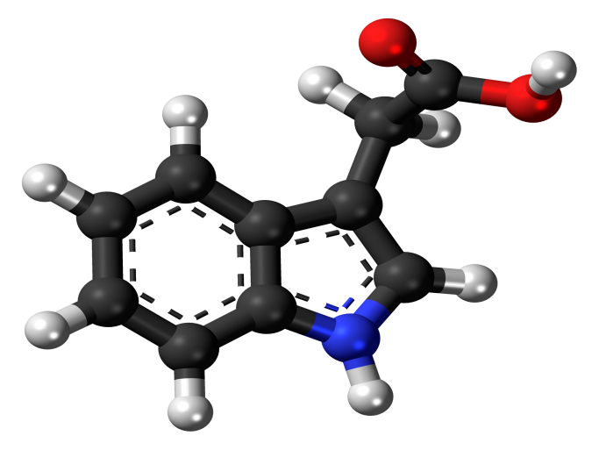 |  | Cell elongation, cell division, root growth, leaf and fruit senescence |  | Lin et al. (2018); Small and Degenhardt (2018); Farman et al. (2019)
2 | IPrA | Indole-3-propionic acid | 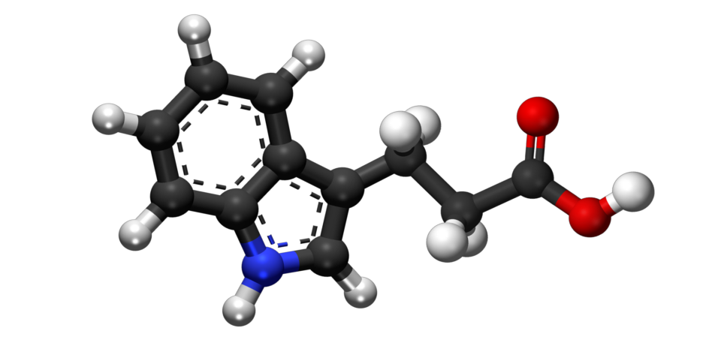 |  | Vascular regulatory functions |  | Venu et al. 2018); Farman et al. (2019); (Pistilli, 2018)
3 | IBA | Indole-3-butyric acid | 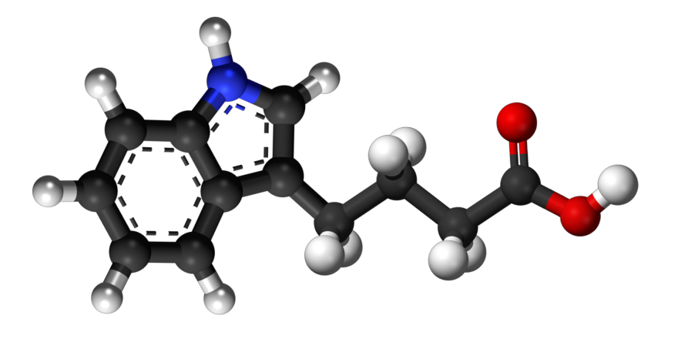 |  | Adventitious root growth |  | Qamar . Muneer. (2005); Farman et al. (2019); (Pistilli, 2017)
4 | PAA | Phenyl acetic acid | 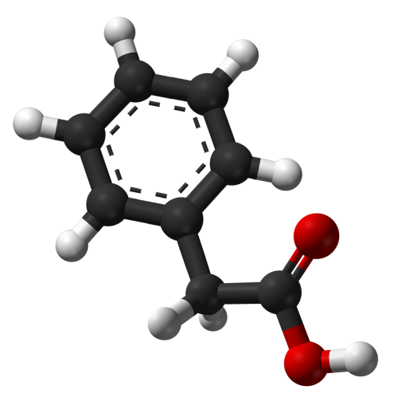 |  | Antimicrobial activity |  | Cook (2019); Farman et al. (2019)
5 | GA_{1,} GA₇ | Active Gibberellic acid | 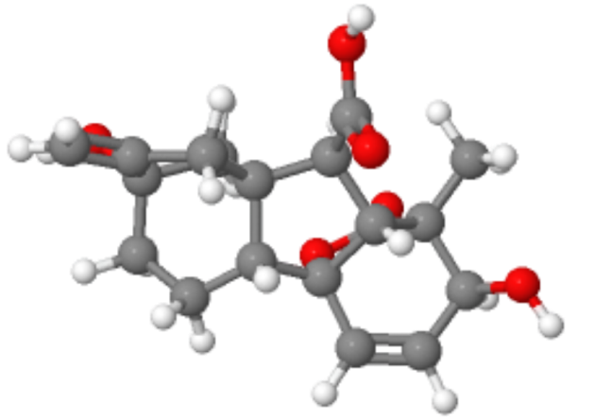 |  | Reduce stomatal resistance, RNA and protein synthesis, membrane permeability, ion accumulation and partitioning in plant tissue |  | Tuna et al. (2008); Farman et al. (2019)
6 | Zeatin | (E)-2-methyl-4-(7H-purin-6-ylamino)but-2-en-1-ol | 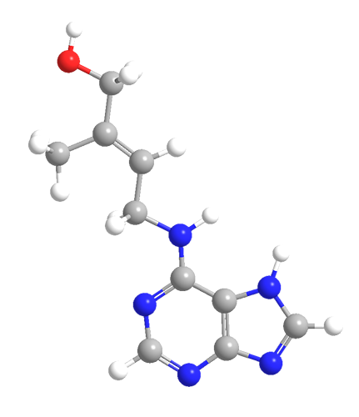 |  | Increased chlorophyll content and enhanced activity of antioxidants |  | Shi et al. (2006); Schafer et al. (2008); Farman et al. (2019); (ACS, 2014)
7 | Kinetin | 6-furfuryl adenine | 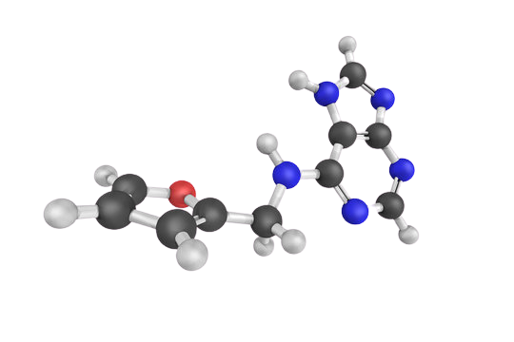 |  | Protects cholorophyll and carotenoids, reduces protease activity |  | Khokhar et al. (2008); Farman et al. (2019); (123RF, 2020)
8 | Ethephon | 2-chloroethylphosphonic acid | 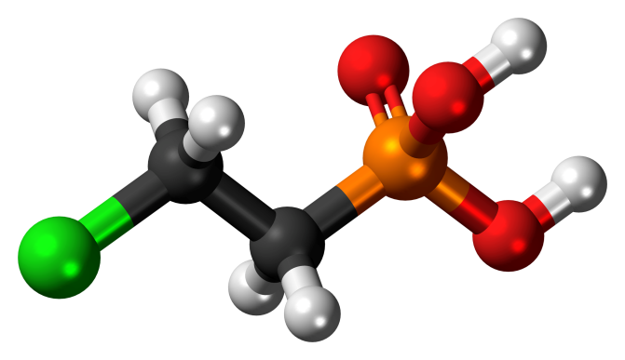 |  | Mobilization of internal tissue nitrate, osmotic adjustment, dormancy breaking |  | Tuteja (2007); Farman et al. (2019)
9 | Abscisic acid | (2Z,4E)-5-[(1S)-1-hydroxy-2,6,6-trimethyl-4-oxocyclohex-2-en-1-yl]-3-methylpenta-2,4-dienoic acid | 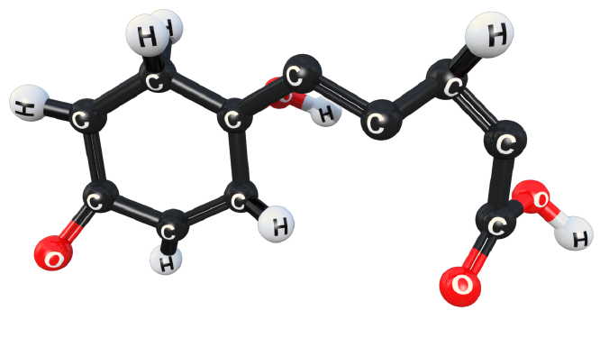 |  | Activates signal pathway, regulates gene expression and cell membrane permeability |  | O'Brien and Benková. (2013); Farman et al. (2019); (TurboSquid, 2020)
10 | Brassinolide | (22R,23R)-2α,3α,22,23-tetrahydroxy-6,7-seco-5α-campestano-6,7-lactone | 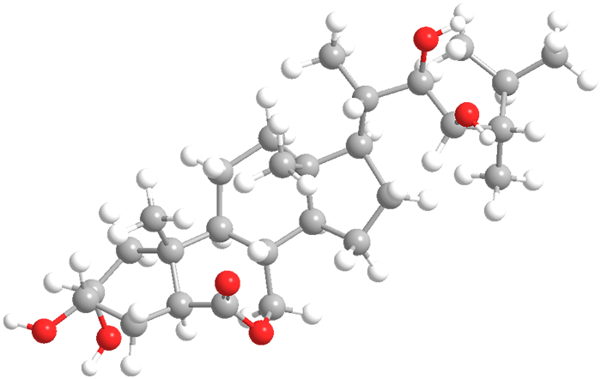 |  | Proton pump activation, reorganization of microtubules and increase ethylene production |  | Kvasnica et al. (2019); Farman et al. (2019); (ACS, 2011)
11 | Castasterone | (22R,23R)-2α,3α,22,23-tetrahydroxy-5α-campestan-6-one | 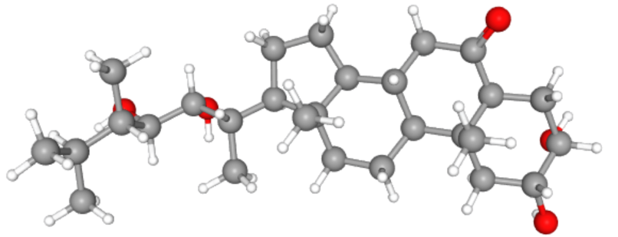 |  | Increase anti-oxidative activity |  | Poonam et al. (2015); Farman et al. (2019)
12 | Typhasterol | (3R,5S,8S,9S,10R,13S,14S,17R)-17-[(2S,3R,4R,5S)-3,4-dihydroxy-5,6-dimethylheptan-2-yl]-3-hydroxy-10,13-dimethyl-1,2,3,4,5,7,8,9,11,12,14,15,16,17-tetradecahydrocyclopenta[a]phenanthren-6-one | 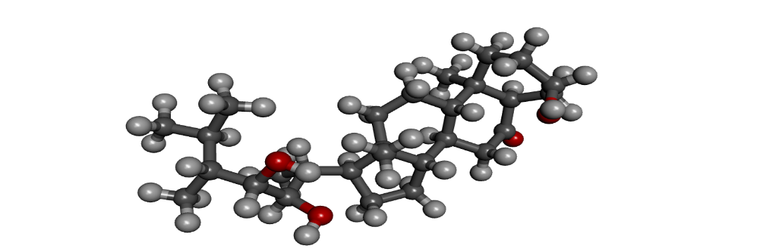 |  | Increase anti-oxidative activity |  | Fariduddin et al. (2014); Farman et al. (2019)
13 | Jasmonic acid | 2-[(1R,2R)-3-oxo-2-[(Z)-pent-2-enyl] cyclopentyl] acetic acid | 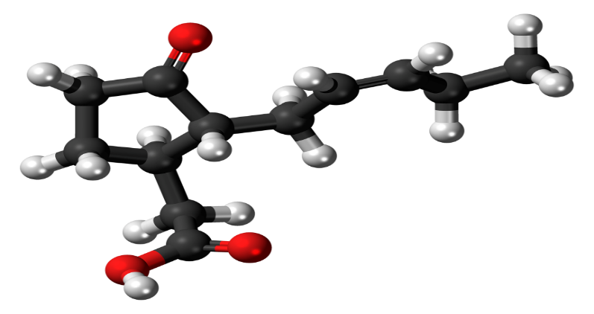 |  | Root elongation, production specific polypeptides |  | Vreugdenhil et al. (2011); Farman et al. (2019)
14 | Methyl jasmonate | Methyl (1R,2R)-3-Oxo-2-(2Z)-2-pentenyl-cyclopentaneacetate | 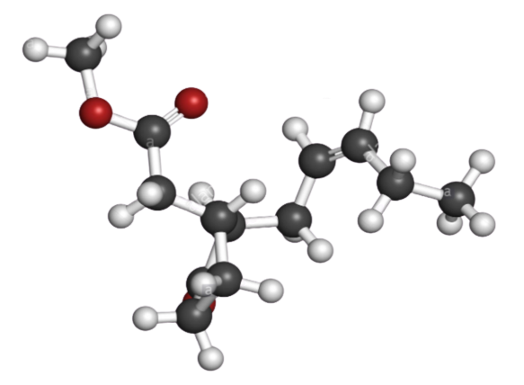 |  | Produce antioxidants |  | Chen et al. (2014); Farman et al. (2019); (Alamy, 2018)
Synthetic/Artificial growth regulators
15 | 2,4-D  hedonal  trinoxol | 2,4- Dichlorophenoxyacetic acid |  | 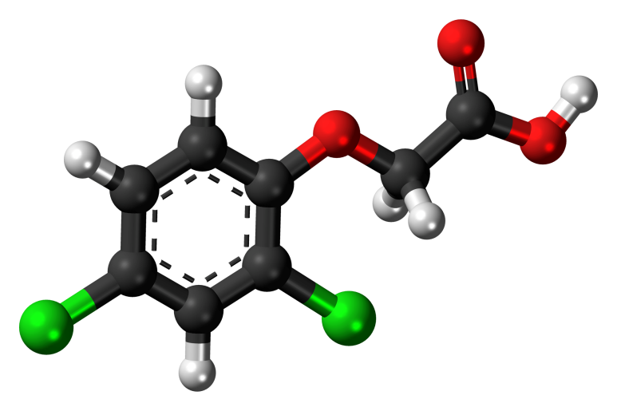
16 | α-NAA | α-Naphthalene acetic acid |  | 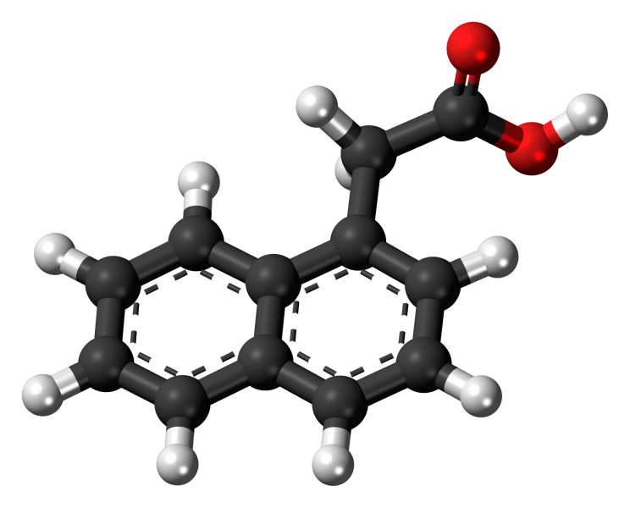 |  | Root growth and fruit thinning |  | Yan et al. (2014); Farman et al. (2019)
18 | Humic acid | 2-nitrobicyclo[2.2.1] hept-5-ene-2,3-dicarboxylic acid |  | 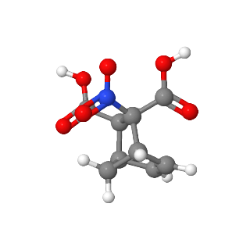 |  | Increase relative water content, photosynthetic pigments and non-enzymatic antioxidants |  | Akladious and Mohamed (2018); (Mol-Instincts, 2020)
19 | Salicylic acid | 2-hydroxybenzoic acid |  | 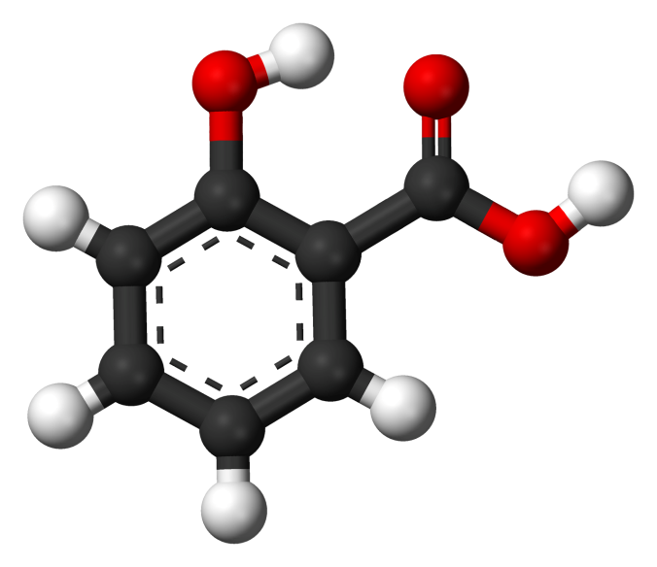 |  | Membrane permeability, regulate polyamine levels, osmotic adjustment, anti-oxidative role |  | Zhu et al. (2019)
20 | Chlormequat chloride | (2-chloroethyltrimethyl-ammonium chloride) |  | 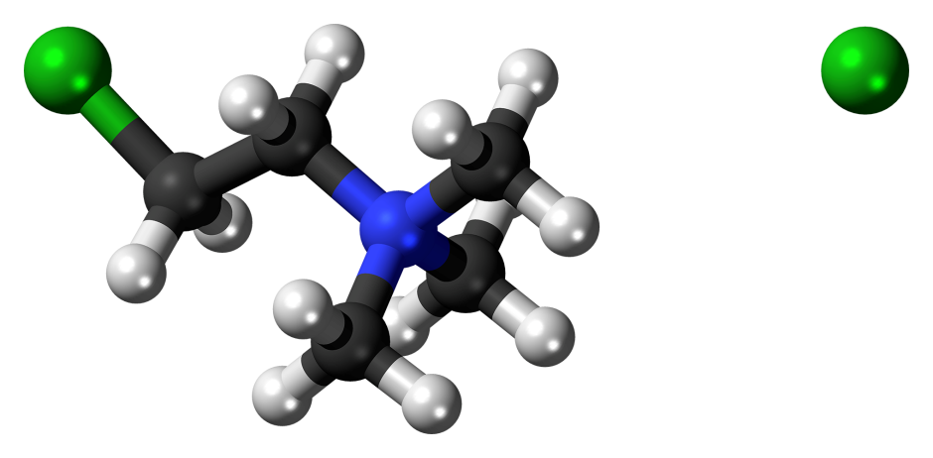 |  | Reduced concentrations of Na⁺ and Cl⁻ ions, suppressed Na⁺/K⁺ ratio, increased concentrations of K+ and Ca²⁺ ions, concentrations, anti-lodging properties in wheat |  | Gurmani et al. (2011)
21 | Glyphosine | N,N-bis(phosphonomethyl)glycine |  | 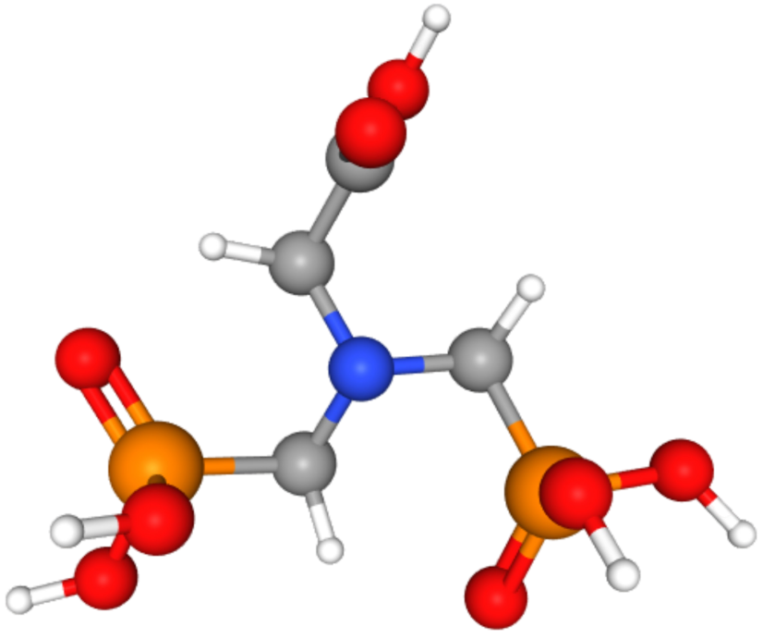 |  | Increases sugarcane yield |  | Gianfagna 1995
22 | Tribufos | 1-bis(butylsulfanyl) phosphorylsulfanylbutane |  | 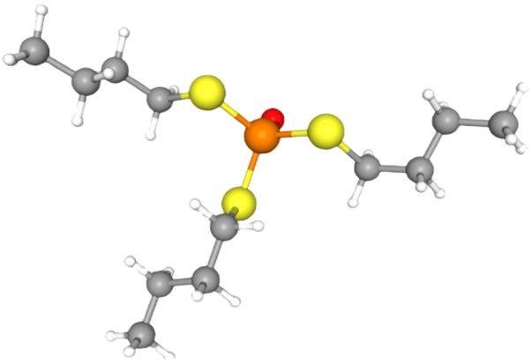 |  | Cotton defoliation |  | (Ma et al., 2019)

