Synthesis, determination, and bio-application in cellular and biomass-bamboo imaging of natural cinnamaldehyde derivatives

Jinlai Yang^{1,2,3,4,5}, Rencong Guo^{1,2,3,4}, Huimin Yang^{1,2,3,4}, Liangru Wu^{1,2,3,4,5*}

Supplementary Material

*Corresponding author: Prof. Liangru Wu
¹China National Bamboo Research Center, Hangzhou 310012, Zhejiang, China.
²Key Laboratory of Bamboo Forest Ecology and Resource Utilization of National Forestry and Grassland Administration, Hangzhou 310012, Zhejiang, China.
³Key Laboratory of High Efficient Processing of Bamboo of Zhejiang Province, Hangzhou 310012, Zhejiang, China.
⁴National Longterm Observation and Research Station for Forest Ecosystem in Hangzhou-Jiaxing-Huzhou Plain, Hangzhou 310012, Zhejiang, China.
⁵Bamboo Industry (Jian'ou) Branch, Fujian Provincial Collaborative Innovation Institute, Jian'ou 353100, Fujian, China.
Email: bamshoots@163.com

Figure S1:
Figure S1. (A) Fluorescence intensity of compound 1, 1+ClO⁻, and 1+ClO⁻ when adding another ROS to the PBS buffer solution (pH=7.4, 10 mM, 50% (v/v) C₂H₅OH), λ_{ex}=375 nm, Em. Slit=5.0 nm, Ex. Slit=6.0 nm; (B, C) Fluorescence intensity of compound 2, 2+ClO⁻, and 2+ClO⁻ when adding another ROS to the PBS buffer solution (pH=7.4, 10 mM, 50% (v/v) C₂H₅OH), λ_{ex}=430 nm, with Em. Slit=5.0 nm, Ex. Slit=9.0 nm.

Figure S2:
Figure S2. (A) Peak fluorescence intensity of compound 1 vs. Fe³⁺ concentrations; (B) F₄₀₄/F₄₂₆ of compound 1 vs. ClO⁻ concentrations; λ_{ex}=375 nm, Fe³⁺: Em. Slit=5.0 nm, Ex. Slit=2.5 nm; ClO⁻: Em. Slit=5.0 nm, Ex. Slit=5.0 nm.

Figure S3:
Figure S3. Peak fluorescence intensity of compound 2 vs. concentrations of Fe³⁺ (A) or ClO⁻ (B); λ_{ex}=430 nm, Fe³⁺: Em. Slit=5.0 nm, Ex. Slit=5.0 nm; ClO⁻: Em. Slit=5.0 nm, Ex. Slit=18.0 nm.

Figure S4:
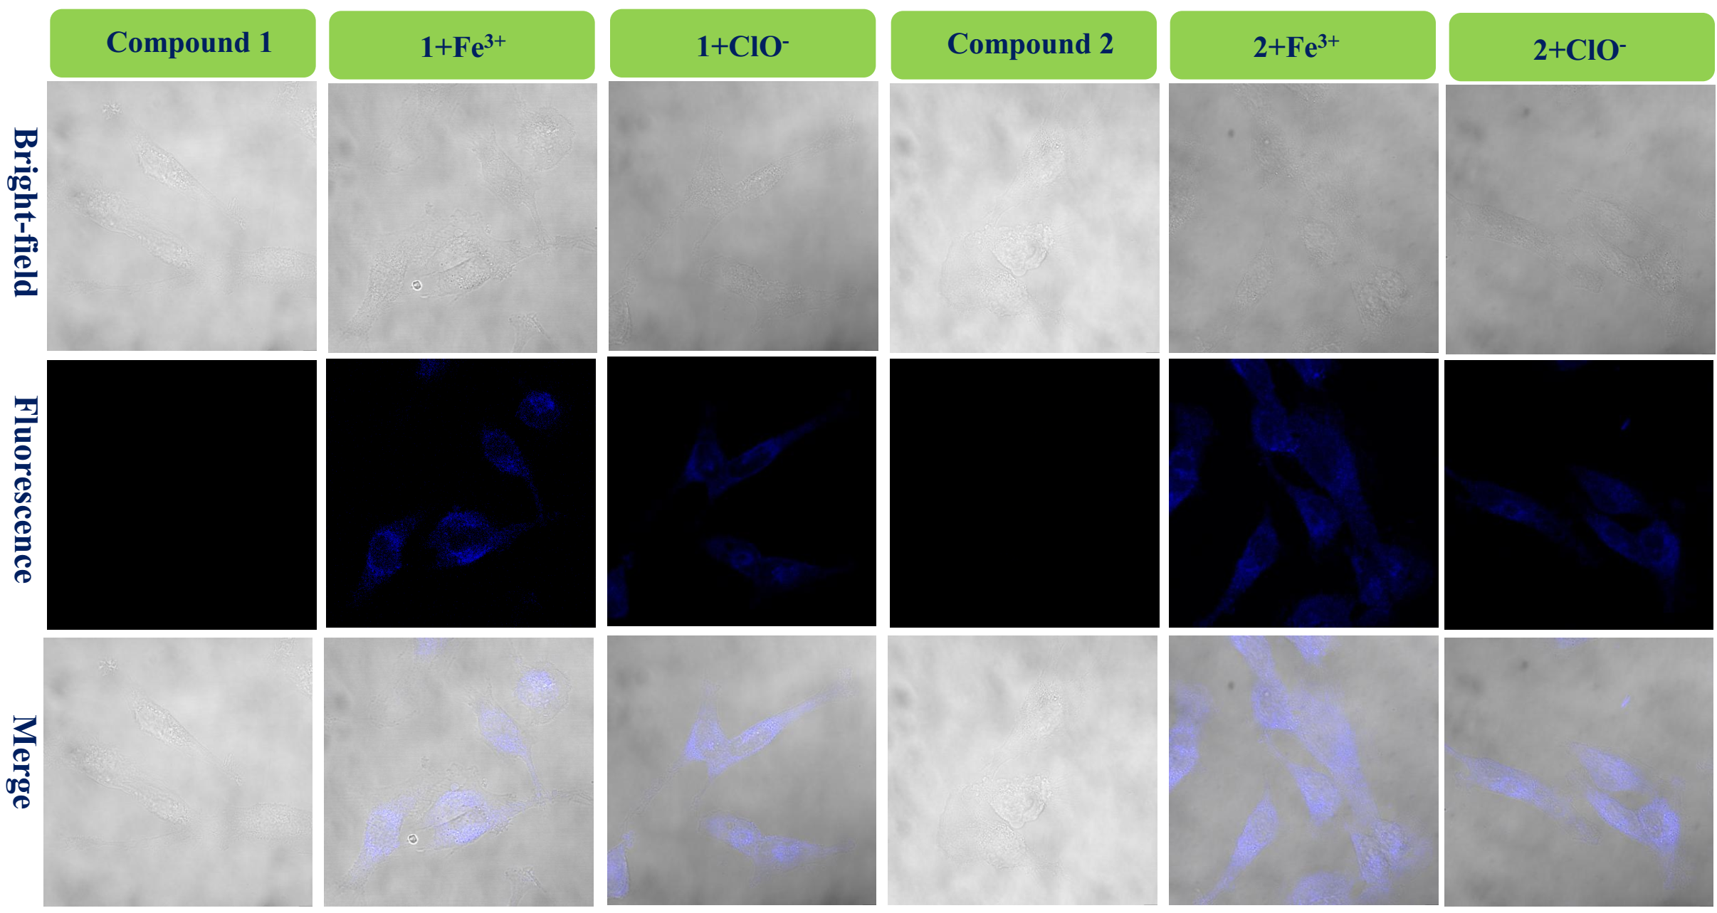
Figure S4. Fluorescence bio-images of the LN-229 cells of probe 1, 1+Fe³⁺, and 1+ClO⁻ and probe 2, 2+Fe³⁺, and 2+ClO⁻.

