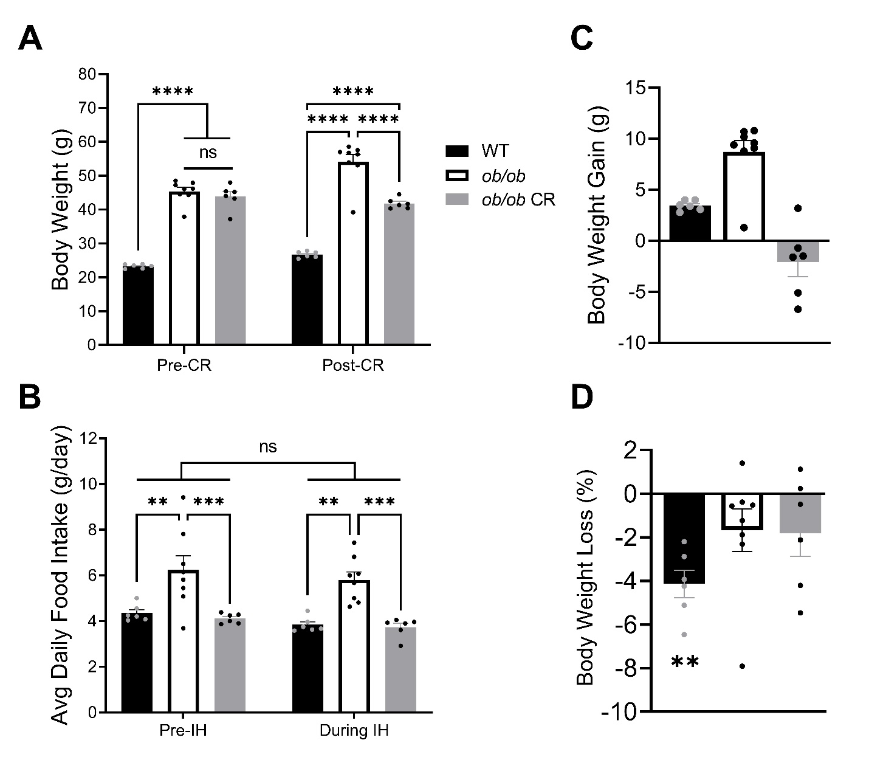Supplemental Figure 1A. Caloric restriction prevents weight gain in ob/ob mice. (A) All ob/ob mice weighed the same prior to CR, but free-fed ob/ob mice (n = 8) weighed more than calorically-restricted ob/ob mice (n = 6) after 4 weeks of CR. (B) Free-fed ob/ob mice had a significantly higher average daily food intake compared to WT (n = 6) and calorically-restricted ob/ob mice during both the 6 days prior to IH and the 6 days during IH. All mice had the same average daily food intake during IH as compared to pre-IH. (C) Calorically-restricted ob/ob mice did not gain weight after 4 weeks of CR, while WT and free-fed ob/ob mice gained weight. (D) WT mice lost weight after 6 days of IH, while free-fed and calorically-restricted ob/ob mice did not lose a significant amount of body weight. Abbreviations: CR, caloric restriction; WT, wild-type; IH, intermittent hypoxia.

