Supplementary data

Exogenous melatonin improved photosynthetic efficiency of photosystem II by reversible phosphorylation of thylakoid proteins in wheat under osmotic stress

Shuai Lin¹, Xiao-Fang Song¹, Hao-Tian Mao¹, Shuang-Qing Li¹, Jie-Ying Gan¹, Ming Yuan¹, Zhong-Wei Zhang², Shu Yuan², Huai-Yu Zhang¹, Yan-Qiu Su^{3,}*, Yang-Er Chen^{1,}*

¹ College of Life Sciences, Sichuan Agricultural University, Ya’an 625014, China, ² College of Resources, Sichuan Agricultural University, Chengdu 611130, China, ³ College of Life Science, Sichuan Normal University, Chengdu, China

*Correspondence:
Yang-Er Chen
anty9826@163.com
Yan-Qiu Su
snowdream215@163.com

Supplementary data contents
Supplemental Figures 1-10

Supplemental Figures 1-10

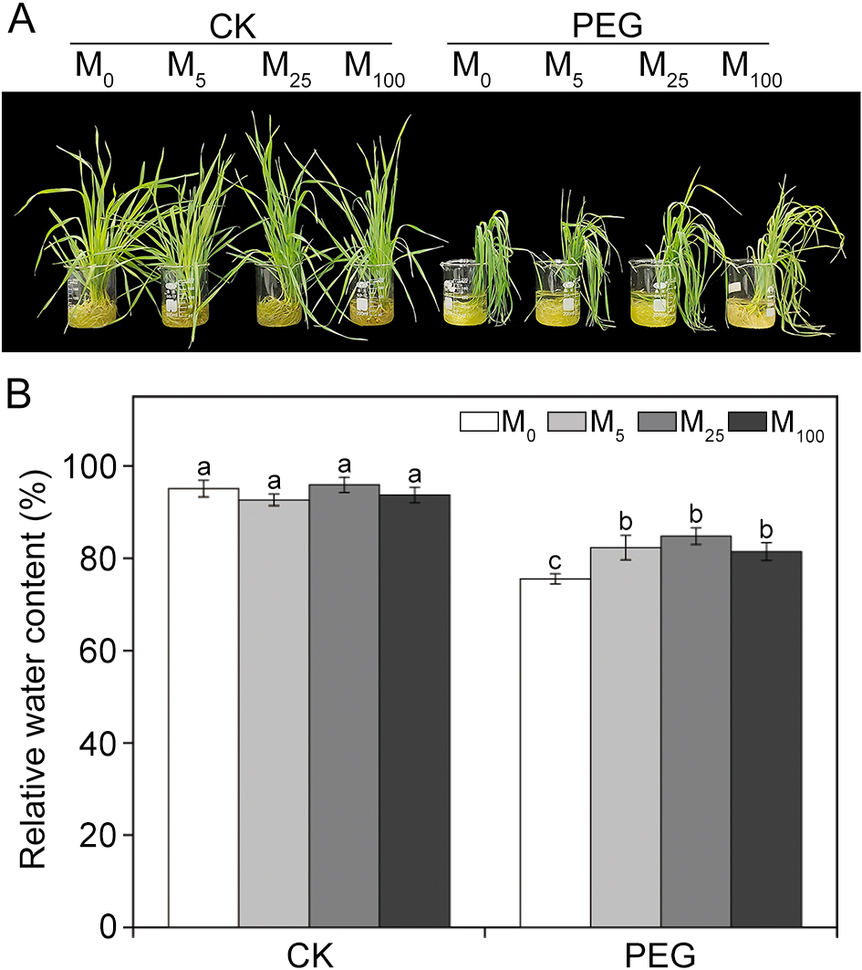
FIGUR S1 Effects of melatonin on phenotype (A) and relative water content (B) in wheat seedlings under osmotic stress. Bars represent standard deviations from three independent biological replicates (n = 3). Different letters indicate significant differences (P < 0.05) according to Duncan’s multiplication range test. CK, non-stressed wheat plants; PEG, osmotic stress for 3 d; M₀-M₁₀₀ show 0, 5, 25, and 100 μM melatonin, respectively.

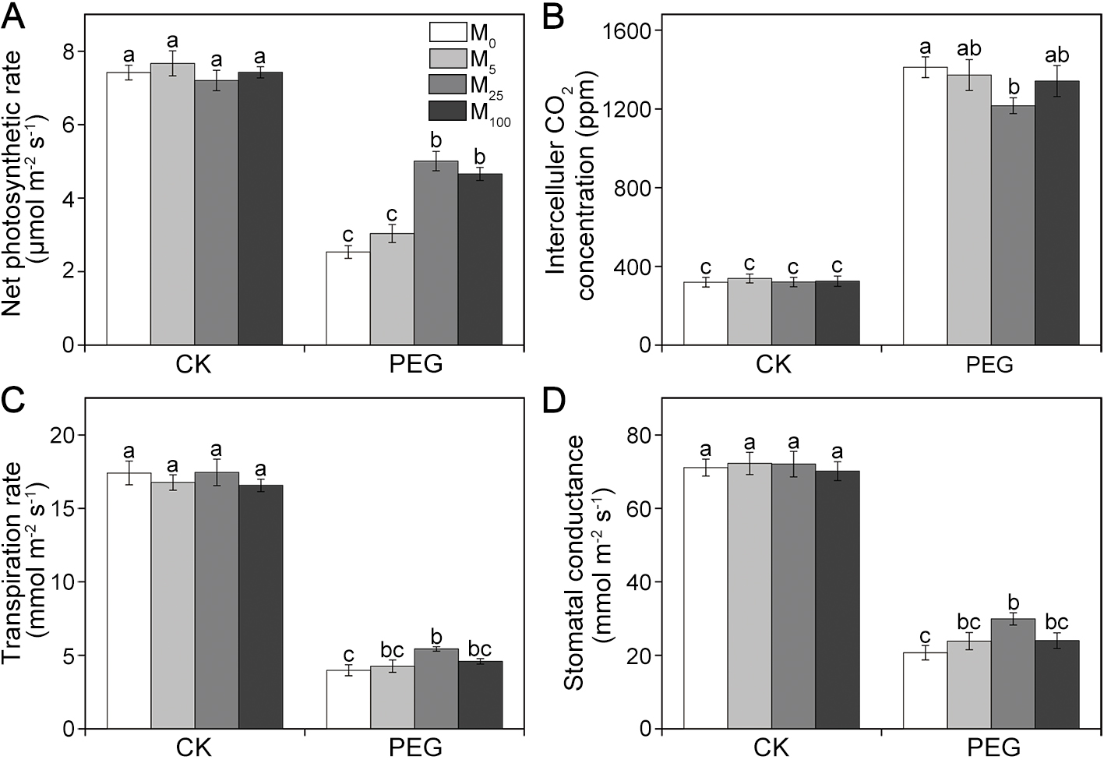
FIGURE S2 Effects of melatonin on net photosynthetic rate (A), intercellular CO₂ concentration (B), transpiration rate (C), and stomatal conductance (D) in wheat seedlings under osmotic stress. Data is presented as mean ± SD for three replicates. Values followed by different letters are significantly different at P < 0.05 according to Duncan’s multiple range test. CK, non-stressed wheat plants; PEG, osmotic stress for 3 d; M₀-M₁₀₀ show 0, 5, 25, and 100 μM melatonin, respectively.

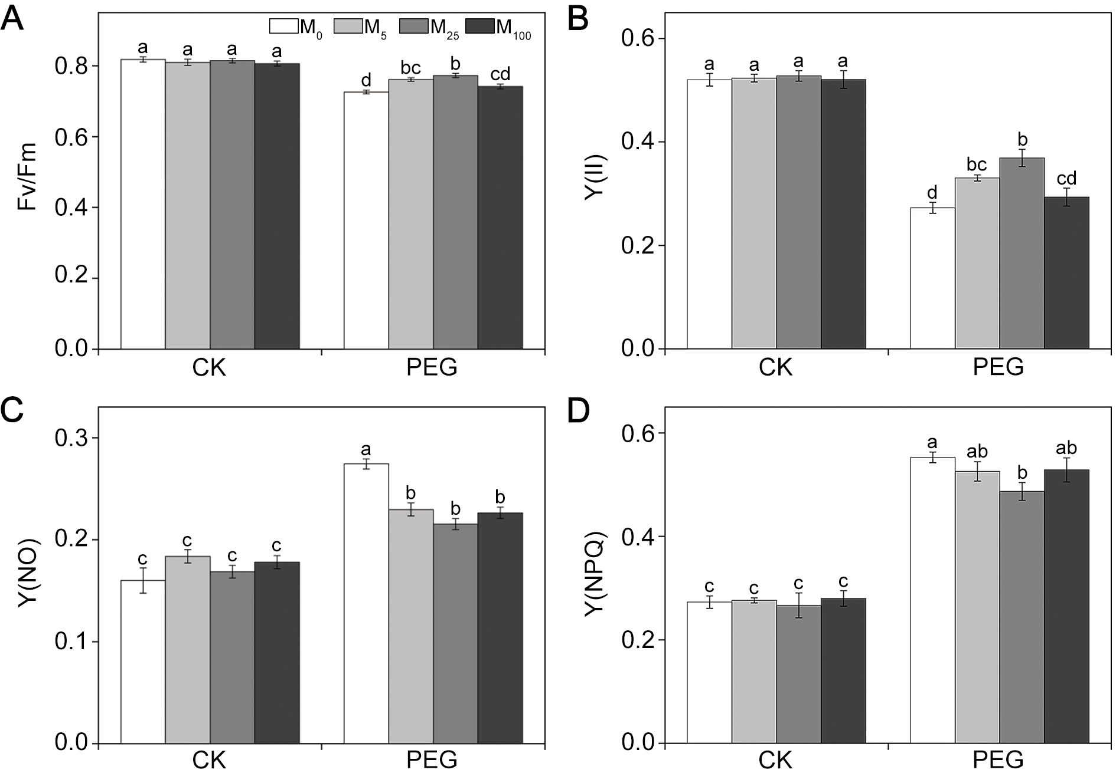
FIGURE S3 Effects of melatonin on Fv/Fm (A), Y(II) (B), Y(NO) (C), and Y(NPQ) (D) in wheat seedlings under osmotic stress. Data is presented as mean ± SD for three replicates. Values followed by different letters are significantly different at P < 0.05 according to Duncan’s multiple range test. CK, non-stressed wheat plants; PEG, osmotic stress for 3 d; M₀-M₁₀₀ show 0, 5, 25, and 100 μM melatonin, respectively.

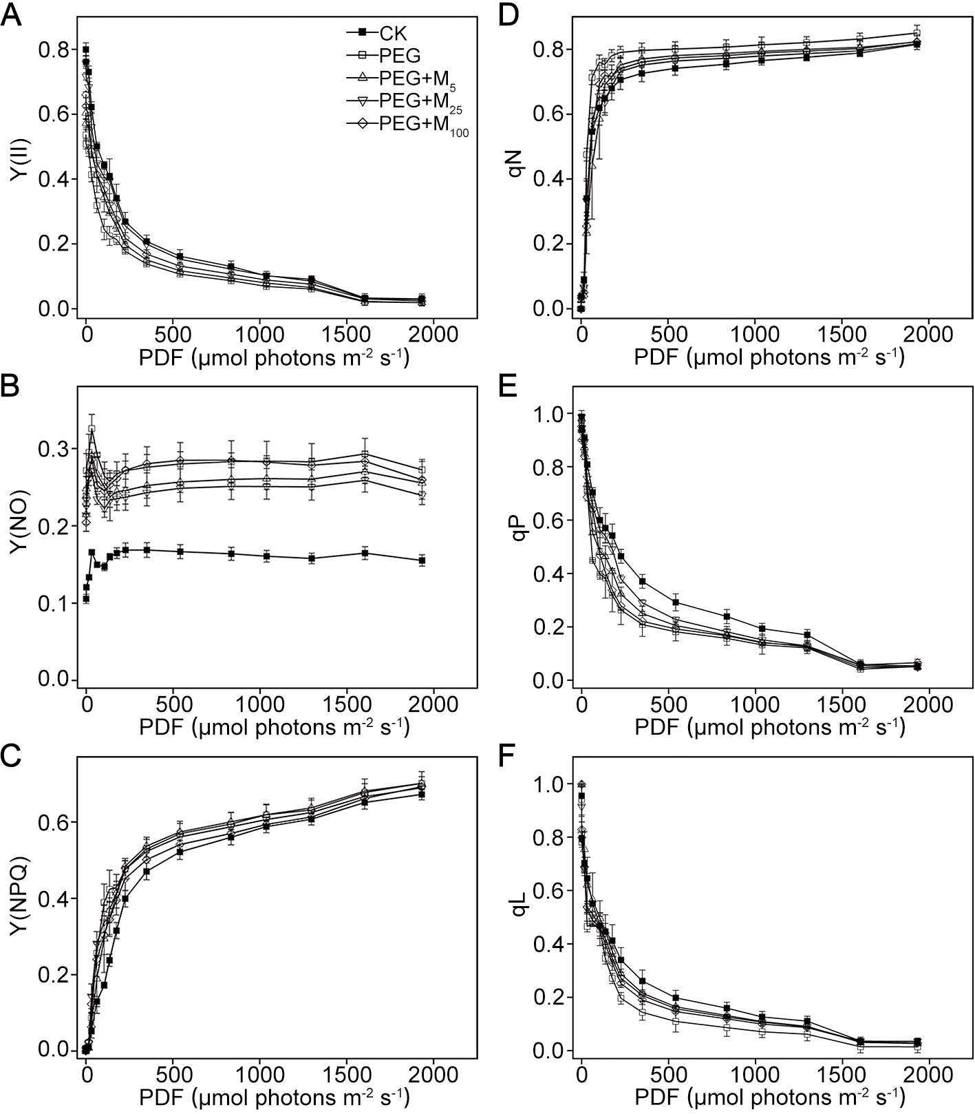
FIGURE S4 Effects of melatonin on light response curves for Y(II) (A), Y(NO) (B), Y(NPQ) (C), qN (D), qP (E), and qL (F) in wheat seedlings under osmotic stress. Bars represent standard deviations from three independent biological replicates (n = 3). CK, non-stressed wheat plants; PEG, osmotic stress for 3 d; M₅-M₁₀₀ show 5, 25, and 100 μM melatonin, respectively.

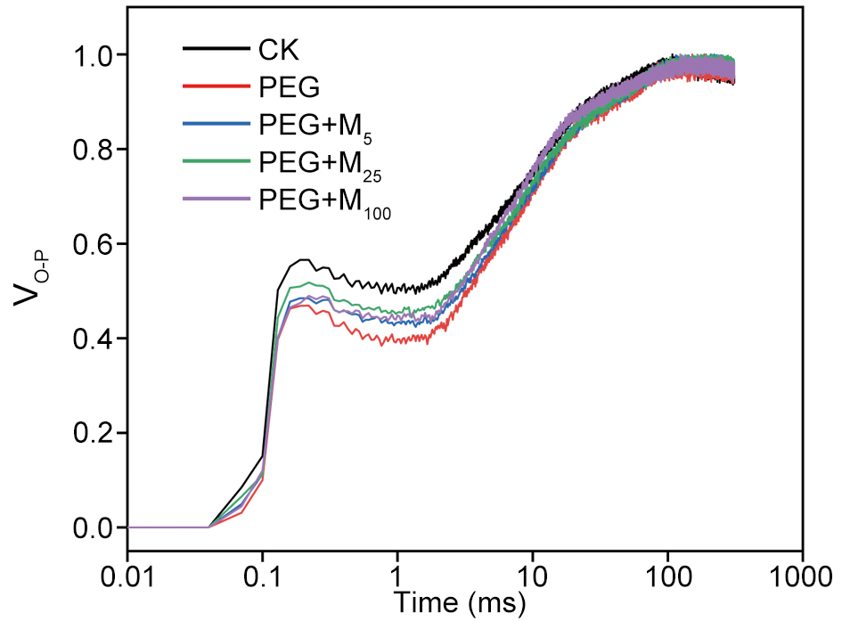
FIGURE S5 Effects of melatonin on V_{O-P} curves in wheat seedlings under osmotic stress. The data in the figure are from three replicated experiments (n = 3). CK, non-stressed wheat plants; PEG, osmotic stress for 3 d; M₅-M₁₀₀ show 5, 25, and 100 μM melatonin, respectively.

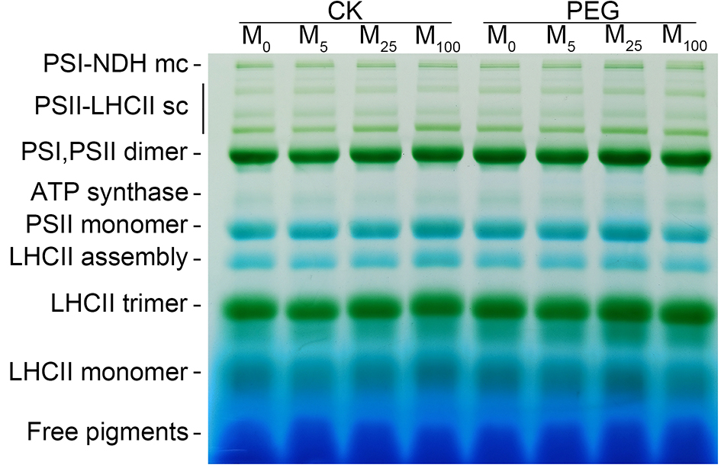
FIGURE S6 Effects of melatonin on thylakoid membrane protein complexes in wheat seedlings under osmotic stress. CK, non-stressed wheat plants; PEG, osmotic stress for 3 d; M₀-M₁₀₀ show 0, 5, 25, and 100 μM melatonin, respectively.

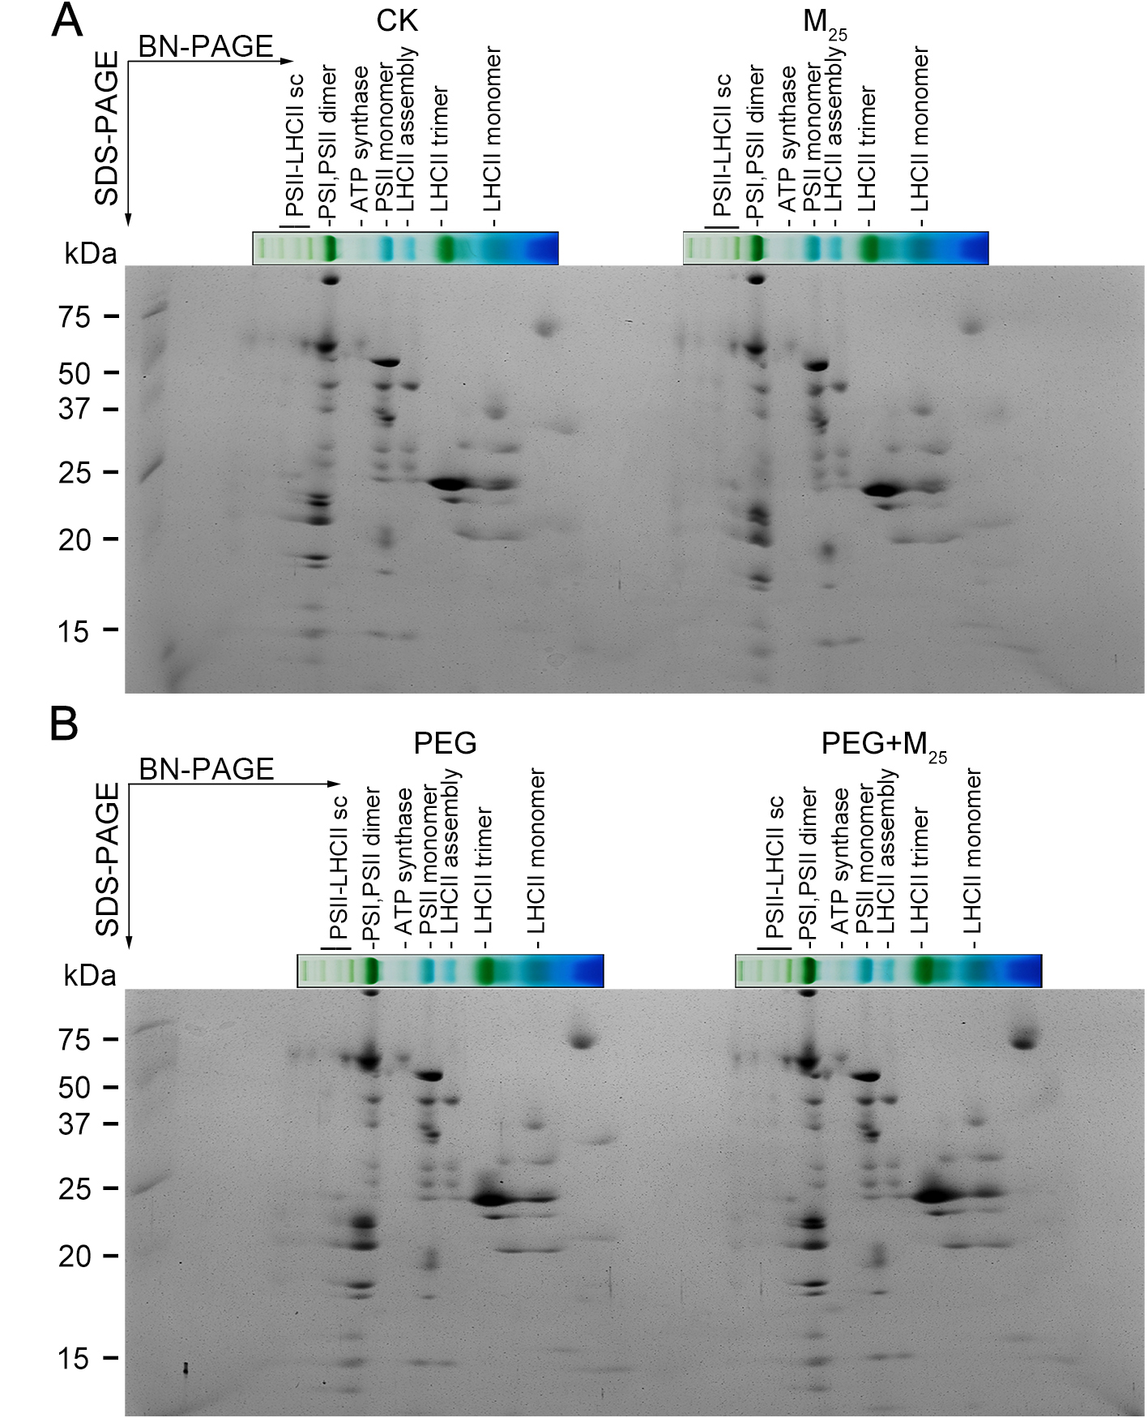
FIGURE S7 Two-dimensional separation of thylakoid membrane protein complexes in wheat seedlings under osmotic stress. Thylakoid protein complexes separated in a BN-PAGE gel were subsequently separated in a second dimension by SDS-PAGE and Coomassie blue staining (CBS). CK, non-stressed wheat plants; PEG, osmotic stress for 3 d; M₂₅, 25 μM melatonin.

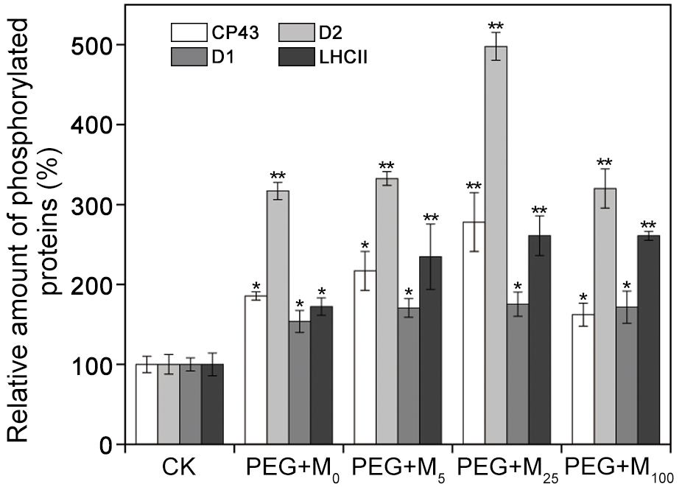
FIGURE S8 Quantification of the immunoblots indicates the relative abundances of the phosphorylated proteins relative to the amount of control (100%). Values are the averages of 3 replicates ± SD. Asterisks indicate statistically significant differences at P < 0.05 level (Duncan’s multiple range test). CK, non-stressed wheat plants; PEG, osmotic stress for 3 d; M₀-M₁₀₀ show 0, 5, 25, and 100 μM melatonin, respectively.

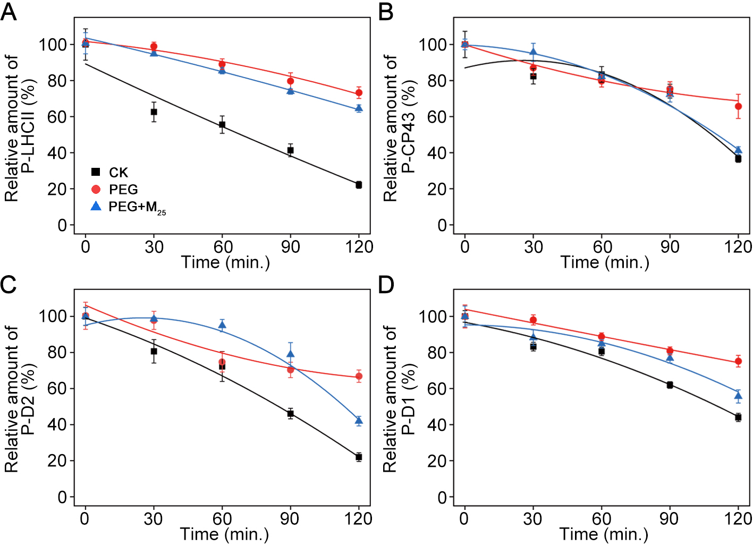
FIGURE S9 Quantification of PSII protein dephosphorylation in wheat seedlings with 25 μM melatonin in vivo under osmotic stress. Results are presented relative to the amount of respective 0 min (100%). The line is a fit of all data to the descriptive hyperbolic equation y = ax² + bx + c. CK, non-stressed wheat plants; PEG, osmotic stress for 3 d; M₂₅, 25 μM melatonin.

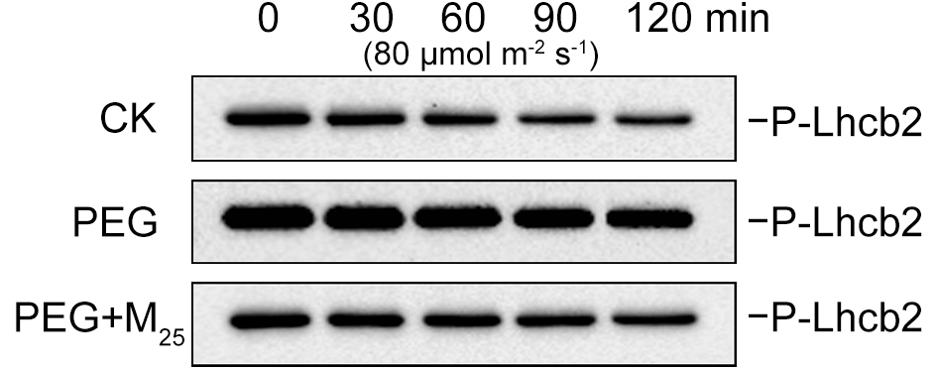
FIGURE S10 Dephosphorylation of Lhcb2 from wheat seedlings with 25 μM melatonin in vivo under osmotic stress. CK, non-stressed wheat plants; PEG, osmotic stress for 3 d; M₂₅, 25 μM melatonin.

