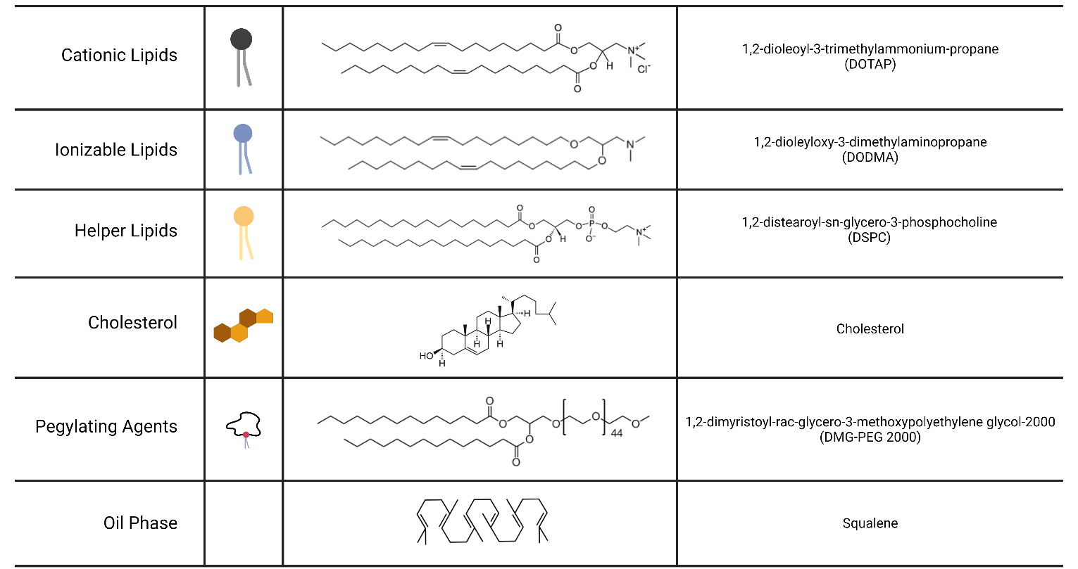
Figure S1. Representative structures of each lipid-based NP components.
Table S1. List of current ionizable lipids.
Abbreviation | Reference | Full Chemical Name
A-066 | 42 | 1-(2,3-bis(((9Z,12Z)-octadeca-9,12-dien-1-yl) oxy) propyl) pyrrolidine
A18 | 50 | ethyl 1-(3-(2-ethylpiperidin-1-yl) propyl)-5,5-di((Z)-heptadec-8-en-1-yl)-2,5-70 dihydro-1H-imidazole-2-carboxylate
A9 (Acuitas) | 48 | NA
ALC-0315 | 41 | ((4-hydroxybutyl) azanediyl) bis(hexane-6,1-diyl) bis(2-hexyldecanoate)
ATX (Arcturus) | 51 | NA
C12-200 | 43 | 1,1′-((2-(4-(2-((2-(bis(2-hydroxydodecyl) amino) ethyl) (2-hydroxydodecyl) amino) ethyl) piperazin-1-yl) ethyl) azanediyl) bis(dodecan-2-ol)
cKK-E12 | 44 | 3,6-bis(4-(bis(2-hydroxydodecyl) amino) butyl) piperazine-2,5-dione
DLinDMA | 38 | 1,2-dilinoleyloxy-N, N-dimethyl-3-aminopropane
DLin-KC2-DMA, KC2 | 36 | N, N-dimethyl-2,2-di-(9Z,12Z)-9,12-octadecadien-1-yl-1,3-dioxolane-4-ethanamine
DLin-MC3-DMA, MC3 | 35 | 4-(dimethylamino)-butanoic acid
DODAP | 37 | 1,2-dioleoyl-3-dimethylammonium-propane
DODMA | 37 | 1,2-dioleyloxy-3-dimethylaminopropane
FTT5 | 46 | Hexa(octan-3-yl) 9,9′,9″,9‴,9″″,9‴″-((((benzene-1,3,5-tricarbonyl) ris(azanediyl)) tris (propane-3,1-diyl)) tris(azanetriyl)) hexanonanoate
L319 | 39 | di((Z)-non-2-en-1-yl) 9-((4-(dimethylamino) butanoyl) oxy) heptadecanedioate
Lipid 5 | 49 | heptadecan-9-yl 8-((2-hydroxyethyl) (8-(nonyloxy)-8-oxooctyl) amino) octanoate
LP01 (Intellia Therapeutics) | 52 | NA
SM-102 | 40 | heptadecan-9-yl 8-((2-hydroxyethyl) (6-oxo-6-(undecyloxy) hexyl) amino) octanoate
ssPalm | 47 | α-D-Tocopherolsuccinoyl
TT3 | 45 | N1, N3, N5-tris(3-(didodecylamino) propyl) benzene-1,3,5-tricarboxamide

