|  |
| --- |
|  |
| **(a)** |
|  |
| **(b)** |

**Supplementary Figure 1.** Assessment of publication bias. **(a).** Begg’s test; **(b).** Egger's test



**Supplementary Figure 2.** Sensitivity analysis of included studies. Detailed data can be seen in Supplementary Table 3.

|  |
| --- |
|  |
| **(a)** |
|  |
| **(b)** |
|  |
| **(c)** |

**Supplementary Figure 3.** Meta-regression of the included studies: **(a).** the geographical location of the study (Others stand for studies from Australia, Brazil, Croatia, New Zealand, Poland, and the UK); **(b).** the measuring methods of serum Zn (AAS/FAAS, ICP-MS, other methods); **(c).** the study types.

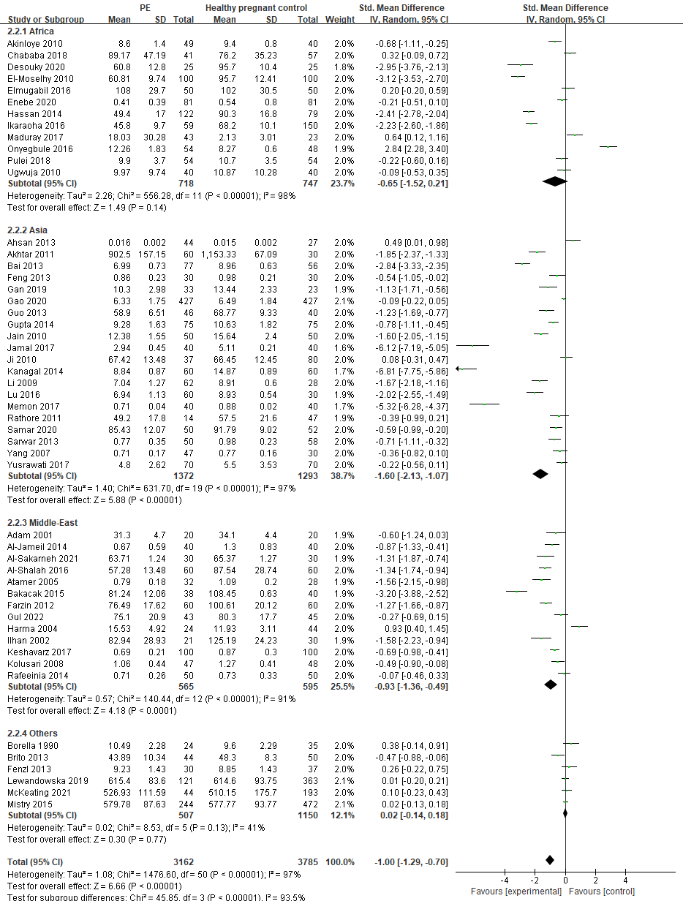

**Supplementary Figure 4**. Maternal serum zinc levels in preeclamptic and healthy pregnant women from Africa, Asia, Middle-East and other regions of the world (Italy, Brazil, Croatia, Poland, Australia, UK, New Zealand)

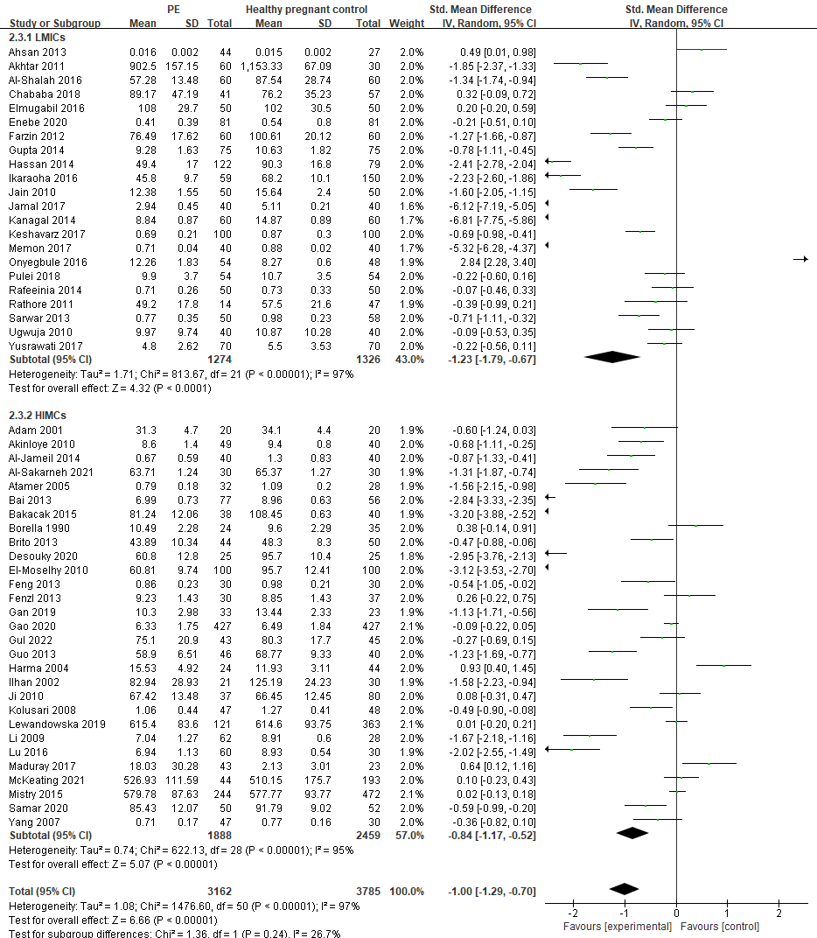

**Supplementary Figure 5.** Maternal serum zinc levels in preeclamptic and healthy pregnant women from LMICs Vs HMICs

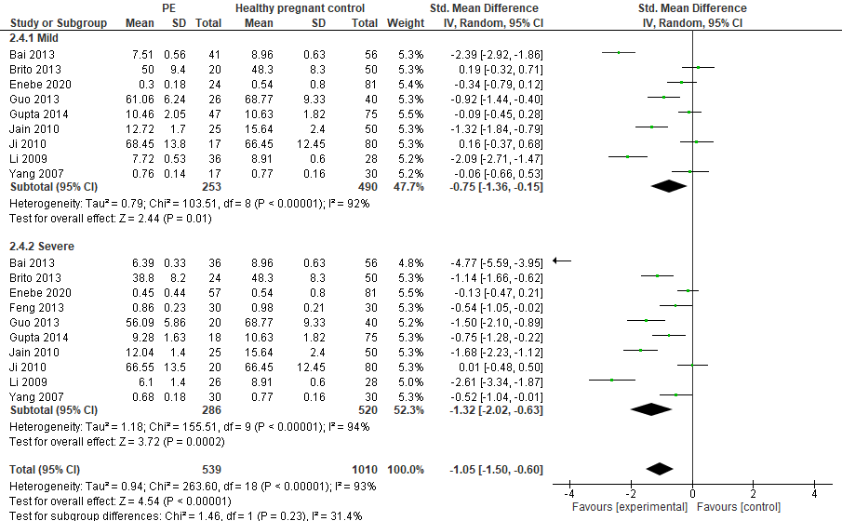

**Supplementary Figure 6.** Maternal serum zinc levels in women with mild Vs severe preeclampsia compared with control