**Supplementary Material**

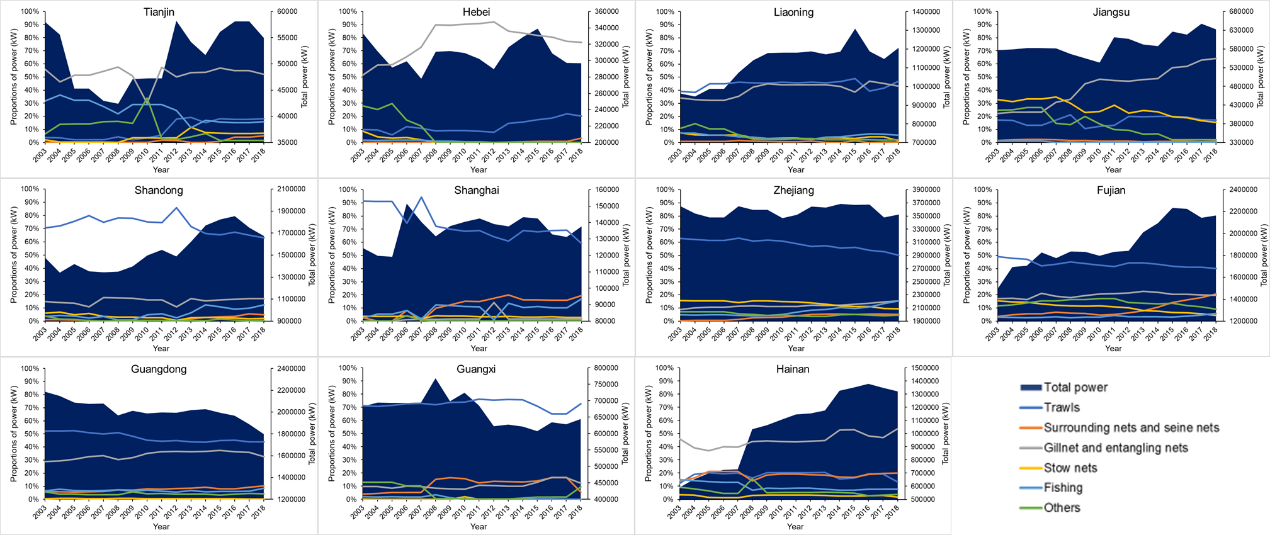

**Figure S1** Proportions of power (by kW) of different fishing vessels classified by fishing gears and total power trends of each province. Based on data from the Chinese National Fishery Statistics Yearbook (Ministry of Agriculture and Rural Affairs of the People's Republic of China, 1990-2019).

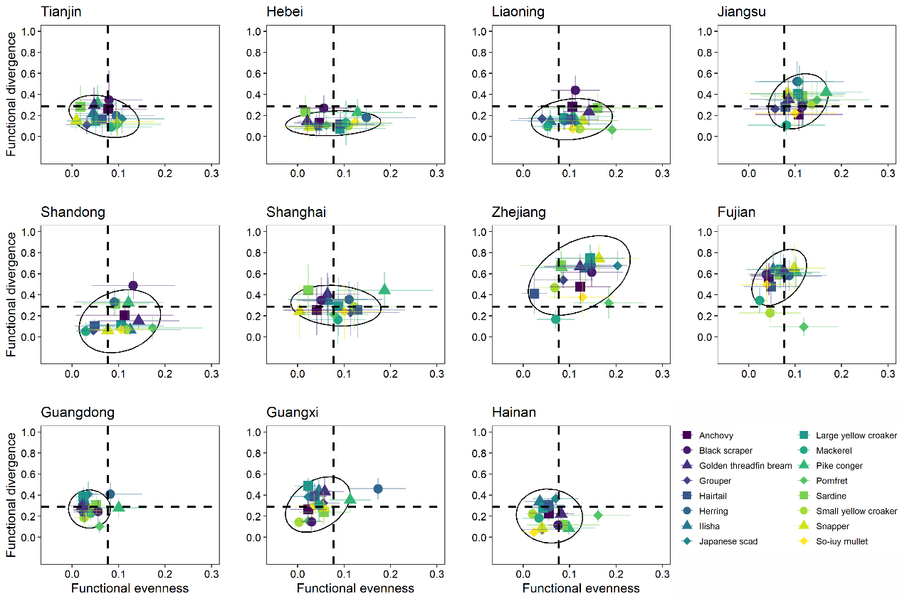

**Figure S2** Contribution of 16 species or species groups for all provinces over the past 30 years. The dashed line indicates the average contribution of all species across three seas. The black circle is 95% confidence level ellipse for a multivariate t-distribution.

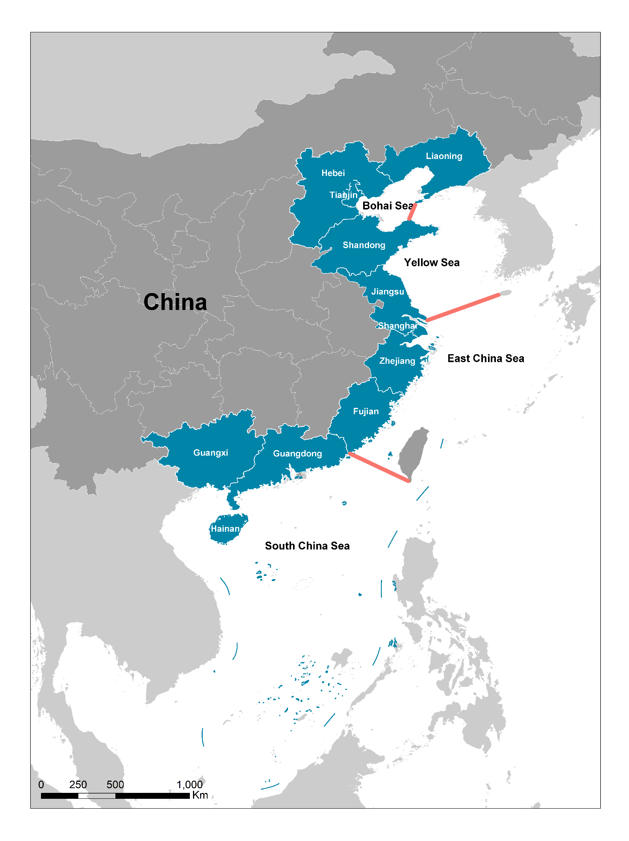

**Figure S3** 11 coastal province administrative regions and sea boundaries (red lines).

**Table S1 List of fish species, species groups and their representative commercial fish species from (Zhao et al., 2022)**

|  |  |  |  |  |  |  |
| --- | --- | --- | --- | --- | --- | --- |
| Species | Order | Family | Latin name | English name | | Chinese name |
|  | Perciformes | Carangidae | *Decapterus maruadsi* (Temminck & Schlegel, 1843) | Japanese scad | | 蓝圆鲹 |
|  | Perciformes | Sciaenidae | *Larimichthys crocea* (Richardson, 1846) | Large yellow croaker | | 大黄鱼 |
|  | Perciformes | Sciaenidae | *Larimichthys polyactis*(Bleeker, 1877) | Small yellow croaker | | 小黄鱼 |
|  | Mugiliformes | Mugilidae | *Planiliza haematocheila* (Temminck & Schlegel, 1845) | So-iuy mullet | | 鮻 |
| Species groups |  |  |  |  |  |  |
| Pike conger | Anguilliformes | Muraenesocidae | *Muraenesox cinereus* (Forsskål, 1775) | Daggertooth pike conger | | 海鳗 |
|  | Anguilliformes | Muraenesocidae | *Congresox talabonoides* (Bleeker, 1853) | Indian pike conger | | 似原鹤海鳗 |
| Ilisha | Clupeiformes | Pristigasteridae | *Ilisha elongata* (Anonymous [Bennett], 1830) | Elongate ilisha | | 鳓 |
|  | Clupeiformes | Pristigasteridae | *Ilisha melastoma* (Bloch & Schneider, 1801) | Indian ilisha | | 黑口鳓 |
| Anchovy | Clupeiformes | Engraulidae | *Engraulis japonicus* (Temminck & Schlegel, 1846) | Japanese anchovy | | 鳀 |
|  | Clupeiformes | Engraulidae | *Thryssa hamiltonii* (Gray, 1835) | Hamilton's thryssa | | 汉氏棱鳀 |
|  | Clupeiformes | Engraulidae | *Thryssa mystax* (Bloch & Schneider, 1801) | Moustached thryssa | | 中颌棱鳀 |
|  | Clupeiformes | Engraulidae | *Thryssa setirostris* (Broussonet, 1782) | Longjaw thryssa | | 长颌棱鳀 |
|  | Clupeiformes | Engraulidae | *Thryssa dussumieri* (Valenciennes, 1848) | Dussumier's thryssa | | 杜氏棱鳀 |
| Sardine | Clupeiformes | Clupeidae | *Sardinella aurita* (Valenciennes, 1847) | Round sardinella | | 金色小沙丁鱼 |
|  | Clupeiformes | Clupeidae | *Sardinella zunasi* (Bleeker, 1854) | Japanese sardinella | | 青鳞小沙丁鱼 |
|  | Clupeiformes | Clupeidae | *Sardinella albella* (Valenciennes, 1847) | White sardinella | | 白腹小沙丁鱼 |
|  | Clupeiformes | Clupeidae | *Sardinella gibbosa* (Bleeker, 1849) | Goldstripe sardinella | | 隆背小沙丁鱼 |
|  | Clupeiformes | Clupeidae | *Sardinella lemuru* (Bleeker, 1853) | Bali sardinella | | 黄泽小沙丁鱼 |
|  | Clupeiformes | Clupeidae | *Sardinops sagax* (Jenyns, 1842) | South American pilchard | | 远东拟沙丁鱼 |
| Herring | Clupeiformes | Clupeidae | *Clupea pallasii pallasii* (Valenciennes, 1847) | Pacific herring | | 太平洋鯡 |
|  | Clupeiformes | Clupeidae | *Dussumieria elopsoides* (Bleeker, 1849) | Slender rainbow sardine | | 黄带圆腹鲱 |
|  | Clupeiformes | Clupeidae | *Etrumeus sadina* (Mitchill, 1814) | Red-eye round herring | | 脂眼鲱 |
| Grouper | Perciformes | Serranidae | *Epinephelus coioides* (Hamilton, 1822) | Orange-spotted grouper | | 点带石斑鱼 |
|  | Perciformes | Serranidae | *Epinephelus awoara* (Temminck & Schlegel, 1842) | Yellow grouper | | 青石斑鱼 |
|  | Perciformes | Serranidae | *Epinephelus bruneus* (Bloch, 1793) | Longtooth grouper | | 褐石斑鱼 |
|  | Perciformes | Serranidae | *Epinephelus chlorostigma* (Valenciennes, 1828) | Brownspotted grouper | | 网纹石斑鱼 |
|  | Perciformes | Serranidae | *Epinephelus epistictus* (Temminck & Schlegel, 1842) | Dotted grouper | | 小纹石斑鱼 |
|  | Perciformes | Serranidae | *Epinephelus fasciatomaculosus* (Peters, 1865) | Rock grouper | | 拟青石斑鱼 |
|  | Perciformes | Serranidae | *Epinephelus fuscoguttatus* (Forsskål, 1775) | Brown-marbled grouper | | 棕点石斑鱼 |
|  | Perciformes | Serranidae | *Epinephelus quoyanus* (Valenciennes, 1830) | Longfin grouper | | 玳瑁石斑鱼 |
|  | Perciformes | Serranidae | *Epinephelus trimaculatus* (Valenciennes, 1828) | Threespot grouper | | 三斑石斑鱼 |
|  | Perciformes | Serranidae | *Epinephelus lanceolatus* (Bloch, 1790) | Giant grouper | | 鞍带石斑鱼 |
|  | Perciformes | Serranidae | *Epinephelus areolatus* (Forsskål, 1775) | Areolate grouper | | 宝石石斑鱼 |
|  | Perciformes | Serranidae | *Epinephelus polyphekadion* (Bleeker, 1849) | Camouflage grouper | | 小牙石斑鱼 |
|  | Perciformes | Serranidae | *Epinephelus malabaricus* (Bloch & Schneider, 1801) | Malabar grouper | | 玛拉巴石斑鱼 |
|  | Perciformes | Serranidae | *Epinephelus latifasciatus* (Temminck & Schlegel, 1842) | Striped grouper | | 宽带石斑鱼 |
|  | Perciformes | Serranidae | *Epinephelus akaara* (Temminck & Schlegel, 1842) | Hong Kong grouper | | 赤点石斑鱼 |
| Snapper | Perciformes | Priacanthidae | *Priacanthus tayenus* (Richardson, 1846) | Purple-spotted bigeye | | 长尾大眼鲷 |
|  | Perciformes | Priacanthidae | *Priacanthus hamrur* (Forsskål, 1775) | Moontail bullseye | | 金目大眼鲷 |
|  | Perciformes | Priacanthidae | *Priacanthus macracanthus* (Cuvier, 1829) | Red bigeye | | 短尾大眼鲷 |
|  | Perciformes | Priacanthidae | *Heteropriacanthus cruentatus* (Lacepède, 1801) | Glasseye |  | 灰鳍异大眼鲷 |
|  | Perciformes | Apogonidae | *Jaydia ellioti* (Day, 1875) | Flag-in cardinal-fish | | 黑边天竺鲷 |
|  | Perciformes | Apogonidae | *Ostorhinchus fasciatus* (White, 1790) | Broadbanded cardinalfish | | 宽条天竺鲷 |
|  | Perciformes | Caesionidae | *Pterocaesio chrysozona* (Cuvier, 1830) | Goldband fusilier | | 金带鳞鳍梅鲷 |
|  | Perciformes | Caesionidae | *Pterocaesio digramma* (Bleeker, 1864) | Double-lined fusilier | | 双带鳞鳍梅鲷 |
|  | Perciformes | Acropomatidae | *Acropoma japonicum* (Günther, 1859) | Glowbelly |  | 日本发光鲷 |
|  | Perciformes | Haemulidae | *Hapalogenys kishinouyei* (Smith & Pope, 1906) | Lined javelinfish | | 纵带髭鲷 |
|  | Perciformes | Haemulidae | *Hapalogenys nigripinnis* (Temminck & Schlegel, 1843) | Short barbeled velvetchin | | 黑鳍髭鲷 |
|  | Perciformes | Haemulidae | *Hapalogenys analis* (Richardson, 1845) | Broadbanded velvetchin | | 臀斑髭鲷 |
|  | Perciformes | Oplegnathidae | *Oplegnathus punctatus* (Temminck & Schlegel, 1844) | Spotted knifejaw | | 斑石鲷 |
|  | Perciformes | Oplegnathidae | *Oplegnathus fasciatus* (Temminck & Schlegel, 1844) | Barred knifejaw | | 条石鲷 |
|  | Perciformes | Sparidae | *Rhabdosargus sarba* (Forsskål, 1775) | Goldlined seabream | | 平鲷 |
|  | Perciformes | Sparidae | *Pagrus major* (Temminck & Schlegel, 1843) | Red seabream | | 真赤鲷（真鲷） |
|  | Perciformes | Sparidae | *Pagrus caeruleostictus* (Valenciennes, 1830) | Bluespotted seabream | | 蓝点赤鲷 |
|  | Perciformes | Sparidae | *Evynnis cardinalis* (Lacepède, 1802) | Threadfin porgy | | 二长棘犁齿鲷 |
|  | Perciformes | Sparidae | *Acanthopagrus schlegelii* (Bleeker, 1854) | Blackhead seabream | | 黑棘鲷 |
|  | Perciformes | Sparidae | *Acanthopagrus latus* (Houttuyn, 1782) | Yellowfin seabream | | 黄鳍棘鲷 |
|  | Perciformes | Sparidae | *Acanthopagrus berda* (Forsskål, 1775) | Goldsilk seabream | | 灰鳍棘鲷 |
|  | Perciformes | Lethrinidae | *Lethrinus ornatus* (Valenciennes, 1830) | Ornate emperor | | 短吻裸颊鲷 |
|  | Perciformes | Lethrinidae | *Lethrinus lentjan* (Lacepède, 1802) | Pink ear emperor | | 扁裸颊鲷 |
|  | Perciformes | Lethrinidae | *Lethrinus semicinctus* (Valenciennes, 1830) | Black blotch emperor | | 半带裸颊鲷 |
|  | Perciformes | Lethrinidae | *Lethrinus nebulosus* (Forsskål, 1775) | Spangled emperor | | 星斑裸颊鲷 |
|  | Perciformes | Lethrinidae | *Lethrinus rubrioperculatus* (Sato, 1978) | Spotcheek emperor | | 红裸颊鲷 |
|  | Perciformes | Lethrinidae | *Gymnocranius griseus* (Temminck & Schlegel, 1843) | Grey large-eye bream | | 灰裸顶鲷 |
|  | Perciformes | Haemulidae | *Plectorhinchus gibbosus* (Lacepède, 1802) | Harry hotlips | | 黑胡椒鲷 |
|  | Perciformes | Haemulidae | *Plectorhinchus lineatus* (Linnaeus, 1758) | Yellowbanded sweetlips | | 条纹胡椒鲷 |
|  | Perciformes | Haemulidae | *Plectorhinchus cinctus* (Temminck & Schlegel, 1843) | Crescent sweetlips | | 花尾胡椒鲷 |
|  | Perciformes | Haemulidae | *Plectorhinchus chaetodonoides* (Lacepède, 1801) | Harlequin sweetlips | | 斑胡椒鲷 |
|  | Perciformes | Haemulidae | *Plectorhinchus pictus* (Tortonese, 1936) | Trout sweetlips | | 胡椒鲷 |
|  | Perciformes | Lobotidae | *Lobotes surinamensis* (Bloch, 1790) | Tripletail |  | 松鲷 |
|  | Perciformes | Caesionidae | *Caesio cuning* (Bloch, 1791) | Redbelly yellowtail fusilier | | 黄尾梅鲷 |
|  | Perciformes | Lutjanidae | *Lutjanus sebae* (Cuvier, 1816) | Emperor red snapper | | 千年笛鲷 |
|  | Perciformes | Lutjanidae | *Lutjanus quinquelineatus* (Bloch, 1790) | Five-lined snapper | | 五线笛鲷 |
|  | Perciformes | Lutjanidae | *Lutjanus johnii* (Bloch, 1792) | John's snapper | | 约氏笛鲷 |
|  | Perciformes | Lutjanidae | *Lutjanus gibbus* (Forsskål, 1775) | Humpback red snapper | | 隆背笛鲷 |
|  | Perciformes | Lutjanidae | *Lutjanus fulviflamma* (Forsskål, 1775) | Dory snapper | | 金焰笛鲷 |
|  | Perciformes | Lutjanidae | *Lutjanus lutjanus* (Bloch, 1790) | Bigeye snapper | | 黄笛鲷 |
|  | Perciformes | Lutjanidae | *Lutjanus russellii* (Bleeker, 1849) | Russell's snapper | | 勒氏笛鲷 |
|  | Perciformes | Lutjanidae | *Lutjanus erythropterus* (Bloch, 1790) | Crimson snapper | | 红鳍笛鲷 |
|  | Perciformes | Lutjanidae | *Lutjanus argentimaculatus* (Forsskål, 1775) | Mangrove red snapper | | 紫红笛鲷 |
|  | Perciformes | Lutjanidae | *Lutjanus carponotatus* (Richardson, 1842) | Spanish flag snapper | | 纵带笛鲷 |
|  | Perciformes | Lutjanidae | *Lutjanus vitta* (Quoy & Gaimard, 1824) | Brownstripe red snapper | | 画眉笛鲷 |
|  | Perciformes | Lutjanidae | *Symphorichthys spilurus* (Günther, 1874) | Sailfin snapper | | 帆鳍笛鲷 |
|  | Perciformes | Lutjanidae | *Lutjanus kasmira* (Forsskål, 1775) | Common bluestripe snapper | | 四带笛鲷 |
|  | Perciformes | Lutjanidae | *Lutjanus malabaricus* (Bloch & Schneider, 1801) | Malabar blood snapper | | 马拉巴笛鲷 |
|  | Beryciformes | Berycidae | *Beryx splendens* (Lowe, 1834) | Splendid alfonsino | | 红金眼鲷 |
|  | Perciformes | Priacanthidae | *Cookeolus japonicus* (Cuvier, 1829) | Longfinned bullseye | | 日本牛目鲷 |
|  | Perciformes | Nemipteridae | *Pentapodus setosus*(Valenciennes, 1830) | Butterfly whiptail | | 线尾锥齿鲷 |
| Hairtail | Perciformes | Trichiuridae | *Trichiurus japonicus* (Temminck & Schlegel, 1844) | Largehead hairtail | | 日本带鱼 |
|  | Perciformes | Trichiuridae | *Lepturacanthus savala* (Cuvier, 1829) | Savalai hairtail | | 沙带鱼 |
|  | Perciformes | Trichiuridae | *Trichiurus lepturus* (Linnaeus, 1758) | Largehead hairtail | | 高鳍带鱼 |
| Golden threadfin bream | Perciformes | Nemipteridae | *Nemipterus virgatus* (Houttuyn, 1782) | Golden threadfin bream | | 金线鱼 |
|  | Perciformes | Nemipteridae | *Nemipterus bathybius* (Snyder, 1911) | Yellowbelly threadfin bream | | 深水金线鱼 |
|  | Perciformes | Nemipteridae | *Nemipterus hexodon* (Quoy & Gaimard, 1824) | Ornate threadfin bream | | 六齿金线鱼 |
|  | Perciformes | Nemipteridae | *Nemipterus japonicus* (Bloch, 1791) | Japanese threadfin bream | | 日本金线鱼 |
|  | Perciformes | Nemipteridae | *Nemipterus marginatus* (Valenciennes, 1830) | Red filament threadfin bream | | 缘金线鱼 |
|  | Perciformes | Nemipteridae | *Nemipterus nemurus* (Bleeker, 1857) | Redspine threadfin bream | | 红棘金线鱼 |
|  | Perciformes | Nemipteridae | *Nemipterus peronii* (Valenciennes, 1830) | Notchedfin threadfin bream | | 裴氏金线鱼 |
| Mackerel | Perciformes | Scombridae | *Scomber japonicus* (Houttuyn, 1782) | Chub mackerel | | 鲐 |
|  | Perciformes | Scombridae | *Scomber australasicus* (Cuvier, 1832) | Blue mackerel | | 狭头鲐 |
|  | Perciformes | Scombridae | *Rastrelliger kanagurta* (Cuvier, 1816) | Indian mackerel | | 羽鳃鲐 |
| Pomfret | Perciformes | Stromateidae | *Pampus chinensis* (Euphrasen, 1788) | Chinese silver pomfret | | 中国鲳 |
|  | Perciformes | Centrolophidae | *Psenopsis anomala* (Temminck & Schlegel, 1844) | Pacific rudderfish | | 刺鲳 |
|  | Perciformes | Ariommatidae | *Ariomma indicum* (Day, 1871) | Indian driftfish | | 印度无齿鲳 |
|  | Perciformes | Stromateidae | *Pampus argenteus* (Euphrasen, 1788) | Silver pomfret | | 银鲳 |
|  | Perciformes | Ephippidae | *Ephippus orbis* (Bloch, 1787) | Orbfish |  | 白鲳 |
|  | Perciformes | Carangidae | *Parastromateus niger* (Bloch, 1795) | Black pomfret | | 乌鲳 |
|  | Perciformes | Drepaneidae | *Drepane punctata* (Linnaeus, 1758) | Spotted sicklefish | | 斑点鸡笼鲳 |
|  | Perciformes | Drepaneidae | *Drepane longimana* (Bloch & Schneider, 1801) | Concertina fish | | 条纹鸡笼鲳 |
|  | Perciformes | Monodactylidae | *Monodactylus argenteus* (Linnaeus, 1758) | Silver moony | | 银大眼鲳 |
| Black scraper | Tetraodontiformes | Monacanthidae | *Thamnaconus septentrionalis* (Günther, 1874) | Greenfin horse-faced filefish | | 绿鳍马面鲀 |
|  | Tetraodontiformes | Monacanthidae | *Thamnaconus hypargyreus* (Cope, 1871) | Lesser-spotted leatherjacket | | 黄鳍马面鲀 |
|  | Tetraodontiformes | Monacanthidae | *Thamnaconus modestus* (Günther, 1877) | Black scraper | | 马面鲀 |

*The traits of *Trichiurus japonicus* (Temminck & Schlegel, 1844) and *Trichiurus lepturus* (Linnaeus, 1758) were considered the same

**Table S2 The** **main fishing waters of the coastal provinces from (Zhao et al., 2022)**

|  |  |  |  |  |  |
| --- | --- | --- | --- | --- | --- |
| Province | Main fishing water | | | | Percentage of total catch |
| Tianjin | Bohai Sea | Yellow Sea |  |  | 89.2%  99.6%  95.2%  92.1%  79.0%  82.4%  96.7%  87.9%  99.9%  100.0%  100.0% |
| Hebei | Bohai Sea | Yellow Sea |  |  |
| Liaoning | Bohai Sea | Yellow Sea |  |  |
| Shandong | Bohai Sea | Yellow Sea |  |  |
| Jiangsu |  | Yellow Sea |  |  |
| Shanghai |  |  | East China Sea |  |
| Zhejiang |  |  | East China Sea |  |
| Fujian |  |  | East China Sea |  |
| Guangdong |  |  |  | South China Sea |
| Guangxi |  |  |  | South China Sea |
| Hainan |  |  |  | South China Sea |

**Table** **S3 Overview of biological traits used to calculate functional diversity indices of fish assemblages from (Zhao et al., 2022)**

|  |  |  |  |
| --- | --- | --- | --- |
| Classification of function | Trait | Type of variable | Units or categories |
| Food acquisition | Diet | Categorical | Planktivorous; Planktivorous and Benthivorous; Benthivorous and Nektivorous;  Planktivorous and Nektivorous; |
|  | Mouth position | Categorical | Superior, Terminal, Inferior |
|  | Trophic level | Continuous | - |
| Locomotion | Water column position | Categorical | Demersal, Pelagic |
|  | Body shape | Categorical | Compressed, Fusiform, Cylindrical |
|  | Maximum body length | Continuous | cm |
| Ecological adaptation | Mean preferred temperature | Continuous | ℃ |

**Table S4 List of** **fish species, species groups and their biological traits from (Zhao et al., 2022)**

|  |  |  |  |  |  |  |  |
| --- | --- | --- | --- | --- | --- | --- | --- |
| Species/species group | Habitat | Mouth position | Body shape | Diet | Preferred mean temperature | Maximum body length (cm) | Trophic level |
| *Decapterus maruadsi* | Pe | Te | Fu | P | 28.0 | 30.0 | 3.40 |
| *Larimichthys crocea* | De | Te | Fu | BN | 22.8 | 80.0 | 3.72 |
| *Larimichthys polyactis* | De | Te | Fu | BN | 16.7 | 40.0 | 3.64 |
| *Planiliza haematocheila* | Pe | Te | Fu | PB | 22.4 | 80.0 | 2.50 |
| Pike conger | De | Te | Cy | BN | 12.1 ± 7.5 | 235.0 ± 21.2 | 4.34 ± 0.06 |
| Ilisha | Pe | Su | Co | P | 28.3 ± 0.5 | 41.0 ± 26.9 | 3.62 ± 0.24 |
| Anchovy | Pe | In | Co | P | 26.5 ± 4.6 | 18.6 ± 5.7 | 3.25 ± 0.54 |
| Sardine | Pe | Te | Co | P | 23.4 ± 5.1 | 26.7 ± 10.1 | 2.79 ± 0.26 |
| Herring | Pe | Te | Cy | P | 17.1 ± 13.0 | 33.0 ± 13.0 | 3.42 ± 0.03 |
| Grouper | De | Su | Co | BN | 25.7 ± 2.9 | 103.5 ± 69.8 | 3.93 ± 0.17 |
| Snapper | De | Te | Co | BN | 26.1 ± 4.1 | 57.6 ± 29.6 | 3.73 ± 0.28 |
| Hairtail | De | Su | Co | BN | 19.6 ± 7.6 | 189.3 ± 77.4 | 4.24 ± 0.06 |
| Golden threadfin bream | De | Te | Fu | BN | 27.4 ± 1.6 | 25.7 ± 6.7 | 3.92 ± 0.27 |
| Mackerel | Pe | Te | Fu | PN | 22.2 ± 4.5 | 50.0 ± 12.1 | 3.56 ± 0.46 |
| Pomfret | De | Te | Co | PB | 27 ± 3.2 | 42.4 ± 17.6 | 3.46 ± 0.39 |
| Black scraper | De | Te | Co | PB | 23.7 ± 2.8 | 25.6 ± 9.4 | 3.40 ± 0.00 |

*De: Demersal; Pe: Pelagic;

Su: Superior; Te: Terminal; In: Inferior;

Co: Compressed; Fu: Fusiform; Cy: Cylindrical;

P: Planktivorous; PB: Planktivorous and Benthivorous; BN: Benthivorous and Nektivorous; PN: Planktivorous and Nektivorous;

**Table S5 Results of Wilcoxon rank sum tests between the relative contributions of fishes with different water column positions and trophic levels to functional diversity** (*p*-values lower than 0.05 are in bold).

|  |  |  |  |  |  |
| --- | --- | --- | --- | --- | --- |
|  | Pelagic vs Demersal | |  | High trophic level vs Low trophic level | |
| Province | FEve | FDiv |  | FEve | FDiv |
| Tianjin | 0.109 | 0.718 |  | **< 0.01** | 0.113 |
| Hebei | 0.143 | 0.321 |  | 0.105 | **< 0.001** |
| Liaoning | **< 0.05** | 0.082 |  | **< 0.001** | 0.222 |
| Jiangsu | 0.782 | 0.253 |  | 0.205 | **< 0.05** |
| Shandong | **< 0.05** | 0.441 |  | **< 0.01** | **< 0.001** |
| Shanghai | 0.269 | 0.856 |  | **< 0.01** | 0.055 |
| Zhejiang | 0.090 | 0.190 |  | **< 0.001** | 0.427 |
| Fujian | **< 0.001** | 0.224 |  | 0.738 | 0.210 |
| Guangdong | 0.875 | **< 0.001** |  | **< 0.001** | 0.667 |
| Guangxi | 0.171 | **< 0.01** |  | **< 0.05** | **< 0.001** |
| Hainan | **< 0.001** | **< 0.001** |  | **< 0.001** | 0.575 |