**FRONTIERS: SPACE PHYSICS**

**Supporting Information for [The role of the inner radiation belt dynamic in the generation of auroral-type sporadic E-layers over South Atlantic Magnetic Anomaly (SAMA)]**

***Da Silva, L. A.1,2****; Shi, J1.; Resende, L. C. A.1,2; Agapitov, O. V. 3; Alves, L. R. 2; Batista, I. S. 2; Arras, C. 4; Vieira, L. E. 2; Deggeroni, V. 2; Marchezi, J. P. 1,2; Wang, C. 1; Moro, J. 1,2; Inostroza, A. 2; Li, H. 1; Medeiros, C. 2; Cardoso, F. R. 5; Jauer, P. 1,2; Alves, M. V. 2; Chen, S. S.2; Liu, Z. 1; Denardini, C. M. 2; González, W. 1,2.*

**1 State Key Laboratory of Space Weather, National Space Science Center, Chinese Academy of Sciences.**

**2 National Institute for Space Research – INPE, São José dos Campos, SP, Brazil.**

**3 University of California, Berkeley - UCB - Space Sciences Laboratory, USA.**

**4 German Research Centre for Geosciences - GFZ, Potsdam, Germany.**

**5 University of São Paulo - USP, Lorena School of Engineering (EEL), SP, Brazil**.

Corresponding author: Da Silva, L. A. ([ligia.alves01@gmail.com](mailto:ligia.alves01@gmail.com) and [ligia.silva@inpe.br](mailto:ligia.silva@inpe.br))

**Table of contents:**

|  |  |
| --- | --- |
| Figure S1 | The total electron density for the three conjunctions measured by the EMFISIS instrument onboard the Van Allen Probes A and B. |
| Figure S2 | Ionograms from Digisondes located at Santa Maria station during the first (a), second (b) and third (c) conjunctions. The red arrows show the Es layers presence. Unfortunately, the Santa Maria ionograms present high 60 Hz interferences from the street lights used nearby the Digisonde site. |
| Figure S3 | Global magnetic field (color's scale) and magnetic equator (red line) in 150 km altitude, VAP-A orbit (white dotted line) and their footprint (white dashed line) on May 28, 2017 (11:00 – 13:00 UT), Santa Maria and Cachoeira Paulista stations (red stars) and the central region of the SAMA (white iso-intensity lines with 22,000 nT). |
| Figure S4 | Ionization rate altitude profiles (panels a, d, g), ionization rate altitude integrated (panels b, e, h) and frequency range altitude (panels c, f, i) considering the third conjunction for Santa Maria station. The total incident energy of electrons is presented in Figure 10. The ionization rate is obtained from empirical model (Fang et al., 2010) considering the total incident energy of electrons presented in Figure 10 and the height scale presented in Figure 15. |
| Figure S5 | Ionization rate altitude profiles (panels a, d, g), ionization rate altitude integrated (panels b, e, h) and frequency range altitude (panels c, f, i) considering the third conjunction for Cachoeira Paulista station. The total incident energy of electrons is presented in Figure 10. The ionization rate is obtained from empirical model (Fang et al., 2010) considering the total incident energy of electrons presented in Figure 10 and the height scale presented in Figure 15. |

**Figures**

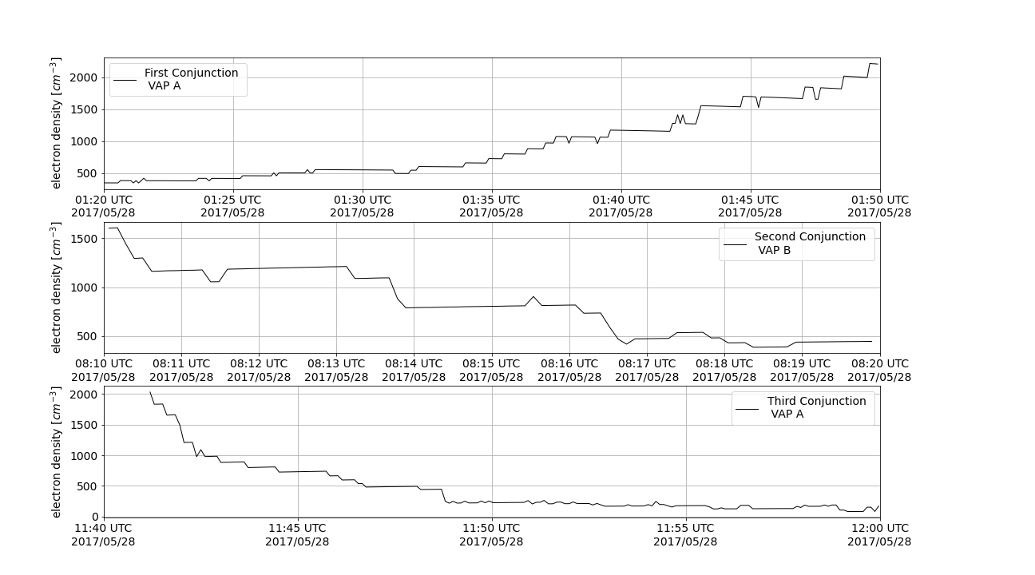

Figure S1: The total electron density for the three conjunctions measured by the EMFISIS instrument onboard the Van Allen Probes A and B.

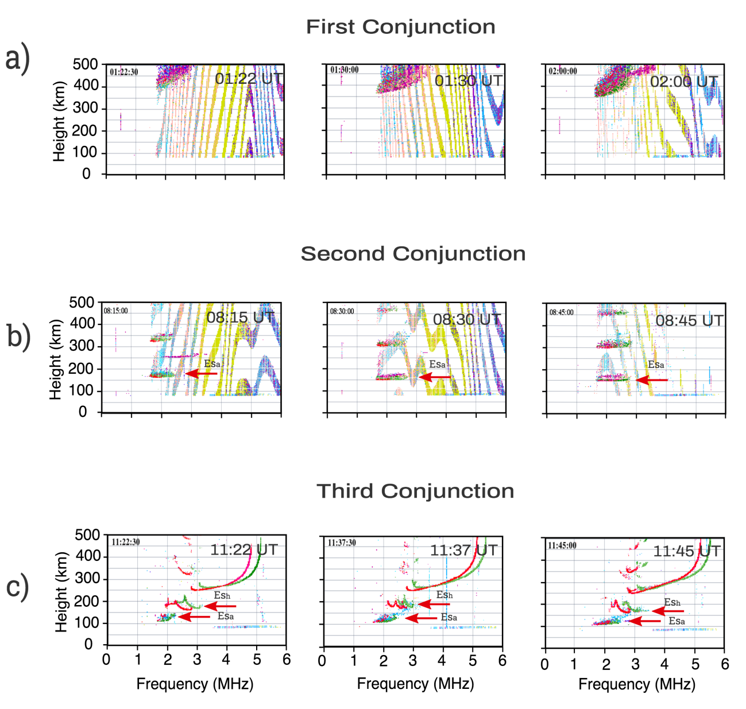

Figure S2: Ionograms from Digisondes located at Santa Maria station during the first (a), second (b) and third (c) conjunctions. The red arrows show the Es layers presence.

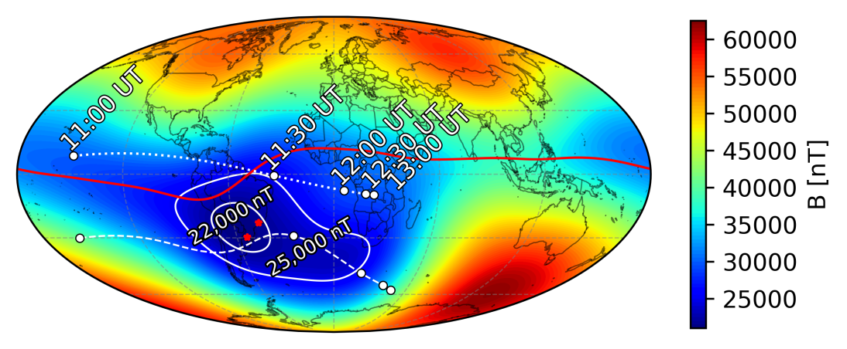

Figure SI3: Global magnetic field (color's scale) and magnetic equator (red line) in 150 km altitude, VAP-A orbit (white dotted line) and their footprint (white dashed line) on May 28, 2017 (11:00 – 13:00 UT), Santa Maria and Cachoeira Paulista stations (red stars) and the central region of the SAMA (white iso-intensity lines with 22,000 nT).

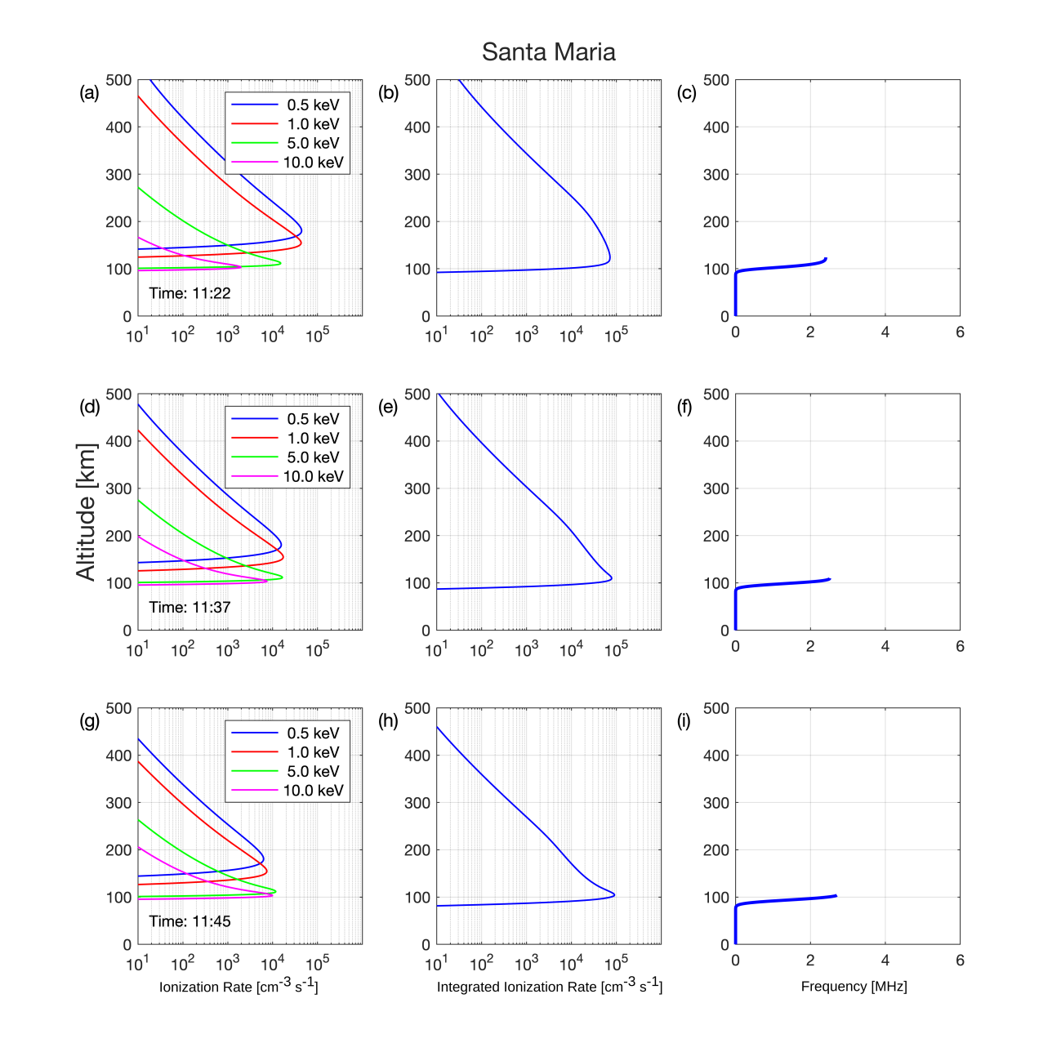

Figure S4: Ionization rate altitude profiles (panels a, d, g), ionization rate altitude integrated (panels b, e, h) and frequency range altitude (panels c, f, i) considering the third conjunction for Santa Maria station. The total incident energy of electrons is presented in Figure 10. The ionization rate is obtained from empirical model (Fang et al., 2010) considering the total incident energy of electrons presented in Figure 10 and the height scale presented in Figure 15.

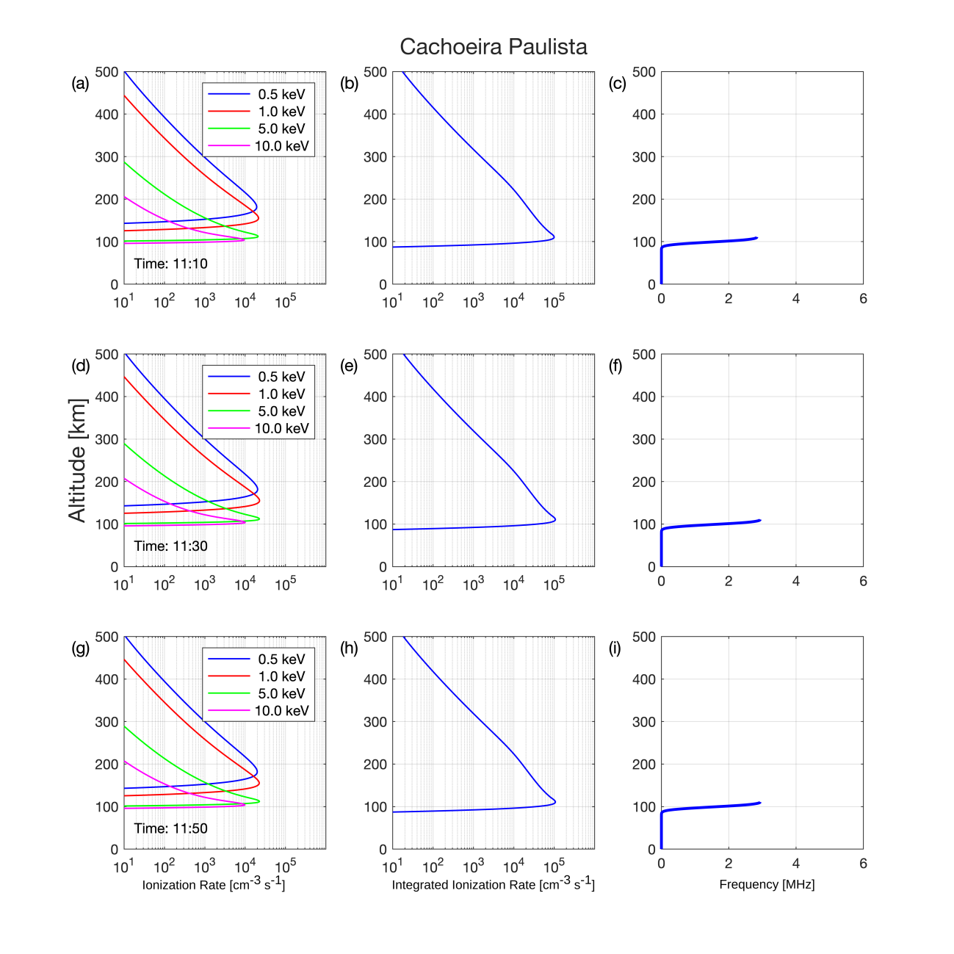

Figure S5: Ionization rate altitude profiles (panels a, d, g), ionization rate altitude integrated (panels b, e, h) and frequency range altitude (panels c, f, i) considering the third conjunction for Cachoeira Paulista station. The total incident energy of electrons is presented in Figure 10. The ionization rate is obtained from empirical model (Fang et al., 2010) considering the total incident energy of electrons presented in Figure 10 and the height scale presented in Figure 15.