**Table2.1** Main reagents needed for experiment

|  |  |  |
| --- | --- | --- |
| Product name | Item No. | Producer |
| PCR Accessory Set | 11327 | Sequenom |
| Iplex Gold Reagent kit（Large） | 10136 | Sequenom |
| SpectroCHIP II&Resin kit（10*384 chip） | 10117-2 | Sequenom |
| Primer |  | Shanghai tianhao biology |

**Table2.2** Main instrument consumables

|  |  |  |
| --- | --- | --- |
| Instrument name | Source of instrument | Model |
| Table high-speed centrifuge | Eppendorf | Centrifuge 5417 |
| PCR instrument | MJ research | PTC200 |
| Pipette | Gilson | 1000μL、200μL、10μL |
| Time of flight mass spectrometer | Sequenom | Mass MARRAY |
| Sample spotting instrument | Sequenom | Mass MARRAY |
| Various models of tip, PCR tube and centrifuge tube | Axygen |  |

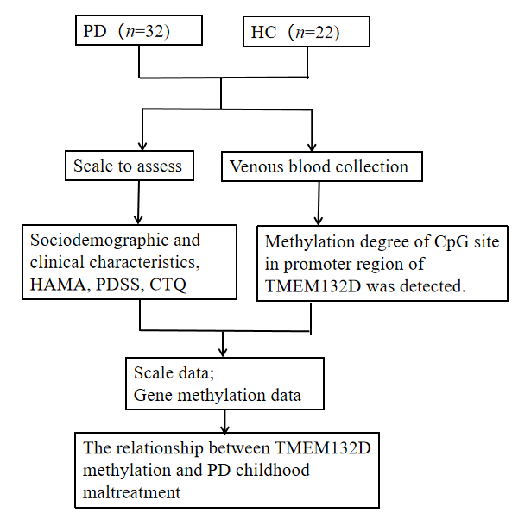

Supplement figure.1 experimental process diagram.