Seawater Dissolved Inorganic Carbon (DIC) experiments

The details of the Seawater Dissolved Inorganic Carbon (DIC) experiments were published in Comeau et al. 2017. DIC treatments were designed to maintain pHT at ~7.9, while dissolved inorganic carbon (DIC) was manipulated to cover a range from ~800 to 3000 µmol kg-1. Treatments were established using combinations of CO₂-free air, pure CO₂, 1 M HCl, and 1 M NaOH. To maintain corals in continuously pre-equilibrated water, treatment water was prepared daily in 100-L header tanks and delivered to the treatment tanks by a peristaltic pump at 100 mL min-1 . To ensure control of seawater pH, pH was controlled simultaneously in the header tank and in the treatment, tanks using a pH-stat (IKS, Karlsbad) that controlled the bubbling of either pure CO₂ or CO₂-free air. CO₂-free air was obtained by scrubbing CO₂ from ambient air passing through three soda-lime columns.
Carbonate chemistry monitoring Seawater pH_{T} was monitored daily using a hand-held pH Meter (Odeon, Ponsel) that was calibrated on the total scale using 2-amino-2-hydroxymethyl-1,3- propanediol (TRIS) buffers at a salinity of 38.0. Every other day, pH_{T} also was measured spectrophotometrically in every tank using the indicator dye m-cresol (Dickson et al. 2007). Total alkalinity (TA) was measured daily in the header tanks (after preparation of the new batch) and the incubation tanks by an open-cell potentiometric titration using an automatic titrator (Methrom Titrando 888 Dosimat). Measurements of TA were conducted on duplicate 4-mL samples at room temperature (~23°C), and A=TA was calculated using a modified Gran function applied to pH values ranging from 3.5 to 3.0 [42]. Measurement precision and accuracy were verified using certified reference material from A. G. Dickson laboratory. Parameters of the carbonate system in seawater were calculated from salinity, temperature, AT and pH_{T} using the R package seacarb.

Table S2. Carbonate chemistry in the [DIC] manipulation experiment (Comeau et al 2017). Carbonate chemistry was manipulated in order to maintain pH_{T} at ambient value (7.94) and constrain the dissolved inorganic carbon (DIC) concentrations to very low (800 µmol kg-1 ), low (1500 µmol kg-1 ), ambient (2200 µmol kg-1 ) and high (2900 µmol kg-1 ) treatments. The partial pressure of CO₂ (pCO2), DIC, and the aragonite saturation state (Ωarag) were calculated from pH_{T}, total alkalinity (AT), temperature (T), and salinity (S). Mean ± SE are given (n = 15). SE for temperature and salinity are < 0.1.
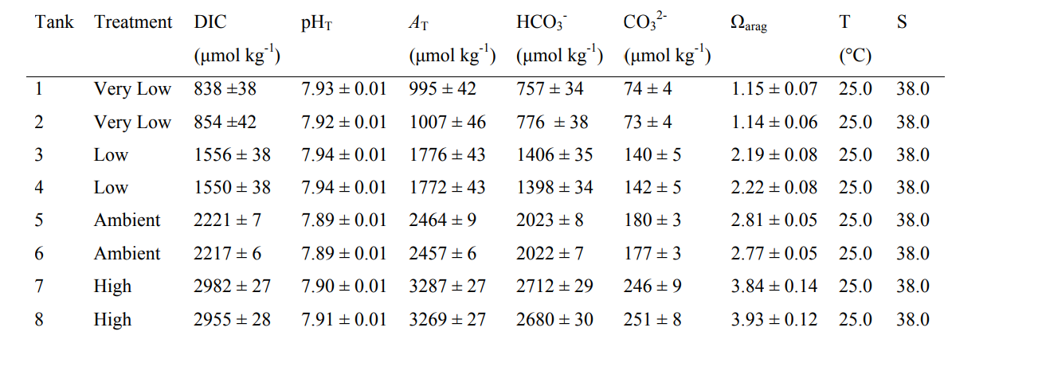

References
Comeau, S. et al. Coral calcifying fluid pH is modulated by seawater carbonate chemistry not solely seawater pH. Proceedings. Biol. Sci. 284, (2017).

Dickson, A. G., Sabine, C. L. & Christian, J. R. Guide to Best Practices for Ocean CO2 Measurements. 191 (2007)

