Supplementary Materials for

“Simulation of diffusive solute transport in heterogeneous porous media with dipping anisotropy”

Danyang Su1*, Mingliang Xie1, K. Ulrich Mayer1 and Kerry T.B. MacQuarrie2

1Department of Earth, Ocean and Atmospheric Sciences, University of British Columbia, Vancouver, BC, V6T 1Z4, Canada

2Department of Civil Engineering, University of New Brunswick, P.O. Box 4400, Fredericton, NB, E3B 5A3, Canada

* Corresponding author: [dsu@eoas.ubc.ca](mailto:dsu@eoas.ubc.ca)

## S.1: Flux calculations across control volume interface

An illustration of flux calculations across a control volume interface is shown in Figure S.1. Similar methods are used for other cell types.

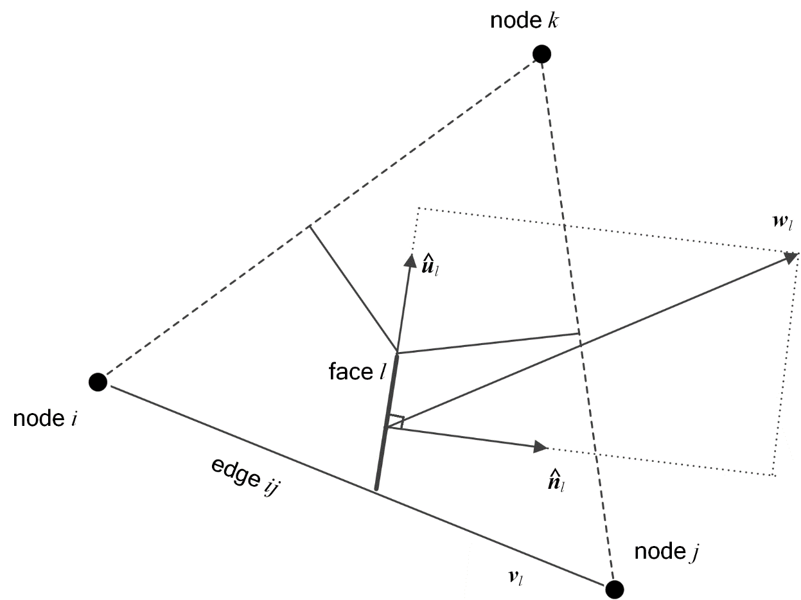

Figure S.1 Illustration of flux calculations across a control volume interface.

## S.2: Green-Gauss gradient reconstruction method

The Green-Gauss (GG) gradient reconstruction method is a piecewise linear reconstruction based on the assumption that the gradient is a constant over a single cell (Nishikawa, 2010).

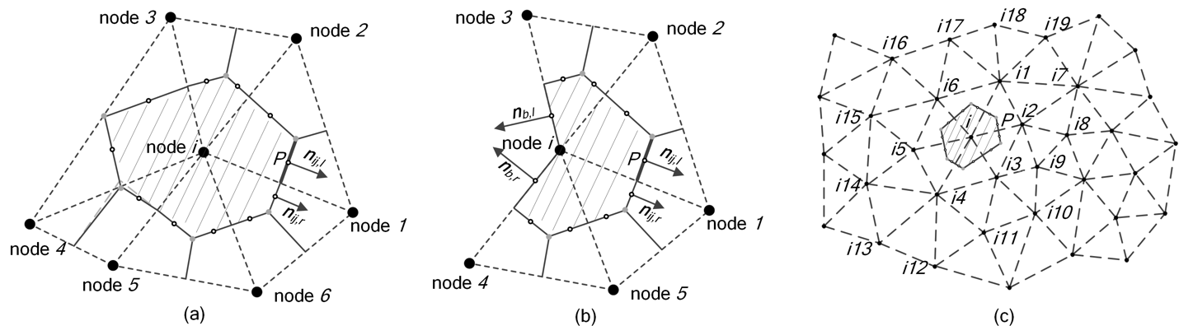

Figure S.2: Illustration of gradient reconstruction, (a) gradient reconstruction for internal node, (b) gradient reconstruction for boundary node, and (c) direct and indirect neighbouring nodes for node i.

For a triangular mesh as shown in Figure S.2(a), the gradient of $ψ$ over the dual control volume $V_{i}$ can be calculated by:

|  |  |  |
| --- | --- | --- |
|  | $$∇ψ=\frac{1}{ΔV_{i}}\sum_{j=1}^{n}{\frac{ψ_{1}+ψ_{j}}{2}\left(n_{ij,l}+n_{ij,r}\right)}$$ | S.1 |

where [L2 in 2D and L3 in 3D] is the area of the dual control volume; $n$ (6 here) is the number of nodes connected to node *i*; $n_{ij,l}$ and $n_{ij,r}$ are the left and right scaled outward normal of the control volume face. For the boundary node as shown Figure S.2(b), the gradient calculation is modified as:

|  |  |  |
| --- | --- | --- |
|  | $$∇ψ=\frac{1}{ΔV_{i}}\left(\begin{aligned}\sum_{j=1,2,5}{\frac{ψ_{1}+ψ_{j}}{2}\left(n_{ij,l}+n_{ij,r}\right)}+ \\ \frac{ψ_{1}+ψ_{3}}{2}n_{13,r}+\frac{ψ_{1}+ψ_{4}}{2}n_{14,l}+ \\ \frac{5ψ_{1}+ψ_{4}}{6}n_{b,r}+\frac{5ψ_{1}+ψ_{3}}{6}n_{b,l}\end{aligned}\right)$$ | S.2 |

where $n_{b,l}$ and $n_{b,r}$ are the left and right scaled outward normal of boundary face.

The detailed information about gradient reconstruction for different cell types is provided by Nishikawa (2010). GG gradient reconstruction guarantees global mass conservation while retaining exactness for linear fluxes around each node on arbitrary triangular and tetrahedral grids and smooth grids with other types of elements (Nishikawa, 2010).

## S.3: Least squares gradient reconstruction method

The least squares (LS) gradient reconstruction method is another piecewise linear reconstruction method that is unrelated to the mesh topology. This method relies on a stencil that identifies relevant neighboring nodes for use in the gradient estimation. The gradient of $ψ$ over the dual control volume $V_{i}$ is obtained by solving for the values of gradients that minimize the sum of the squares of the differences between neighboring values and calculated values based on the gradient (Mavriplis, 2003). The objective to be minimized is given as:

|  |  |  |
| --- | --- | --- |
|  | $$\sum_{j=1}^{n}{ω_{ij}^{2}E_{ij}^{2}}$$ | S.3 |

where $ω_{ij}$ is a weighting factor and $E_{ij}^{2}$ is the error calculated by:

|  |  |  |
| --- | --- | --- |
|  | $$E_{ij}^{2}={\left(-{dψ}_{ij}+u_{x,i}dx_{ij}+u_{y,i}dy_{ij}\right)}^{2}$$ | S.4 |

where ${dψ}_{ij}=ψ_{j}-ψ_{i}$, $dx_{ij}=x_{j}-x_{i}$, with similar expressions for $dy_{ij}$; $u_{x,i}$ and $u_{y,i}$ are the two gradient components to be solved. Dropping the subscript $i$ for clarity, a system of two equations for the two gradient components are obtained by solving the minimization problem of:

|  |  |  |
| --- | --- | --- |
|  | $$\left\{\begin{aligned}\frac{∂\sum_{j=1}^{n}{ω_{ij}^{2}E_{ij}^{2}}}{∂u_{x}}=0 \\ \frac{∂\sum_{j=1}^{n}{ω_{ij}^{2}E_{ij}^{2}}}{∂u_{y}}=0\end{aligned}\right.$$ | S.5 |

Equation S.5 can be rewritten as:

|  |  |  |
| --- | --- | --- |
|  | $$\left\{\begin{aligned}a_{11}u_{x}+a_{12}u_{y}=b_{1} \\ a_{21}u_{x}+a_{22}u_{y}=b_{2}\end{aligned}\right.$$ | S.6 |

where

|  |  |  |
| --- | --- | --- |
|  | $$a_{11}=\sum_{j=1}^{n}{ω_{ij}^{2}{dx}_{ij}^{2}}$$ $$a_{22}=\sum_{j=1}^{n}{ω_{ij}^{2}{dy}_{ij}^{2}}$$ $$a_{12}=a_{21}=\sum_{j=1}^{n}{ω_{ij}^{2}{dx}_{ij}^{}}{dy}_{ij}^{}$$ $$b_{1}=\sum_{j=1}^{n}{ω_{ij}^{2}{{dψ}_{ij}^{}dx}_{ij}^{}}$$ $$b_{2}=\sum_{j=1}^{n}{ω_{ij}^{2}{{dψ}_{ij}^{}dy}_{ij}^{}}$$ | S.7 |

Equation S.7 can be solved using Cramer’s rule. The determination of the system is given by:

|  |  |  |
| --- | --- | --- |
|  | $$DET=a_{11}a_{22}-a_{12}a_{21}$$ | S.8 |

If the determinant is non-zero, the gradient solution is given by:

|  |  |  |
| --- | --- | --- |
|  | $$\left\{\begin{aligned}u_{x}=\frac{b_{1}a_{22}-{b_{2}a}_{12}}{DET} \\ u_{y}=\frac{b_{2}a_{11}-{b_{1}a}_{21}}{DET}\end{aligned}\right.$$ | S.9 |

For the unweighted cases ($ω_{ij}=1)$, the determinant corresponds to a difference in quantities of the order $O\left(dx^{6}\right)$, which may lead to an ill-conditioned system ($DET=0$). In this case, an alternative method such as QR factorization can be used to obtain the solution. When the inverse distance weighting ( $ω_{ij}=1/\sqrt{{dx}_{ij}^{2}+{dy}_{ij}^{2}})$ is used, the determinant scales as $O\left(1\right)$, and the system is much better conditioned.

Although LS gradient reconstruction for node *i* is unrelated to the mesh topology, a commonly used method is to select the neighboring nodes in the first stencil layer that directly connect to the node *i*. As shown in Figure S.2(c), node *i1* to node *i6* are selected to calculate the gradient at node *i*. Alternatively, the user can select the nodes in both the first and second stencil layers to calculate the gradient at node *i* where node *i1* to node *i19* are selected.

## S.4: High-order least squares gradient reconstruction method

Unlike piecewise linear gradient reconstruction methods that calculate the gradient on the nodes and support first-order partial derivatives only, the high-order least squares (HLS) gradient reconstruction method is a piecewise quadratic reconstruction method that calculates the gradient directly on the center of the control volume interface, with support of higher-order partial derivatives.

HLS gradient reconstruction is based on the truncated Taylor expansion of the function $ψ$ for the control volume *i*, which can be written as (Pasdunkorale & Turner, 2005; Sejekan, 2016):

|  |  |  |
| --- | --- | --- |
|  |  | S.10 |

where ${dx}_{Pi}=x_{i}-x_{P}$, with similar expressions for ${dy}_{Pi}$. The final least-squares system is formed for every neighboring node within the stencil of the control volume *i*, by collating together all Taylor expansions of function $ψ$, and can be written as:

|  |  |  |
| --- | --- | --- |
| $$\left[\begin{aligned}\begin{matrix}ω_{P1} & ω_{P1}{dx}_{P1} & ω_{P1}{dy}_{P1}\end{matrix}\begin{matrix} & ω_{P1}{dx}_{P1}^{2} & ω_{P1}{dxdy}_{P1}\end{matrix}\begin{matrix} & ω_{P1}{dy}_{P1}^{2} & ⋯\end{matrix} \\ \begin{matrix}ω_{P2} & ω_{P2}{dx}_{P2} & ω_{P2}{dy}_{P2}\end{matrix}\begin{matrix} & ω_{P2}{dx}_{P2}^{2} & ω_{P2}{dxdy}_{P2}\end{matrix}\begin{matrix} & ω_{P2}{dy}_{P2}^{2} & ⋯\end{matrix} \\ \begin{matrix}ω_{P3} & ω_{P3}{dx}_{P3} & ω_{P3}{dy}_{P3}\end{matrix}\begin{matrix} & ω_{P3}{dx}_{P3}^{2} & ω_{P3}{dxdy}_{P3}\end{matrix}\begin{matrix} & ω_{P3}{dy}_{P3}^{2} & ⋯\end{matrix} \\ \begin{matrix} ⋮ & ⋮ & ⋮ \end{matrix}\begin{matrix} & ⋮ & ⋮ \end{matrix}\begin{matrix} & ⋮ & ⋱\end{matrix} \\ \begin{matrix}ω_{Pn} & ω_{Pn}{dx}_{Pn} & ω_{Pn}{dy}_{Pn}\end{matrix}\begin{matrix} & ω_{Pn}{dx}_{Pn}^{2} & ω_{Pn}{dxdy}_{Pn}\end{matrix}\begin{matrix} & ω_{Pn}{dy}_{Pn}^{2} & ⋯\end{matrix}\end{aligned}\right]{\left(\begin{aligned}\begin{aligned}\begin{aligned}\begin{aligned}\begin{matrix}ψ \\ \frac{∂ψ}{∂x} \\ \frac{∂ψ}{∂y}\end{matrix} \\ \frac{∂^{2}ψ}{2∂x^{2}}\end{aligned} \\ \frac{∂^{2}ψ}{∂x∂y}\end{aligned} \\ \frac{∂^{2}ψ}{2∂y^{2}}\end{aligned} \\ ⋮\end{aligned}\right)}_{P}=\left(\begin{aligned}\begin{matrix}ω_{P1}ψ_{1} \\ ω_{P2}ψ_{2} \\ ω_{P3}ψ_{3}\end{matrix} \\ ⋮ \\ ω_{Pn}ψ_{n}\end{aligned}\right)$$ | | |
|  |  | S.11 |

where $ω_{Pi}$ is the spatial weighting, similar as that in Equation S.3. Typically, inverse distance weighting is used. Equation S.11 is over determined and can be written as $AX=B$. Since $A$ is purely geometrical and mesh dependent, the solution can be sped up by precomputing and storing the pseudo-inverse of matrix $A$. The solution is obtained by $X=A^{-1}B$, where $A^{-1}$ is the pseudo-inverse of matrix $A$.

Similar to the LS gradient reconstruction method, different stencil layers can be used in the gradient reconstruction for control volume interface center *P*. As shown in Figure S.2(c), node *i, i1, i2* are in the first stencil layer of center point *P* and node *i3* to *i19* are in the second and third stencil layers. The use of first and second stencil layers in gradient reconstruction is denoted as HLS2. Similarly, the notation HLS3 or HLS4 implies that extra third or fourth layers are used. It is worth mentioning that by ignoring the high-order partial derivatives ( $\frac{∂^{2}ψ}{∂x^{2}},$ $\frac{∂^{2}ψ}{∂x∂y},$ $\frac{∂^{2}ψ}{∂y^{2}},⋯$), Equation S.11 is reduced to a general linear system, if only the nodes in the first stencil layer are used.

## S.5: Quantitative analysis of the effect of mesh resolution on model error

To facilitate a quantitative analysis of the effect mesh resolution on model accuracy, we calculated the L2 norm in comparison to the analytical results and determined the rate of convergence as a function of mesh resolution based on the following equations:

$E_{L2,i}=\sqrt{\frac{1}{N}\sum_{j=1}^{N}{{\left(u_{j}^{numerical}-u_{j}^{analytical}\right)}^{2}}}$ S.12

$R_{C}=\frac{ln⁡\left(E_{L2,i}/E_{L2,i-1}\right)}{ln⁡\left(h_{i}/h_{i-1}\right)}$ S.13

where $i$ represents the $i^{th}$ mesh, $h_{i}$ is a sequence of mesh resolution $h_{i}<h_{i-1}$, i.e. $h_{i}$ is more refined than $h_{i-1}. { E}_{L2,i}$ is the L2-norm for the $i^{th}$ mesh, $N$ is the number of nodes, $u_{j}^{numerical}$ are the concentrations obtained with the numerical solution, $u_{j}^{analytical}$ are the concentrations obtained with the analytical solution, and $R_{C}$ is the rate of convergence.

Taking the 3D verification case (Section 3.2), for example, the L2 norms were calculated after 500 days and 1000 days for different mesh resolutions. The results show a super-linear decrease in the L2 norm, with increased refinement of the global average mesh resolution. The results of the error analysis are depicted in Figure S.3 to Figure S.5. and

Table S.1 to Table S.3.

Figure S.3 L2 norm for 3D diffusion case with anisotropy ratio 10:5:1.

Table S.1 L2 norm and convergence rate for 3D diffusion case with anisotropy ratio 10:5:1.

|  |  |  |  |  |
| --- | --- | --- | --- | --- |
| Average Mesh  Resolution (m) | t = 500 days | | t = 1000 days | |
| Norm L2 | Rate L2 | Norm L2 | Rate L2 |
| 2.20E-01 | 5.83E-09 |  | 2.34E-09 |  |
| 1.10E-01 | 3.73E-09 | 6.44E-01 | 1.36E-09 | 7.79E-01 |
| 5.50E-02 | 1.71E-09 | 1.13E+00 | 6.46E-10 | 1.08E+00 |
| 3.00E-02 | 6.24E-10 | 1.66E+00 | 2.62E-10 | 1.49E+00 |

Figure S.4 L2 norm for 3D diffusion case with anisotropy ratio 5:2:1.

Table S.2 L2 norm and convergence rate for 3D diffusion case with anisotropy ratio 5:2:1.

|  |  |  |  |  |
| --- | --- | --- | --- | --- |
| Average Mesh  Resolution (m) | t = 500 days | | t = 1000 days | |
| Norm L2 | Rate L2 | Norm L2 | Rate L2 |
| 2.20E-01 | 1.08E-08 |  | 4.74E-09 |  |
| 1.10E-01 | 7.38E-09 | 5.49E-01 | 2.86E-09 | 7.31E-01 |
| 5.50E-02 | 3.49E-09 | 1.08E+00 | 1.36E-09 | 1.07E+00 |
| 3.00E-02 | 9.69E-10 | 2.12E+00 | 4.76E-10 | 1.73E+00 |

Figure S.5 L2 norm for 3D diffusion case with anisotropy ratio 5:1:1.

Table S.3 L2 norm and convergence rate for 3D diffusion case with anisotropy ratio 5:1:1.

|  |  |  |  |  |
| --- | --- | --- | --- | --- |
| Average Mesh  Resolution (m) | t = 500 days | | t = 1000 days | |
| Norm L2 | Rate L2 | Norm L2 | Rate L2 |
| 2.20E-01 | 1.16E-08 |  | 5.86E-09 |  |
| 1.10E-01 | 8.93E-09 | 3.82E-01 | 3.76E-09 | 6.41E-01 |
| 5.50E-02 | 5.03E-09 | 8.28E-01 | 1.96E-09 | 9.36E-01 |
| 3.00E-02 | 8.75E-10 | 2.89E+00 | 5.44E-10 | 2.12E+00 |

## S.6: Effect of mesh resolution on simulation results of 3D anisotropic diffusion verification problem

In the numerical solution, the point source is simplified by a piecewise boundary condition, which is represented by tetrahedron cells with an average edge length of 0.01 m. The distances from the source point to the observation point are 0.53 m for observation point #1, 0.72 m for observation point #2, and 0.15 m for observation points #3 to #5. Numerical dispersion has a substantial impact on the calculated diffusive flux, especially for observation points #3 to #5, which are much closer to the source location than observation points #1 and #2. Numerical dispersion can be reduced by refining the mesh. We tested four meshes with refinement between the source location and observation points for the 3D simulation scenarios with different anisotropic ratios. The results indicate that the numerical model provides a much better match to the analytical solution with increasing mesh refinement, as shown in Figures S.6 to S.8.

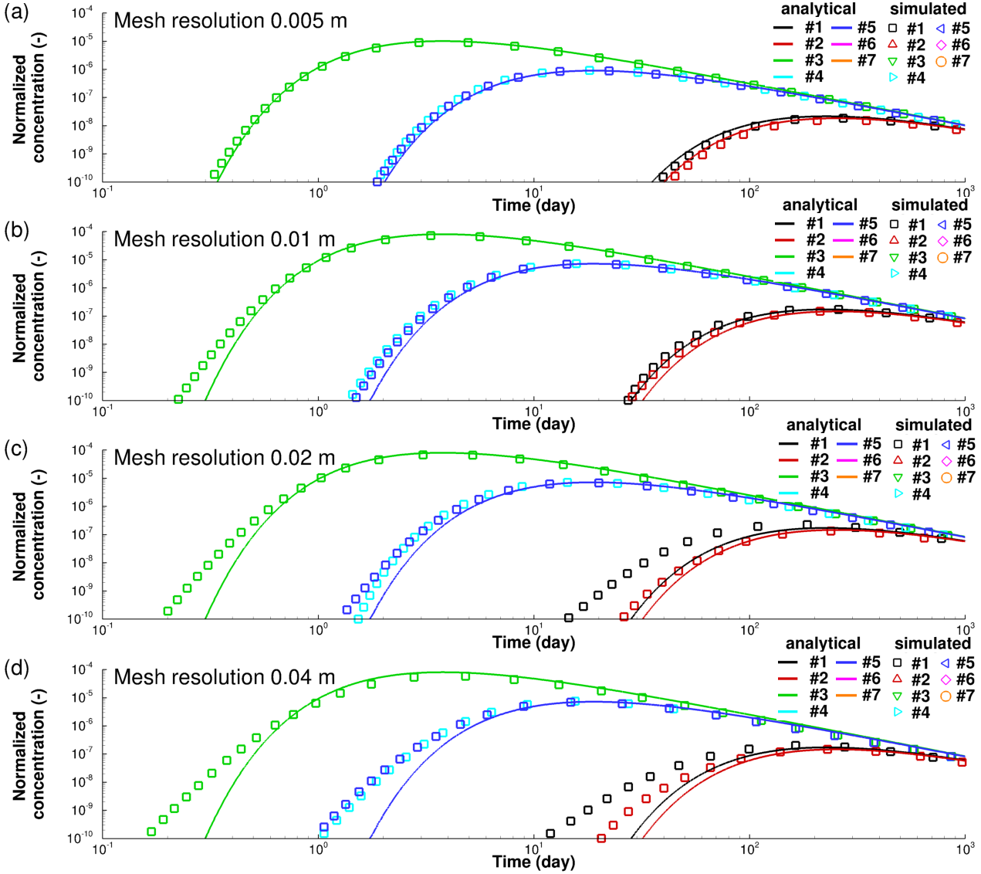

Figure S.6 Mesh resolution effect on simulated results for 3D anisotropic diffusion verification problem with anisotropy ratio $τ_{xx}^{'}:τ_{yy}^{'}:τ_{zz}^{'}=5:1:1$. Lines are analytical solutions and symbols are numerical solutions.

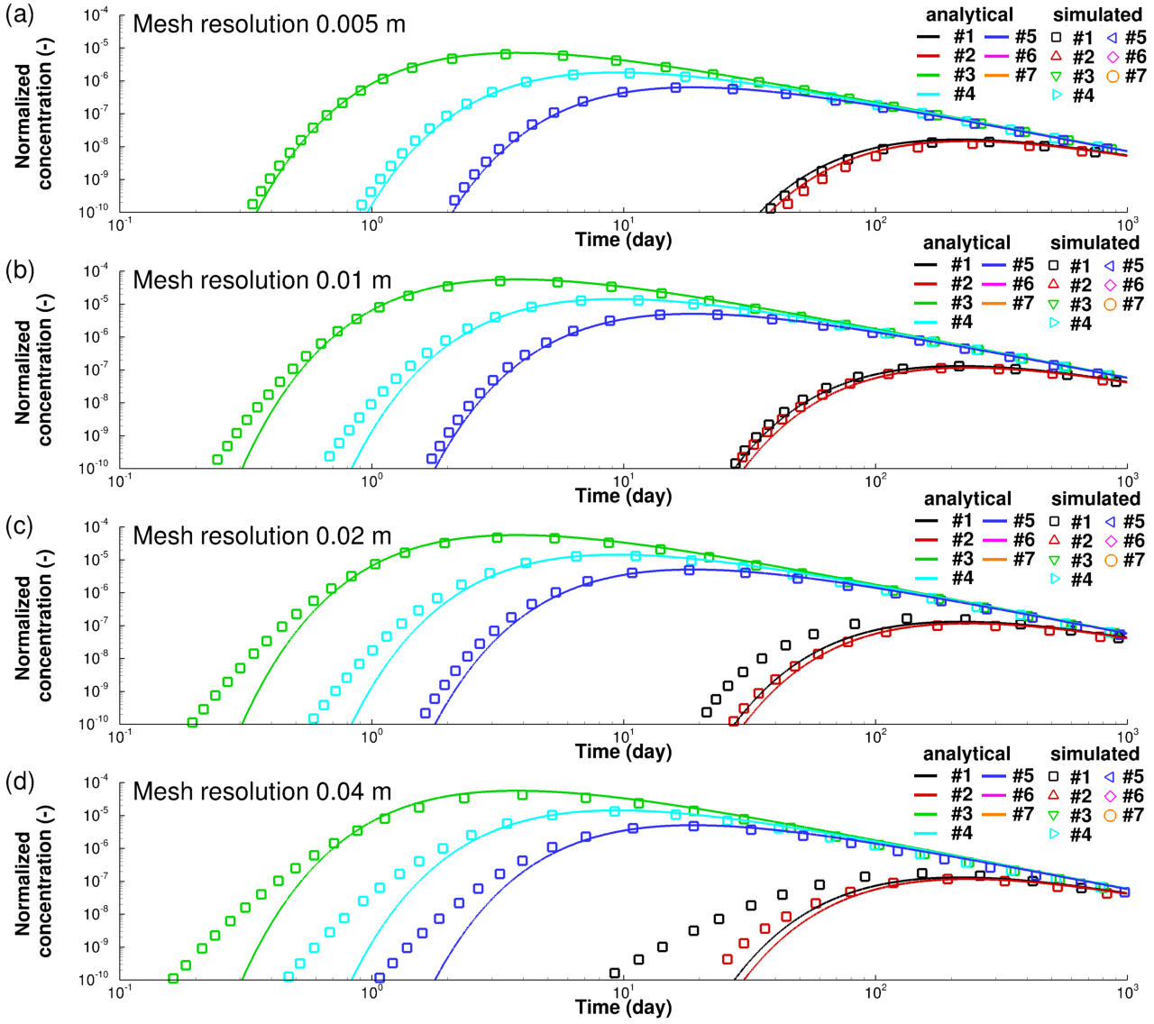

Figure S.7 Mesh resolution effect on simulated results for 3D anisotropic diffusion verification problem with anisotropy ratio $τ_{xx}^{'}:τ_{yy}^{'}:τ_{zz}^{'}=5:2:1$. Lines are analytical solutions and symbols are numerical solutions.

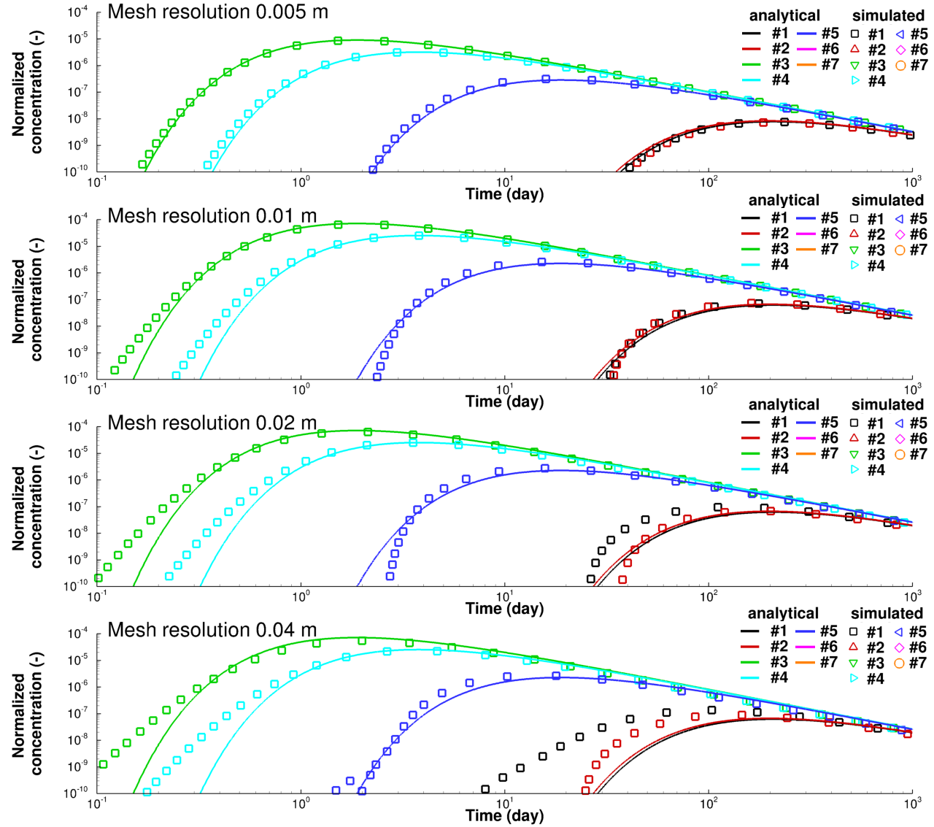

Figure S.8 Mesh resolution effect on simulated results for 3D anisotropic diffusion verification problem with anisotropy ratio $τ_{xx}^{'}:τ_{yy}^{'}:τ_{zz}^{'}=10:5:1$. Lines are analytical solutions and symbols are numerical solutions.

## S.7: Dilution index versus time for simulation of CI-D in-situ diffusion experiment

The plume volume over time can be expressed in terms of the dilution index (Kitanidis 1994). The dilution index was determined over time for the simulation of the CI-D in-situ diffusion experiment (Figure S.9). Differences between the plume volumes for the isotropic and anisotropic cases are small in this case, especially at early time. This can be explained by the fact that the material directly surrounding the borehole is isotropic. The effect of anisotropy only manifests itself, when the plume enters the anisotropic Opalinus clay. However, even towards the end of the simulation, relative differences are restricted to less than 5%, implying that the effect of anisotropy on plume volume is relatively small.

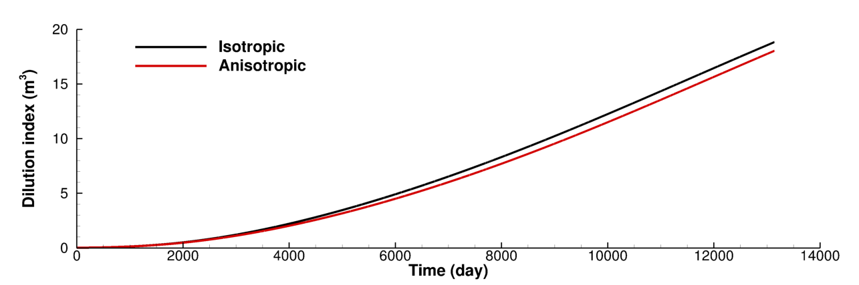

Figure S.9 Dilution index for anisotropic and equivalent isotropic diffusion scenarios for CI-D in-situ diffusion experiment.

## S.8: Dilution index versus time for simulation of a hypothetical DGR site

Significant differences can be observed between anisotropic and equivalent isotropic scenarios for the dilution index for the simulations of the hypothetical DGR site (Figure S.10). The dilution index representing the plume volume is up to 90% larger for the equivalent isotropic scenario compared to the anisotropic scenario, implying that the plume is much larger for the isotropic case. These significant differences are due to the layered nature of this system. In the isotropic case, the plume can enter neighbouring layers with higher diffusivity, allowing for the plume to spread more readily, while for the anisotropic case, the plume remains in the shale layer. Overall, the results for this case indicate that ignoring dipping anisotropy causes substantial differences and can lead to misleading results.

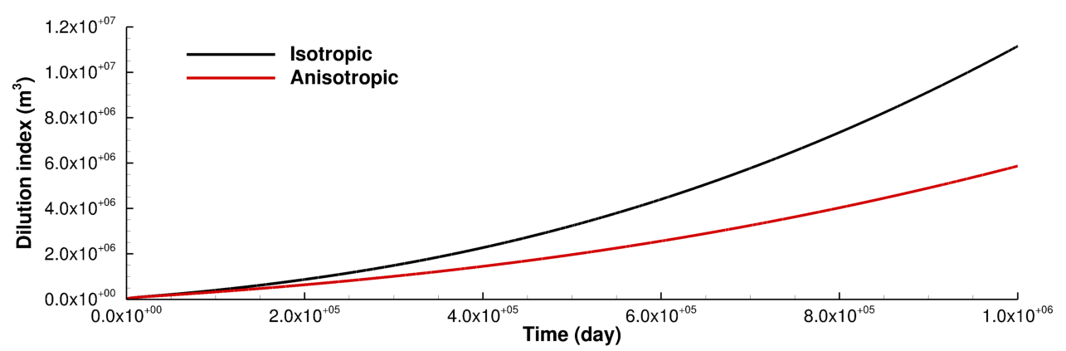

Figure S. Dilution index for anisotropic and equivalent isotropic diffusion scenarios for a hypothetical DGR site.

Acknowledgement: S.2 to S.4 are reprinted from the supplementary material of publication “Numerical investigation of flow instabilities using fully unstructured discretization for variably saturated flow problems, 143, 103673, Su, D., Mayer, K. U., and MacQuarrie, K. T. B. (2020). Advances in Water Resources”, with permission from Elsevier.

# References

Kitanidis, P.K. 1994. The concept of the Dilution Index. Water Resources Research, **30**: 2011–2026. John Wiley & Sons, Ltd. doi:10.1029/94WR00762.

Mavriplis, D. J., 2003. *Revisiting the Least-squares Procedure for Gradient Reconstruction on Unstructured Meshes,* 16th AIAA Computational Fluid Dynamics Conference, Orlando, Florida, US.

Nishikawa, H., 2010. Beyond Interface Gradient: A General Principle for Constructing Diffusion Schemes. *40th Fluid Dynamics Conference and Exhibit,* 273(15), pp. AIAA 2010-5093.

Pasdunkorale, J. & Turner, I. W., 2005. A second order control-volume finite-element least-squares strategy for simulating diffusion in strongly anisotropic media. *Journal of Computational Mathematics,* Volume 23, pp. 1-16.

Sejekan, C. B., 2016. *Improving Finite-Volume Diffusive Fluxes Through Better Reconstruction,* s.l.: s.n.