Supplementary Material

Statistical analyses.
Figure | Experiment Description | Experiment # | (n) value | Mean +/- SEM | Statistical method | P-value
Figure 2A | RBM3 protein expression in C2C12 myotubes cellular fraction.  4 conditions:  (1) 37˚C-6h  (2) 28˚C-6h  (3) 37˚C-24h  (4) 28˚C-24h | Experiment 1 | n=6 per condition. | (1) 37˚C-6h  1.108±0.065  (2) 28˚C-6h  1.149±0.076  (3) 37˚C-24h  0.834±0.063  (4) 28˚C-24h  1.459±0.067 | Two-way ANOVA  Tukey post hoc | 37˚C-24h v. 28˚C-24h  p<0.0001, 
Figure 2A | RBM3 protein expression in C2C12 myotubes cellular fraction.  4 conditions:  (1) 37˚C-6h  (2) 28˚C-6h  (3) 37˚C-24h  (4) 28˚C-24h | Experiment 2  (Representative) | n=6 per condition. | (1) 37˚C-6h  0.537±0.039  (2) 28˚C-6h  0.683±0.031  (3) 37˚C-24h  0.605±0.072  (4) 28˚C-24h  1.152±0.039 | Two-way ANOVA  Tukey post hoc | 37˚C-24h v. 28˚C-24h  p<0.0001,****
Figure 2A | RBM3 protein expression in C2C12 myotubes cellular fraction.  4 conditions:  (1) 37˚C-6h  (2) 28˚C-6h  (3) 37˚C-24h  (4) 28˚C-24h | Experiment 3 | n=6 per condition. | (1) 37˚C-6h  1.265±0.063  (2) 28˚C-6h  1.193±0.045  (3) 37˚C-24h  1.207±0.044  (4) 28˚C-24h  1.441±0.039 | Two-way ANOVA  Tukey post hoc | 37˚C-24h v. 28˚C-24h  p<0.0092,**
Figure 2B | VEGF-A protein expression in C2C12 myotubes cellular fraction.  2 conditions:  (1) 37˚C-24h  (2) 28˚C-24h | Experiment 1  (Representative) | n=6 per condition. | (1) 37˚C-24h  9.212±0.2346  (2) 28˚C-24h  9.449±0.3392 | Unpaired student’s  t-test | 37˚C-24h v. 28˚C-24h  p=0.5791, n.s
Figure 2C | VEGF-A protein expression in C2C12 myotubes secreted fraction.  2 conditions:  (1) 37˚C-24h  (2) 28˚C-24h | Experiment 1  (Representative) | n=6 per condition. | (1) 37˚C-24h  9.426±0.3929  (2) 28˚C-24h  4.576±0.5159 | Unpaired student’s  t-test | 37˚C-24h v. 28˚C-24h  p=0.0001, ***
Figure 3A | THBS1 protein expression in C2C12 myotubes secreted fraction.  2 conditions:  (1) 37-24h  (2) 28-24h | Experiment 1 | n=3 per condition. | Total band:  (1) 37-24h  32330±265  (2) 28-24h  27156±1061  Top band:  (1) 37-24h  19390±2032  (2) 28-24h  16580±1584  Middle band:  (1) 37-24h  6673±1244  (2) 28-24h  8755±1202  Lower band:  (1) 37-24h  6266±465.6  (2) 28-24h  1822±409.1 | Unpaired student’s  t-test | Total band:  37-24h v. 28-24h  p=0.0984, n.s  Top band:  37-24h v. 28-24h  p=0.3367, n.s  Middle band:  37-24h v. 28-24h  p=0.2951, n.s  Lower band:  37-24h v. 28-24h  p=0.0020, **
Figure 3A | THBS1 protein expression in C2C12 myotubes secreted fraction.  2 conditions:  (1) 37-24h  (2) 28-24h | Experiment 2 | n=3 per condition. | Total band:  (1) 37-24h  45607±2564  (2) 28-24h  37286±1217  Top band:  (1) 37-24h  22815±1630  (2) 28-24h  20576±2909  Middle band:  (1) 37-24h  9318±2652  (2) 28-24h  9620±1598  Lower band:  (1) 37-24h  13474±2253  (2) 28-24h  7090±971.7 | Unpaired student’s  t-test | Total band:  37-24h v. 28-24h  p=0.0428, *  Top band:  37-24h v. 28-24h  p=0.5388, n.s  Middle band:  37-24h v. 28-24h  p=0.9269, n.s  Lower band:  37-24h v. 28-24h  p=0.0599, n.s
Figure 3A | THBS1 protein expression in C2C12 myotubes secreted fraction.  2 conditions:  (1) 37-24h  (2) 28-24h | Experiment 3 | n=3 per condition. | Total band:  (1) 37-24h  53035±1196  (2) 28-24h  38595±1927  Top band:  (1) 37-24h  27065±1503  (2) 28-24h  20575±1356  Middle band:  (1) 37-24h  11183±2172  (2) 28-24h  9785±599.7  Lower band:  (1) 37-24h  14787±957.5  (2) 28-24h  8235±1029 | Unpaired student’s  t-test | Total band:  37-24h v. 28-24h  p=0.0031, **  Top band:  37-24h v. 28-24h  p=0.0327, *  Middle band:  37-24h v. 28-24h  p=0.5685, n.s  Lower band:  37-24h v. 28-24h  p=0.0096, **
Figure 3A | THBS1 protein expression in C2C12 myotubes secreted fraction.  2 conditions:  (1) 37-24h  (2) 28-24h | Experiment 4  (Representative) | n=6 per condition. | Total band:  (1) 37-24h  29434±2189  (2) 28-24h  23708±1404  Top band:  (1) 37-24h  15380±1443  (2) 28-24h  14285±1455  Middle band:  (1) 37-24h  3199±489.2  (2) 28-24h  4063±602.4  Lower band:  (1) 37-24h  10584±1106  (2) 28-24h  5362±711.8 | Unpaired student’s  t-test | Total band:  37-24h v. 28-24h  p=0.0523, n.s  Top band:  37-24h v. 28-24h  p=0.6047, n.s  Middle band:  37-24h v. 28-24h  p=0.2916, n.s  Lower band:  37-24h v. 28-24h  p=0.0019, **
Figure 3C | THBS1 protein expression in C2C12 myotubes cellular fraction.  2 conditions:  (1) 37-24h  (2) 28-24h | Experiment 1  (Representative) | n=6 per condition. | (1) 37-24h  0.1808±0.01938  (2) 28-24h  0.4031±0.02941 | Unpaired student’s  t-test | 37-24h v. 28-24h  p<0.0001, 
Figure 4A | THBS1 protein expression in C2C12 myotubes cellular fraction.  4 conditions:  (1) 37-6h  (2) 28-6h  (3) 37-24h  (4) 28-24h | Experiment 1  (Representative) | n=6 per condition. | (1) 37-6h  0.343±0.048  (2) 28-6h  0.530±0.074  (3) 37-24h  0.378±0.028  (4) 28-24h  0.677±0.040 | Two-way ANOVA  Tukey post hoc | 37-6h v. 28-24h  p=0.0007, ***  37-24h v. 28-24h  p=0.0023, **
Figure 4A | THBS1 protein expression in C2C12 myotubes cellular fraction.  4 conditions:  (1) 37-6h  (2) 28-6h  (3) 37-24h  (4) 28-24h | Experiment 2 | n=6 per condition. | (1) 37-6h  0.306±0.015  (2) 28-6h  0.426±0.022  (3) 37-24h  0.281±0.022  (4) 28-24h  0.637±0.042 | Two-way ANOVA  Tukey post hoc | 37-6h v. 28-6h  p=0.0249, *  37-6h v. 28-24h  p<0.0001,   37-24h v. 28-6h  p=0.0059, **  37-24h v. 28-24h  p<0.0001, 
Figure 4A | THBS1 protein expression in C2C12 myotubes cellular fraction.  4 conditions:  (1) 37-6h  (2) 28-6h  (3) 37-24h  (4) 28-24h | Experiment 3 | n=6 per condition. | (1) 37-6h  0.393±0.042  (2) 28-6h  0.557±0.072  (3) 37-24h  0.374±0.034  (4) 28-24h  0.747±0.049 | Two-way ANOVA  Tukey post hoc | 37-6h v. 28-24h  p=0.0005, ***  37-24h v. 28-24h  p=0.0003, ***
Figure 4B | THBS1 mRNA expression in C2C12 myotubes cellular fraction.  4 conditions:  (1) 37-6h  (2) 28-6h  (3) 37-24h  (4) 28-24h | Experiment 1 | n=6 per condition. | (1)37-6h  1.550±0.187  (2)28-6h  1.212±0.090  (3)37-24h  1.047±0.119  (4)28-24h  1.797±0.278 | Two-way ANOVA  Tukey post hoc | 37-24h v. 28-24h  p=0.0412, *
Figure 4B | THBS1 mRNA expression in C2C12 myotubes cellular fraction.  4 conditions:  (1) 37-6h  (2) 28-6h  (3) 37-24h  (4) 28-24h | Experiment 2  (Representative) | n=6 per condition. | (1) 37-6h  1.187±0.079  (2) 28-6h  1.117±0.046  (3) 37-24h  0.955±0.108  (4) 28-24h  2.012±0.145 | Two-way ANOVA  Tukey post hoc | 37-6h v. 28-24h  p<0.0001,   28-6h v. 28-24h  p<0.0001,   37-24h v. 28-24h  p<0.0001, 
Figure 4B | THBS1 mRNA expression in C2C12 myotubes cellular fraction.  4 conditions:  (1) 37-6h  (2) 28-6h  (3) 37-24h  (4) 28-24h | Experiment 3 | n=6 per condition. | (1) 37-6h  1.058±0.055  (2) 28-6h  0.893±0.023  (3) 37-24h  1.230±0.065  (4) 28-24h  1.577±0.039 | Two-way ANOVA  Tukey post hoc | 37-6h v. 28-24h  p<0.0001,   37-24h v. 28-6h  p=0.0004, ***  28-6h v. 28-24h  p<0.0001,   37-24h v. 28-24h  p=0.0003, ***
Figure 4C | THBS1 protein expression in C2C12 myotubes cellular fraction.  4 conditions:  (1) Control (37)  (2) Cooling (28)  (3) Re-warming  (4) Re-cooling | Experiment 1  (Representative) | n=6 per condition. | (1) Control (37)  0.4007±0.03862  (2) Cooling (28)  0.5369±0.01745  (3) Re-warming  0.3408±0.03403  (4) Re-cooling  0.4880±0.02047 | Ordinary one-way ANOVA  Tukey’s multiple comparisons test | Control v. Cooling  p=0.0167, *  Cooling v. Re-warming  p=0.0006, ***  Re-warming v. Re-cooling  p=0.0092, **
Figure 4C | THBS1 protein expression in C2C12 myotubes cellular fraction.  4 conditions:  (1) Control (37)  (2) Cooling (28)  (3) Re-warming  (4) Re-cooling | Experiment 2 | n=6 per condition. | (1) Control (37)  0.4357±0.03077  (2) Cooling (28)  0.6636±0.04257  (3) Re-warming  0.4223±0.04064  (4) Re-cooling  0.5346±0.05760 | Ordinary one-way ANOVA  Tukey’s multiple comparisons test | Control v. Cooling  p=0.0077, **  Cooling v. Re-warming  p=0.0047, **
Figure 6AB | mSMECs migration, number of cells per field of view, in response to stimulation with C2C12-conditioned media.  4 conditions:  (1) Non-stim  (2) Stim  (3) 37  (4) 28 | Experiment 1 | n=6 per condition. | (1) Non-stim  80.07±5.997  (2) Stim  154.7±5.366  (3) 37  32.47±2.054  (4) 28  43.63±2.732 | Ordinary one-way ANOVA  Tukey’s multiple comparisons test | Non-stim v. Stim  p<0.0001,   37 v. 28  p=0.3066, n.s
Figure 6AB | mSMECs migration, number of cells per field of view, in response to stimulation with C2C12-conditioned media.  4 conditions:  (1) Non-stim  (2) Stim  (3) 37  (4) 28 | Experiment 2 | n=6 per condition. | (1) Non-stim  39.46±3.812  (2) Stim  75.72±2.422  (3) 37  36.03±1.346  (4) 28  43.40±5.948 | Ordinary one-way ANOVA  Tukey’s multiple comparisons test | Non-stim v. Stim  p<0.0001,   37 v. 28  p=0.5289, n.s
Figure 6AB | mSMECs migration, number of cells per field of view, in response to stimulation with C2C12-conditioned media.  4 conditions:  (1) Non-stim  (2) Stim  (3) 37  (4) 28 | Experiment 3  (Representative) | n=6 per condition. | (1) Non-stim  26.63±3.662  (2) Stim  57.54±2.891  (3) 37  29.78±3.318  (4) 28  24.50±6.016 | Ordinary one-way ANOVA  Tukey’s multiple comparisons test | Non-stim v. Stim  p=0.0002, ***  37 v. 28  p=0.8055, n.s
Figure 6AB | mSMECs migration, number of cells per field of view, in response to stimulation with C2C12-conditioned media.  4 conditions:  (1) Non-stim  (2) Stim  (3) 37  (4) 28 | Experiment 4 | n=6 per condition. | (1) Non-stim  89.45±7.740  (2) Stim  142.9±3.685  (3) 37  105.0±6.118  (4) 28  92.17±5.038 | Ordinary one-way ANOVA  Tukey’s multiple comparisons test | Non-stim v. Stim  p<0.0001,   37 v. 28  p=0.4256, n.s
Figure 6AB | mSMECs migration, number of cells per field of view, in response to stimulation with C2C12-conditioned media.  4 conditions:  (1) Non-stim  (2) Stim  (3) 37  (4) 28 | Experiment 5 | n=6 per condition. | (1) Non-stim  53.13±5.744  (2) Stim  97.04±3.038  (3) 37  31.70±2.481  (4) 28  36.82±5.096 | Ordinary one-way ANOVA  Tukey’s multiple comparisons test | Non-stim v. Stim  p<0.0001,   37 v. 28  p=0.8348, n.s
Figure 6AB | mSMECs migration, number of cells per field of view, in response to stimulation with C2C12-conditioned media.  4 conditions:  (1) Non-stim  (2) Stim  (3) 37  (4) 28 | Experiment 6 | n=6 per condition. | (1) Non-stim  38.25±2.513  (2) Stim  84.75±1.751  (3) 37  32.56±1.221  (4) 28  33.50±3.096 | Ordinary one-way ANOVA  Tukey’s multiple comparisons test | Non-stim v. Stim  p<0.0001,   37 v. 28  p=0.9907, n.s
Figure 7A | RBM3 protein expression in mSMEC cellular fraction.  2 conditions:  (1)37-24h  (2)28-24h | Experiment 1  (Representative) | n=6 per condition. | (1)37-24h  1.061±0.04477  (2)28-24h  1.300±0.04630 | Unpaired student’s  t-test | 37-24h v. 28-24h  p=0.0041, **
Figure 7A | RBM3 protein expression in mSMEC cellular fraction.  2 conditions:  (1)37-24h  (2)28-24h | Experiment 2 | n=6 per condition. | (1)37-24h  1.275±0.05246  (2)28-24h  1.454±0.04762 | Unpaired student’s  t-test | 37-24h v. 28-24h  p=0.0303, *
Figure 7A | RBM3 protein expression in mSMEC cellular fraction.  2 conditions:  (1)37-24h  (2)28-24h | Experiment 3 | n=6 per condition. | (1)37-24h  1.051±0.06923  (2)28-24h  1.238±0.05614 | Unpaired student’s  t-test | 37-24h v. 28-24h  p=0.0624, n.s
Figure 7B | mSMEC proliferation in either control (37) or cold (28) conditions.  3 timepoints analyzed: Day0, Day1, Day2.  5 conditions:  (1) Day0  (2) Day1-37  (3) Day1-28  (4) Day2-37  (5) Day2-28 | Experiment 1  (Representative) | n=8 per conditions (1), (2), (3), (5).  n=5 per condition (4). | (1) Day0  16538.375±716.125  (2) Day1-37  36672.620±3488.868  (3) Day1-28  23651.394±2769.046  (4) Day2-37  111832.120±3995.202  (5) Day2-28  24403.701±1582.401 | Two-way ANOVA  Tukey post hoc | Day0 v. Day1-37  p<0.0001,   Day0 v. Day2-37  p<0.0001,   Day1-37 v. Day1-28  p=0.0032, **  Day2-37 v. Day2-28  p<0.0001, 
Figure 7B | mSMEC proliferation in either control (37) or cold (28) conditions.  3 timepoints analyzed: Day0, Day1, Day2.  5 conditions:  (1) Day0  (2) Day1-37  (3) Day1-28  (4) Day2-37  (5) Day2-28 | Experiment 2 | n=8 per condition. | (1) Day0  16683.875±1829.976  (2) Day1-37  54183.824±5434.26  (3) Day1-28  30995.811±1006.853  (4) Day2-37  108599.115±8182.196  (5) Day2-28  22594.660±1706.450 | Two-way ANOVA  Tukey post hoc3 | Day0 v. Day1-37  p<0.0001,   Day0 v. Day2-37  p<0.0001,   Day1-37 v. Day1-28  p=0.0046, **  Day2-37 v. Day2-28  p<0.0001, 
Figure 7B | mSMEC proliferation in either control (37) or cold (28) conditions.  3 timepoints analyzed: Day0, Day1, Day2.  5 conditions:  (1) Day0  (2) Day1-37  (3) Day1-28  (4) Day2-37  (5) Day2-28 | Experiment 3 | n=8 per conditions (1), (2), (3), (5).  n=4 per condition (4). | (1) Day0  16302.000±1048.748  (2) Day1-37  55455.363±4525.666  (3) Day1-28  31682.126±2288.485  (4) Day2-37  83267.125±14925.931  (5) Day2-28  37742.983±4975.329 | Two-way ANOVA  Tukey post hoc | Day0 v. Day1-37  p<0.0001,   Day0 v. Day2-37  p<0.0001, ***  Day1-37 v. Day2-28  p=0.0046, **  Day2-37 v. Day2-28  p<0.0001, 
Figure 8A | mSMEC non-stimulated (Non-stim) and stimulated (Stim) rates of migration, number of cells per field of view, following preconditioning in either control (37) or cold (28) conditions.  4 conditions:  (1) Non-stim-37  (2) Non-stim-28  (3) Stim-37  (4) Stim-28 | Experiment 1 | n=6 per condition. | (1) Non-stim-37  53.444±3.424  (2) Non-stim-28  37.875±2.916  (3) Stim-37  93.875±3.108  (4) Stim-28  77.736±2.477 | Two-way ANOVA  Tukey post hoc | Non-stim 37 v. Stim 37  p<0.0001,   Non-stim 28 v. Stim 28  p<0.0001,   Non-stim 37 v. Non-stim 28  p=0.0076, **  Stim 37 v. Stim 28  p=0.0057, **
Figure 8A | mSMEC non-stimulated (Non-stim) and stimulated (Stim) rates of migration, number of cells per field of view, following preconditioning in either control (37) or cold (28) conditions.  4 conditions:  (1) Non-stim-37  (2) Non-stim-28  (3) Stim-37  (4) Stim-28 | Experiment 2 | n=6 per condition. | (1) Non-stim-37  29.111±2.265  (2) Non-stim-28  17.250±1.982  (3) Stim-37  86.042±2.740  (4) Stim-28  76.125±3.418 | Two-way ANOVA  Tukey post hoc | Non-stim 37 v. Stim 37  p<0.0001,   Non-stim 28 v. Stim 28  p<0.0001,   Non-stim 37 v. Non-stim 28  p=0.0236, *  Stim 37 v. Stim 28  p=0.0691, n.s
Figure 8A | mSMEC non-stimulated (Non-stim) and stimulated (Stim) rates of migration, number of cells per field of view, following preconditioning in either control (37) or cold (28) conditions.  4 conditions:  (1)Non-stim-37  (2)Non-stim-28  (3)Stim-37  (4)Stim-28 | Experiment 3  (Representative) | n=6 per condition. | (1)Non-stim-37  21.917±1.616  (2)Non-stim-28  15.083±1.621  (3)Stim-37  56.792±2.737  (4)Stim-28  52.958±1.787 | Two-way ANOVA  Tukey post hoc | Non-stim 37 v. Stim 37  p<0.0001,   Non-stim 28 v. Stim 28  p<0.0001,   Non-stim 37 v. Non-stim 28  p=0.1050, n.s  Stim 37 v. Stim 28  p=0.5383, n.s

Figure 8A | mSMEC non-stimulated (Non-stim) and stimulated (Stim) rates of migration, number of cells per field of view, following preconditioning in either control (37) or cold (28) conditions.  4 conditions:  (1)Non-stim-37  (2)Non-stim-28  (3)Stim-37  (4)Stim-28 | Experiment 4 | n=6 per condition. | (1)Non-stim-37  37.125±3.460  (2)Non-stim-28  32.861±1.308  (3)Stim-37  73.167±5.108  (4)Stim-28  93.681±2.617 | Two-way ANOVA  Tukey post hoc | Non-stim 37 v. Stim 37  p<0.0001,   Non-stim 28 v. Stim 28  p<0.0001,   Non-stim 37 v. Non-stim 28  p=0.8135, n.s  Stim 37 v. Stim 28  p=0.0021, **
Figure 8A | mSMEC non-stimulated (Non-stim) and stimulated (Stim) rates of migration, number of cells per field of view, following preconditioning in either control (37) or cold (28) conditions.  4 conditions:  (1)Non-stim-37  (2)Non-stim-28  (3)Stim-37  (4)Stim-28 | Experiment 5 | n=6 per condition. | (1)Non-stim-37  36.722±2.668  (2)Non-stim-28  34.639±2.640  (3)Stim-37  74.625±2.303  (4)Stim-28  79.417±3.537 | Two-way ANOVA  Tukey post hoc | Non-stim 37 v. Stim 37  p<0.0001,   Non-stim 28 v. Stim 28  p<0.0001,   Non-stim 37 v. Non-stim 28  p=0.9529, n.s  Stim 37 v. Stim 28  p=0.6340, n.s
Figure 8B | mSMEC fold increase in stimulated migration relative to unstimulated conditions.  2 conditions:  (1) 37 Stim / 37 Non-stim  (2) 28 Stim / 28 Non-stim | Experiment 1 | n=6 per condition. | (1) 37 Stim / 37 Non-stim  1.756±0.05816  (2) 28 Stim / 28 Non-stim  2.052±0.06539 | Unpaired student’s  t-test | 37 v. 28  p=0.0070, **
Figure 8B | mSMEC fold increase in stimulated migration relative to unstimulated conditions.  2 conditions:  (1) 37 Stim / 37 Non-stim  (2) 28 Stim / 28 Non-stim | Experiment 2 | n=6 per condition. | (1) 37 Stim / 37 Non-stim  2.956±0.09414  (2) 28 Stim / 28 Non-stim  4.413±0.1981 | Unpaired student’s  t-test | 37 v. 28  p<0.0001, 
Figure 8B | mSMEC fold increase in stimulated migration relative to unstimulated conditions.  2 conditions:  (1) 37 Stim / 37 Non-stim  (2) 28 Stim / 28 Non-stim | Experiment 3  (Representative) | n=6 per condition. | (1) 37 Stim / 37 Non-stim  2.591±0.1249  (2) 28 Stim / 28 Non-stim  3.511±0.1185 | Unpaired student’s  t-test | 37 v. 28  p=0.0003, ***
Figure 8B | mSMEC fold increase in stimulated migration relative to unstimulated conditions.  2 conditions:  (1) 37 Stim / 37 Non-stim  (2) 28 Stim / 28 Non-stim | Experiment 4 | n=6 per condition. | (1) 37 Stim / 37 Non-stim  1.971±0.1376  (2) 28 Stim / 28 Non-stim  2.851±0.07964 | Unpaired student’s  t-test | 37 v. 28  p=0.0002, ***
Figure 8B | mSMEC fold increase in stimulated migration relative to unstimulated conditions.  2 conditions:  (1) 37 Stim / 37 Non-stim  (2) 28 Stim / 28 Non-stim | Experiment 5 | n=6 per condition. | (1) 37 Stim / 37 Non-stim  2.032±0.06271  (2) 28 Stim / 28 Non-stim  2.293±0.07964 | Unpaired student’s  t-test | 37 v. 28  p=0.0548, n.s
Figure 8C | mSMEC proliferation in response to preconditioning in either control (37) or cold (28) conditions.  6 conditions:  (1) T0-37  (2) T0-28  (3) T24-37  (4) T24-28  (5) T48-37  (6) T48-28 | Experiment 1 | n=6-7 per condition. | (1) T0-37  8169.143±650.337  (2) T0-28  12087.571±747.131  (3) T24-37  18107.674±1598.931  (4) T24-28  19505.903±1242.522  (5) T48-37  47634.640±4958.407  (6) T48-28  57621.211±2630.831 | Two-way ANOVA  Tukey post hoc | T0-37 v. T24-37  p=0.0727, n.s  T0-37 v. T48-37  p<0.0001,   T0-28 v. T24-28  p=0.2982, n.s  T0-28 v. T48-28  p<0.0001, 
Figure 8C | mSMEC proliferation in response to preconditioning in either control (37) or cold (28) conditions.  6 conditions:  (1) T0-37  (2) T0-28  (3) T24-37  (4) T24-28  (5) T48-37  (6) T48-28 | Experiment 2 | n=6-7 per condition. | (1) T0-37  11809.533±1226.298  (2) T0-28  11684.476±704.436  (3) T24-37  20887.000±1884.091  (4) T24-28  17522.500±1067.984  (5) T48-37  38021.053±5268.859  (6) T48-28  43451.337±4124.183 | Two-way ANOVA  Tukey post hoc | T0-37 v. T24-37  p=0.2780, n.s  T0-37 v. T48-37  p<0.0001,   T0-28 v. T24-28  p=0.7613, n.s  T0-28 v. T48-28  p<0.0001, 
Figure 8C | mSMEC proliferation in response to preconditioning in either control (37) or cold (28) conditions.  6 conditions:  (1) T0-37  (2) T0-28  (3) T24-37  (4) T24-28  (5) T48-37  (6) T48-28 | Experiment 3 | n=6-7 per condition. | (1) T0-37  12403.500±1088.278  (2) T0-28  10396.833±825.534  (3) T24-37  23810.309±3014.776  (4) T24-28  18709.522±1944.749  (5) T48-37  47260.700±8192.986  (6) T48-28  34529.847±4597.213 | Two-way ANOVA  Tukey post hoc | T0-37 v. T24-37  p=0.3452, n.s  T0-37 v. T48-37  p<0.0001,   T0-28 v. T24-28  p=0.6766, n.s  T0-28 v. T48-28  p<0.0029, **
Figure 9BD | Basal (230kda, 210kda, 150kda) and phosphorylated (Y1175) protein expression of VEGFR2 in mSMEC.  4 conditions:  (1)-VEGF-37  (2)-VEGF-28  (3)+VEGF-37  (4)+VEGF-28 | Experiment 1 | n=3 per condition. | 230kda  (1)-VEGF-37  0.541±0.135  (2)-VEGF-28  0.640±0.149  (3)+VEGF-37  0.323±0.071  (4)+VEGF-28  0.513±0.062  210kda  (1)-VEGF-37  0.217±0.056  (2)-VEGF-28  0.475±0.060  (3)+VEGF-37  0.313±0.047  (4)+VEGF-28  0.545±0.040  150kda  (1)-VEGF-37  0.121±0.034  (2)-VEGF-28  0.570±0.128  (3)+VEGF-37  0.209±0.062  (4)+VEGF-28  0.949±0.195  Y1175  (1)-VEGF-37  0.139±0.017  (2)-VEGF-28  0.093±0.031  (3)+VEGF-37  0.563±0.096  (4)+VEGF-28  0.612±0.048  Y1175/230kda  (1)-VEGF-37  0.279±0.047  (2)-VEGF-28  0.164±0.060  (3)+VEGF-37  1.793±0.203  (4)+VEGF-28  1.250±0.248 | Two-way ANOVA  Tukey post hoc | 230kda  n.s  210kda  -VEGF-37 v. -VEGF-28  p=0.0303, *  +VEGF-37 v. +VEGF-28  p=0.0495,*  150kda  +VEGF-37 v. +VEGF-28  p=0.0115, *  Y1175  -VEGF-37 v. +VEGF-37  p=0.0031, **  -VEGF-28 v. +VEGF-28  p=0.0008, ***  Y1175/230kda  -VEGF-37 v. +VEGF-37  p=0.0009, ***  -VEGF-28 v. +VEGF-28  p=0.0070, **
Figure 9BD | Basal (230kda, 210kda, 150kda) and phosphorylated (Y1175) protein expression of VEGFR2 in mSMEC.  4 conditions:  (1)-VEGF-37  (2)-VEGF-28  (3)+VEGF-37  (4)+VEGF-28 | Experiment 2  (Representative) | n=3 per condition. | 230kda  (1)-VEGF-37  0.376±0.021  (2)-VEGF-28  0.700±0.021  (3)+VEGF-37  0.152±0.040  (4)+VEGF-28  0.438±0.114  210kda  (1)-VEGF-37  0.099±0.015  (2)-VEGF-28  0.301±0.044  (3)+VEGF-37  0.140±0.039  (4)+VEGF-28  0.435±0.071  150kda  (1)-VEGF-37  0.410±0.116  (2)-VEGF-28  0.794±0.183  (3)+VEGF-37  0.377±0.098  (4)+VEGF-28  1.736±0.229  Y1175  (1)-VEGF-37  0.238±0.030  (2)-VEGF-28  0.138±0.016  (3)+VEGF-37  0.398±0.032  (4)+VEGF-28  0.268±0.019  Y1175/230kda  (1)-VEGF-37  0.626±0.050  (2)-VEGF-28  0.198±0.028  (3)+VEGF-37  2.945±0.721  (4)+VEGF-28  0.684±0.147 | Two-way ANOVA  Tukey post hoc | 230kda  -VEGF-37 v. -VEGF-28  p=0.0258, *  +VEGF-37 v. +VEGF-28  p=0.0470, *  210kda  +VEGF-37 v. +VEGF-28  p=0.0090, **  150kda  -VEGF-28 v. +VEGF-28  p=0.0159, *  +VEGF-37 v. +VEGF-28  p=0.0018, **  Y1175  -VEGF-37 v. +VEGF-37  p=0.0090, **  -VEGF-28 v. +VEGF-28  p=0.0272, *  +VEGF-37 v. +VEGF-28  p=0.0279, *  Y1175/230kda  -VEGF-37 v. +VEGF-37  p=0.0093, **  +VEGF-37 v. +VEGF-28  p=0.0107, *
Figure 9BD | Basal (230kda, 210kda, 150kda) and phosphorylated (Y1175) protein expression of VEGFR2 in mSMEC.  4 conditions:  (1)-VEGF-37  (2)-VEGF-28  (3)+VEGF-37  (4)+VEGF-28 | Experiment 3 | n=3 per condition. | 230kda  (1)-VEGF-37  0.296±0.063  (2)-VEGF-28  0.537±0.066  (3)+VEGF-37  0.099±0.013  (4)+VEGF-28  0.335±0.098  210kda  (1)-VEGF-37  0.097±0.022  (2)-VEGF-28  0.285±0.070  (3)+VEGF-37  0.114±0.018  (4)+VEGF-28  0.322±0.070  150kda  (1)-VEGF-37  0.138±0.055  (2)-VEGF-28  0.422±0.119  (3)+VEGF-37  0.191±0.034  (4)+VEGF-28  0.806±0.255  Y1175  (1)-VEGF-37  0.556±0.135  (2)-VEGF-28  0.420±0.034  (3)+VEGF-37  0.981±0.207  (4)+VEGF-28  0.722±0.185  Y1175/230kda  (1)-VEGF-37  2.185±0.806  (2)-VEGF-28  0.811±0.144  (3)+VEGF-37  9.817±1.120  (4)+VEGF-28  2.370±0.634 | Two-way ANOVA  Tukey post hoc | 230kda  n.s  210kda  n.s  150kda  n.s  Y1175  n.s  Y1175/230kda  -VEGF-37 v. +VEGF-37  p=0.0005, ***  +VEGF-37 v. +VEGF-28  p=0.0006, ***
Figure 11B | THBS1 protein expression in ex-vivo muscle incubation assay samples exposed to control (37) or cold (28) conditions.  2 conditions:  (1)37-24h  (2)28-24h | Experiment 1  (Representative) | n=6 per condition. | (1)37-24h  0.5144±0.1107  (2)28-24h  1.032±0.1703 | Unpaired student’s  t-test | 37 v. 28  p=0.0290, *

Differentiated C2C12 myotubes (after 5 days of differentiation) and cultured up to 6h and 24h at 37˚C or 28˚C.

C2C12, 37˚C, 5 days + 0h, 10x
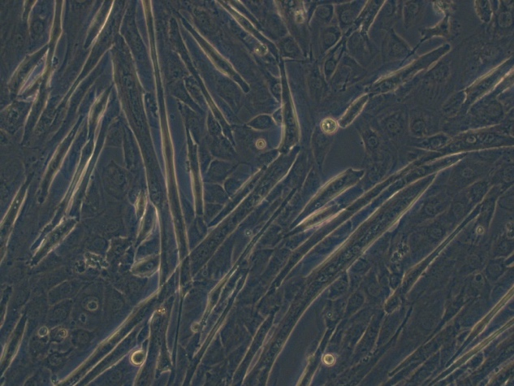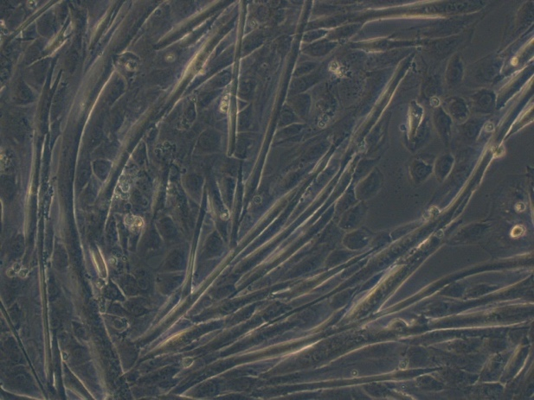

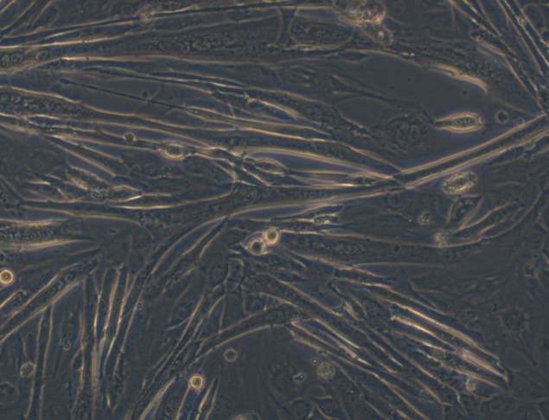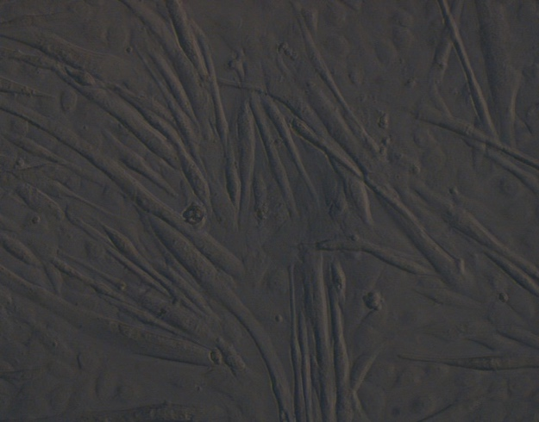

C2C12, 37˚C, 5 days + 0h, 4x

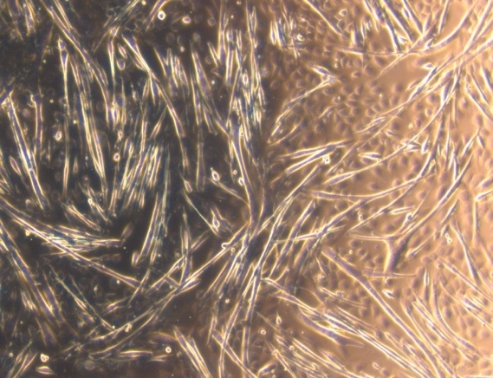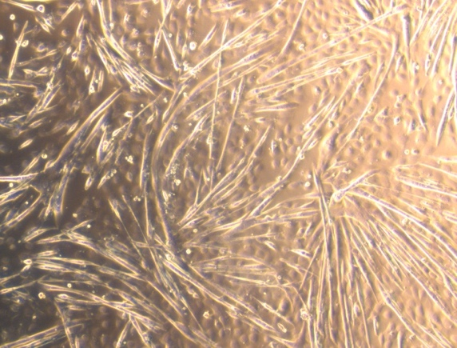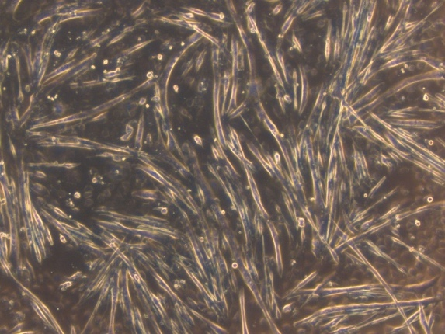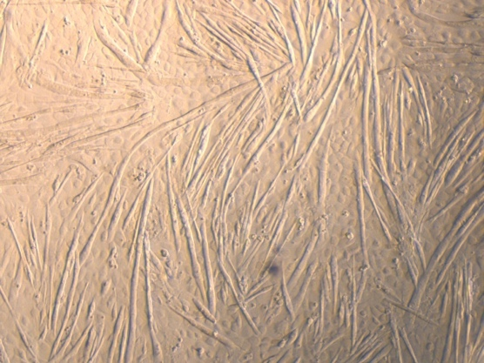

C2C12, 28˚C, 5 days + 0h, 10x

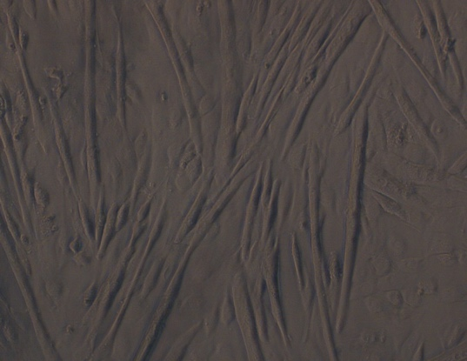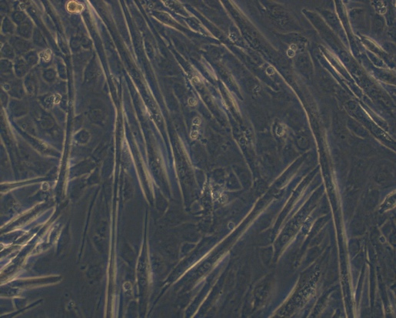
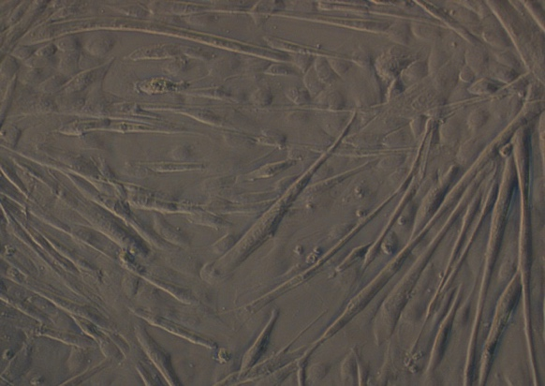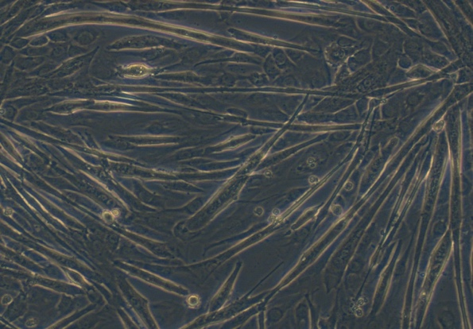

C2C12, 28˚C, 5 days + 0h, 4x

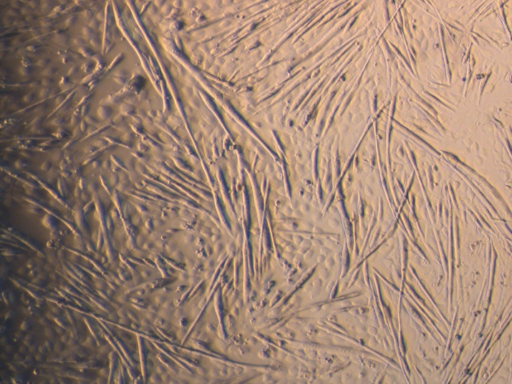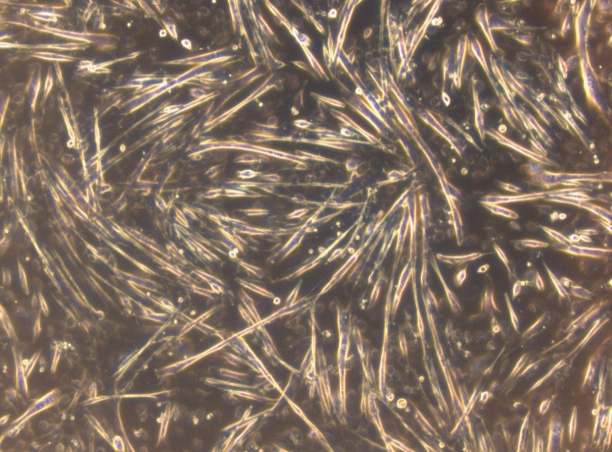

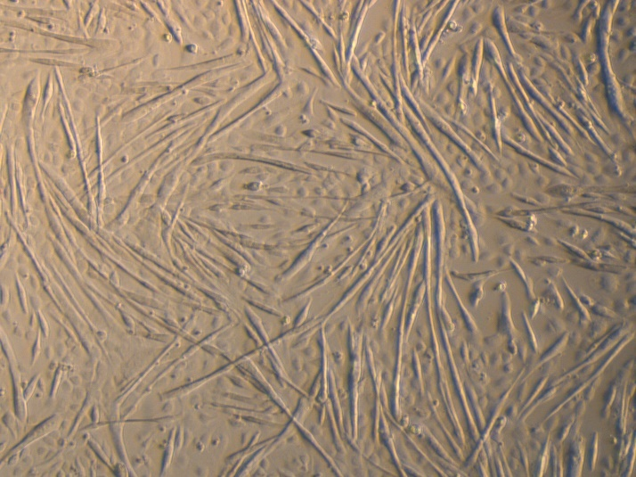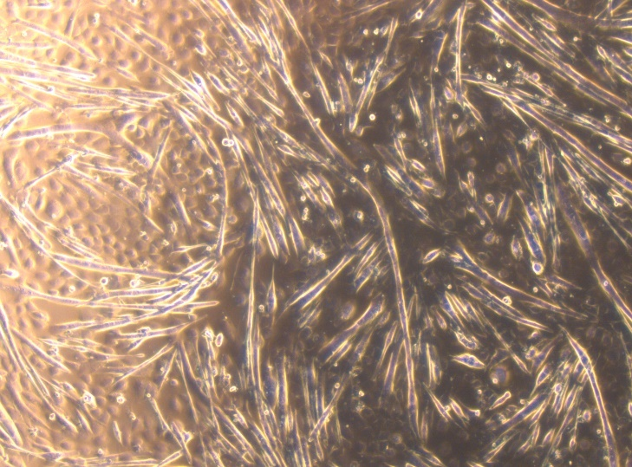

C2C12, 37˚C, 5 days + 6h, 10x

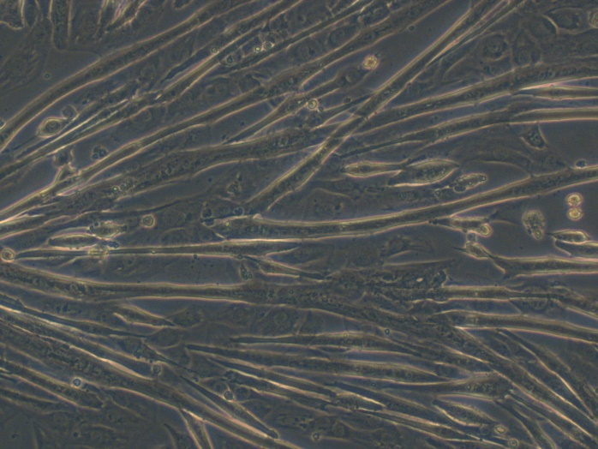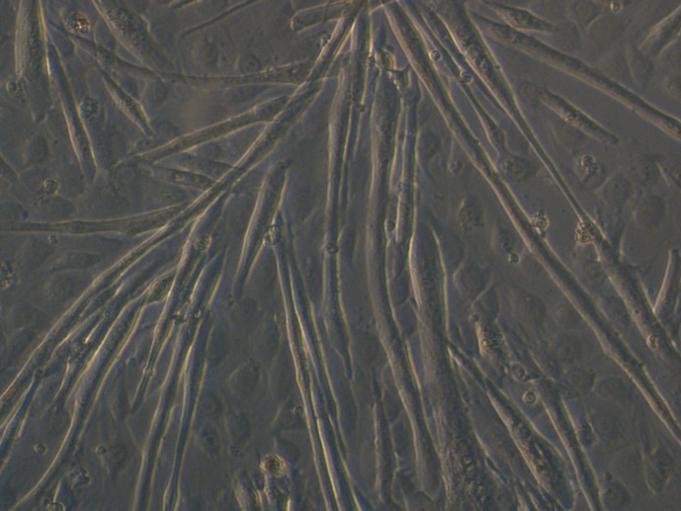

C2C12, 37˚C, 5 days + 6h, 4x

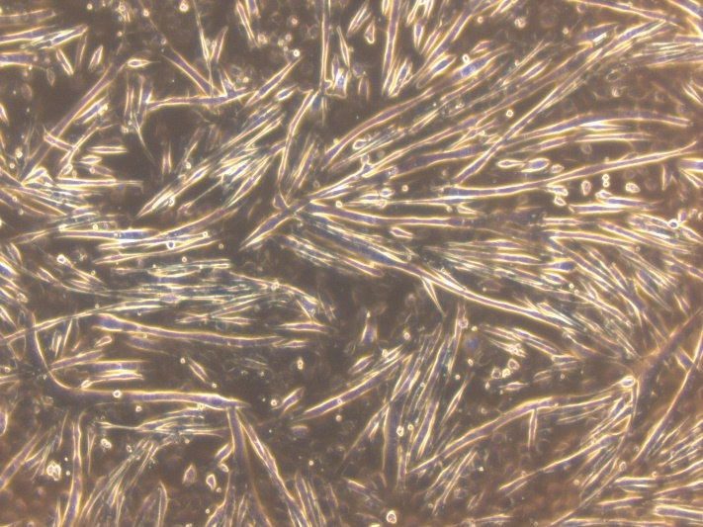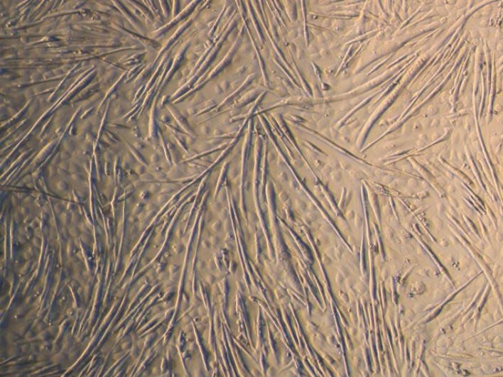

C2C12, 28˚C, 5 days + 6h, 10x

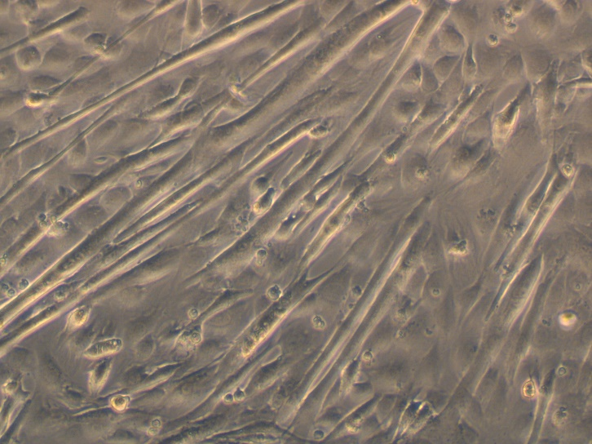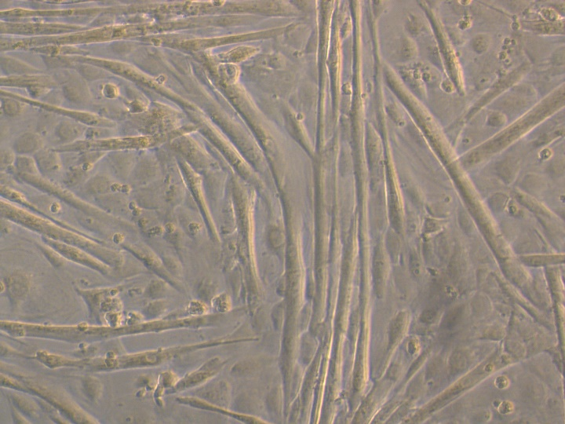

C2C12, 28˚C, 5 days + 6h, 4x

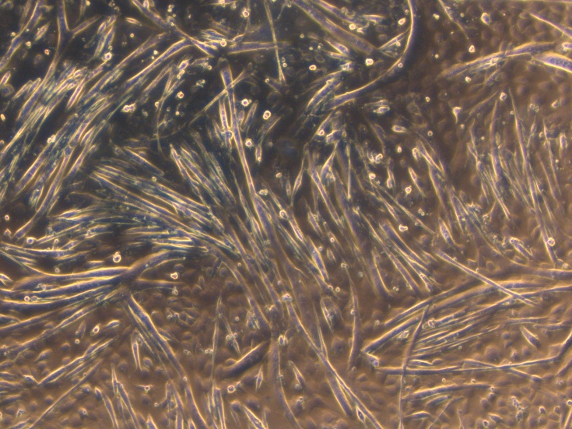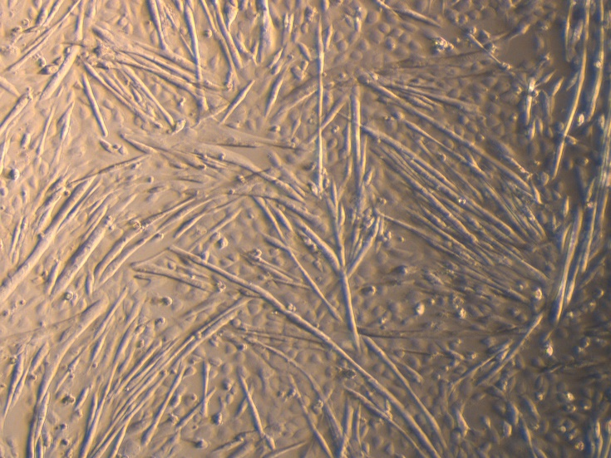

C2C12, 37˚C, 5 days + 24h, 10x

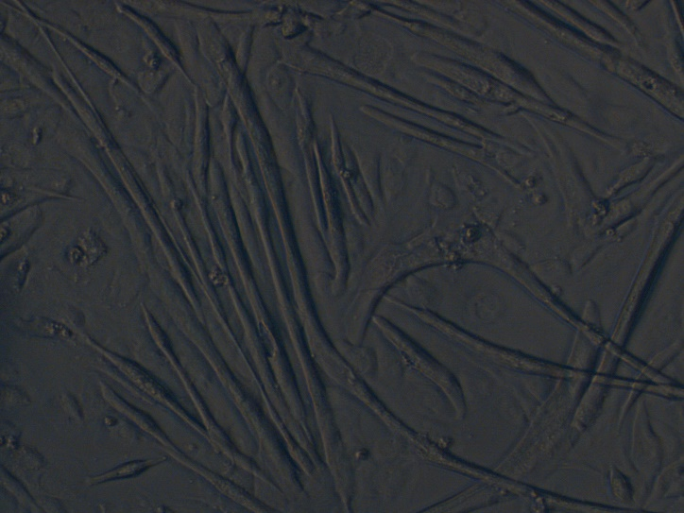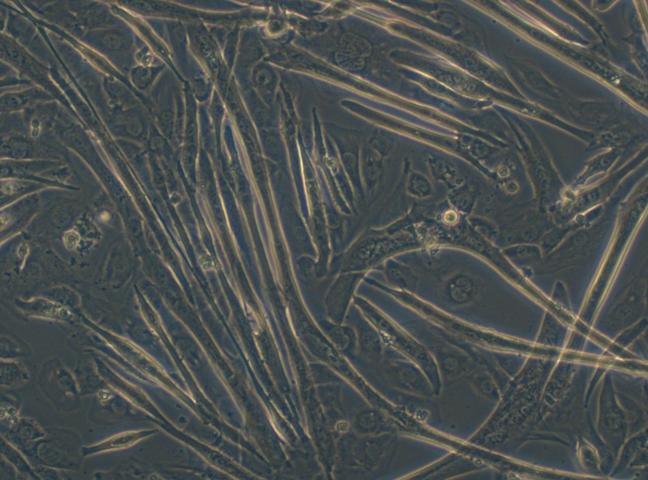

C2C12, 37˚C, 5 days + 24h, 4x

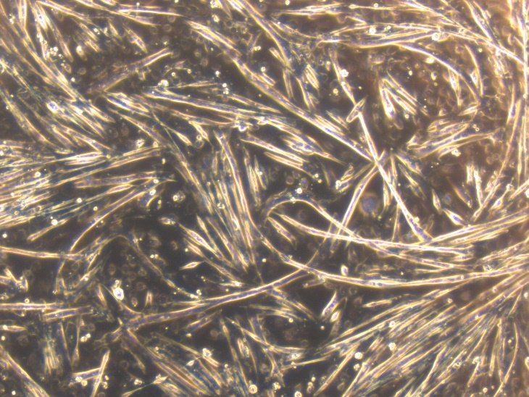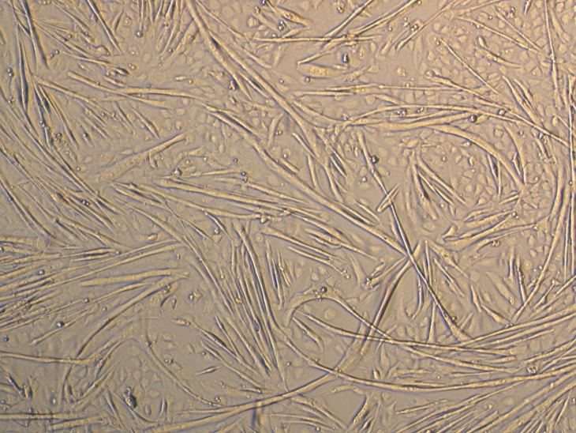
C2C12, 28˚C, 5 days + 24h, 10x

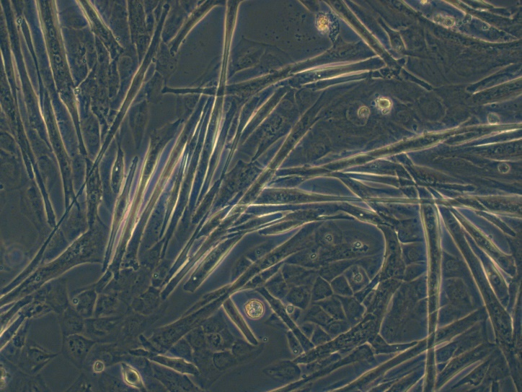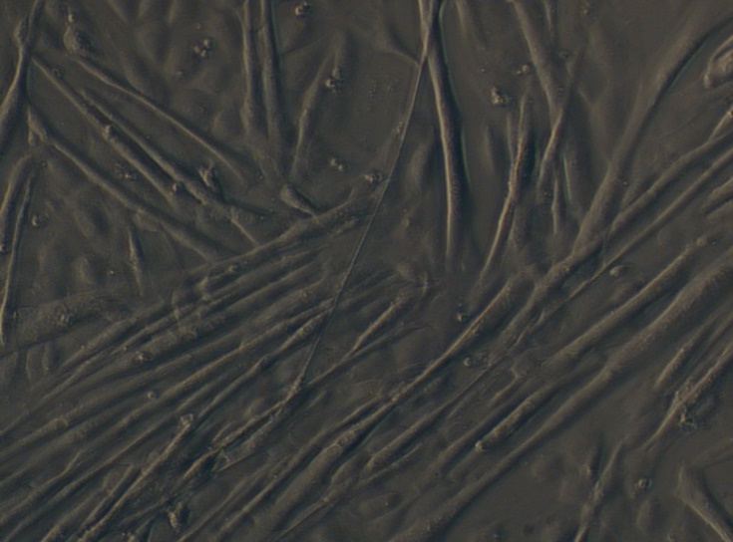

C2C12, 28˚C, 5 days + 24h, 4x

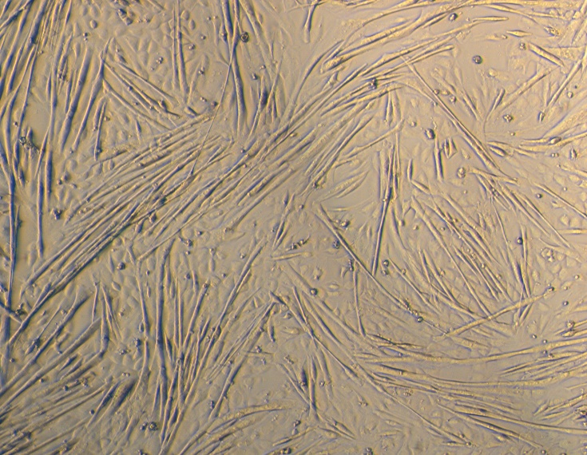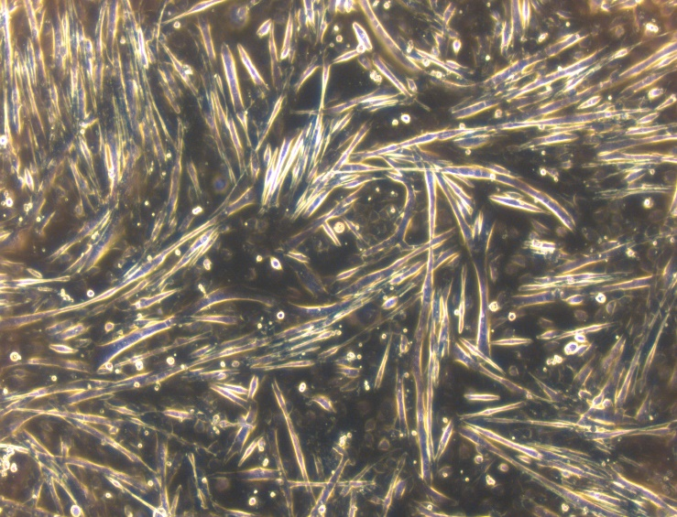

3 Ponceau S staining images for cellular protein detection

FIGURE 2A, RBM3 detection in C2C12 at 6h, Experiment #1
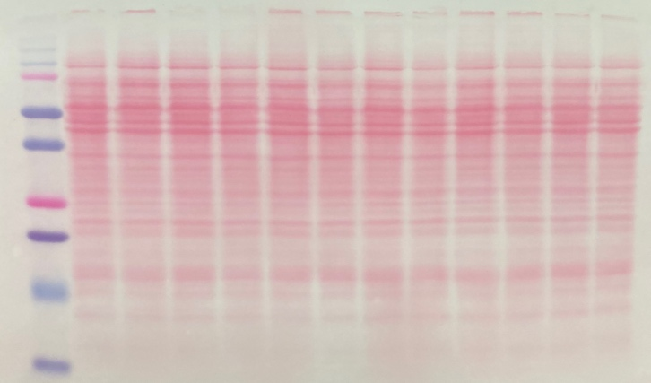

FIGURE 2A, RBM3 detection in C2C12 at 6h, Experiment #2
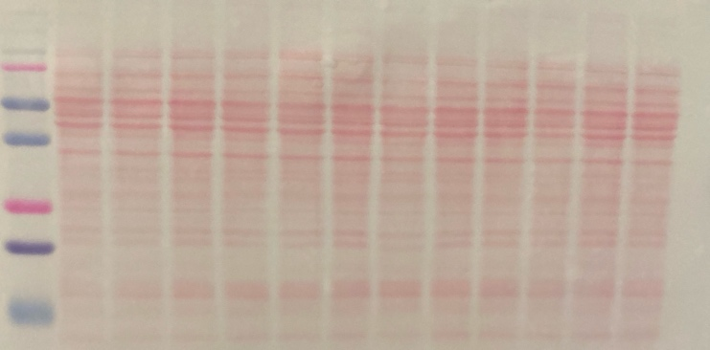

FIGURE 2A, RBM3 detection in C2C12 at 24h, Experiment #1
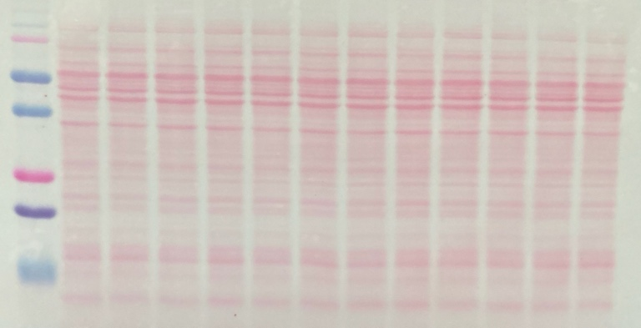

FIGURE 2A, RBM3 detection in C2C12 at 24h, Experiment #2
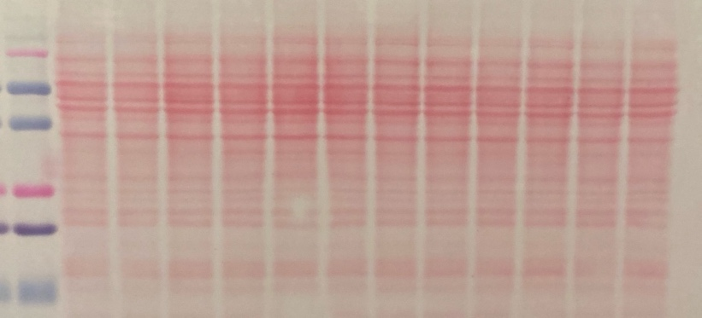

FIGURE 2A, RBM3 detection in C2C12 at 6h and 24h, Experiment #3 Gel #1
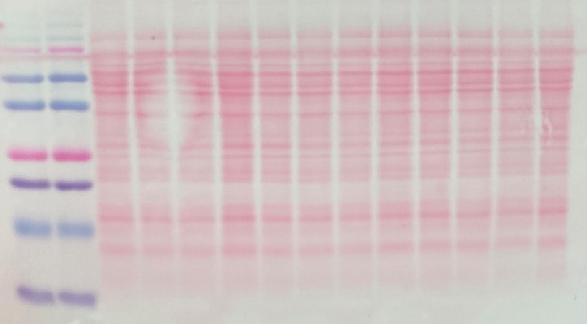

FIGURE 2A, RBM3 detection in C2C12 at 6h and 24h, Experiment #3 Gel #1
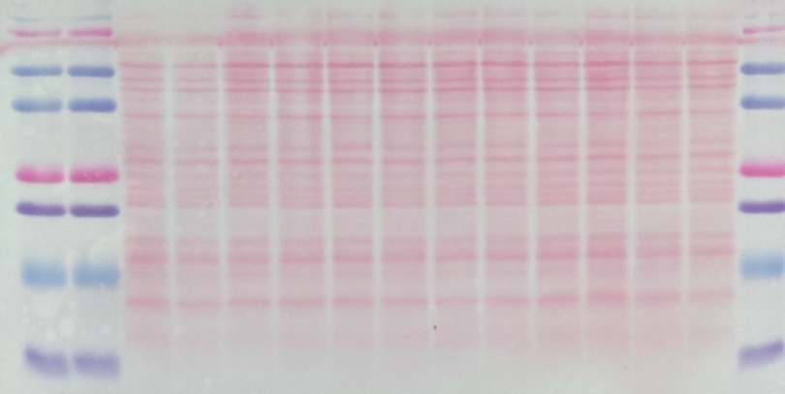

FIGURE 3C, THBS-1 detection in C2C12 at 24h
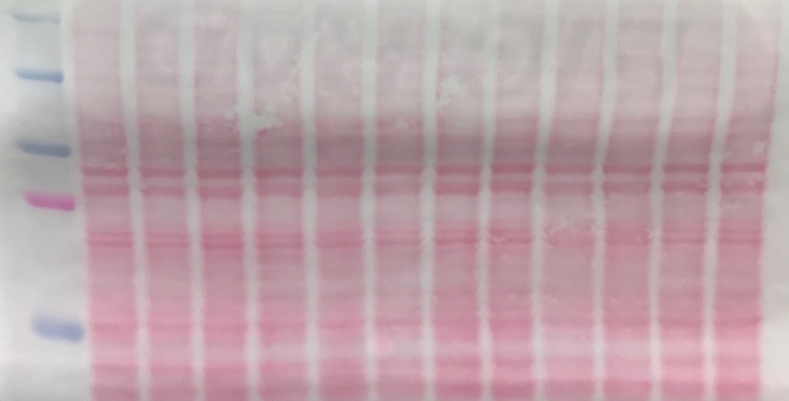

FIGURE 3A, THBS-1 detection in C2C12 secreted fraction at 24h, Experiment #1
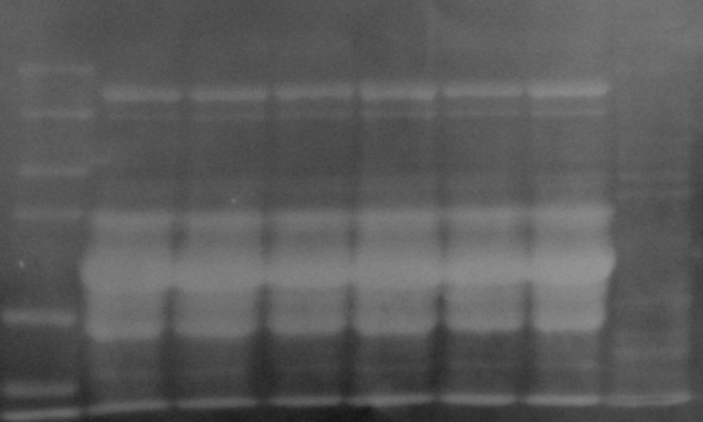

FIGURE 3A, THBS-1 detection in C2C12 secreted fraction at 24h, Experiment #2
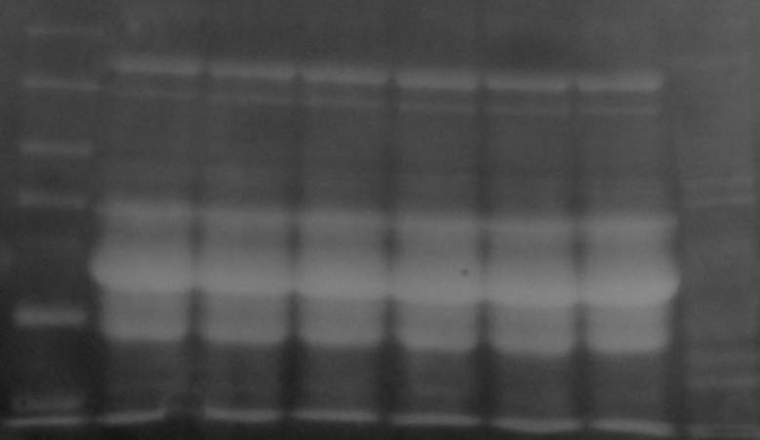

FIGURE 3A, THBS-1 detection in C2C12 secreted fraction at 24h, Experiment #3
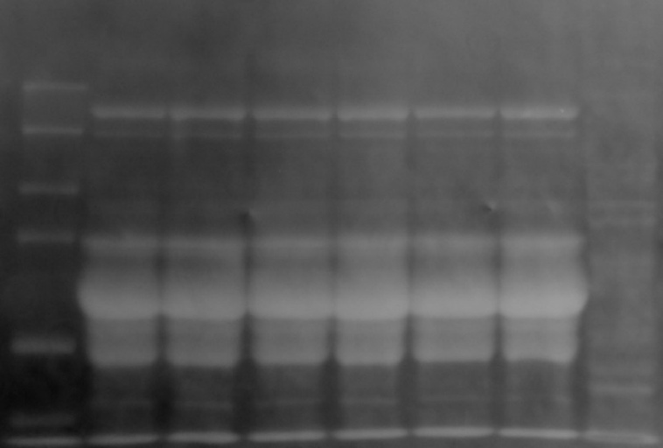

FIGURE 4A, THBS-1 detection in C2C12 at 6h and 24h, Experiment #1, Gel #2
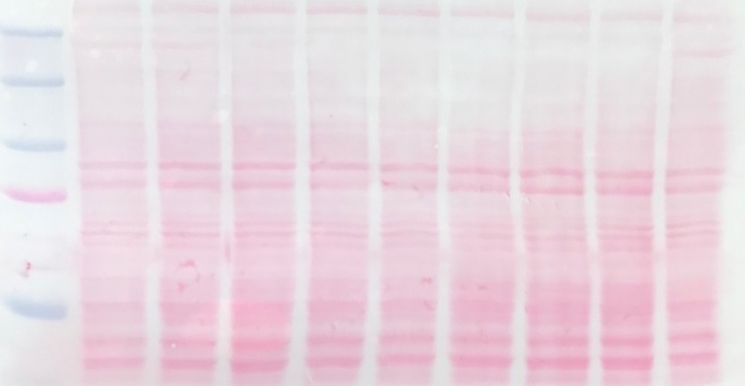

FIGURE 4A, THBS-1 detection in C2C12 at 6h and 24h, Experiment #2, Gel #3
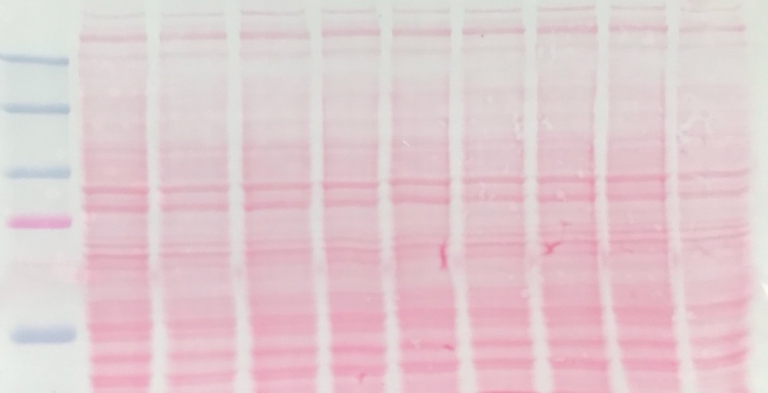

FIGURE 4A, THBS-1 detection in C2C12 at 6h and 24h, Experiment #3, Gel #3
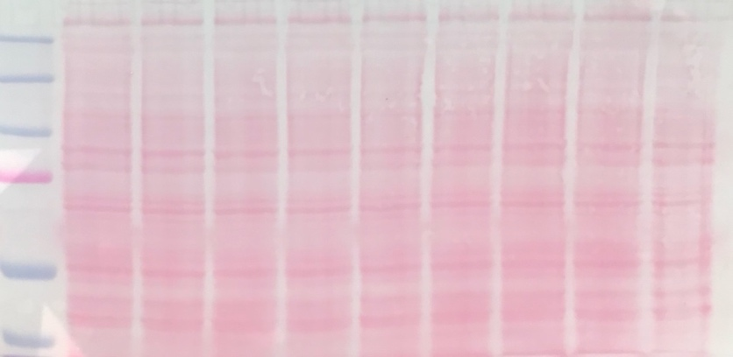

FIGURE 4A, THBS-1 detection in C2C12 at 6h and 24h, Representative (Gel #1)
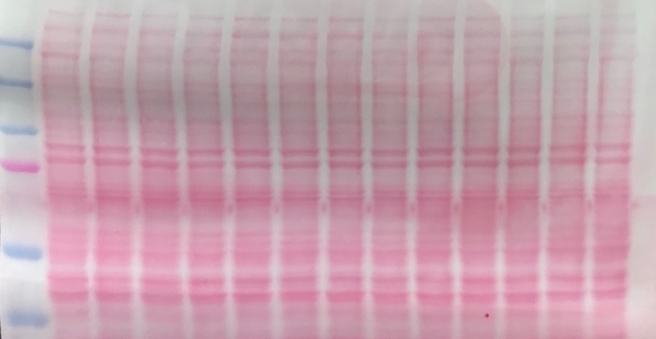

FIGURE 4C, THBS-1 detection in C2C12 (Rewarming), Experiment #1, Gel #2
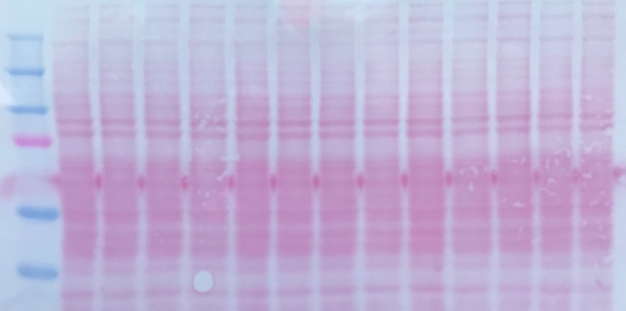

FIGURE 4C, THBS-1 detection in C2C12 (Rewarming), Experiment #2, Gel #1
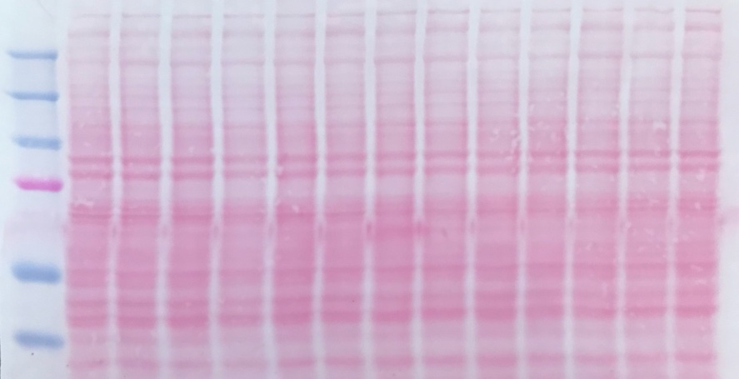

FIGURE 7, RBM3 detection in SMECs, Experiment #1, 24h
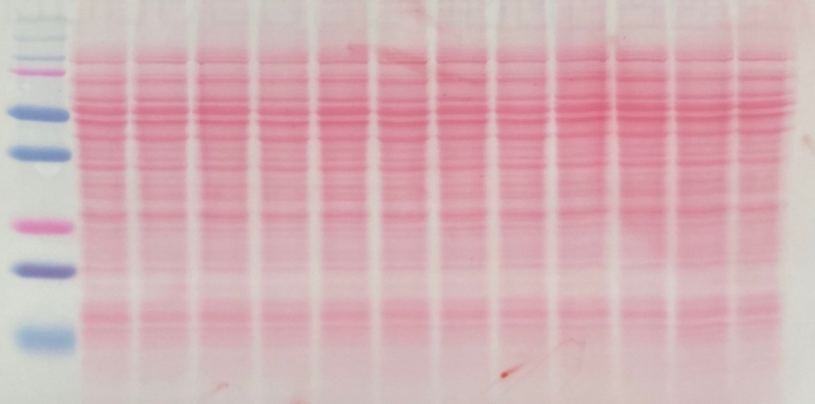

FIGURE 7, RBM3 detection in SMECs, Experiment #2, 24h
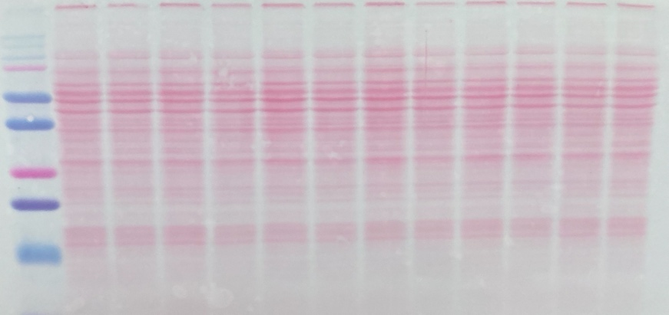

FIGURE 7, RBM3 detection in SMECs, Experiment #3, 24h
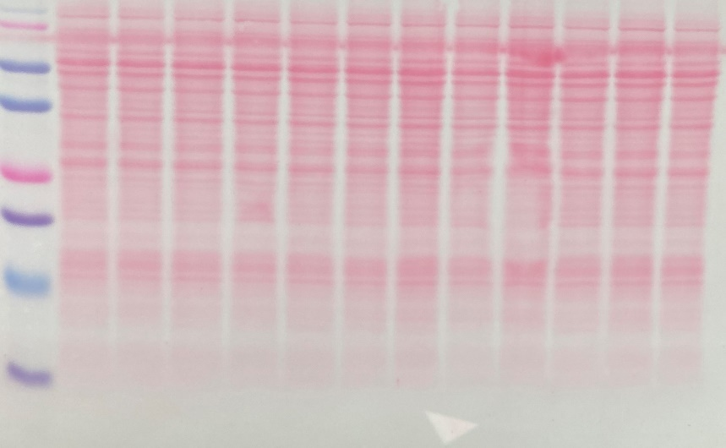

FIGURE 9A, VEGFR2 detection in SMECs, Experiment #1
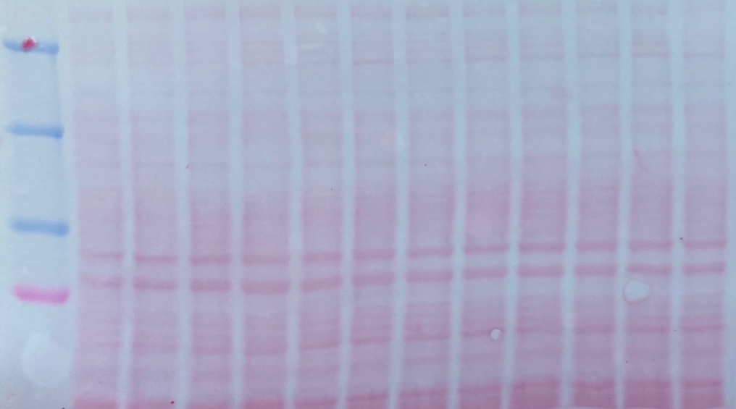

FIGURE 9A, VEGFR2 detection in SMECs, Experiment #2
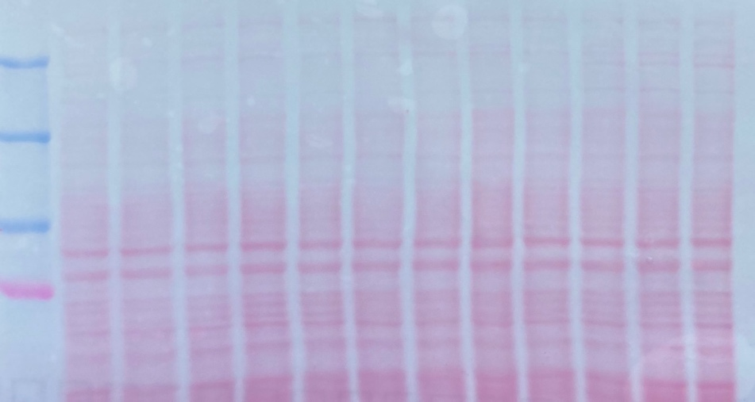

FIGURE 9A, VEGFR2 detection in SMECs, Experiment #3
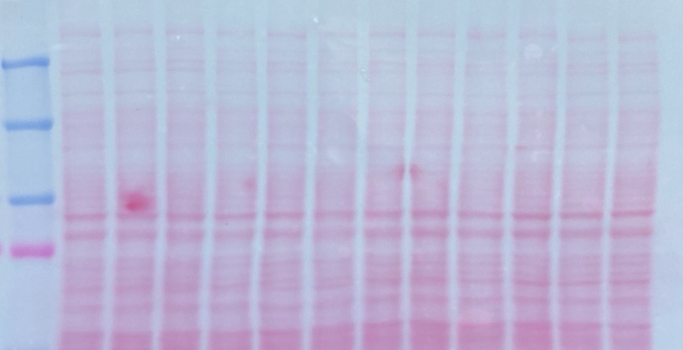

FIGURE 9C, Y1175 detection in SMECs, Experiment #1
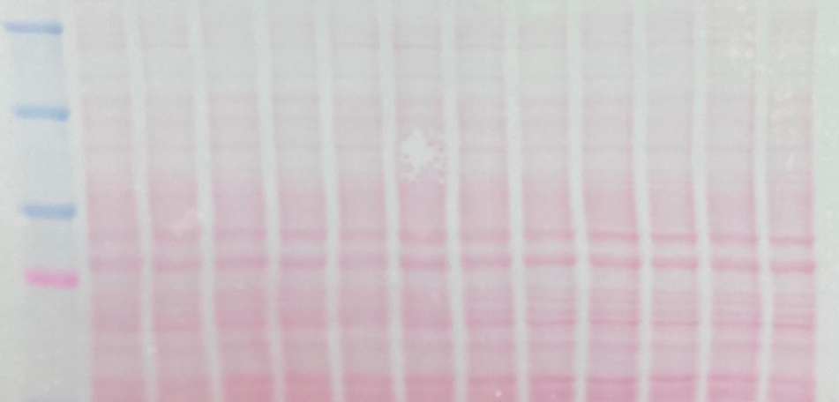

FIGURE 9C, Y1175 detection in SMECs, Experiment #2
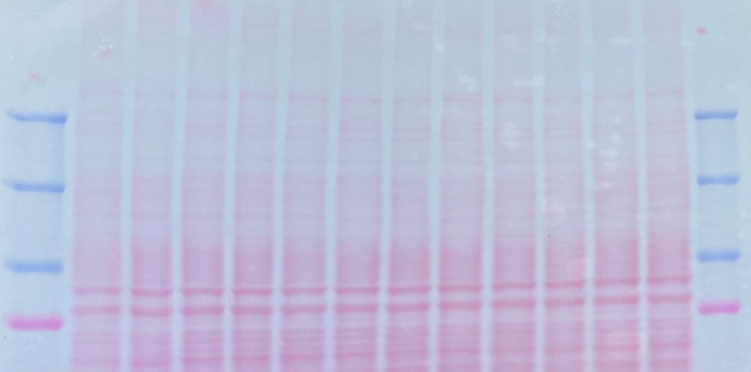

FIGURE 9C, Y1175 detection in SMECs, Experiment #3
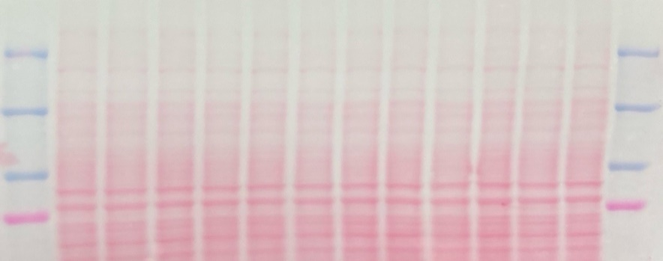

FIGURE 11A, RBM3 detection in vastus lateralis fragments, Gel #1
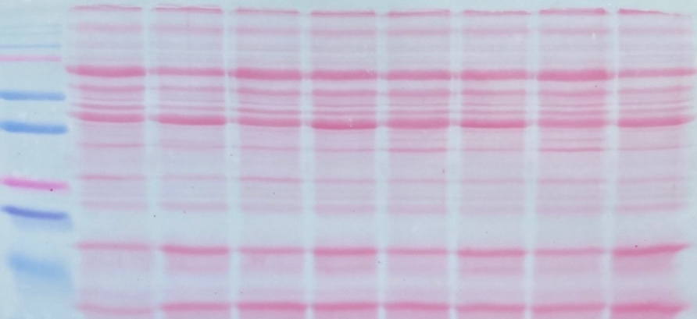

FIGURE 11B, THBS-1 detection in vastus lateralis fragments, Gel #1
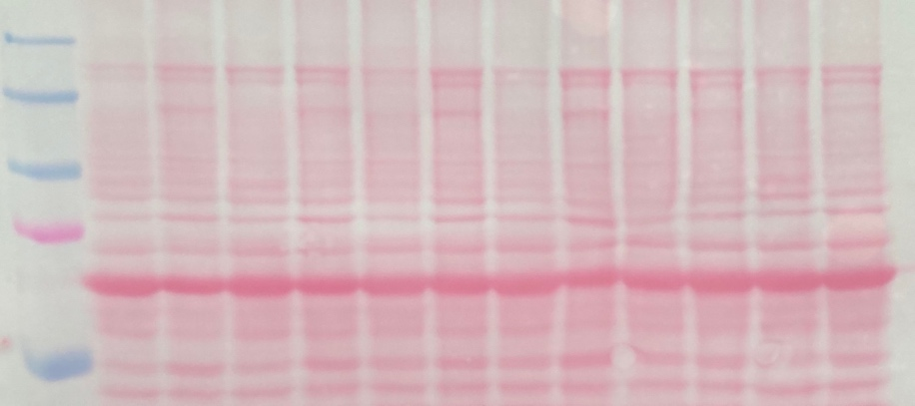

4 Uncropped images from all western blots

Figure 2A: C2C12 myotubes exposed to cold stress (28) or control (37) conditions for 6h and 24h. RBM3 expression determined in cell lysate. RBM3 protein immunoblotted with clone EPR6061. B-actin used as a loading control, clone C4. n=3 independent experiments (EXP1,2,3) with 6 samples (1-6) per condition.
LOADING (SAME FOR EXP1,2)
37-6h-1 | 28-6h-1 | 37-6h-2 | 28-6h-2 | 37-6h-3 | 28-6h-3 | 37-6h-4 | 28-6h-4 | 37-6h-5 | 28-6h-5 | 37-6h-6 | 28-6h-6

EXP1-6h
RBM3 EPR6061
B-actin C4
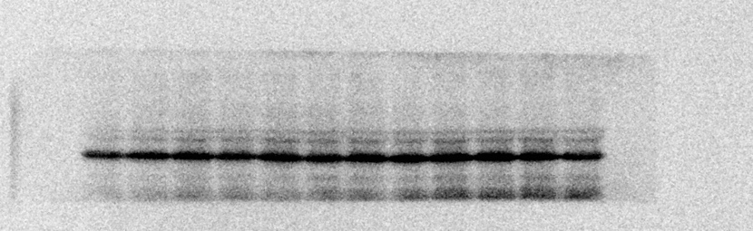

EXP2-6h
RBM3 EPR6061

B-actin C4
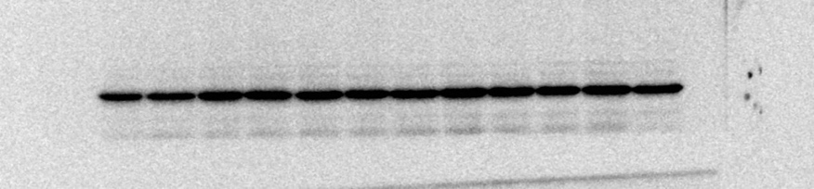

LOADING (SAME FOR EXP1,2)
37-24h-1 | 28-24h-1 | 37-24h-2 | 28-24h-2 | 37-24h-3 | 28-24h-3 | 37-24h-4 | 28-24h-4 | 37-24h-5 | 28-24h-5 | 37-24h-6 | 28-24h-6

EXP1-24h
RBM3 EPR6061
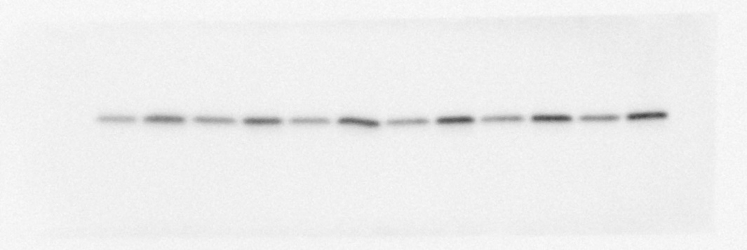
B-actin C4
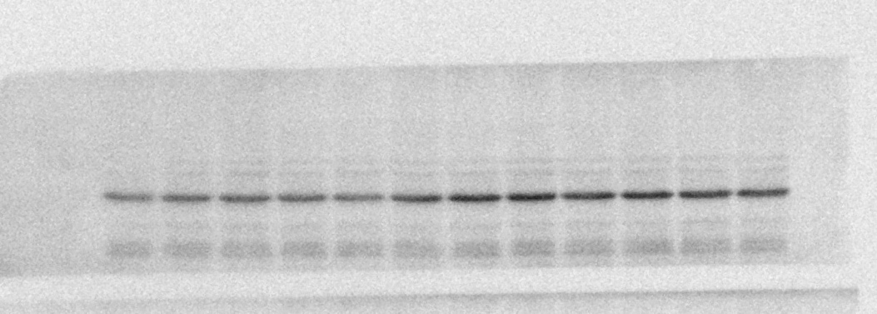

EXP2-24h
RBM3 EPR6061
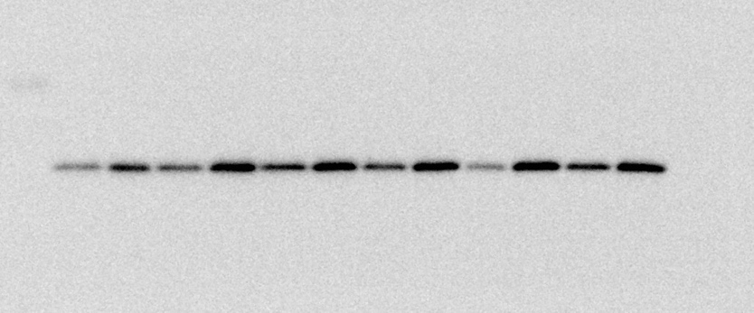

B-actin C4
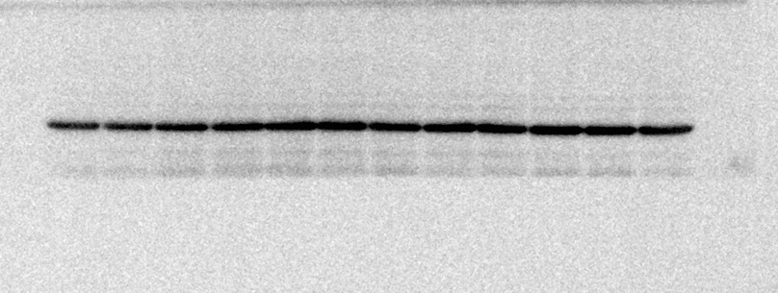

EXP3
LOADING
GEL#1(TOP)
37-6h-1 | 28-6h-1 | 37-24h-1 | 28-24h-1 | 37-6h-2 | 28-6h-2 | 37-24h-2 | 28-24h-2 | 37-6h-3 | 28-6h-3 | 37-24h-3 | 28-24h-3

GEL#2(BOTTOM)

37-6h-4 | 28-6h-4 | 37-24h-4 | 28-24h-4 | 37-6h-5 | 28-6h-5 | 37-24h-5 | 28-24h-5 | 37-6h-6 | 28-6h-6 | 37-24h-6 | 28-24h-6
RBM3 EPR6061
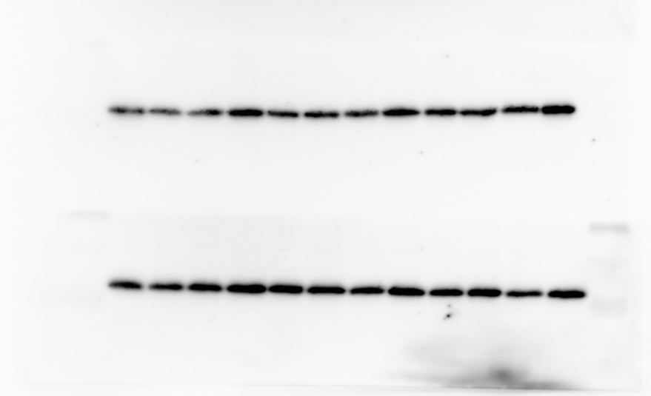

B-actin C4
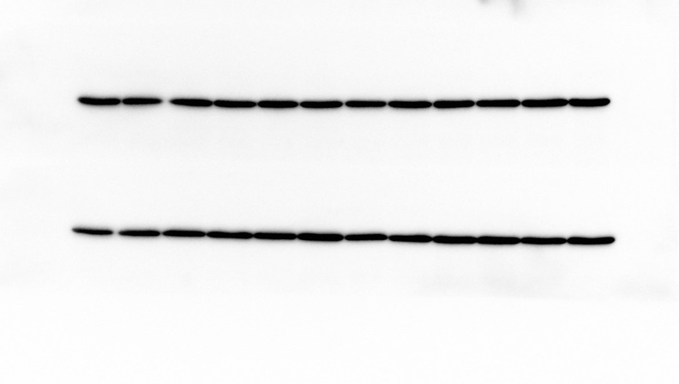

Figure 3A: C2C12 myotubes exposed to cold stress (28) or control (37) conditions for 24h. Cell media analyzed for secreted THBS1 protein expression. THBS1 immunoblotted with clone A6.1. Ponceau S. Stain used as a loading control. n=3 independent experiments (EXP) with n=3 samples (1-3) per condition.
LOADING
GEL #1 (EXP1)
37-24h-1 | 28-24h-1 | 37-24h-2 | 28-24h-2 | 37-24h-3 | 28-24h-3 | C2C12  Intracellular
GEL #2 (EXP2)
37-24h-1 | 28-24h-1 | 37-24h-2 | 28-24h-2 | 37-24h-3 | 28-24h-3 | C2C12  cell lysate
GEL #3 (EXP3)
37-24h-1 | 28-24h-1 | 37-24h-2 | 28-24h-2 | 37-24h-3 | 28-24h-3 | C2C12  cell lysate

THBS1 A6.1 GEL #1 (TOP) and GEL #2 (BOTTOM)

THBS1 A6.1 GEL #3
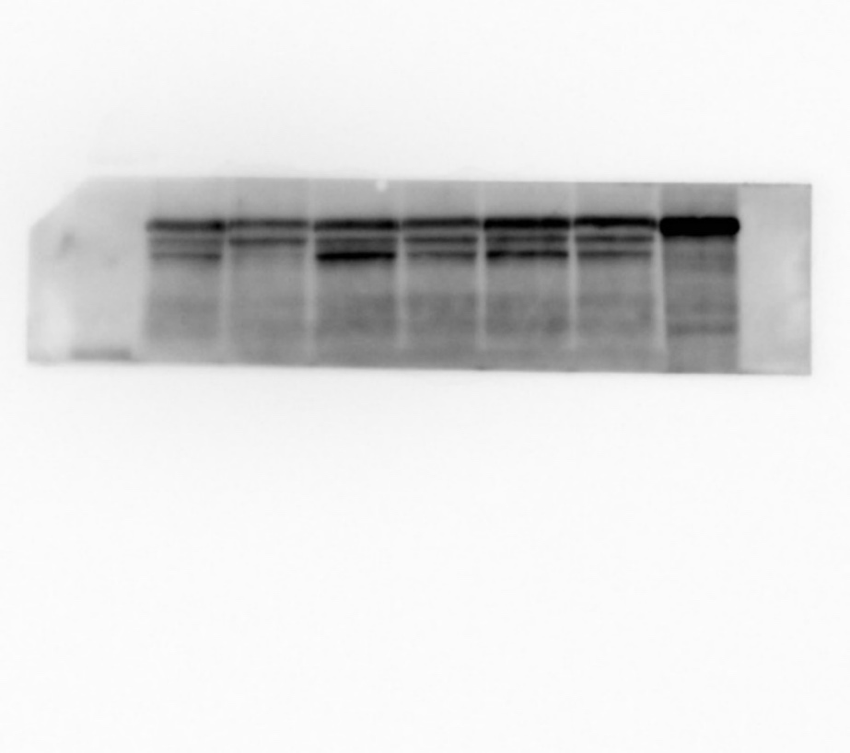
Ponceau S GEL #1
Ponceau S GEL #2

Ponceau S GEL #3

FIGURE 3A CONTINUED EXP4
C2C12 myotubes exposed to cold stress (28) or control (37) conditions for 24h. THBS1 protein expression in cell lysate immunoblotted with A6.1 clone, Ponceau S stain used as loading control. n=1 independent experiments with 6 samples (1-6) per condition.
LOADING:
GEL#1 (TOP)
37-24h-1 | 28-24h-1 | 37-24h-2 | 28-24h-2 | 37-24h-3 | 28-24h-3 | C2C12  cell lysate
GEL #2 (BOTTOM)
37-24h-4 | 28-24h-4 | 37-24h-5 | 28-24h-5 | 37-24h-6 | 28-24h-6 | C2C12  cell lysate
THBS1 A6.1, Gel #1 (TOP), Gel #2 (BOTTOM)
Ponceau S. Stain GEL #1
Ponceau S. Stain GEL #2

Figure 3B: Qualitative assessment of THBS1 protein expression in C2C12 cell lysate, C2C12 cell media, Differentiation media, Horse Serum and DMEM. THBS1 immunoblotted with clone A6.1. n=1 independent experiment.
LOADING
C2C12 cell lysate | C2C12 cell media | C2C12 cell lysate | Differentiation media | Horse Serum | DMEM

TOP GEL USED IN MANUSCRIPT, A6.1 INVITROGEN THBS1

Figure 3C: C2C12 myotubes exposed to cold stress (28) or control (37) conditions for 24h. Cellular expression of THBS1 immunoblotted with clone A6.1. B-actin used as a loading control. n=1 independent experiments with 6 samples (1-6) per condition.
LOADING:
37-24h-1 | 28-24h-1 | 37-24h-2 | 28-24h-2 | 37-24h-3 | 28-24h-3 | 37-24h-4 | 28-24h-4 | 37-24h-5 | 28-24h-5 | 37-24h-6 | 28-24h-6

THBS1 A6.1
B-actin C4
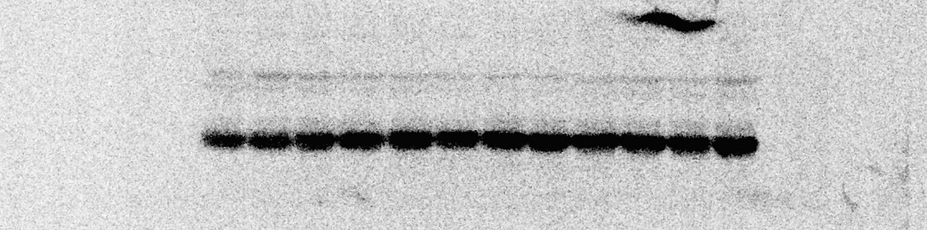

Figure 4A: C2C12 myotubes exposed to cold stress (28) or control (37) conditions for 6h and 24h. Cellular THBS1 protein expression immunoblotted by clone A6.1. B-actin used as a loading control, clone C4. n=3 independent experiments (EXP) with 6 samples (1-6) per condition (3 Gels per experiment). n=1 representative blot with 6 samples (1-6) per condition (2 gels).
LOADING (SAME FOR EXP1, EXP2, EXP3).
GEL #1 (TOP)
37-6h-1 | 28-6h-1 | 37-24h-1 | 28-24h-1 | 37-6h-2 | 28-6h-2 | 37-24h-2 | 28-24h-2 | Pool
GEL #2 (MIDDLE)
37-6h-3 | 28-6h-3 | 37-24h-3 | 28-24h-3 | 37-6h-4 | 28-6h-4 | 37-24h-4 | 28-24h-4 | Pool
GEL #3 (BOTTOM)
37-6h-5 | 28-6h-5 | 37-24h-5 | 28-24h-5 | 37-6h-6 | 28-6h-6 | 37-24h-6 | 28-24h-6 | Pool

EXP1
THBS1 A6.1

B-actin C4

EXP 2
THBS1 A6.1

B-actin C4

EXP3
THBS1 A6.1 GEL #1 (BOTTOM)

B-actin C4 GEL #1
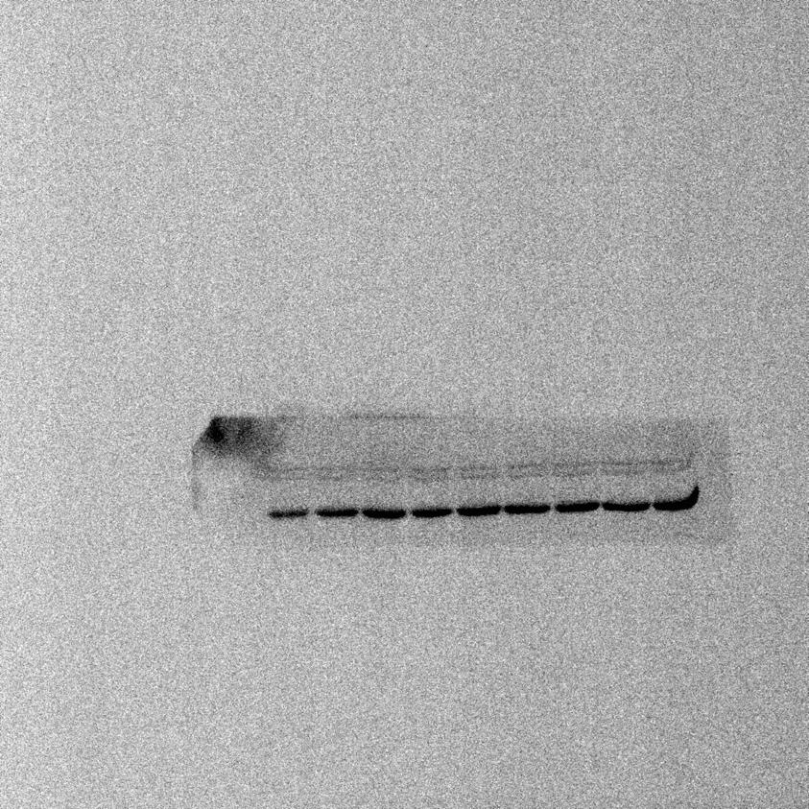

THBS1 A6.1 GEL #2 (MIDDLE) GEL #3 (BOTTOM)

B-actin C4 GEL #2 (MIDDLE) GEL #3 (BOTTOM)
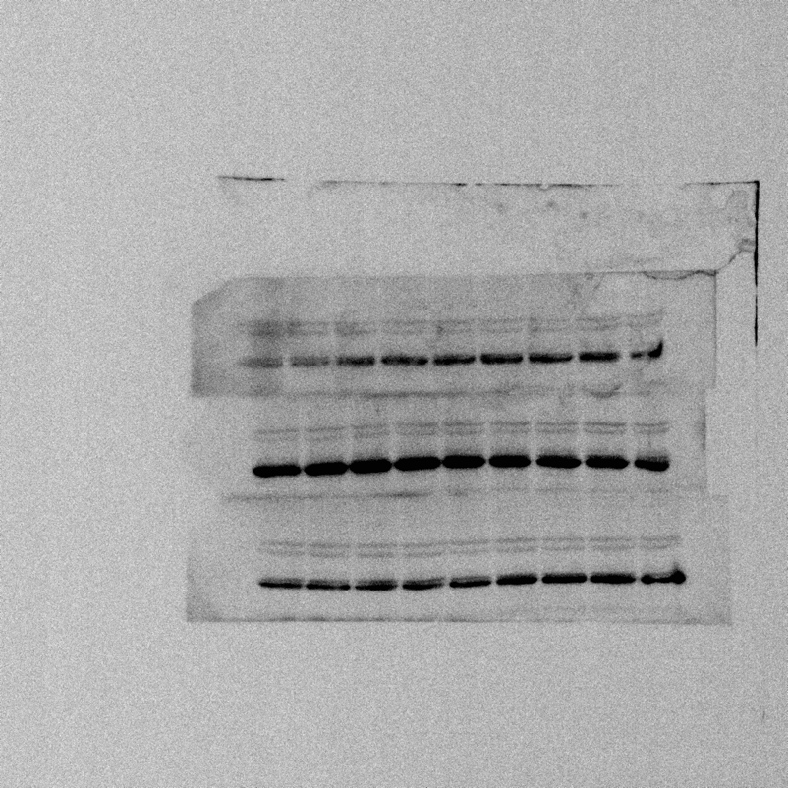

REPRESENATIVE BLOT (NOT EXP 1,2,3,)
LOADING
GEL #1 (TOP)
37-6h-1 | 28-6h-1 | 37-24h-1 | 28-24h-1 | 37-6h-2 | 28-6h-2 | 37-24h-2 | 28-24h-2 | 37-6h-3 | 28-6h-3 | 37-24h-3 | 28-24h-3 | Pool
GEL #2 (BOTTOM)
37-6h-4 | 28-6h-4 | 37-24h-4 | 28-24h-4 | 37-6h-5 | 28-6h-5 | 37-24h-5 | 28-24h-5 | 37-6h-6 | 28-6h-6 | 37-24h-6 | 28-24h-6 | Pool

THBS1 A6.1

B-actin C4

Figure 4C: C2C12 myotubes exposed to cold stress (28), control (37), re-warming (RW) and re-cooling (RC) conditions. Cellular THBS1 protein expression by immunoblotting with clone A6.1. B-actin used as a loading control, Clone C4. n=2 independent experiments (EXP) with 6 samples (1-6) per condition.
LOADING (SAME FOR EXP1,2)
GEL #1 (TOP)
37-12h-1 | 28-12h-1 | RW-1 | RC-1 | 37-12h-2 | 28-12h-2 | RW-2 | RC-2 | 37-12h-3 | 28-12h-3 | RW-3 | RC-3 | Pool
GEL #2 (BOTTOM)
37-12h-4 | 28-12h-4 | RW-4 | RC-4 | 37-12h-5 | 28-12h-5 | RW-5 | RC-5 | 37-12h-6 | 28-12h-6 | RW-6 | RC-6 | Pool

EXP1
THBS1 A6.1
B-actin C4

EXP2
THBS1 A6.1
B-actin C4

Figure 7A: RBM3 cellular protein expression in SMECs exposed to cold stress (28) or control (37) conditions for 24h. RBM3 immunoblotted with clone EPR6061. B-actin used as a loading control, clone C4. n=3 independent experiments (EXP) with 6 samples (1-6) per condition.
LOADING (SAME FOR EXP1,2,3)
37-24h-1 | 28-24h-1 | 37-24h-2 | 28-24h-2 | 37-24h-3 | 28-24h-3 | 37-24h-4 | 28-24h-4 | 37-24h-5 | 28-24h-5 | 37-24h-6 | 28-24h-6

EXP1
RBM3 EPR6061

B-actin C4

EXP2
RBM3 EPR6061
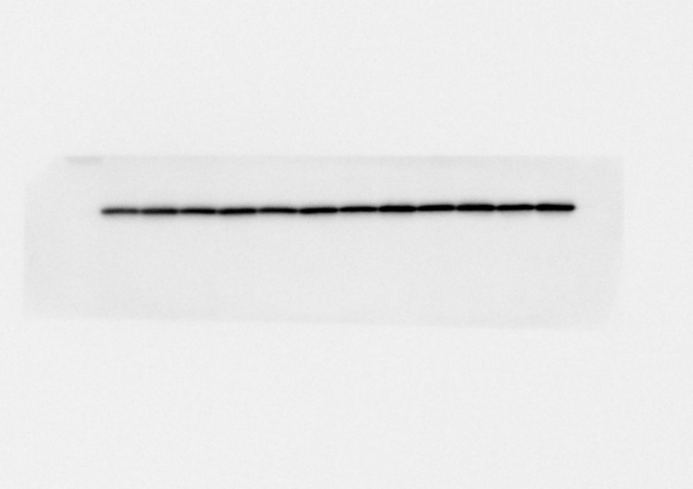

B-actin C4

EXP3
RBM3 EPR6061
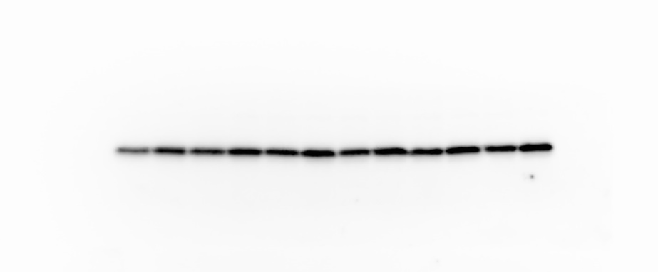

B-actin C4
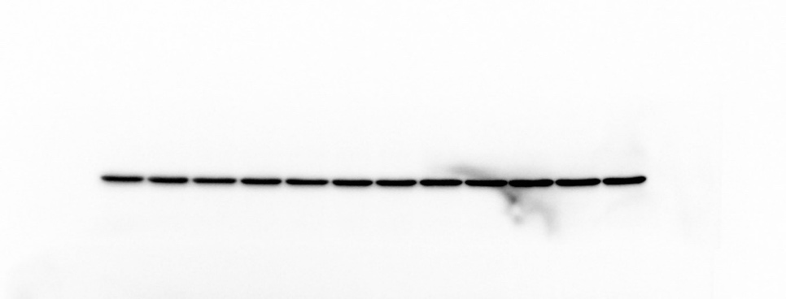

Figure 9A: VEGFR2 cellular expression in SMECs exposed to cold stress (28) or control (37) conditions for 24h and stimulated with or without recombinant VEGF-A (mVEGF-A165). VEGFR2 immunoblotted with clone D5B1. A/B-tubulin used as a loading control, polyclonal. n=3 independent experiments (EXP) with 3 samples (1-3) per condition.
LOADING (SAME FOR EXP 1,2,3)
37-24h-1 | 28-24h-1 | 37-24h-1 | 28-24h-1 | 37-24h-2 | 28-24h-2 | 37-24h-2 | 28-24h-2 | 37-24h-3 | 28-24h-3 | 37-24h-3 | 28-24h-3
-VEGFA | -  VEGFA | +  VEGFA | +  VEGFA | -  VEGFA | -  VEGFA | +  VEGFA | +  VEGFA | -  VEGFA | -  VEGFA | +  VEGFA | +  VEGFA

EXP1
VEGFR2 D5B1
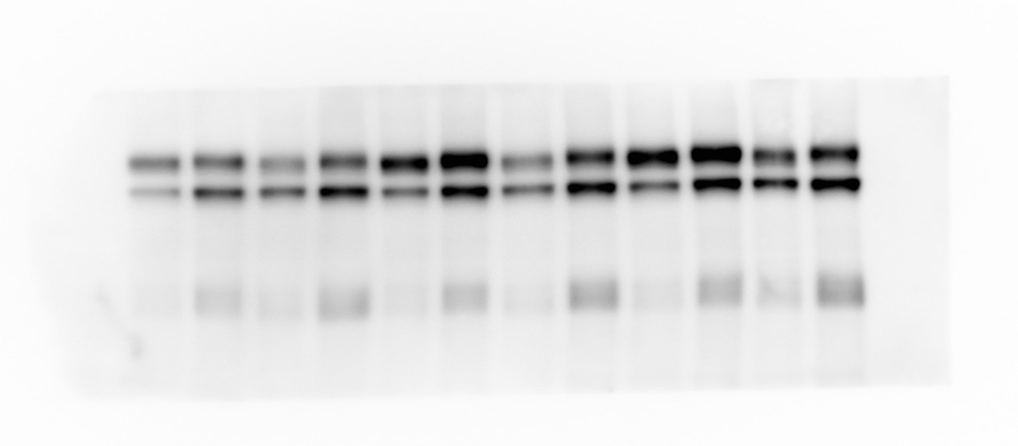
Tubulin Polyclonal
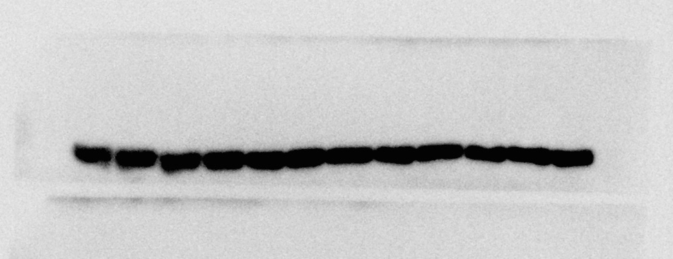

EXP2
VEGFR2 D5B1
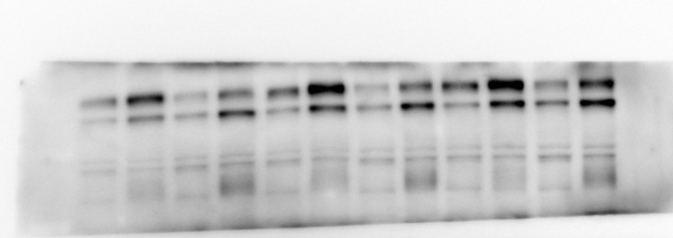
Tubulin Polyclonal
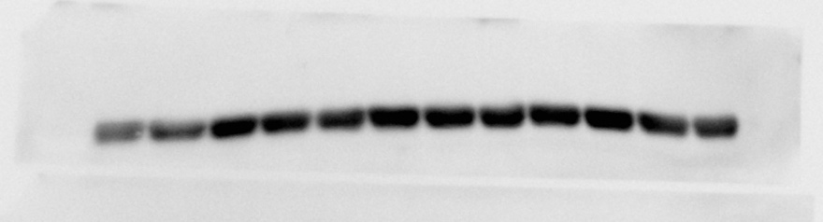

EXP3
VEGFR2 D5B1
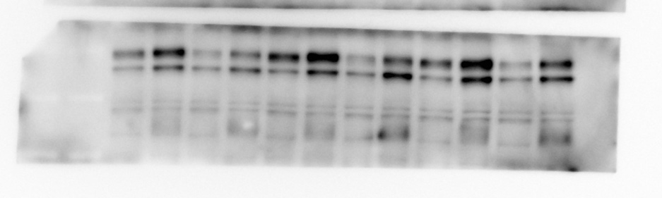

Tubulin Polyclonal
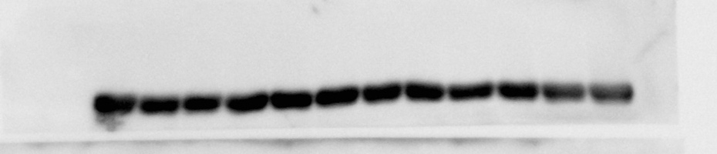

Figure 9C: p-VEGFR2-Y1175 cellular expression in SMECs exposed to cold stress (28) or control (37) conditions for 24h and stimulated with or without recombinant VEGF-A (mVEGF-A165). p-VEGFR2-Y1175 immunoblotted with clone D5B11. A/B-tubulin used as a loading control, polyclonal. n=3 independent experiments (EXP) with 3 samples (1-3) per condition.
SMEC intracellular p-VEGFR2-Y1175 EXP1
LOADING (SAME FOR EXP1,2,3)
37-24h-1 | 28-24h-1 | 37-24h-1 | 28-24h-1 | 37-24h-2 | 28-24h-2 | 37-24h-2 | 28-24h-2 | 37-24h-3 | 28-24h-3 | 37-24h-3 | 28-24h-3
-VEGFA | -  VEGFA | +  VEGFA | +  VEGFA | -  VEGFA | -  VEGFA | +  VEGFA | +  VEGFA | -  VEGFA | -  VEGFA | +  VEGFA | +  VEGFA

EXP1
p-VEGFR2-Y1175 D5B11
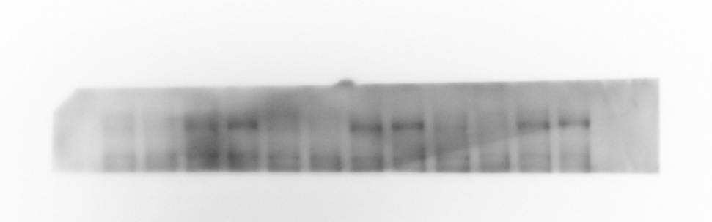
Tubulin Polyclonal
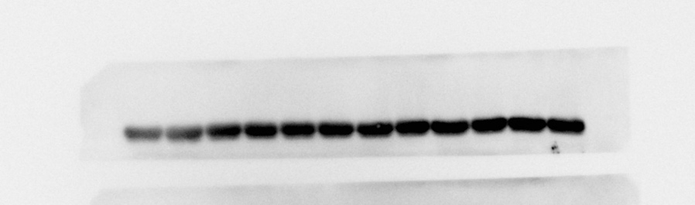

EXP2
p-VEGFR2-Y1175 D5B11
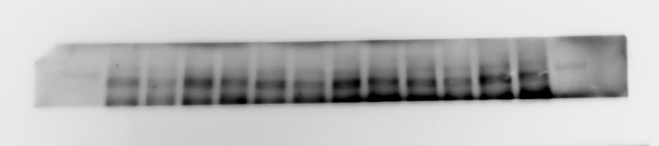
Tubulin Polyclonal
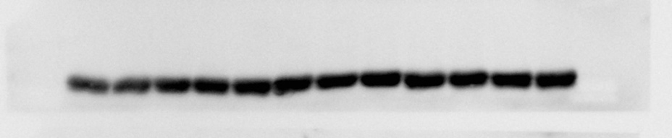
EXP3
p-VEGFR2-Y1175 D5B11
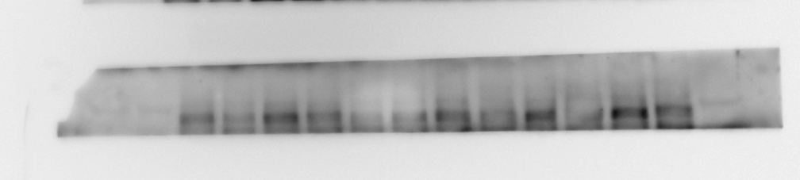
Tubulin Polyclonal
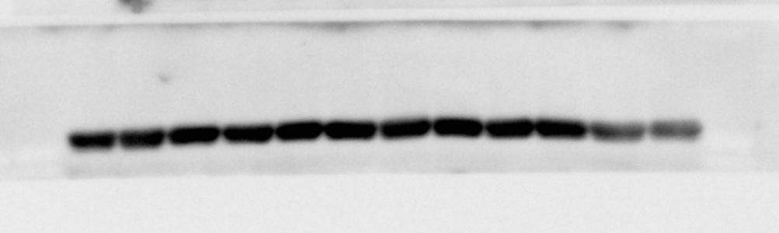

Figure 11A: RBM3 cellular protein expression in ex-vivo muscle incubation assay (EMI) vastus lateralis muscle fragments exposed to cold stress (28) or control (37) conditions for 24h. RBM3 immunoblotted with clone EPR6061. B-actin used as a loading control, clone C4. n=1 independent experiment with 7 samples (1-7) per condition.

LOADING
GEL #1 (TOP)
37-24h-1 | 28-24h-1 | 37-24h-2 | 28-24h-2 | 37-24h-3 | 28-24h-3 | 37-24h-4 | 28-24h-4

GEL #2 (BOTTOM)
37-24h-5 | 28-24h-5 | 37-24h-6 | 28-24h-6 | 37-24h-7 | 28-24h-7

RBM3 EPR6061

B-actin C4

Figure 11B: THBS1 cellular protein expression in EMI samples exposed to cold stress (28) or control (37) conditions for 24h. THBS1 immunoblotted with clone D7EF5. B-actin used as a loading control, clone C4. n=1 independent experiment with 6 samples (1-6) per condition.
LOADING
37-24h-1 | 28-24h-1 | 37-24h-2 | 28-24h-2 | 37-24h-3 | 28-24h-3 | 37-24h-4 | 28-24h-4 | 37-24h-5 | 28-24h-5 | 37-24h-6 | 28-24h-6

THBS1 D7EF5
B-actin C4
