Supplementary Figure-S1. Subgroup analysis of LUTS prevalence based on different diagnostic methods
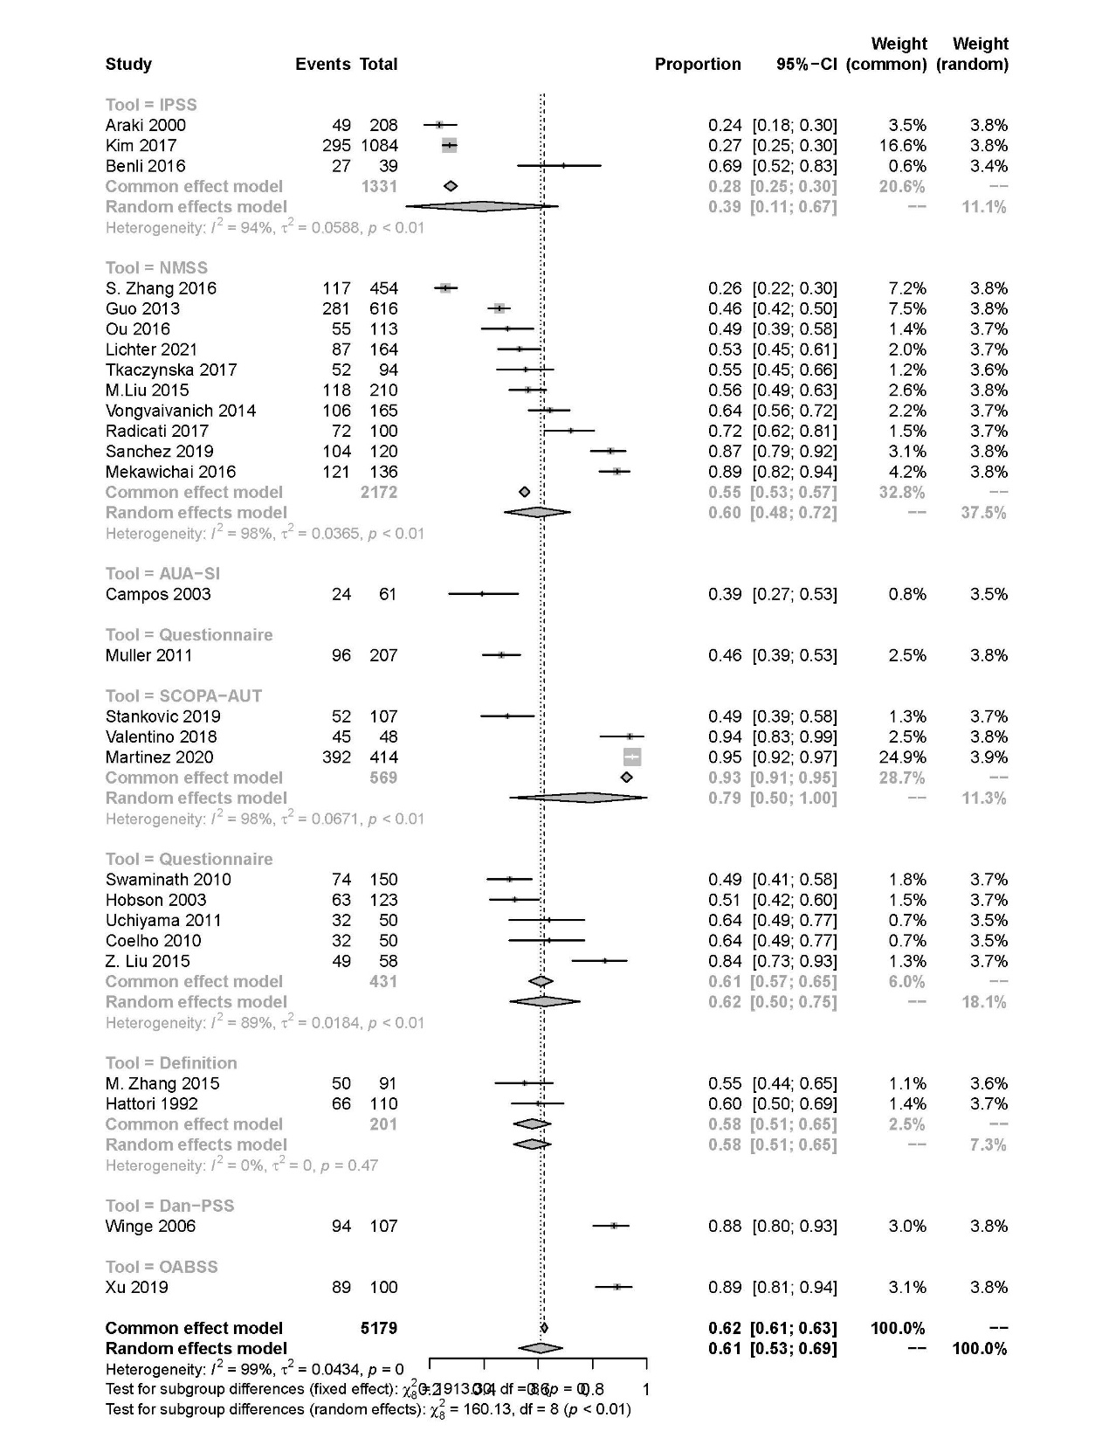

Supplementary Figure-S2. Forest plot showing the prevalence of storage symptoms in PD
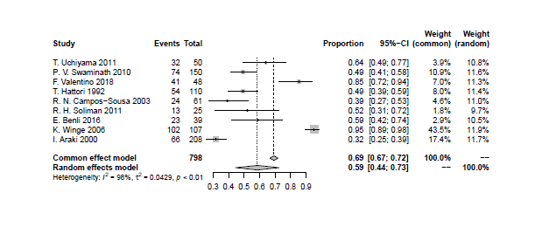
Supplementary Figure-S3. Forest plot showing the prevalence of OAB in PD
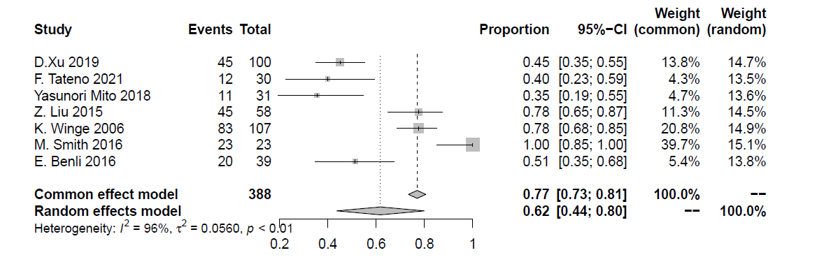
Supplementary Figure-S4. Forest plot showing the prevalence of urgency in PD
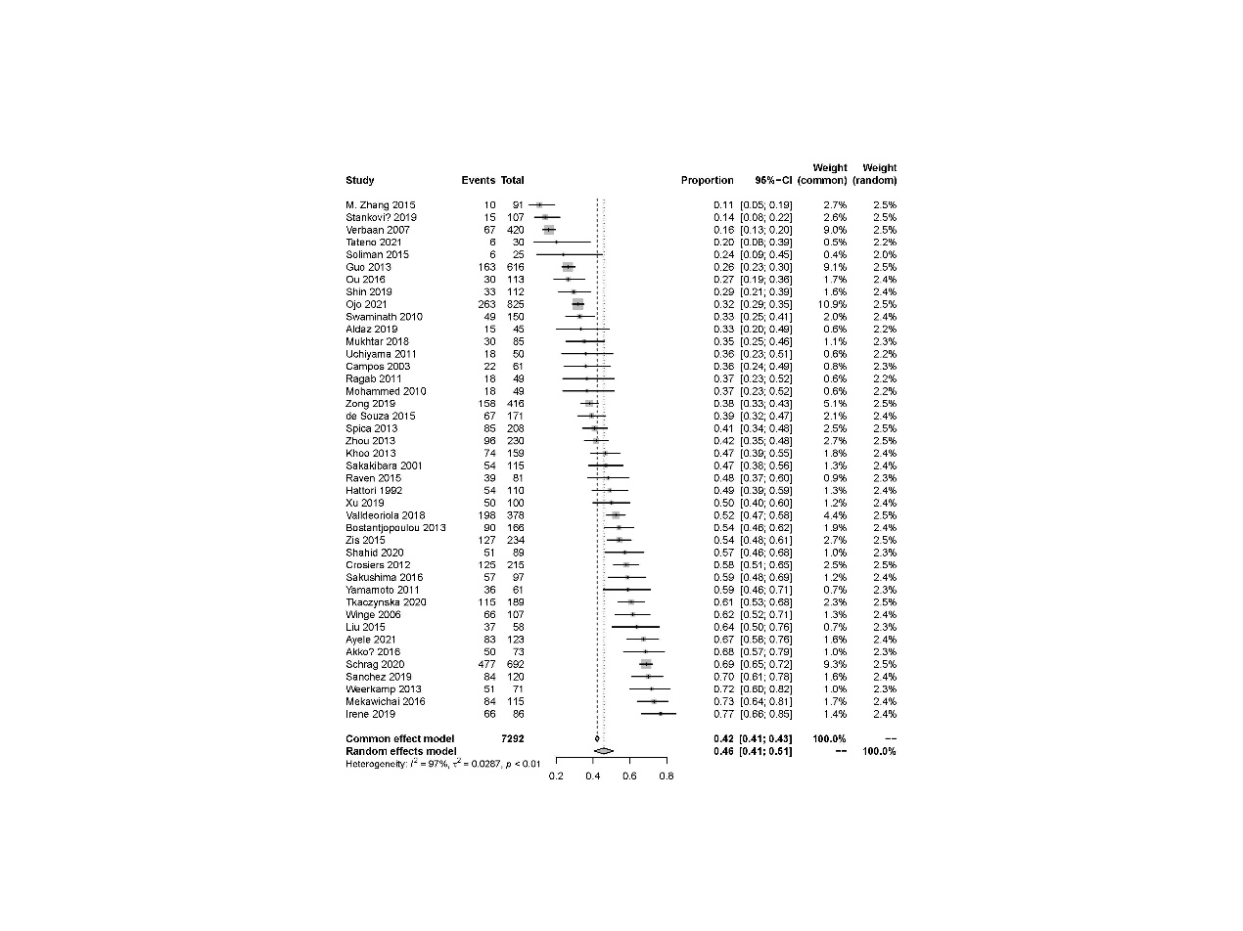
Supplementary Figure-S5. Forest plot showing the prevalence of urinary frequency in PD
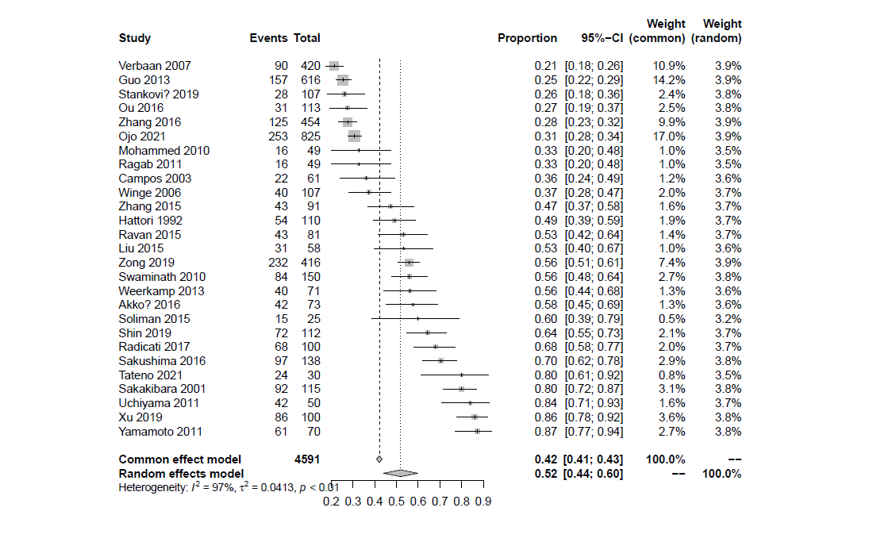
Supplementary Figure-S6. Forest plot showing the prevalence of nocturia in PD
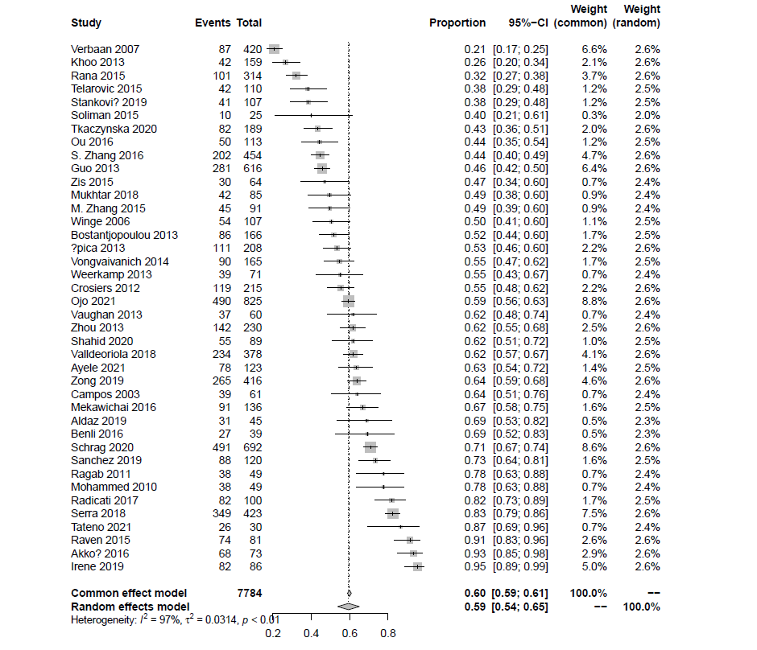

Supplementary Figure-S7. Forest plot showing the prevalence of pollakiuria in PD
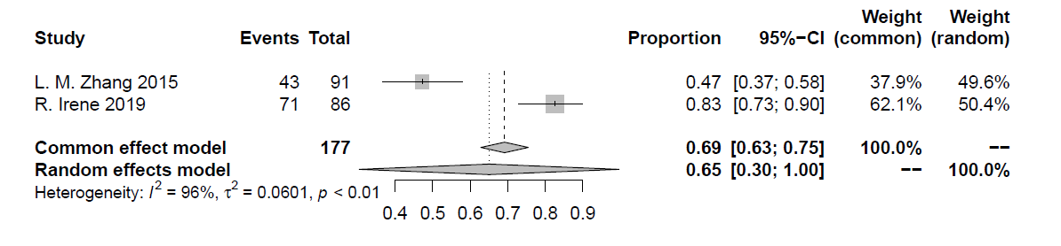
Supplementary Figure-S8. Forest plot showing the prevalence of voiding symptoms in PD
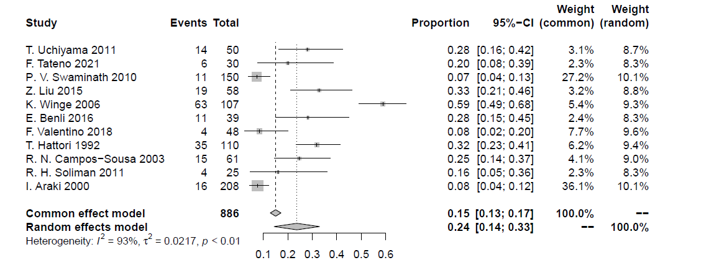

Supplementary Figure-S9. Subgroup analysis of retention prevalence based on different diagnostic methods
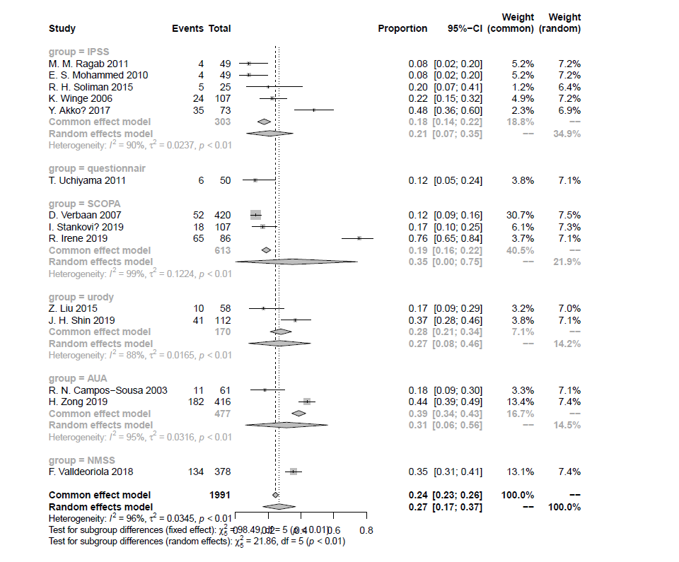
Supplementary Figure-S10. Forest plot showing the prevalence of dysuria in PD
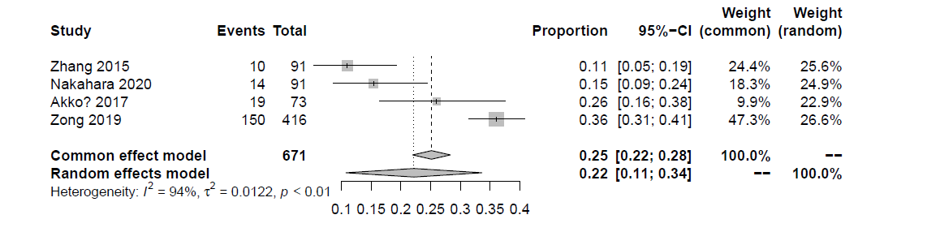
Supplementary Figure-S11. Forest plot showing the prevalence of hesitancy in PD
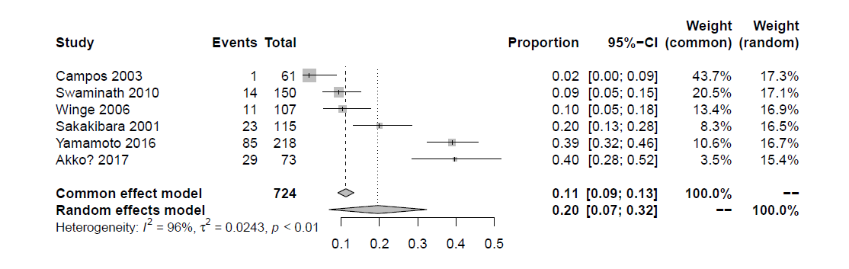
Supplementary Figure-S12. Forest plot showing the prevalence of prolongation in PD
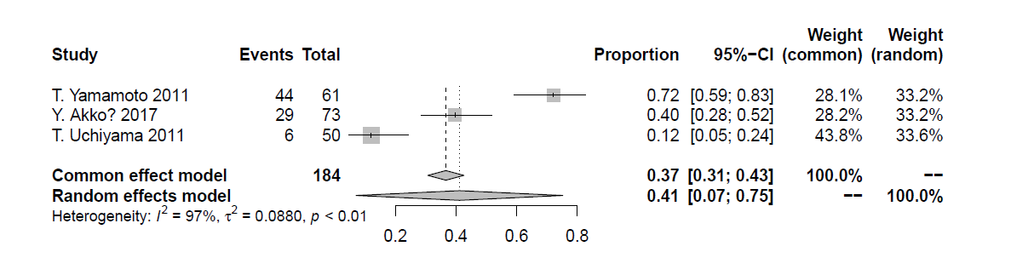
Supplementary Figure-S13. Forest plot showing the prevalence of intermittency in PD
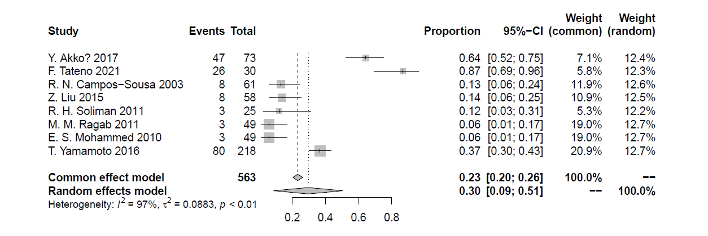
Supplementary Figure-S14. Forest plot showing the prevalence of weak stream of urice in PD
