**Supplementary data 2.**

Figure 1. Standard curve of wheat plant metabolite content under salinity condition.

1. 6-BA

Regression Equation: y = 4135.50769 x + 360.51167 (r = 0.99893)

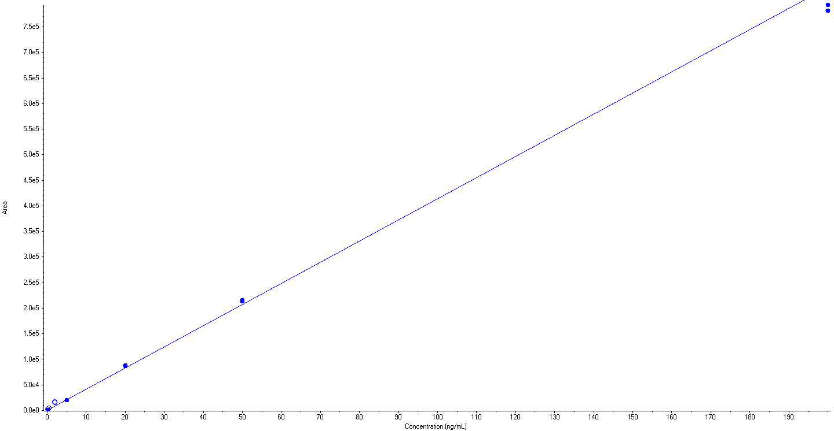

1. IAA

Regression Equation: y = 3457.46901 x + -221.74385 (r = 0.99289)

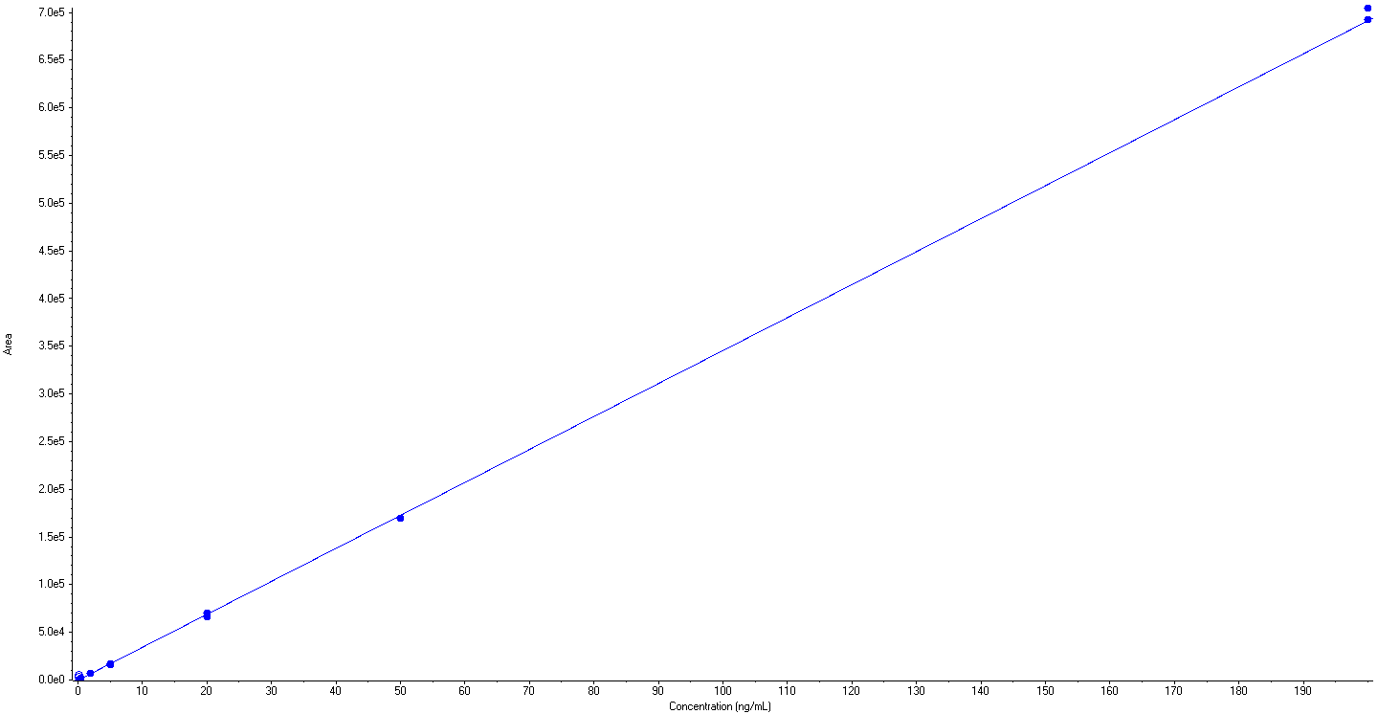

1. GA3

Regression Equation: y = 4977.27838 x + -205.88276 (r = 0.99418)

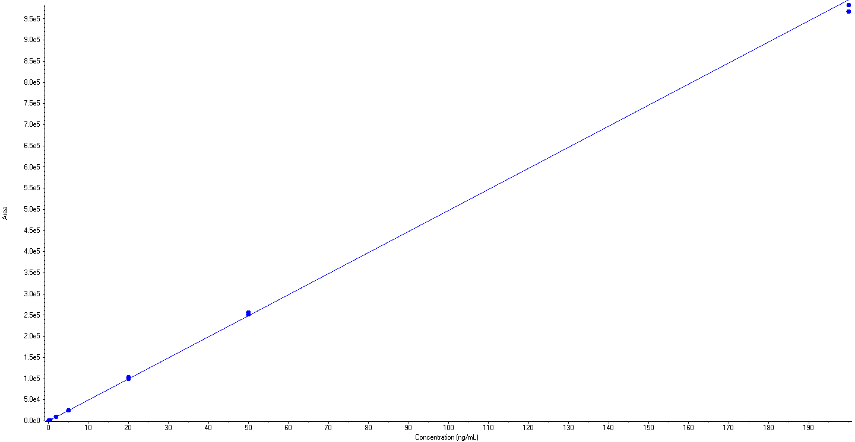

1. IPA

Regression Equation: y = 9.15843e4 x + -2526.33011 (r = 0.99623)

