## Appendix I Description of the Reading Bots Prototype

The prototype of the reading bots consists of two features: guided reading, and reading history.

After readers input the text in the reading materials and select the proficiency level, they can click **Start Reading** to go to the **Pre-reading** page.

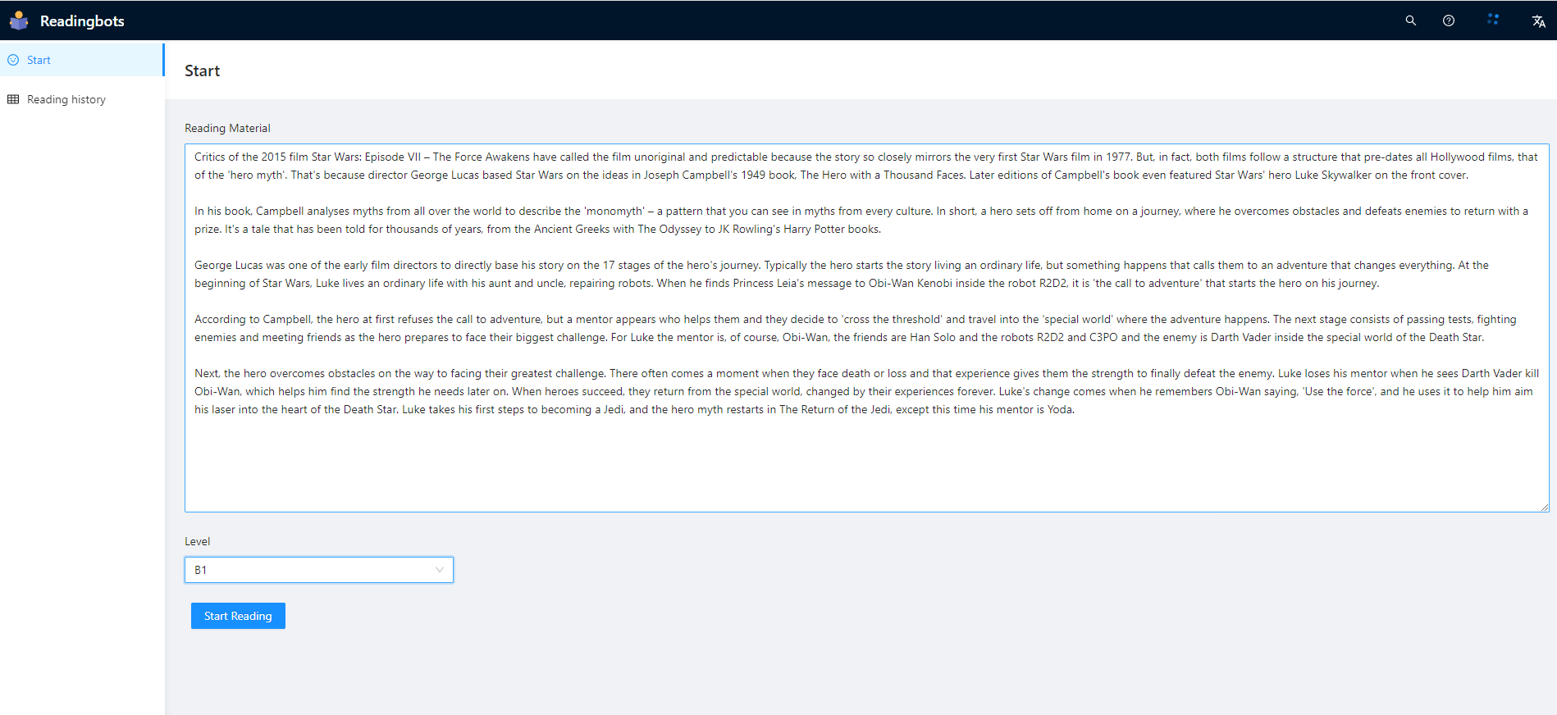

Figure 1 Start Reading Page

In the **Pre-reading** page, the guiding questions, vocabulary, and proper nouns are automatically generated or identified to prepare the necessary knowledge and context for the while-reading stage.

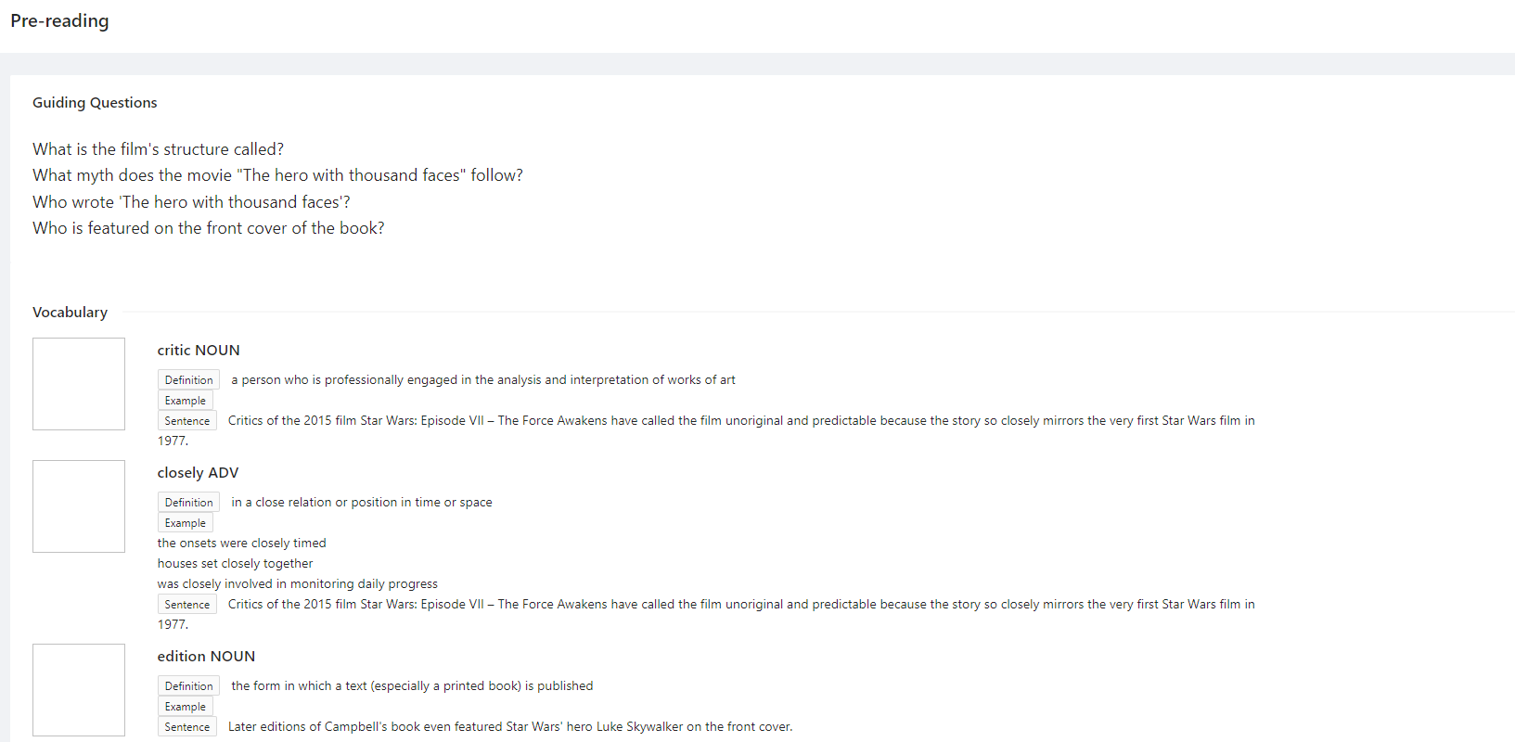

Figure 2 Pre-reading page (I)

文本

Figure 3 Pre-reading page (II)

In the **While-reading** page, after selecting a sentence and clicking **Simplify Sentence**, readers can view the simplification results.

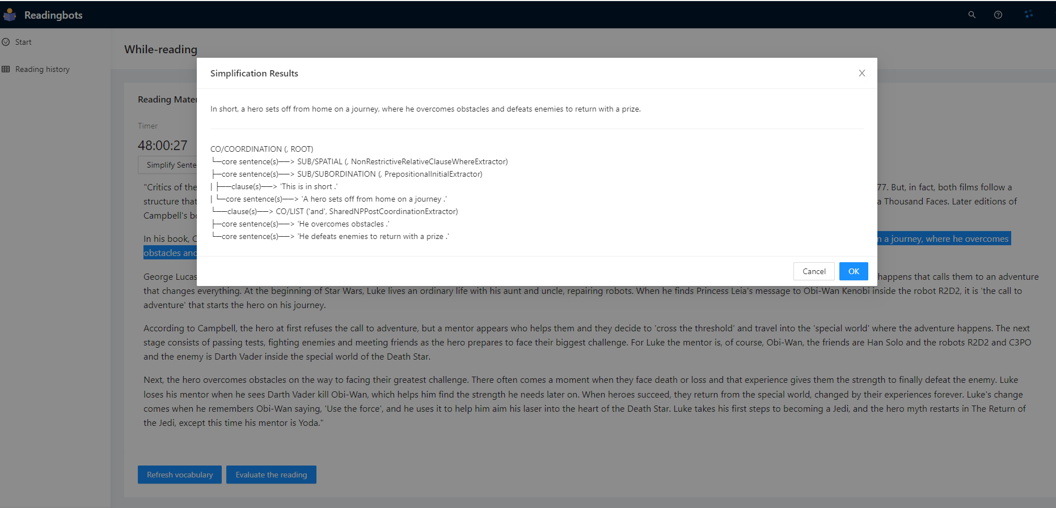

Figure 4 While-reading page

In the **Post-reading** page, readers are prompted with fill-in-the-blank questions, multiple choice questions and writing tasks.

Figure 5 Post-reading page (I)

Figure 6 Post-reading page (II)

After submitting the results, readers can view the scores.

Figure 7 Scoring results page

In the **Reading history** page, readers can view their past reading activities and the recorded details.

Figure 8 Reading history page

Figure 9 History details page (I)

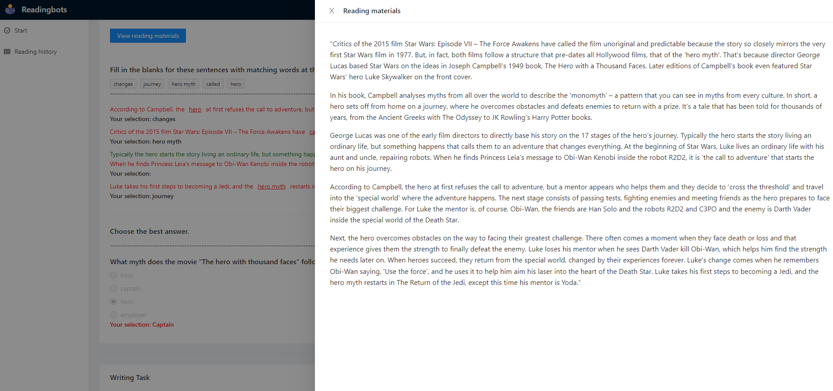

Figure 10 History details page (II)