未标题-1

**Figure S1: Mutational profiles of PTPNs in the TCGA cohort.**

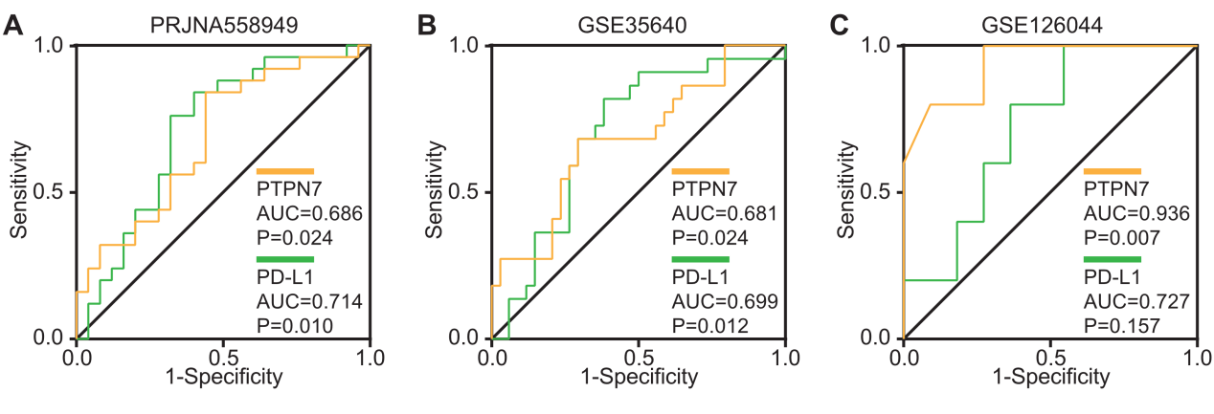**Figure S2: Comparison of PTPN7 and PDL1 in clinical efficacy and prognostic value**