Supporting information

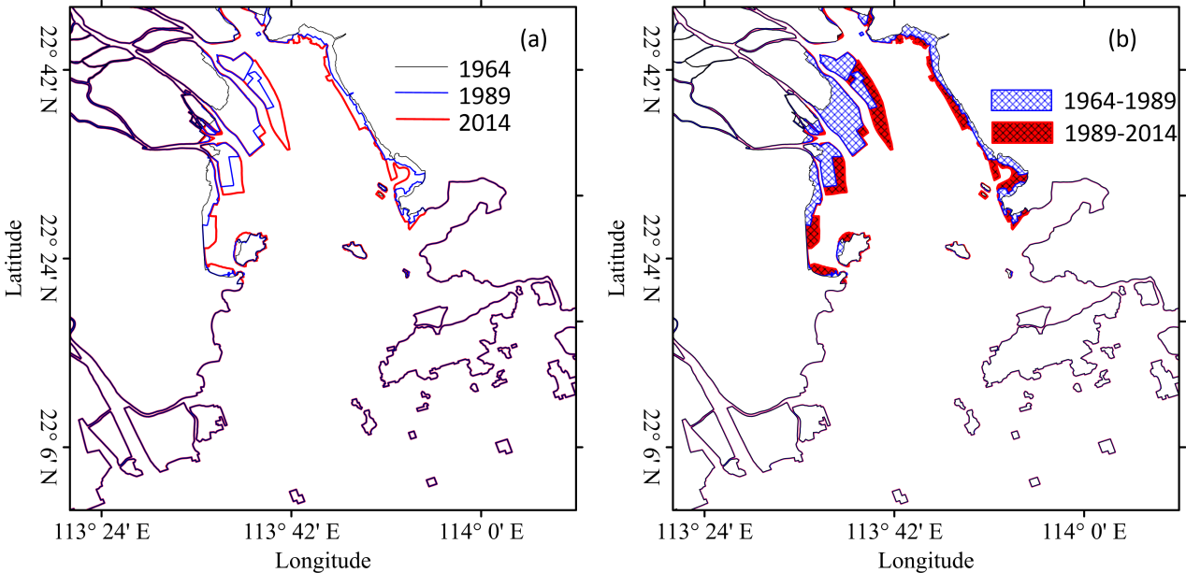

Figure S1. Changes in coastlines (a) and the reclaimed areas (b) of LDB from 1964 to 2014.

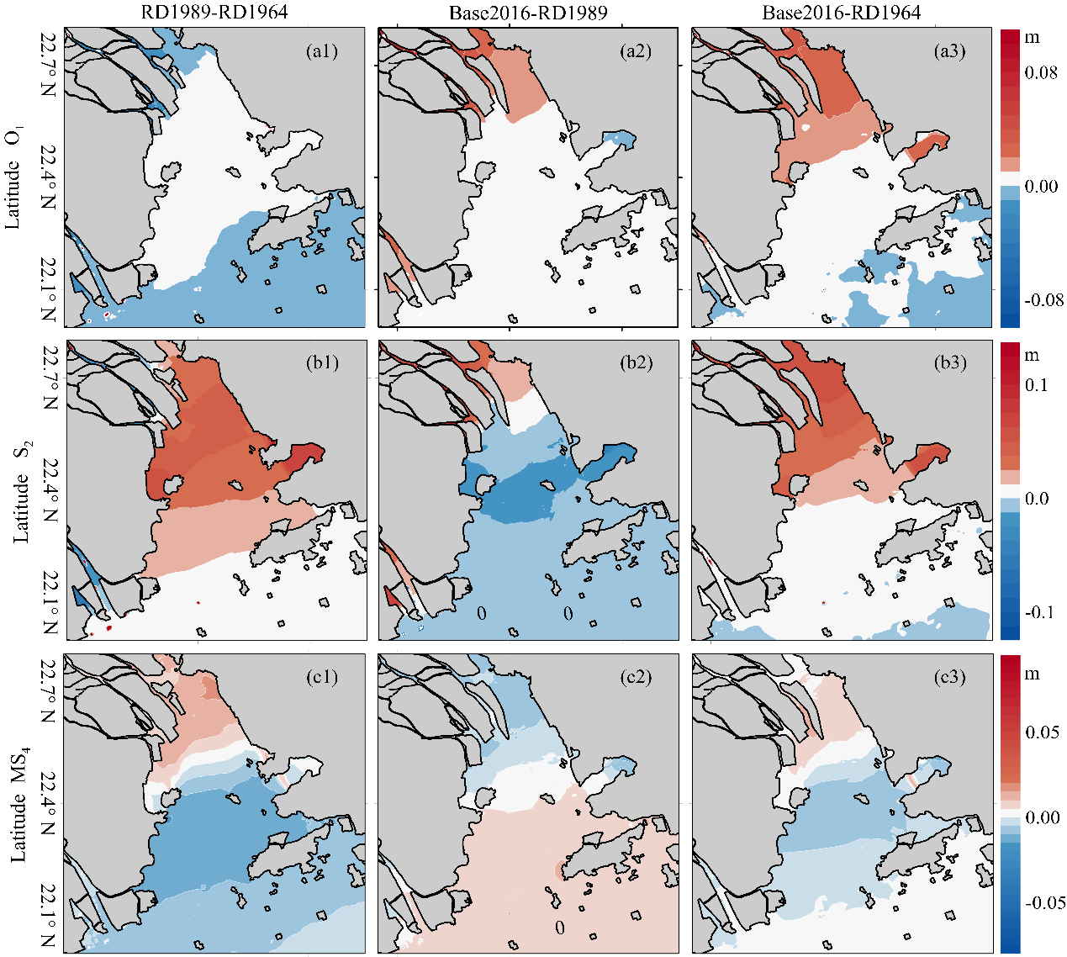

Figure S2. Contour map of the changes in O1 (a1-a3), S2 (b1-b3), and MS4 (c1-c3) amplitudes, where the numbers (1, 2, 3) represent the periods of 1964-1989, 1989-2016, 1964-2016, respectively.

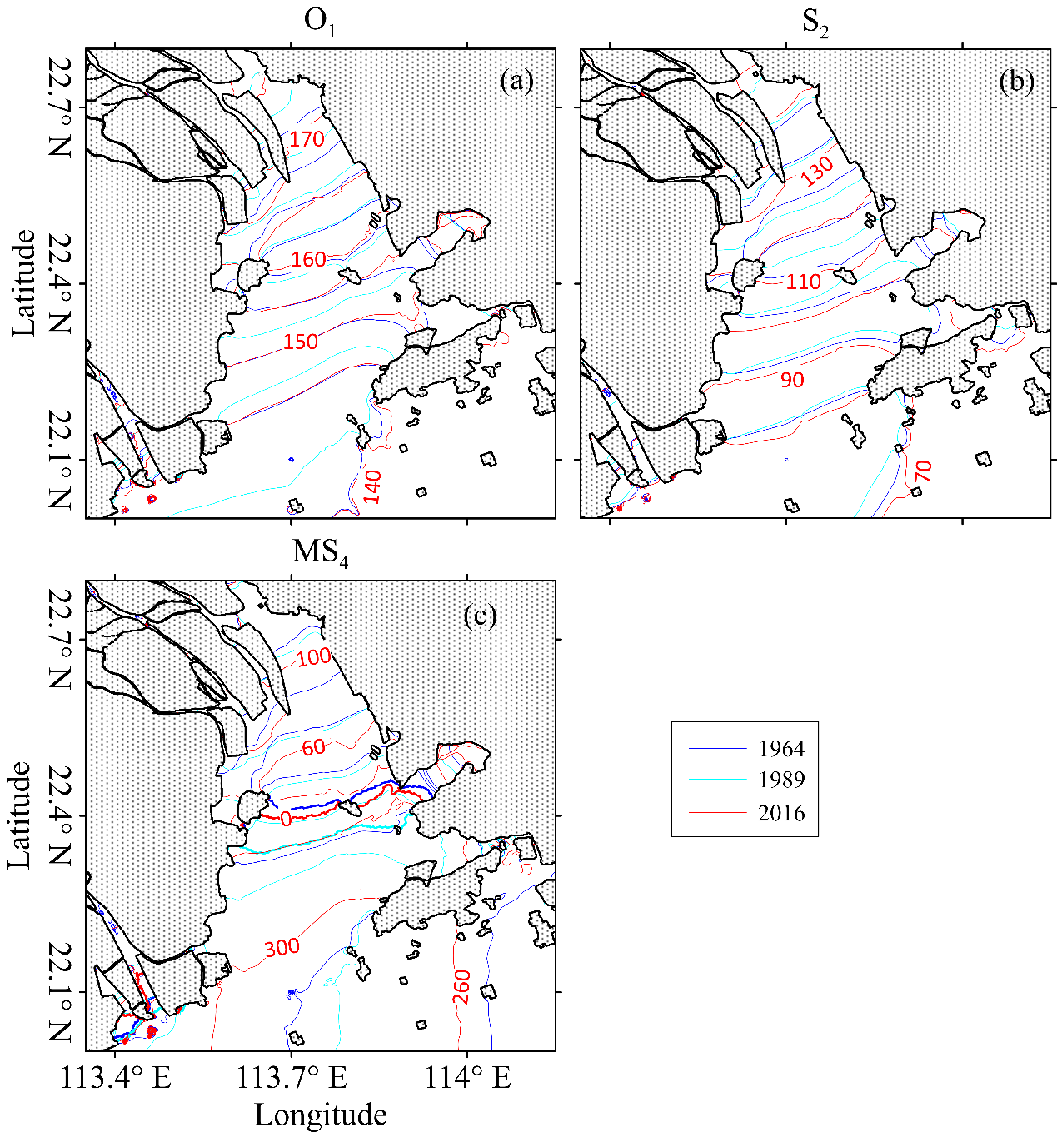

Figure S3. Contour map of the changes in O1 (a1-a3), S2 (b1-b3), and MS4 (c1-c3) tidal phases, where the numbers (1, 2, 3) represent the periods of 1964-1989, 1989-2016, 1964-2016, respectively.