Supplementary data
Functional analysis of soybean cyst nematode-inducible synthetic promoters and their regulation by biotic and abiotic stimuli in transgenic soybean (Glycine max)
Mst Shamira Sultana^{1,2}, Mitra Mazarei^{1,2}, Reginald J. Millwood¹, Wusheng Liu³, Tarek Hewezi¹, C. Neal Stewart Jr.^{1,2*}
¹Department of Plant Sciences, University of Tennessee, Knoxville, Tennessee, USA
²Center for Agricultural Synthetic Biology, University of Tennessee, Knoxville, Tennessee, USA
³Department of Horticultural Science, North Carolina State University, Raleigh, North Carolina, USA
* Corresponding author: C. Neal Stewart Jr. Tel: 865-974-6487; Email: nealstewart@utk.edu

Supplementary Table (S1): Core motifs within the two selected synthetic promoters.

Promoter | Tetramerized motif sequences | Core motifs
4×M1.1 | TAAAATAAAGTTCTTTAATT | TAAAA
 |  | TAAAGT
 |  | TCTTTA
 |  | TTAATT
4×M2.3 | ATATAATTAAGT | ATATAA
 |  | TAATTA
 |  | ATTAAGT
 |  | AAGT

Supplementary Table (S2): List of primers used in PCR and qRT-PCR.

Gene | Forward primer | Reverse primer
Gus | CGACTGGGCAGATGAACATG | GTTCAGGCACAGCACATCAA
Bar | GAAGTCCAGCTGCCAGAAAC | AAGCACGGTCAACTTCCGTA
chvA | CGAAACGCTGTTCGGCCTGTGG | GTTCAGCAGGCCGGCATCCTGG
Gus (qRT-PCR) | CTGCATCGGCGAACTGATC | GTCCTGTAGAAACCCCAACC
GmUBI3 | GTGTAATGTTGGATGTGTTCCC | ACACAATTGAGTTCAACACAAACCG

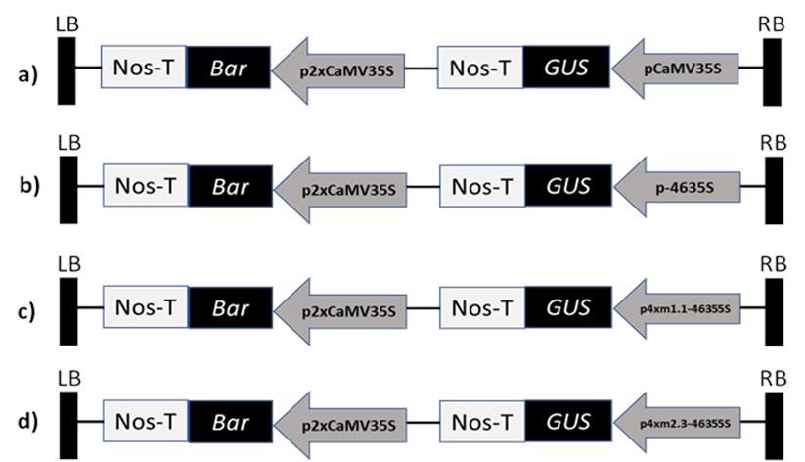

Supplementary Figure (S1): Schematic diagrams of promoter-GUS constructs. Left border (LB) and right border (RB) flanking the T-DNA insert are represented by black vertically elongated rectangles. 35SCaMV, 35S Cauliflower mosaic virus promoter; -4635S, minimal 35SCaMV promoter; 4×1.1 and 4×2.3, four repeats of the corresponding core motif; Nos-T, nopaline synthase terminator; Bar, bialaphos resistance gene; GUS, reporter gene.

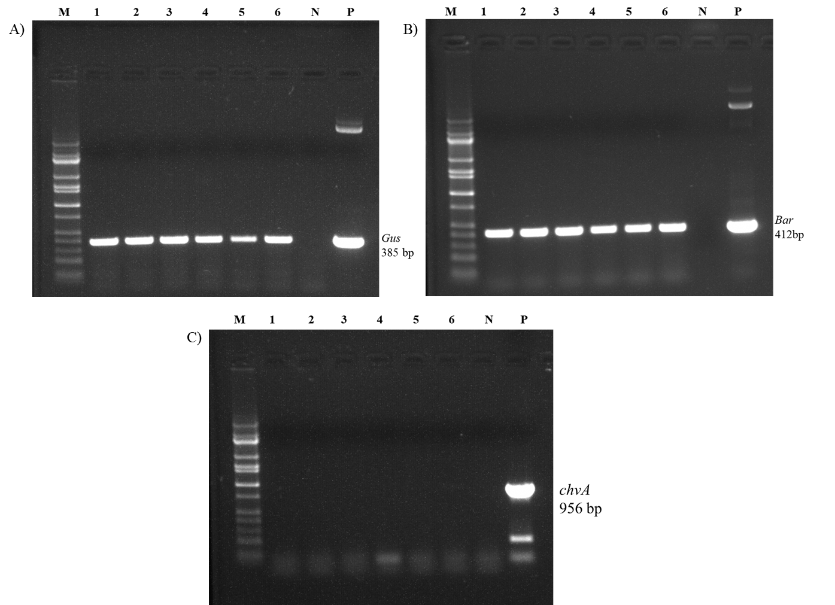

Supplementary Figure (S2): Molecular characterization of transgenic soybean plants containing promoter-GUS constructs. PCR analysis of genomic DNA extracted from leaves of 3-week-old plants. Lanes 1-3 are transgenic soybean lines L1, L2, and L3 containing 4×M1.1 promoter construct. Lanes 4-6 are transgenic soybean lines L1, L2, and L3 containing 4×M2.3 promoter construct. Lane N is non-transgenic wild-type soybean. Lane P is positive control template vector plasmid. The expected amplified DNA band size indicate presence of (A) GUS gene (385 bp) and (B) Bar gene (412 bp). chvA gene (C) was used as a control for the Agrobacterium contamination. No amplification was observed in transgenic lines (C). M, DNA marker.

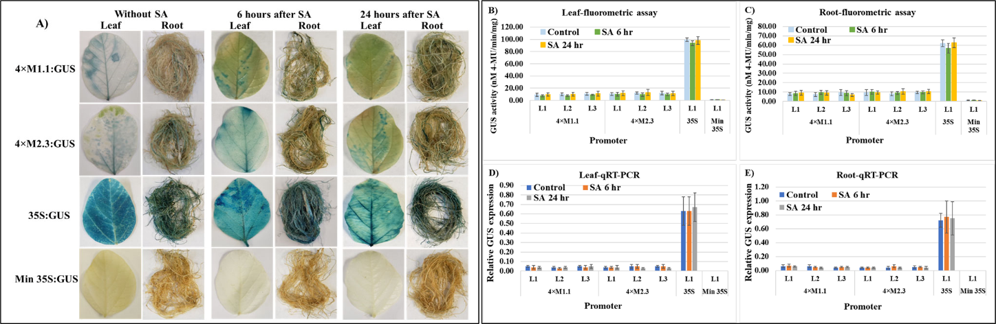

Supplementary Figure (S3): GUS activity in leaves and roots of 3-week-old T₃ transgenic soybean containing the individual promoter-GUS construct subjected to mock (untreated control) and salicylic acid (SA) (100 µM) at two time points of 6 h and 24 h after treatment. (A) Histochemical staining for GUS activity in transgenic soybean plants. (B, C) Fluorometric assay for GUS activity in leaf (B) and root (C). (D, E) Quantitative real-time RT-PCR (qRT-PCR) analysis for GUS expression in leaf (D) and root (E). The relative levels of transcripts were normalized to soybean ubiquitin gene (GmUBI3). Three independent transgenic lines (L1, L2, and L3) were used for 4×M1.1 and 4×M2.3 promoter-GUS constructs. One transgenic line (L1) was used for 35S and minimal (Min) 35S promoter-GUS constructs. Bars represent mean values of six biological replicates (plants) ± standard error. Statistical analysis by a two-sample paired t-test (P <0.05) indicated no significant differences between treated and untreated plants.

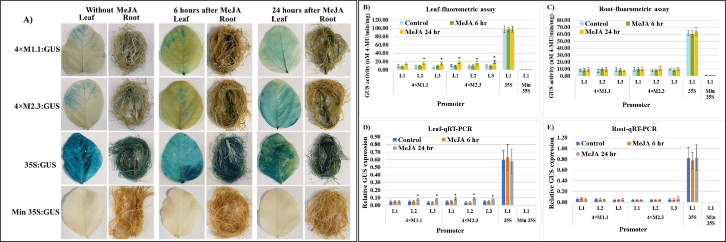
Supplementary Figure (S4): GUS activity in leaves and roots of 3-week-old T₃ transgenic soybean containing the individual promoter-GUS construct subjected to mock (untreated control) and methyl jasmonate (MeJA) (100 µM) at two time points of 6 h and 24 h after treatment. (A) Histochemical staining for GUS activity in transgenic soybean plants. (B, C) Fluorometric assay for GUS activity in leaf (B) and root (C). (D, E) Quantitative real-time RT-PCR (qRT-PCR) analysis for GUS expression in leaf (D) and root (E). The relative levels of transcripts were normalized to soybean ubiquitin gene (GmUBI3). Three independent transgenic lines (L1, L2, and L3) were used for 4×M1.1 and 4×M2.3 promoter-GUS constructs. One transgenic line (L1) was used for 35S and minimal (Min) 35S promoter-GUS constructs. Bars represent mean values of six biological replicates (plants) ± standard error. Statistical significance (p < 0.05) was determined by two-sample paired t-test. Bars with asterisk (*) indicate significant difference compared to untreated control plants.

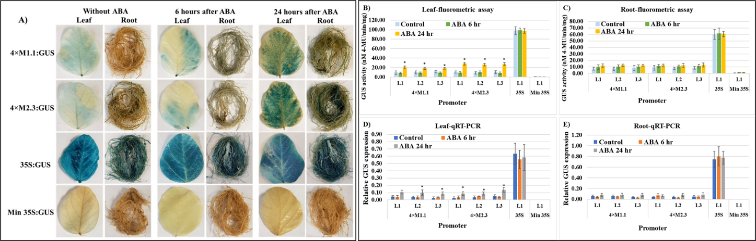
Supplementary Figure (S5). GUS activity in leaves and roots of 3-week-old T₃ transgenic soybean containing the individual promoter-GUS construct subjected to mock (untreated control) and abscisic acid (ABA) (100 µM) at two time points of 6 h and 24 h after treatment. (A) Histochemical staining for GUS activity in transgenic soybean plants. (B, C) Fluorometric assay for GUS activity in leaf (B) and root (C). (D, E) Quantitative real-time RT-PCR (qRT-PCR) analysis for GUS expression in leaf (D) and root (E). The relative levels of transcripts were normalized to soybean ubiquitin gene (GmUBI3). Three independent transgenic lines (L1, L2, and L3) were used for 4×M1.1 and 4×M2.3 promoter-GUS constructs. One transgenic line (L1) was used for 35S and minimal (Min) 35S promoter-GUS constructs. Bars represent mean values of six biological replicates (plants) ± standard error. Statistical significance (p < 0.05) was determined by two-sample paired t-test. Bars with asterisk (*) indicate significant difference compared to untreated control plants.

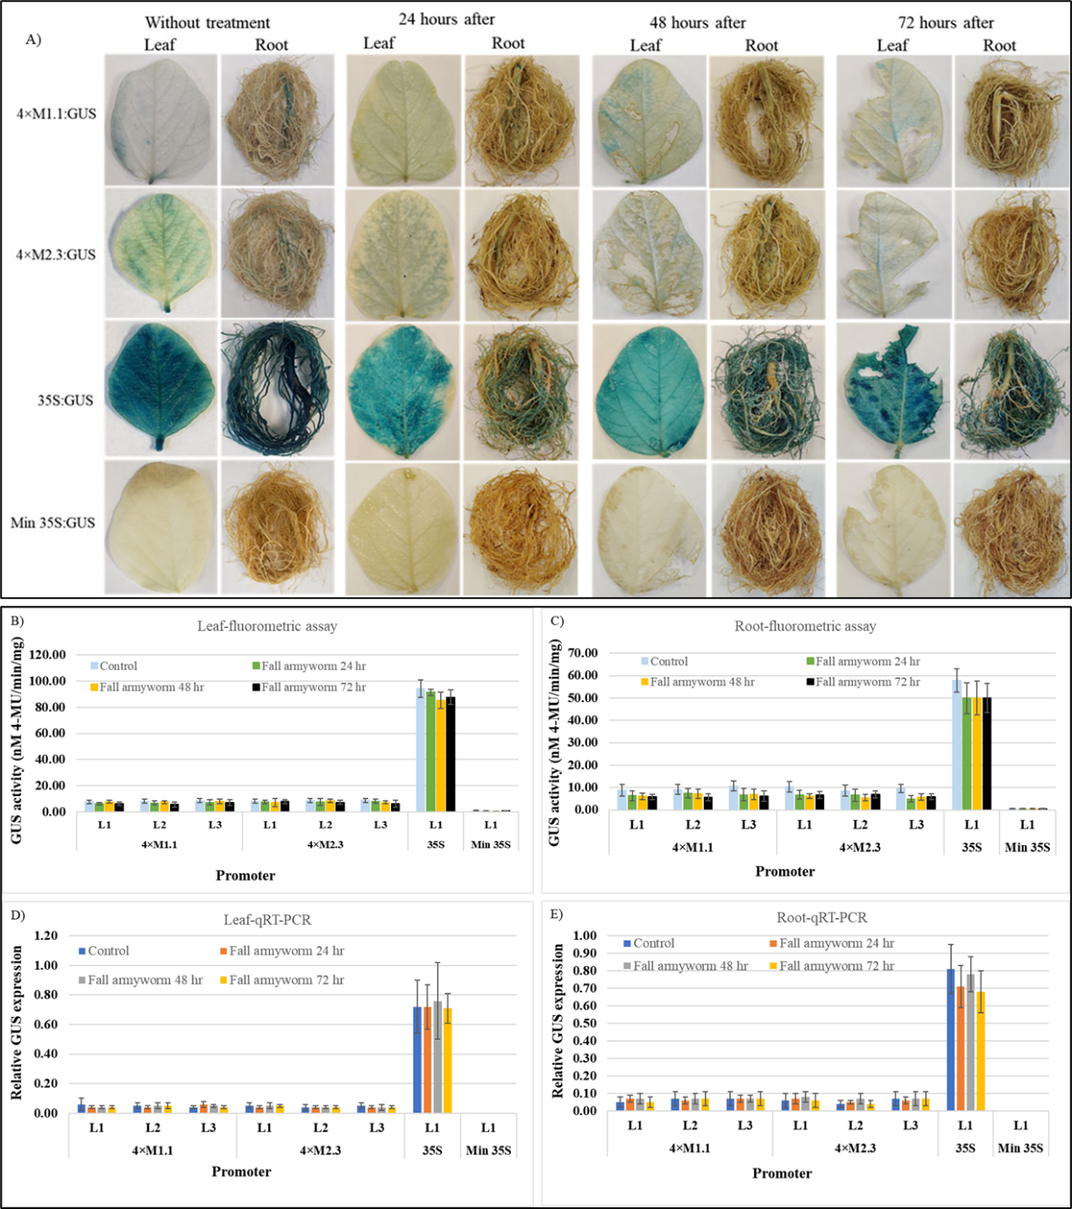
Supplementary Figure (S6): GUS activity in leaves and roots of transgenic soybean containing the individual promoter-GUS construct untreated or treated with fall armyworm (Spodoptera frugiperda) larvae at 24, 48, and 72 h after larval infestation. (A) Histochemical staining for GUS activity in transgenic soybean plants. (B, C) Fluorometric assay for GUS activity in leaf (B) and root (C). (D, E) Quantitative real-time RT-PCR (qRT-PCR) analysis for GUS expression in leaf (D) and root (E). The relative levels of transcripts were normalized to soybean ubiquitin gene (GmUBI3). Three independent transgenic lines (L1, L2, and L3) were used for 4×M1.1 and 4×M2.3 promoter-GUS constructs. One transgenic line (L1) was used for 35S and minimal (Min) 35S promoter-GUS constructs. Bars represent mean values of six biological replicates (plants) ± standard error. Statistical analysis by a two-sample paired t-test (P <0.05) indicated no significant differences between treated and untreated plants.
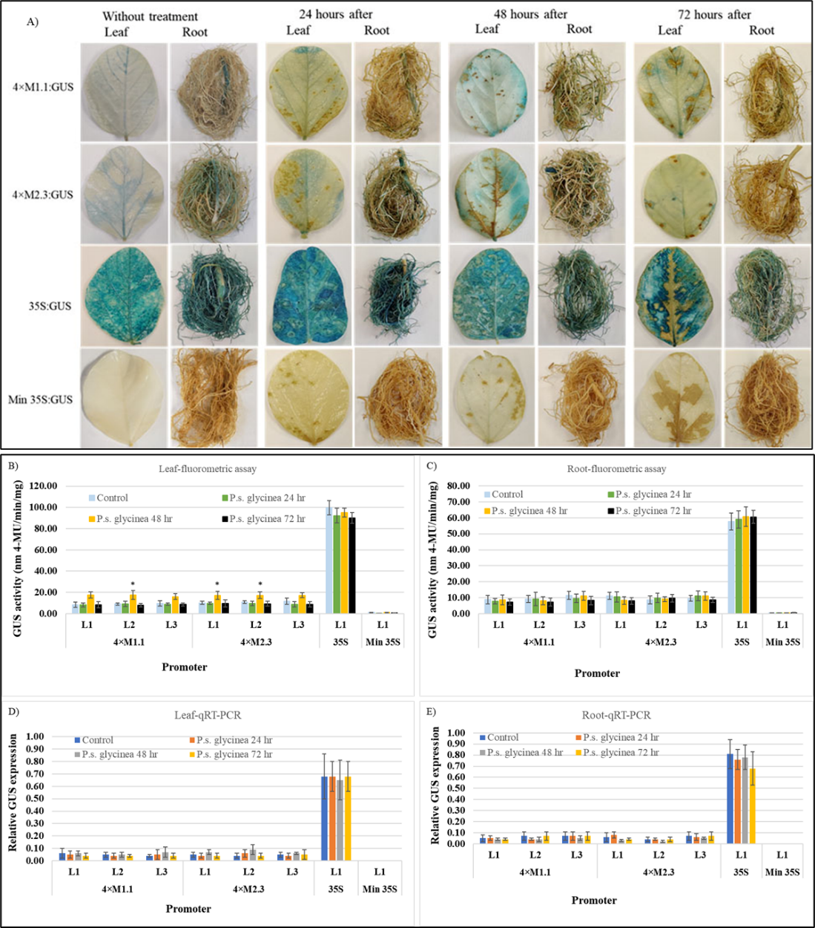

Supplementary Figure (S7): GUS activity in leaves and roots of transgenic soybean containing the individual promoter-GUS construct treated with 10 mM MgCl₂ (mock control) or pseudomonas syringe pv. glycinea at 24, 48, and 72 h after treatment. (A) Histochemical staining for GUS activity in transgenic soybean plants. (B, C) Fluorometric assay for GUS activity in leaf (B) and root (C). (D, E) Quantitative real-time RT-PCR (qRT-PCR) analysis for GUS expression in leaf (D) and root (E). The relative levels of transcripts were normalized to soybean ubiquitin gene (GmUBI3). Three independent transgenic lines (L1, L2, and L3) were used for 4×M1.1 and 4×M2.3 promoter-GUS constructs. One transgenic line (L1) was used for 35S and minimal (Min) 35S promoter-GUS constructs. Bars represent mean values of six biological replicates (plants) ± standard error. Statistical significance (p < 0.05) was determined by two-sample paired t-test. Bars with asterisk (*) indicate significant difference compared to untreated control plants.
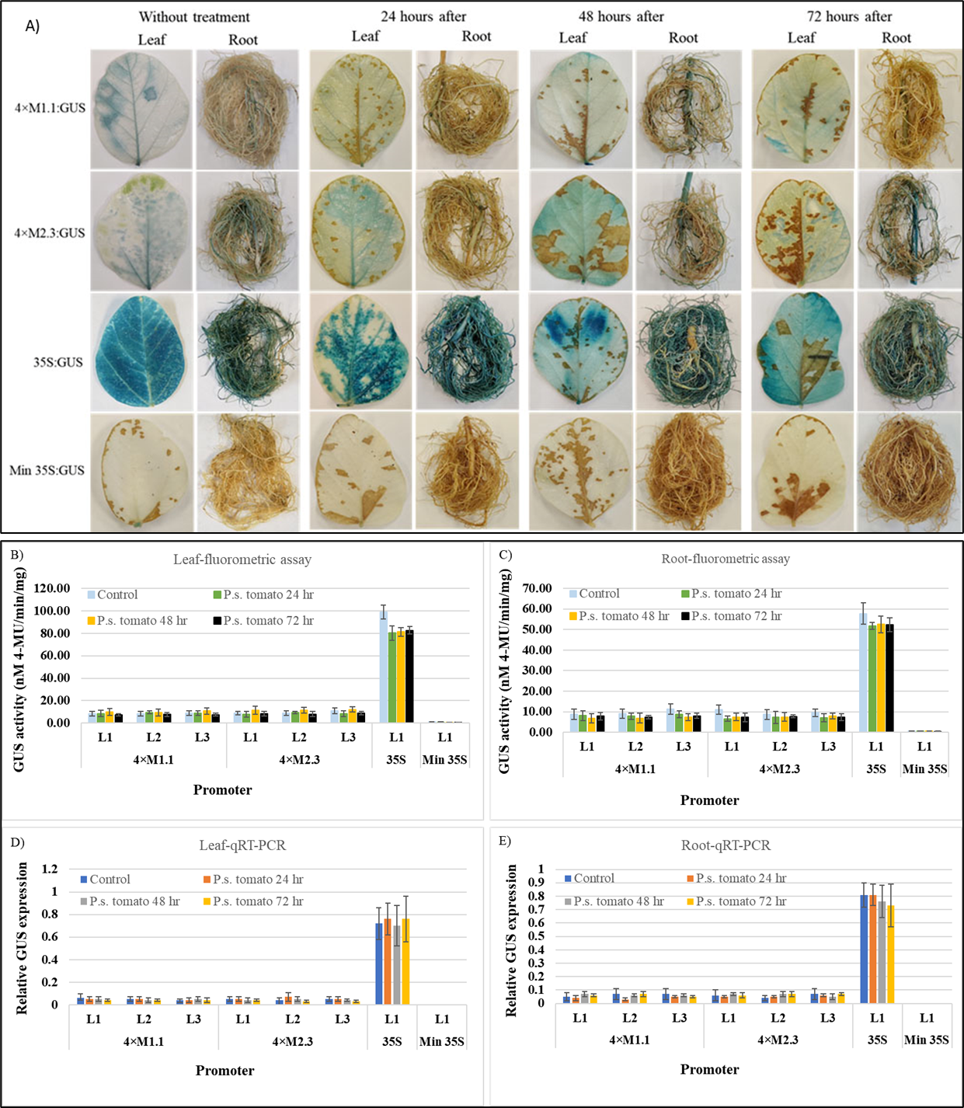
Supplementary Figure (S8): GUS activity in leaves and roots of transgenic soybean containing the individual promoter-GUS construct treated with 10 mM MgCl₂ (mock control) or Pseudomonas syringe pv. tomato at 24, 48, and 72 h after treatment. (A) Histochemical staining for GUS activity in transgenic soybean plants. (B, C) Fluorometric assay for GUS activity in leaf (B) and root (C). (D, E) Quantitative real-time RT-PCR (qRT-PCR) analysis for GUS expression in leaf (D) and root (E). The relative levels of transcripts were normalized to soybean ubiquitin gene (GmUBI3). Three independent transgenic lines (L1, L2, and L3) were used for 4×M1.1 and 4×M2.3 promoter-GUS constructs. One transgenic line (L1) was used for 35S and minimal (Min) 35S promoter-GUS constructs. Bars represent mean values of six biological replicates (plants) ± standard error. Statistical analysis by a two-sample paired t-test (P <0.05) indicated no significant differences between treated and untreated plants.
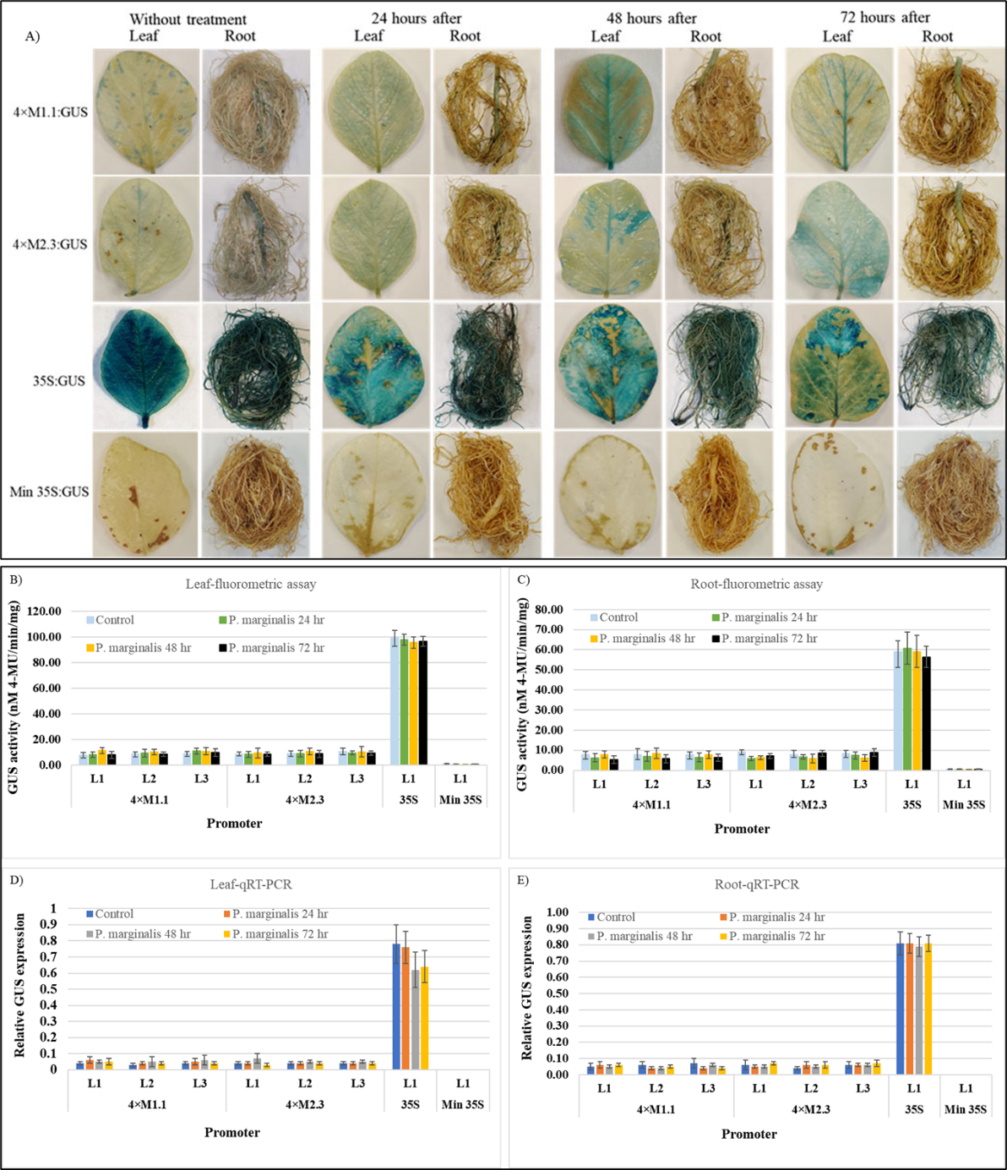

Supplementary Figure (S9): GUS activity in leaves and roots of transgenic soybean containing the individual promoter-GUS construct treated with 10 mM MgCl₂ (mock control) or Pseudomonas marginalis at 24, 48, and 72 h after treatment. (A) Histochemical staining for GUS activity in transgenic soybean plants. (B, C) Fluorometric assay for GUS activity in leaf (B) and root (C). (D, E) Quantitative real-time RT-PCR (qRT-PCR) analysis for GUS expression in leaf (D) and root (E). The relative levels of transcripts were normalized to soybean ubiquitin gene (GmUBI3). Three independent transgenic lines (L1, L2, and L3) were used for 4×M1.1 and 4×M2.3 promoter-GUS constructs. One transgenic line (L1) was used for 35S and minimal (Min) 35S promoter-GUS constructs. Bars represent mean values of six biological replicates (plants) ± standard error. Statistical analysis by a two-sample paired t-test (P <0.05) indicated no significant differences between treated and untreated plants.

