Supplementary Material

Validation of Annual Growth Increments
The assumption that otolith increments were formed annually was assessed using in-situ oxytetracycline (OTC) tagging and mark-recapture methods. Tetracycline is a common antibiotic that is metabolized by the fish and incorporated into bone, and glows yellow/green when viewed under fluorescent light (Cappo et al., 2000). A formation of a single annual increment over a 13-month period outside of the tetracycline band within the otolith would validate that each band is formed annually. Due to some variability of band formation over the lifespan this species, this process can also help resolve annual ages in some samples. Due to the high site fidelity of Garibaldi (Limbaugh, 1964; Clarke, 1970), it was assumed that recapture of tagged individuals from the same site after approximately 13-14 months would be feasible. On 21 September 2018, 49 Garibaldi were captured by divers using a 20 m x 5 m monofilament barrier net with 3/8” mesh and hand nets outfitted with ½” monofilament mesh at about 8 m depth at Flat Rock, a natural rocky reef site on the North Palos Verdes Peninsula, CA. Fish were brought alive to the research vessel, measured (TL, mm), and then injected with a dosage of 50 mg kg^{–1} body weight of oxytetracycline HCL solution (Bio-Mycin® 200, a broad-spectrum antibiotic approved for use in animals) into their musculature (McFarlane and Beamish, 1987). Fish were then tagged with two uniquely identifiable T-bar tags below the spinous dorsal fin, one in the anterior and one in the posterior on opposite sides. Fish were then kept in bins with aerators to oxygenate the seawater for approximately 15 min to assess their condition before being released back into the water at the capture site.
The tagging site was visited quarterly by divers and fish with tags were observed, although the number of observed fish with tags decreased each quarter. Five tagged fish were recaptured by divers by pole spear on 4 November 2019, roughly 13.5 months after tagging, measured in the field (TL, mm) and brought back to the lab on ice for dissection. Otoliths were removed and sectioned using the previously described methods, and then stored without exposure to light which can degrade tetracycline that was incorporated into the otolith. To visualize the tetracycline band within the otolith sections, sections were viewed with a Nikon e200 fluorescence microscope and photographed with a digital camera following Cappo et al. (2000). This study was reviewed and approved by the Institutional Care and Use Committees at both Cal Poly Pomona and Occidental College.

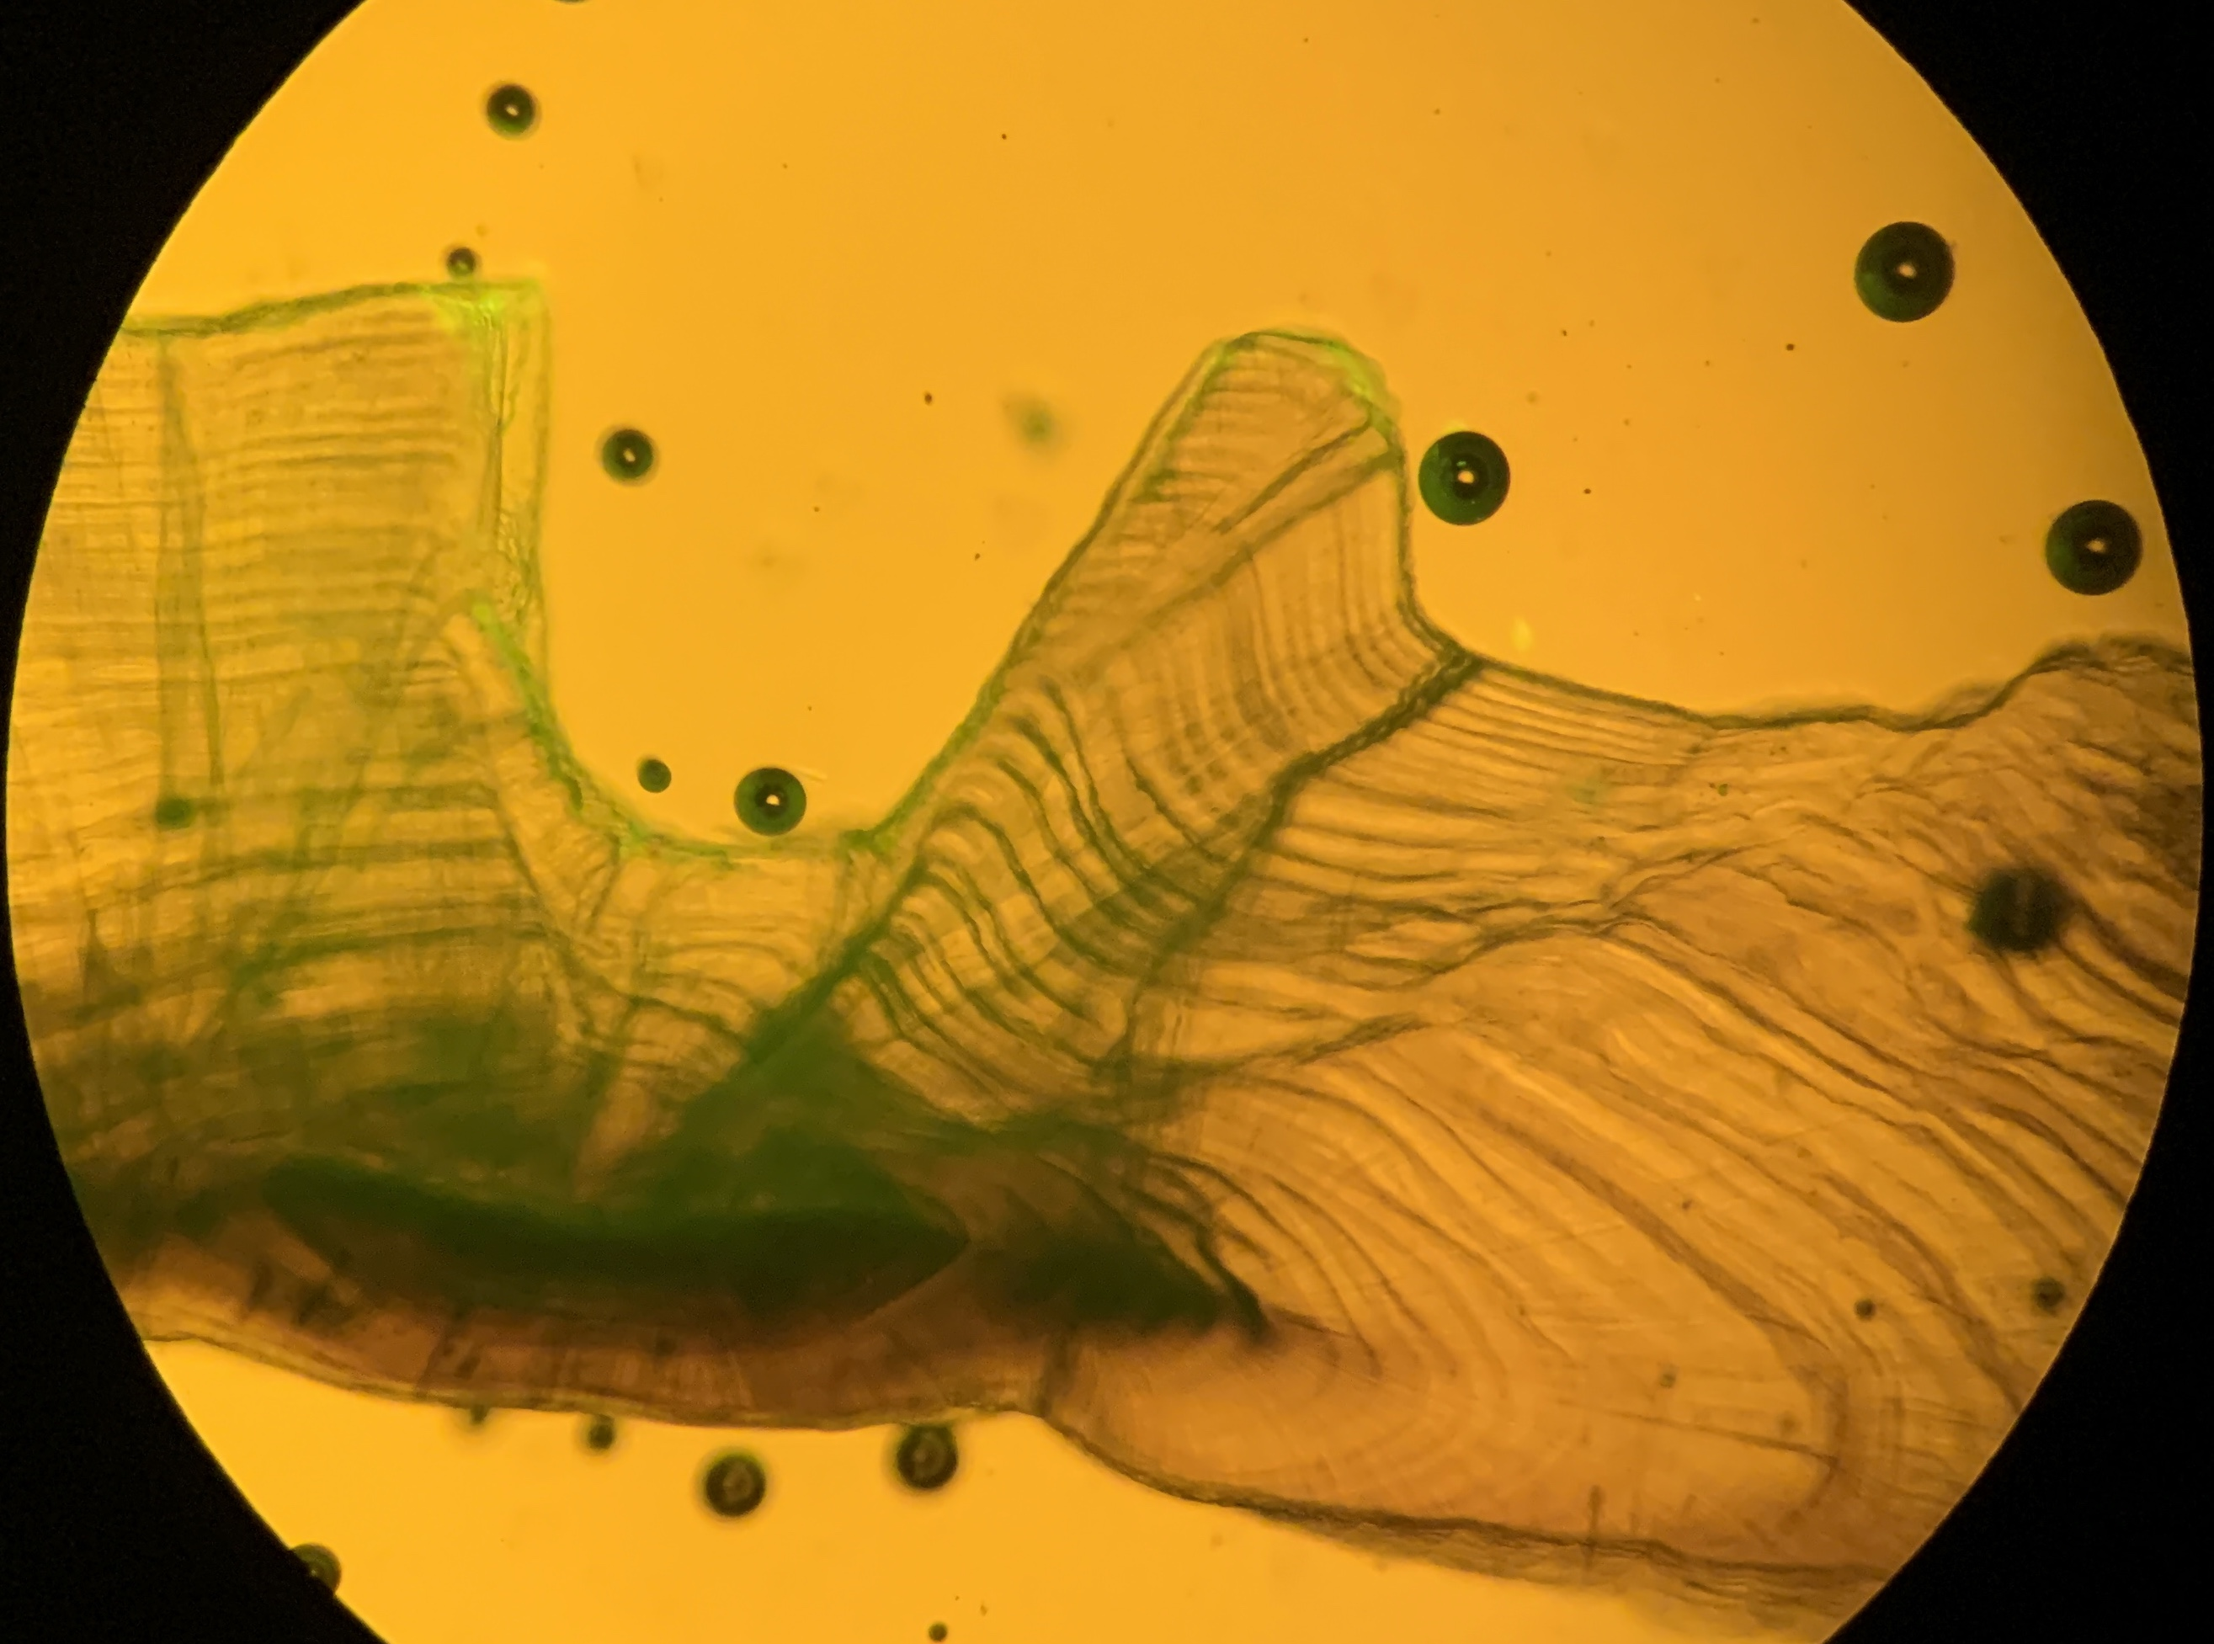
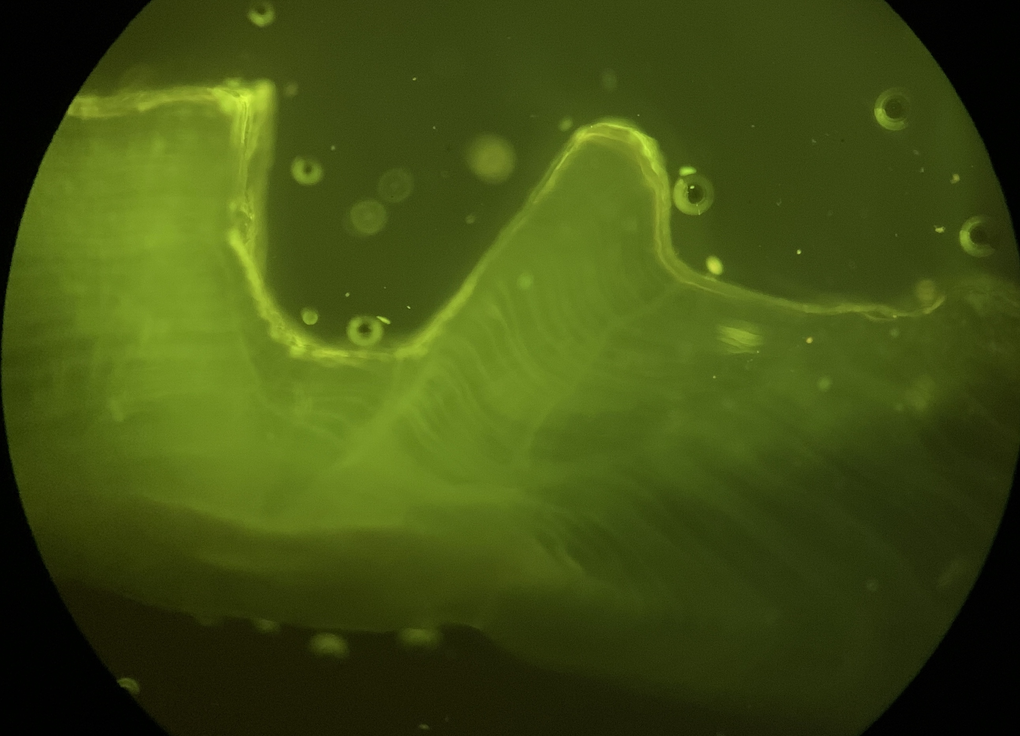
Table S1. Recaptured Garibaldi (Hypsypops rubicundus) from the 409-day in-situ mark-recapture experiment. Total length is final TL in mm as measured in the laboratory after fish had been on ice for approximately 5 hours, which is similar to conditions under which measurements were conducted for the life history methods. Initial length and final length are TL in mm as measured in the field. Growth is initial length subtracted from final length in mm. Percent growth is percent increase from initial length.
ID # | Sex | Age | Lab Total Length (mm) | Field  Initial Length (TL, mm) | Field  Final Length (TL, mm) | Growth (mm) | % Growth
1123 | F | 7 | 163.42 | 170 | 180 | 10 | 5.88%
1124 | M | 6 | 179.16 | 174 | 185 | 11 | 6.32%
1115 | M | 5 | 192.84 | 188 | 190 | 2 | 1.06%
1116 | F | 21 | 231.13 | 232 | 235 | 3 | 1.29%
1137 | M | 14 | 257.29 | 250 | 260 | 10 | 4.00%
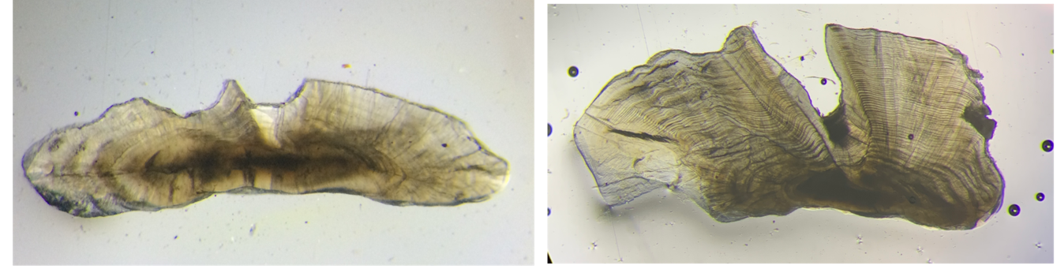
Figure S1. Sectioned sagittal otolith of a 193 mm (TL) Garibaldi (Hypsypops rubicundus) (ID # 1115) from Flat Rock, Palos Verdes injected with tetracycline on 21 September 2018 and collected on 4 November 2019. Section photographed under (A) transmitted and fluorescent light and (B) fluorescent light to demonstrate tetracycline band (light yellow).
Figure S2. Transverse sections of sagittal otoliths showing annuli (dark/opaque rings) from a 4 year old and 55 year old Garibaldi (Hypsypops rubicundus).
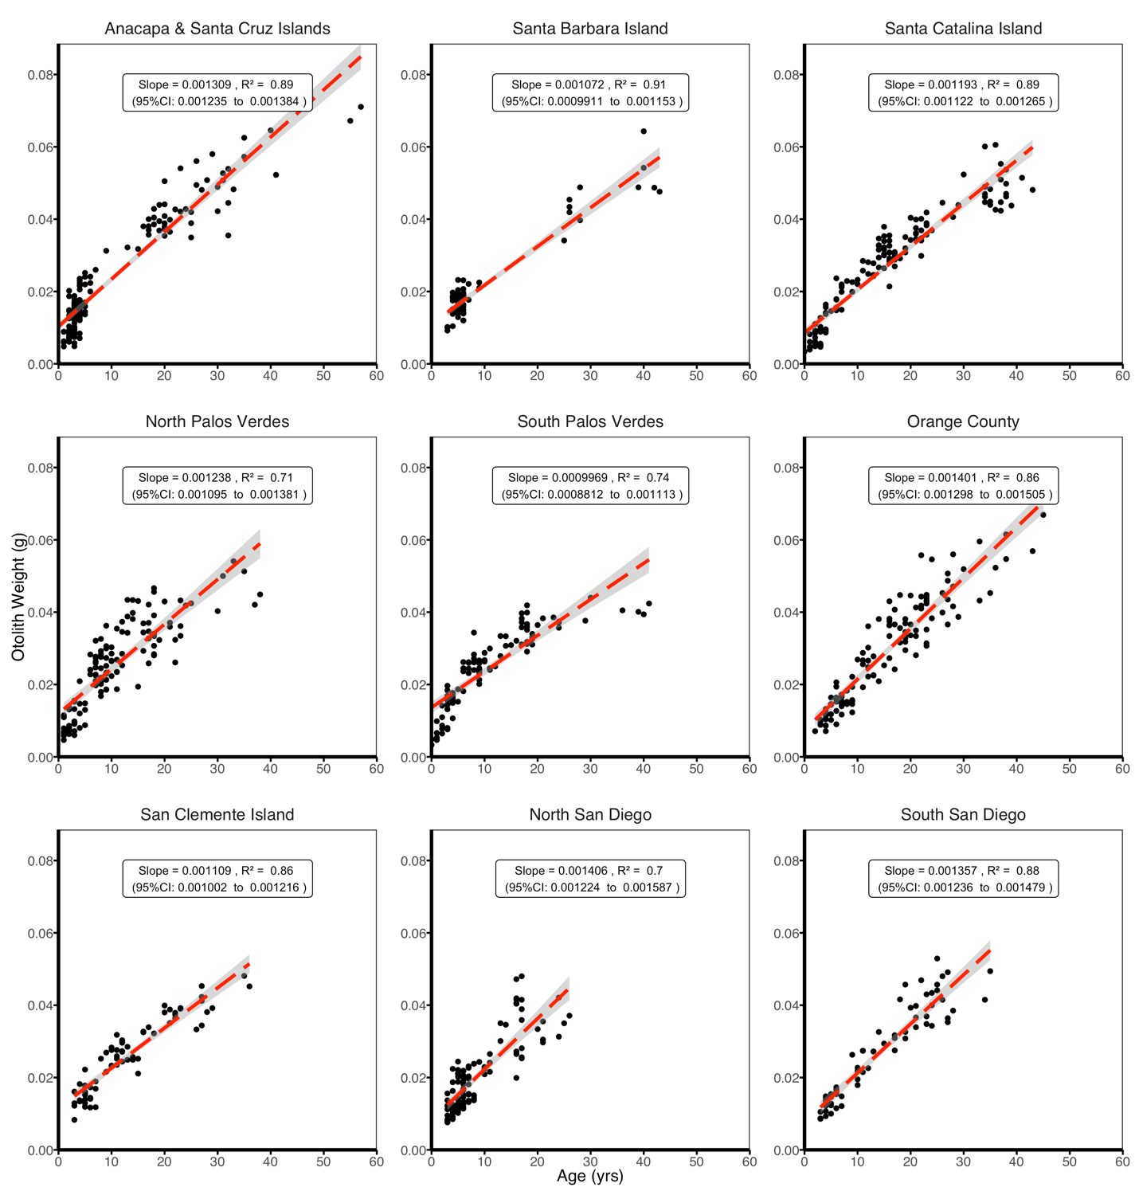
Figure S3. Relationship between age in years and sagittal otolith weight (g) in Garibaldi (Hypsypops rubicundus) sampled from each of the nine study locations. Slope, 95% confidence intervals, and R² values of the regressions are reported.

Five of the 49 (10.2%) tetracycline and T-bar tagged Garibaldi were recaptured 13.5 months (409 days) after initial tagging and included two females and three males. Recaptured Garibaldi ranged in size from 163 - 257 mm and in ages from 5-21 years at time of recapture (Table S1). All specimens had an identifiable tetracycline band when viewed under fluorescent light (Figure S1), and consistently added a single increment to the otolith structure beyond the tetracycline mark during the period between treatment and recapture validating the assumption that increments are formed on an annual basis. On average fish length increased by 3.7% (range: 1.06% to 5.88%) over the 409-day period between tagging and recapture (Table S1). These findings support the three criteria for use in age-based approaches as described in Fowler & Doherty (1992): (1) they displayed an internal structure of increments (Figure S2) (2) increments were related to a regular time scale of formation (annual), and (3) a positive relationship was found between otolith weight and age (Figure S3), indicating that otoliths grow throughout the lifespan of the fish. We found similar increases in relative length from the five individuals recovered during the tagging study as DeMartini et al. (1994) (3.7% in the present study, compared to 3% in DeMartini’s study). However, growth rates reported for this age validation study should be interpreted cautiously, as some previous studies have indicated that T-bar tags can have a negative impact on growth in some species (McFarlane and Beamish, 1990; DeMartini et al., 1994; Johnson et al., 1994). When considering the high site fidelity and territoriality of Garibaldi and recovery rates in previous studies (Johnson et al (1994) reported a recovery rate of 30%), the 10.2% recovery rate in the present study was lower than anticipated. Johnson et al. (1994) attributed this phenomenon to tag loss, and not migration, and our results support that same conclusion. All five recovered fish, which were released with two physical T-bar tags, only had a single tag when recovered, indicating T-bar tag loss was likely greater than 50%. In addition, fish were recaptured after 6-8 months in Johnson et al. 1994, while fish were recaptured after 13.5 months in the present study. During quarterly site visits, the number of tagged Garibaldi observed decreased over each quarter, further attributing reduced recovery rates to tag loss.
This is the first known study to use in-situ mark-recapture of OTC tagged bony fish within the Southern California Bight (SCB) to validate the annual periodicity of otolith increment formation. This method is one of the most robust methods for validating the periodicity of growth increment formation because the growth increments that are being validated are formed while the fish is growing in its natural environment (Beamish and McFarlane, 1983; Campana, 2001). Previous studies using these methods for fish in the SCB are restricted to elasmobranchs (Smith et al., 2003; Wells et al., 2013; Kinney et al., 2016) or laboratory settings (Sakagawa and Kimura, 1976). Methods to confirm age in other studies within the Bight include radiometric approaches (Cailliet et al., 2001; Allen and Andrews, 2012) and marginal increment or otolith edge analysis (i.e., analysis of growth zones over time) which assumes annual periodicity if there was a seasonal formation of the opaque growth zone at the edge of the otolith (Love et al., 1990; Allen et al., 1995; Williams et al., 2012). Marginal increment or otolith edge analysis appears to be the most commonly used, yet considered the least effective method of age validation due to its subjectivity in interpretation and being restricted in application to young, fast-growing fish (Campana, 2001). Radiometric approaches, where the concentration of ¹⁴C from nuclear testing in the 1950’s and 1960’s is measured within the otolith and compared to ecosystem-specific (i.e., rivers, oceans, lakes) reference chronologies of Δ ¹⁴C, provide one of the best methods for confirming longevity in long-lived species but are not well suited for short-lived species or fish from environments where reference chronologies are not established (Campana, 2001). Since reference chronologies are available, as indicated by the successful bomb radiocarbon dating completed on Giant Seabass otoliths from the SCB (Allen and Andrews, 2012), and recaptured Garibaldi in this study ranged from 4-21 years, only a small subset of the total observed age range, this type of validation could further support annuli-based ageing in older fish.

Morphometric Relationships

Length-Length Conversions
Length-length conversion models to convert estimates to standard, fork and head-lengths were analyzed using maximum likelihood estimation.
Table S2. Length-length conversions for Fork Length (FL, mm), Standard Length (SL, mm), and Head Length (HL, mm) to Total Length (TL, mm) for the linear equation TL = a+b(XL), where XL is one of the lengths denoted below.
Length Conversion | a | b | R²
Head Length to Total Length | 11.77 | 3.98 | 0.91
Standard Length to Total Length | 8.27 | 1.21 | 0.98
Fork Length to Total Length | 0.35 | 1.10 | 0.99

Length-Weight Conversions
Length-weight models for all fish collected, males and females, and fish collected from natural and artificial reefs were fitted to the standard length-weight exponential equation using regression analysis with maximum likelihood estimation,
W = aTL^{b},
where W is total wet body weight in grams, and TL is total length in mm.

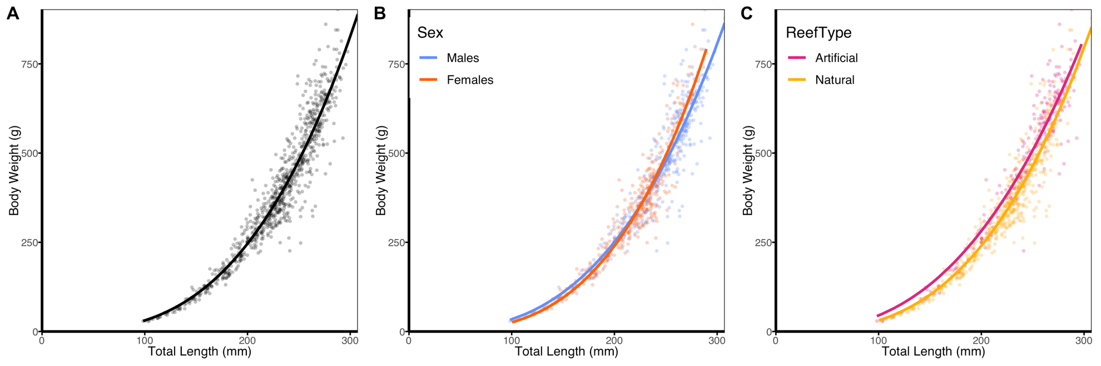
Figure S4. Length-weight relationships for A) all fish, B) male (blue) and female (fuchsia) Garibaldi (Hypsypops rubicundus), and C) Garibaldi by reef type (artificial is denoted in orange and natural is teal).

Model Selection Results
Table S3. Von Bertalanffy growth function model selection results. Models were ranked according to the difference in AIC (Δ AICc). K indicates the number of parameters in each model and log L is the log likelihood for each model. Akaike weights (w_{i}) were calculated to assess the relative likelihood of each model in the set and were interpreted as the weight of evidence in favor of the model.
Model | k | log 𝑳 | AICc | Δ AICc | 𝑤_{𝑖}
Location x Reef Type x Sex | 84 | -4,396.5 | 8,975.6 | 0.0 | 1.0
Location x Reef Type | 42 | -4,478.0 | 9,043.4 | 67.8 | 0.0
Temperature x Reef Type x Sex | 30 | -4,541.0 | 9,143.8 | 168.2 | 0.0
Location x Sex | 54 | -4,515.8 | 9,145.4 | 169.8 | 0.0
Temperature x Reef Type | 15 | -4,592.0 | 9,214.5 | 238.8 | 0.0
Location | 27 | -4,585.4 | 9,226.3 | 250.7 | 0.0
Temperature x Sex | 18 | -4,635.5 | 9,307.7 | 332.0 | 0.0
Island/Mainland x Reef Type x Sex | 18 | -4,653.7 | 9,344.0 | 368.4 | 0.0
Temperature | 9 | -4,692.4 | 9,403.0 | 427.4 | 0.0
Reef Type x Sex | 12 | -4,691.9 | 9,408.0 | 432.3 | 0.0
Island/Mainland x Reef Type | 9 | -4,696.1 | 9,410.4 | 434.8 | 0.0
Reef Type | 6 | -4,724.8 | 9,461.7 | 486.1 | 0.0
Sex | 6 | -4,737.7 | 9,487.5 | 511.9 | 0.0
Island/Mainland | 6 | -4,773.7 | 9,559.5 | 583.9 | 0.0
Null Model | 3 | -4,779.9 | 9,565.8 | 590.2 | 0.0

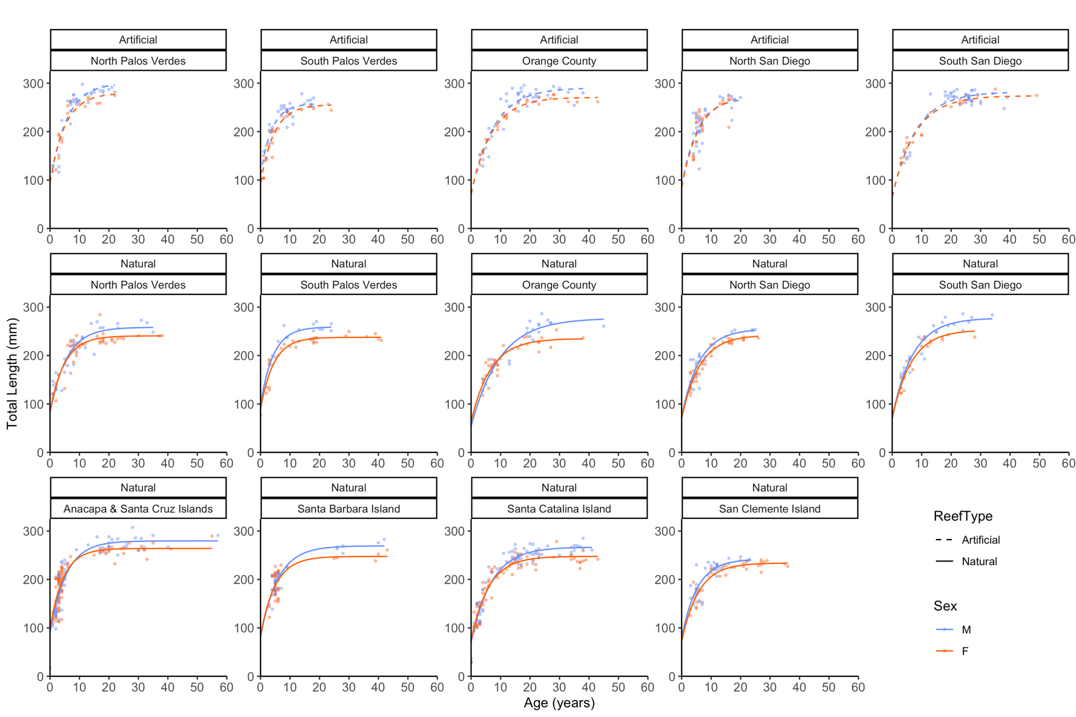
Figure S5. Von Bertalanffy growth curves of Garibaldi (Hypsypops rubicundus) by reef type and sex for each of the nine sampled locations fitted using maximum likelihood estimation. Natural reefs are denoted by solid lines, and artificial reefs are by dashed lines. Males are in blue, and females are in orange.
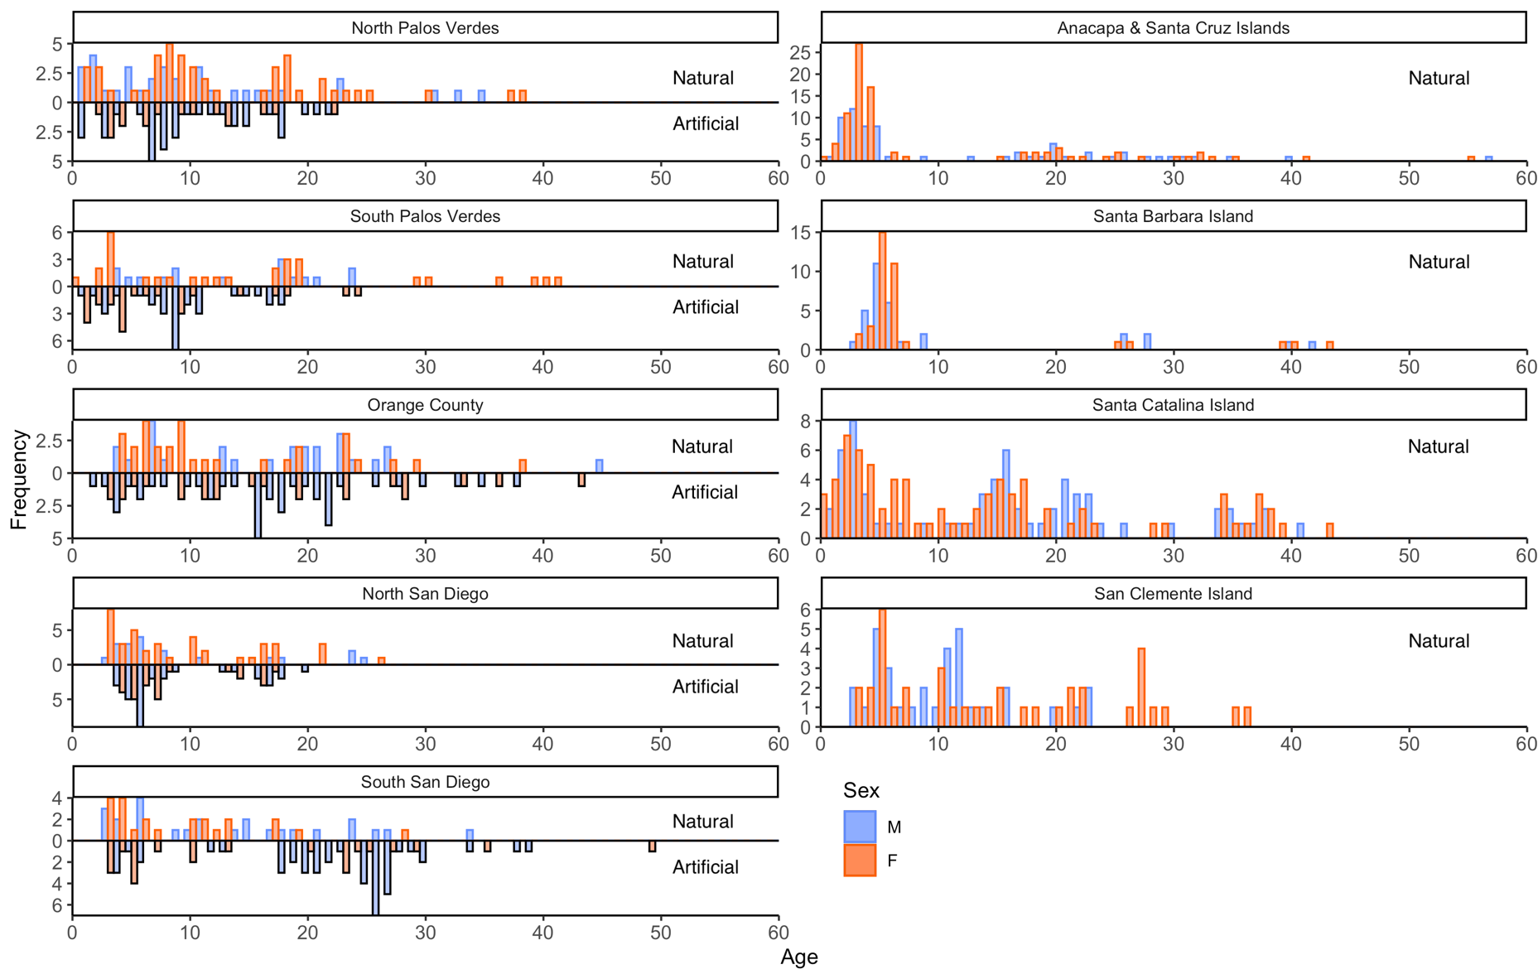
Figure S6. Age frequency distributions of Garibaldi by reef type and sex for each of the nine sampled locations. Artificial reefs are outlined in black. Blue bars indicate males, and orange bars indicate females.

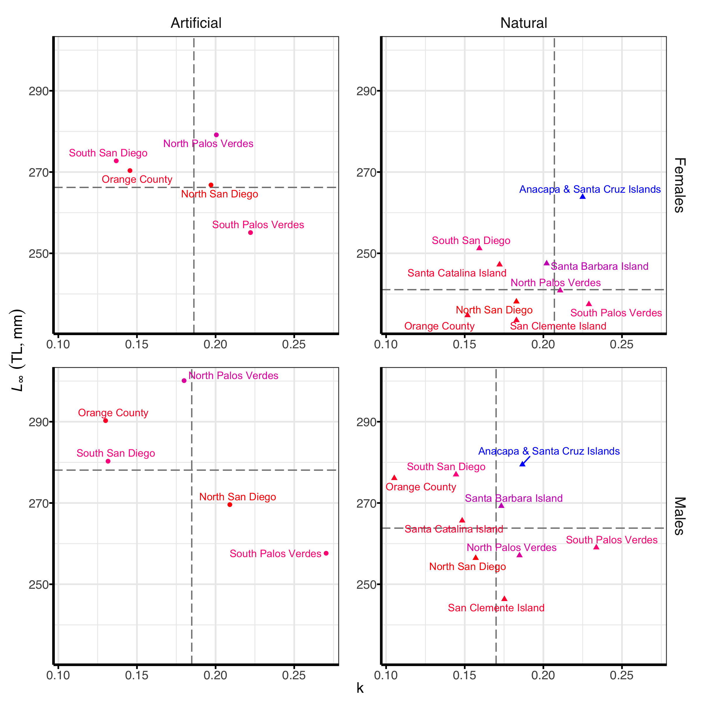
Figure S7. Relationship between mean asymptotic length (L∞) and k parameters from the highest ranked (and most complex) model (Table 1 in main text) for Garibaldi (Hypsypops rubicundus). Locations are colored from a scale of blue (cold) to red (warm) based on mean annual SST (°C) for January 2002-December 2018. Mean annual SST values are derived from merged 1 km resolution data from MODIS-Aqua and MODIS-Terra composited over 1-month intervals by the California Current Ecosystem Long-Term Ecological Research program based at Scripps Institution of Oceanography (available from http://www.wimsoft.com/CAL/). Dashed lines are mean k and L∞ values for each panel.

Table S4. Garibaldi longevity for each sex at each reef type within each location. T_{max} represents the maximum age, or oldest individual in the population, T_{max 25%} represents the mean age of the oldest 25% of fish collected, and T_{max 10%} represents the mean age of the oldest 10% of fish collected.
Population |  | Male |  |  |  | Female
Region | Reef Type | n | T_{max} | T_{max25%} | T_{max10%} | n | T_{max} | T_{max25%} | T_{max10%}
Anacapa & Santa Cruz Islands | Natural | 65 | 57 | 28 | 36 | 87 | 55 | 26 | 35
Santa Barbara Island | Natural | 32 | 42 | 26 | 34 | 37 | 43 | 14 | 37
Santa Catalina Island | Natural | 70 | 41 | 30 | 37 | 77 | 43 | 31 | 38
North Palos Verdes | Natural | 34 | 35 | 23 | 29 | 46 | 38 | 24 | 31
 | Artificial | 35 | 22 | 18 | 20 | 17 | 22 | 16 | 20
South Palos Verdes | Natural | 16 | 24 | 22 | 24 | 30 | 41 | 30 | 40
 | Artificial | 32 | 18 | 15 | 18 | 25 | 24 | 15 | 22
Orange County | Natural | 26 | 45 | 27 | 33 | 31 | 38 | 25 | 30
 | Artificial | 41 | 38 | 27 | 33 | 24 | 43 | 32 | 37
San Clemente Island | Natural | 33 | 23 | 16 | 22 | 38 | 36 | 28 | 32
North San Diego | Natural | 19 | 25 | 22 | 24 | 40 | 26 | 19 | 22
 | Artificial | 32 | 20 | 17 | 18 | 25 | 17 | 15 | 16
South San Diego | Natural | 25 | 34 | 25 | 29 | 23 | 28 | 18 | 20
 | Artificial | 45 | 39 | 30 | 34 | 22 | 49 | 32 | 38
All | All | 505 | 57 | 26 | 32 | 522 | 55 | 26 | 34

Models in Set
Table S5. Life history parameters for Garibaldi (Hypsypops rubicundus) in the Southern California Bight. Von Bertalanffy growth parameters were fitted using maximum likelihood estimation and 95% confidence intervals from the likelihood profile. L∞ is mean asymptotic total length in mm, k is the yearly rate at which TL approaches L∞. The value of t0 was fixed at -2.1 years. T_{max} represents the maximum age, or oldest individual in the population, T_{max25%} represents the mean age of the oldest 25% of fish collected, and T_{max10%} represents the mean age of the oldest 10% of fish collected.

Population |  |  | Parameters and 95% Confidence Intervals |  |  |  |  |  | Longevity
 | n | Size  (TL mm) | L∞  (mm) | 95% CI | k  (yr⁻¹) | 95% CI | σ | 95% CI | T_{max} | T_{max10%} | T_{max25%}
All | 1030 | 18 - 307 | 260 | 257 - 262 | 0.18 | 0.17 - 0.19 | 25 | 24 - 26 | 57 | 34 | 27

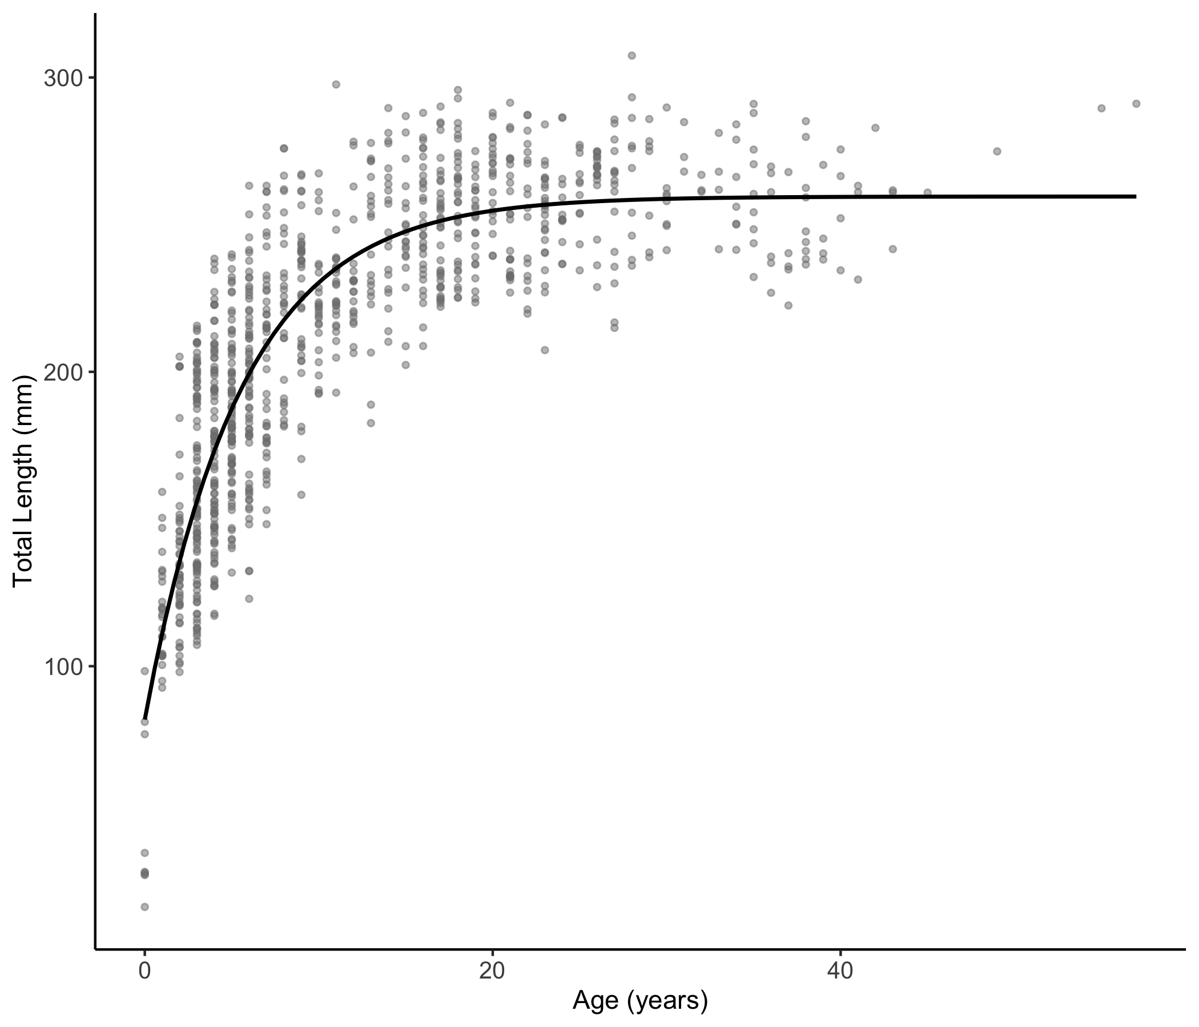
Figure S8. Von Bertalanffy growth curve of Garibaldi (Hypsypops rubicundus) fitted using maximum likelihood estimation.

Table S6. Life history parameters for male and female Garibaldi (Hypsypops rubicundus) pooled across all locations. Von Bertalanffy growth parameters were fitted using maximum likelihood estimation and 95% confidence intervals from the likelihood profile. L∞ is mean asymptotic total length in mm, k is the yearly rate at which TL approaches L∞. The value of t0 was fixed at -2.1 years. T_{max} represents the maximum age, or oldest individual in the population, T_{max25%} represents the mean age of the oldest 25% of fish collected, and T_{max10%} represents the mean age of the oldest 10% of fish collected.
Population |  |  | Parameters and 95% Confidence Intervals |  |  |  |  |  | Longevity
Sex | n | Size  (TL mm) | L∞  (mm) | 95% CI | k  (yr⁻¹) | 95% CI | σ | 95% CI | T_{max} | T_{max10%} | T_{max25%}
F | 523 | 18 - 290 | 247 | 243 - 250 | 0.20 | 0.19 - 0.21 | 24 | 23 - 25 | 55 | 34 | 26
M | 507 | 29 - 307 | 271 | 267 - 274 | 0.17 | 0.16 - 0.18 | 24 | 23 - 26 | 57 | 32 | 27

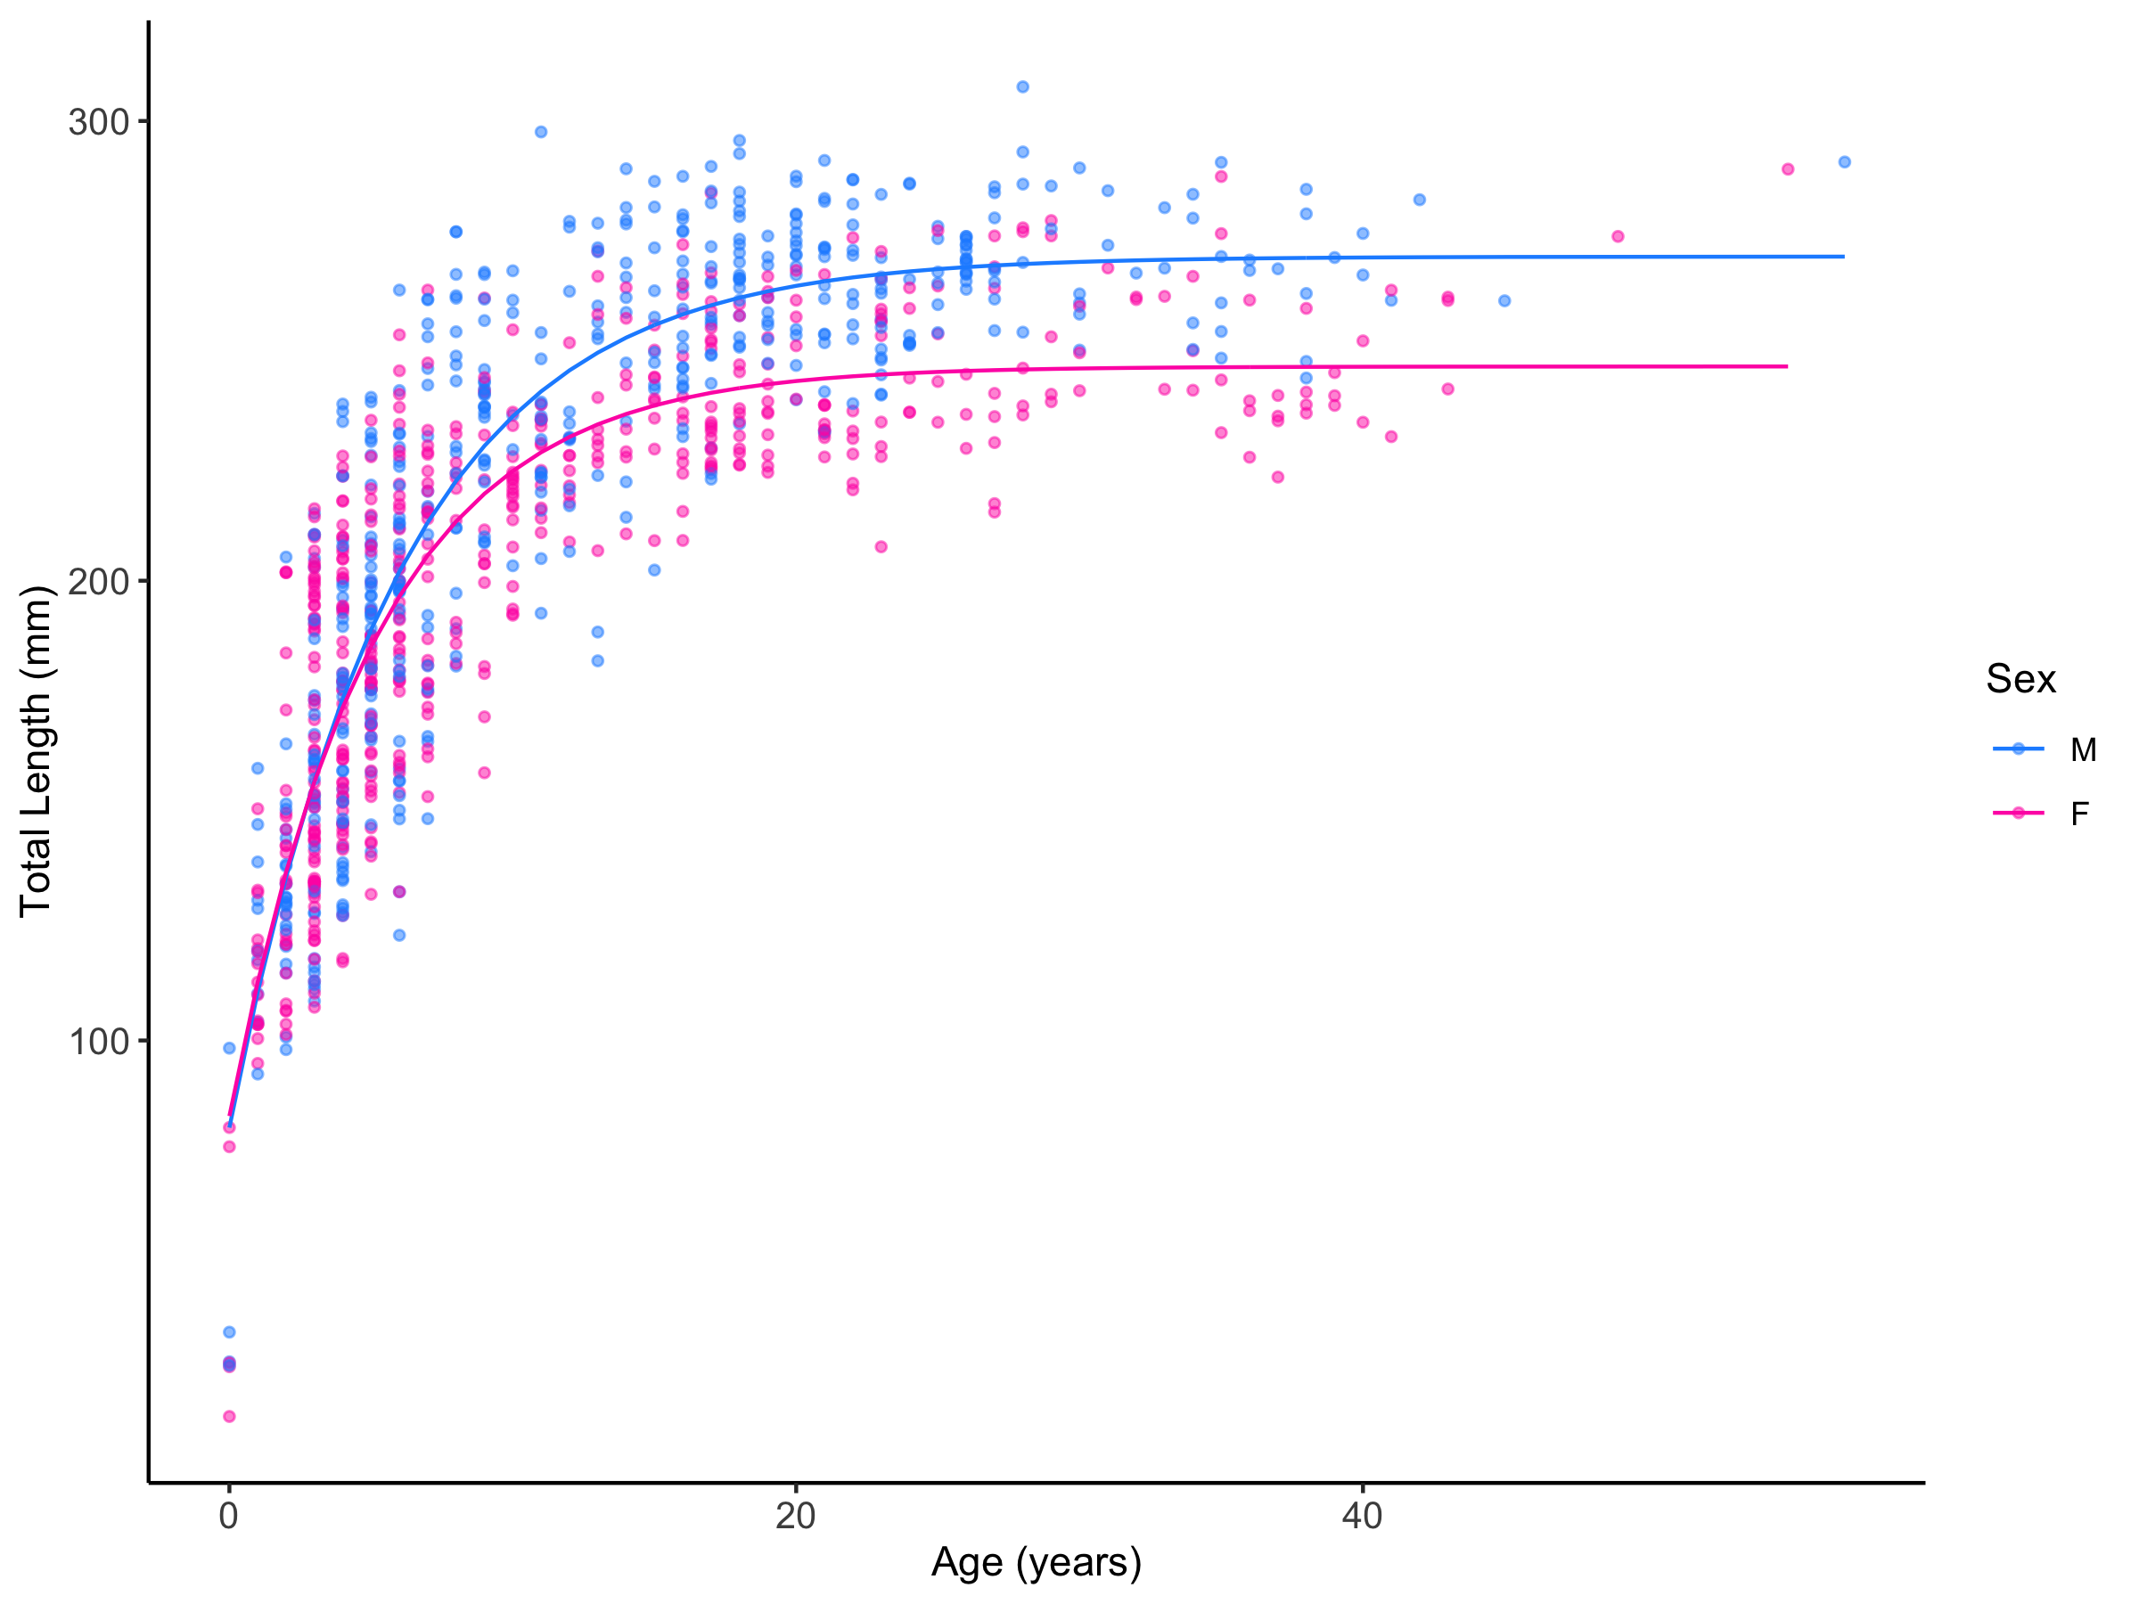
Figure S9. Von Bertalanffy growth curves for male and female Garibaldi (Hypsypops rubicundus) fitted using maximum likelihood estimation. Males are denoted in blue and females are denoted in fuchsia.

Table S7. Life history parameters for Garibaldi (Hypsypops rubicundus) from artificial and natural reefs pooled across all locations. Von Bertalanffy growth parameters were fitted using maximum likelihood estimation and 95% confidence intervals from the likelihood profile. L∞ is mean asymptotic total length in mm, k is the yearly rate at which TL approaches L∞. The value of t₀ was fixed at -2.1 years. T_{max} represents the maximum age, or oldest individual in the population, T_{max 25%} represents the mean age of the oldest 25% of fish collected, and T_{max 10%} represents the mean age of the oldest 10% of fish collected.

Population |  |  | Parameters and 95% Confidence Intervals |  |  |  |  |  | Longevity
Reef Type | n | Size  (TL mm) | L∞  (mm) | 95% CI | K  (yr⁻¹) | 95% CI | σ | 95% CI | T_{max} | T_{max10%} | T_{max25%}
Artificial | 298 | 98 - 298 | 276 | 271 - 281 | 0.17 | 0.16 - 0.19 | 23 | 22 - 25 | 49 | 31 | 26
Natural | 732 | 18 - 307 | 252 | 249 - 255 | 0.19 | 0.18 - 0.19 | 24 | 23 - 25 | 57 | 35 | 27

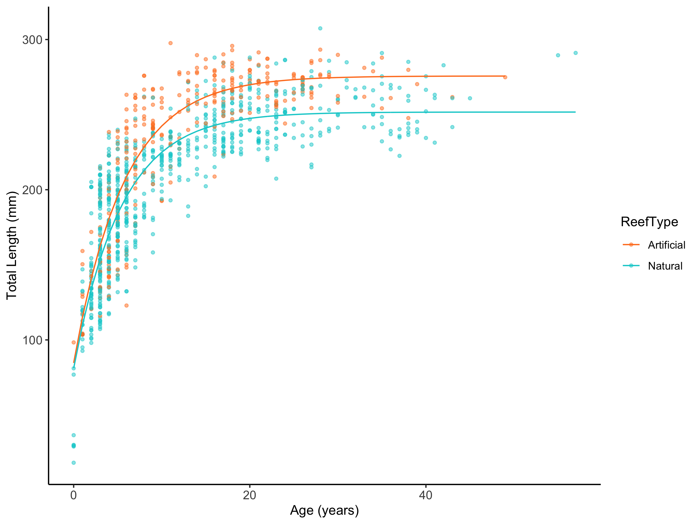
Figure S10. Von Bertalanffy growth curves for Garibaldi (Hypsypops rubicundus) from natural and artificial reefs fitted using maximum likelihood estimation. Fish from natural reefs are denoted in teal and artificial reefs are denoted in orange.
Table S8. Life history parameters for Garibaldi (Hypsypops rubicundus) from warm, intermediate, and cool sites pooled across locations. Von Bertalanffy growth parameters were fitted using maximum likelihood estimation and 95% confidence intervals from the likelihood profile. L∞ is mean asymptotic total length in mm, k is the yearly rate at which TL approaches L∞. The value of t₀ was fixed at -2.1 years. T_{max} represents the maximum age, or oldest individual in the population, T_{max 25%} represents the mean age of the oldest 25% of fish collected, and T_{max 10%} represents the mean age of the oldest 10% of fish collected.
Population |  |  | Parameters and 95% Confidence Intervals |  |  |  |  |  | Longevity
Temp | n | Size  (TL mm) | L∞  (mm) | 95% CI | K  (yr⁻¹) | 95% CI | σ | 95% CI | T_{max} | T_{max10%} | T_{max25%}
Intermediate | 419 | 77 - 298 | 264 | 260 - 268 | 0.18 | 0.17 - 0.19 | 23 | 21 - 24 | 49 | 32 | 25
Warm | 459 | 29 - 296 | 258 | 254 - 262 | 0.16 | 0.15 - 0.17 | 23 | 21 - 24 | 45 | 34 | 27
Cool | 152 | 18 - 307 | 271 | 264 - 279 | 0.20 | 0.19 - 0.22 | 25 | 23 - 28 | 57 | 36 | 28
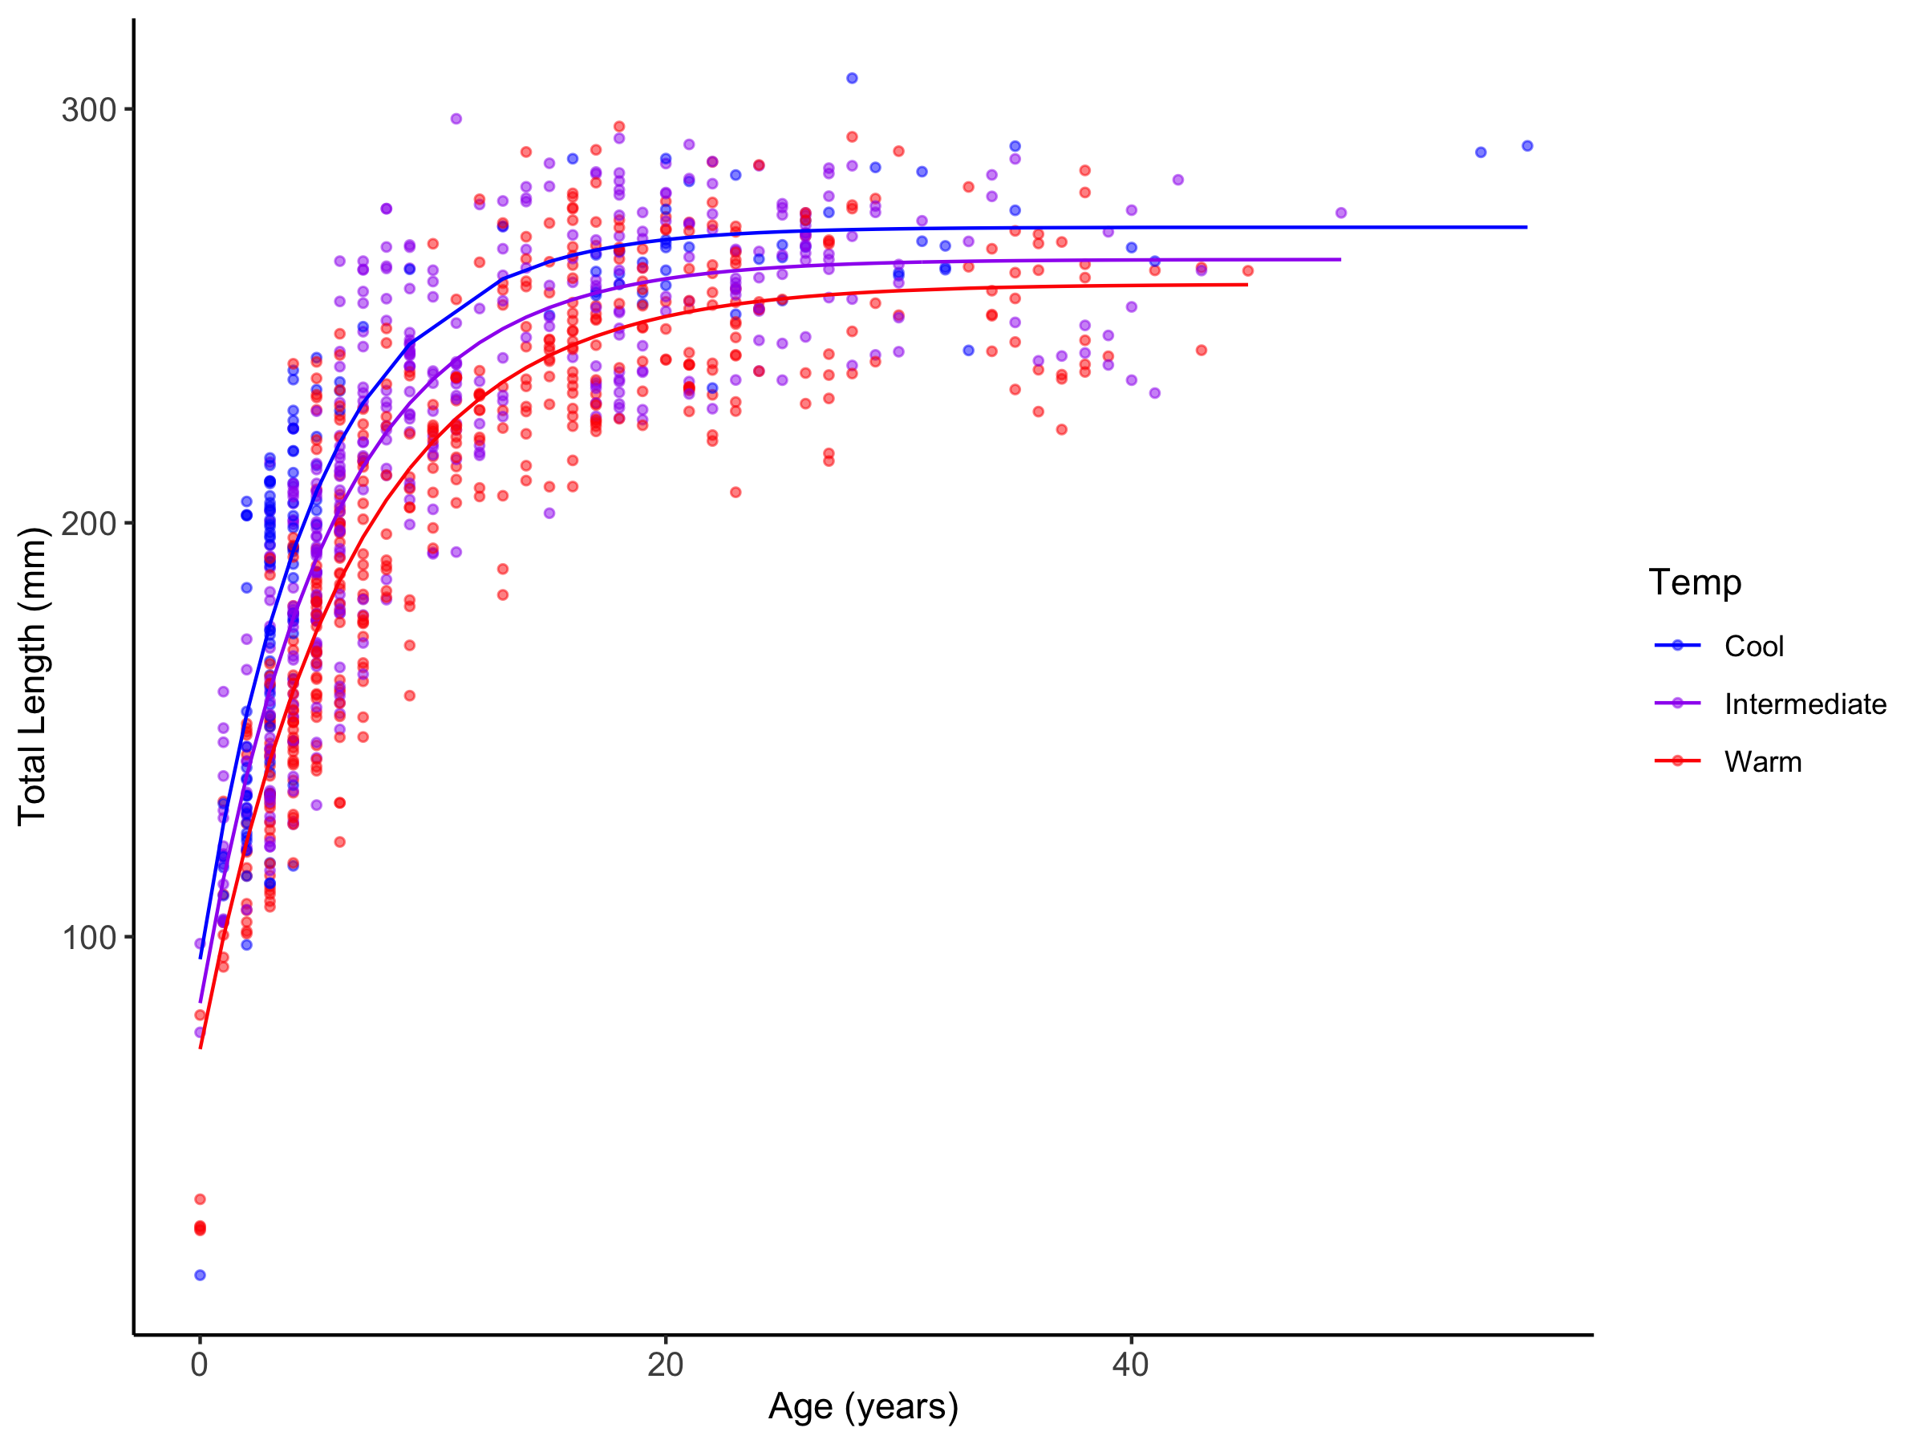Figure S11. Von Bertalanffy growth curves for Garibaldi (Hypsypops rubicundus) from warm (red), intermediate (purple), and cool (blue) sites pooled across locations fitted using maximum likelihood estimation.

Table S9. Life history parameters for Garibaldi (Hypsypops rubicundus)from island and mainland sites pooled across locations. Von Bertalanffy growth parameters were fitted using maximum likelihood estimation and 95% confidence intervals from the likelihood profile. L∞ is mean asymptotic total length in mm, k is the yearly rate at which TL approaches L∞. The value of t₀ was fixed at -2.1 years. T_{max} represents the maximum age, or oldest individual in the population, T_{max 25%} represents the mean age of the oldest 25% of fish collected, and T_{max 10%} represents the mean age of the oldest 10% of fish collected.
Population |  |  | Parameters and 95% Confidence Intervals |  |  |  |  |  | Longevity
Location | n | Size  (TL mm) | L∞  (mm) | 95% CI | K  (yr⁻¹) | 95% CI | σ | 95% CI | T_{max} | T_{max10%} | T_{max25%}
Mainland | 588 | 77 - 298 | 264 | 260 - 268 | 0.17 | 0.16 - 0.18 | 25 | 23 - 26 | 49 | 31 | 24
Island | 442 | 18 - 307 | 255 | 251 - 259 | 0.19 | 0.18 - 0.20 | 25 | 23 - 27 | 57 | 37 | 29
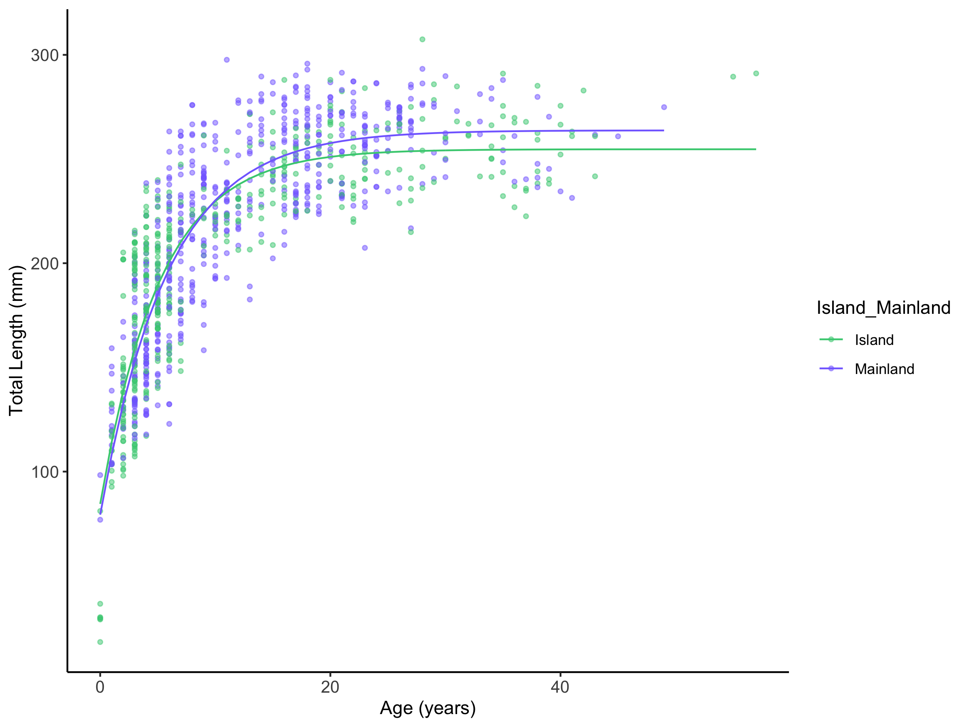Figure S12. Von Bertalanffy growth curves for Garibaldi (Hypsypops rubicundus) from island (green) and island (purple) sites pooled across locations fitted using maximum likelihood estimation.

Table S10. Life history parameters for male and female Garibaldi (Hypsypops rubicundus) from artificial and natural reef sites pooled across locations. L∞ is mean asymptotic total length in mm, k is the yearly rate at which TL approaches L∞. The value of t₀ was fixed at -2.1 years. T_{max} represents the maximum age, or oldest individual in the population, T_{max 25%} represents the mean age of the oldest 25% of fish collected, and T_{max 10%} represents the mean age of the oldest 10% of fish collected.
Population |  |  |  | Parameters and 95% Confidence Intervals |  |  |  |  |  | Longevity
Reef Type | Sex | n | Size  (TL mm) | L∞  (mm) | 95%  CI | k  (yr⁻¹) | 95%  CI | σ | 95%  CI | T_{max} | T_{max10%} | T_{max25%}
Artificial | M | 185 | 98 - 298 | 279 | 273 - 285 | 0.18 | 0.16 - 0.19 | 24 | 22 - 27 | 39 | 29 | 26
 | F | 113 | 103 - 288 | 267 | 259 - 275 | 0.18 | 0.16 - 0.2 | 21 | 19 - 24 | 49 | 31 | 24
Natural | M | 322 | 29 - 307 | 264 | 259 - 269 | 0.17 | 0.16 - 0.18 | 23 | 21 - 24 | 57 | 33 | 27
 | F | 410 | 18 - 290 | 241 | 237 - 245 | 0.20 | 0.19 - 0.21 | 24 | 22 - 25 | 55 | 35 | 27
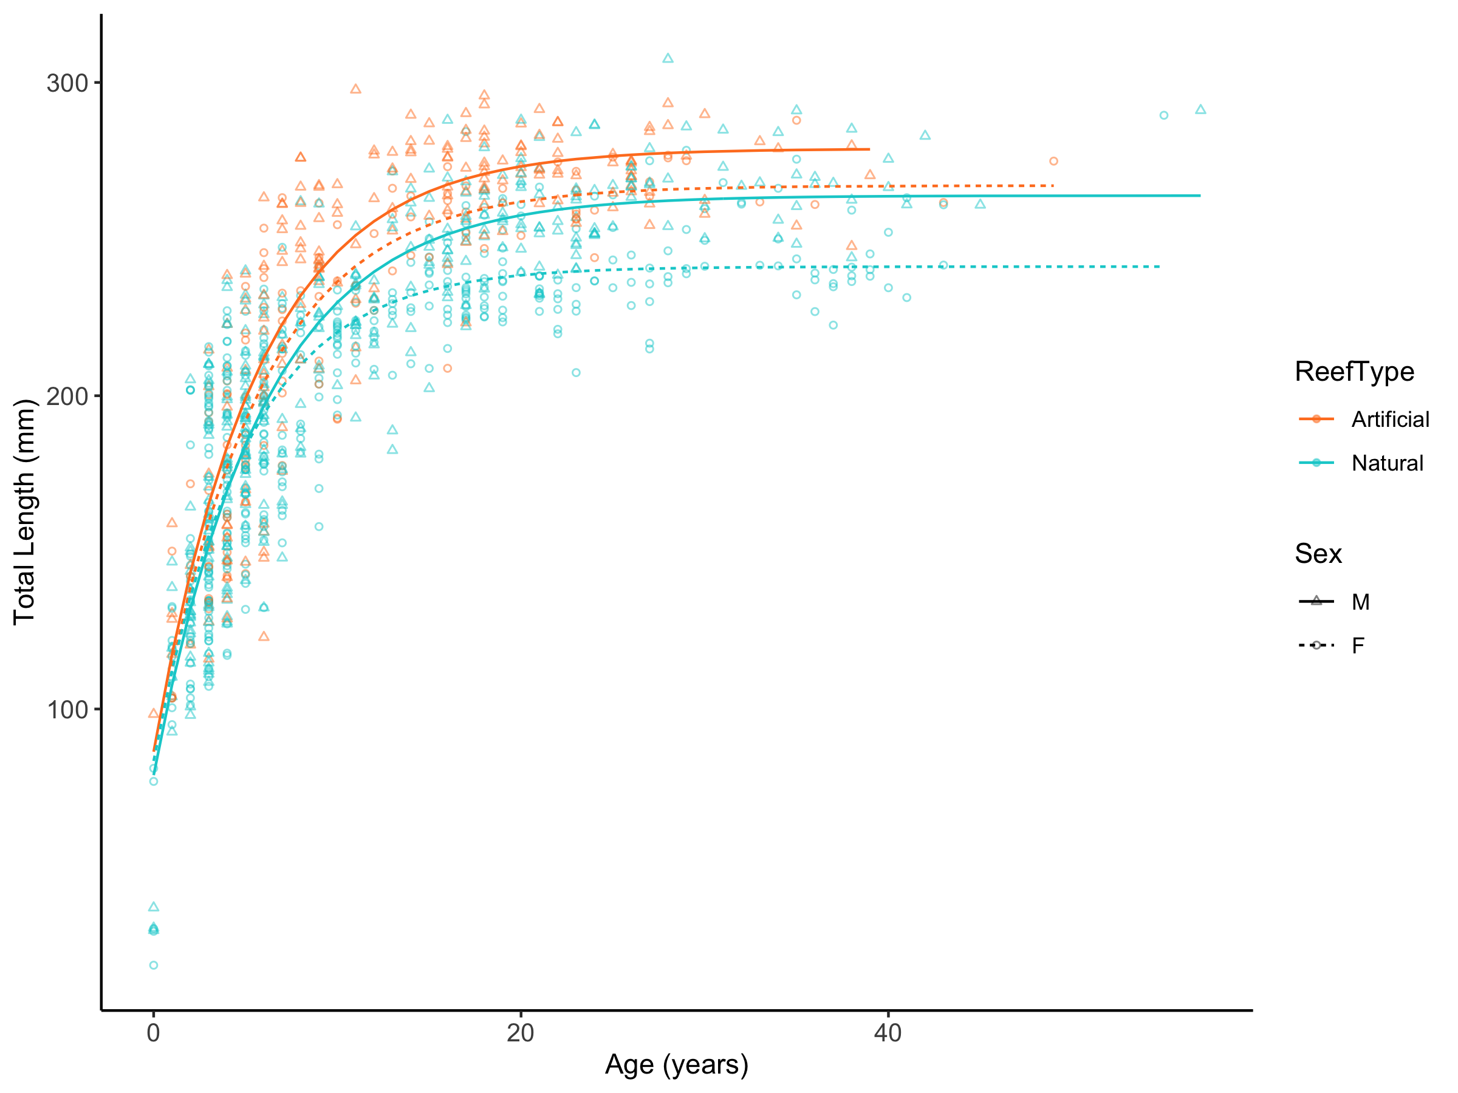Figure S13. Von Bertalanffy growth curves for male and female Garibaldi (Hypsypops rubicundus) from artificial and natural reef sites pooled across locations fitted using maximum likelihood estimation. Fish from natural reefs are denoted in teal and females are denoted in orange.

Table S11. Life history parameters for Garibaldi (Hypsypops rubicundus) from natural reef island sites and artificial and natural reef mainland sites pooled across locations. Von Bertalanffy growth parameters were fitted using maximum likelihood estimation and 95% confidence intervals from the likelihood profile. L∞ is mean asymptotic total length in mm, k is the yearly rate at which TL approaches L∞. The value of t₀ was fixed at -2.1 years. T_{max} represents the maximum age, or oldest individual in the population, T_{max 25%} represents the mean age of the oldest 25% of fish collected, and T_{max 10%} represents the mean age of the oldest 10% of fish collected.
Population |  |  |  | Parameters and 95% Confidence Intervals |  |  |  |  |  | Longevity
Island/  Mainland | Reef Type | n | Size (TL mm) | L∞  (mm) | 95% CI | k  (yr⁻¹) | 95% CI | σ | 95%  CI | T_{max} | T_{max10%} | T_{max25%}
Island | Natural | 442 | 18 - 307 | 255 | 251 - 259 | 0.19 | 0.18 - 0.20 | 25 | 23 - 27 | 57 | 37 | 29
Mainland | Natural | 290 | 77 - 286 | 250 | 246 - 255 | 0.17 | 0.16 - 0.18 | 20 | 19 - 22 | 45 | 30 | 24
 | Artificial | 298 | 98 - 298 | 276 | 271 - 281 | 0.17 | 0.16 - 0.19 | 23 | 22 - 25 | 49 | 31 | 26
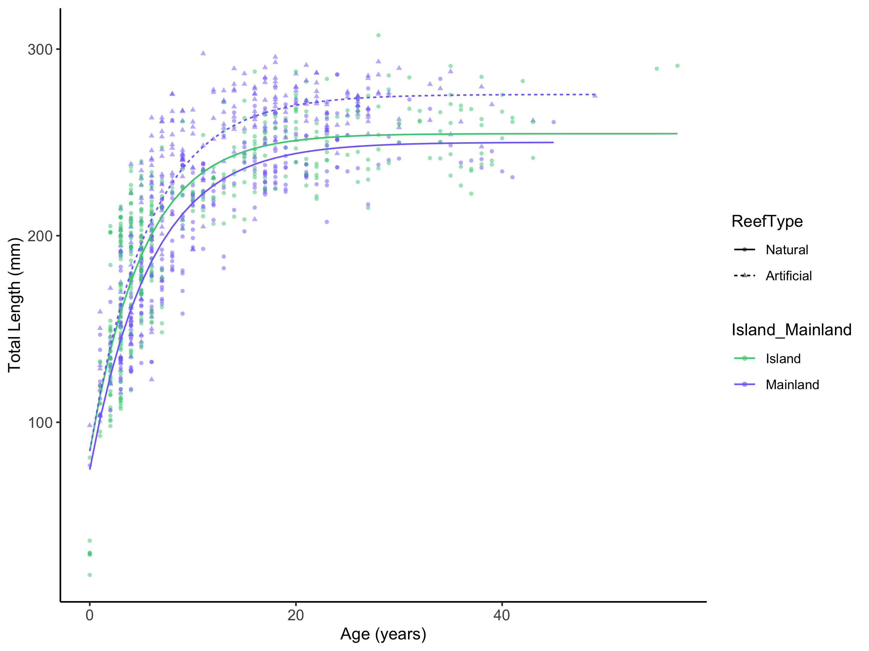Figure S14. Von Bertalanffy growth curves for Garibaldi (Hypsypops rubicundus) from island (green) and mainland (purple) artificial (dashed) and natural (solid) reef sites pooled across locations fitted using maximum likelihood estimation.
Population |  |  |  | Parameters and 95% Confidence Intervals |  |  |  |  |  | Longevity
Temp | Sex | n | Size  (TL mm) | L∞  (mm) | 95% CI | k  (yr⁻¹) | 95% CI | σ | 95%  CI | T_{max} | T_{max10%} | T_{max25%}
Cool | M | 65 | 98 - 307 | 280 | 269 - 290 | 0.18 | 0.17 - 0.20 | 24 | 20 - 29 | 57 | 36 | 28
 | F | 87 | 18 - 290 | 264 | 253 - 275 | 0.22 | 0.20 - 0.25 | 26 | 22 - 30 | 55 | 35 | 26
Intermediate | M | 219 | 98 - 298 | 274 | 269 - 279 | 0.18 | 0.17 - 0.19 | 22 | 20 - 24 | 42 | 30 | 26
 | F | 200 | 77 - 288 | 249 | 243 - 255 | 0.20 | 0.18 - 0.21 | 21 | 19 - 23 | 49 | 34 | 25
Warm | M | 223 | 29 - 296 | 268 | 263 - 275 | 0.15 | 0.14 - 0.16 | 23 | 21 - 26 | 45 | 34 | 26
 | F | 236 | 29 - 278 | 246 | 241 - 251 | 0.17 | 0.16 - 0.18 | 20 | 18 - 21 | 43 | 34 | 27
Table S12. Life history parameters for male and female Garibaldi (Hypsypops rubicundus) from warm, intermediate and cool sites pooled across locations. Von Bertalanffy growth parameters were fitted using maximum likelihood estimation and 95% confidence intervals from the likelihood profile. L∞ is mean asymptotic total length in mm, k is the yearly rate at which TL approaches L∞. The value of t₀ was fixed at -2.1 years. T_{max} represents the maximum age, or oldest individual in the population, T_{max 25%} represents the mean age of the oldest 25% of fish collected, and T_{max 10%} represents the mean age of the oldest 10% of fish collected.
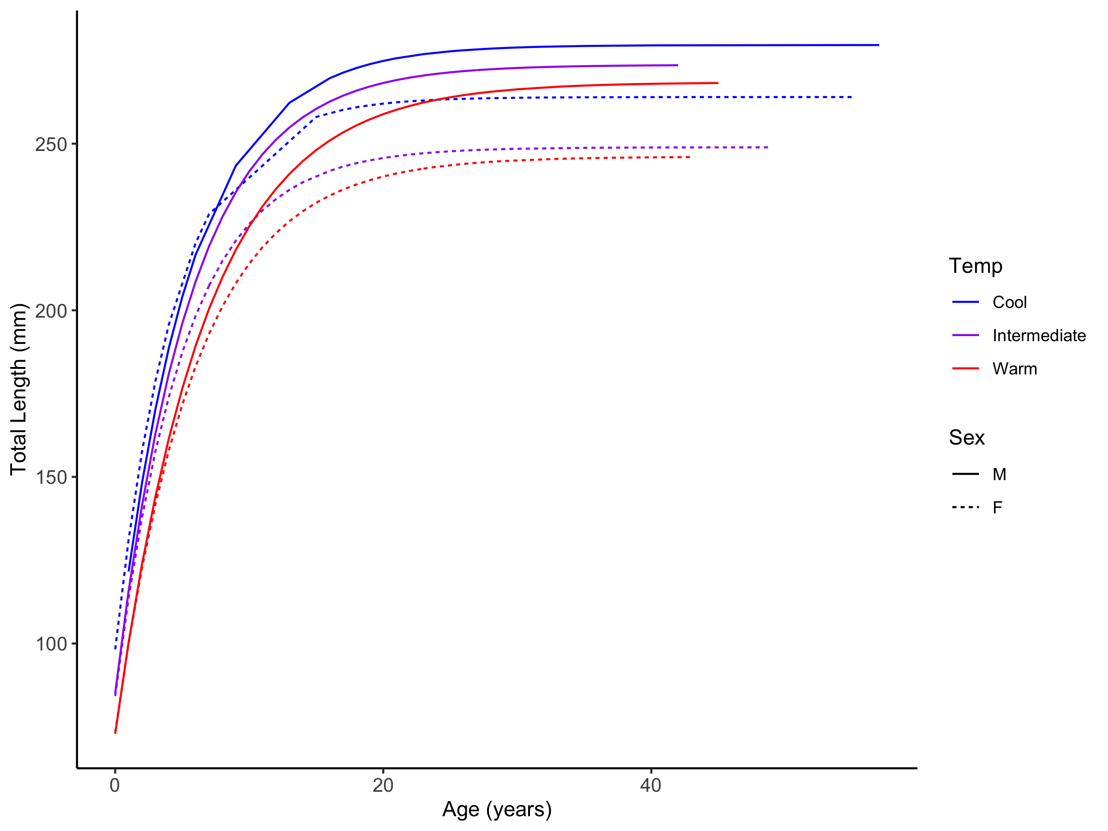
Figure S15. Von Bertalanffy growth curves for male (solid) and female (dashed) Garibaldi (Hypsypops rubicundus) from warm (red), intermediate (purple), and cool (blue) sites pooled across locations fitted using maximum likelihood estimation.
Table S13. Life history parameters for Garibaldi (Hypsypops rubicundus) from warm, intermediate and cool artificial and natural reef sites pooled across locations. Von Bertalanffy growth parameters were fitted using maximum likelihood estimation and 95% confidence intervals from the likelihood profile. L∞ is mean asymptotic total length in mm, k is the yearly rate at which TL approaches L∞. The value of t₀ was fixed at -2.1 years. T_{max} represents the maximum age, or oldest individual in the population, T_{max 25%} represents the mean age of the oldest 25% of fish collected, and T_{max 10%} represents the mean age of the oldest 10% of fish collected.
Population |  |  |  | Parameters and 95% Confidence Intervals |  |  |  |  |  |  | Longevity
Temp | Reef Type | n | Size (TL mm) |  | L∞  (mm) | 95% CI | k  (yr⁻¹) | 95% CI | σ | 95% CI | T_{max} | T_{max10%} | T_{max25%}
Cool | Natural | 152 | 18 - 307 |  | 271 | 264 - 279 | 0.20 | 0.19 - 0.22 | 25 | 23 - 28 | 57 | 36 | 28
Intermediate | Natural | 243 | 76 - 286 |  | 252 | 247 - 257 | 0.19 | 0.18 - 0.2 | 19 | 18 - 21 | 43 | 34 | 26
 | Artificial | 176 | 98 - 298 |  | 275 | 269 - 281 | 0.19 | 0.17 - 0.2 | 22 | 21 - 25 | 49 | 30 | 26
Warm | Natural | 337 | 29 - 286 |  | 251 | 247 - 255 | 0.16 | 0.15 - 0.16 | 18 | 18 - 20 | 45 | 34 | 28
 | Artificial | 122 | 120 - 296 |  | 278 | 270 - 286 | 0.16 | 0.15 - 0.17 | 22 | 20 - 26 | 43 | 30 | 25
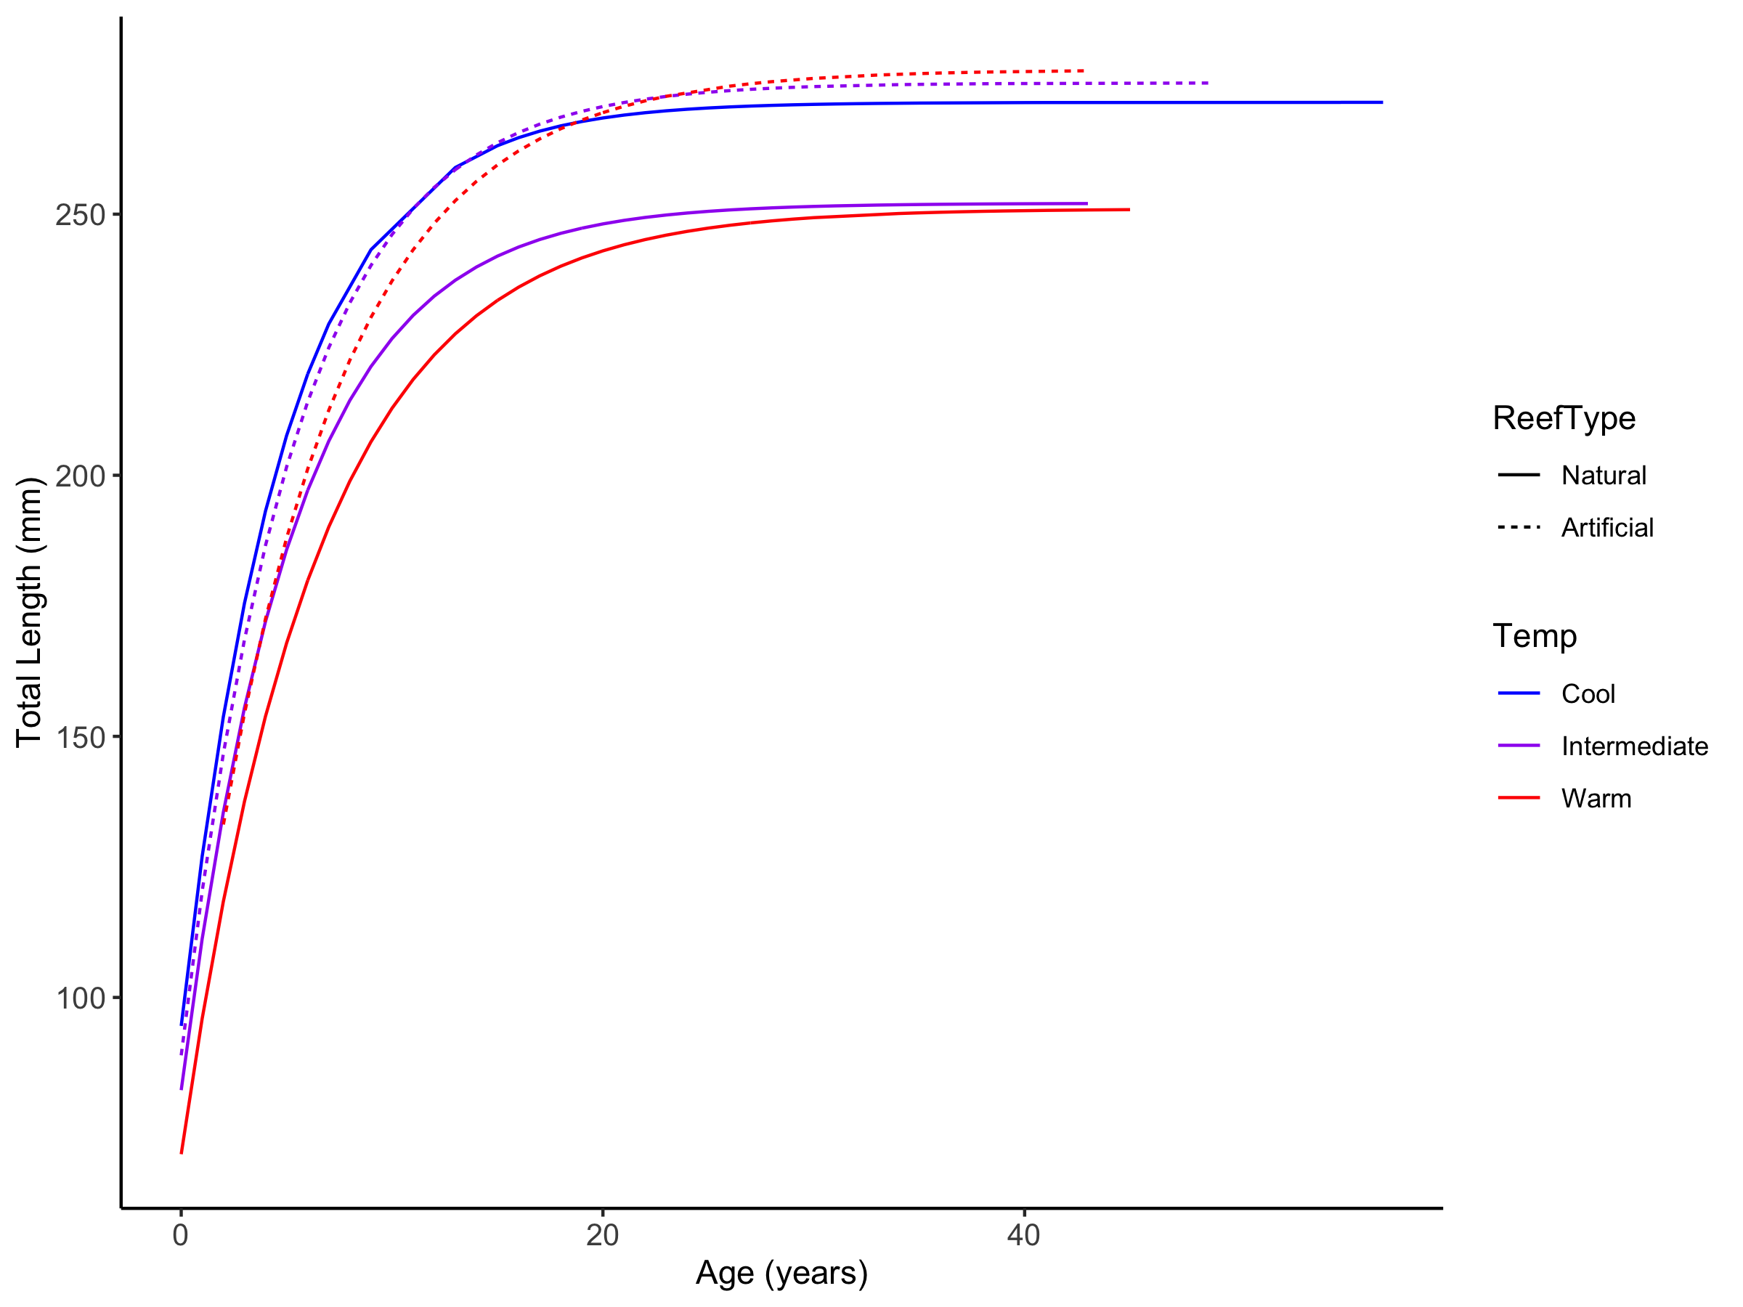
Figure S16. Von Bertalanffy growth curves for Garibaldi (Hypsypops rubicundus) from warm (red), intermediate (purple), and cool (blue) natural (solid) and artificial (dashed) reef sites pooled across locations fitted using maximum likelihood estimation
Table S14. Life history parameters for male and female Garibaldi (Hypsypops rubicundus) from mainland and island artificial and natural reef sites pooled across locations. Von Bertalanffy growth parameters were fitted using maximum likelihood estimation and 95% confidence intervals from the likelihood profile. L∞ is mean asymptotic total length in mm, k is the yearly rate at which TL approaches L∞. The value of t₀ was fixed at -2.1 years. T_{max} represents the maximum age, or oldest individual in the population, T_{max 25%} represents the mean age of the oldest 25% of fish collected, and T_{max 10%} represents the mean age of the oldest 10% of fish collected.

Population |  |  |  |  | Parameters and 95% Confidence Intervals |  |  |  |  |  | Longevity
Island/  Mainland | Reef Type | Sex | n | Size (TL mm) | L∞  (mm) | 95% CI | k  (yr⁻¹) | 95% CI | σ | 95% CI | T_{max} | T_{max10%} | T_{max25%}
Mainland | Natural | M | 120 | 119 - 286 | 263 | 256 - 271 | 0.16 | 0.15 - 0.18 | 21 | 19 - 24 | 45 | 28 | 25
Island | Natural | M | 202 | 29- 307 | 265 | 260 - 271 | 0.17 | 0.16 - 0.18 | 23 | 21 - 25 | 57 | 37 | 28
Mainland | Natural | F | 170 | 76- 284 | 239 | 235 - 245 | 0.17 | 0.17 - 0.19 | 17 | 15 - 19 | 41 | 32 | 23
Island | Natural | F | 240 | 18- 290 | 245 | 239 - 251 | 0.21 | 0.20 - 0.23 | 26 | 23 - 28 | 55 | 37 | 29
Mainland | Artificial | M | 185 | 98 - 298 | 279 | 273 - 285 | 0.18 | 0.16 - 0.19 | 24 | 22 - 27 | 39 | 29 | 26
Mainland | Artificial | F | 113 | 103 - 288 | 267 | 259 - 275 | 0.18 | 0.16 - 0.20 | 21 | 19 - 24 | 49 | 31 | 24

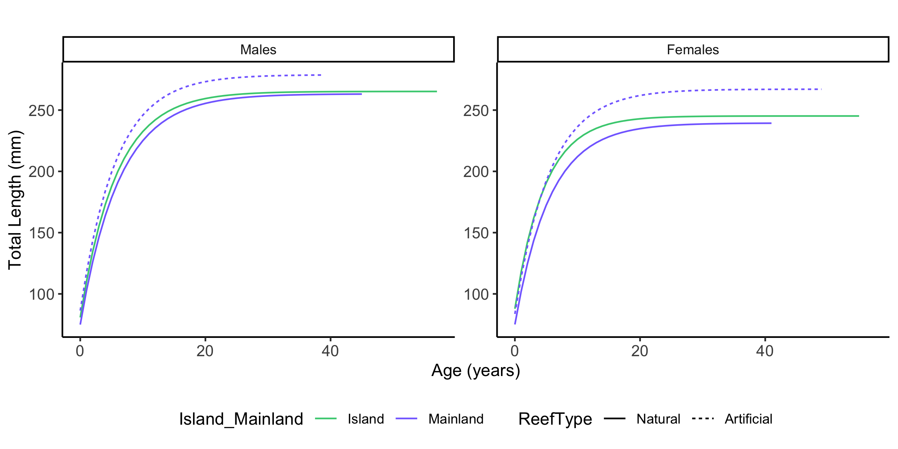Figure S17. Von Bertalanffy growth curves for male and female Garibaldi (Hypsypops rubicundus) from island (green) and mainland (purple) artificial (dashed) and natural (solid) reef sites pooled across locations fitted using maximum likelihood estimation.
Table S15. Life history parameters for male and female Garibaldi (Hypsypops rubicundus) from warm, intermediate, and cool artificial and natural reef sites pooled across locations. Von Bertalanffy growth parameters were fitted using maximum likelihood estimation and 95% confidence intervals from the likelihood profile. L∞ is mean asymptotic total length in mm, k is the yearly rate at which TL approaches L∞. The value of t₀ was fixed at -2.1 years. T_{max} represents the maximum age, or oldest individual in the population, T_{max 25%} represents the mean age of the oldest 25% of fish collected, and T_{max 10%} represents the mean age of the oldest 10% of fish collected.

Population |  |  |  |  | Parameters and 95% Confidence Intervals |  |  |  |  |  | Longevity
Temp | Reef Type | Sex | n | Size (TL mm) | L∞  (mm) | 95% CI | k  (yr⁻¹) | 95% CI | σ | 95%CI | T_{max} | T_{max10%} | T_{max25%}
Cool | Natural | M | 65 | 98 - 307 | 280 | 269 - 290 | 0.18 | 0.17 - 0.20 | 24 | 20 - 29 | 57 | 36 | 28
 |  | F | 87 | 18 - 290 | 264 | 253 - 275 | 0.22 | 0.20 - 0.25 | 26 | 22 - 30 | 55 | 35 | 26
Intermediate | Natural | M | 107 | 119 - 286 | 266 | 259 - 273 | 0.17 | 0.16 - 0.19 | 17 | 15 - 20 | 42 | 31 | 25
 |  | F | 136 | 76 - 284 | 241 | 236 - 247 | 0.20 | 0.19 - 0.22 | 18 | 16 - 21 | 43 | 35 | 25
 | Artificial | M | 112 | 98 - 298 | 277 | 271 - 284 | 0.19 | 0.18 - 0.21 | 22 | 20 - 26 | 39 | 30 | 26
 |  | F | 64 | 103 - 288 | 266 | 256 - 277 | 0.19 | 0.17 - 0.21 | 22 | 19 - 26 | 49 | 30 | 25
Warm | Natural | M | 150 | 29 - 286 | 262 | 256 - 269 | 0.15 | 0.14 - 0.16 | 20 | 18 - 22 | 45 | 35 | 28
 |  | F | 187 | 29 - 278 | 241 | 237 - 245 | 0.17 | 0.16 - 0.18 | 16 | 15 - 18 | 43 | 35 | 28
 | Artificial | M | 73 | 120 - 296 | 283 | 272 - 294 | 0.15 | 0.14 - 0.18 | 24 | 21 - 29 | 38 | 27 | 23
 |  | F | 49 | 132 - 277 | 269 | 258 - 281 | 0.17 | 0.15 - 0.19 | 20 | 16 - 24 | 43 | 34 | 24

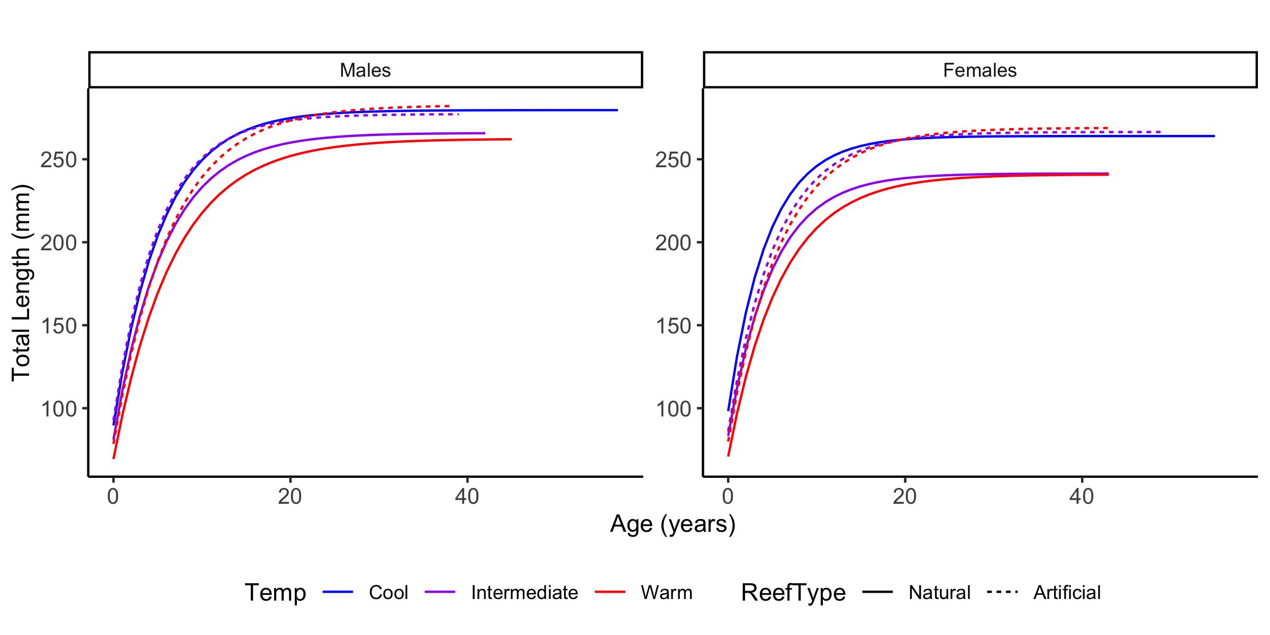Figure S18. Von Bertalanffy growth curves for male and female Garibaldi (Hypsypops rubicundus) from warm (red), intermediate (purple), and cool (blue) natural (solid) and artificial (dashed) reef sites pooled across locations fitted using maximum likelihood estimation.

Table S16. Life history parameters for Garibaldi (Hypsypops rubicundus) from each location. Von Bertalanffy growth parameters were fitted using maximum likelihood estimation and 95% confidence intervals from the likelihood profile. L∞ is mean asymptotic total length in mm, k is the yearly rate at which TL approaches L∞. The value of t₀ was fixed at -2.1 years. T_{max} represents the maximum age, or oldest individual in the population, T_{max 25%} represents the mean age of the oldest 25% of fish collected, and T_{max 10%} represents the mean age of the oldest 10% of fish collected.

Population |  |  | Parameters and 95% Confidence Intervals |  |  |  |  |  | Longevity
Location | n | Size  (TL mm) | L∞  (mm) | 95% CI | k  (yr⁻¹) | 95% CI | σ | 95% CI | T_{max} | T_{max10%} | T_{max25%}
Anacapa & Santa Cruz Isands | 152 | 18 - 307 | 271 | 264 - 279 | 0.20 | 0.19 - 0.22 | 25 | 23 - 28 | 57 | 36 | 28
Santa Barbara Island | 69 | 122 - 283 | 259 | 248 - 272 | 0.18 | 0.16 - 0.21 | 20 | 17 - 23 | 43 | 37 | 16
Santa Catalina Island | 150 | 29 - 285 | 257 | 252 - 262 | 0.16 | 0.15 - 0.17 | 18 | 16 - 20 | 43 | 38 | 30
North Palos Verdes | 132 | 107 - 298 | 262 | 254 - 271 | 0.20 | 0.18 - 0.22 | 26 | 23 - 30 | 38 | 28 | 22
South Palos Verdes | 103 | 77 - 278 | 251 | 246 - 257 | 0.24 | 0.22 - 0.26 | 18 | 16 - 20 | 41 | 30 | 22
Orange County | 122 | 118 - 296 | 273 | 265 - 282 | 0.13 | 0.11 - 0.14 | 22 | 20 - 25 | 45 | 34 | 28
San Clemente Island | 71 | 126 - 247 | 237 | 229 - 244 | 0.19 | 0.17 - 0.21 | 17 | 15 - 20 | 36 | 30 | 25
North San Diego | 116 | 118 - 276 | 257 | 246 - 269 | 0.18 | 0.16 - 0.20 | 26 | 23 - 29 | 26 | 20 | 18
South San Diego | 115 | 122 - 288 | 278 | 273 - 283 | 0.13 | 0.12 - 0.14 | 15 | 13 - 17 | 49 | 34 | 29
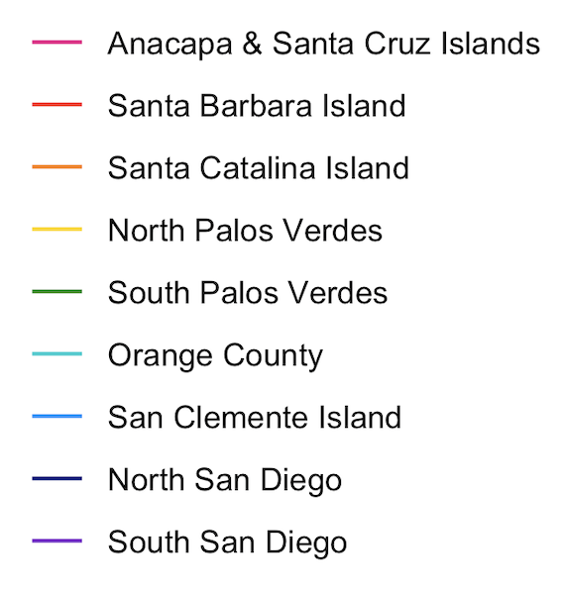
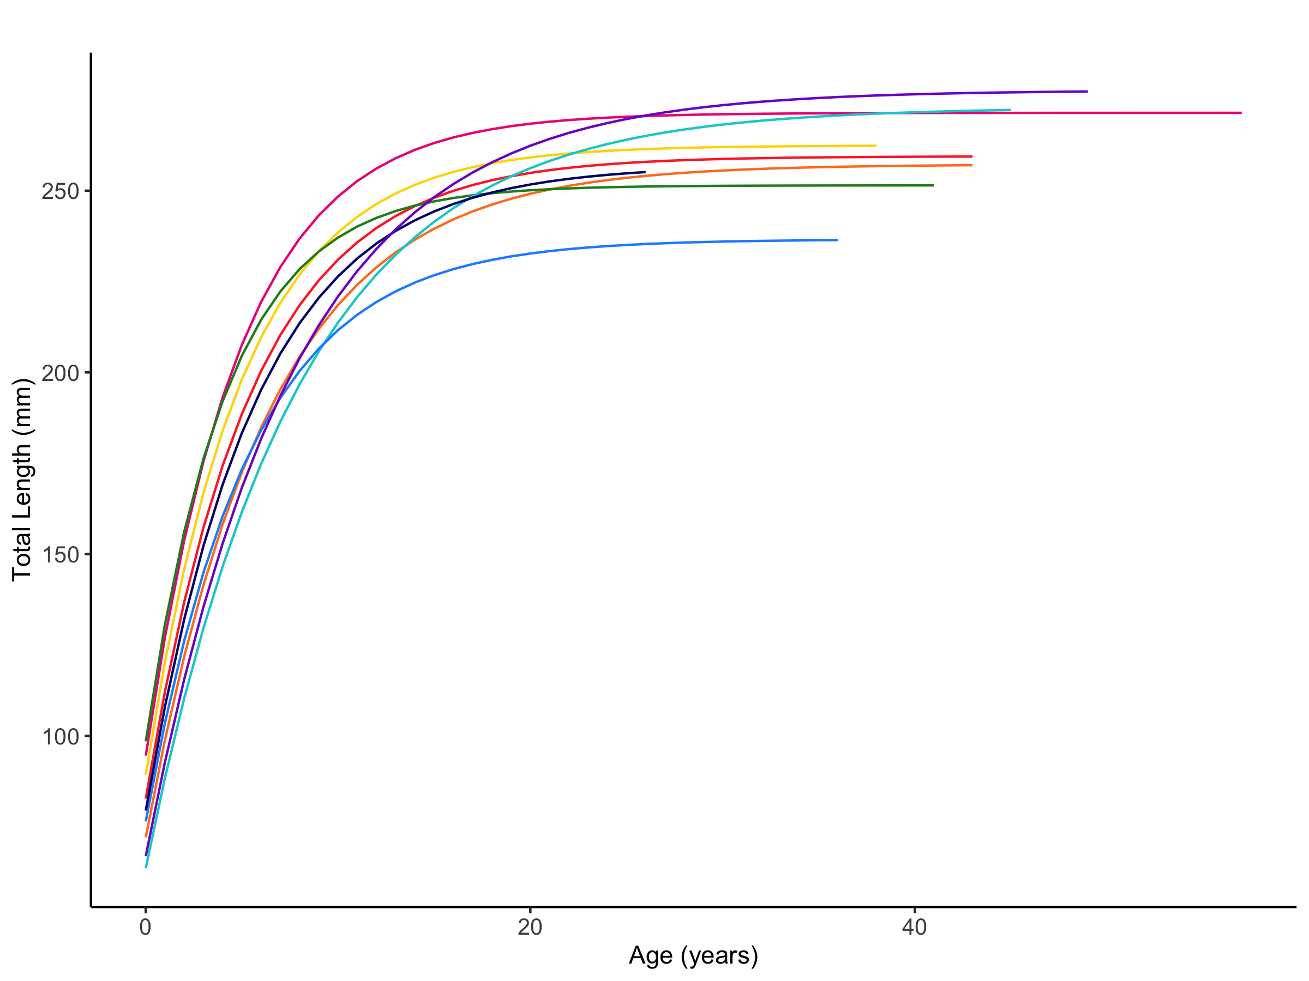
Location
Figure S19. Von Bertalanffy growth curve of Garibaldi (Hypsypops rubicundus) by location fitted using maximum likelihood estimation.

Table S17. Life history parameters for male and female Garibaldi (Hypsypops rubicundus) from each location. Von Bertalanffy growth parameters were fitted using maximum likelihood estimation and 95% confidence intervals from the likelihood profile. L∞ is mean asymptotic total length in mm, k is the yearly rate at which TL approaches L∞. The value of t₀ was fixed at -2.1 years. T_{max} represents the maximum age, or oldest individual in the population, T_{max 25%} represents the mean age of the oldest 25% of fish collected, and T_{max 10%} represents the mean age of the oldest 10% of fish collected.

Population |  |  |  | Parameters and 95% Confidence Intervals |  |  |  |  |  | Longevity
Location | Sex | n | Size (TL mm) | L∞ (mm) | 95% CI | k (yr⁻¹) | 95% CI | σ | 95% CI | T_{max} | T_{max10%} | T_{max25%}
Anacapa & Santa Cruz Islands | M | 65 | 98 - 307 | 280 | 269 - 290 | 0.18 | 0.17 - 0.20 | 24 | 20 - 29 | 57 | 36 | 28
 | F | 87 | 18 - 290 | 264 | 253 - 275 | 0.22 | 0.20 - 0.25 | 26 | 22 - 30 | 55 | 35 | 26
Santa Barbara Island | M | 32 | 139 - 283 | 269 | 257 - 282 | 0.17 | 0.15 - 0.19 | 14 | 11 - 18 | 42 | 34 | 26
 | F | 37 | 122 - 261 | 248 | 228 - 268 | 0.20 | 0.16 - 0.25 | 23 | 18 - 29 | 43 | 37 | 14
Santa Catalina Island | M | 72 | 29 - 285 | 266 | 259 - 273 | 0.15 | 0.13 - 0.16 | 18 | 15 - 21 | 41 | 37 | 31
 | F | 78 | 29 - 278 | 247 | 241 - 254 | 0.17 | 0.16 - 0.18 | 17 | 14 - 20 | 43 | 38 | 31
North Palos Verdes | M | 69 | 116 - 298 | 280 | 268 - 294 | 0.18 | 0.15 - 0.21 | 26 | 22 - 31 | 35 | 27 | 21
 | F | 63 | 107 - 284 | 247 | 238 - 256 | 0.22 | 0.19 - 0.25 | 22 | 19 - 26 | 38 | 28 | 22
South Palos Verdes | M | 48 | 98 - 278 | 258 | 252 - 265 | 0.26 | 0.23 - 0.29 | 14 | 12 - 18 | 24 | 22 | 19
 | F | 55 | 76 - 256 | 242 | 235 - 250 | 0.23 | 0.21 - 0.26 | 16 | 14 - 20 | 41 | 36 | 26
Orange County | M | 67 | 120 - 296 | 284 | 273 - 296 | 0.12 | 0.11 - 0.14 | 22 | 19 - 26 | 45 | 33 | 27
 | F | 55 | 118 - 277 | 256 | 246 - 266 | 0.14 | 0.12 - 0.16 | 19 | 16 - 23 | 43 | 34 | 29
San Clemente Island | M | 33 | 148 - 247 | 242 | 228 - 259 | 0.19 | 0.15 - 0.24 | 19 | 15 - 25 | 23 | 22 | 16
 | F | 38 | 126 - 241 | 234 | 227 - 241 | 0.17 | 0.16 - 0.20 | 13 | 11 - 17 | 36 | 32 | 28
North San Diego | M | 51 | 123 - 276 | 264 | 247 - 284 | 0.18 | 0.15 - 0.22 | 28 | 23 - 34 | 25 | 21 | 19
 | F | 65 | 118 - 273 | 251 | 238 - 265 | 0.17 | 0.15 - 0.20 | 22 | 19 - 27 | 26 | 20 | 17
South San Diego | M | 70 | 132 - 287 | 280 | 274 - 286 | 0.13 | 0.12 - 0.15 | 15 | 13 - 18 | 39 | 33 | 29
 | F | 45 | 122 - 288 | 268 | 259 - 277 | 0.14 | 0.12 - 0.15 | 13 | 11 - 17 | 49 | 34 | 27

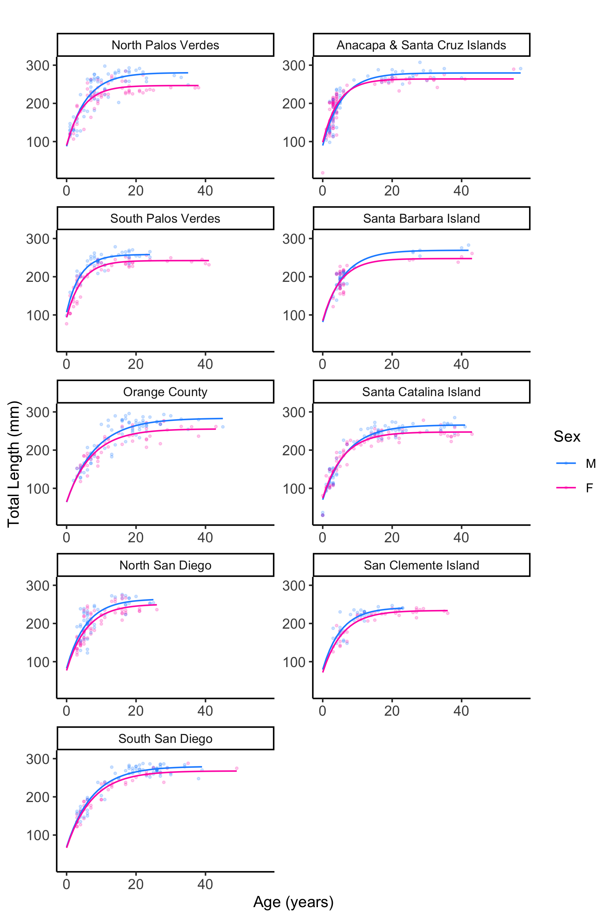
Figure S20. Von Bertalanffy growth curves of male (blue) and female (fuchsia) Garibaldi (Hypsypops rubicundus) by location fitted using maximum likelihood estimation.

Table S18. Life history parameters for Garibaldi (Hypsypops rubicundus) from artificial and natural reefs from each location. Von Bertalanffy growth parameters were fitted using maximum likelihood estimation and 95% confidence intervals from the likelihood profile. L∞ is mean asymptotic total length in mm, k is the yearly rate at which TL approaches L∞. The value of t₀ was fixed at -2.1 years. T_{max} represents the maximum age, or oldest individual in the population, T_{max 25%} represents the mean age of the oldest 25% of fish collected, and T_{max 10%} represents the mean age of the oldest 10% of fish collected.

Population |  |  |  | Parameters and 95% Confidence Intervals |  |  |  |  |  | Longevity
Location | Reef Type | n | Size  (TL mm) | L∞  (mm) | 95% CI | k  (yr⁻¹) | 95% CI | σ | 95% CI | T_{max} | T_{max10%} | T_{max25%}
Anacapa & Santa Cruz Islands | Natural | 152 | 18 - 307 | 271 | 264 - 279 | 0.20 | 0.19 - 0.22 | 25 | 23 - 28 | 57 | 36 | 28
Santa Barbara Island | Natural | 69 | 122 - 283 | 259 | 248 - 272 | 0.18 | 0.16 - 0.21 | 20 | 17 - 23 | 43 | 37 | 16
Santa Catalina Island | Natural | 150 | 29 - 285 | 257 | 252 - 262 | 0.16 | 0.15 - 0.17 | 18 | 16 - 20 | 43 | 38 | 30
North Palos Verdes | Natural | 80 | 107 - 284 | 247 | 239 - 254 | 0.20 | 0.18 - 0.22 | 18 | 16 - 22 | 38 | 32 | 25
 | Artificial | 52 | 116 - 298 | 295 | 283 - 308 | 0.18 | 0.16 - 0.21 | 20 | 17 - 25 | 22 | 20 | 18
South Palos Verdes | Natural | 46 | 76 - 270 | 246 | 239 - 253 | 0.23 | 0.20 - 0.25 | 16 | 14 - 20 | 41 | 37 | 27
 | Artificial | 57 | 98 - 278 | 260 | 251 - 269 | 0.23 | 0.21 - 0.26 | 17 | 14 - 20 | 24 | 19 | 16
Orange County | Natural | 57 | 118 - 286 | 257 | 246 - 268 | 0.12 | 0.11 - 0.14 | 18 | 15 - 22 | 45 | 32 | 27
 | Artificial | 65 | 120 - 296 | 283 | 276 - 291 | 0.14 | 0.12 - 0.15 | 16 | 14 - 20 | 43 | 35 | 29
San Clemente Island | Natural | 71 | 126 - 247 | 237 | 229 - 244 | 0.19 | 0.17 - 0.21 | 17 | 15 - 20 | 36 | 30 | 25
North San Diego | Natural | 59 | 118 - 254 | 246 | 236 - 257 | 0.16 | 0.15 - 0.18 | 16 | 14 - 20 | 26 | 23 | 20
 | Artificial | 57 | 123 - 276 | 271 | 254 - 291 | 0.18 | 0.15 - 0.22 | 26 | 22 - 32 | 20 | 18 | 16
South San Diego | Natural | 48 | 122 - 286 | 271 | 261 - 282 | 0.14 | 0.13 - 0.16 | 16 | 13 - 19 | 34 | 27 | 22
 | Artificial | 67 | 134 - 288 | 280 | 275 - 286 | 0.12 | 0.11 - 0.13 | 14 | 12 - 17 | 49 | 36 | 30

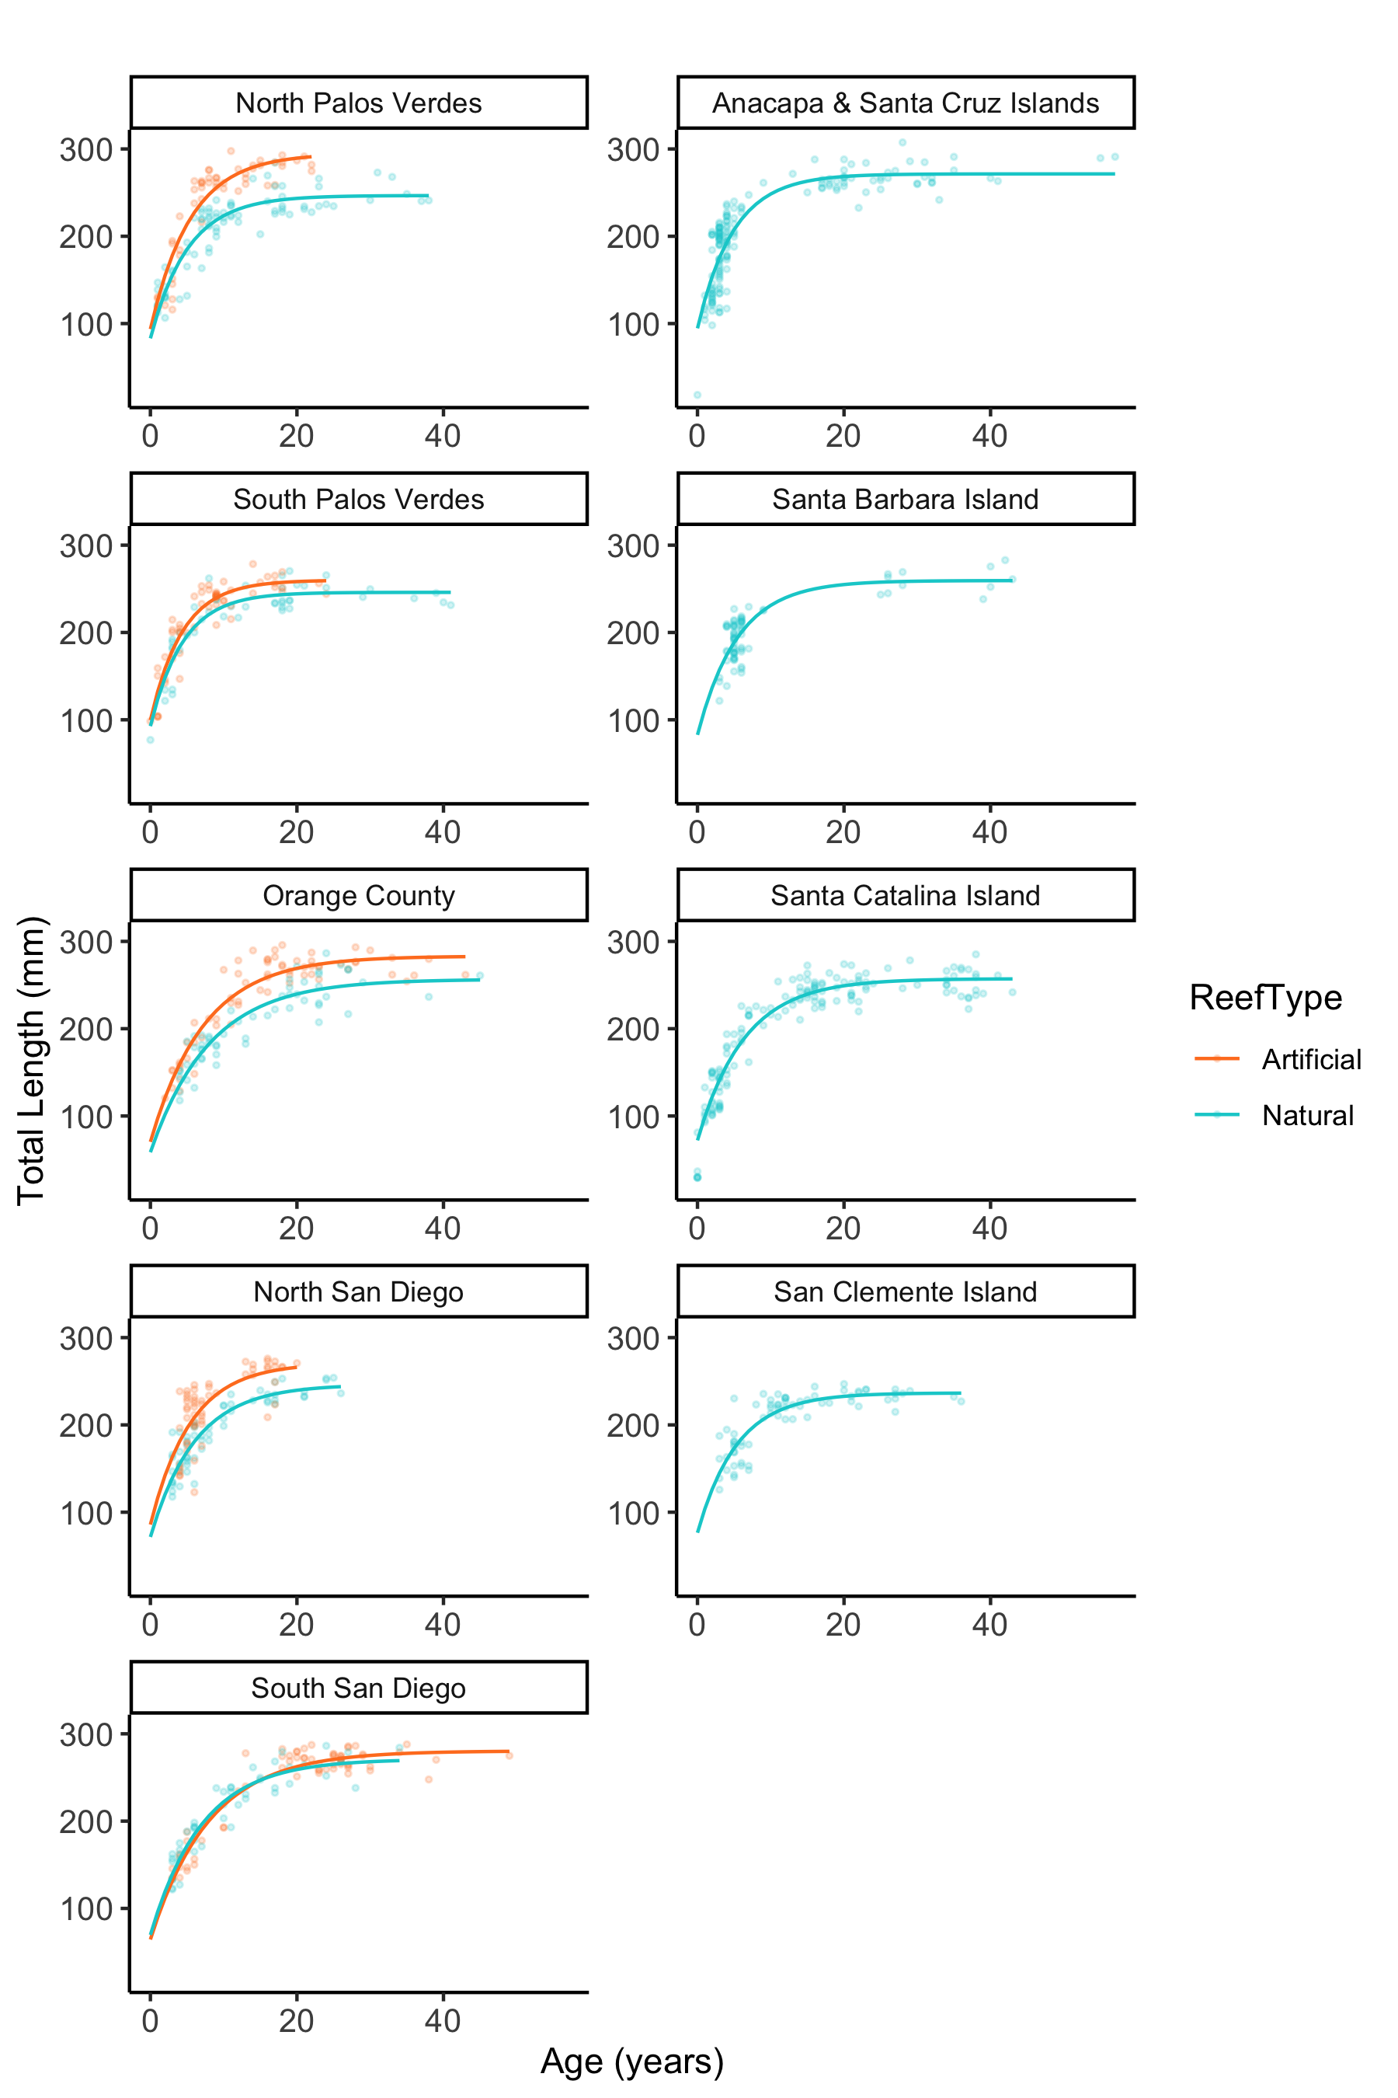
Figure S21. Von Bertalanffy growth curves of Garibaldi (Hypsypops rubicundus) at artificial (orange) and natural (teal) reefs by location fitted using maximum likelihood estimation.

References
Aburto-Oropeza, O., Paredes, G., Mascareñas-Osorio, I., and Sala, E. (2010). Climatic influence on reef fish recruitment and fisheries. Marine Ecology Progress Series 410, 283-287.
Allen, L.G., and Andrews, A.H. (2012). Bomb radiocarbon dating and estimated longevity of Giant Sea Bass (Stereolepis gigas). Bulletin, Southern California Academy of Sciences 111(1), 1-14.
Allen, L.G., Hovey, T.E., Love, M., and Smith, J.T.W. (1995). The life history of the spotted sand bass (Paralabrax maculatofasciatus) within the Southern California Bight. California Cooperative Oceanic Fisheries Investigations Report, 193-203.
Beamish, R., and McFarlane, G. (1983). The forgotten requirement for age validation in fisheries biology. Transactions of the American Fisheries Society 112(6), 735-743.
Beukers, J.S., and Jones, G.P. (1998). Habitat complexity modifies the impact of piscivores on a coral reef fish population. Oecologia 114(1), 50-59.
Beverton, R.J.H., and Holt, S.J. (1959). "A review of the lifespans and mortality rates of fish in nature, and their relation to growth and other physiological characteristics," in Ciba Foundation Symposium ‐ The Lifespan of Animals (Colloquia on Ageing).), 142-180.
Cailliet, G.M., Andrews, A., Burton, E., Watters, D., Kline, D., and Ferry-Graham, L. (2001). Age determination and validation studies of marine fishes: do deep-dwellers live longer? Experimental Gerontology 36(4-6), 739-764.
Campana, S.E. (2001). Accuracy, precision and quality control in age determination, including a review of the use and abuse of age validation methods. Journal of Fish Biology 59, 197-242.
Cappo, M., Eden, P., Newman, S.J., and Robertson, S. (2000). A new approach to validation of periodicity and timing of opaque zone formation in the otoliths of eleven species of Lutjanus from the central Great Barrier Reef. Fishery Bulletin 98, 474-488.
Choat, J.H., and Robertson, D.R. (2002). Age-based studies. Coral reef fishes: dynamics and diversity in a complex ecosystem. Academic Press, San Diego, California, USA, 57-80.
Clarke, T.A. (1970). Territorial Behavior and Population Dynamics of a Pomacentrid Fish, the Garibaldi Hypsypops rubicunda. Ecological Society of America 40(2), 189-212.
Cook, G.S. (2011). Rocky Reef Fish Connectivity: Patterns, Processes, and Population Dynamics. Ph.D., University of California, San Diego.
DeMartini, E.E., Barnett, A.M., Johnson, T.D., and Ambrose, R.F. (1994). Growth and Production Estimates for Biomass-Dominant Fishes on a Southern California Artificial Reef. Bulletin of Marine Science 55, 484-500.
Durazo, R., and Baumgartner, T. (2002). Evolution of oceanographic conditions off Baja California: 1997–1999. Progress in Oceanography 54(1-4), 7-31.
Fowler, A.J., and Doherty, P.J. (1992). Validation of annual growth increments in the Otoliths of two species of Damselfish from the Southern Great Barrier Reef. Marine and Freshwater Research 43(5), 1057-1068. doi: https://doi.org/10.1071/MF9921057.
Hixon, M.A., and Jones, G.P. (2005). Competition, predation, and density‐dependent mortality in demersal marine fishes. Ecology 86(11), 2847-2859.
Johnson, T., Barnett, A., DeMartini, E., Craft, L., Ambrose, R., and Purcell, L. (1994). Fish production and habitat utilization on a southern California artificial reef. Bulletin of Marine Science 55(2-3), 709-723.
Kinney, M., Wells, R., and Kohin, S. (2016). Oxytetracycline age validation of an adult shortfin mako shark Isurus oxyrinchus after 6 years at liberty. Journal of Fish Biology 89(3), 1828-1833.
Limbaugh, C. (1964). Notes on the Life History of Two Californian Pomacentrid: Garibaldis, Hypsypops rubicunda (Girard), and Blacksmiths, Chromis punctipinnis (Cooper). Pacific Science 18, 41-50.
Love, M.S., Morris, P., McCrae, M., and Collins, R. (1990). Life history aspects of 19 rockfish species (Scorpaenidae: Sebastes) from the Southern California Bight. NOAA Technical Report NMFS 827, 38.
McFarlane, G.A., and Beamish, R.J. (1987). Selection of Dosages of Oxytetracycline for Age Validation Studies. Canadian Journal of Fisheries and Aquatic Sciences 44, 905-909.
McFarlane, G.A., and Beamish, R.J. (1990). Effect of an External Tag on Growth of Sabiefish (Anoplopoma fimbria), and Consequences to Mortality and Age at Maturity. Canadian Journal of Fisheries and Aquatic Sciences 47(8), 1551-1557.
Sakagawa, G.T., and Kimura, M. (1976). Growth of laboratory-reared northern anchovy, Engraulis mordax, from southern California. Fish. Bull 74(2), 271-279.
Selkoe, K.A., Vogel, A., and Gaines, S.D. (2007). Effects of ephemeral circulation on recruitment and connectivity of nearshore fish populations spanning Southern and Baja California. Marine Ecology Progress Series 351, 209-220.
Smith, S.E., Mitchell, R.A., and Fuller, D. (2003). Age-validation of a leopard shark (Triakis semifasciata) recaptured after 20 years. Fishery Bulletin 101(1), 194-198.
Trip, E.D.L., Choat, J.H., Wilson, D.T., and Robertson, D.R. (2008). Inter-oceanic analysis of demographic variation in a widely distributed Indo-Pacific coral reef fish. Marine Ecology Progress Series 373, 97-109.
Victor, B.C., Wellington, G.M., Robertson, D.R., and Ruttenberg, B.I. (2001). The effect of the El Niño–Southern Oscillation event on the distribution of reef-associated labrid fishes in the eastern Pacific Ocean. Bulletin of Marine Science 69(1), 279-288.
Wells, R., Smith, S.E., Kohin, S., Freund, E., Spear, N., and Ramon, D.A. (2013). Age validation of juvenile shortfin mako (Isurus oxyrinchus) tagged and marked with oxytetracycline off southern California. Fishery Bulletin 111(2), 147-160.
Williams, J.P., Claisse, J.T., Pondella, D.J., Medeiros, L., Valle, C.F., and Shane, M.A. (2012). Patterns of life history and habitat use of an important recreational fishery species, Spotfin Croaker, and their potential fishery implications. Marine and Coastal Fisheries 4(1), 71-84.

