**Differential fitness-relevant effects of natural and synthetic microfibers following early life exposure in fish and invertebrates**

*Siddiqui S*, Hutton SJ, Dickens JM, Pedersen EI, Harper S, Brander SM*

Oregon State University, Corvallis, OR-97333

*Corresponding author [susanne.brander@oregonstate.edu](mailto:susanne.brander@oregonstate.edu)

Author Address: Marine Studies Building, Oregon State University, Newport, Oregon 97350.

**SI Table 1** Technical quality (QA/QC) for particle characterization, experimental design and risk assessment.

|  |  |  |  |
| --- | --- | --- | --- |
| Particle Characterization | | | |
| 1. Particle Size | Cotton microfibers (MF) (60-120 um), Polyester microfibers (80-100 um), Polypropylene microfibers (80-120 um) | | |
| 2. Particle Shape | irregular length fibers | | |
| 3. Polymer Type | Cotton, polyester and polypropylene | | |
| 4. Source of MP | Rope | | |
| 5. Data Reporting | Reported as particles per ml | | |
| Experimental Design | | | |
| 7. Laboratory Preparation | Cotton lab coats were used. Measures were taken to eliminate laboratory sources of MP contamination | | |
| 8. Verification of Background Contamination | Background MF contamination samples were taken (White= 10% of total fiber type) | | |
| 9. Verification of Exposure | Internalization visualized with microscopy | | |
| 10. Homogeneity of Exposure | MF counts taken of wastewater to verify homogeneity of exposures | | |
| 11. Exposure Assessment | Exposure and internalization verified using microscopy | | |
| 12. Replication | Mysids: n=9, Silversides: n=6 | | |
| Applicability in ecological risk assessment | | | |
| 13. End Points | Mortality, Behavior, Growth, Internalization | | |
| 14. Presence of Natural (food) Particles | Yes (Mysids fed brine shrimp, Silversides fed algae fish food) | | |
| 15. Reporting of Effect Thresholds | Threshold assessed using dose-response curves. ECx values reported | | |
| 16. Quality of Dose-Response Relationship | A treatment control plus 3 MF concentrations were assessed | | |
| Ecological Relevance | | | |
| 17. Concentration Range Tested | The lowest concentration (3 particles/ml) was selected based on measured environmental concentrations | | |
| 18. Aging and Biofouling | Particles were not aged or befouled. They were dispersed using NOM. | | |
| 19. Diversity of MP tested | 3 type MF based on composition was used in a range of sizes | | |
| 20. Exposure Time | Mysids: 7 days, Silversides: 96 hours | | |
| 21. Nominal Water Concentration (particles/ml ± Std error) | | | |
| Exposure concentration | 3 ,10, 30 | | |
| Nominal Concentration | 3 ± 6 | 10±1.5 | 30± 3 |

**SI Table 2** Water quality data for Mysid Shrimp (*A. bahia*) larvae during experimental period. ND = Not Detected. All values reported as mean ± standard error.

|  |  |  |  |  |  |
| --- | --- | --- | --- | --- | --- |
|  | pH | Dissolved Oxygen (mg/L) | Salinity (ppt) | Temperature  ºC | Ammonia  (ppm) |
| 15 ppt | 8.50 ± 0.043 | 7.29 ± 0.045 | 15.00 ± 0.001 | 23.04 ± 0.045 | 0.031 ± 0.012 |
| 20 ppt | 7.89 ± 0.057 | 6.8 ± 0.065 | 20.10 ± 0.021 | 22.84 ± 0.053 | 0.041 ± 0.012 |
| 25ppt | 8.45 ± 0.029 | 7.025 ± 0.043 | 25.99 ± 0.002 | 23.05 ± 0.050 | ND |

**SI Table 3** Water quality data for Silverside (*M. beryllina*) yolk sac larvae during experimental period. ND = Not Detected. All values reported as mean ± standard error.

|  |  |  |  |  |  |
| --- | --- | --- | --- | --- | --- |
|  | pH | Dissolved Oxygen (mg/L) | Salinity (ppt) | Temperature  ºC | Ammonia  (ppm) |
| 5 ppt | 8.26 ± 0.021 | 8.50 ± 0.069 | 5.06 ± 0.006 | 23.04 ± 0.055 | 0.012 ± 0.011 |
| 15 ppt | 8.20 ± 0.057 | 7.69 ± 0.033 | 15.09 ± 0.075 | 22.94 ± 0.053 | 0.035 ± 0.002 |
| 25ppt | 7.59 ± 0.063 | 7.98 ± 0.067 | 24.99 ± 0.001 | 23.01 ± 0.060 | ND |

**SI Table 4** Microfiber behavioral statistical results in Mysid shrimp (*A. bahia*) in comparison to control. *p < 0.05 (Dunnett’s test); ˄ represents increasing and ˅ represents decreasing from control.

|  |  |  |  |  |  |
| --- | --- | --- | --- | --- | --- |
| **Variables** | **MF Type** | **Concentration** | **Salinity (PSU)** | **Dark** | **Light** |
| Distance (Total) | Cotton | C1 | 15 | **˄\*** | **˄\*** |
| 20 | **˄\*** | - |
| 25 | **-** | **-** |
| C2 | 15 | **˄\*** | - |
| 20 | - | **˄\*** |
| 25 | - | - |
| C3 | 15 | **˄\*** | - |
| 20 | - | - |
| 25 | - | **˄\*** |
| Polyester | C1 | 15 | **˄\*** | **˄\*** |
| 20 | **˄\*** | **˄\*** |
| 25 | **˄\*** | **˄\*** |
| C2 | 15 | **˄\*** | **˄\*** |
| 20 | **˄\*** | **˄\*** |
| 25 | **˄\*** | - |
| C3 | 15 | **-** | - |
| 20 | **˄\*** | - |
| 25 | **-** | **˄\*** |
| Polypropylene | C1 | 15 | **˄\*** | - |
| 20 | - | **˄\*** |
| 25 | **˄\*** | **˄\*** |
| C2 | 15 | **˄\*** | **˄\*** |
| 20 | **˄\*** | **˄\*** |
| 25 | **˄\*** | **˄\*** |
| C3 | 15 | - | **˄\*** |
| 20 | - | **˄\*** |
| 25 | **˄\*** | **˄\*** |
| Angular velocity | Cotton | C1 | 15 | - | - |
| 20 | **˄\*** | - |
| 25 | - | **˄\*** |
| C2 | 15 | - | - |
| 20 | **˄\*** | - |
| 25 | - | **˄\*** |
| C3 | 15 | - | - |
| 20 | - | - |
| 25 | - | **˄\*** |
| Polyester | C1 | 15 | **˄\*** | - |
| 20 | **-** | - |
| 25 | **-** | **˄\*** |
| C2 | 15 | - | - |
| 20 | - | - |
| 25 | - | - |
| C3 | 15 | **˄\*** | **˄\*** |
| 20 | - | - |
| 25 | **˄\*** | - |
| Polypropylene | C1 | 15 | - | - |
| 20 | - | - |
| 25 | - | **˅\*** |
| C2 | 15 | - | - |
| 20 | - | - |
| 25 | - | **˅\*** |
| C3 | 15 | - | **˅\*** |
| 20 | **˄\*** | - |
| 25 | **˅\*** | **˅\*** |
| Velocity | Cotton | C1 | 15 | **˄\*** | - |
| 20 | **˅\*** | - |
| 25 | **˄\*** | - |
| C2 | 15 | **˄\*** | - |
| 20 | **˅\*** | **˄\*** |
| 25 | **˄\*** | **˄\*** |
| C3 | 15 | **˄\*** | - |
| 20 | **˅\*** | - |
| 25 | **˄\*** | - |
| Polyester | C1 | 15 | **˅\*** | **˄\*** |
| 20 | **˄\*** | **˄\*** |
| 25 | **˄\*** | **˄\*** |
| C2 | 15 | **˅\*** | **˄\*** |
| 20 | **˄\*** | **˄\*** |
| 25 | **˄\*** | **˄\*** |
| C3 | 15 | **˅\*** | - |
| 20 | **˄\*** | - |
| 25 | **˄\*** | **˄\*** |
| Polypropylene | C1 | 15 | **˄\*** | - |
| 20 | - | **˄\*** |
| 25 | **˄\*** | **˄\*** |
| C2 | 15 | - | **˄\*** |
| 20 | **˄\*** | **˄\*** |
| 25 | **˅\*** | **˄\*** |
| C3 | 15 | **˅\*** | - |
| 20 | **˅\*** | **˄\*** |
| 25 | **˅\*** | **˄\*** |
| Freezing | Cotton | C1 | 15 | **-** | **˄\*** |
| 20 | **-** | **˄\*** |
| 25 | **˄\*** | **˄\*** |
| C2 | 15 | - | - |
| 20 | **˄\*** | **˄\*** |
| 25 | **˄\*** | **˄\*** |
| C3 | 15 | **˄\*** | - |
| 20 | - | - |
| 25 | - | - |
| Polyester | C1 | 15 | - | **˄\*** |
| 20 | **˅\*** | **˄\*** |
| 25 | **-** | **˄\*** |
| C2 | 15 | **˅\*** | **˄\*** |
| 20 | **˄\*** | **˄\*** |
| 25 | **˄\*** | **˄\*** |
| C3 | 15 | - | - |
| 20 | **˅\*** | - |
| 25 | **˄\*** | **˄\*** |
| Polypropylene | C1 | 15 | **˄\*** | - |
| 20 | **˄\*** | **˄\*** |
| 25 | **˄\*** | **˄\*** |
| C2 | 15 | **˄\*** | **˄\*** |
| 20 | **˅\*** | **˄\*** |
| 25 | **˅\*** | **˄\*** |
| C3 | 15 | - | - |
| 20 | - | **˄\*** |
| 25 | - | **˄\*** |
| Movement | Cotton | C1 | 15 | **˄\*** | - |
| 20 | - | - |
| 25 | - | - |
| C2 | 15 | **˄\*** |  |
| 20 | - | - |
| 25 | - | - |
| C3 | 15 | **˄\*** | - |
| 20 | - | - |
| 25 | - | - |
| Polyester | C1 | 15 | **˄\*** | **˅\*** |
| 20 | - | **˅\*** |
| 25 | - | **˅\*** |
| C2 | 15 | **˄\*** | - |
| 20 | **˅\*** | - |
| 25 | - | - |
| C3 | 15 | - | **˄\*** |
| 20 | - | **˅\*** |
| 25 | - | - |
| Polypropylene | C1 | 15 | **˄\*** | **˅\*** |
| 20 | - | - |
| 25 | - | - |
| C2 | 15 | **˄\*** | - |
| 20 | - | - |
| 25 | - | - |
| C3 | 15 | **˄\*** | **˅\*** |
| 20 | **˅\*** | **˄\*** |
| 25 | - | - |
| In Zone Duration | Cotton | C1 | 15 | - | - |
| 20 | - | - |
| 25 | - | - |
| C2 | 15 | - |  |
| 20 | - | - |
| 25 | **˄\*** | - |
| C3 | 15 | **˄\*** | - |
| 20 | - | - |
| 25 | - | - |
| Polyester | C1 | 15 | **˅\*** | - |
| 20 | **˅\*** | **˅\*** |
| 25 | **˅\*** | - |
| C2 | 15 | **˅\*** | - |
| 20 | **˅\*** | - |
| 25 | - | - |
| C3 | 15 | **˅\*** | **˅\*** |
| 20 | - | - |
| 25 | - | - |
| Polypropylene | C1 | 15 | **˄\*** | **˅\*** |
| 20 | **˅\*** | - |
| 25 | - | - |
| C2 | 15 | **˄\*** | **˅\*** |
| 20 | **˅\*** | - |
| 25 | **˅\*** | - |
| C3 | 15 | **˄\*** | **˄\*** |
| 20 | - | **˅\*** |
| 25 | **˅\*** | **˅\*** |
| Meander | Cotton | C1 | 15 | - | **˅\*** |
| 20 | - | **˄\*** |
| 25 | **˄\*** | **˅\*** |
| C2 | 15 | - | **˅\*** |
| 20 | - | **˄\*** |
| 25 | **˄\*** | **˅\*** |
| C3 | 15 | - | **˅\*** |
| 20 | - | **˄\*** |
| 25 | **˄\*** | **˅\*** |
| Polyester | C1 | 15 | - | **˅\*** |
| 20 | - | **˄\*** |
| 25 | **˅\*** | **˅\*** |
| C2 | 15 | **˅\*** | **˅\*** |
| 20 | **˅\*** | **˄\*** |
| 25 | - | **˅\*** |
| C3 | 15 | - | **˅\*** |
| 20 | - | **˄\*** |
| 25 | **˅\*** | **˅\*** |
| Polypropylene | C1 | 15 | **˄\*** | **˅\*** |
| 20 | **˅\*** | **˄\*** |
| 25 | **˅\*** | **˅\*** |
| C2 | 15 | **˄\*** | **˅\*** |
| 20 | **˅\*** | **˄\*** |
| 25 | **˅\*** | **˅\*** |
| C3 | 15 | - | **˅\*** |
| 20 | **˅\*** | **˄\*** |
| 25 | **˅\*** | **˅\*** |
| Turn Angle | Cotton | C1 | 15 | - | - |
| 20 | **˄\*** | - |
| 25 | - | **˅\*** |
| C2 | 15 | - | - |
| 20 | **˄\*** | - |
| 25 | - | **˅\*** |
| C3 | 15 | - | - |
| 20 | - | - |
| 25 | - | **˅\*** |
| Polyester | C1 | 15 | **˄\*** | - |
| 20 | - | - |
| 25 | - | **˅\*** |
| C2 | 15 | - | - |
| 20 | - | - |
| 25 | - | - |
| C3 | 15 | **˄\*** | **˄\*** |
| 20 | - | - |
| 25 | - | - |
| Polypropylene | C1 | 15 | - | **˅\*** |
| 20 | - | - |
| 25 | - | **˅\*** |
| C2 | 15 | - | **˅\*** |
| 20 | - | - |
| 25 | - | **˅\*** |
| C3 | 15 | - | **˅\*** |
| 20 | - | - |
| 25 | - | **˅\*** |

**SI Table 5** Microfiber behavioral statistical results in Silverside (*M. beryllina*) in comparison to control. *p < 0.05 (Dunnett’s test); ˄ represents increasing and ˅ represents decreasing from control.

|  |  |  |  |  |  |
| --- | --- | --- | --- | --- | --- |
| **Variables** | **MF Type** | **Concentration** | **Salinity (PSU)** | **Dark** | **Light** |
| Distance (Total) | Cotton | C1 | 5 | **˄\*** | **˄\*** |
| 15 | **˄\*** | - |
| 25 | **˄\*** | **-** |
| C2 | 5 | **˄\*** | - |
| 15 | **˄\*** | **˄\*** |
| 25 | **˄\*** | - |
| C3 | 5 | **˄\*** | - |
| 15 | **˄\*** | - |
| 25 | **˅\*** | **˄\*** |
| Polyester | C1 | 5 | **˄\*** | **˄\*** |
| 15 | **-** | **˄\*** |
| 25 | **-** | **˄\*** |
| C2 | 5 | **˄\*** | **˄\*** |
| 15 | **-** | **˄\*** |
| 25 | **-** | - |
| C3 | 5 | **˄\*** | - |
| 15 | **-** | - |
| 25 | **-** | **˄\*** |
| Polypropylene | C1 | 5 | **˄\*** | - |
| 15 | - | **˄\*** |
| 25 | **˅\*** | **˄\*** |
| C2 | 5 | **-** | **˄\*** |
| 15 | **-** | **˄\*** |
| 25 | **-** | **˄\*** |
| C3 | 5 | - | **˄\*** |
| 15 | - | **˄\*** |
| 25 | **-** | **˄\*** |
| Angular velocity | Cotton | C1 | 5 | **˅\*** | - |
| 15 | **˅\*** | - |
| 25 | **˅\*** | **˄\*** |
| C2 | 5 | - | - |
| 15 | **-** | - |
| 25 | - | **˄\*** |
| C3 | 5 | **˅\*** | - |
| 15 | **˅\*** | - |
| 25 | **˅\*** | **˄\*** |
| Polyester | C1 | 5 | **˅\*** | - |
| 15 | **˅\*** | - |
| 25 | **˅\*** | **˄\*** |
| C2 | 5 | - | - |
| 15 | - | - |
| 25 | **˅\*** | - |
| C3 | 5 | **˅\*** | **˄\*** |
| 15 | **˅\*** | - |
| 25 | **˄\*** | - |
| Polypropylene | C1 | 5 | - | - |
| 15 | - | - |
| 25 | - | **˅\*** |
| C2 | 5 | - | - |
| 15 | **˅\*** | - |
| 25 | - | **˅\*** |
| C3 | 5 | **˄\*** | **˅\*** |
| 15 | **˅\*** | - |
| 25 | **˅\*** | **˅\*** |
| Velocity | Cotton | C1 | 5 | **˄\*** | - |
| 15 | **˄\*** | - |
| 25 | **-** | - |
| C2 | 5 | **˄\*** | - |
| 15 | **˄\*** | **˄\*** |
| 25 | **˅\*** | **˄\*** |
| C3 | 5 | **˅\*** | - |
| 15 | **˅\*** | - |
| 25 | **˅\*** | - |
| Polyester | C1 | 5 | **˄\*** | **˄\*** |
| 15 | **˅\*** | **˄\*** |
| 25 | **˅\*** | **˄\*** |
| C2 | 5 | **˄\*** | **˄\*** |
| 15 | **-** | **˄\*** |
| 25 | **˅\*** | **˄\*** |
| C3 | 5 | **˅\*** | - |
| 15 | **˅\*** | - |
| 25 | **˄\*** | **˄\*** |
| Polypropylene | C1 | 5 | - | - |
| 15 | **˄\*** | **˄\*** |
| 25 | **˅\*** | **˄\*** |
| C2 | 5 | - | **˄\*** |
| 15 | **-** | **˄\*** |
| 25 | **˅\*** | **˄\*** |
| C3 | 5 | **˄\*** | - |
| 15 | **-** | **˄\*** |
| 25 | **˅\*** | **˄\*** |
| Freezing | Cotton | C1 | 5 | **-** | **˄\*** |
| 15 | **-** | **˄\*** |
| 25 | **-** | **˄\*** |
| C2 | 5 | **˄\*** | - |
| 15 | **˄\*** | **˄\*** |
| 25 | **˄\*** | **˄\*** |
| C3 | 5 | **-** | - |
| 15 | **˄\*** | - |
| 25 | - | - |
| Polyester | C1 | 5 | **˄\*** | **˄\*** |
| 15 | **˄\*** | **˄\*** |
| 25 | **˄\*** | **˄\*** |
| C2 | 5 | **-** | **˄\*** |
| 15 | **˄\*** | **˄\*** |
| 25 | **-** | **˄\*** |
| C3 | 5 | **˄\*** | - |
| 15 | **-** | - |
| 25 | **˄\*** | **˄\*** |
| Polypropylene | C1 | 5 | **-** | - |
| 15 | **-** | **˄\*** |
| 25 | **˄\*** | **˄\*** |
| C2 | 5 | **˄\*** | **˄\*** |
| 15 | **˅\*** | **˄\*** |
| 25 | **˅\*** | **˄\*** |
| C3 | 5 | - | - |
| 15 | - | **˄\*** |
| 25 | **˄\*** | **˄\*** |
| Movement | Cotton | C1 | 5 | **˄\*** | - |
| 15 | **˄\*** | - |
| 25 | **˄\*** | - |
| C2 | 5 | **˄\*** |  |
| 15 | - | - |
| 25 | - | - |
| C3 | 5 | **˄\*** | - |
| 15 | ˅* | - |
| 25 | - | - |
| Polyester | C1 | 5 | **˄\*** | **˅\*** |
| 15 | **-** | **˅\*** |
| 25 | **˄\*** | **˅\*** |
| C2 | 5 | **˄\*** | - |
| 15 | **˅\*** | - |
| 25 | - | - |
| C3 | 5 | **˄\*** | **˄\*** |
| 15 | **˅\*** | **˅\*** |
| 25 | **˅\*** | - |
| Polypropylene | C1 | 5 | **˄\*** | **˅\*** |
| 15 | - | - |
| 25 | **˅\*** | - |
| C2 | 5 | **˄\*** | - |
| 15 | **˅\*** | - |
| 25 | - | - |
| C3 | 5 | **˄\*** | **˅\*** |
| 15 | - | **˄\*** |
| 25 | **˅\*** | - |
| In Zone Duration | Cotton | C1 | 5 | - | - |
| 15 | **˄\*** | - |
| 25 | - | - |
| C2 | 5 | - |  |
| 15 | - | - |
| 25 | **˅\*** | - |
| C3 | 5 | **˄\*** | - |
| 15 | **˄\*** | - |
| 25 | **˄\*** | - |
| Polyester | C1 | 5 | **-** | - |
| 15 | **-** | **˅\*** |
| 25 | **-** | - |
| C2 | 5 | **˄\*** | - |
| 15 | **-** | - |
| 25 | **˅\*** | - |
| C3 | 5 | **-** | **˅\*** |
| 15 | **˅\*** | - |
| 25 | **˅\*** | - |
| Polypropylene | C1 | 5 | **˄\*** | **˅\*** |
| 15 | **-** | - |
| 25 | - | - |
| C2 | 5 | **˄\*** | **˅\*** |
| 15 | **˅\*** | - |
| 25 | **-** | - |
| C3 | 5 | **˄\*** | **˄\*** |
| 15 | **˅\*** | **˅\*** |
| 25 | **˅\*** | **˅\*** |
| Meander | Cotton | C1 | 5 | **-** | **˅\*** |
| 15 | **˅\*** | **˄\*** |
| 25 | **-** | **˅\*** |
| C2 | 5 | - | **˅\*** |
| 15 | **˅\*** | **˄\*** |
| 25 | **-** | **˅\*** |
| C3 | 5 | **˅\*** | **˅\*** |
| 15 | **˅\*** | **˄\*** |
| 25 | **˄\*** | **˅\*** |
| Polyester | C1 | 5 | **˄\*** | **˅\*** |
| 15 | **˅\*** | **˄\*** |
| 25 | **˅\*** | **˅\*** |
| C2 | 5 | **˄\*** | **˅\*** |
| 15 | **˅\*** | **˄\*** |
| 25 | **˅\*** | **˅\*** |
| C3 | 5 | - | **˅\*** |
| 15 | **˅\*** | **˄\*** |
| 25 | **˅\*** | **˅\*** |
| Polypropylene | C1 | 5 | **˄\*** | **˅\*** |
| 15 | **˅\*** | **˄\*** |
| 25 | **˅\*** | **˅\*** |
| C2 | 5 | **˄\*** | **˅\*** |
| 15 | **-** | **˄\*** |
| 25 | **˅\*** | **˅\*** |
| C3 | 5 | - | **˅\*** |
| 15 | **˄\*** | **˄\*** |
| 25 | **˅\*** | **˅\*** |
| Turn Angle | Cotton | C1 | 5 | - | - |
| 15 | **˅\*** | - |
| 25 | - | **˅\*** |
| C2 | 5 | - | - |
| 15 | **˅\*** | - |
| 25 | - | **˅\*** |
| C3 | 5 | **˅\*** | - |
| 15 | **˅\*** | - |
| 25 | **˅\*** | **˅\*** |
| Polyester | C1 | 5 | **˅\*** | - |
| 15 | **˅\*** | - |
| 25 | **˅\*** | **˅\*** |
| C2 | 5 | - | - |
| 15 | - | - |
| 25 | **˅\*** | - |
| C3 | 5 | **˅\*** | **˄\*** |
| 15 | **˅\*** | - |
| 25 | **˄\*** | - |
| Polypropylene | C1 | 5 | - | **˅\*** |
| 15 | - | - |
| 25 | - | **˅\*** |
| C2 | 5 | - | **˅\*** |
| 15 | **˄\*** | - |
| 25 | - | **˅\*** |
| C3 | 5 | - | **˅\*** |
| 15 | - | - |
| 25 | - | **˅\*** |



Fig S.1 Microfiber preparation protocol



Fig. S2. Experimental Setup

Fig. S3. Internalization of microfibers. Silverside (*M. beryllina*) larvae exposed to highest concentrations of A) Cotton microfiber, B) Polyester microfiber, C) Polypropylene microfiber; images from Zeiss microscope taken following clearing with CUBIC reagent. Fibers are pictured in the gut and along the intestines.

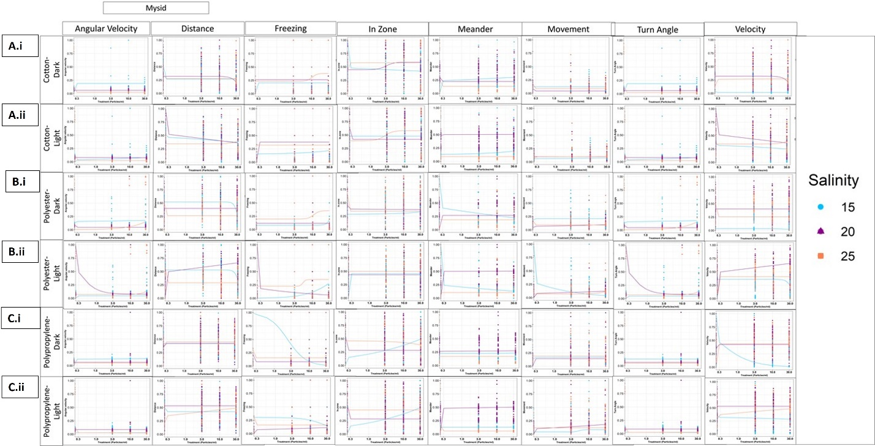

Fig. S4. Mysid shrimp (*A. bahia*) behavioral dose response curves after 7 days exposure to cotton, polypropylene and polyester microfiber in combined average dark and light cycles across a salinity gradient 15PSU – 25PSU. Data normalized to 0-1 scale. * p < 0.05 ANOVA test followed by Tukey test, comparing all concentrations to their respective salinity NOM control within each cycle per salinity.

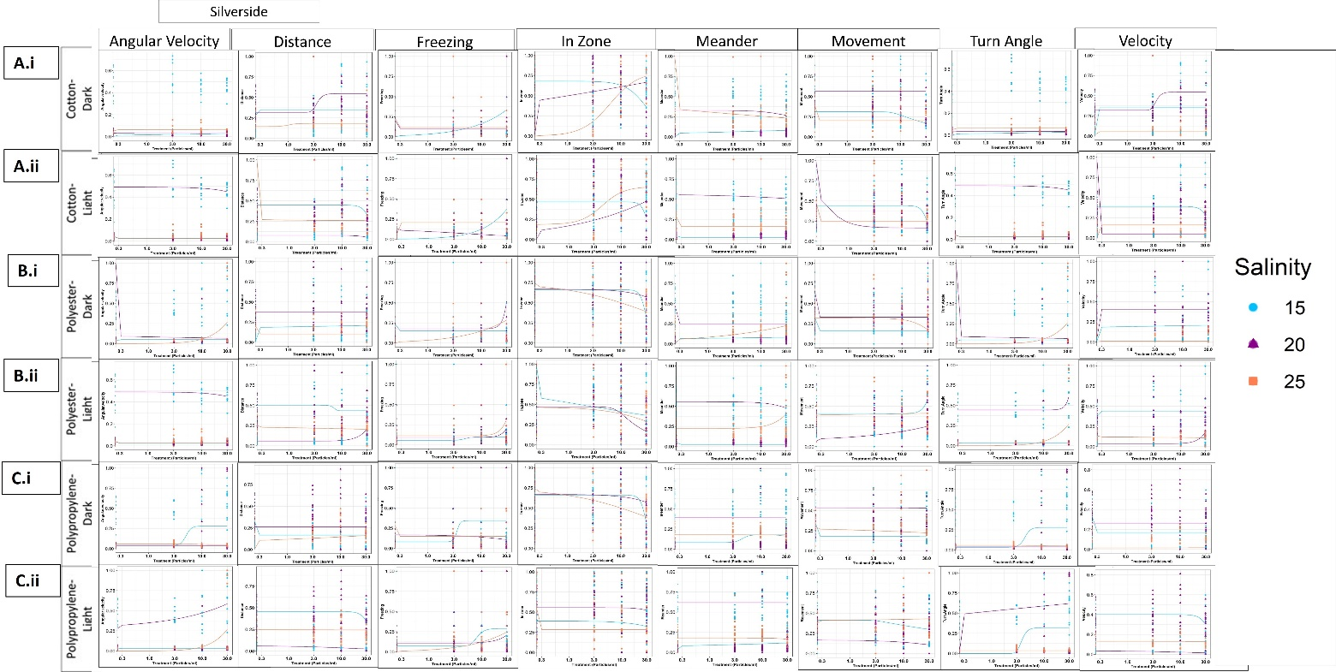

Fig. S5. Silverside (*M. beryllina*) larvae behavioral dose response curves after 4 days exposure to cotton, polypropylene and polyester microfiber in combined average dark and light cycles across a salinity gradient 15PSU – 25PSU. Data normalized to 0-1 scale. * p < 0.05 ANOVA test followed by Tukey test, comparing all concentrations to their respective salinity NOM control within each cycle per salinity.