Supplementary Material

# Supplementary Text

## Three-endmember model for nitrate formation

The model includes three formation paths, namely ·OH oxidation (day: NO2 +·OH → HNO3), N2O5 hydrolysis (night: N2O5 + H2O → 2HNO3) and hydrocarbon paths (night: NO3 + R [DMS/ hydrocarbons] → HNO3). Based on N and O isotopic mass-balance and the assumptions that atmospheric isotopic equilibrium is achieved between NO and NO2 during the daytime, and NO2, NO3 and N2O5 during the nighttime, aerosol nitrates formed by ·OH oxidation, N2O5 hydrolysis and hydrocarbon paths yield distinctive δ15N-δ18O (Walters and Michalski, 2016).

The formula for calculation is as follows:

(1) ·OH oxidation path:

(2) N2O5 hydrolysis path:

$${δ^{15}N-{{NO}_{3}^{-}}_{\left(N_{2}O_{5}\right)}=δ}^{15}N-HN{O_{3}}_{\left(N_{2}O_{5}\right)}=δ^{15}N-N_{2}O_{5}=δ^{15}N-NO_{2}+1000×(^{15}α_{\frac{N_{2}O_{5}}{NO_{2}}}-1) (1-3)$$

$$δ^{18}O-{{NO}_{3}^{-}}_{\left(N_{2}O_{5}\right)}=δ^{18}O-HN{O_{3}}_{\left(N_{2}O_{5}\right)}=\frac{5}{6}×δ^{18}O-N_{2}O_{5}+\frac{1}{6}×δ^{18}O-H_{2}O =\frac{5}{6}×[1000×(^{18}α_{\frac{N_{2}O_{5}}{NO_{2}}}-1)+δ^{18}O-NO_{2}]+\frac{1}{6}×δ^{18}O-H_{2}O (1-4)$$

(3) Hydrocarbon path:

$${δ^{15}N-{{NO}_{3}^{-}}_{\left(NO_{3}+R\right)}=δ}^{15}N-HN{O_{3}}_{\left(NO_{3}+R\right)}=δ^{15}N-NO_{3}=δ^{15}N-NO_{2}+1000×(^{15}α_{\frac{NO_{3}}{NO_{2}}}-1) (1-5)$$

$${δ^{18}O-{{NO}_{3}^{-}}_{\left(NO_{3}+R\right)}=δ}^{18}O-HN{O_{3}}_{\left(NO_{3}+R\right)}=δ^{18}O-NO_{3}=δ^{18}O-NO_{2}+1000×(^{18}α_{\frac{NO_{3}}{NO_{2}}}-1) (1-6)$$

where $f_{NO_{2}}$ is the the fraction of NO2 in NOX and nitrogen and oxygen fractionation factors are calculated according to equations 1-7 and 1-8, respectively. αX/Y and αY/X are reciprocal to each other.

15αX/Y=A/T4×1010+B/T3×108+C/T2×106+D/T×104)/1000+1

18αX/Y=(A/T4×1010+B/T3×108+C/T2×106+D/T×104)/1000+1

where values of A to D are listed in Table S3.

At the Qianliyan island, ranges of δ15N-NOx, δ18O-NOx, temperature, and δ18O-H2O were chosen as -15 to 0‰, 112 to 122‰, -5 to 30 ℃, 0.7-0.9 (Han et al., 2011; Walters and Michalski, 2016; Zong et al., 2017) and -16 to -10‰ (<http://isohis.iaea.org>).

As Fig. S3 shown, δ15N-NO3- and δ18O-NO3- in Qianliyan aerosol nitrate fall in the scope of δ15N-δ18O endmember of this model (the cyan polygon). Then the portions of each nitrate formation path were calculated via simmr.

# Supplementary Figures and Tables

## Supplementary Figures

**Figure S1.** End-member δ15N-δ18O values of aerosol nitrate in three-endmember model and seasonally coded aerosol nitrate isotopic compositions of the Qianliyan Island in 2018.

**Figure S2.** Examples for the a) northern, b) southern and c) eastern continental clusters, and d) the open-sea and e) the marginal-sea clusters. Each sample is subjected to four 72h backward trajectories. The start time is T, T + 6 h, T + 12 h and T + 18 h, respectively, where T is the start time of each sample. From left to right, the traceability of trajectory is subsequently weakened as the starting time increases at equal time intervals of the sampling period.

**Figure S3.** Seasonal concentrations of aerosol TSP, nitrate and ammonium, and seasonal isotopic compositions of aerosol nitrate and ammonium at the Qianliyan island in 2018.



Fig. S1

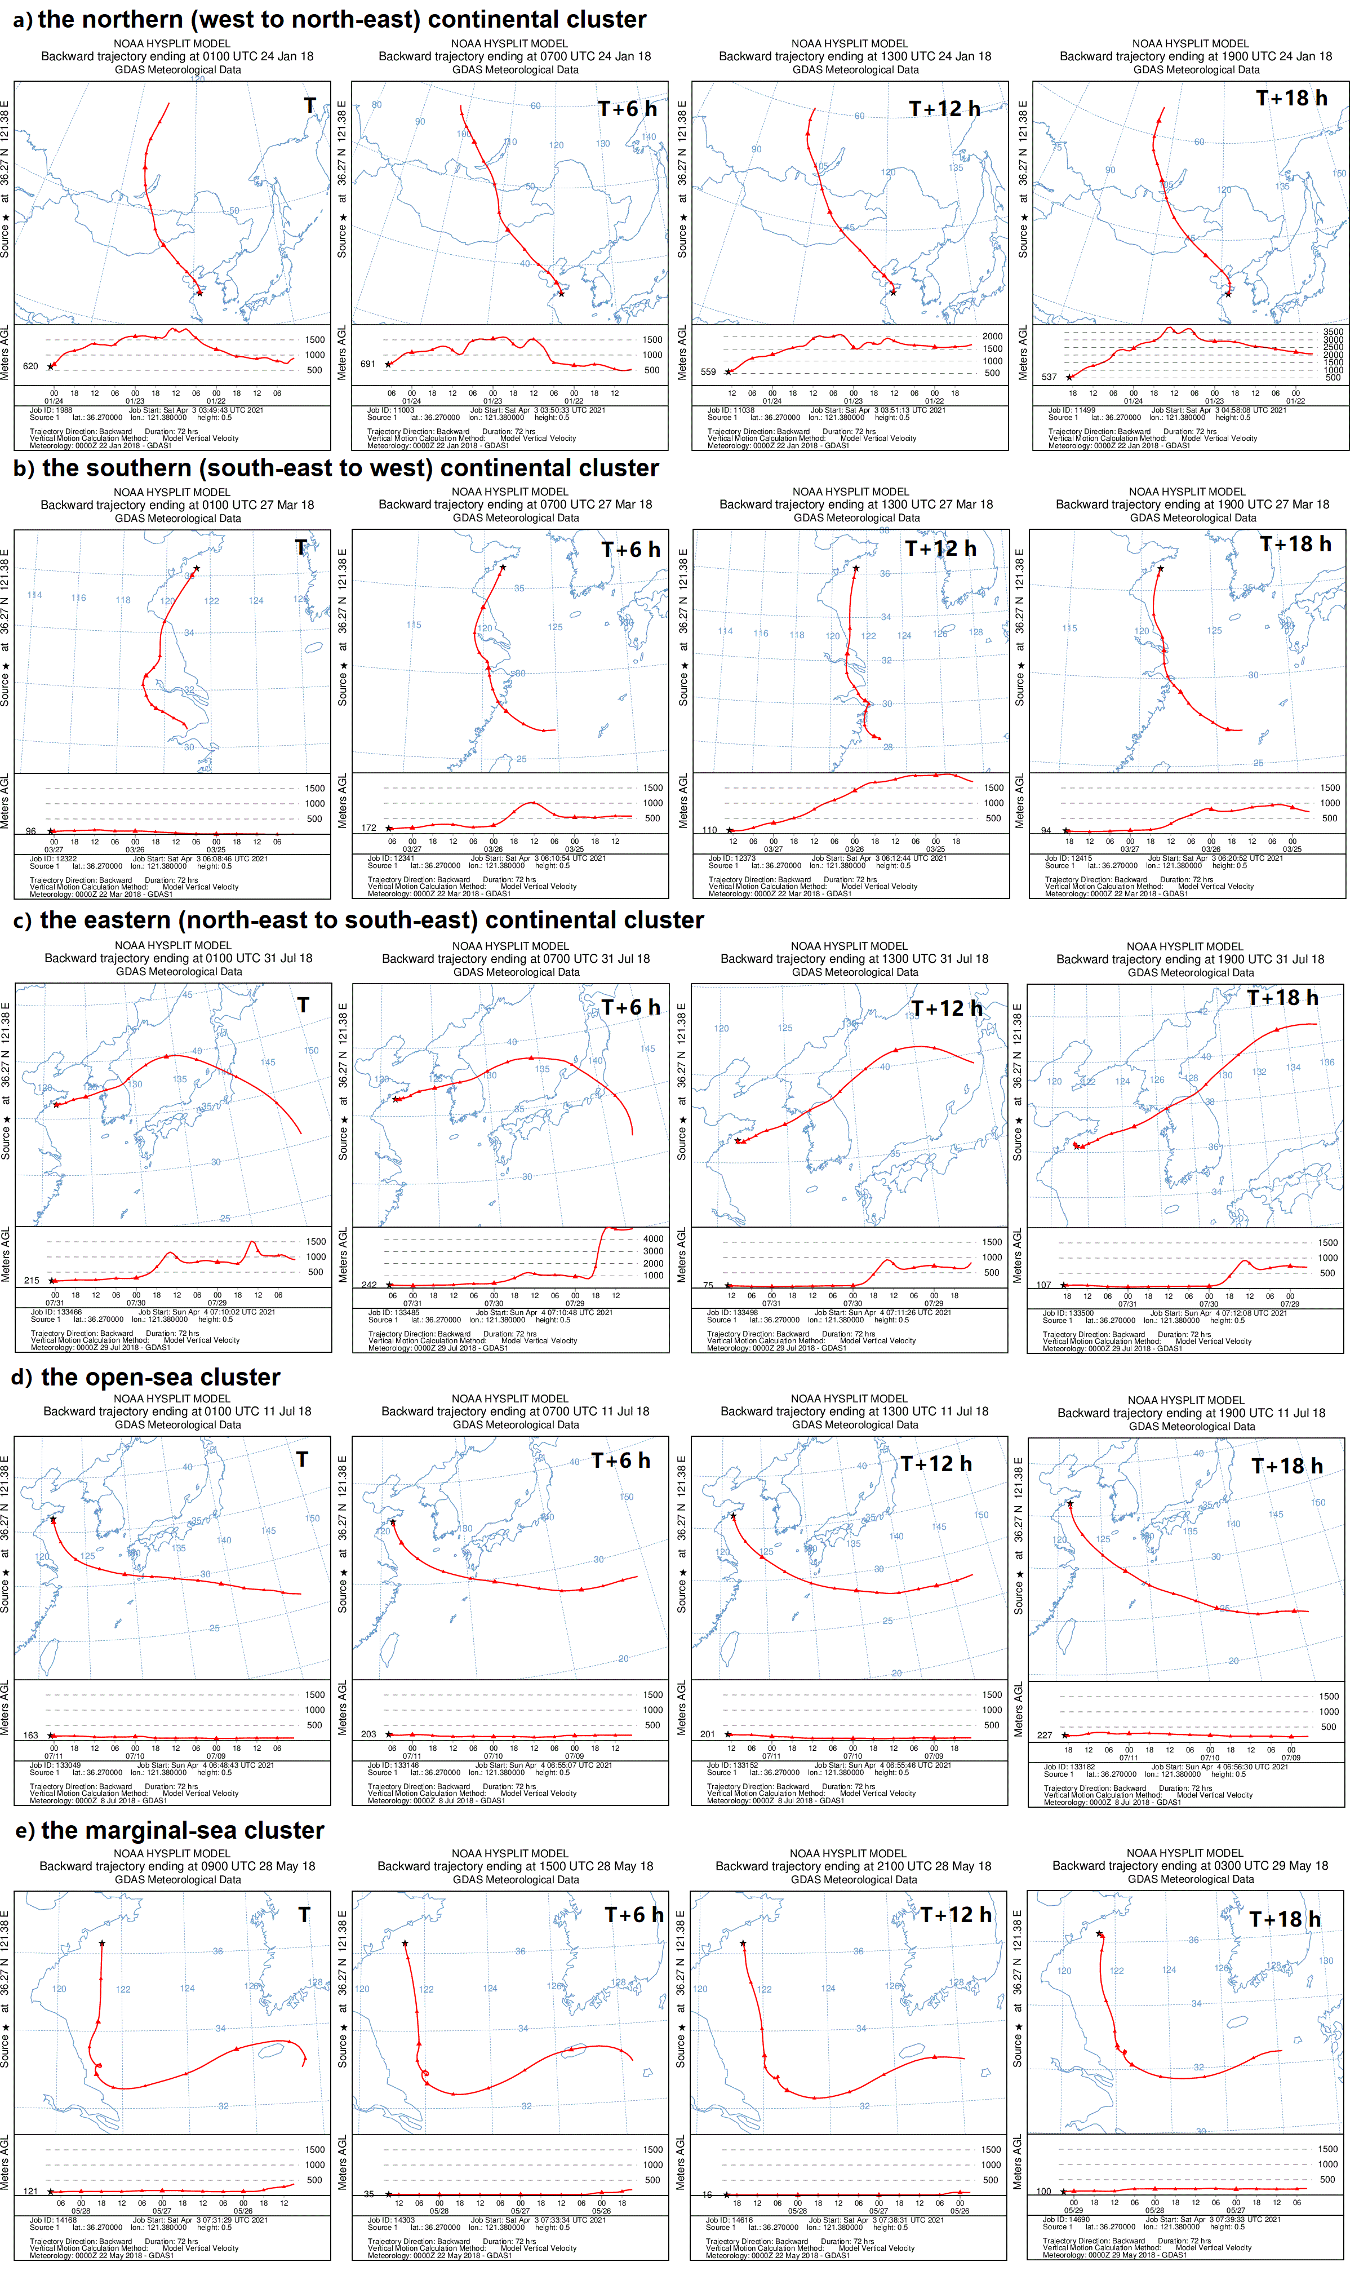

Fig. S2



Fig. S2-continued



Fig. S3

## Supplementary Tables

**Table S1.** The source δ15N-NH4+ and δ15N-NO3- for aerosol apportion.

|  |  |  |  |  |
| --- | --- | --- | --- | --- |
| **Source** | **δ**15**N-nitrate (‰)** | **Reference** | **δ**15**N-ammonium (‰)** | **Reference** |
| Biomass burning | -0.8 ± 1.2 | Shi et al., 2022 | 12.0 ± 0.0 | Kawashima and Kurahashi, 2011 |
| Fertilizer | 0.0 ± 2.0 | Michalski et al., 2015 | -0.2 ± 2.1 | Bateman et al., 2007 |
| Animal waste | -19.3 ± 10.3 | Felix and Elliott, 2014 | 13.6 ± 7.3 | Yeatman et al., 2001 |
| Road dust/soil | 11.3 ± 0.1 | Dong et al., 2022 | 38.0 ± 20.5 | Dong et al., 2022 |
| Vehicle emission | -12.6 ± 2.2 | Zong et al., 2020 | -14.2 ± 2.8 | Chang et al. 2016 |
| Coal combustion | 19.5 ± 2.3 | Felix et al., 2012 | -13.0 ± 2.3 | Felix et al. 2013 |
| Marine | -2.0 ± 2.8 | Luo et al., 2018 | -4.7 ± 2.7 | Felix et al. 2013 |

**Table S2.** Pearson correlation matrix between meteorological parameters, temperature (T, °C), relative humidity (RH, ‰) and sunshine hour (SH, T), concentrations of NO3- and NH4+ and δ15N-NH4+ and δ15N-NO3-. The correlation analysis was run on SPSS software (version 26).

|  |  |  |  |  |  |  |  |  |
| --- | --- | --- | --- | --- | --- | --- | --- | --- |
|  | RH | T | SH | NH4+ | δ15N-NH4+ | NO3- | δ15N-NO3- | δ18O-NO3- |
| RH | 1 |  |  |  |  |  |  |  |
| T | 0.35* | 1 |  |  |  |  |  |  |
| SH | 0.58** | 0.76** | 1 |  |  |  |  |  |
| NH4+ | 0.03 | -0.11 | -0.11 | 1 |  |  |  |  |
| δ15N-NH4+ | -0.10 | 0.22 | 0.23 | -0.10 | 1 |  |  |  |
| NO3- | -0.06 | -0.11 | -0.18 | 0.89** | -0.19 | 1 |  |  |
| δ15N-NO3- | -0.41** | -0.83** | -0.72** | -0.13 | -0.19 | -0.06 | 1 |  |
| δ18O-NO3- | -0.34* | -0.61** | -0.64** | 0.40** | -0.18 | 0.42** | 0.47** | 1 |
| * Significant different at 0.05 level | | | | | | | | |
| ** Significant different at 0.01 level | | | | | | | | |

**Table S3.** Values of A, B, C and D for 15αX/Y and 18αX/Y

|  |  |  |  |  |
| --- | --- | --- | --- | --- |
|  | A | B | C | D |
| 15NO2/NO | 3.8834 | -7.7299 | 6.0101 | -0.17928 |
| 15NO3/NO2 | -2.7193 | 3.6759 | -0.92418 | -0.54189 |
| 15N2O5/NO2 | 0.69398 | -1.9859 | 2.3876 | -0.16308 |
|  | A | B | C | D |
| 18NO/NO2 | -0.04129 | 1.1605 | -1.8829 | 0.74723 |
| 18H2O/·OH | 2.1137 | -3.8026 | 2.5653 | 0.59410 |
| 18N2O5/NO2 | -0.54136 | 0.13073 | 1.2477 | -0.1272 |
| 18NO2/NO3 | 1.03163 | -1.38703 | 0.24875 | 0.3082 |

# References

Bateman, A. S. and Kelly, S. D. (2007). Fertilizer nitrogen isotope signatures. *Isot. Environ. Health S.* 43(3), 237-247. doi: 10.1080/10256010701550732

Chang, Y., Liu, X., Deng, C., Dore, A. J., and Zhuang, G. (2016). Source apportionment of atmospheric ammonia before, during, and after the 2014 APEC summit in Beijing using stable nitrogen isotope signatures. *Atmos. Chem. Phys.* 16(18), 11635-11647. doi: 10.5194/acp-16-11635-2016

Dong, X., Guo, Q., Han, X., Wei, R., and Tao, Z. (2022). The isotopic patterns and source apportionment of nitrate and ammonium in atmospheric aerosol. *Sci. Total Environ.* 803, 149559. doi: 10.1016/j.scitotenv.2021.149559

Felix, J. D. and Elliott, E. M. (2014). Isotopic composition of passively collected nitrogen dioxide emissions: Vehicle, soil and livestock source signatures. *Atmospheric Environ.* 92, 359-366. doi: 10.1016/j.atmosenv.2014.04.005

Felix, J. D., Elliott, E. M., and Shaw, S. L. (2012). Nitrogen isotopic composition of coal-fired power plant NOx: Influence of emission controls and implications for global emission inventories. *Environ. Sci. Technol.* 46(6), 3528-3535. doi: 10.1021/es203355v

Felix, J. D., Elliott, E. M., Gish, T. J., McConnell, L. L., and Shaw, S. L. (2013). Characterizing the isotopic composition of atmospheric ammonia emission sources using passive samplers and a combined oxidation-bacterial denitrifier approach. *Rapid Commun. Mass Spectrom.* 27(20), 2239-2246. doi: 10.1002/rcm.6679

Han, S., Bian, H., Feng, Y., Liu, A., Li, X., Zeng, F., et al. (2011). Analysis of the relationship between O3, NO and NO2 in Tianjin, China. *Aerosol Air Qual. Res.* 11(2), 128-139. doi: 10.4209/aaqr.2010.07.0055

Kawashima, H. and Kurahashi, T. (2011). Inorganic ion and nitrogen isotopic compositions of atmospheric aerosols at Yurihonjo, Japan: Implications for nitrogen sources. *Atmospheric Environment*, 45(35), 6309-6316. doi: 10.1016/j.atmosenv.2011.08.057

Luo, L., Kao, S. J., Bao, H., Xiao, H., Xiao, H., Yao, X., et al. (2018). Sources of reactive nitrogen in marine aerosol over the Northwest Pacific Ocean in spring. *Atmos. Chem. Phys.* 18(9), 6207-6222. doi: 10.5194/acp-18-6207-2018

Michalski, G., Kolanowski, M., and Riha, K. M. (2015). Oxygen and nitrogen isotopic composition of nitrate in commercial fertilizers, nitric acid, and reagent salts. *Isot. Environ. Health S.* 51(3), 382-391. [doi: 10.1080/10256016.2015.1054821](https://doi.org/10.1080/10256016.2015.1054821)

Shi, Y., Tian, P., Jin, Z., Hu, Y., Zhang, Y., and Li, F. (2022). Stable nitrogen isotope composition of NOx of biomass burning in China. *Sci. Total Environ.* 803, 149857. doi: 10.1016/j.scitotenv.2021.149857

Walters, W. W., and Michalski, G. (2016). Theoretical calculation of oxygen equilibrium isotope fractionation factors involving various NOy molecules, OH, and H2O and its implications for isotope variations in atmospheric nitrate. *Geochimica Cosmochimica Acta.* 191, 89-101. doi: 10.1016/j.gca.2016.06.039

Yeatman, S. G., Spokes, L. J., Dennis, P. F., and Jickells, T. D. (2001). Comparisons of aerosol nitrogen isotopic composition at two polluted coastal sites. *Atmospheric Environ.* 35(7), 1307-1320. doi: 10.1016/S1352-2310(00)00408-8

Zong, Z., Sun, Z., Xiao, L., Tian, C., Liu, J., Sha, Q., et al. (2020). Insight into the variability of the nitrogen isotope composition of vehicular NOx in China. *Environ. Sci. Technol.* 54(22), 14246-14253. doi: 10.1021/acs.est.0c04749

Zong, Z., Wang, X., Tian, C., Chen, Y., Fang, Y., Zhang, F., et al. (2017). First assessment of NOx sources at a regional background site in north China using isotopic analysis linked with modeling. *Environ. Sci. Technol.* 51 (11), 5923-5931. doi: 10.1021/acs.est.6b06316