**Online Resource 1** Nutrient and Trace Element concentrations(μg g1 DW) in bark and debarked-trunk of trees grown on the two study sites (Fresnes-sur-Escaut and Pierrelaye) for the two treatments (control and inoculated).



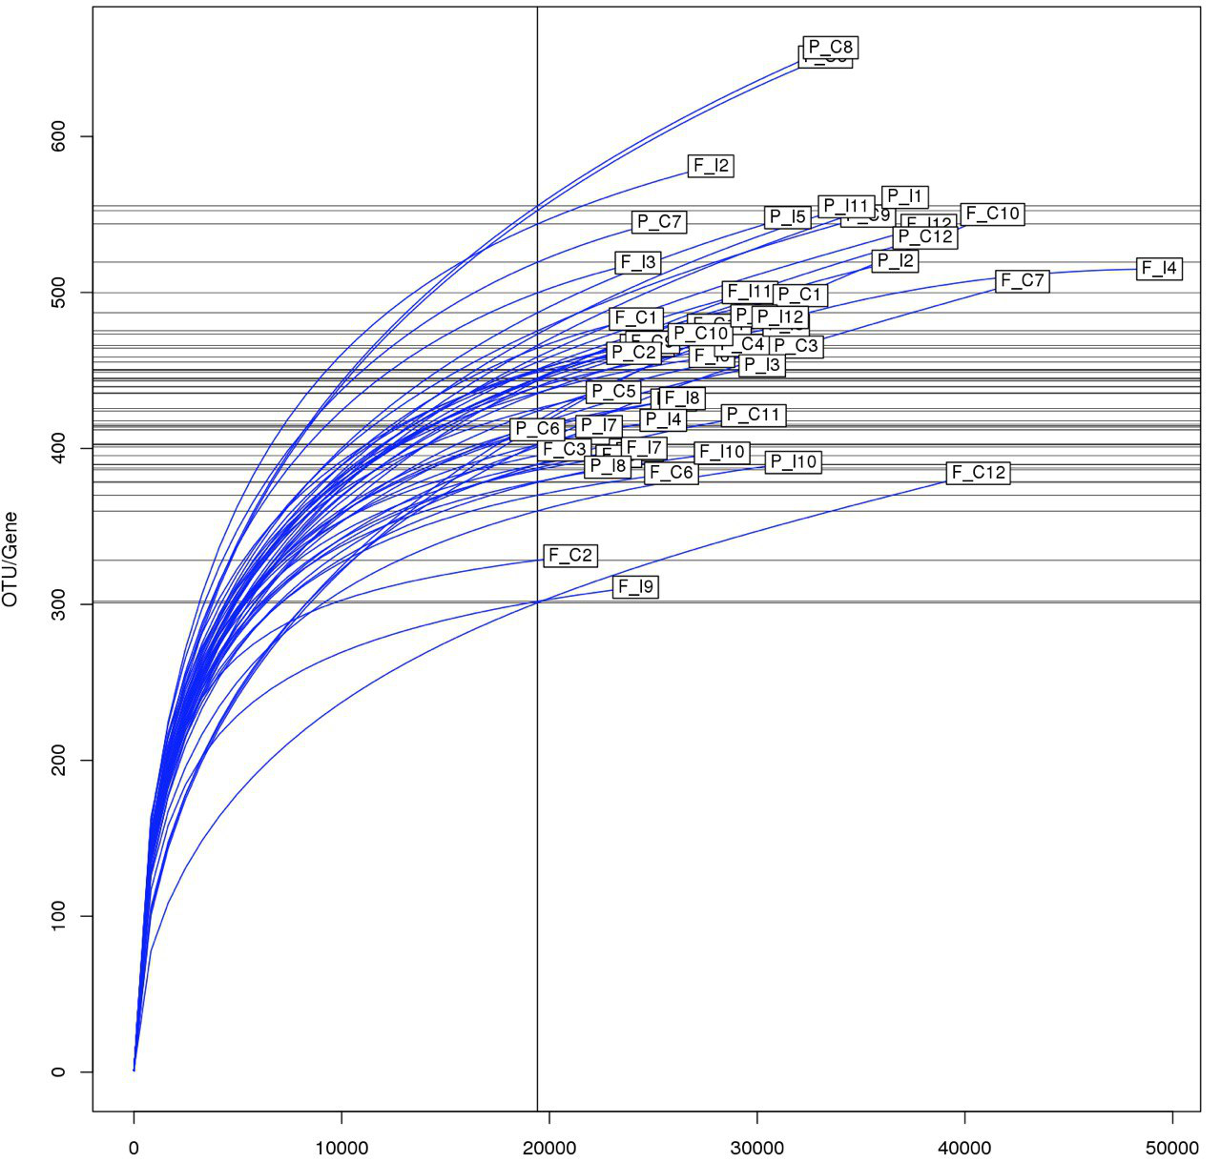

**Online Resource 2** Rarefaction analysis of ITS1 region sequence data for estimating fungal diversity based on a threshold of < 97% sequence similarity for the delineation of operational taxonomic units (OTUs). Comparisons of the fungal communities from the two study soils (Fresnes-sur-Escaut and Pierrelaye) and two treatments (control and inoculated) of *Populus* Skadofield trials.

**Online Resource 3** Example of FUNguild assignment table





**Online Resource 4** Relative proportion of fungal sequences from the two sites (Fresnes-sur-Escaut: F; Pierrelaye: P) and the two treatments (control: C; inoculated: I) assigned to the major fungal guilds.