Supplementary Material

Social distancing policies in Korea
As of July 1, 2020, there is a change in the social distancing level standards in Korea. As shown in Table 1, there were from level 1 to 3 before July 1, 2020, thereafter, as Table 2 shows, it is divided into levels 1 to 4. According to Table 1 and Table 2, it can be said that the level 1 and
1.5 of previous social distancing are similar to the level 1 of revised social distancing. In the same way, the level 2 of previous social distancing is similar to the level 2 of revised social distancing, and the level 2.5 and 2.5+α of previous social distancing are similar to the level 3 of revised social distancing. During the data fitting period, the social distancing policy is pre-revision and therefore corresponds to LVs 0, 1, 2, 2.5. However, in the paper, LVs 0, 1, 2, and 3 were indicated as standard after revision.

Table 1. Social Distancing applied from 7 November 2020 to 30 June 2021

 | Description
Level | Private gatherings | Events | Assemblies
1 | 500+ people only with advance reporting to local authorities | 500+ people only with advance reporting to local authorities | 500+ people only with advance reporting to local authorities
1.5 | 500+ people only with advance reporting to local authorities | 500+ people only with advance reporting to local authorities | 100+ prohibited
2 | 100+ people prohibited | 100+ people prohibited | 100+ people prohibited
2.5 | 50+ people prohibited | 50+ people prohibited | 50+ people prohibited
2.5+α | 5+ people prohibited | 50+ people prohibited | 50+ people prohibited
3 | 10+ people prohibited | 10+ people prohibited | 10+ people prohibited

Table 2. Revised Social Distancing applied after 1 July 2021

 | Description
Level | Private gatherings | Events | Assemblies
1 | Comply with COVID-19 protocols | 500+ people only with advance reporting to local authorities | 500+ people prohibited
2 | 9+ people prohibited | 100+ people prohibited | 100+ people prohibited
3 | 5+ people prohibited | 50+ people prohibited | 50+ people prohibited
4 | 3+ people prohibited | Events prohibited | Prohibited except 1 person protests

Results of parameter fitting for β
Table 3. The matrices of the transmission rate β for SD level 0, 1, 2, 3
SD Level 0
(February 1, 2020 - February 23, 2020; mean($R_{t}$)= 4.663)
2.325E-04 | 8.597E-06 | 3.061E-05 | 8.453E-04 | 1.466E-04 | 7.411E-05 | 7.930E-05 | 3.399E-01
5.698E-03 | 1.206E-01 | 2.417E-01 | 1.157E-01 | 3.335E-03 | 1.159E-02 | 3.209E-03 | 1.047E-01
2.765E-01 | 5.435E-02 | 6.181E-01 | 1.360E-01 | 9.998E-01 | 3.148E-01 | 6.930E-01 | 9.940E-02
9.485E-04 | 4.675E-04 | 1.348E-04 | 9.269E-01 | 6.655E-04 | 1.953E-03 | 5.378E-04 | 9.889E-01
9.886E-01 | 5.244E-03 | 4.559E-04 | 2.487E-01 | 7.699E-06 | 1.521E-01 | 8.024E-01 | 1.945E-01
5.238E-01 | 1.740E-04 | 7.689E-05 | 9.996E-01 | 7.881E-06 | 7.526E-06 | 3.004E-01 | 9.990E-01
1.234E-02 | 1.818E-03 | 1.352E-06 | 8.415E-01 | 9.028E-05 | 5.909E-04 | 4.865E-03 | 9.994E-01
1.038E-03 | 5.019E-04 | 5.373E-05 | 2.572E-01 | 2.086E-04 | 2.561E-03 | 6.376E-04 | 9.356E-01

SD Level 1
(October 12, 2020 - November 23, 2020; mean($R_{t}$)= 1.659)

2.325E-04 | 8.597E-06 | 3.061E-05 | 8.453E-04 | 1.466E-04 | 7.411E-05 | 7.930E-05 | 3.399E-01
5.698E-03 | 1.206E-01 | 2.417E-01 | 1.157E-01 | 3.335E-03 | 1.159E-02 | 3.209E-03 | 1.047E-01
2.765E-01 | 5.435E-02 | 6.181E-01 | 1.360E-01 | 9.998E-01 | 3.148E-01 | 6.930E-01 | 9.940E-02
9.485E-04 | 4.675E-04 | 1.348E-04 | 9.269E-01 | 6.655E-04 | 1.953E-03 | 5.378E-04 | 9.889E-01
9.886E-01 | 5.244E-03 | 4.559E-04 | 2.487E-01 | 7.699E-06 | 1.521E-01 | 8.024E-01 | 1.945E-01
5.238E-01 | 1.740E-04 | 7.689E-05 | 9.996E-01 | 7.881E-06 | 7.526E-06 | 3.004E-01 | 9.990E-01
1.234E-02 | 1.818E-03 | 1.352E-06 | 8.415E-01 | 9.028E-05 | 5.909E-04 | 4.865E-03 | 9.994E-01
1.038E-03 | 5.019E-04 | 5.373E-05 | 2.572E-01 | 2.086E-04 | 2.561E-03 | 6.376E-04 | 9.356E-01

SD Level 2
(November 24, 2020- December 22, 2020; mean($R_{t}$)= 1.201)

2.476E-04 | 3.010E-04 | 2.763E-01 | 4.761E-05 | 5.148E-04 | 6.774E-06 | 1.758E-06 | 1.247E-04
5.371E-04 | 1.032E-03 | 3.290E-01 | 4.020E-06 | 3.091E-05 | 3.978E-04 | 6.129E-07 | 2.285E-05
9.469E-04 | 6.725E-03 | 3.576E-01 | 2.833E-03 | 3.739E-04 | 3.766E-05 | 2.774E-04 | 2.859E-04
5.000E-03 | 5.271E-03 | 4.233E-01 | 5.783E-03 | 3.086E-03 | 7.617E-06 | 4.314E-03 | 8.406E-03
1.561E-05 | 3.033E-03 | 3.963E-01 | 2.362E-03 | 3.577E-04 | 1.415E-05 | 2.377E-04 | 2.325E-02
1.061E-03 | 7.193E-03 | 4.490E-01 | 4.743E-03 | 2.705E-04 | 8.180E-04 | 3.485E-04 | 7.219E-02
7.510E-05 | 4.682E-05 | 5.933E-01 | 8.982E-06 | 4.977E-05 | 5.844E-05 | 2.655E-05 | 2.197E-05
3.025E-07 | 1.937E-05 | 6.211E-01 | 8.632E-05 | 2.289E-06 | 3.914E-05 | 9.681E-07 | 1.533E-05

SD Level 3
(December 22, 2020- February,15,2021; mean($R_{t}$)= 1.005)

3.097E-01 | 1.515E-06 | 2.025E-06 | 3.543E-08 | 2.052E-05 | 4.176E-06 | 2.255E-07 | 2.224E-06
2.920E-01 | 2.187E-05 | 4.531E-05 | 1.126E-04 | 9.712E-05 | 7.483E-05 | 5.879E-05 | 2.760E-05
4.777E-05 | 4.736E-06 | 3.112E-05 | 2.081E-08 | 2.481E-05 | 1.570E-05 | 2.569E-01 | 9.281E-08
1.239E-03 | 1.450E-01 | 3.526E-05 | 1.839E-05 | 2.284E-05 | 1.281E-05 | 1.565E-01 | 5.076E-06
2.421E-04 | 1.019E-03 | 7.905E-05 | 1.777E-04 | 1.106E-04 | 9.180E-05 | 2.381E-01 | 5.704E-08
5.122E-05 | 7.155E-05 | 6.482E-05 | 1.656E-04 | 1.058E-04 | 2.519E-07 | 2.840E-01 | 6.562E-05
2.416E-01 | 9.972E-02 | 4.611E-04 | 9.365E-04 | 6.897E-04 | 6.158E-04 | 6.388E-03 | 6.069E-04
1.012E-04 | 9.113E-05 | 3.979E-05 | 4.361E-05 | 1.692E-05 | 2.134E-05 | 2.684E-01 | 2.277E-06

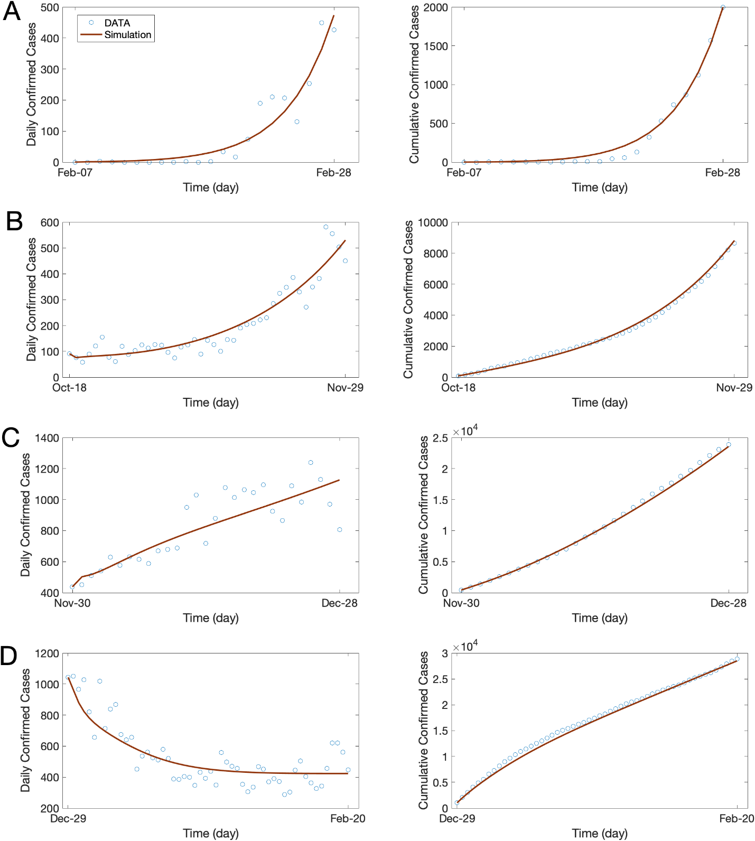
Figure 1. Comparison of the confirmed case data and simulation results for (Left)Daily confirmed cases of all ages (Right) Cumulative confirmed cases of all ages for (A) SD level 0 (B) SD level 1 (C) SD level 2 (D) SD level 3

The effective reproduction numbers

We computed the effective reproduction number $R_{t}$, which measures the mean number of the secondary cases infected by an infectious individual at time $t$, which is obtained by calculating the spectral radius of the next-generation matrix. Let $x={\left(E_{i},A_{i},I_{i},H_{i}^{M},H_{i}^{H},H_{i}^{I},S_{i},V_{i},R_{i},D_{i}\right)}^{T}$ for $i=1, ⋯, 8$. Let $F\left(x\right)$ represents all of the new infections and the net transition rates of the corresponding compartments are represented by $V\left(x\right).$

$$F\left(x\right)=\left(\begin{aligned}(S_{i}+(1-τ)V_{i})Λ_{i} \\ 0 \\ 0 \\ 0 \\ 0 \\ 0 \\ 0 \\ 0 \\ 0 \\ 0\end{aligned}\right)$$
where $Λ_{i}=\sum_{k}{\frac{β_{ik}(I_{k}+θ_{k}A_{k})}{N_{k}}}.$

$$V\left(x\right)=\left(\begin{aligned}αE_{i} \\ -ραE_{i}+γ^{A}A_{i} \\ -\left(1-ρ\right)ρE_{i}+qI_{i} \\ -{qδ}^{M}I_{i}+γ^{M}H_{i}^{M} \\ -qδ^{H}I_{i}+γ^{H}H_{i}^{H} \\ -qδ^{I}I_{i}+γ^{I}H_{i}^{I} \\ Λ_{i}S_{i}+ϕ_{i}υ \\ -ϕ_{i}υ+(1-τ)Λ_{i}V_{i} \\ {-γ}^{A}A_{i}-γ^{M}H_{i}^{M}-γ^{H}H_{i}^{H}-\left(1-κ^{I}\right)γ^{I}H_{i}^{I} \\ {-κ}^{I}η^{I}H_{i}^{I}\end{aligned}\right)$$

Then, $F$ and $V$ are $48*48$ matrices given by $F=\left[\frac{∂F_{i}}{∂x_{j}}(x_{0})\right]$ and $V=\left[\frac{∂V_{i}}{∂x_{j}}(x_{0})\right]$ with $1≤i,j≤48$ as a part of next generation operator where $x_{0}$ is the disease-free state. Thus, we obtain

$$F=\left[\begin{matrix}0_{8,8} & θ_{A}M_{A} & M_{A} & 0_{8,8} & 0_{8,8} & 0_{8,8} \\ 0_{8,8} & 0_{8,8} & 0_{8,8} & 0_{8,8} & 0_{8,8} & 0_{8,8} \\ 0_{8,8} & 0_{8,8} & 0_{8,8} & 0_{8,8} & 0_{8,8} & 0_{8,8} \\ 0_{8,8} & 0_{8,8} & 0_{8,8} & 0_{8,8} & 0_{8,8} & 0_{8,8} \\ 0_{8,8} & 0_{8,8} & 0_{8,8} & 0_{8,8} & 0_{8,8} & 0_{8,8} \\ 0_{8,8} & 0_{8,8} & 0_{8,8} & 0_{8,8} & 0_{8,8} & 0_{8,8}\end{matrix}\right].$$

Here $M_{A}$ is the matrix computed as
$$M_{A}=diag\{\left(S_{1}+\left(1-τ\right)V_{1}\right),\left(S_{2}+\left(1-τ\right)V_{2}\right), ⋯,\left(S_{8}+\left(1-τ\right)V_{8}\right)\}_{8}*B*diag\{\frac{1}{N_{1}},\frac{1}{N_{2}},⋯,\frac{1}{N_{8}}\}_{8},$$
where $B=[β_{ij}]$, $S_{i}$ is the susceptible population of age group $i$, $V_{i}$ is the vaccinated population of age group $i$, $diag\{\}_{n}$ denotes the diagonal matrix with $n$ diagonal entries.

$$V=\left[\begin{matrix}M_{B} & 0_{8,8} & 0_{8,8} & 0_{8,8} & 0_{8,8} & 0_{8,8} \\ -ρM_{B} & M_{C} & 0_{8,8} & 0_{8,8} & 0_{8,8} & 0_{8,8} \\ -(1-ρ{)M}_{B} & 0_{8,8} & M_{D} & 0_{8,8} & 0_{8,8} & 0_{8,8} \\ 0_{8,8} & 0_{8,8} & {-δ}^{M}M_{D} & M_{E} & 0_{8,8} & 0_{8,8} \\ 0_{8,8} & 0_{8,8} & {-δ}^{H}M_{D} & 0_{8,8} & M_{F} & 0_{8,8} \\ 0_{8,8} & 0_{8,8} & {-δ}^{I}M_{D} & 0_{8,8} & 0_{8,8} & M_{G}\end{matrix}\right]$$

where $M_{B}=α*I_{8}$,$M_{C}=γ^{A}*I_{8}$, $M_{D}=q*I_{8}$,$M_{E}=γ^{M}*I_{8}$, $M_{F}=γ^{H}*I_{8}$, $M_{G}=γ^{I}*I_{8}$, and $I_{8}$ is the size 8 identity matrix.
Then, the inverse matrix of $V$ is
$$V^{-1}=\left[\begin{matrix}{M_{B}}^{-1} & 0_{8,8} & 0_{8,8} & 0_{8,8} & 0_{8,8} & 0_{8,8} \\ ρ{M_{C}}^{-1} & {M_{C}}^{-1} & 0_{8,8} & 0_{8,8} & 0_{8,8} & 0_{8,8} \\ (1-ρ){M_{D}}^{-1} & 0_{8,8} & {M_{D}}^{-1} & 0_{8,8} & 0_{8,8} & 0_{8,8} \\ (1-ρ){{δ^{M}M}_{E}}^{-1} & 0_{8,8} & δ^{M}{M_{E}}^{-1} & {M_{E}}^{-1} & 0_{8,8} & 0_{8,8} \\ (1-ρ){{δ^{H}M}_{F}}^{-1} & 0_{8,8} & δ^{H}{M_{F}}^{-1} & 0_{8,8} & {M_{F}}^{-1} & 0_{8,8} \\ (1-ρ)δ^{I}{M_{G}}^{-1} & 0_{8,8} & δ^{I}{M_{G}}^{-1} & 0_{8,8} & 0_{8,8} & {M_{G}}^{-1}\end{matrix}\right]$$.

Hence, one can obtain the next generation matrix $G$ as

$G=FV^{-1}=\left[\begin{matrix}(\frac{ρθ_{A}}{γ^{A}}+\frac{1-ρ}{q})M_{A} & \frac{θ_{A}}{γ^{A}}M_{A} & \frac{1}{q}M_{A} & 0_{8,8} & 0_{8,8} & 0_{8,8} \\ 0_{8,8} & 0_{8,8} & 0_{8,8} & 0_{8,8} & 0_{8,8} & 0_{8,8} \\ 0_{8,8} & 0_{8,8} & 0_{8,8} & 0_{8,8} & 0_{8,8} & 0_{8,8} \\ 0_{8,8} & 0_{8,8} & 0_{8,8} & 0_{8,8} & 0_{8,8} & 0_{8,8} \\ 0_{8,8} & 0_{8,8} & 0_{8,8} & 0_{8,8} & 0_{8,8} & 0_{8,8} \\ 0_{8,8} & 0_{8,8} & 0_{8,8} & 0_{8,8} & 0_{8,8} & 0_{8,8}\end{matrix}\right]$.

Finally, the effective reproduction number $R_{t}$ is computed as the spectral radius $ρ(G)$ of the next generation matrix $G$, i.e., $R_{t}=ρ(G)$.

$R_{t}=ρ\left(G\right)=(\frac{ρθ_{A}}{γ^{A}}+\frac{1-ρ}{q})ρ\left(M_{A}\right)$.

The effect of rollout speed of vaccination on disease transmission

Table 4. The numbers of cumulative confirmed cases, cumulative death, and maximum hospitalized population in ICU for various social distancing level, rollout speed (C_{v}), and vaccine efficacy ($τ).$Bold text indicates when the maximum number of inpatients with severe symptoms is less than the ICU bed capacity.

 |  | $$τ=0.79$$ |  |  | $$τ=0.6$$
SD | C_{v} | Cumulative cases | Cumulative death | Max($H^{I}$) | Cumulative cases | Cumulative death | Max($H^{I}$)
LV 0 | 1 | 4.177E+7 | 4.026E+5 | 5.808E+5 | 4.228E+7 | 4.105E+5 | 5.957E+5
 | 2 | 4.086E+7 | 3.884E+5 | 5.459E+5 | 4.199E+7 | 4.061E+5 | 5.778E+5
 | 3 | 3.977E+7 | 3.712E+5 | 5.071E+5 | 4.168E+7 | 4.012E+5 | 5.584E+5
 | 4 | 3.844E+7 | 3.501E+5 | 4.636E+5 | 4.134E+7 | 3.956E+5 | 5.373E+5
 | 5 | 3.676E+7 | 3.240E+5 | 4.146E+5 | 4.097E+7 | 3.893E+5 | 5.144E+5
LV 1 | 1 | 1.463E+7 | 1.185E+5 | 6.828E+4 | 2.060E+7 | 1.715E+5 | 1.059E+5
 | 2 | 1.981E+6 | 1.509E+4 | 8.657E+3 | 5.706E+6 | 4.412E+4 | 2.312E+4
 | 3 | 5.021E+5 | 3,799.9 | 2,535.4 | 1.361E+6 | 10,338. | 5,652.1
 | 4 | 2.322E+5 | 1,757.5 | 1,311.5 | 5.626E+5 | 4,266.4 | 2,459.2
 | 5 | 1.418E+5 | 1,075.1 | 872.2 | 3.200E+5 | 2,427.7 | 1,461
LV 2 | 1 | 2.729E+5 | 3,310.3 | 1,151.8 | 4.334E+5 | 5,249.6 | 1,572.1
 | 2 | 1.087E+5 | 1,309.2 | 674.1 | 1.514E+5 | 1,830.8 | 807.9
 | 3 | 7.094E+4 | 848.6 | 540.2 | 9.442E+4 | 1,135.3 | 624.9
 | 4 | 5.424E+4 | 644.7 | 470.7 | 7.069E+4 | 845.6 | 536.8
 | 5 | 4.476E+4 | 529. | 425.8 | 5.774E+4 | 687.4 | 482.1
LV 3 | 1 | 6.876E+4 | 587.5 | 153.9 | 7.787E+4 | 675.4 | 155.1
 | 2 | 4.825E+4 | 379.6 | 149.8 | 5.930E+4 | 484.3 | 151.6
 | 3 | 4.154E+4 | 309.2 | 146.7 | 5.320E+4 | 418.9 | 148.9
 | 4 | 3.825E+4 | 274.6 | 144. | 5.022E+4 | 386.9 | 146.5
 | 5 | 3.628E+4 | 253.9 | 141.7 | 4.844E+4 | 367.7 | 144.5

Cost estimation

Table 5. Cost values for the case of admission to the treatment center for mild patients
SD | C_{v} | Medical expenses | Wage loss | Death | Vaccination | GDP loss | Total
LV 0 | 1 | 1.877E+11 | 4.335E+10 | 5.476E+9 | 2.176E+9 | 0 | 2.387E+11
 | 2 | 1.836E+11 | 4.257E+10 | 5.323E+9 | 2.176E+9 | 0 | 2.337E+11
 | 3 | 1.785E+11 | 4.163E+10 | 5.135E+9 | 2.176E+9 | 0 | 2.275E+11
 | 4 | 1.723E+11 | 4.045E+10 | 4.901E+9 | 2.176E+9 | 0 | 2.198E+11
 | 5 | 1.643E+11 | 3.893E+10 | 4.605E+9 | 2.176E+9 | 0 | 2.100E+11
LV 1 | 1 | 6.344E+10 | 1.532E+10 | 1.688E+9 | 2.176E+9 | 3.290E+9 | 8.592E+10
 | 2 | 8.484E+9 | 2.077E+9 | 2.193E+8 | 2.176E+9 | 3.290E+9 | 1.625E+10
 | 3 | 2.148E+9 | 5.265E+8 | 5.535E+7 | 2.176E+9 | 3.290E+9 | 8.196E+9
 | 4 | 9.931E+8 | 2.434E+8 | 2.560E+7 | 2.176E+9 | 3.290E+9 | 6.728E+9
 | 5 | 6.065E+8 | 1.486E+8 | 1.565E+7 | 2.176E+9 | 3.290E+9 | 6.237E+9
LV 2 | 1 | 1.322E+9 | 2.827E+8 | 4.390E+7 | 2.176E+9 | 2.961E+10 | 3.344E+10
 | 2 | 5.250E+8 | 1.125E+8 | 1.738E+7 | 2.176E+9 | 2.961E+10 | 3.244E+10
 | 3 | 3.418E+8 | 7.337E+7 | 1.128E+7 | 2.176E+9 | 2.961E+10 | 3.222E+10
 | 4 | 2.607E+8 | 5.607E+7 | 8.581E+6 | 2.176E+9 | 2.961E+10 | 3.211E+10
 | 5 | 2.146E+8 | 4.625E+7 | 7.048E+6 | 2.176E+9 | 2.961E+10 | 3.206E+10
LV 3 | 1 | 2.938E+8 | 6.807E+7 | 8.423E+6 | 2.176E+9 | 1.053E+11 | 1.078E+11
 | 2 | 1.981E+8 | 4.655E+7 | 5.554E+6 | 2.176E+9 | 1.053E+11 | 1.077E+11
 | 3 | 1.668E+8 | 3.952E+7 | 4.584E+6 | 2.176E+9 | 1.053E+11 | 1.077E+11
 | 4 | 1.514E+8 | 3.606E+7 | 4.107E+6 | 2.176E+9 | 1.053E+11 | 1.077E+11
 | 5 | 1.423E+8 | 3.399E+7 | 3.823E+6 | 2.176E+9 | 1.053E+11 | 1.077E+11

Table 6. Cost values for the case of home treatment for mild patients
SD | C_{v} | Medical expenses | Wage loss | Death | Vaccination | GDP loss | Total
LV 0 | 1 | 1.173E+11 | 2.884E+10 | 5.476E+9 | 2.176E+9 | 0 | 1.538E+11
 | 2 | 1.148E+11 | 2.836E+10 | 5.323E+9 | 2.176E+9 | 0 | 1.507E+11
 | 3 | 1.117E+11 | 2.776E+10 | 5.135E+9 | 2.176E+9 | 0 | 1.468E+11
 | 4 | 1.077E+11 | 2.701E+10 | 4.901E+9 | 2.176E+9 | 0 | 1.418E+11
 | 5 | 1.027E+11 | 2.603E+10 | 4.605E+9 | 2.176E+9 | 0 | 1.355E+11
LV 1 | 1 | 3.849E+10 | 1.015E+10 | 1.688E+9 | 2.176E+9 | 3.290E+9 | 5.579E+10
 | 2 | 5.088E+9 | 1.372E+9 | 2.193E+8 | 2.176E+9 | 3.290E+9 | 1.215E+10
 | 3 | 1.286E+9 | 3.478E+8 | 5.535E+7 | 2.176E+9 | 3.290E+9 | 7.155E+9
 | 4 | 5.946E+8 | 1.608E+8 | 2.560E+7 | 2.176E+9 | 3.290E+9 | 6.247E+9
 | 5 | 3.632E+8 | 9.816E+7 | 1.565E+7 | 2.176E+9 | 3.290E+9 | 5.943E+9
LV 2 | 1 | 8.802E+8 | 1.924E+8 | 4.390E+7 | 2.176E+9 | 2.961E+10 | 3.291E+10
 | 2 | 3.486E+8 | 7.649E+7 | 1.738E+7 | 2.176E+9 | 2.961E+10 | 3.223E+10
 | 3 | 2.264E+8 | 4.985E+7 | 1.128E+7 | 2.176E+9 | 2.961E+10 | 3.208E+10
 | 4 | 1.723E+8 | 3.806E+7 | 8.581E+6 | 2.176E+9 | 2.961E+10 | 3.201E+10
 | 5 | 1.416E+8 | 3.137E+7 | 7.048E+6 | 2.176E+9 | 2.961E+10 | 3.197E+10
LV 3 | 1 | 1.739E+8 | 4.441E+7 | 8.423E+6 | 2.176E+9 | 1.053E+11 | 1.077E+11
 | 2 | 1.120E+8 | 2.991E+7 | 5.554E+6 | 2.176E+9 | 1.053E+11 | 1.076E+11
 | 3 | 9.175E+7 | 2.517E+7 | 4.584E+6 | 2.176E+9 | 1.053E+11 | 1.076E+11
 | 4 | 8.179E+7 | 2.284E+7 | 4.107E+6 | 2.176E+9 | 1.053E+11 | 1.076E+11
 | 5 | 7.584E+7 | 2.145E+7 | 3.823E+6 | 2.176E+9 | 1.053E+11 | 1.076E+11

The effects of SD level mitigation
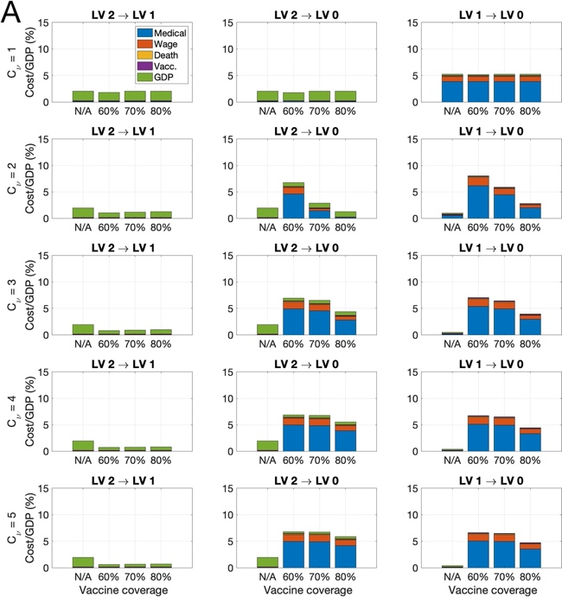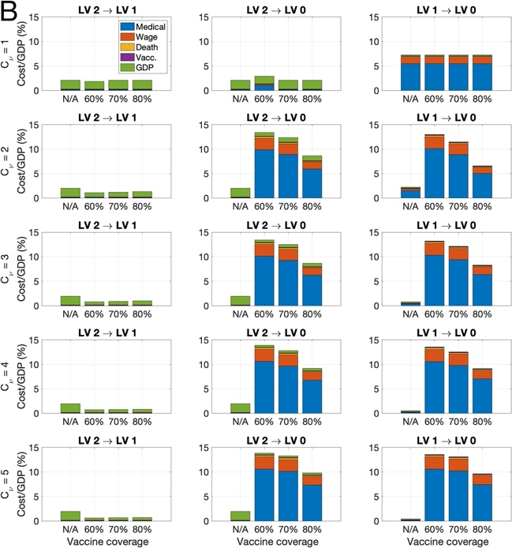
Figure 2. Ratio of cost to GPD for each SD level mitigation scenario when the vaccination coverage rate is reached at 60, 70, 80% (N/A indicates that social distancing easing is not implemented.) (Top) Admission to the treatment center for mild patients (Bottom) Home treatment for mild patients for $(A) τ=0.79$ and (B) $τ=0.6$ in case of $C_{ν}=1,2,...,5$.

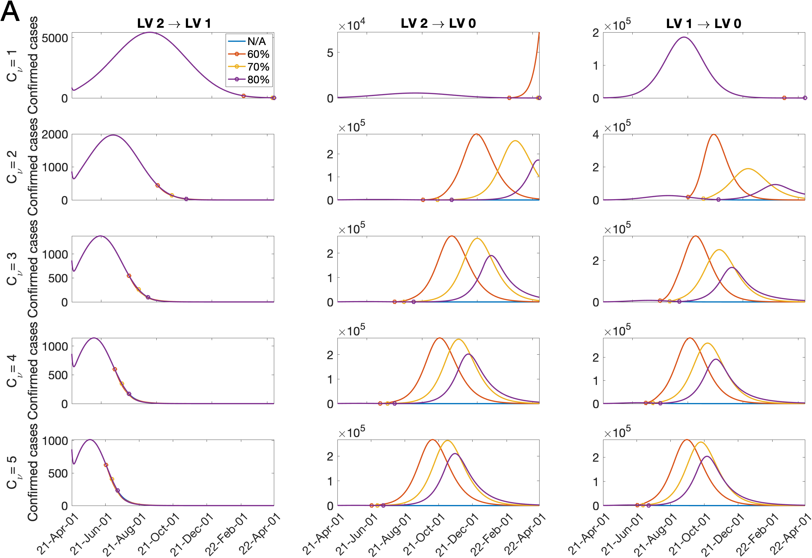
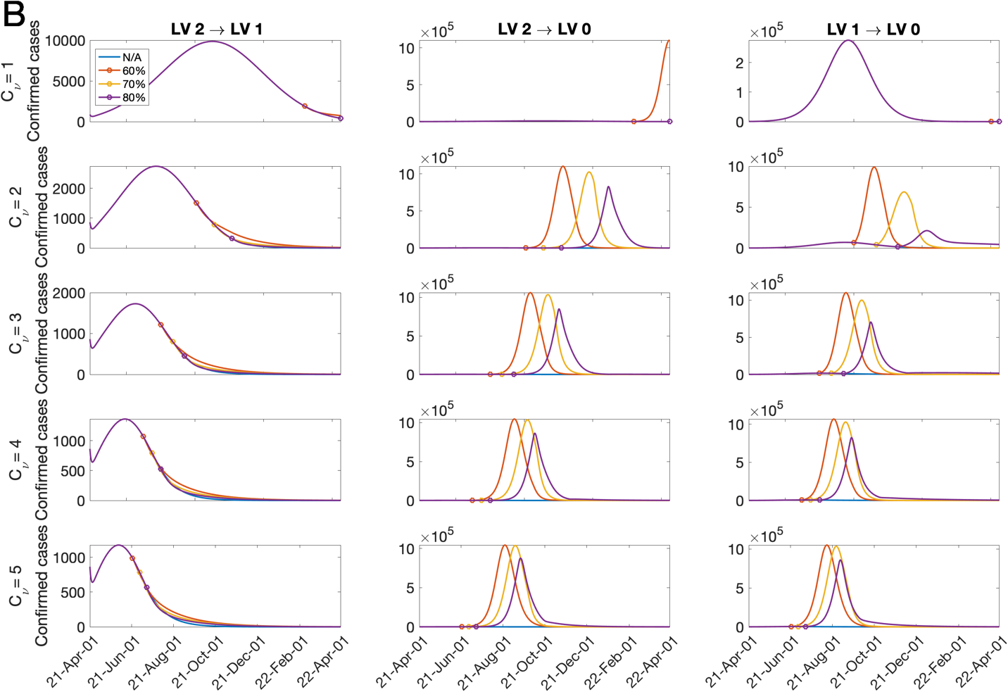
Figure 3. Daily confirmed cases for each SD level mitigation scenario when the vaccination coverage rate is reached at 60, 70, 80% for $C_{ν}=1,2,..., 5$ for $(A) τ=0.79$ and (b) $τ=0.6$.
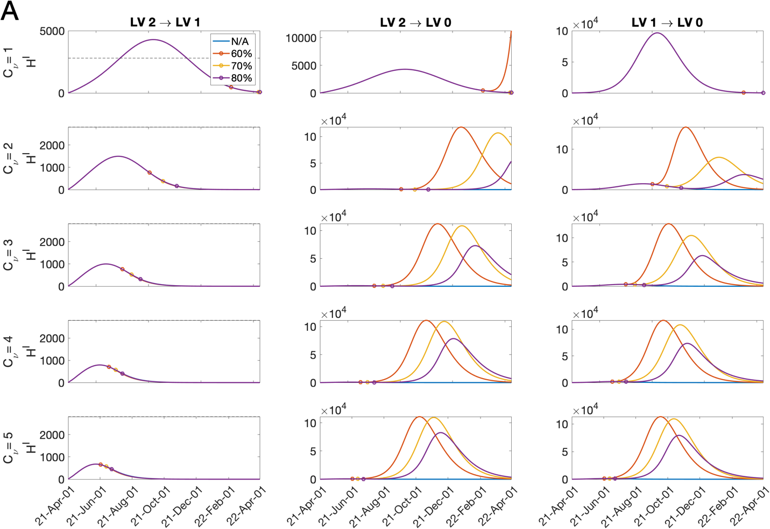
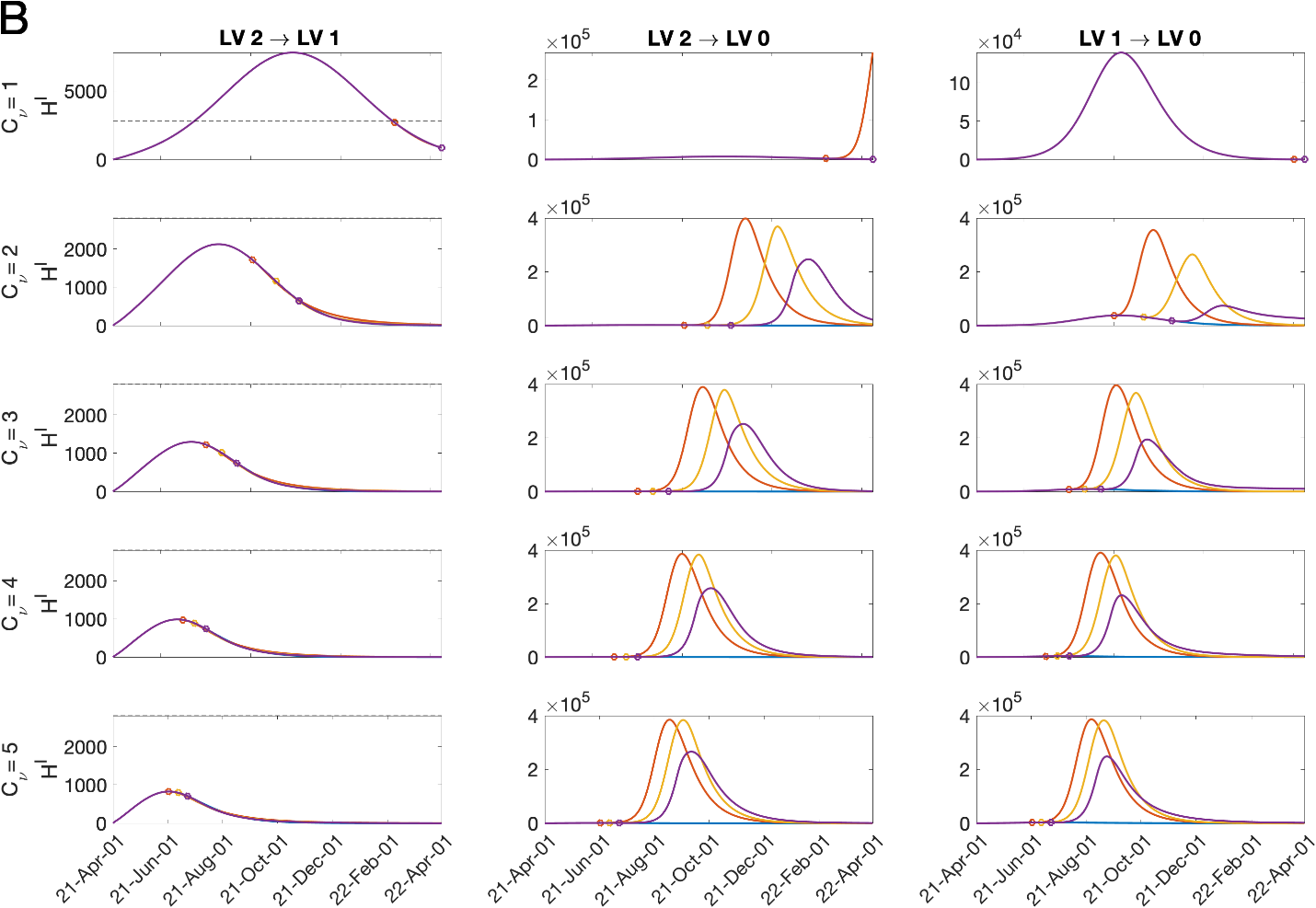
Figure 4. Hospitalized population with severe symptoms for each SD level mitigation scenario when the vaccination coverage rate is reached at 60, 70, 80% for $C_{ν}=1,2,..., 5$ for $(A) τ=0.79$ and (b) $τ=0.6$. The dashed line represents the number of ICU bed for COVID-19 patients in Korea.
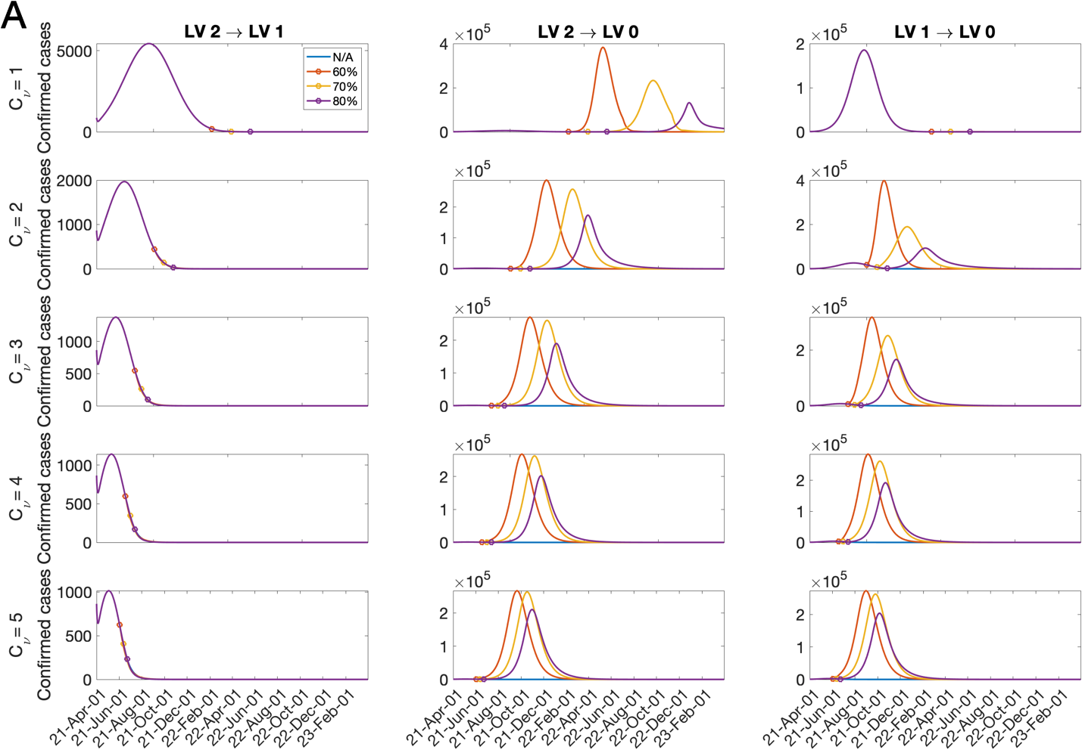
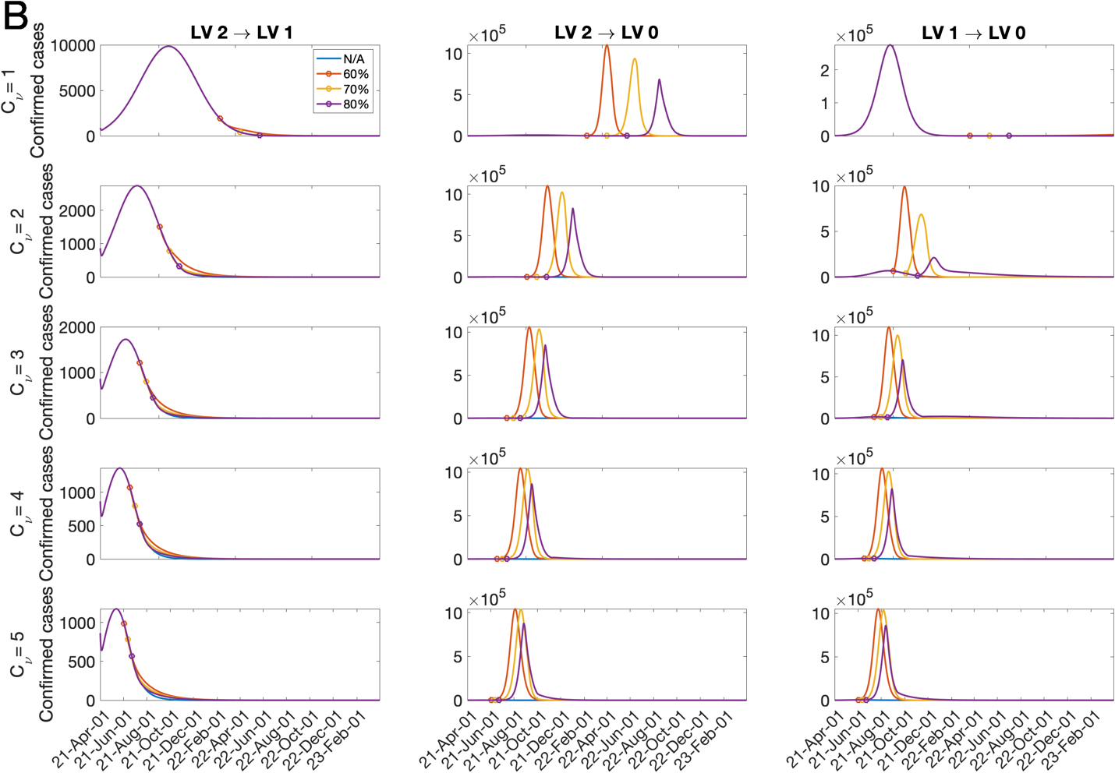
Figure 5. Daily confirmed cases for each SD level mitigation scenario when the vaccination coverage rate is reached at 60, 70, 80% for $C_{ν}=1,2,..., 5$ for $(A) τ=0.79$ and (B) $τ=0.6$. Simulation duration is 2 years.

Table 7. Cumulative confirmed cases for each SD level mitigation scenario when the vaccination coverage rate is reached at 60, 70, 80% for $C_{ν}=3, 4, 5$ for $τ=0.79$and $0.6$ Simulation duration is (A) 1 year and (B) 2 years .

(A) |  | SD LV 2 → LV 1 |  |  |  | SD LV 2 → LV 0 |  |  |  | SD LV 1 → LV 0
$$τ$$ | $$C_{ν}$$ | N/A | 60% | 70% | 80% | N/A | 60% | 70% | 80% | N/A | 60% | 70% | 80%
0.79 | $$1$$ | 8.840E+5 | 8.839E+5 | 8.840E+5 | 8.840E+5 | 8.840E+5 | 1.662E+6 | 8.840E+5 | 8.840E+5 | 1.690E+7 | 1.690E+7 | 1.690E+7 | 1.690E+7
 | $$2$$ | 2.191E+5 | 2.190E+5 | 2.190E+5 | 2.191E+5 | 2.191E+5 | 2.076E+7 | 1.754E+7 | 5.235E+6 | 2.635E+6 | 2.402E+7 | 1.835E+7 | 9.603E+6
 | $$3$$ | 1.205E+5 | 1.201E+5 | 1.201E+5 | 1.203E+5 | 1.205E+5 | 2.029E+7 | 1.993E+7 | 1.284E+7 | 6.363E+5 | 2.155E+7 | 1.988E+7 | 1.238E+7
 | 4 | 8.416E+4 | 8.364E+4 | 8.372E+4 | 8.392E+4 | 8.416E+4 | 2.021E+7 | 2.005E+7 | 1.441E+7 | 2.831E+5 | 2.063E+7 | 2.005E+7 | 1.375E+7
 | 5 | 6.565E+4 | 6.504E+4 | 6.512E+4 | 6.531E+4 | 6.565E+4 | 2.019E+7 | 2.009E+7 | 1.527E+7 | 1.687E+5 | 2.036E+7 | 2.009E+7 | 1.468E+7
0.6 | $$1$$ | 1.808E+6 | 1.813E+6 | 1.808E+6 | 1.808E+6 | 1.808E+6 | 1.869E+7 | 1.808E+6 | 1.808E+6 | 2.276E+7 | 2.276E+7 | 2.276E+7 | 2.276E+7
 | $$2$$ | 3.583E+5 | 3.776E+5 | 3.630E+5 | 3.595E+5 | 3.583E+5 | 3.628E+7 | 3.359E+7 | 2.477E+7 | 7.472E+6 | 3.631E+7 | 3.259E+7 | 1.974E+7
 | $$3$$ | 1.804E+5 | 1.934E+5 | 1.854E+5 | 1.825E+5 | 1.804E+5 | 3.648E+7 | 3.439E+7 | 2.511E+7 | 1.813E+6 | 3.705E+7 | 3.473E+7 | 2.334E+7
 | 4 | 1.212E+5 | 1.316E+5 | 1.263E+5 | 1.239E+5 | 1.212E+5 | 3.706E+7 | 3.519E+7 | 2.623E+7 | 7.285E+5 | 3.730E+7 | 3.558E+7 | 2.546E+7
 | 5 | 9.286E+4 | 1.018E+5 | 9.784E+4 | 9.580E+4 | 9.286E+4 | 3.749E+7 | 3.609E+7 | 2.778E+7 | 4.047E+5 | 3.752E+7 | 3.641E+7 | 2.698E+7

(B) |  | SD LV 2 → LV 1 |  |  |  | SD LV 2 → LV 0 |  |  |  | SD LV 1 → LV 0
$$τ$$ | $$C_{ν}$$ | N/A | 60% | 70% | 80% | N/A | 60% | 70% | 80% | N/A | 60% | 70% | 80%
0.79 | $$1$$ | 8.843E+5 | 8.844E+5 | 8.842E+5 | 8.843E+5 | 8.843E+5 | 2.358E+7 | 1.902E+7 | 8.521E+6 | 1.690E+7 | 1.695E+7 | 1.690E+7 | 1.690E+7
 | $$2$$ | 2.191E+5 | 2.190E+5 | 2.190E+5 | 2.191E+5 | 2.191E+5 | 2.085E+7 | 2.003E+7 | 1.210E+7 | 2.635E+6 | 2.402E+7 | 1.860E+7 | 1.164E+7
 | $$3$$ | 1.205E+5 | 1.201E+5 | 1.201E+5 | 1.203E+5 | 1.205E+5 | 2.031E+7 | 2.005E+7 | 1.361E+7 | 6.363E+5 | 2.155E+7 | 1.990E+7 | 1.272E+7
 | 4 | 8.416E+4 | 8.364E+4 | 8.372E+4 | 8.392E+4 | 8.416E+4 | 2.022E+7 | 2.008E+7 | 1.462E+7 | 2.831E+5 | 2.063E+7 | 2.006E+7 | 1.386E+7
 | 5 | 6.565E+4 | 6.504E+4 | 6.512E+4 | 6.531E+4 | 6.565E+4 | 2.019E+7 | 2.010E+7 | 1.536E+7 | 1.687E+5 | 2.036E+7 | 2.010E+7 | 1.473E+7
0.6 | $$1$$ | 1.819E+6 | 1.853E+6 | 1.821E+6 | 1.819E+6 | 1.819E+6 | 3.607E+7 | 3.250E+7 | 2.303E+7 | 2.276E+7 | 2.311E+7 | 2.276E+7 | 2.276E+7
 | $$2$$ | 3.583E+5 | 3.784E+5 | 3.635E+5 | 3.598E+5 | 3.583E+5 | 3.628E+7 | 3.359E+7 | 2.478E+7 | 7.473E+6 | 3.631E+7 | 3.259E+7 | 2.470E+7
 | $$3$$ | 1.804E+5 | 1.936E+5 | 1.856E+5 | 1.826E+5 | 1.804E+5 | 3.648E+7 | 3.439E+7 | 2.519E+7 | 1.814E+6 | 3.705E+7 | 3.473E+7 | 2.513E+7
 | 4 | 1.212E+5 | 1.317E+5 | 1.264E+5 | 1.239E+5 | 1.212E+5 | 3.706E+7 | 3.519E+7 | 2.629E+7 | 7.293E+5 | 3.730E+7 | 3.558E+7 | 2.578E+7
 | 5 | 9.286E+4 | 1.019E+5 | 9.789E+4 | 9.584E+4 | 9.286E+4 | 3.749E+7 | 3.609E+7 | 2.779E+7 | 4.051E+5 | 3.752E+7 | 3.641E+7 | 2.703E+7

The vaccination effects on SARS-CoV-2 variants

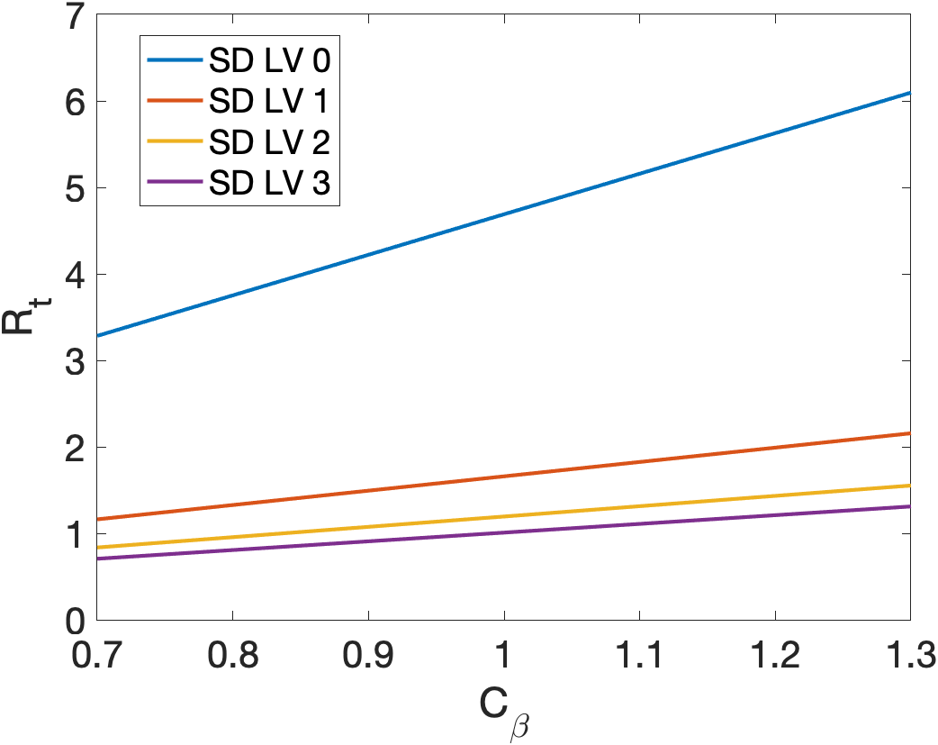

Figure 6. Plot of $R_{t}$ corresponding to $β$ that is varied as $β×C_{β }$for $C_{β}=0.7 - 1.3$ under SD LV 0, 1, 2, and 3, and the rollout speed $C_{ν}=1, 2, 3, 4$.

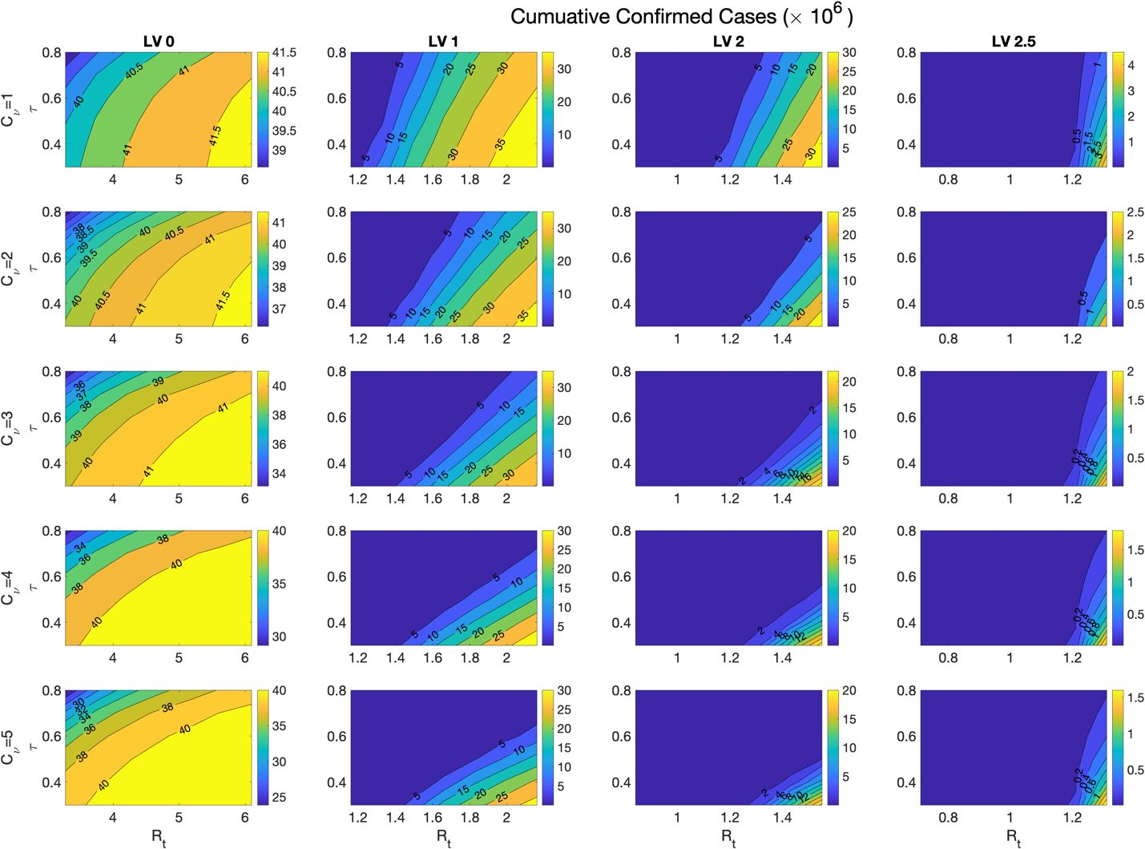
Figure 7. Cumulative confirmed cases $(×{10}^{6})$ for $τ=0.3 - 0.8$ and for $R_{t}$ corresponding to $β$ that is varied as $β×C_{β }$for $C_{β}=0.7 - 1.3$ under SD LV 0, 1, 2, and 3, and the rollout speed $C_{ν}=1, 2, ...,5$.

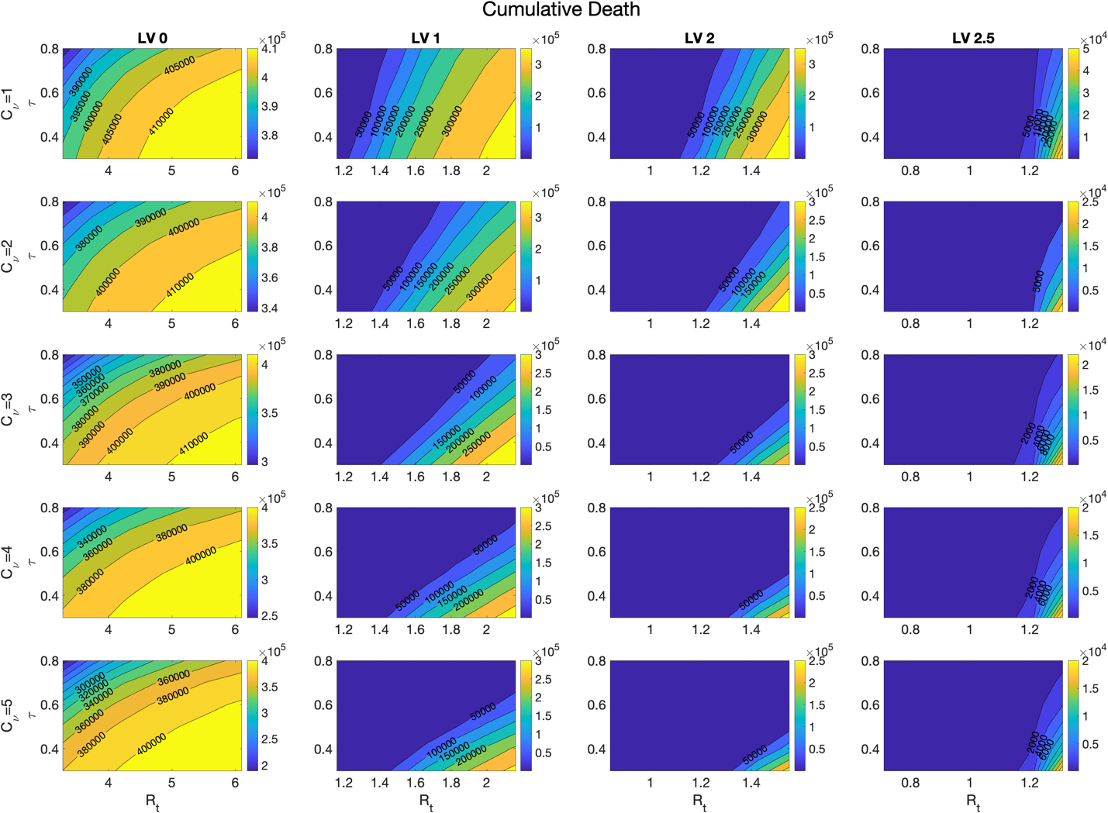
Figure 8. Cumulative deaths for $τ=0.3 - 0.8$ and for $R_{t}$ corresponding to $β$ that is varied as $β×C_{β }$for $C_{β}=0.7 - 1.3$ under SD LV 0, 1, 2, and 3, and the rollout speed $C_{ν}=1, 2, ...,5$.

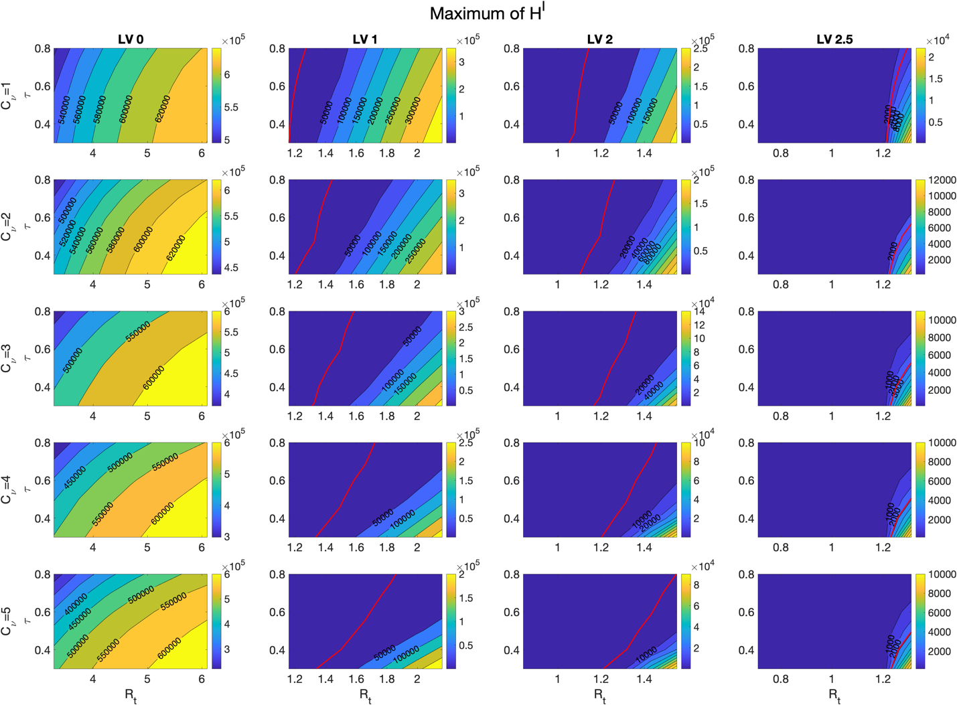
Figure 9. Maximum of hospitalized population with severe symptoms for $τ=0.3 - 0.8$ and for $R_{t}$ corresponding to $β$ that is varied as $β×C_{β }$for $C_{β}=0.7 - 1.3$ under SD LV 0, 1, 2, and 3, and the rollout speed $C_{ν}=1, 2, ...,5$. Red lines indicate 2800, which is the capacity of the intensive care unit for COVID-19 patients in Korea.

