Cycles | MA |  | MC |  | GC |  | MG
 | GlcA | pH | GlcA | pH | GlcA | pH | GlcA | pH
Cycle 1 | 0.04 ± 0.02 | 6.25 ± 0.01 | 0.09 ± 0.01 | 6.32 ± 0.04 | 8.33 ± 0.65 | 3.6 ± 0.06 | 7.43 ± 1.79 | 3.55 ± 0.04
Cycle 2 | 0.08 ± 0.07 | 6.16 ± 0.01 | 0.13 ± 0.02 | 6.17 ± 0.01 | 9.26 ± 1.23 | 3.55 ± 0.03 | 7.19 ± 1 | 3.5 ± 0.01
Cycle 3 | 0.06 ± 0.06 | 6.06 ± 0.02 | 0.08 ± 0 | 6.03 ± 0.04 | 6.89 ± 1.91 | 3.49 ± 0.02 | 9 ± 1.05 | 3.45 ± 0.02
Cycle 4 | 0.03 ± 0.04 | 6.31 ± 0.02 | 0.08 ± 0.06 | 6.29 ± 0.04 | 8.25 ± 2.53 | 3.69 ± 0.03 | 7.1 ± 1.14 | 3.63 ± 0.01
Cycle 5 | -0.02 ± 0.09 | 6.34 ± 0.01 | 0.09 ± 0.02 | 6.22 ± 0.03 | 7.58 ± 1.23 | 3.67 ± 0.04 | 8.67 ± 0.66 | 3.61 ± 0.02
Cycle 6 | -0.06 ± 0.04 | 6.38 ± 0.02 | 0.06 ± 0.02 | 6.26 ± 0.01 | 7.35 ± 2.08 | 3.69 ± 0.03 | 9.92 ± 2.61 | 3.63 ± 0.02
Cycle 7 | 0.06 ± 0.05 | 6.43 ± 0.04 | 0.04 ± 0.05 | 6.29 ± 0.01 | 7.75 ± 1.74 | 3.72 ± 0.02 | 7.47 ± 1.67 | 3.65 ± 0.03
Cycle 8 | 0.06 ± 0.03 | 6.42 ± 0.03 | -0.01 ± 0.07 | 6.29 ± 0.01 | 5.57 ± 2.09 | 3.72 ± 0.02 | 7.29 ± 1.51 | 3.65 ± 0.02
Cycle 25 | 0.09 ± 0.04 | 6.41 ± 0.02 | 0.01 ± 0.02 | 6.19 ± 0.02 | 10.07 ± 2.14 | 3.73 ± 0.03 | 8.54 ± 1.44 | 3.65 ± 0.04
Cycle 28 | -0.04 ± 0.01 | 6.41 ± 0.03 | -0.05 ± 0.01 | 6.26 ± 0.05 | 6.11 ± 0.22 | 3.66 ± 0.12 | 6.6 ± 1.23 | 3.59 ± 0.13
Cycle 30 | 0.08 ± 0.02 | 6.37 ± 0.05 | 0.01 ± 0.05 | 6.27 ± 0.02 | 7.65 ± 0.77 | 3.49 ± 0.02 | 4.87 ± 0.45 | 3.39 ± 0.01
Tables
Supplementary Table 1 Production of gluconic acid among cycle of adaptation and change in pH of culture medium after five days of incubation; Data were reported as mean ± standard deviation

Supplementary Table 2 Comparison between wild type and 30 cycle adapted strain in fructose in terms of BC yield, consumed carbon source, gluconic acid and pH. All the data were represented as mean ± standard deviation
Condition | BC yield (g/L) | Consumed CS (g/L) | Gluconic acid (g/L) | pH
1MF | 2.24 ± 0.32 | 6.76 ± 0.21 | 0.13 ± 0.03 | 5.9 ± 0.02
30MF | 3.47 ± 0.11 | 10.6 ± 1.04 | 0.68 ± 0.48 | 6.18 ± 0

Figures
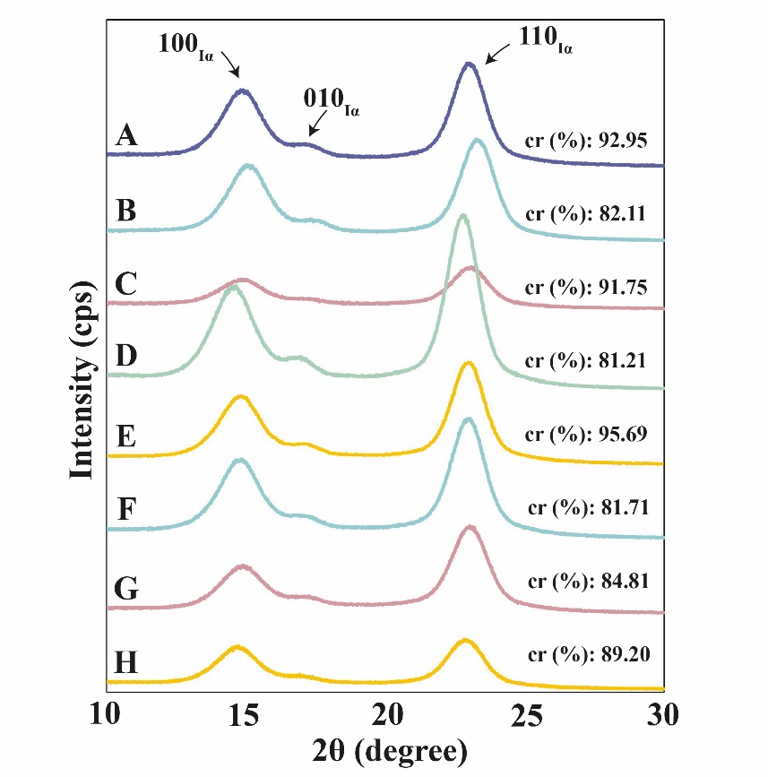

Figure S1 BC X-ray diffraction spectra of (A) 1GC, (B) 1MA, (C) 1MG, (D) 1MC, (E) 1MF, (F) 30MA, (G) 30MG, (H) 30MF. The spectra for each conditions show the characteristic peaks of BC at 14.5º, 16.6º and 22.7º of 2θ.

