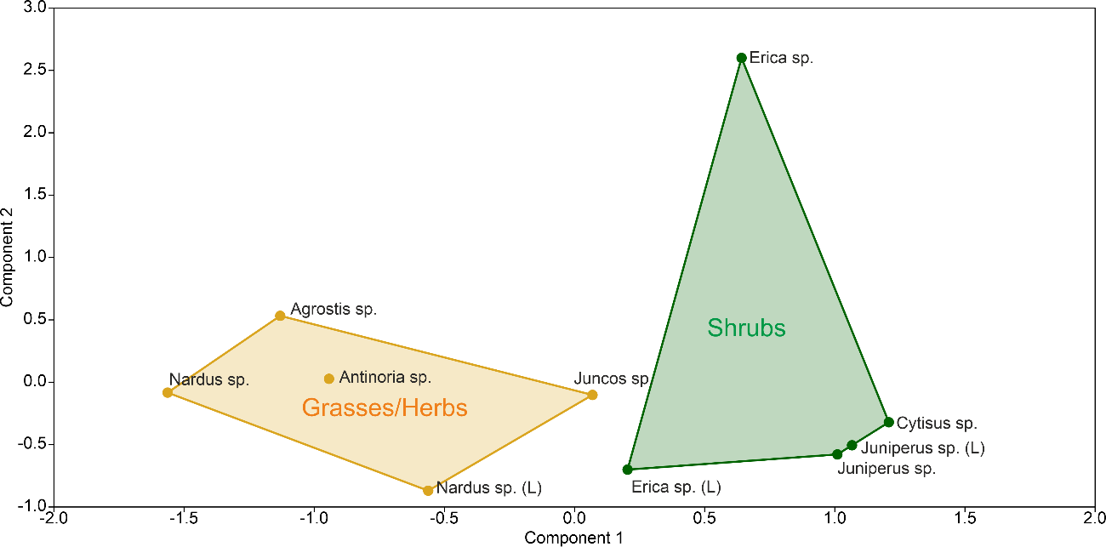

**Supplementary Figure 1** – Bi-plot diagram of the Principal Component Analysis (PCA), performed in Past4.07b using the correlation matrix of the odd n-alkane concentrations (from C17 to C35) and isotopic values (carbon and hydrogen) from C25 to C33 of dominant plants in the Lake Peixão area. Yellowish shaded areas correspond to grasses/herbs, and green shaded to shrubs ecological forms.

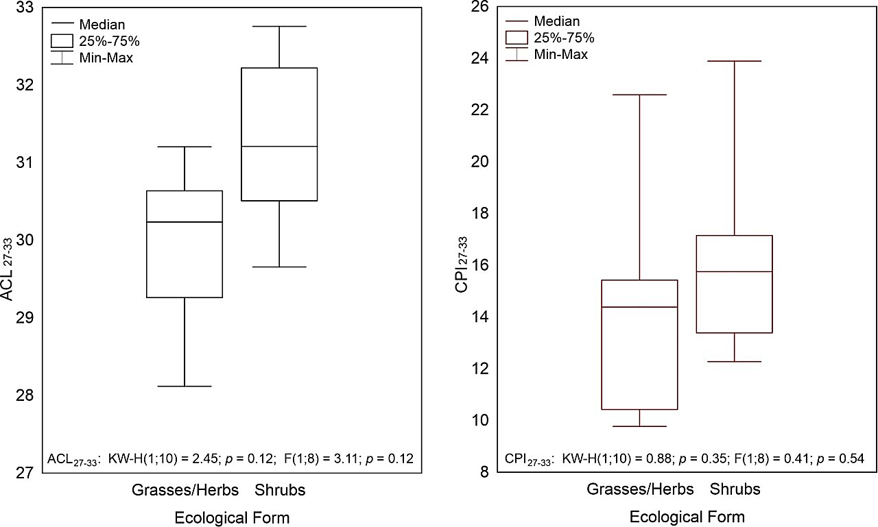

**Supplementary Figure 2**– Boxplots for Average Chain Length (ACL) and Carbon Preference Index (CPI) of samples from modern plants and vegetation litter in Lake Peixão area, grouped by ecological form (i.e., shrubs and grasses/herbs). KW-H stands for Kruskal–Wallis H test and F for F-test.

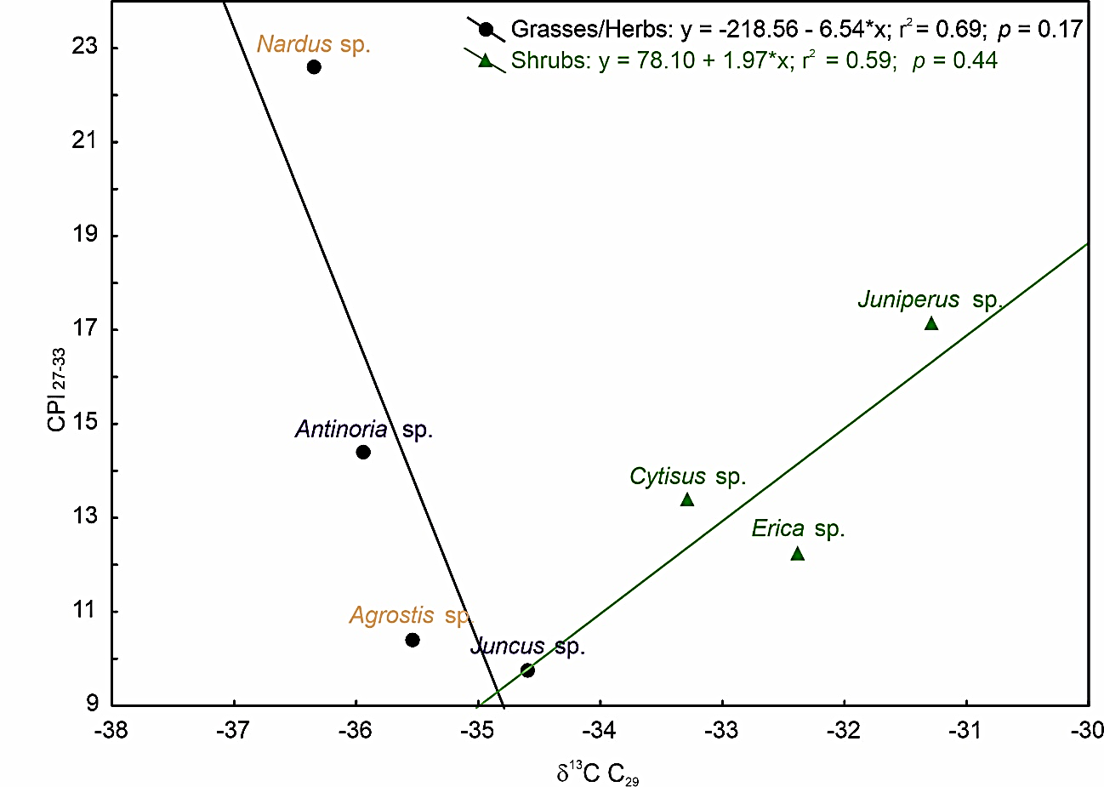

**Supplementary Figure 3**– CPI vs. δ13C values of C29 *n*-alkane (δ13C C29) of dominant modern plants in the vegetation cover of Lake Peixão catchment area. Circles correspond to grasses/herbs ecological forms, aquatic-related plants in blue and grasses plants in yellowish color; triangles correspond to shrubs ecological forms.

**Table 1** – Isotopic composition of hydrogen and carbon of C25 - C33 *n*-alkanes of modern plants in the Lake Peixão area, vegetation litter, and lake surface sediment. *Veg. meaning vegetation

|  |  |  |  |  |  |  |  |  |  |  |  |  |  |  |  |  |  |  |  |  |  |  |  |
| --- | --- | --- | --- | --- | --- | --- | --- | --- | --- | --- | --- | --- | --- | --- | --- | --- | --- | --- | --- | --- | --- | --- | --- |
| Sample | Ecological Form | Environment | Sample Type* | δD C25 | SD | δ13C C25 | SD | δD C27 | SD | δ13C C27 | SD | δD C29 | SD | δ13C C29 | SD | δD C31 | SD | δ13C C31 | SD | δDC33 | SD | δ13C C33 | SD |
| *Agrostis* sp. | grass/herb | terrestrial | Veg. | -215 | 1.7 | -35 | 0.0 | -207 | 0.7 | -35 | 0.0 | -203 | 0.3 | -36 | 0.0 | -209 | 1 | -36 | 0.0 | -191 | 2.7 | -36 | 0.1 |
| *Nardus sp.* | grass/herb | terrestrial | Veg. | -236 | 0.2 | -35 | 0.0 | -212 | 0.6 | -35 | 0.0 | -236 | 1.2 | -36 | 0.1 | -218 | 1 | -36 | 0.0 | -211 | 2.1 | -37 | 0.1 |
| *Antinoria* sp. | grass/herb | aquatic related | Veg. | -200 | 0.1 | -35 | 0.2 | -185 | 0.4 | -35 | 0.1 | -177 | 0.8 | -36 | 0.1 | -184 | 0 | -37 | 0.0 | -186 | 0.3 | -36 | 0.2 |
| *Juncus* sp. | grass/herb | aquatic related | Veg. | -170 | - | -33 | 0.1 | -187 | - | -34 | 0.0 | -175 | - | -35 | 0.0 | -173 | - | -33 | 0.0 | - | - | -30 | 0.1 |
| *Erica* sp. | shrub | terrestrial | Veg. | - | - | -31 | 0.2 | -156 | 1.4 | -32 | 0 | -161 | 1.6 | -32 | 0.0 | -155 | 2 | -31 | 0.0 | -151 | 0.9 | -30 | 0.1 |
| *Juniperus* sp. | shrub | terrestrial | Veg. | - | - | - | - | - | - | - | - | - | - | -31 | 0.5 | -137 | 2 | -31 | 0.0 | -146 | 0.2 | -29 | 0.0 |
| *Cytisus* sp. | shrub | terrestrial | Veg. | -146 | 0.2 | -29 | 0.1 | -122 | - | -32 | 0 | -131 | - | -33 | 0.0 | -129 | - | -34 | 0.0 | -119 | - | -32 | 0.5 |
| *Nardus* sp. (L) | grass/herb | terrestrial | veg. litter | - | - | -33 | 0.2 | - | - | -33 | 0.0 | -193 | - | -35 | 0.0 | -216 | - | -36 | 0.0 | -200 | - | -35 | 0.1 |
| *Erica* sp. (L) | shrub | terrestrial | veg. litter | - | - | -31 | - | - | - | -32 | - | -165 | - | -34 | - | -183 | - | -33 | - | -169 | - | -32 | - |
| *Juniperus* sp. (L) | shrub | terrestrial | veg. litter | - | - | -29 | 0.3 | - | - | -29 | 0.1 | -156 | - | -32 | 0.1 | -157 | 1 | -31 | 0.1 | -151 | 0.2 | -29 | 0.1 |
| Lake surface sediment | - | mix | sediments | -161 | - | -32 | 0.1 | -162 | 1.5 | -32 | 0.1 | -178 | 2.1 | -33 | 0.1 | -189 | 1.7 | -33 | 0.0 | -183 | 1.2 | -32 | 0.1 |