**Supporting Information**

**Sesquiterpenes from *Ambrosia artemisiifolia* and their allelopathy**

Zhixiang Liu 1,2, Nan Zhang 2, Xiaoqing Ma 2, Tong Zhang 2, Xuan Li 2, Ge Tian 2, Yulong Feng 1,2,*, Tong An 1,2,*

1 College of Plant Protection, Shenyang Agricultural University, Shenyang 110866, P.R. China

2 College of Biological Science and Technology, Shenyang Agricultural University, Shenyang 110866, P.R. China

*Corresponding authors. Phone: +86-24-88487163. Fax: +86-24-88492799.

E-mail addresses: [fyl@syau.edu.cn](mailto:fyl@syau.edu.cn) (Y.-L. Feng); m18602463916@163.com (T. An).

**Figure. S1.**  The UV spectrum of compound **1**

**Figure. S2.** The HR-ESIMS spectrum of compound **1**

**Figure. S3.** The 1H-NMR spectrum of compound **1**

**Figure. S4.** The 13C-NMR spectrum of compound **1**

**Figure. S5.** The HSQC spectrum of compound **1**

**Figure. S6.** The HMBC spectrum of compound **1**

**Figure. S7.** The NOESY spectrum of compound **1**

**Figure. S8.** The UV spectrum of compound **2**

**Figure. S9.** The HR-ESIMS spectrum of compound **2**

**Figure. S10.** The 1H-NMR spectrum of compound **2**

**Figure. S11.** The 13C-NMR spectrum of compound **2**

**Figure. S12.**  The HSQC spectrum of compound **2**

**Figure. S13.** The HMBC spectrum of compound **2**

**Figure. S14.** The NOESY spectrum of compound **2**

**Figure. S15.**  The UV spectrum of compound **3**

**Figure. S16.** The HR-ESIMS spectrum of compound **3**

**Figure. S17.** The 1H-NMR spectrum of compound **3**

**Figure. S18.** The 13C-NMR spectrum of compound **3**

**Figure. S19.**  The HSQC spectrum of compound **3**

**Figure. S20.** The HMBC spectrum of compound **3**

**Figure. S21.** The NOESY spectrum of compound **3**

**Figure. S22.**  The UV spectrum of compound **4**

**Figure. S23.** The HR-ESIMS spectrum of compound **4**

**Figure. S24.** The 1H-NMR spectrum of compound **4**

**Figure. S25.** The 13C-NMR spectrum of compound **4**

**Figure. S26.** The HSQC spectrum of compound **4**

**Figure. S27.** The HMBC spectrum of compound **4**

**Figure. S28.** The NOESY spectrum of compound **4**

**Figure. S29.** The MS spectra of compounds **1** in the TIC chromatogram.

**Figure. S30.** The MS spectra of compounds **2** in the TIC chromatogram.

**Figure. S31.** The MS spectra of compounds **3** in the TIC chromatogram.

**Figure. S32.** The MS spectra of compounds **4** in the TIC chromatogram.

**Figure. S33.** The MS/MS spectra of compounds **1** in the TIC chromatogram.

**Figure. S34.** The MS/MS spectra of compounds **2** in the TIC chromatogram.

**Figure. S35.** The MS/MS spectra of compounds **3** in the TIC chromatogram.

**Figure. S36.** The MS/MS spectra of compounds **4** in the TIC chromatogram.

**Figure. S1.**

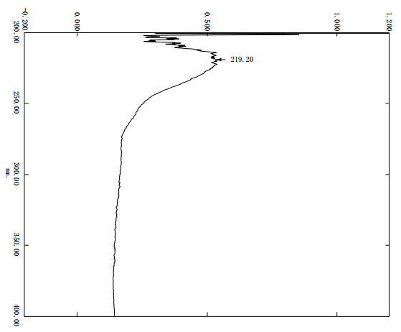

**Figure. S2.**

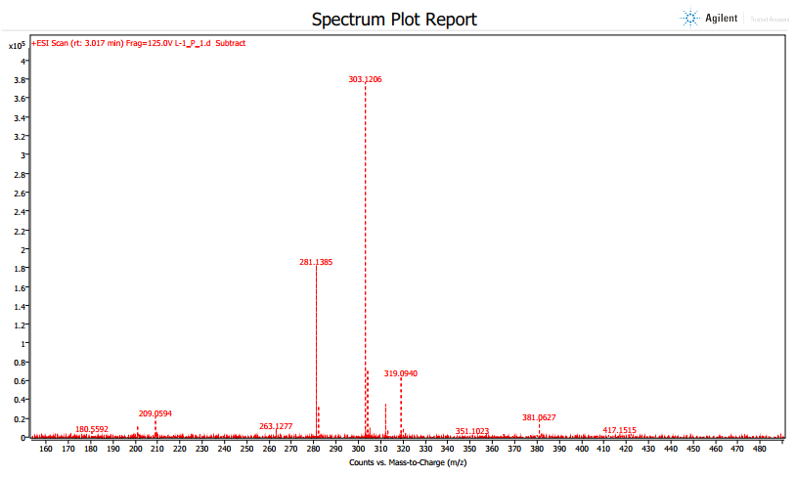

**Figure. S3.**

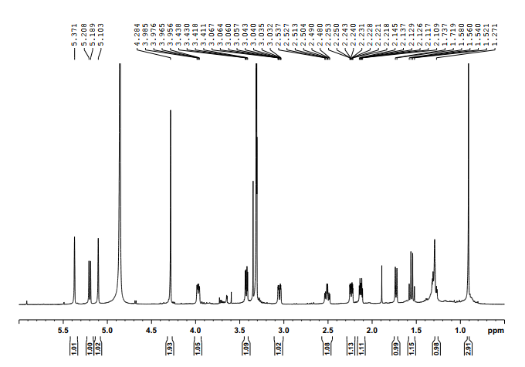

**Figure. S4.**

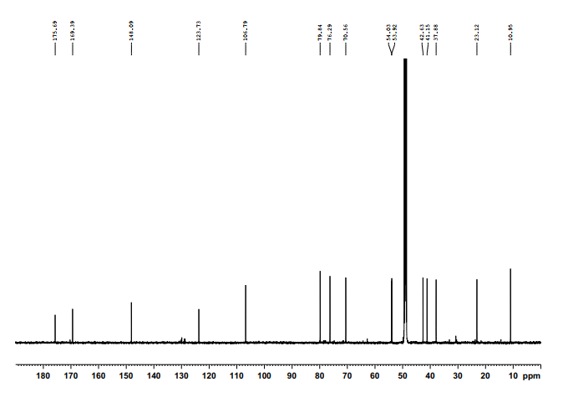

**Figure. S5.**

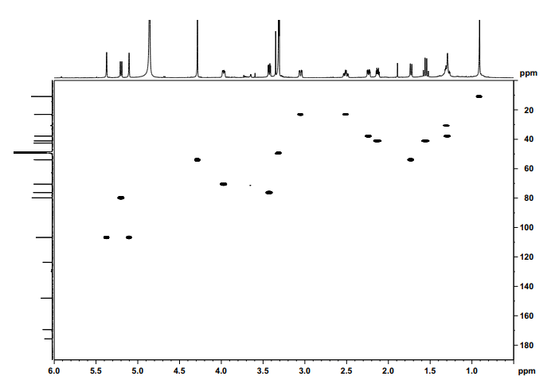

**Figure. S6.**

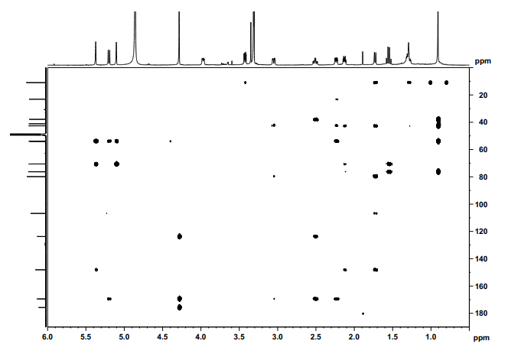

**Figure. S7.**

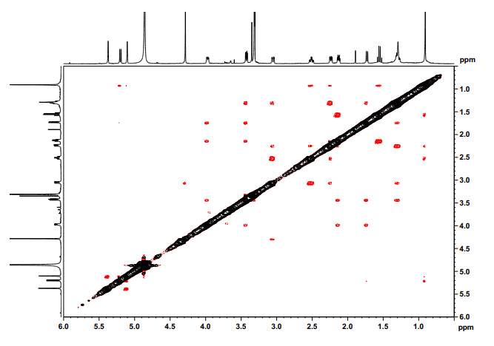

**Figure. S8.**

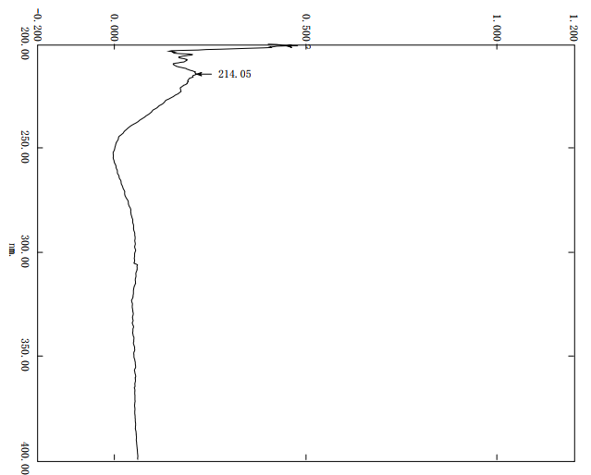

**Figure. S9.**

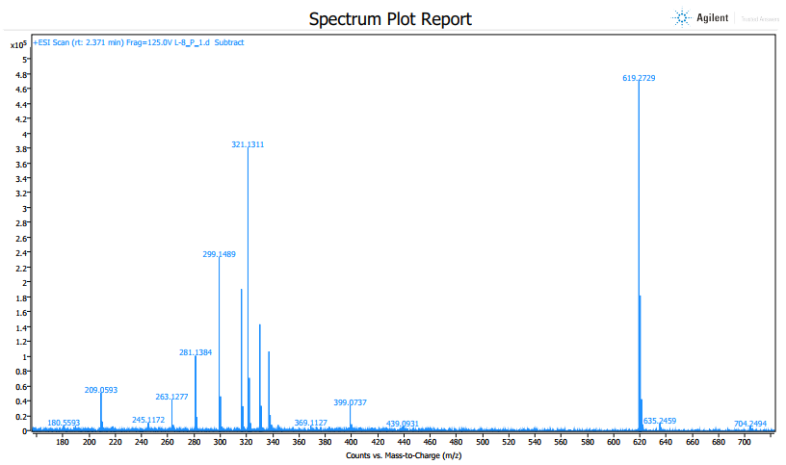

**Figure. S10.**

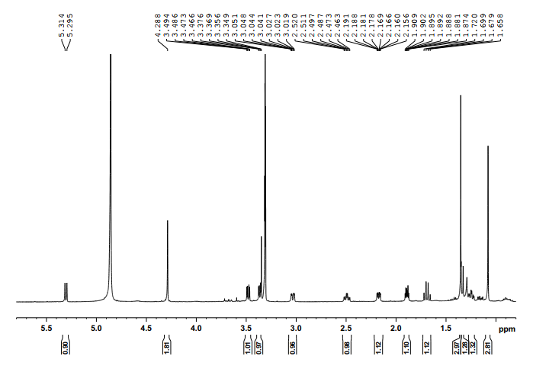

**Figure. S11.**

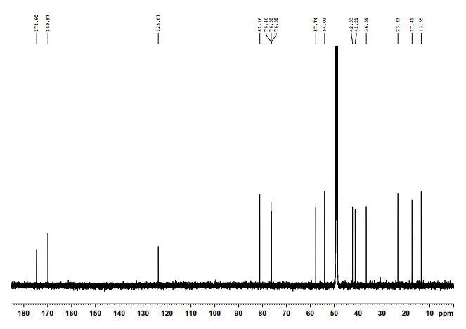

**Figure. S12.**

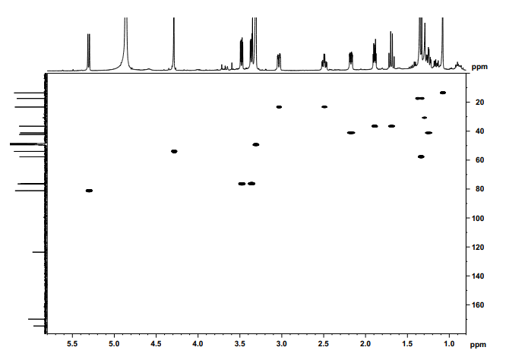

**Figure. S13.**

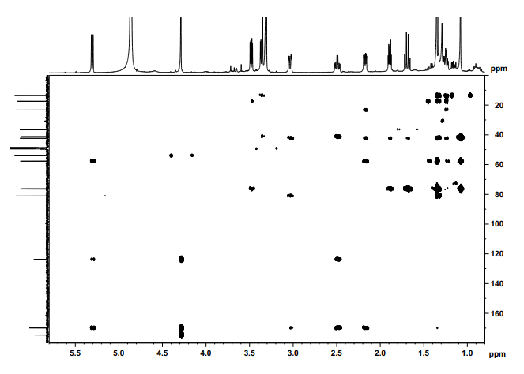

**Figure. S14.**

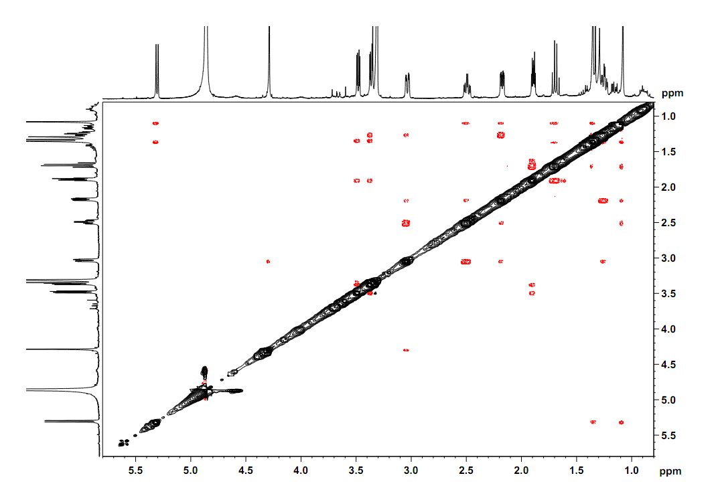

**Figure. S15.**

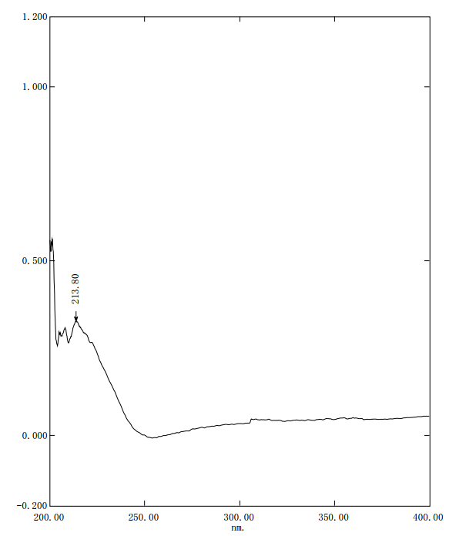

**Figure. S16.**

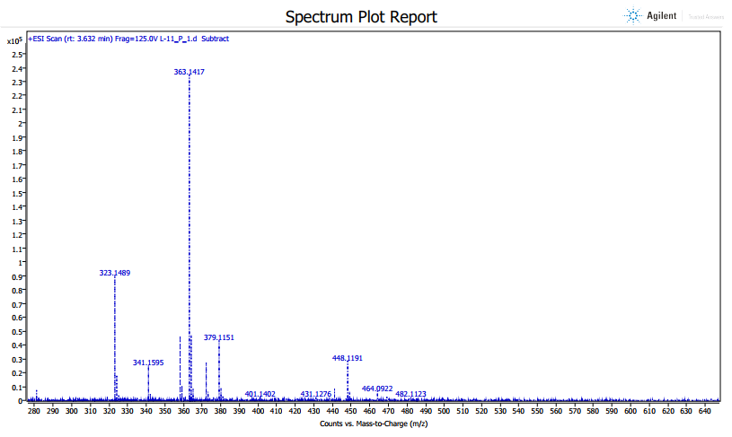

**Figure. S17.**

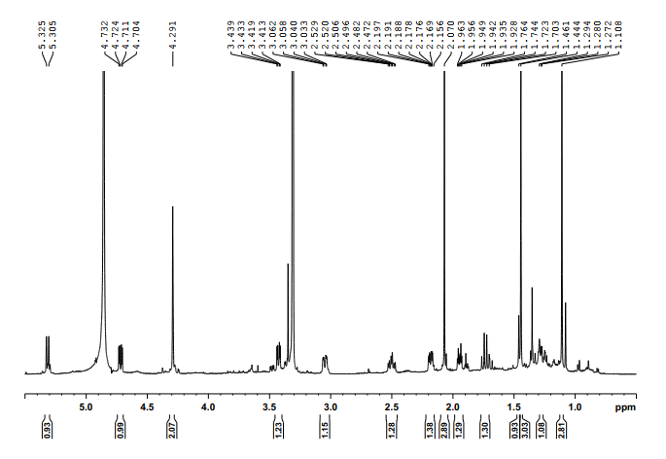

**Figure. S18.**

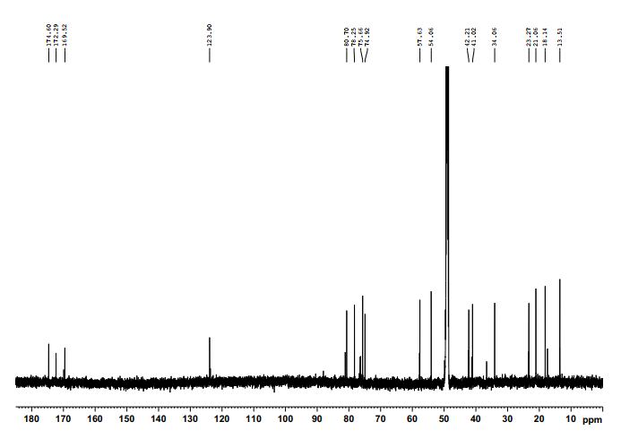

**Figure. S19.**

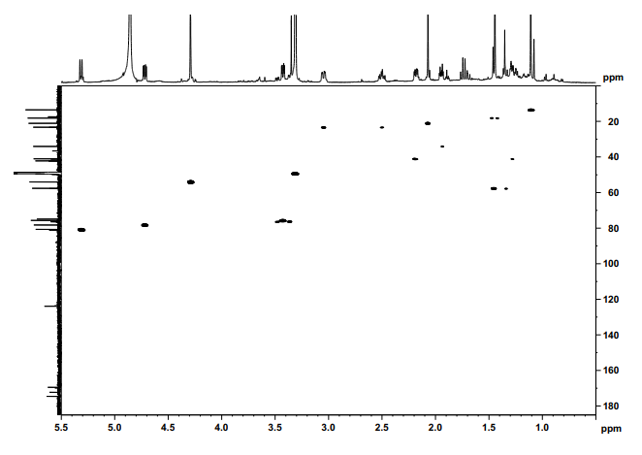

**Figure. S20.**

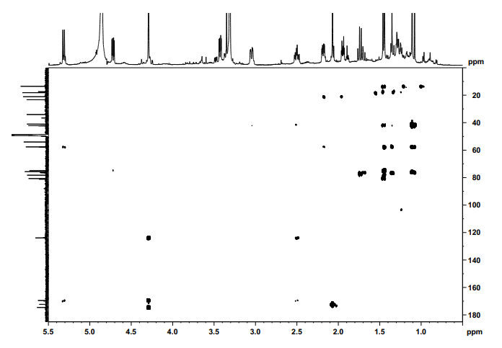

**Figure. S21.**

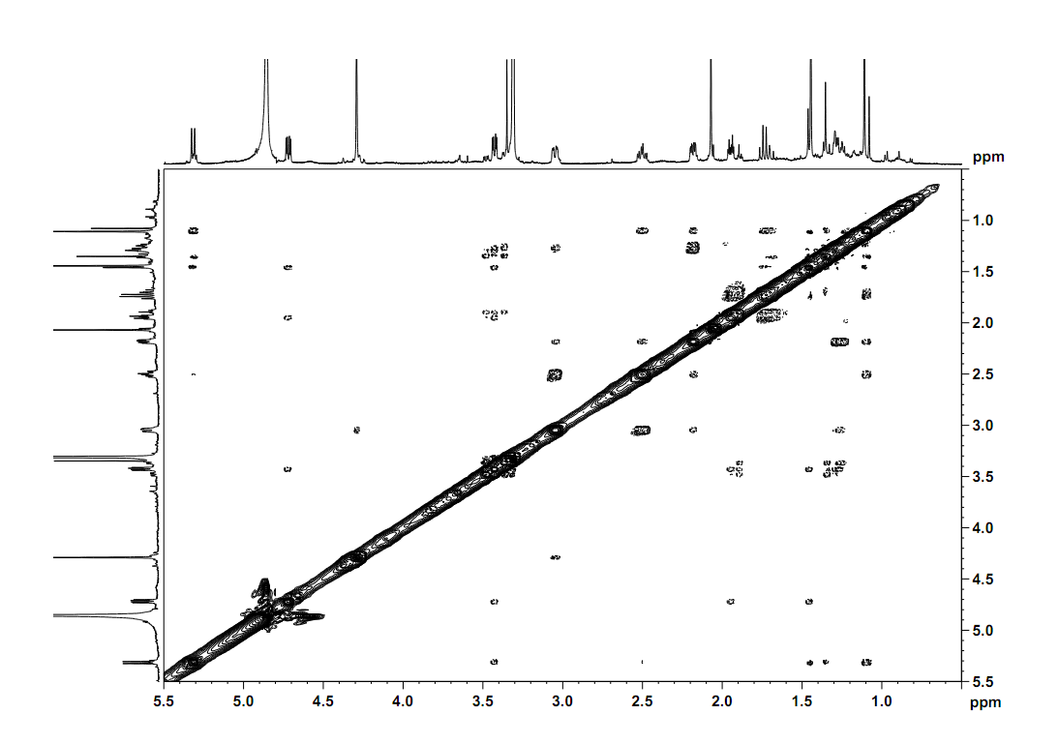

**Figure. S22.**

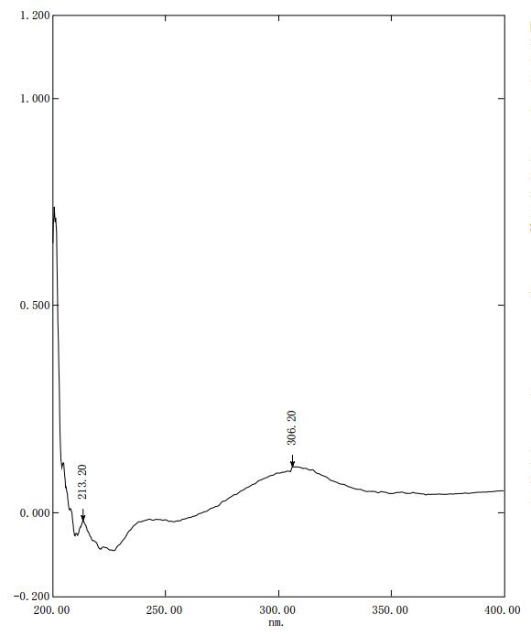

**Figure. S23.**

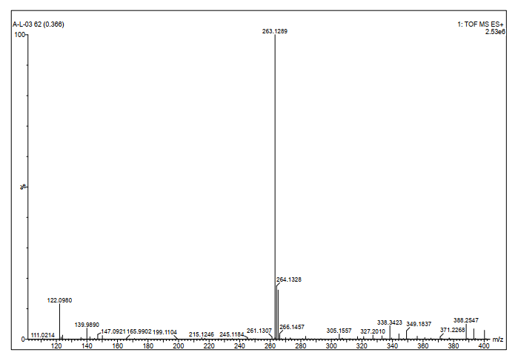

**Figure. S24.**

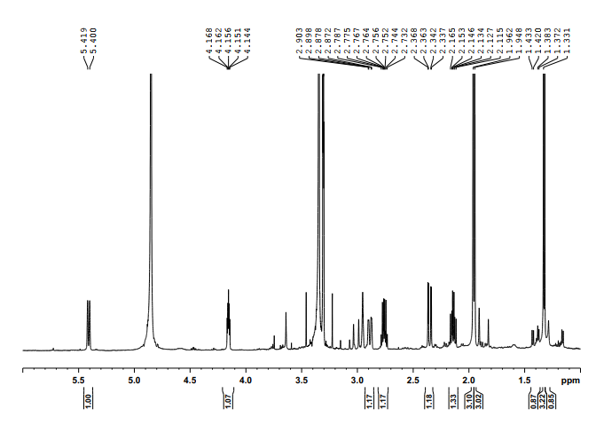

**Figure. S25.**

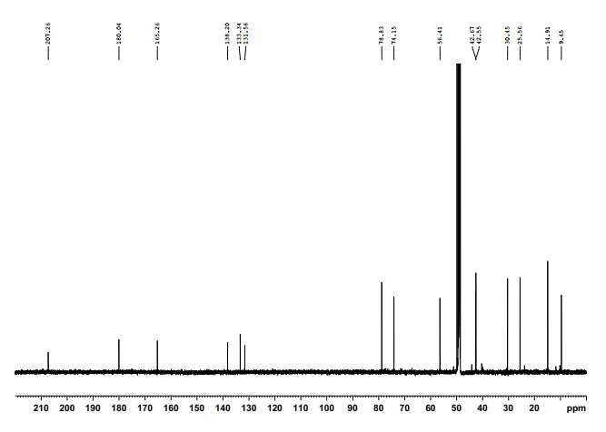

**Figure. S26.**

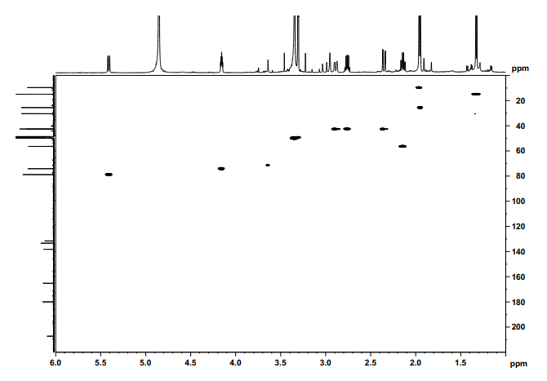

**Figure. S27.**

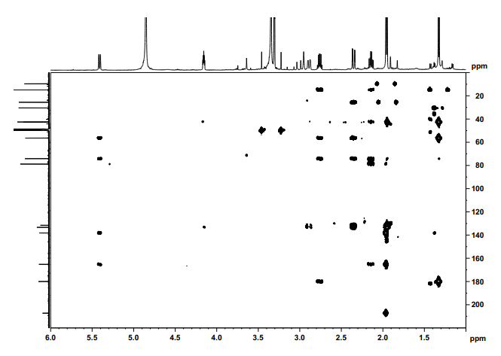

**Figure. S28.**

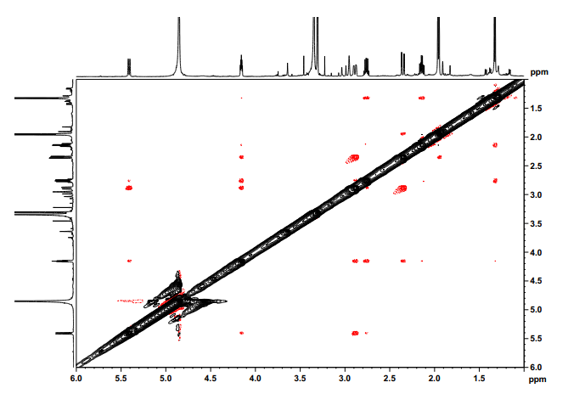

**Figure. S29.**

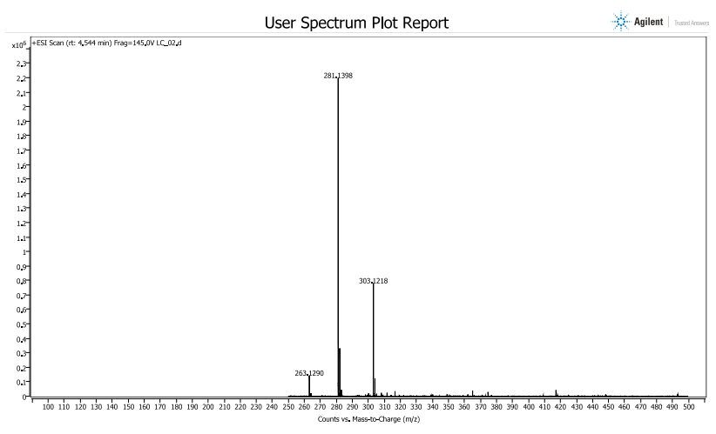

**Figure. S30.**

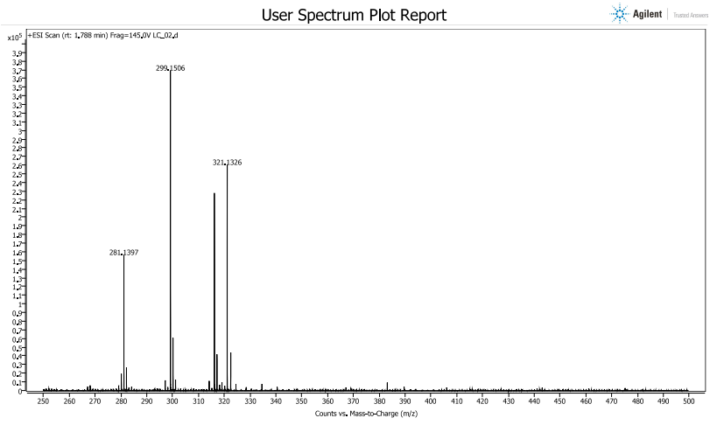

**Figure. S31.**

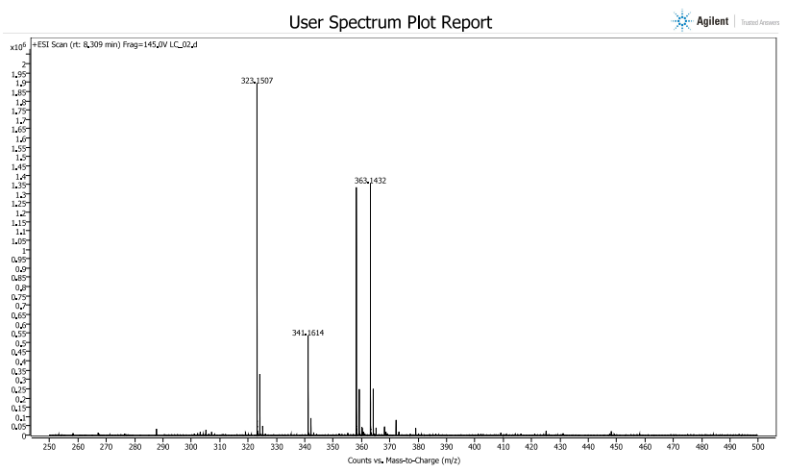

**Figure. S32.**

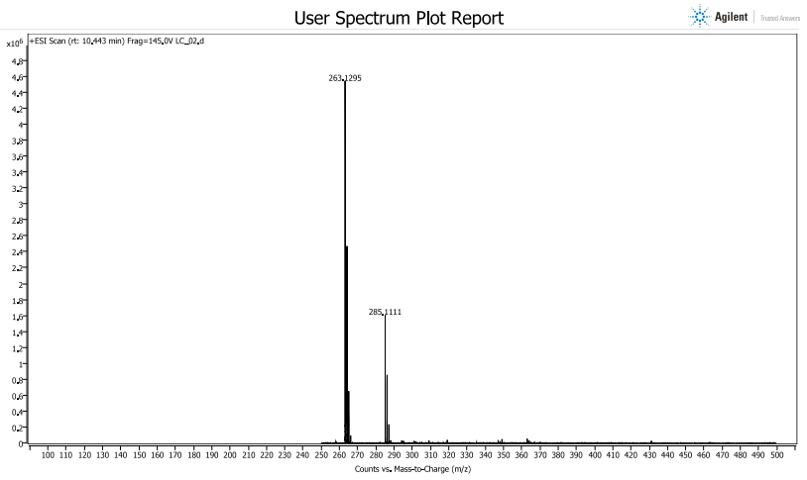

**Figure. S33.**

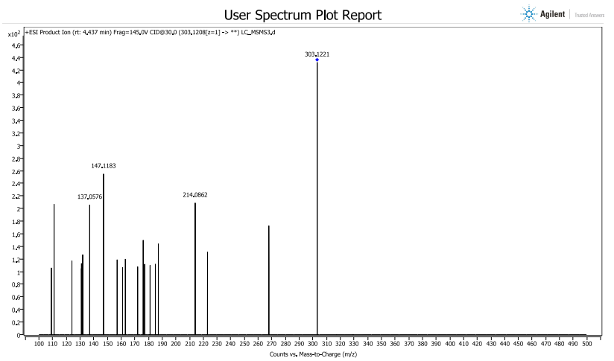

**Figure. S34.**

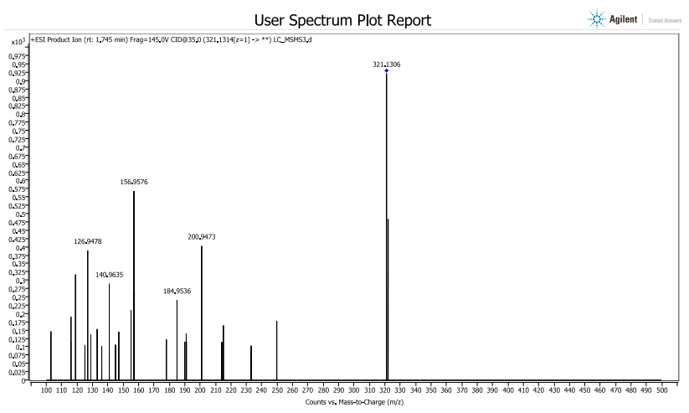

**Figure. S35.**

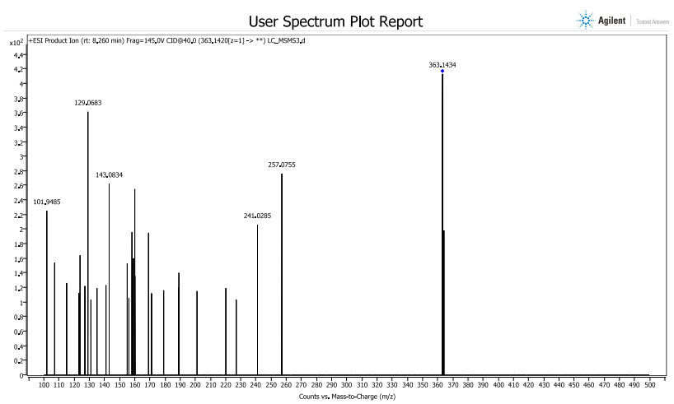

**Figure. S36.**

