Supplementary Material

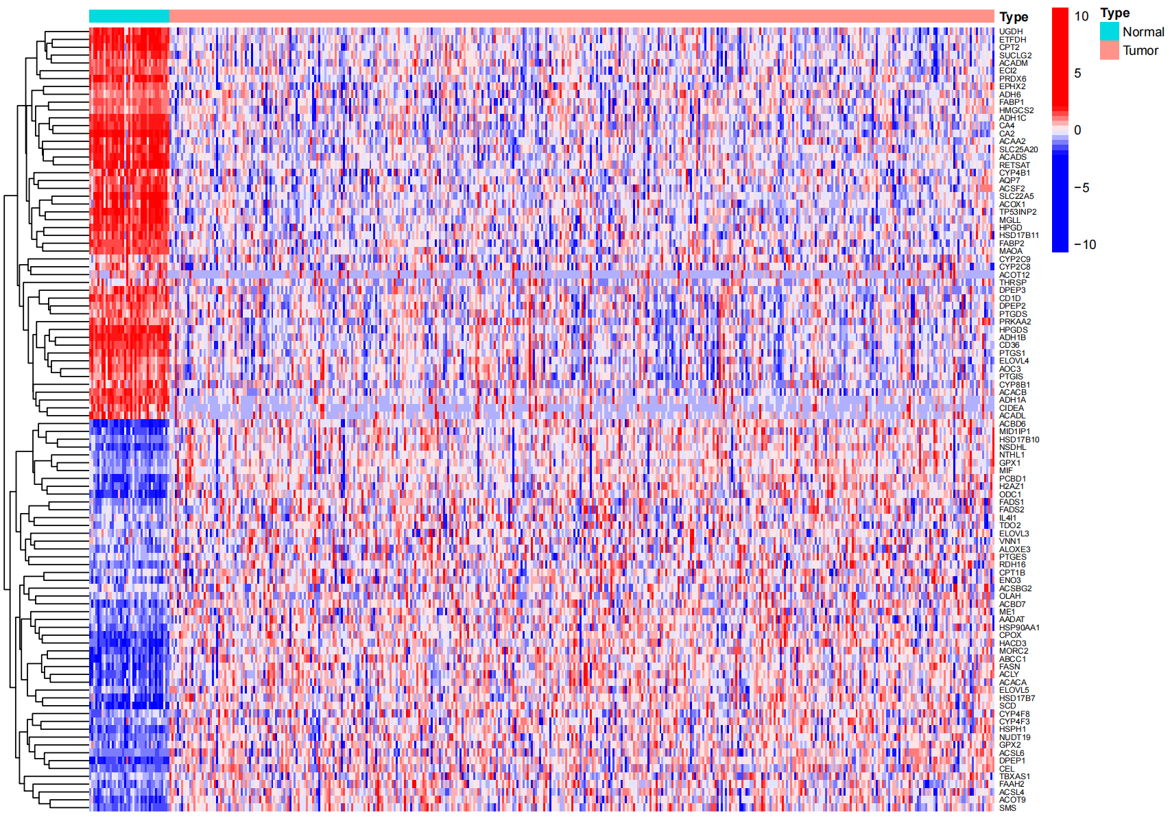

**Supplementary Figure 1**. Identification of differential expressed FAM-related genes in COAD

sFigure 2

**Supplementary Figure 2.** Validation of the performance of the risk model using GEO dataset. (A) Kaplan-Meier (KM) analysis of OS based on the 8 FAM-related signature. (B) ROC analysis of the risk signature in predicting the OS. (C) Survival status distribution in high-risk group and low-risk group. (D) Risk score distribution of the high-risk group and low-risk group.