Supplementary Material

# Supplementary Figures:

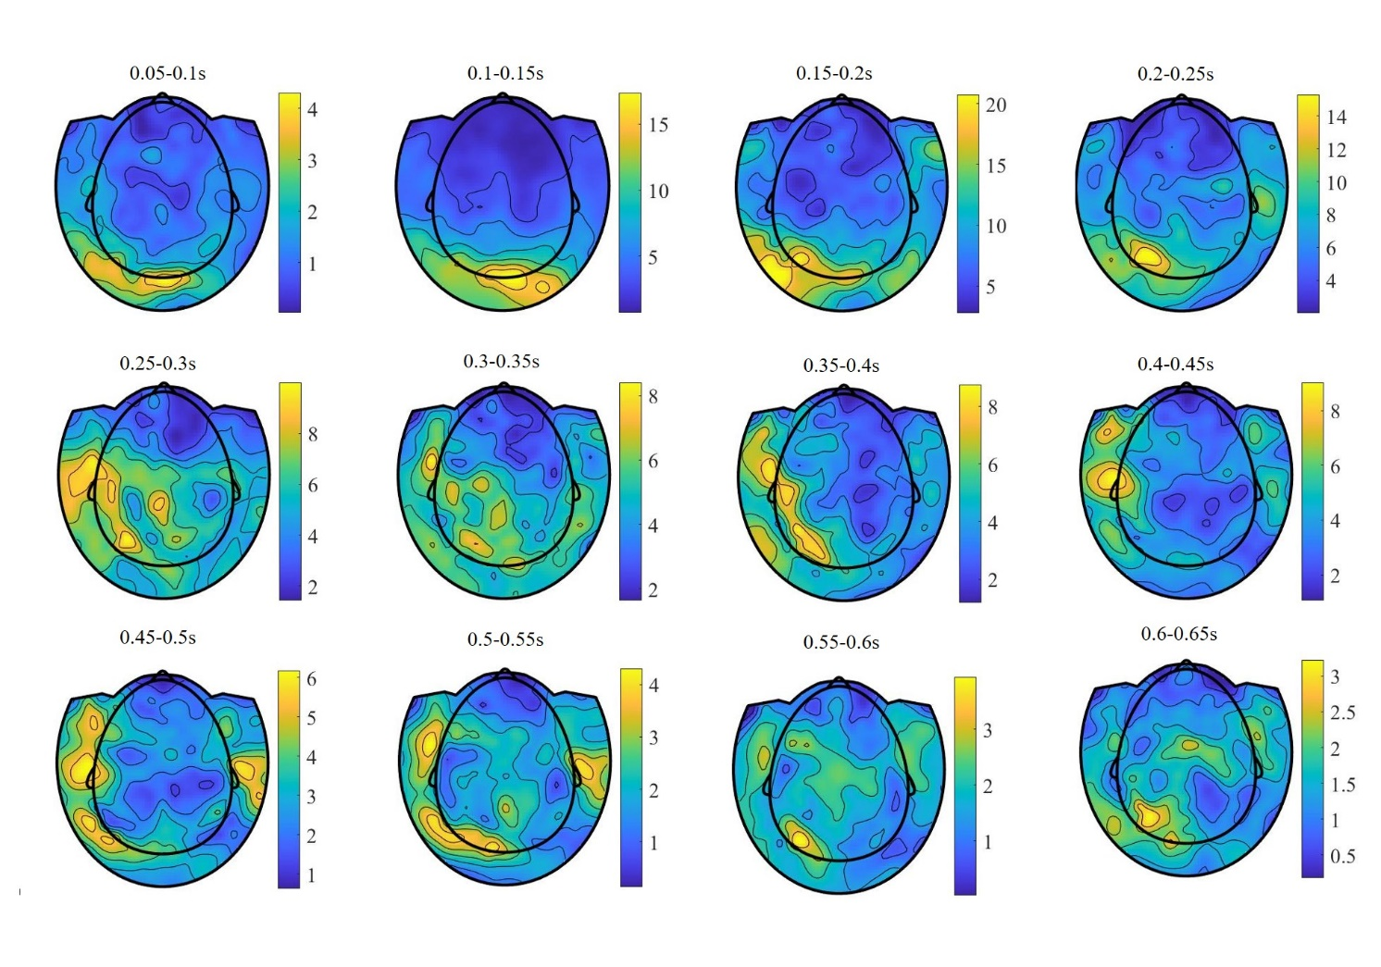

**Supplementary Figure 1.**. Mean planar field distributions in sensor space in controls between 50 and 650ms after stimulus onset in steps of 50ms.

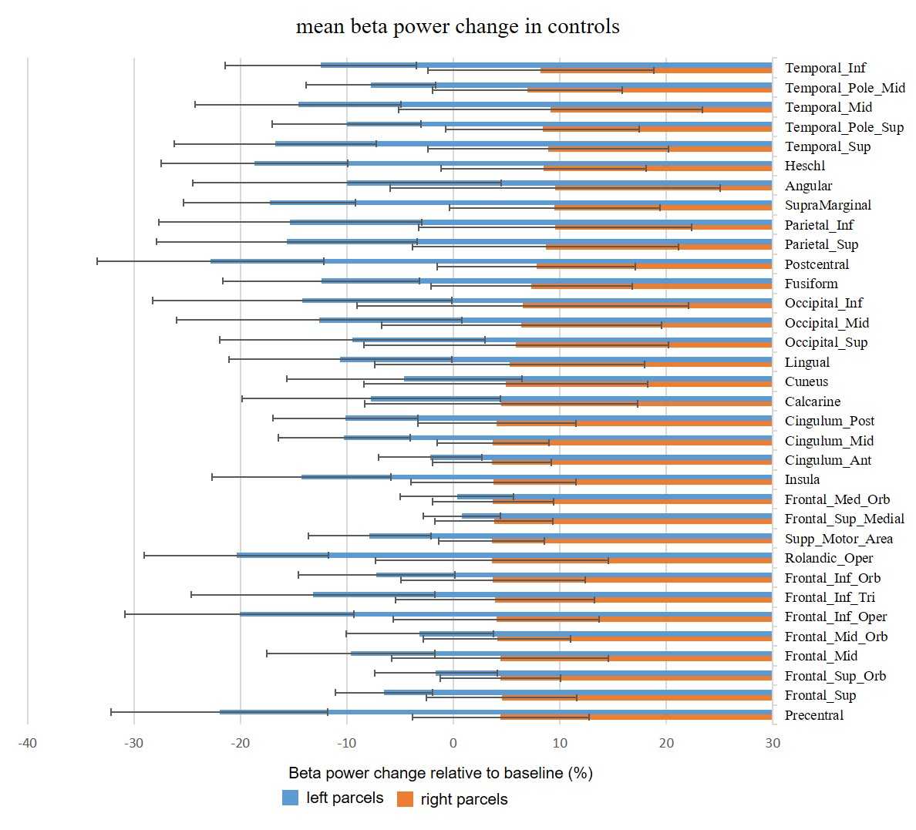

Supplementary Figure . Mean beta power change relative to baseline in controls in left and right anatomical parcels.

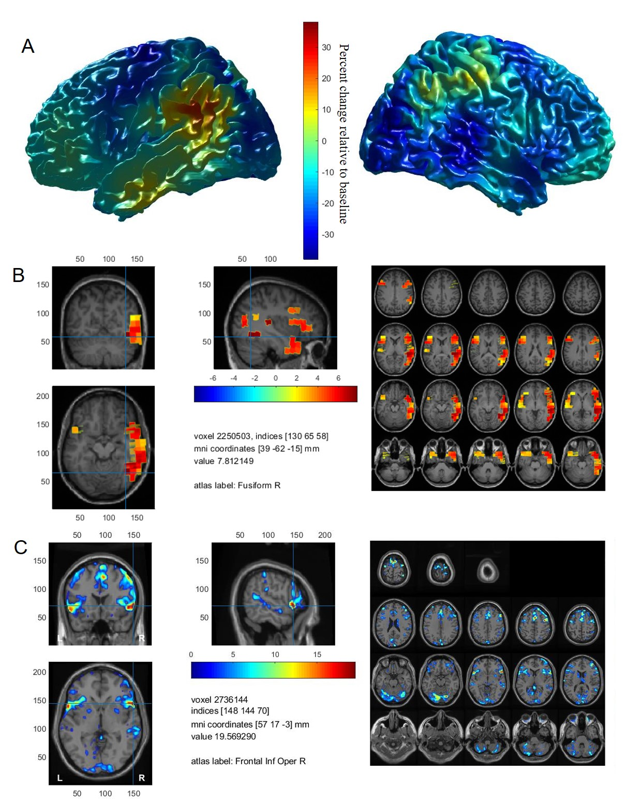

Supplementary Figure . Activation maps in patient 1 with right language dominance in Wada test. A. MEG localization of event related beta modulation between 0.3-1 sec after stimulus onset. Percent change relative to baseline (-0.7-0 sec). B. MEG result of cluster-based permutation testing which was restricted to the regions of interest. The peak t-value is situated within the right temporal lobe. C. fMRI statistical t-map thresholded at p<0.001, uncorrected with a cluster size of 10 voxels. Statistics were not restricted to ROIs. The peak t-value is situated within the pars opercularis of the right IFG.